Commuter Survey- Fall 2014

# Executive Summary

This is the second annual comprehensive commuter survey at the University of Utah, and similar transportation surveys are widely used at other universities. The data from this survey is used to create the GHG Inventory and for STARS reporting, which help to track progress in sustainability. This data can also be used in the Transportation Master Plan and for other strategic efforts from Commuter Services. In this survey, students, faculty, and staff were asked about their commuting habits to the University.

# Fall 2014 Commuting Facts

* 696,779 miles are traveled one way each day to the University of Utah.
* 53% of the campus population travels in a single-occupancy vehicle (SOV), followed by 37.5% that travels via UTA, including TRAX, FrontRunner, and bus.
* If driving were not an option, SOV drivers would take UTA; the top two reasons for not taking UTA were convenience and time.
* 62% of respondents travel to the University on Tuesday, making it the busiest commute day of the week.
* 89% of respondents chose walking as their preferred method of transportation on campus. 23% Prefer using the campus shuttle. Red is the most popular shuttle route, followed by Blue, then Black.
* South main campus is the most popular campus destination.

The following graph breaks down the percentage of users per mode by association and miles traveled. During the Fall 2014 semester, Staff made up 25% of the total miles traveled by single occupancy vehicle (SOV), followed by Undergraduates at 15%. As the top two users of SOVs, staff and undergraduates provide the largest opportunity for behavioral changes in commuting, and can be targeted in future surveys for this purpose.

# Survey Respondents

Of the 42,228 students, faculty, and staff affiliated with the University of Utah in the Fall of 2014, 11,451 people participated in this survey.

# Statistics

In order for the survey to have statistical significance, we needed at least the following participation:

**Students:** At least 1,024 respondents out of 25,135 in order to have a 95% confidence level and margin of error of +/- 3%.

**Faculty:** At least 764 respondents out of 2,689 in order to have a 95% confidence level and a margin of error of +/- 3%.

**Staff:** At least 994 respondents out of 14,405 in order to have a 95% confidence level and a margin of error of +/- 3%.

From the survey, we had statistically significant results for all three groups:

**Students:** 21% of the total student population, which is 4,308 more students than were needed for significance, took the survey. We can be 95% certain that these responses can be extrapolated to the entire student body, +/- .97%.

**Faculty:** 61% of the total faculty population, which is 883 more faculty responses than needed for significance, took the survey. We can be 95% certain that these responses can be extrapolated to the faculty population, +/-1.47 %.

**Staff:** 31% of the total staff population, which is 3,478 more staff response than needed for significance, took the survey. We can be 95% certain that these responses can be extrapolated to the staff population, +/- 1.13%

# Distances and Modes of Transit

The following graph shows the number of miles traveled by different modes in a typical day during the inbound commute. Personal vehicles account for the most miles traveled to the University, followed by UTA. During the Fall 2014 semester, the average number per person of inbound miles traveled in a day was 16.5. Extrapolated to the entire University of Utah population, this equates to a total of 696,779 miles traveled each day to the University.

The following graph is a comparison of the modes of transportation by the percentage of total miles in the fall of 2013 and 2014. Survey methodologies have changed, so the change from year to year could have sampling error.

The following graphs show the percentage of users per mode for each day of the week. Tuesday and Wednesday are the busiest commuting days with 62% of respondents traveling that day. Friday is the least busy weekday at 54%.

Drivers were asked what their second choice of transportation would be if driving were not an option. Over 80% said they would take UTA. They were then asked why they choose to drive instead of taking UTA, and most of these respondents said driving is simply more convenient and time efficient.

Respondents were asked how many commuting trips they took to the University on a typical day. Commuting to and from a destination is considered to be two trips. There was confusion among respondents about what a commuting trip was. Because of this, these numbers may not accurately reflect the actual number of commuting trips taken, and commuting trips were assumed to be 2 per day of commute (inbound and outbound).

Of the 8,052 respondents who used a personal vehicle to commute, over half reported 20-29 miles per gallon. The EPA’s Fuel Economy and Environment Label requirements for model year 2013 cars and light trucks is 26 MPG (US EPA).

# Transportation and Distribution on Campus

Respondents were asked to choose the mode(s) of transportation they use while moving around on campus. The preferred transportation method of 89% of the respondents is by foot. 23% travel by U campus shuttle, and 16% choose to drive.

Of the respondents who use the U Campus Shuttle, over half use the Red and Blue routes most often, and about 29% use the Black route.

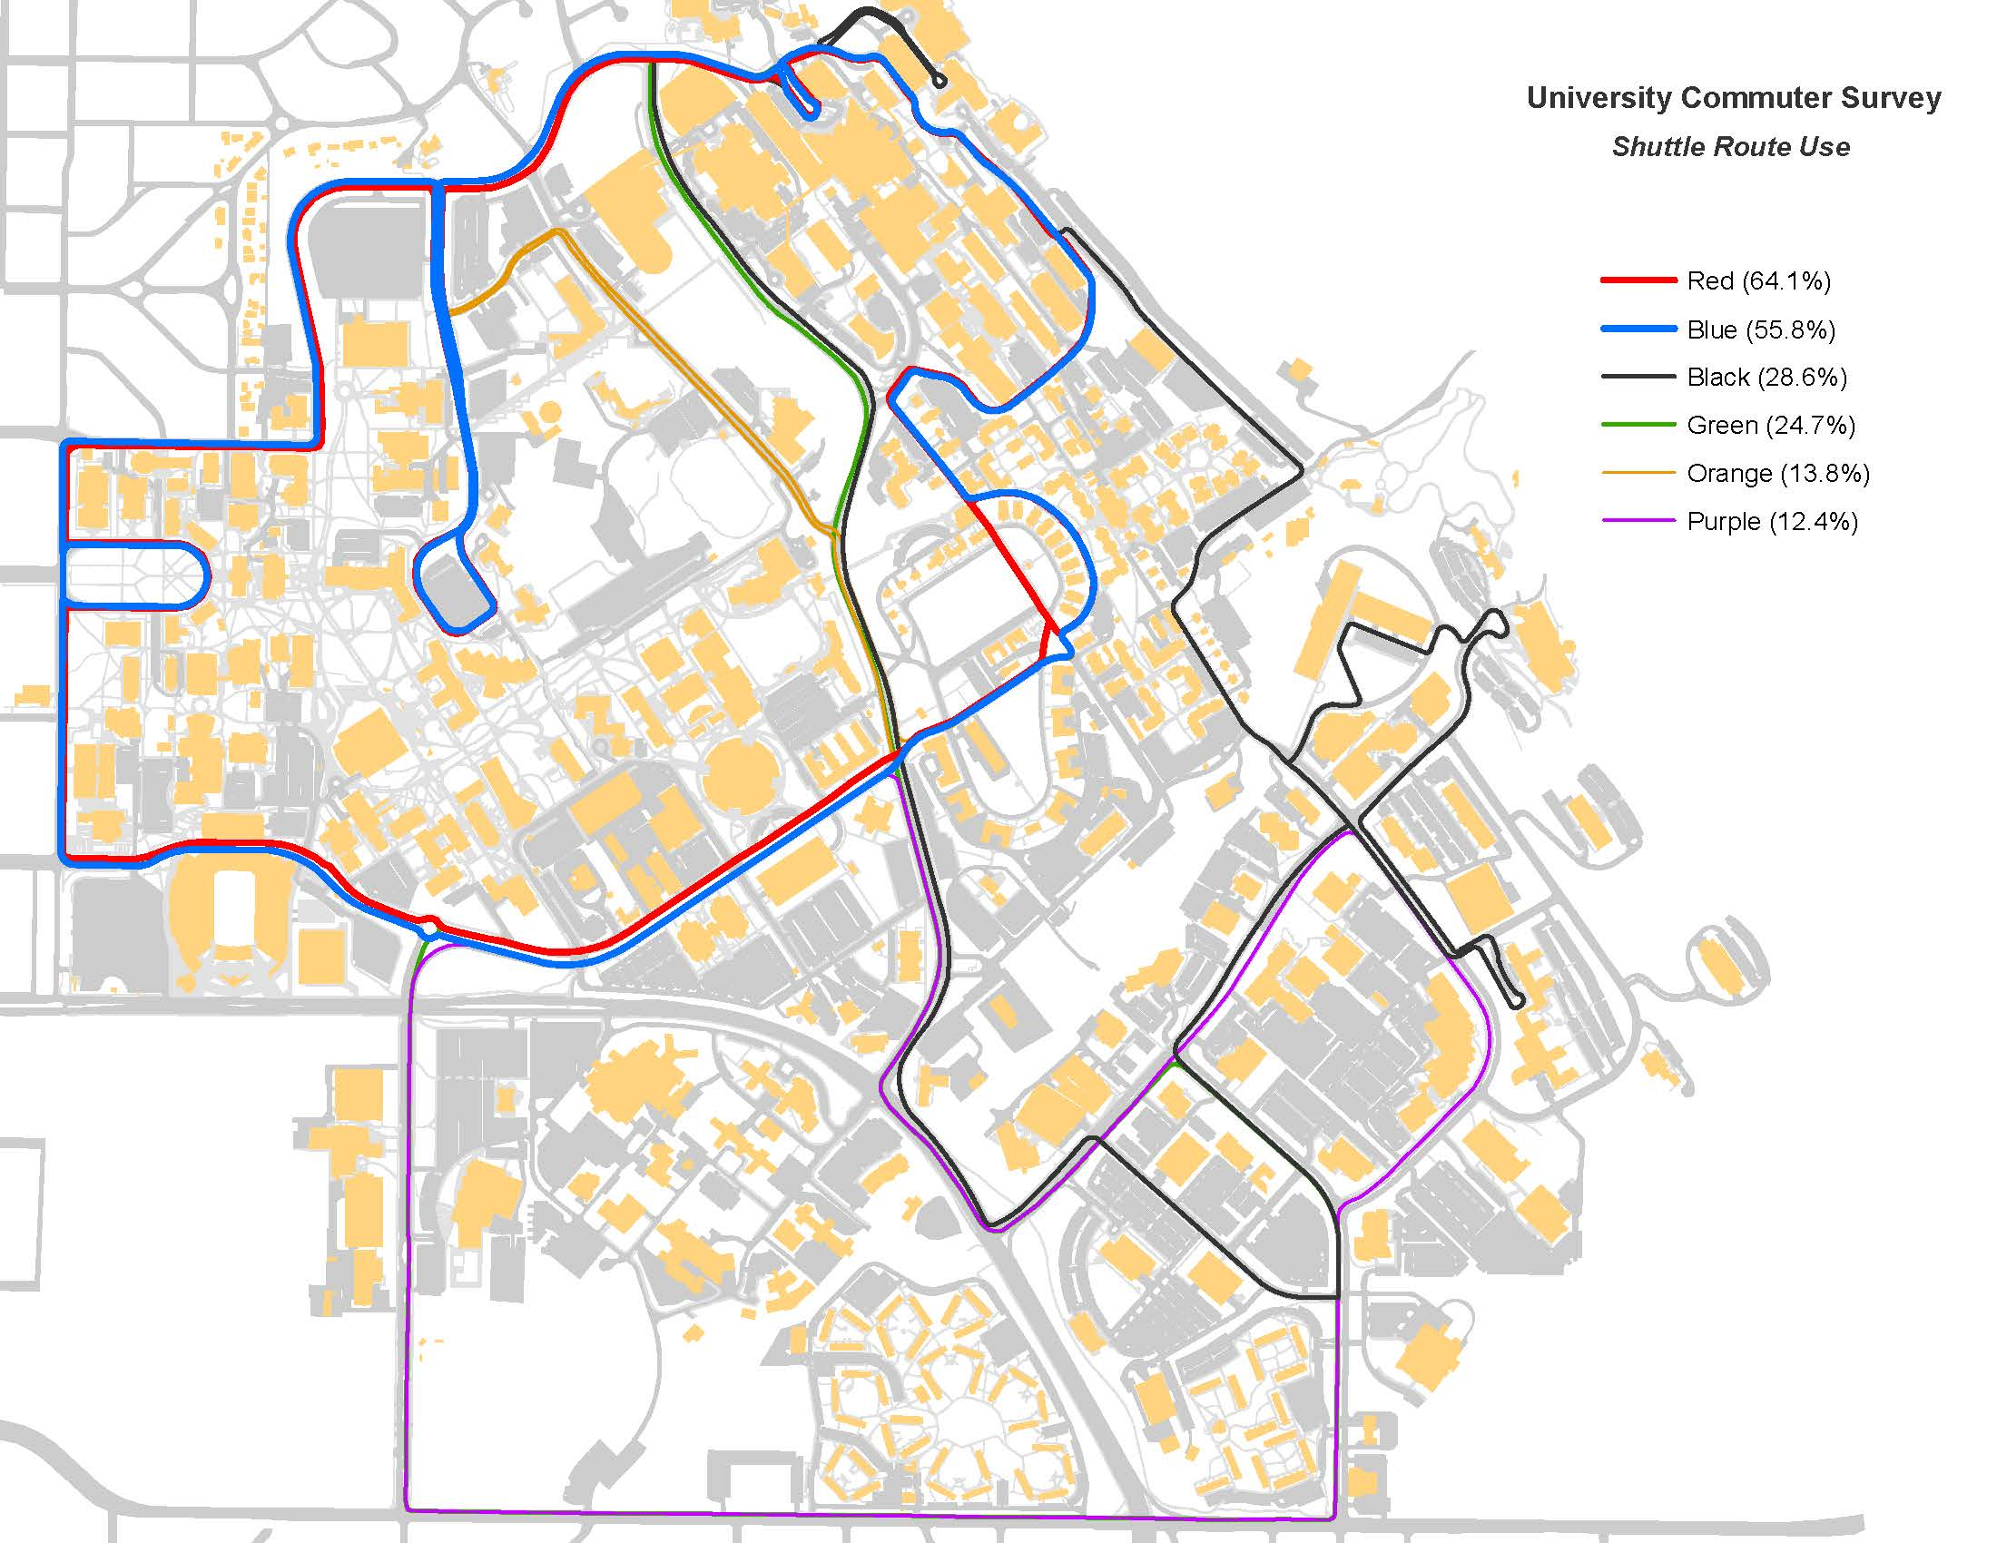

The below graph depicts the breakdown of students living on campus. Most respondents, about 28%, live in the East or West Village Students Apartments.

The map below shows each general campus destination with its corresponding percentage of respondents. Main campus south is the post popular destination with 39% of respondents commuting to this area.

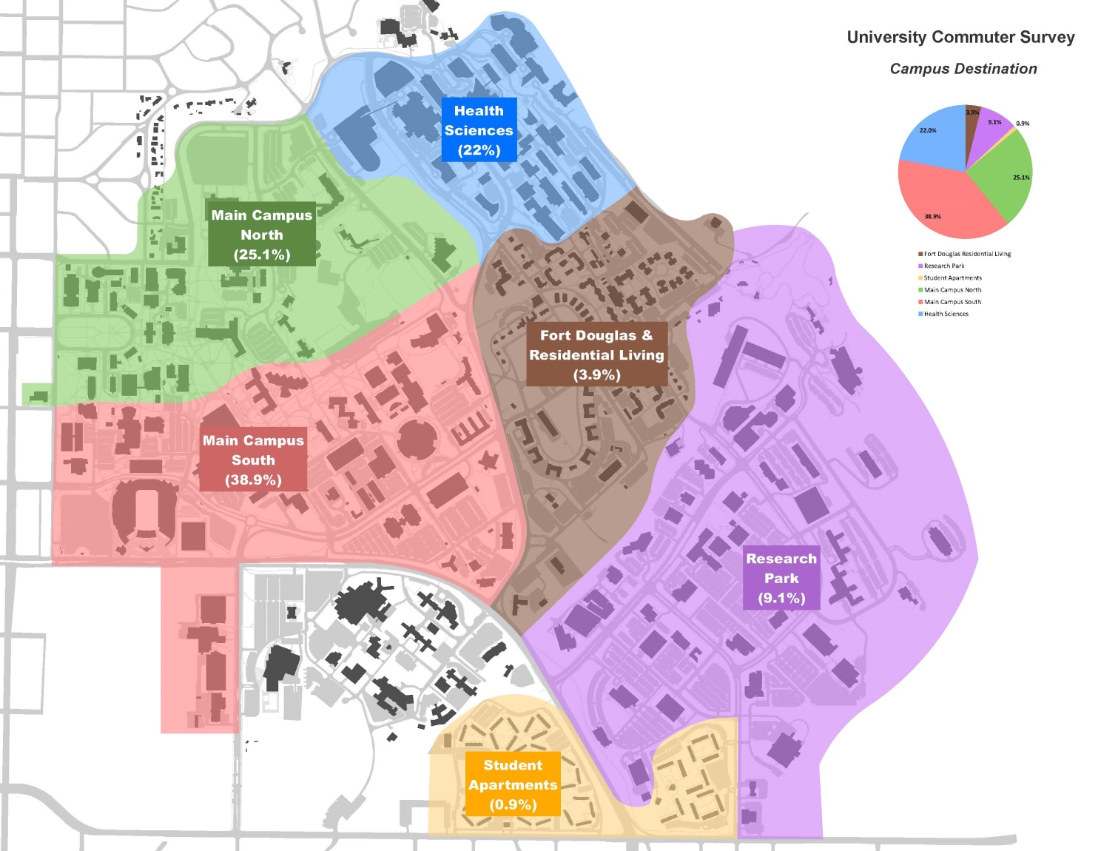

**Zip Code Distribution**

This map shows the distribution density of the respondents by zip code. Most live in downtown Salt Lake City, the 84102 zip code.

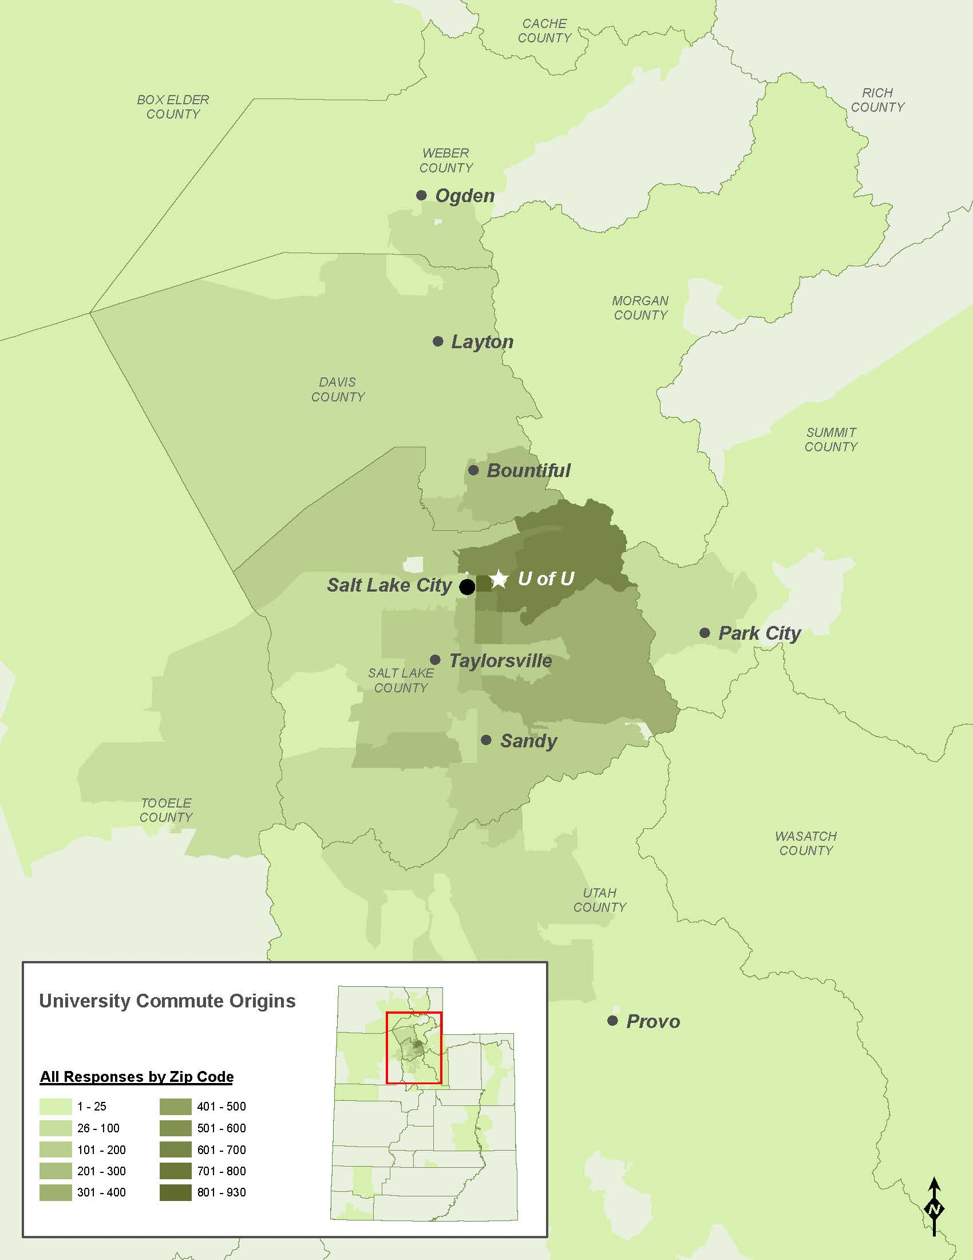

Respondents were asked when they generally arrive and depart their destinations on campus. Just over 30% typically arrive between 7am and 8:59am, and departure is spread out between 12pm and 6:59pm.

**Suggested Locations for Electric Vehicle Charging Stations**

Users of electric cars were asked where they would find charging stations most useful. This map depicts all suggested locations along with the number of times they were suggested. 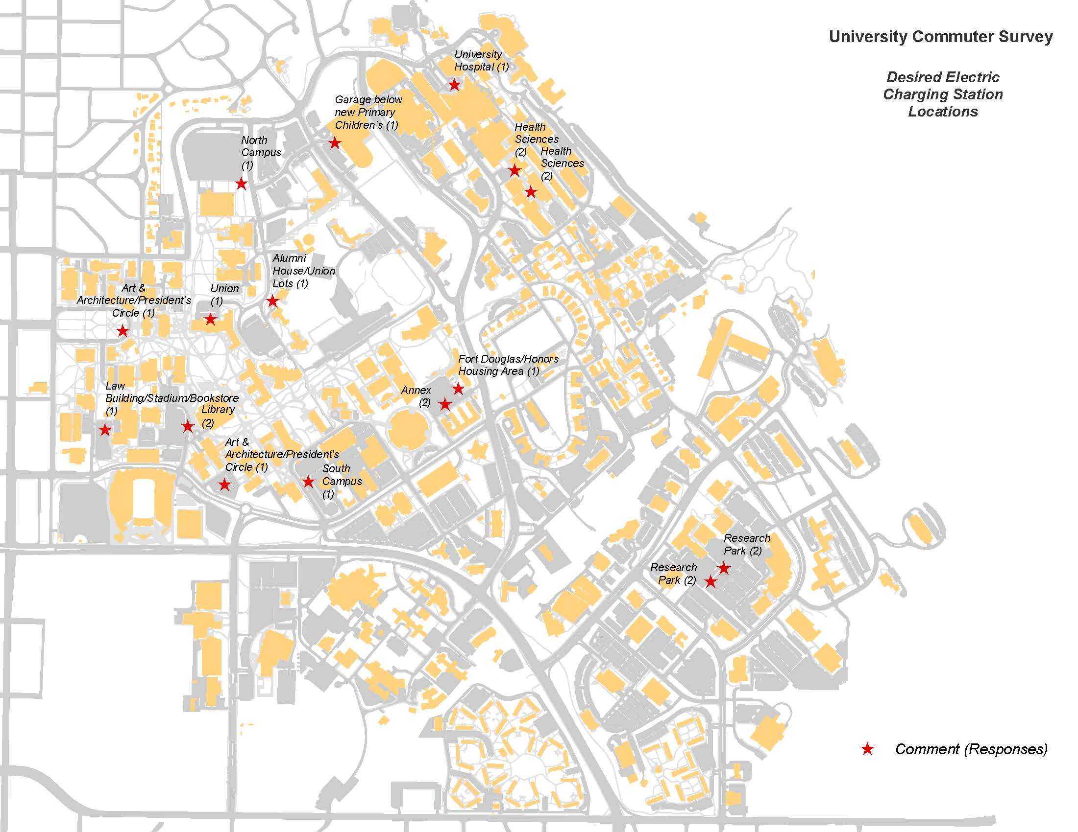

There were 7 fewer Electric Vehicles reported in Fall 2014 than in Fall 2013.

Appendix

# Questions Asked on the Survey

This is a comprehensive list of all possible questions on the survey. Many of these questions may have been asked conditionally based on answered to previous questions in order to expedite the process.

1. For each of the 2014 semesters, please select the answer that best describes your status with the University of Utah (Choose all that apply)
2. For each of the 2014 semesters, what is your association with the University of Utah? Please select an answer for each of the three semesters
3. Did you live on campus for any of the 2014 semesters?
4. For the semesters you lived on campus, which campus housing did you reside in? (Choose all that apply)
5. From which zipcode do you begin your inbound commute?
6. What is your total number of commute trips (inbound plus outbound) per day?
7. For the fall 2014 semester, where is your main University of Utah commuting destination?
8. For the Fall 2014 semester, select the general campus destination of your inbound commute (Choose all that apply)
9. For the Fall 2014 Semester, What mode(s) of transportation do you use to get to campus each day during your inbound commutes? (Choose all that apply)
10. Approximately how many total miles is your inbound commute to your University of Utah destination by personal vehicle, motorcycle, motorscooter, or moped, carpool, UTA TRAX, UTA Frontrunner, UTA Bus, bicycle, scooter, skateboard, or rollerskates, foot, U Campus Shuttle? If unsure of the distance, click here for Google Maps
11. Are your inbound and outbound commutes the same for the 2014 fall semester?
12. For the Fall 2014 Semester, what mode(s) of transportation do you use to get from campus each day during your outbound commutes? (Choose all that apply)
13. Approximately how many total miles is your outbound commute to your University of Utah destination by personal vehicle, motorcycle, motorscooter, or moped, carpool, UTA TRAX, UTA Frontrunner, UTA Bus, bicycle, scooter, skateboard, or rollerskates, foot, U Campus Shuttle? If unsure of the distance, click here for Google Maps
14. When you are on campus, how do you normally move around on campus (i.e., from class to class or meeting to meeting)? (Choose all that apply)
15. When you commute using the U Campus Shuttle, which routes do you normally use? (Choose all that apply) If unsure, follow this link for U of U Shuttle info www.uofubus.com
16. At what time(s) do you normally arrive at your campus destination? (Choose all that apply)
17. At what time(s) do you normally leave your campus destination? (Choose all that apply)
18. If you drive alone or carpool, what would encourage you to carpool more frequently? (Choose all that apply)
19. Please explain what would encourage you to carpool more frequently
20. What would be your second choice of transportation if driving were not an option?
21. What are the reasons you choose to drive instead of riding UTA? (Choose all that apply) please specify
22. What are the reasons you choose to drive instead of using your bicycle, scooter, skateboard, or rollerskates? (Choose all that apply) please specify
23. What are the reasons you choose to drive instead of walk or run? (Choose all that apply)
24. What are the reasons you choose to drive instead of riding the U Campus Shuttle? (Choose all that apply)
25. When you drive to campus, do you usually park on campus?
26. If you park on campus, select the area(s) with the parking lots that you typically use
27. For the personal vehicle you use most often to commute, enter your miles per gallon (MPG) number below. If unsure of mileage, use this calculator to find combined mileage and enter the number in the box below
28. Are you driving an all-electric vehicle? Choose an answer for each semester in which you are affiliated with the University of Utah
29. Would you find it useful to have charging stations on campus?
30. Where on campus would you find charging stations most useful?
31. You have just answered questions on your commuting habits for Fall 2014. How are your commutes different in the Spring 2014 and Summer 2014 semesters? (Choose all that apply)
32. Please explain how your commutes are unique
33. What is your age?
34. What is your gender identity? (check all that apply)
35. Would you like to be contacted in the future to participate in additional transportation surveys to help us improve?
36. Please provide your E-mail address to participate in future surveys
37. Do you wish to be entered into the prize drawing for one of five $200 gift cards to the Campus Bookstore?
38. To be entered into the prize drawing, you must provide your uNID (University ID number), full name, and a valid email address below. Be assured that your responses to the survey questions, when forwarded to Commuter Services for evaluation, do not include your personal identification information used for the prize drawing.

Work Cited

US EPA. "New Fuel Economy and Environment Labels for a New Generation of Vehicles." *US EPA*. United States Environmental Protection Agency, 6 July 2011. Web. 17 Mar. 2015. <http://www.epa.gov/otaq/carlabel/documents/420f11017a.pdf>.