RE: STARS Review

February 21, 2018

To whom it may concern,

Please accept this letter as my affirmation that I have reviewed the UWRF 2017 STARS report. I have documented my concerns and suggestions and discussed them with Mark Klapatch, UWRF Sustainability and Custodial Supervisor. He has reviewed my concerns and suggestions and has made changes to the report. I have since reviewed the areas I noted of concern. All concerns have been addressed. I do not see any remaining issues and I am confident that the UWRF report is accurate.

If you have any questions, please feel free to contact me.

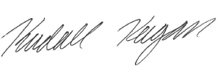

Kendall Keegan

University of Wisconsin-River Falls Student

President of the Student Alliance for Local and Sustainable Agriculture

Kendall.keegan@my.uwrf.edu