(We try not to use paper except for special occasions like this!)

The Haverford community works hard to live out its values of sustainability, or the idea that we can meet our needs today while making sure that everyone’s needs will also be met in the future. This translates into ways of working and living that support our people and our environment.

Commuting:
- SEPTA buses, regional rail, and high speed line are a short walk from campus.
- The RideECO program allows Haverford employees to save money on public transportation through pre-tax payroll deductions. Contact: Human Resources
- Bike racks are everywhere on campus. There’s a bike fix-it station by the South Lot for quick repairs. Employees are welcome to shower in the Gardner Integrated Athletic Center.
- 4 charging stations for Electric Vehicle (EVs) are available in the South Lot. Contact: Facilities

Recycling & Waste:
- Recycling on campus is single stream: any marked recycle bin is good for cans, bottles, plastics, and paper. The cleaner the better!
- Anything else, including waste contaminated by food, goes in our regular landfill trash bins.
- When in doubt, throw it out! It’s better than contaminating the recycling or compost streams.
- If you’re really serious, you can compost your food waste in the bins by the Dining Center dish return.

Get Involved!
- Many individuals and community groups are working on sustainability-related related topics. Get in touch with colleagues on the Council on Sustainability and Social Responsibility (CSSR) to learn more!
- www.haverford.edu/sustainability

Food & Dining:
- Employees can purchase meals in the Dining Center and Coop and enjoy a range of local, sustainable, healthy food choices.
- Like to grow food? The Haverford College Farm always welcomes volunteers. Contact: Facilities

Green Office Program:
- See our Green Squirrel Checklist on the web to see how you can help the College make smart choices in the things you do every day, like double-sided printing and energy settings on your computer.
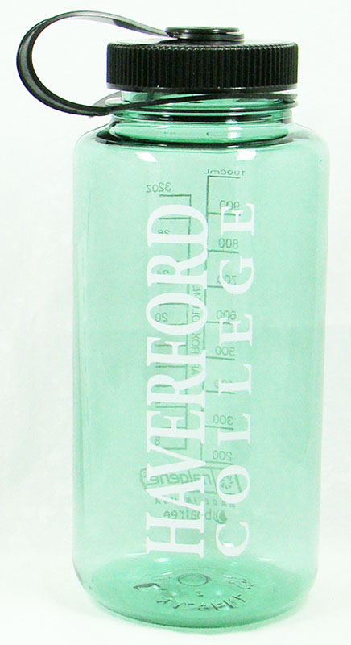
Water:
- Water bottle stations across campus let you save money and reduce waste by reusing your own refillable bottle. FLIP OVER TO LEARN HOW TO GET YOURS!

Did you know?
- Haverford’s 216-acre campus is an arboretum, featuring a 2.2 mile Nature Trail.
- Haverford buys 100% of its electricity from renewable sources.
- Haverford shares an Environmental Studies program with Bryn Mawr and Swarthmore Colleges.
- Students made the Dining Center “tray-less” in 2010 to save food and water.
- Stokes, Kim, and Tritton Halls all have green roofs.
- Food grown by students at the Haverford College Farm goes to the Dining Center and local food pantries.

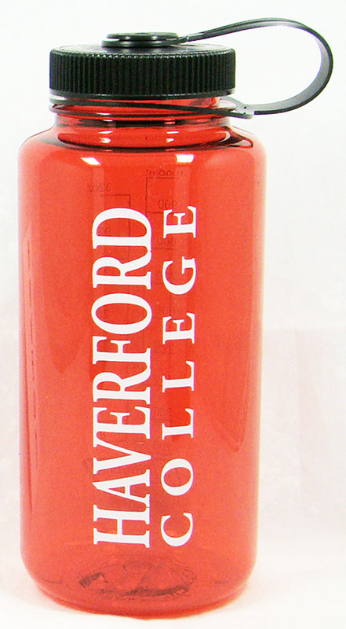

As a new community member, we’d like to give you your own…

WATER BOTTLE!

- Just bring the voucher below to the Haverford College Bookstore to pick out yours.

- Then, see how many filling stations you can find on campus. Hint: there’s one upstairs from the Bookstore.

Each year community members avoid sending thousands of disposable bottles and cups into the waste stream by refilling their own bottles.

Haverford College Bookstore

Haverford College Bookstore is an independent bookstore owned and operated by Haverford College welcoming students, faculty, staff, and our neighbors. The Bookstore is located on the first floor of the Whitehead Campus Center. The Bookstore provides many items to support our community’s academic and lifestyle needs, including “fair trade” goods such as chocolates, coffee, health and beauty goods, jewelry, clothing, cards and gifts. We also offer school supplies made with 100% post-consumer waste recycled materials.

Welcome Water Bottle Voucher

Name: ___________________________________

Department: ___________________________________

Date: ___________________________________

