June 4, 2021

STARS Steering Committee
Association for the Advancement of Sustainability in Higher Education
1536 Wynkoop Street, Suite 100
Denver, CO 80202

Dear Colleagues:

I am delighted to once again share a statement in support of the University of Wisconsin Oshkosh’s sustainability efforts and partnership with the Association for the Advancement of Sustainability in Higher Education (AASHE). As you will see in this year’s STARS report, UWO continues to transform and challenge itself to not only do better but also innovate and lead.

With ever precious resources, and while emerging from a global pandemic, this institution’s leadership, faculty and staff, student body and other stakeholders continue to collaborate. We challenge one another to stretch and change culture within an organization of nearly 15,000 people in a region of tens of thousands more. We push ourselves to more deeply and completely integrate processes, technologies and other advancements, including food waste diversion, biogas innovations and Climate Action Plan development. These are only a few areas of focus. We are invested in a holistically sustainable future on and beyond UWO’s three campuses.

A new Climate Action Committee is poised to help us draft a Sustainability and Climate Action Plan that dovetails with a forthcoming UWO-wide Strategic Plan. Meanwhile, we empower our Sustainability Institute for Regional Transformations (SIRT) to not only share knowledge and guidance that greens area organizations and communities but also helps them become financially durable and champions of social justice. As you know, these are essential dimensions of true sustainability.

We are committed to a lasting symbiosis with AASHE. We value your vital feedback knowing it keeps this now-150-year-old university on its path toward an ideal and goal expressed in our alma mater: “that all may live with dignity upon the earth we share.”

Sincerely,
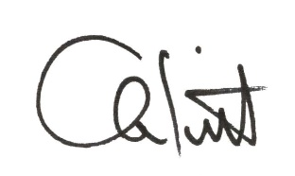
Andrew J. Leavitt, Chancellor
University of Wisconsin Oshkosh

