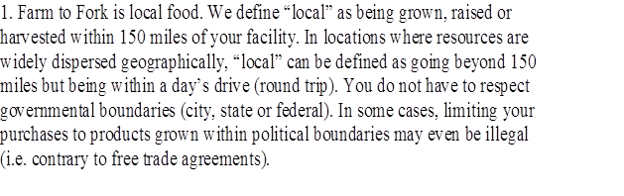 | Oberlin Local defined and supporting local economy, artisans', and nurturing town gown as much as possible within 150 miles | 
AG ACESS | 100%
BOWMAN AND LANDES TURKEYS INC | 100%
NEW CREATION FARMS , PORK, BEEF, ALL C.H. G.C.F. | 100%
COUNTRYSIDE FOODS LLC | 38%
CARUSO'S COFFEE F.T. LOCALLY ROASTED | 100%
FRUITIQUE INC | 100%
GIBSONS | 100%
HAGEN GROUP INC THE TOMATOES TOLEDO DEFORTELLI BRAND | 100%
JORGENSONS APIARY HONEY | 100%
PREMIER PRODUCE | 13%
MILLER ORCHARDS | 100%
NEW AGRARIAN CENTER | 100%
SCHWEBEL BAKING | 100%
SEBALLOS BAKING | 100%
CITY FRESH /  GREEN CITY FROWERS CLEVELAND HOLMES COUNTY | 100%
VANKAMPEN FOODS | 100%
CIFT - FROZEN LOCALLY GROWN PRODUCTS | 100%
CHEFS GARDEN HURON | 100%
GROBERS FRUIT FARM | 100%
FENICKS CORN FARM | 100%
VELVET VIEW YOGURT | 100%

