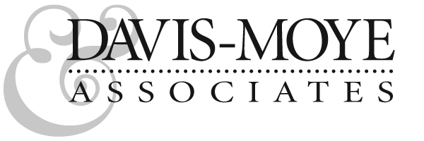
Fine Arts/Creative Services
2630 Talley street #302 • Decatur • Georgia • 30030
T • 678.296.4256 E • davismoye9@gmail.com web • davismoye.com

May 31, 2018

STARS Steering Committee
Association for the Advancement of Sustainability in Higher Education
2401 Walnut Street, Suite 102
Philadelphia, PA 19103

Dear STARS Representative:

During the fall semester 2017 I served as visiting curator for the Dalton Gallery at Agnes Scott College. Our fall exhibition, Weatherwise/Otherwise: Artists Respond to Climate Change, was co-sponsored by the Dalton Gallery and the Center for Sustainability. This timely project featured artists whose work reflected and recorded indisputable effects of climate change in beautiful and evocative ways that left no room for argument. The critical response was supportive, as was campus and community response, with increased attendance both in the galleries and at standing-room only lectures and presentations.
Arts groups drawing from the metro area, climate advocacy groups, school groups, church groups, and other organizations all arranged special tours, bringing attention to the topic from a wide range of the community; common responses were “I never thought of it that way,” and “This is so much more evident than I thought.”

We discovered in organizing this exhibition what effective advocates artists can be, both in emphasizing the beauties of our existing world and in pointing out consequences awaiting us without action. We reinforced our belief that the arts and sustainability initiatives can be effective and visible allies in consciousness raising and in presenting complex concepts to a broad audience.

We feel that the response to this exhibition indicates serious potential for art exhibits as a valuable tool for the sustainability message, and to be expanded into a formal credit within the STARS framework.

Thank you for your attention.



Dorothy Moye
Davis-Moye & Associates
Visiting curator, Dalton Gallery of Agnes Scott College

