CLIMATE ACTION AND SUSTAINABILITY PLAN

January 2016

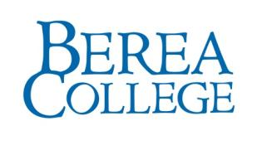

Developed for Berea College by Brendle Group, Inc.
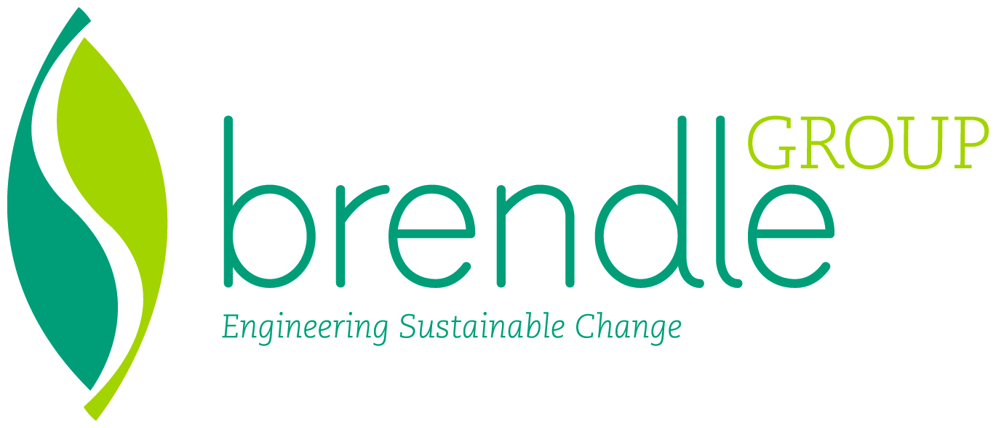
www.BrendleGroup.com
January 2016

The contents of this report are offered as guidance only. Brendle Group, Inc. and all sources referenced in this report do not (a) make any warranty or representation, expressed or implied, with respect to the accuracy, completeness, or usefulness of the information contained in this report, or that the use of any information, apparatus, method, or process disclosed in this report may not infringe on privately owned rights; or (b) assume any liabilities with respect to the use of, or for damages resulting from the use of, any information, apparatus, method or process disclosed in this report. Reference herein to any specific commercial product, process, or service by trade name, trademark, manufacturer, or otherwise does not necessarily constitute or imply its endorsement, recommendation, or favoring by Brendle Group, Inc.

Executive Summary
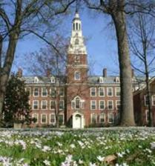
The Strategic Planning Council, in its Strategic Directions for Sustainability at Berea College (SDSBC) that were adopted by the Board of Trustees in February 2011, has called sustainability, “the defining issue of our time and an undergirding issue of all aspects of our mission.“ This statement establishes sustainability as a cross-cutting issue in Berea’s mission and sets the stage for this Plan to advance the recommendations of SDSBC. The Plan builds on Berea’s sense of mission and its history of progress in sustainability to recommend specific strategies to achieve short- and long-term sustainability goals.
SDSBC organized sustainability at Berea around five initiatives. The first three are addressed directly in this Plan: Continuously Reduce Ecological Footprint, Climate Neutrality, and Culture and Education. The fourth initiative involves sharing sustainability within the Berea community and the broader off-campus community and is addressed through connections to the strategies for the first three initiatives. The final initiative recommends drafting a new commitment on sustainability and is not part of the scope of this Plan.
The first initiative, Continuously Reduce Ecological Footprint, aims for Berea to reduce the ecosystem resources, usually measured in terms of land area, required to supply the inputs and assimilate the outputs of the campus population. An ecological footprint conducted for the campus in 2001 found the per capita footprint at Berea to be similar to the U.S. average. This Plan proposes strategies related to food production, water footprint reduction (both in terms of quantity and quality), purchasing policies, and solid waste management to reduce the ecological footprint.
The second initiative, Climate Neutrality, aims for Berea to reduce its net greenhouse gas emissions to zero as directed in the American College & University Presidents’ Climate Commitment, first signed by Dr. Larry Shinn in 2007. The current president, Dr. Lyle Roelofs, has not yet signed the Presidents’ Climate Commitment.
Berea’s emissions for Academic Year 2014-2015 were 30,448 metric tons of carbon dioxide equivalent, or MTCO2e, and approximately 80 percent of those emissions resulted from consuming electricity and natural gas. This Plan proposes energy efficiency, energy conservation, and renewable energy as well as commuting and travel strategies to reduce emissions.
The third and final initiative addressed in this Plan, Culture and Education, seeks to create a culture of sustainability through educating Berea students, faculty, and staff to raise awareness of regional and global challenges and educate on the means to address those challenges. This initiative includes incorporating sustainability in curriculum and professional development for faculty and staff and increasing collaboration within the campus community as well as the broader community. The success of many of the strategies recommended under Initiatives 1 and 2 will depend on engagement and participation from the campus community, making the Culture and Education initiative critical to the success of the rest of the Plan.
This Plan also aligns with the seventh commitment in Berea’s overall mission statement (The Great Commitments of Berea College): “To maintain a residential campus and to encourage in all members of the community a way of life characterized by mindful and sustainable living, health and wellness, zest for learning, high personal standards, and concern for the welfare of others.”
This Plan is designed to build on the sustainability achievements of the past and to establish a clear roadmap for Berea to thoughtfully and thoroughly achieve its sustainability goals moving forward. This Plan will need to be a living plan that involves dynamically adapting to the changing circumstances in the world and at Berea, evaluating the success of the strategies Berea is implementing, adopting new research from social sciences, and recognizing new technologies that may help Berea achieve its aims. Berea principles of mindful living and recognition of sustainability as a theme within its broader mission form a good foundation for success. As SDSBC recognized, Berea’s success in this endeavor is important as a member of the broader global community, as a leader in higher education sustainability, and as an educational institution preparing students to deal with many global challenges.

Introduction and Approach
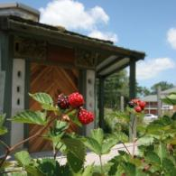
The Strategic Planning Council, in its Strategic Directions for Sustainability at Berea College (SDSBC) which were adopted by the Board of Trustees in February 2011, has called sustainability, “the defining issue of our time and an undergirding issue of all aspects of our mission.“
Noting that the world’s current rates of greenhouse gas (GHG) emissions and of natural resource consumption have created serious threats to the natural systems that sustain us, and recognizing the magnitude of organizational change, culture shift, and collaboration that will be required to address these problems, SDSBC establishes five core initiatives for sustainability:
- Systematically and continuously reduce consumption of natural resources directly (e.g., water, raw materials, etc.) and indirectly (e.g., manufactured goods).
- Immediately and continuously reduce Berea College’s consumption of non-renewable fossil fuels and CO2 production, including a plan and timeline for becoming climate neutral.
- Create a culture of sustainability through education of Berea’s community regarding global and regional ecological crises and methods for addressing this crisis.
- Share sustainable ideas and practices with both the community of Berea itself and the larger community beyond the campus in the process of extending the College’s educational and action initiatives.
- Draft a new commitment on sustainability (or revise the current seventh commitment on “mindful living”) for the mission of the College, understood in ecological, economic, and human terms (Completed)
Development of the Plan was overseen by an advisory group of faculty, students, and staff and included workshops and surveys open to the entire campus community. The Plan is organized to align with the vision and goals of SDSBC and addresses the next step recommendations from SDSBC:

- Systematically and continuously reduce consumption of natural resources directly (e.g., water, raw materials, etc.) and indirectly (e.g., manufactured goods):
  - Gather baseline-data on consumption of raw materials (e.g., water-use) and manufactured goods (e.g., purchasing, facilities-repairs/renovations, production and disposal of food, etc.);
  - Develop immediate and long-range plans for reducing consumption of raw materials and manufactured goods;
  - Seek improvements and implement plans that will reduce the College’s overall ecological footprint; and
  - Monitor results and revise plans and practices to achieve continuous improvement.

- Immediately and continuously reduce Berea College’s consumption of non-renewable fossil fuels and CO2 production:
  - Gather baseline-carbon-data through an extensive survey of all College activities;
  - Develop goals, policies, and plans for reduction of fossil fuel use and reduction of carbon-creation through College activities;
  - Integrate plans with annual and long-term budgetary processes;
  - Monitor results and alter policies and plans as needed to ensure maximum and continuous progress; and
  - Develop a plan with timeframe for Berea College to become carbon neutral.

- Create a culture of sustainability through education of Berea’s community regarding global and regional ecological crises and methods for addressing this crisis.
  - Charge the College Faculty, with the assistance of the Dean of the Faculty and the appropriate committees, with leading a process that will, with the next General Education revision develop learning outcomes for sustainability that can be incorporated into the Aims of General Education.
  - Identify where emphases on sustainability can be incorporated and added to the curriculum.
  - Develop appropriate workshops and support for faculty from all disciplines that support curricular changes that promote education about sustainability.
  - Provide training and professional development for staff so that sustainability becomes an integrated part of the entire College culture. Berea should design training to enable staff to produce sustainability assessments − the information in such assessments would become essential elements in reports produced by the standing Committee on Sustainability.
  - Provide opportunities for and collaborate with students to devise sustainability education and incentives through residence life and student organizations.
  - Actively and intentionally guide and engage students by providing opportunities for them to be involved in sustainability activities at all levels – curricular, co-curricular, labor, and institutional facilities – not only to enhance their educational experience but to foster ownership and leadership at Berea College and beyond.
  - Create formal and informal educational programs and opportunities to teach and engender more sustainable lifestyles and practices.

- Share sustainable ideas and practices with both the community of Berea itself and the larger community beyond the campus in the process of extending the College’s educational and action initiatives.
  - Develop alliances/exchanges with officials of the city, county, and region to effect positive, ecological changes;
  - Gather, serve as repository for, and disseminate information, and promote best practices about ecology and sustainability (e.g., through conferences, websites, etc.);
  - Learn from successful initiatives already practiced by members in the local community, and support these efforts to enhance their effectiveness;
  - Seek alliances with colleges, universities, businesses, and non-profit organizations to extend the core goals stated previously.

Stakeholder input from workshops and interviews was organized across the three initiatives of ecological footprint, carbon neutrality and culture and education, with the fourth initiative on community partnerships serving as a cross-cutting consideration in developing strategies. Stakeholder input also was further sorted by tactics that support the strategies and existing practices from which to build the momentum.

In addition to strategy-specific input, the stakeholder engagement process gleaned numerous suggestions for cross-cutting principles and values to use in developing the Plan:

- Communicate an honest understanding of limits and sacrifices as essential qualities for a realistic plan.
- Emphasize the need for all hands to be on deck to achieve the ambitious goal of climate neutrality.
- Stress the importance of dates and metrics and the implications of the goals – economic, social and environmental.
- Link how to do it with what we teach and how we operate.
- Leverage the self-sufficient roots and history of Berea.
- Develop tools for good decision-making (governance) moving forward (e.g., triple bottom line analysis).
- Capitalize on ethic of ‘live simply’ and work college experience.
- Build on strong history of food production.
- Resist technology as first solution.
- Use real-time information sharing.
- Look at whole picture in decision-making.
- Understand what motivates people.
- Avoid terms that alienate.
- Consider best balance between mandatory and voluntary approaches.
- Look for ways to remove obstacles.

The remainder of this Plan provides the individual strategies, analysis, and aggregated results relative to the four core initiatives.

Baseline Sustainability Inventory
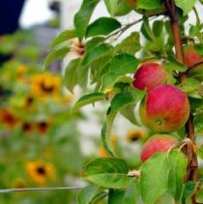
The purpose of the baseline inventory was to review Berea’s activities and current circumstances to provide context for identifying effective next steps for Berea to continue to improve its sustainability performance.

AASHE STARS™
The Association for the Advancement of Sustainability in Higher Education’s (AASHE) Sustainability Tracking, Assessment & Rating System (STARS) helps higher education institutions measure their sustainability through a self-reporting process. There are 204 standard and 4 innovation points available in STARS. Berea has not completed STARS reporting since 2011; however, in 2011 Berea received a Silver rating with an overall score of 50.29. Of 188 institutions reporting STARS ratings in 2011, 51 achieved Bronze, 100 achieved Silver like Berea, 37 achieved Gold, and none achieved Platinum. Berea’s scores on individual categories, where the score is the percentage of applicable points earned in the category, include 28.54 percent on Education & Research; 55.97 percent on Operations; and 54.35 percent on Planning, Administration & Engagement. A review of individual STARS credits provided direction for some of the strategies in this Plan, including a stronger element of sustainability in new student orientation (see Appendix A) and increased incorporation of sustainability in curriculum. In general, the previous STARS submittal provides a good background of Berea’s current sustainability activities.

Greenhouse Gas Inventory
Berea was one of the early signatories of ACUPCC, which obligates institutions to prepare a GHG inventory and climate action plan, with the eventual goal of achieving climate neutrality.
Berea has completed GHG inventories for Fiscal Year 2007-2008 through Fiscal Year 2014-2015. Fiscal Year 2014-2015, Berea’s emissions were predominately from purchased electricity and the stationary combustion of natural gas (Figure 1), with those two sources accounting for approximately 80 percent of direct and indirect energy emissions. An understanding of these emissions was used to inform the forecast of GHG emissions for Berea and the strategies recommended in this Plan.

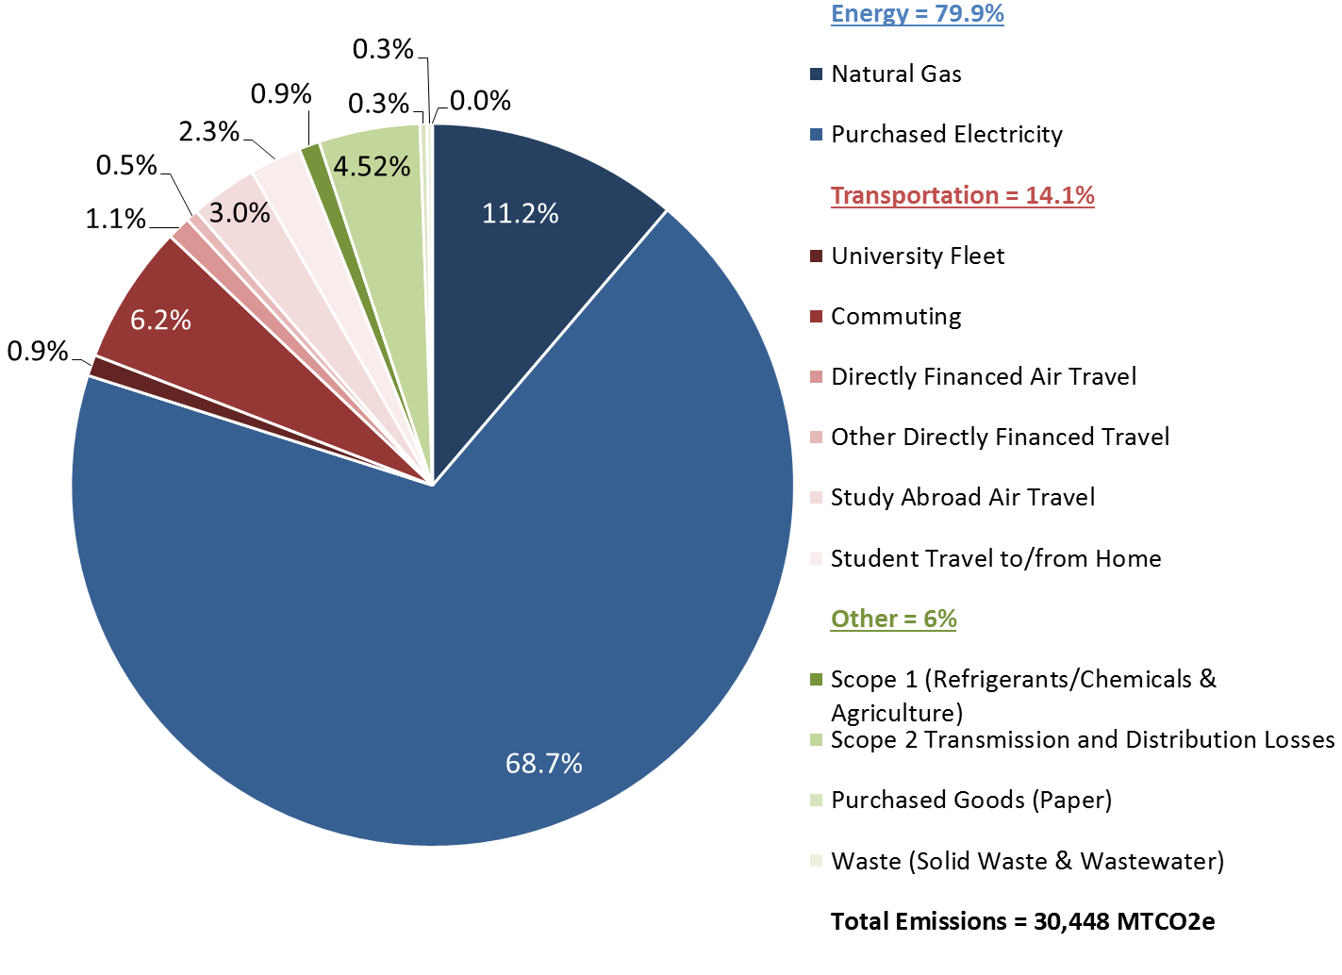
Figure 1. Fiscal Year 2014-2015 GHG Emissions by Source

Benchmarking
To provide some context for the range of performance among other institutions of higher education, Berea was benchmarked against a number of peers, other Kentucky schools, and best in class institutions for which this information was available through ACUPCC’s Reporting System.
There are many factors that contribute to an institution’s GHG emissions and therefore benchmarks have to be considered with care. The local climate’s impact on heating and cooling systems, available electricity resource mix, and the age of buildings are just a few of the many factors that are largely outside of an institution’s direct influence but have a significant impact on emissions.
In addition, the varying extent to which indirect emissions, like airline travel, are included in an institution’s inventory can also make comparisons difficult. Therefore, the following benchmarks are for direct (Scope 1) and indirect electricity (Scope 2) GHG emissions since these are accounted for more consistently.
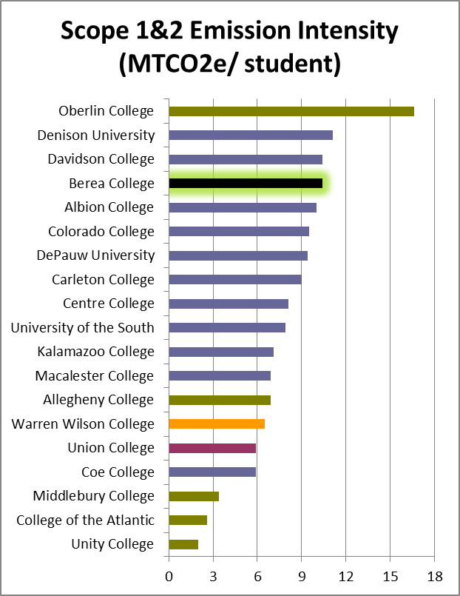
Best in Class
Peer Institution
Kentucky School
Work College
Figure 2. Scope 1 and 2 Emission Intensity per Student

As Figure 2 and Figure 3 indicate, Berea’s GHG emissions are on the higher end of the range of benchmarked schools on per student and per square foot of floor space bases. To some extent, this position is a result of the relatively high carbon intensity of Berea’s electricity supply. Considering just energy intensity in buildings, as shown in Figure 4, Berea is roughly in the middle of the distribution.
Based on the performance of these benchmarked institutions, Berea has examples of institutions that have lower energy intensity in their buildings and lower overall carbon intensity. This affirms the opportunity for Berea to continue to reduce the energy intensity of its buildings, to seek lower carbon energy sources to meet its remaining needs, and progress to a climate neutral goal.
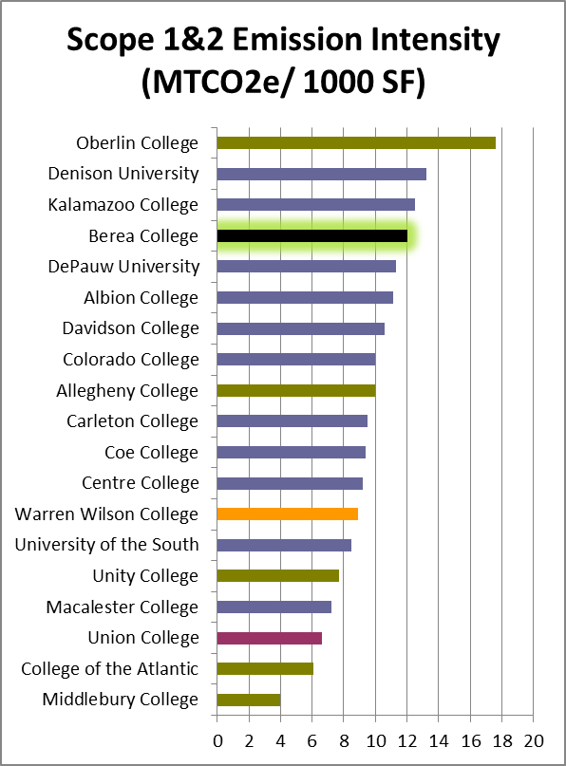
Best in Class
Peer Institution
Kentucky School
Work College
Figure 3. Scope 1 and 2 Emission Intensity per 1,000 Square Feet
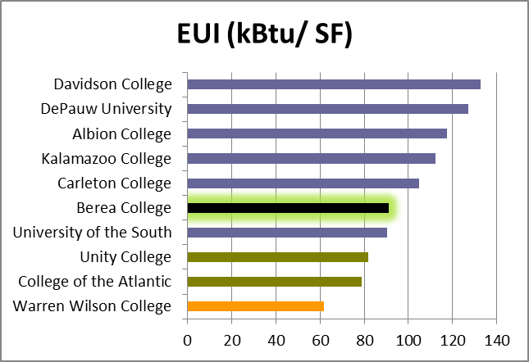
Figure 4. Energy Use Intensity per Square Foot, per Year

Water Footprint
Though there is currently no existing protocol for developing a water footprint, the Water Footprint Network has started to develop a concept. The Network’s Water Footprint Assessment Manual has been extremely helpful in providing general guidance in developing a water footprint for Berea. Using this guidance, Berea’s water footprint includes three defined types of water:
- Blue Water: municipal water or other water supplies taken from surface or groundwater supplies and delivered to campus
- Green Water: rainwater that is captured and stored for use within the campus boundary
- Stormwater Equivalent Volume: the volume of water required to assimilate the pollutant load from stormwater runoff to regulatory pollutant concentration limits in the receiving water body
Rather than just looking at direct water consumption, this volumetric measure of both water consumption and pollution offers a wider perspective on how Berea is affecting its local water system.
In Fiscal Year 2014-2015 Berea used over 26 million gallons of water in facilities, processes, and irrigation. Berea is addressing this water use footprint through water efficiency. This use is well within the available water supply in the region. However, when looking at sustainable water management more holistically, it’s important to also consider the impact that Berea has on water quality, mainly through campus stormwater run-off. EPA nutrient limits were used to determine the assimilated volume of water associated with storm water and added to the campus water footprint. As shown in Figure 5 the total water footprint for Berea during Fiscal Year 2014-2015 was over 214 million gallons, with the large majority (88 percent) the result of stormwater runoff impacts of the campus.
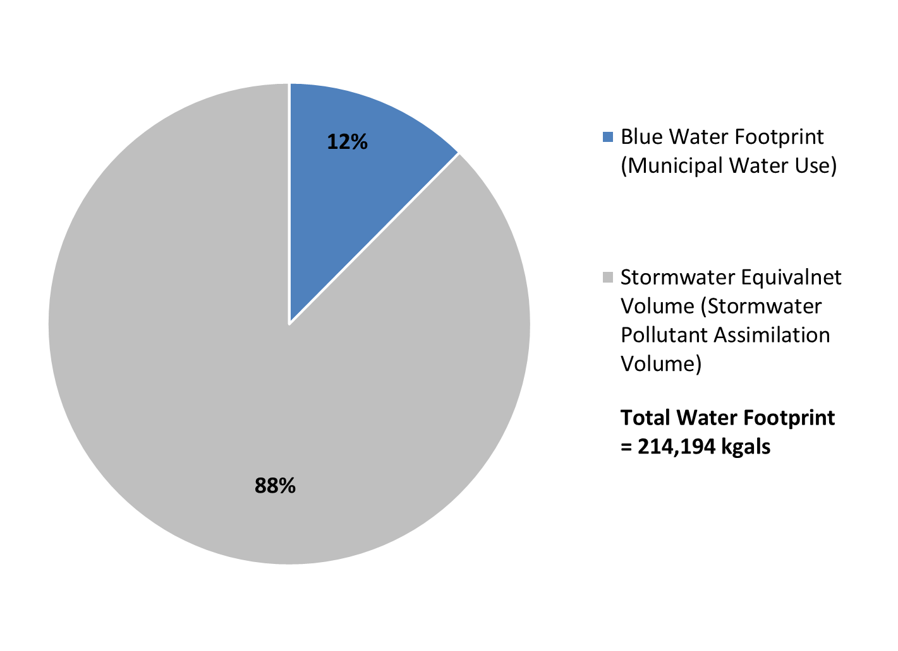
Figure 5. Fiscal Year 2014-2015 Water Footprint

Waste Inventory
The current waste management activities taking place at Berea include recycling as well as composting Food Service’s food waste. During Fiscal Year 2014-2015, Berea generated a total of 1,603 short tons of waste with a 71 percent diversion rate from recycling and composting activities on campus (Figure 6).
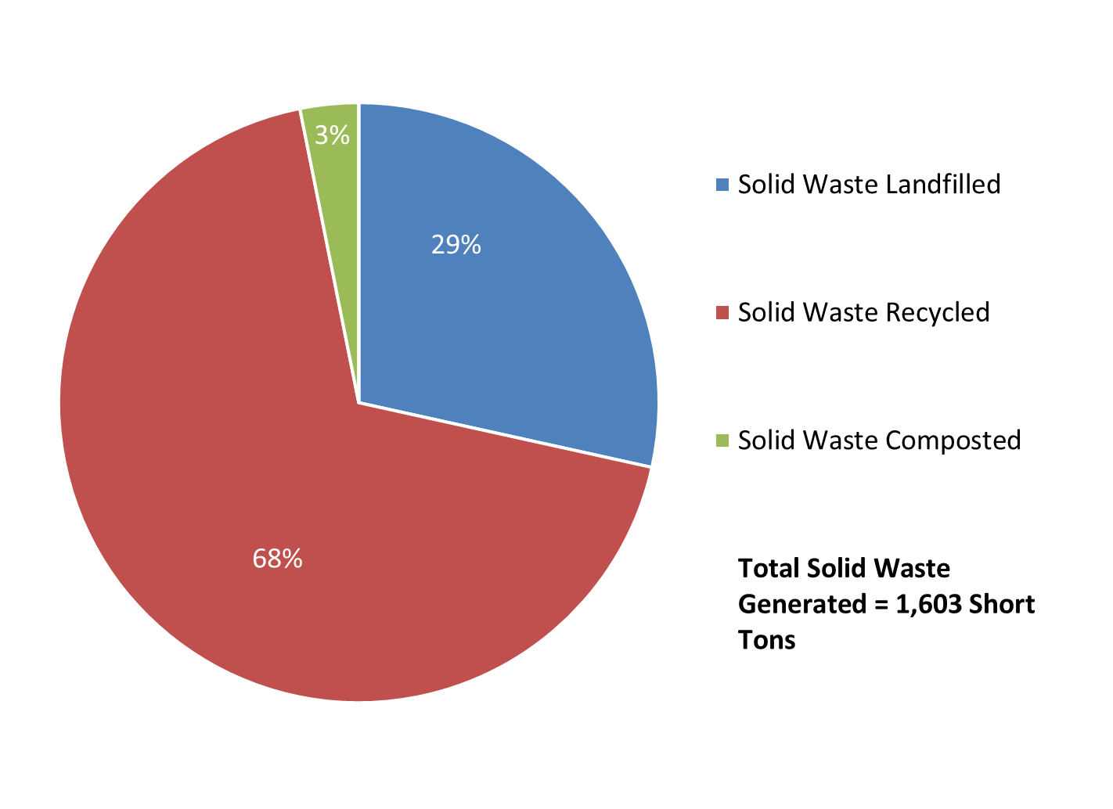
Figure 6. Fiscal Year 2014-2015 Waste Inventory

Current Sustainability Practices
There are many existing policies and practices at Berea that provide a solid foundation for the strategies proposed in this Plan. To understand this existing foundation and ensure that this Plan aligns with it, the following were reviewed as part of the inventory process: building assessments, renovation standards, master planning, renewable and traditional energy studies, and existing behavioral and operational initiatives.
Some of the more important existing practices include the following:
- Clear strategic direction in SDSBC: Strategic Directions for Sustainability at Berea College
- The Operations and Sustainability Department
- Implementation of efficiency recommendations from the Aramark assessments in existing buildings
- Policy for pursuing LEED™ Silver equivalent in new construction and renovations
- Data collection and tracking with the GHG inventory
- Strong sustainability background in Sustainable and Environmental Studies (SENS), the Office of Sustainability, the Agriculture and Natural Resources program, and other campus institutions
- Sustainability Committee with elected and appointed representation from students, faculty, and staff

Summary of Strategies
Quantitative analysis was conducted at the strategy level for carbon-related efforts while more qualitative analysis was conducted for the remaining strategies. The following sections summarize the strategies analyzed in this Plan by topic area for each of the three sustainability initiatives.

Initiative 1: Continuously Reduce Ecological Footprint
The ecological footprint is a measure of ecosystem resources, in terms of land area, required to supply the inputs and assimilate the outputs of a population. The ecological footprint accounts for many of the same activities that are accounted for in Berea’s GHG inventory. However, viewing Berea’s activities through the lens of an ecosystem footprint may better identify other environmental and social impacts beyond GHG emissions and will encompass additional impacts from the life cycles of Berea’s inputs, including energy, food, consumables, raw materials, and water. Increasingly, GHG accounting is moving to include more indirect life-cycle emissions (Scope 3) and will eventually align better with the broader inclusions in the ecological footprint.
An ecological footprint for Berea College in 2001 found that the per capita footprint at Berea was similar to that of the U.S. average. About one quarter of that footprint resulted from consuming electricity and natural gas. This quarter will be primarily addressed by Initiative 2 in planning for climate neutrality. The remaining three quarters are the focus of Initiative 1, which seeks to reduce the ecological footprint associated with Berea’s key inputs − food, consumables and raw materials, and water − and solid waste outputs. Since a current ecological footprint was not available, the strategies for initiative 1 will be measured by tracking indicators associated with each strategy.

Table 1. Strategies for Initiative 1
Strategy | Metrics
Increased Berea Food Production and Support for Local Agriculture | - Pounds of food produced on College land holdings  - Pounds of food purchased within 150 miles of the campus  - Pounds of food purchased from Sysco Louisville’s local and traditional food lines (for evaluation of percent of total food purchased locally)
Water Footprint Reduction | - Municipal water use  - Per capita water use  - Captured rainwater (annual volume captured and used)  - Percent of campus covered by impermeable surfaces  - Percent of campus runoff volume captured by on-site stormwater BMPs
Purchasing Policies | - Metrics for specific products (e.g., percent of paper consumed with 100 percent recycled content, percent of electronics equipment certified to a certain EPEAT level, etc.)  - Percentage of food purchased regionally (Dining Services already tracking this)
Solid Waste Management | - Annual gross/net operational solid waste per capita  - Diversion rate (recycle and compost)

Initiative 2: Greenhouse Gas Reductions leading to Climate Neutrality
Berea College will use ACUPCC’s definition of climate neutrality for consistency with the current GHG accounting approach and with other institutions setting targets for ACUPCC:
Climate neutrality is defined as having no net greenhouse gas (GHG) emissions, within a minimum scope of boundaries laid out in this Guide. This is to be achieved through such measures as conservation, renewable energy, and carbon offsets or other measures to mitigate the remaining emissions.
The minimum scope of boundaries includes all direct emissions (Scope 1) from sources such as boilers and fleet vehicles on campus; all indirect energy emissions (Scope 2) from electricity purchases; and selected indirect emissions (Scope 3) from daily commutes to campus, institution financed air travel, and solid waste. Some indirect emissions are not included in the ACUPCC definition and therefore this definition should be seen as the minimum emissions mitigation and/or offset required to attain climate neutrality. Berea College’s goal is to reduce greenhouse gas emissions by 70% below 2010 levels by the year 2036. The strategy is to engage operations, academics, staff, faculty, and donor relations to communicate current greenhouse gas emissions as they relate to energy, natural gas, transportation, and all other sources of emissions in order to encourage behavioral and operational changes on campus.

Initiative 3: Culture and Education
The last of the three primary sustainability initiatives at Berea seeks to create a culture of sustainability through educating Berea students, faculty, and staff to raise awareness of regional and global challenges and educate on the means to address those challenges. This initiative includes incorporating sustainability in curriculum and professional development for faculty and staff, and increasing collaboration within the campus community as well as the broader community. In addition to the strategies specific to Initiative 3 listed in the table below, each of the strategies identified in the first two initiatives also addresses opportunities to engage a broader community in the strategy through education or participation.
Table 4. Strategies for Initiative 3
Strategy | Metrics
Sustainability in the Curriculum | - Number of sustainability-focused courses: sustainability is the main focus of the course or a course that examines an issue through the lens of sustainability  - Number of sustainability-related courses: sustainability is incorporated as a module or unit  - Sustainability literacy assessment built on a defined set of learning outcomes
Professional Development to Support Sustainability | - Number of staff trained in triple bottom line analysis  - Number of position descriptions with sustainable goals for staff/faculty members
Student Engagement in Sustainability | - Number of students engaged in groups related to sustainability  - Number of annual events or projects incorporating sustainability  - Number of articles in campus publications addressing sustainability issues
Labor Positions to Support the Plan | - Number of sustainability-related labor positions  - Number of sustainability-focused labor positions  - Student sustainability literacy – initially tied to student labor checklist
Employer Assistance Program | - Number of events on campus promoting sustainability at home and in the broader community

Strategies to Reduce Ecological Footprint (Initiative 1)

Increased Berea Food Production and Support for Local Agriculture
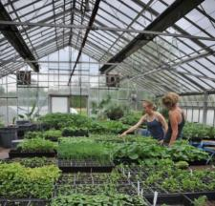
In 2004, Berea College formed a local foods initiative (LFI) composed of students, faculty, and staff to engage the College in promoting the development of a sustainable food system. The College is particularly well suited for this type of initiative given its focus on learning and action to solve real-world problems, its labor and learning approach to education, its desire to positively enhance the local economy, and its own farm resources. In fact, more than 18 percent of total food purchases were from local sources during the 2014-15 year.
As a result of the initiative, nine recommendations were developed to move Berea toward a more sustainable local food system, six of which have been implemented since 2005 and are listed below:
- Berea has committed to increasing the use of responsibly produced regional and local foods and is engaged in fostering conditions to increase the availability of such foods.
- Berea has revised its contract with Sodexo (food service provider) to include language allowing more flexibility around purchasing local food and Sysco Louisville (supplier) has recently developed a catalog of locally sourced products from which to choose.
- The food service partnership with Sodexo includes a commitment to Berea’s goals, a shared responsibility for overcoming challenges to these goals, dedication to necessary staff training to work with unprocessed ingredients, and tools for accurately counting local and regional food use at the College. Sodexo also has goals toward sustainability (Better Tomorrow Plan) that include local, sustainable, and seasonal products.
- The first food procurement option for the College is its own agricultural products.
- The second food procurement option for the College is direct from area farmers.
Work toward other initiative recommendations is ongoing and involves addressing product liability related to local producers, establishing a commitment toward sustainable food systems, and developing cooperative relationships with other institutions (cooperative purchasing, etc.) to spur the supply and dependability of local foods and encourage surplus processing in local economies.
In addition, Berea College can continue to increase its own farm production and encourage local growers and businesses through the following efforts, some of which are already underway or completed:
- Re-introduced poultry program (laying hens and meat birds) as a student driven project and matched local price of poultry.
- A packing shed was completed that accommodates increased production and meets health and safety guidelines for Sodexo. Additional processing facilities will be required to meet goals (e.g. a cook-chill facility).
- Encourage local food processing and partnerships with food pantries to take advantage of seasonal surplus.
- Seek sources for specific local products like honey and hydroponic lettuce.
- Sponsor local food events at campus food venues and support food week in October.
- Use surplus or seasonal items from College farm and local growers for catering or special events.
- Add hoop houses on College farm to expand growing season.
- Increase production of select items for wholesaling.
- Develop additional food storage space which will be needed to meet goals.
- Develop a local supplier network/infrastructure that can be shared with the community and other organizations with like-minded food goals. Continue to offer products at farmer’s market, farm store, and college bookstore.
- Identify and study potential of edible forest products (e.g. acorns, maple syrup).
- Provide retail space for locally grown or produced products in the Berea College Farm Store, which already offers a variety of food products from the College and surrounding areas.
Metrics
- Dollar value of food produced on College land holdings
- Dollar value of food purchased within 150 miles of the campus
- Dollar value of food purchased from Sysco Louisville’s local and traditional food lines (for evaluation of percent of total food purchased locally)
Goals
- Near-Term: Purchase 51 percent of food from College and local area farmers (within 150 miles) by 2018.
- Long-Term: Purchase 80 percent of food from College and local area farmers (within 150 miles) by 2030.
Technical feasibility: The Berea College farms, gardens, and land holdings (almost 500 acres) support the goals of this strategy. In addition, Kentucky has a large number of farms and beef producers compared to other states, making local food more viable for Berea.

Capacity for implementation: Many of the recommendations from the LFI are either complete or underway. Efforts to develop supplier networks may involve continued collaboration with Sodexo and regional assistance and cooperation with other purchasers.

Cross-cutting themes
- Labor programs: Student opportunities related to College farm and Farm Store
- Partnerships/policy: Local growers and processors, Sodexo, purchasing cooperatives with other organizations
Implementation plan
- Responsible parties: College Farm, Agriculture and Natural Resources Department, Dining Services, Labor and Student Life.
- Implementation path: Incorporate recommendations into annual review cycle.

Phase | Opportunity | Next Steps
Phase 1  (2016) | Expand and leverage farm production | - Investigate hoop houses or other equipment needs.  - Develop methods for using surplus from farm and local growers (processing).
Phase 2  (2016-2017) | Develop local supply network | - Invite local growers and processors to submit product information.  - Become familiar with Sysco Louisville local resource catalog and modify purchasing to be in line with goals.  - Sponsor local food events and promote more locally processed products in Farm Store.
Phase 3  (2017) | Develop purchasing cooperative | Identify and collaborate with other local institutions to leverage larger purchasing influence on suppliers and producers.

Water Footprint Reduction
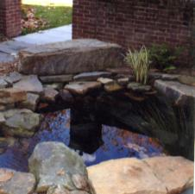
Berea College’s water footprint includes two components, water use and water pollution/quality. To reduce the campus water footprint, both aspects will need to be addressed. Considering the limited water supply in Berea’s watershed, water use may be particularly important to Berea.
Water Use
Berea has recently targeted upgrading end-use fixtures campus wide as a strategy to reduce municipal water usage. The college just completed retrofitting toilets to low-flow models and will begin retrofitting restroom faucets and showerheads with lower flow models soon.
In addition to the end-use fixture upgrades listed above, there is also an opportunity to encourage water conservation on campus through various awareness and incentive programs:
- Awareness
  - Use direct digital control (DDC) as a tool for Facilities Management to troubleshoot potential problems, identify leaks, etc.
- Incentives
  - Develop competitions and water use challenges.
Aside from addressing efficiency improvements and water conservation on campus, another focus of water use at Berea is minimizing or eliminating the campus’ blue water footprint (use of external water supplies) and replacing that supply with on-site rainwater capture (green water footprint).
Water Pollution/Quality
The other aspect of Berea’s water footprint that will be addressed here is the impacts of stormwater runoff from campus to the water quality in the local receiving water bodies. There are a number of different measures that can be taken to improve runoff water quality:
- Rainwater harvesting: The efforts to capture rainwater as a means of reducing Berea’s blue water footprint will also reduce the runoff from campus (rooftop runoff will be collected and stored for supply) and therefore reduce the water quality impacts of the campus.
- On-site Stormwater Management: Currently Berea and the City of Berea have limited active stormwater management; runoff from storm events is entering directly into receiving water bodies without any treatment. By installing stormwater best management practices (BMPs) on campus, such as constructed wetlands and retention ponds, Berea would be able to treat the stormwater runoff before it enters the local receiving waters, thereby improving runoff water quality and reducing the campus grey water footprint.
Metrics
- Municipal water use
- Per capita water use
- Percent of roof area with rainwater catchment
- Percent of campus covered by impermeable surfaces
- Percent of campus runoff volume captured by on-site stormwater BMPs
Goals
- Near-Term (2025): Reduce total Berea water footprint by 25 percent below 2010-2011 baseline.
- Long-Term (2050): Become a water neutral campus − reduce campus blue and grey water footprints to zero.
Technical feasibility: The current end-use fixture replacement will be relatively straightforward and will require little to no additional analysis or design prior to implementation.

Capacity for implementation: Almost all of the recommendations can be completed internally by Facilities Management. On-site stormwater management may be best addressed in collaboration with the City of Berea as the City is also currently addressing its future plans for improved stormwater management.

Cross-cutting Themes
- Campus engagement
  - Create residence hall competitions to encourage participation by students.
- Labor programs
  - Support end-use fixture upgrades (e.g., inventory of standard flow fixtures, preparing materials, replacing fixtures).
  - Support maintenance activities.
- Partnerships/policy: Through local/regional partnerships and collaboration, encourage changes to current Kentucky plumbing code to allow for use of greywater, waterless urinals, and composting toilets.
Implementation plan
- Responsible parties: Operations and Sustainability, Facilities Management

Phase | Opportunity | Next Steps
Phase 1  (2016-2017) | - Water fixture upgrades  - Metering and data tracking | - Continue water end-use fixture upgrades.  - Develop system to begin tracking sub-metered water uses to better understand where water savings are being achieved and set specific water use reduction goals by building type (e.g., residence halls vs. classrooms).  - Troubleshoot lack of savings recognized for conversion to air-cooled condensing units.  - Once all building systems are converted to Automated Logic, develop a plan to program alarms to better identify/track leaks, etc.
Phase 2  (2016-2017) | - Residential hall and department water conservation challenges | - Develop plan/approach for conducting bi-annual residential hall water conservation competitions.
Continuous and ongoing | - Awareness and incentives  - Rainwater harvesting  - Reduced impervious area  - Stormwater management | Develop a plan for becoming a net-zero water campus, where next steps include the following:  - Continuing reductions in indoor and outdoor water use on campus.  - Addressing barriers in current state plumbing code.  - Compiling a list of best practices from existing rainwater harvesting projects on campus.  - Reducing the amount of impervious area on campus.  - Coordinating with the City of Berea to begin addressing on-site stormwater management using lessons learned from pilot projects that have already been implemented on campus.

Purchasing Policies
Berea currently employs a number of purchasing practices related to sustainability. Many of these practices are embodied in the Purchasing Policy, which was developed in 2007 and revised in 2012. In addition to addressing overall best practices in procurement, the Policy includes a “Sustainability Initiatives in Procurement” section, which specifies that procurement decisions will consider recycled content, waste minimization, and energy efficiency in the purchasing decision-making process – along with total life cycle impacts, cost, and durability.
The Purchasing Policy specifically addresses a number of purchasing categories related to sustainability, including making the following purchases whenever possible:
- ENERGY STAR products, appliances, and equipment
- Electronic Products Environmental Assessment Tool (EPEAT) personal computers, notebook computers, and monitors
- Fair Trade-certified coffee, tea, rice, fruit, and other such foods in Dining Services, at catered events, and in offices
- Fair Trade-certified clothing, handicrafts, jewelry, and other gift items in College stores
- Office supplies with recycled content from vendors, with particular use of 100 percent post-consumer recycled paper that is either Forest Stewardship Council (FSC) or Sustainable Forestry Initiative (SFI) certified and available from the College’s Printing Services
Other practices related to sustainability in procurement include using Green Seal certified cleaning products for campus-wide housekeeping. Dining Services is also currently phasing out disposable packaging in favor of non-disposable service ware in catering operations. The purchase of locally-sourced products is also encouraged where feasible.
In general, best practices in sustainability for procurement include purchasing products that reduce their environmental and/or social impact because of the way they are made, transported, stored, packed, used, and disposed. When determining whether a product is preferable, the following standards should be considered:

- Available locally
- Bio based
- Biodegradable
- Carcinogen-free
- Chlorofluorocarbon (CFC) free
- Compostable
- Durable, reusable, or refillable
- Energy and water efficient
- Heavy metal free (i.e., no lead, mercury, cadmium)
- Low toxicity
- Low volatile organic compound (VOC) content
- Made from renewable products
- Persistent, Bio accumulative toxic (PBT) free
- Post-consumer content
- Recycled content/recyclable
- Reduced GHG emissions
- Reduced packaging
- Refurbished

While Berea’s Purchasing Policy is comprehensive and is being effectively applied to purchasing decisions, there are opportunities to improve on both the policy as well as purchasing practices. These opportunities include the following:
- Add Language Assessing the Need for Purchases: Berea’s goal is to significantly reduce its overall ecological footprint. As a result, in addition to providing guidelines for incorporating sustainability in product purchases, the Policy could also include guidance and a process to justify the need for new purchases in the first place. Building on Berea’s 7th Great Commitment, encouraging “mindful living”, this could include having faculty and staff document need for more significant new purchases given environmental, social, and economic factors involved in new purchases compared to other alternatives – including repair, re-purposing of another good (Berea already has a strong surplus program), or purchasing a used replacement (also a strong practice in many areas). This practice could be implemented through the use of a checklist, as well as in education and training. Reinstituting the Office Supply Exchange program that previously existed at Berea would be a good mechanism for encouraging reuse.
- Improve Tracking and Monitoring of Sustainability-related Purchasing: Berea currently does not comprehensively track its supply chain (e.g., use of paper with recycled content, number and level of EPEAT-certified computers, etc.), and its Banner ERP software currently does not provide the capability to track such purchases.
- Provide More Campus Education, Particularly for Small Purchases: While there is widespread campus support for the sustainability aspects of the Purchasing Policy, there is opportunity to better integrate sustainability considerations into smaller purchases for which a Purchase Order is not necessary. This includes, for example, small office supply orders by individual departments directly to Hurst. One such information tool could be a simple purchasing guide for staff, faculty, and students that build on existing resources developed by Berea on office greening, as exemplified in Error! Reference source not found..
- Expand the Topics and Purchases Covered by the Purchasing Policy: While the Purchasing Policy covers a range of products and topics (e.g., recycled content, waste minimization, energy efficiency, total life cycle impacts), other topics could be added, such as carbon footprint, water efficiency, chemicals (such as VOCs), etc. In addition, other large purchases could be added to the policy, such as vehicles (fuel efficiency, alternative fuels), building materials, and/or landscape management materials.
Table 5: Potential Campus Guidelines for Small Purchases
When buying these products or services | Look for these Standards
Office Supplies
Multi-use office paper | 30% or greater post-consumer recycled content
Toner cartridges | Remanufactured cartridges
Break room supplies | Post-consumer recycled content , Biodegradable/compostable
Binders and indexes | Post-consumer recycled content
Envelopes and shipping supplies | Post-consumer recycled content
Filing supplies | Post-consumer recycled content
Paper products | Post-consumer recycled content
Writing instruments | Post-consumer recycled content
General office supplies | Post-consumer recycled content
Electronics
Computing equipment (e.g., desktops, laptops, monitors, servers) | EPEAT Certified (verification level “Silver” or “Gold”), Energy Star certified
Office equipment (e.g., copiers, printers) | Energy Star certified
Cleaning Supplies
Cleaning supplies (e.g., cleaners, disinfectants, floor cleaning and waxing materials) | Green Seal certified, U.S. Environmental Protection Agency (EPA), Design for the Environment (DfE) Approved
Paper products (e.g., toilet tissue, paper towels) | EcoLogo certified, Green Seal certified ,EPA Compliant
Furniture
Office furniture (e.g., chairs, desks, modular walls/furniture) | Business and Institutional Furniture Manufacturer’s Association, (BIFMA) level certification, Cradle to Cradle certified, Indoor Advantage certification, Polyvinyl chloride (PVC) Free
Paint
Paint | Low or no VOCs
University Vehicles
Vehicles | Electric for light-duty, campus-only vehicles  Zero or ultra-low emissions
Light Bulbs
Screw-in type bulbs | ENERGY STAR qualified Compact Fluorescent (CFL)
Pin-type bulbs | Toxicity characteristic leaching procedure (TCLP) compliant
Water Service
Drinking water | Filtration unit
Appliances
Refrigerators | ENERGY STAR certified
Dishwashers | ENERGY STAR certified
Washing machines | ENERGY STAR certified
Room air conditioners | ENERGY STAR certified
Source: Yale University Sustainable Procurement Standards Guide, Revised 4/2011

Metrics
- Percent by cost of all purchases for goods that include sustainability aspects
- Metrics for specific products (e.g., percent of paper consumed with 100 percent recycled content, percent of electronics equipment certified to a certain EPEAT level, etc.)
- Percentage of food purchased regionally (Dining Services already tracking this)
- Ratio of decentralized to total purchases by tracking cost by vendor on p-cards
Technical feasibility: Many of the opportunities identified can be implemented easily with currently available technology and by means of revising policy and encouraging more campus engagement in purchasing decisions. Efficient tracking the sustainability properties of purchases, however, will require upgrades and/or add-ons for Berea’s current Enterprise Resource Planning system.

Capacity for implementation: One of the limiting factors for maintaining and tracking purchasing at Berea will be allocating the appropriate staff members to oversee the implementation and management of the program. As is the case with other strategies, Berea should consider specifying a student labor position for sustainable purchasing.

Cross-cutting themes
- Campus engagement
  - Outreach and engagement campaign to expand sustainability-related purchasing practices
  - Potential to integrate purchasing ideas with campus survey on additional ideas for improving waste management on campus
  - Student/class engagement in conducting department-specific assessments of current purchasing practices and recommending changes to policy and/or practices
- Labor programs
  - Support for purchasing audit (e.g., data collection, analyzing results, implementation plan)
  - Support for campus Purchasing Policy campaign (e.g., creating standard signage, distributing signs and containers)
- Faculty/staff professional development: Purchasing guide for small purchases, along with training and means for tracking progress
Implementation plan
- Responsible parties: Purchasing, Information Systems and Services, Operations and Sustainability, Facilities Management

Phase | Opportunity | Next Steps
Phase 1  (2016-2017) | Research purchasing tracking options | Purchasing to coordinate with campus intern(s) to research options for tracking purchasing related to sustainability. Options could include add-ons to Banner ERP, Rosslyn Analytics or SciQuest, the latter of which offers a Total Supplier Manager for higher education that reportedly includes sustainability metrics.
 | Develop staff, faculty, and student purchasing guide | Develop brief guide that provides guidelines for what to look for in specific purchases (see previous table) as well as specific product recommendations where appropriate. Encourage departments to share what they learn.
 | Integrate purchasing practices with other campus engagement strategies | Provide department-specific incentives to report on sustainability in purchasing annually. Could be a “purchasing challenge” for example.
Phase 2  (TBD) | Expand Purchasing Policy | Solicit ideas from campus (potential survey) on options for next iteration of Purchasing Policy.  Expand Purchasing Policy to other topics and product categories.

Solid Waste Management
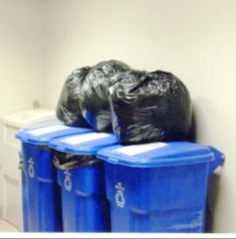
There are three areas of focus for solid waste management at Berea: total waste generation, percent of waste recycled, and percent of waste composted. During the 2014-2015 school year, Berea generated 682 pounds of waste per capita (1,603 total tons), of which 68% percent was recycled and 3 percent was composted. In the last few years, Berea has implemented a number of programs to reduce paper use on campus. The College has begun charging departments for their paper use and providing students with a $5 print credit. After this credit is exhausted students must pay out of pocket for any printing the rest of the term.
The college also has a move-in/move-out program. The move in recycling program recycled 1 ton of cardboard in 2015. The move out day program has partnered with the local Goodwill to place their bins in the dorms during the past two academic years and collected around 2 tons of goods both years.
There are opportunities to reduce the total waste generated on campus as well as increase the diversion rate through campus-wide policies and awareness, additional recycling and compost collection containers, and consistent signage and educational efforts.
Metrics
- Annual gross/net operational solid waste per capita
- Diversion rate (recycle and compost)
Goals
- Near-term (2022):
  - Reduce total solid waste generation to 470 pounds per person per year.
  - Achieve an 80 percent diversion rate (recycle and compost).
- Long-term (2030):
  - Reduce total solid waste generation to 270 pounds per person per year.
  - Become a net-zero waste campus (90 percent diversion rate).
Technical feasibility: The majority of the opportunities identified can be implemented easily with currently available technology.

Capacity for implementation: One of the limiting factors for implementing a successful waste management program at Berea will be allocating the appropriate staff resources to implement and manage the program. Berea should consider creating a new student labor position or integrating these efforts into an existing position.

To achieve the net-zero standard of 90 percent diversion additional options and/or more aggressive implementation of the proposed strategies will have to be considered.

Cross-cutting themes
- Campus engagement
  - Outreach and awareness campaign about new waste management policy
  - Education about recycling and composting options including during orientation (see Appendix A: New Student Primer)
  - Campus community survey for input on additional ideas for improving waste management on campus
  - Student/class engagement in identification and analysis of activities using information from waste audit
- Labor Support with Current Positions
  - Support for waste audit (e.g., data collection, analyzing results, implementation plan)
  - Support for campus solid waste management policy campaign (e.g., creating standard signage, distributing signs and containers)
  - Collection of food waste from campus for hauling to farm (with dining services waste)
- Partnerships/policy: Opportunity for collaboration with student farm
Implementation plan
- Responsible parties: Operations and Sustainability, Facilities Management.
- Additional Resources
  - Warren Wilson Composting Program: www.warren-wilson.edu/~recycle/compost.php
  - Office of Sustainability Website: How to Recycle at Berea College https://www.berea.edu/sustainability/take-action/how-to-recycle-at-berea-college/
Phase | Opportunity | Next Steps
Phase 1  (2015 – 2016) | Implement single-stream recycling campus wide | Develop and coordinate a “Zero Waste Team” of administrative and dorm building captains to help with implementation and operational efficiencies
 | Standardize recycling bins across campus | Tap the new “Zero Waste Team” members to help determine bin needs based on building use.
 | Develop and implement “green” event procedures and policies for College events | Implement and publicize these new green event procedures campus wide based on lessons learned during the 2014-2015 academic year
Phase 2  (2016 – 2017) | Conduct waste audit | - Identify areas for improvement, including container location, count, and size; addition of compost collection throughout campus.  - Create a solid waste management plan, including budget, schedule for rollout, and estimated impact for each identified activity.  - Implement no/low cost opportunities (signage, relocation of containers, etc.).
 | Develop a campus-wide solid waste management policy | - Standardize signage, containers, and practices throughout campus.  - Communicate campus policies and waste reduction goals to encourage participation.
Phase 3 | TBD | Specific waste management activities will depend on the results of the waste audit. The following are some options to consider:  - Paper use reduction efforts  - Student “free” store for exchange of goods like clothes  - Zero-waste events  - Reusable coffee mugs (welcome gift for incoming students?)  - Goodwill donation program  - Food donations to local food banks, soup kitchens, and shelters  - Student move-in/move-out programs  - Association for the Advancement of Sustainability in Higher Education (AASHE) resources/case studies for additional ideas

Strategies for Climate Neutrality (Initiative 2)

Energy Efficiency in Existing Buildings
As part of Aramark’s 2010 building energy assessments of 1.2 million square feet − about 85 percent of Berea’s building space, over 400 energy efficiency recommendations were identified that include installing more efficient equipment, replacing aged or non-functional equipment, maintaining equipment, and improving control strategies. Berea is working with a local consultant to implement the energy conservation measures for nine of the buildings included in Aramark’s study. This strategy will also include interval analysis of campus buildings that are part of the building automation system (BAS).
In addition to reducing energy consumption and the associated GHG emissions, many of these projects will also reduce Berea’s energy demand and the associated demand charges on those meters where such charges are applicable.
Metrics
- Electricity consumption per square foot
- Natural gas consumption per square foot

Technical feasibility: Berea is already in the initial process of implementation.

Capacity for implementation: These recommendations can be completed internally by Facilities Management. Regional contracts may be solicited for other recommendations.

Key assumptions
- Aramark’s assumptions for estimating energy savings
- Natural gas savings for this strategy are omitted since it is assumed the central plant geothermal system will eliminate the need for natural gas
- Unit costs of $0.083/kWh for electricity
- Electric rate escalation of 2.4% percent per year

Cross-cutting themes
- Campus engagement
  - Occupant survey for suggestions prior to implementing recommendations (e.g., learn about occupant experience with lighting to inform controls or changes in lighting technology)
  - Before/after images and performance for recommendations or packages of recommendations for communicating with students/staff/faculty
  - Energy efficient appliance list for residence halls to help students contribute to building efficiency (similar to the current Freshman Refrigerator Program.)
- Labor programs
  - Support for lighting retrofits (e.g., preparing materials, cleaning lenses, preparing bulbs/ballasts for recycling)
  - Support for maintenance activities
- Faculty/staff professional development: Certified Lighting Energy Professional if changes in lighting design are occurring in-house
Implementation plan
- Responsible parties: Operations and Sustainability, Facilities Management
Phase | Opportunity | Next Steps
Phase 1  (In process) | Complete renovations to nine buildings | Buildings have been identified and Berea is in the process of determining which measures will be implemented.
 | Interval analysis | A Facilities staff member will be trained to complete a full interval analysis for each building on the BAS. Based on the analysis, controls will be adjusted to operate buildings more efficiently.

Deep Energy Retrofits of Existing Buildings
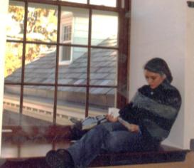
As previously discussed, the limitations Berea currently faces in lowering the carbon intensity of its electricity supply make it all the more important for the College to focus on reducing energy consumption. Building energy consumption accounts for about 80 percent of the College’s GHG emissions and should be the primary focus of Berea’s efforts. Renovating existing buildings instead of building new ones also limits new resource consumption and leverages the embodied energy and emissions in the existing structures, which is supportive of Initiative 1 to reduce the College’s ecological footprint. When new construction is necessary, aggressive designs that significantly reduce or even negate (e.g., net zero) building energy consumption should be pursued.
The previous strategy for energy efficiency in existing buildings involves mostly isolated system upgrades. These retrofits have relatively low capital cost, can be implemented quickly, and can be done independently of other upgrades and renovations. A deep energy retrofit goes beyond this isolated system approach.
Deep energy, or deep green, retrofits apply a whole-building design approach. Where a traditional building renovation could be mostly aesthetic and involve only minimal efficiency upgrades to equipment like lighting, a deep energy retrofit includes a full design consideration of all building systems, including the building envelope, HVAC systems, lighting, and controls. Some of the concepts considered in a deep energy retrofit are covered in Berea’s Renovation Standards developed by the Rocky Mountain Institute in 2002.
A review of literature and case studies related to deep energy retrofits indicates that energy use in many buildings can be reduced by 50 to 75 percent over the same building before renovation. Brendle Group, the consultant for this Plan, reduced the energy consumption in its office by about 70 percent using this process. Morrison Residence Hall, at the University of North Carolina at Chapel Hill, reduced energy consumption by over 50 percent with an aggressive retrofit and occupant competitions. The 2002 renovation of Lincoln Hall at Berea resulted in an estimated 48 percent reduction in energy use. Similarly successful renovations have taken place in Deep Green, Anna Smith, and Knapp Hall.
Achieving aggressive energy use reduction through a deep energy retrofit is not an easy task. It can be complicated by building age, the quality of original construction, and building type, where some buildings may be more difficult to improve because of their inherent energy intensity (e.g., recreation centers). Finding a design team capable of delivering on these aggressive goals can also be difficult. Despite the challenges, the successes documented in green building literature indicate deep energy retrofits are a viable strategy for addressing building energy consumption.
Berea’s renovation policy describes a minimum standard of performance equivalent to LEED™ Silver. To achieve this, Berea is already committed to significant energy use reductions because energy reduction points are so important to achieving any LEED rating. The maximum points available in LEED correspond with a 44 percent reduction relative to a code-basis building.
This Plan recommends that Berea take its renovation policy one step further by committing to a minimum 55 percent energy use reduction relative to the existing building – where the 55 percent is the combined reduction from energy efficiency and deep energy retrofit strategies – in each renovation project. Berea’s average energy use intensity across its building stock is currently 91 kBtu/square foot. After the energy efficiency work that is currently in the planning phase, it is projected that the average EUI will be approximately 90 kBtu/square foot. By the end of the deep energy retrofits, the average EUI would be 62 kBtu/square foot. This estimate does not include natural gas savings attributed to a central plant geothermal opportunity for buildings that are on the campus hot water loop. Additionally keep in mind that renewable energy technologies, such as solar thermal or wood furnaces, integrated at the time of renovation, when installed costs may be lower, can help to displace fossil-fueled energy sources and make the EUI targets more achievable.
By entering into each project with a specific target in mind, energy use reduction can become a primary driver for the project budget, design team selection, and building design decisions. While this target may not be attainable on every renovation project, seeking to meet or exceed it on each project will keep Berea accountable to the overall goal of significant energy use reductions and climate neutrality.
In addition to setting aggressive design goals, Berea should measure the operational performance of renovation projects and hold them to the performance predicted by the building design and energy model. Continuously reviewing performance, commissioning systems, and training occupants will be important to achieving the energy use reductions designed in the building renovations. This will also provide data for Berea to evaluate the renovation approaches and technologies to inform future renovation projects.
Metrics
- Electricity consumption per square foot
- Natural gas consumption per square foot

Technical feasibility: The literature on deep energy retrofits and Berea’s experience with projects like Lincoln Hall indicate that significant energy use reductions can be attained during building renovation. Continued performance monitoring during operation will be important to ensure that designed savings are realized.

Capacity for implementation: Berea’s experiences with Lincoln, Deep Green, Anna Smith, and Knapp Hall suggest that some existing design team relationships may be sufficient to achieve the level of savings targeted.

Key assumptions
- Unit costs of $0.083/kWh for electricity, $8.26/MMBtu for natural gas.
- Electric rate escalation of 2.4 percent per year; no escalation for natural gas because of fixed price contract through 2018 and then 3.5 percent per year escalation thereafter.
- Fifty-five percent reduction in energy consumption from the current building energy use intensities (EUIs) based on data compiled by Aramark (where the average building EUI on campus was 99.7 kBtu per square foot) (To get to the 55 percent reduction, two components are included: the existing energy efficiency work and this deep energy retrofit strategy.)
- Retrofitting all major buildings that are greater than 15 years old (about 680,000 square feet) according to the updated Capital Plan
- Exclusion of some campus buildings (e.g. Central Plant, Draper Hall, and Lincoln Hall, Ann Smith Residence Hall, etc.) because significant retrofits have recently occurred or buildings are planned to be demolished

Cross-cutting themes
- Campus engagement
  - Occupant survey for suggestions prior to implementing recommendations (e.g., learn about occupant experience with lighting to inform controls or changes in lighting technology)
  - Before/after images and performance for recommendations or packages of recommendations for students/staff/faculty
  - Publication of progress toward targets, begin adding operating costs into the performance of buildings on campus
- Labor programs: Building performance monitoring
- Partnerships/policy: Design team
Implementation plan
- Responsible parties: Operations and Sustainability, Facilities Management

Phase | Opportunity | Next Steps
Phase 1  (2016 – 2025) | Attempt to achieved deep energy targets on renovations in current Capital Plan | - Set deep energy targets for renovations in current Capital Plan  - Use these projects as pilots for process and costing  - Monitor building performance to understand if targets are met in operations
Phase 2 (2025-) | Incorporate deep energy retrofits into future capital plans | - Continue to budget for and execute on deep energy retrofits, aiming to reach additional building stock  - Adjust retrofit and operations approaches based on lessons learned in Phase 1

Energy Conservation in Existing Buildings
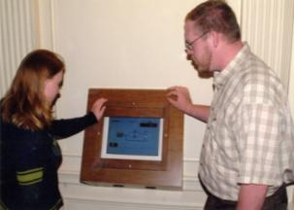
The potential for building occupants to conserve energy through behavior has been demonstrated on many campuses nationwide and the savings are sometimes significant. By turning off lights, powering off and unplugging unused appliances, better managing windows and doors, responsibly operating dishwashers and laundry equipment, and better controlling building temperatures, occupants have a large toolbox for reducing building energy consumption.
During the 2013-2014 academic year Berea participated in the Campus Conservation Nationals. This competition pits higher education campuses against one another in a competition to reduce electricity consumption. Berea’s 14 participating buildings reduced their electrical consumption during that period by 11.3%. As a result, Berea won the Bluegrass Unplugged group that included University of Kentucky, University of Louisville, and Western Kentucky University. Additionally Berea ranked in the top 10 schools overall.
For the Campus Conservation Nationals competition, Berea trained residence hall monitors, provided evening programs, made posters, and encouraged students to come up with their own ways of engaging their peers, such as creating games related to energy conservation. An on campus laser tag and ice cream party was also used to incentivize student participation.
All of these energy conservation efforts help strengthen an infrastructure that Berea can use to become a campus where energy conservation is not just part of a finite competition but becomes a social norm. While the continuous flow of students through campus provides a challenge in educating students on how to reduce their personal energy consumption, it also provides an opportunity for these challenge mechanisms to be continually effective since students are not as likely to become bored with them over the course of their relatively short time at Berea.
Creating a sustained social norm around energy conservation will also raise awareness for the energy saving potential of buildings receiving deep energy retrofits, and informed occupants will help those buildings perform as designed.
Metrics
- Electricity consumption per square foot
- Natural gas consumption per square foot
- Comparison to historical performance

Technical feasibility: Energy conservation is an accessible strategy that relies primarily on awareness and education.

Capacity for implementation: Facilities Management has demonstrated the capacity to conduct an energy conservation campaign and can apply the lessons learned from each year’s Conservation Nationals to future efforts.

Key assumptions
- Fifty percent of electricity consumption attributed to activities under building occupant control
- Persistent 5 percent reduction in electricity consumption in all buildings (This is less than the magnitude of savings achieved in many buildings during the Conservation Nationals to account for diminished savings when not in a challenge and because some buildings do not have the Building Dashboard.)
- Savings applied to projected electricity use after planned efficiency projects are implemented
- Unit costs of $0.083/kWh for electricity, $8.26/MMBtu for natural gas
- Electric rate escalation of 2.4 percent per year; no escalation for natural gas because of fixed price contract through 2018 and then 3.5 percent per year escalation thereafter

Cross-cutting themes
- Campus engagement
  - Green basketball game
  - Social media
  - Student organizations
  - Residence hall leadership
- Labor programs
  - Data tracking
  - Outreach
Implementation plan
- Responsible parties: Operations and Sustainability, Facilities Management

Phase | Opportunity | Next Steps
Phase 1  (2015 – 2016) | Establish regular challenge routine with fall and spring sessions | Standardize outreach approaches and resources to streamline continued delivery of challenges
Phase 2 (TBD) | Coordinate with social scientists at Berea to enhance performance | Coordinate with social scientists at Berea to use the challenges as a means to establish new social norms regarding energy use at Berea

Energy Efficiency in Information Technology
Information technology (IT) infrastructure, such as servers, network equipment, storage devices, computers, handheld devices, and printers, are becoming increasingly large consumers of electricity in institutions of all sorts – including higher education. The energy consumption of these devices can be reduced through purchasing and operational decisions.
One of the biggest efficiency opportunities in server infrastructure is the practice of virtualization, which allows numerous services to operate on a single piece of hardware, thereby reducing the total number of physical servers and resulting electricity consumption. Berea already runs 50 to 60 virtual servers on 5 virtual hosts. There are approximately 25 remaining physical servers that are slated for future virtualization. IS&S is also working to consolidate storage in storage area networks (SANs), which can also improve efficiency.
Another significant opportunity in IT efficiency is power management for computers of end users (e.g., labs, faculty, staff, and student computers). This begins at purchase by selecting a computer with power management capabilities. Berea’s policy of purchasing EPEAT® Silver or better computers ensures that power management features are available. This purchasing policy also supports the ecological footprint reduction goals of Initiative 1 because EPEAT requires manufacturers to consider material selection, design for end of life, project longevity, end-of-life management, and packaging.
Unfortunately, even if power management features are available, they must be configured to function properly. IS&S only manages a few computers on campus directly and there are not many computer labs because every student gets a laptop. So, while there may be a limited opportunity for direct, automatic control of computer power management settings, IS&S can work in cooperation with other departments to reach out to faculty, staff, and students to encourage good power management practices. Good power management practices include enabling sleep features for when a computer is not in use and turning computers and accessories off overnight and for weekends. Furthermore, these educational efforts can also address phantom plug-load control and power strips for turning off computer equipment and other electronics.
Metrics
- Number of physical servers or server utilization
- Penetration of computer power management in end user computers

Technical feasibility: Server virtualization solutions are widely available and IS&S has already virtualized many servers. Power management features are easy to set up and typically work well with newer computer hardware. These features are well documented.

Capacity for implementation: IS&S could prepare resources to instruct faculty, students, and staff on power management features and collaborate with other departments and campus groups to disseminate the information.

Key assumptions
- Unit costs of $0.083/kWh for electricity
- Electric rate escalation of 2.4 percent per year

Cross-cutting themes
- Campus engagement: Student groups and peer-to-peer interactions can support computer power management behaviors
- Labor programs: Position could be used to support regular audits of computer power management settings and providing support in setting up power management settings
Implementation plan
- Responsible parties: IS&S, Operations and Sustainability, Facilities Management

Phase | Opportunity | Next Steps
Phase 1  (2016 – ) | Outreach and support campaign for computer power management | - Develop outreach materials (e.g., website) for implementing computer power management settings  - Roll out with outreach campaign and repeat annually

Commuting
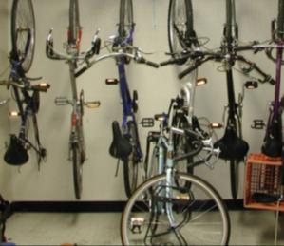
ACUPCC specifically requires participating institutions to inventory and include faculty, staff, and student daily commuting GHG emissions in their climate neutrality plans. These emissions are outside of the direct control of Berea (Scope 3) but ACUPCC recognizes that there are a number of actions an institution can take to reduce these emissions. At Berea, daily commuting was responsible for 6.2 percent of total emissions during the 2014-2015 academic year. These emissions are attributed to faculty, staff, and students.

According to the commuter survey conducted in spring 2009, 72 percent of Berea’s faculty and staff are single occupant vehicle commuters. The survey indicated that 65 percent of employees commute less than 8 miles a day round trip. The most common reasons given for not walking or biking included “distance too great,” “no safe route,” “bad weather,” and “it takes too long.” Obviously, some of these issues are outside of Berea’s influence, but efforts to address the others could help to reduce commuting emissions.

There are a number of actions that were identified by campus stakeholders that Berea could undertake:

- Implement a ride-matching survey or website for faculty and staff to facilitate carpooling (Enterprise Car Share Service implemented 2014)
- Continue to work with the City on integrating planning (e.g., bike paths) between campus and the community
- Improve road striping to provide a defined bike lane on campus and nearby streets
- Work with the City on identifying and promoting opportunities for diverse residential options near campus that will be appealing to faculty and staff
- Continually improve bike infrastructure on campus, including paths, secure bike parking and storage, and shower facilities where appropriate (Bike self-repair stations installed on campus 2016)
- Provide a bike safety workshop at the beginning of fall semester that includes safe cycling in traffic and suggested routes near campus
- Improve proximity to goods and services through efforts such as the Farm Store to reduce the need for off-campus trips
- Review parking fees and consider a daily fee, instead of yearly, that would encourage occasional alternative commutes
- Study effectiveness of shuttle service

In addition to any efforts undertaken by Berea, Federal fuel efficiency standards will also gradually increase the efficiency of Berea employee vehicles and thereby reduce commuting emissions. Standards finalized in 2012 by the U.S. Department of Transportation and U.S. Environmental Protection Agency will result in a fleet fuel efficiency of nearly 55 miles per gallon by 2025. These emissions reductions have been accounted for as a part of the ABAU forecast and do not represent a separate strategy.

Metrics
- Travel mode
- Vehicle miles travelled
- Fuel economy

Technical feasibility: Many of the suggested approaches for decreasing single occupant vehicle commuting and associated vehicle miles traveled have been successfully implemented at other institutions. The challenge for Berea will be to identify the right mix of approaches to help employees identify viable alternatives to single occupant vehicle commuting.

Capacity for implementation: Almost all of the recommendations can be completed internally by Berea.

Key assumptions
- Average fleet increase in fuel economy of 25 percent by 2025 (less than 50 percent in standards because some cars will be purchased before standard is in full effect and some will not be replaced)

Cross-cutting themes
- Campus engagement: Could be instituted as a challenge similar to the structure of the energy conservation challenges
- Labor programs
  - Bike maintenance
  - Support of commuter surveys
- Curriculum and research: Faculty research on effectiveness of local transport systems
- Faculty/staff professional development: League of American Bicyclists Certified Instructor training to provide bicycle safety training to faculty, staff, and students
- Partnerships/policy: City of Berea
Implementation plan
- Responsible parties: Operations & Sustainability, the Office of Institutional Research and Assessment, and interested faculty through cooperation with the City and integration with facility and grounds improvements at Berea

Phase | Opportunity | Next Steps
Phase 1  (2015-2017) | Form a working group to prioritize next steps | Form a working group from Operations & Sustainability, parking management, interested faculty, and students to review options, consider the outcomes of planned studies, and prioritize next steps.

Alternative Fuel Vehicles
At Berea, gasoline and diesel fleet vehicles were responsible for about 0.9 percent of total emissions during the 2014-2015 fiscal year. Although this is a small percentage of the college’s overall inventory, Berea is interested in moving to alternative fuel vehicles to replace some of its existing fleet. Berea has already invested in electric golf carts instead of full sized vehicles or gasoline vehicles for various departments to travel around campus. Additionally compressed natural gas (CNG) vehicles have been considered to replace trucks used by the Facilities Management department.

Currently the College has about 32 small electric vehicles used by a variety of departments and there are an additional 11 gasoline golf carts used by Facilities Management. Typically electric golf carts perform better than gasoline carts when comparing equivalent fuel efficiency. Electric golf carts also provide the opportunity to use renewable energy sources as a means to re-charge when necessary. In addition, electric golf carts since they are approximately a third less expensive to operate. However, due to the fuel mix of Berea’s electric utility, electric carts actual produce 8% more emissions than similar gasoline carts when they are charged with electricity from the grid. Nevertheless, as Berea’s utility alters its fuel mix to meet standards set by 111(d) of The Clean Air Act, this carbon penalty will disappear.

Switching to CNG vehicles is also a good alternative to traditional gas vehicles. These vehicles are available in sizes that range from consumer sedans to semi-trucks. Berea is interested in using these vehicles to replace some of its fleet service vehicles. CNG vehicles have an environmental as well as economic benefit since they emit 24 percent less emissions and fuel is 53 percent less expensive than gas powered equivalent vehicles.

Metrics
- Fuel economy
- Number of alternative fuel vehicles
- Vehicle miles travelled

Technical feasibility: CNG buses and trucks are common on many college campuses. However, Berea would need to invest in infrastructure upgrades, including a CNG filling station, in order to pursue this opportunity in earnest. The majority of Berea’s small cart fleet is already electric powered and no major infrastructure changes would be necessary to switch the remaining carts to electric.

Capacity for implementation: Converting any of the college’s vehicle fleet to CNG is a new strategy that will need a thorough vetting before it is implemented. Additionally due to the infrastructure changes that would be required, it would be necessary to work with external parties to fully implement this strategy.

Key assumptions
- Fuel economy for gasoline carts assumed to be 14 miles per gallon and electric carts assumed to have an equivalent fuel economy of 47 miles per gallon
- Unit costs of $0.083/kWh for electricity, $8.26/MMBtu for natural gas, $2.30/ gallons for gasoline
Cross-cutting themes
- Campus engagement: Include discussion of alternative fuel vehicles in campus tour
- Labor programs: Support CNG infrastructure upgrades and O&M
Implementation plan
- Responsible parties: Operations & Sustainability and Facility Management

Phase | Opportunity | Next Steps
Phase 1  (2016-2018) | Form a working group to prioritize next steps | Form a working group from Operations & Sustainability, parking management, interested faculty, and students to review options, consider the outcomes of planned studies, and prioritize next steps.

Air Travel
Like daily commuting, ACUPCC specifically requires participating institutions to inventory and include institutionally financed air travel GHG emissions in their climate neutrality plans. At Berea, air travel was responsible for about 4.1 percent of total emissions during the 2014-2015 fiscal year. The majority of these emissions, 74 percent, are the result of study abroad travel and the remainder is due to development, recruiting, training, conferences, and other campus business.

Air travel emissions are a difficult category to address because, as in the case of study abroad programs, there are few or no alternative that would provide a similar experience without traveling and many of the destinations cannot be reached without air travel. Therefore it is difficult to reduce the emissions without impacting the educational or business mission. There are some approaches for Berea and its faculty, staff, and students to consider to reduce the impact of airline travel. For each trip, the following should be considered.

- Determine if the travel is necessary or if the educational or business aim could be achieved through another means such as a video conference.
- Consider rail alternatives that may have a lower carbon impact than air travel. There are numerous online calculators that can assist in calculating the impact of particular travel itineraries and modes.
- Support airlines that are making efforts to reduce their GHG emissions through increased fleet fuel efficiency and alternative fuels. These initiatives are not yet pervasive in industry and it will be difficult to consistently support them today.
- Select direct flights whenever possible.
- Consider selecting future study abroad sites based on efficient travel access such as a direct flight from the departure airport.
- Create a program to engage study-abroad students in understanding their travel impacts. For example, students could be required to calculate the emissions from their travel and make a commitment to support efforts to reduce emissions either at Berea or at their study-abroad destination. These efforts could include coordinating an outreach or emission reduction program (e.g. being part of outreach for energy conservation efforts) or committing to actions that will reduce their own personal emissions (e.g. committing to no car use at Berea). These commitments could result in a quantifiable reduction to help offset the student’s study-abroad travel.
- Berea and partner universities could also consider funding commercial carbon offset programs for the air travel category because it is so difficult to address these emissions.

Metrics
- Airline miles travelled
- TBD: depends on approach

Technical feasibility: All of the suggested approaches for decreasing air travel emissions are technically viable. The market for more efficient air carriers remains underdeveloped.

Capacity for implementation: All of the recommendations can be implemented internally by Berea.

Cross-cutting themes
- Campus engagement:
  - Faculty, staff, and students consider the necessity of air travel and its impacts
  - Study-abroad participants are required to make commitments to emission reducing activities in return for the travel experience
- Partnerships/policy: Study-abroad destinations
Implementation plan
- Responsible parties: Study Abroad programs, Development, Operations & Sustainability, travel office or agencies

Phase | Opportunity | Next Steps
Phase 1  (2016-2017) | Develop program for engaging study abroad students in understanding/mitigating their travel impacts | Form a working group from Study Abroad office, Operations & Sustainability, interested faculty, and students to develop a set of program parameters.

Strategies for Culture and Education (Initiative 3)

Sustainability in the Curriculum
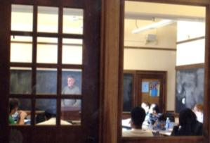
This strategy is built on recommendations by faculty and students provided while developing this Plan as well as best practices from other colleges and universities as outlined by AASHE in the STARS framework and related training materials.
Generally, AASHE notes that higher education has a key role to play in helping society move to a sustainable future, including the following activities:
- Developing curriculum that examines how we shape a sustainable world
- Preparing learners for living sustainably both professionally and personally
- Explicitly helping the learner deeply understand the interactions, interconnections, and consequences of actions and decisions
Furthermore, AASHE indicates the role of higher education includes finding new ways to educate students differently – changing the pedagogy by using the campus and community as the context for sustainability education. Thus, this curriculum strategy is linked to every other strategy in this Plan because the educational experience of students is a function not just of what students are taught and how they are taught, but also how the college conducts research, operates, purchases, design facilities, invests, and interacts with local communities. While this may be a new pedagogy for campuses throughout the country, using the campus to teach is a longstanding area of excellence for Berea due to its work college mission and emphasis on social justice and action.
Berea’s Being and Becoming doctrine established in 1996 reinforces the AASHE objectives with the second pair of common learning goals that urged the College both “to understand the interconnectedness of our natural, fabricated, and human worlds” and “to understand the workings of our natural environment and the consequences of human interventions.” To accomplish these objectives, SDSBC included two recommendations related to curriculum:
- Charge the College Faculty with the assistance of the Dean of the Faculty and the appropriate committees with leading a process that will within the next 2 years: (1) develop learning outcomes for sustainability that can be incorporated into the Aims of General Education, (2) identify where emphases on sustainability can be incorporated and added to the curriculum, and (3) develop appropriate workshops and programs for faculty from all disciplines that support curricular changes that promote education about sustainability.
- Actively and intentionally guide and engage students by providing opportunities for them to be involved in sustainability activities at all levels – curricular, co-curricular, labor, and institutional facilities – not only to enhance their educational experience but to foster ownership and leadership at Berea and in advocacy beyond campus.
The remainder of this strategy describes a plan for achieving these two recommendations, taking into account the following input during stakeholder interviews with students, faculty, and staff:
- Create Avenues to Inspire and Benefit Faculty: Faculty are already infusing sustainability into their teaching, in part as a logical extension of social justice. This is happening organically. For example, in statistics, the statistical tools learned might be surveys and experiments, where the lens or application might be sustainability. An organic effort driven by individual faculty interests and expertise is more effective than a top-down approach because the faculty need the flexibility and autonomy to do what they do best in educating students. All the same, there is much that can be done to foster this organic activity to grow faculty ownership of sustainability. Since faculty are already doing a lot, the approach needs to provide benefits and recognition and support for these efforts, encouraging more. Ideas include awards for things like ‘innovation in teaching’ or ‘best syllabus modification’ addressing a certain sustainability challenge. Another suggestion is to create a dedicated fund for teams of faculty to obtain mini-grants to conduct cross-disciplinary research. For example, a mini-grant to enhance a power generation class by collaborating with forestry on biomass.
- Build on existing momentum in SENS and Compton Chair. Increase the number of students taking SENS 100 and look to grow the number of SENS students, sustainability courses in other disciplines, and SENS labor positions. For example, in Asian studies, one faculty member now teaches a course on Energy Security in Southeast Asia.
- Look for ways to infuse sustainability throughout other curricular areas. As one student noted, sustainability is like learning another language – if you want to be fluent, you have to immerse in it and live it. Look for areas to infuse sustainability across a variety of courses and provide experiences for students to apply sustainability. Educate professors more so they can incorporate sustainability into their classes, such as sociology and economics, or even fine arts. In Child and Family Studies, one faculty member uses the text Affluenza (DeGraaf, Wann, and Naylor) to teach about household sustainability.

Metrics
- Number of SENS students
- Number of sustainability-focused courses: sustainability is the main focus of the course or a course that examines an issue through the lens of sustainability
- Number of sustainability-related courses: sustainability is incorporated as a module or unit
- Number of programs with a sustainability-focused or sustainability-related requirement
- Sustainability literacy assessment built on a defined set of learning outcomes
- Dollars for cross-disciplinary teaching/research in sustainability
- Syllabus modifications related to sustainability

Technical feasibility: The technical feasibility of this strategy depends on the degree that faculty members have the knowledge, skills, resources, support, incentives, and dispositions to advance sustainability in curriculum delivery. This requires a mix of professional development, leadership, and collaboration among faculty, including mentoring and social networks.

Capacity for implementation: Berea has several new and existing assets that comprise the existing capacity for implementing this strategy:
- Existing excellence in teaching social justice as a structure – faculty understand and embrace social justice and infuse it as part of their work; Berea can be contributors on how social justice extends to sustainability
- SENS program
- New Compton Chair position
- Alignment with Being and Becoming and SDSBC recommendations
- Sustainability-related labor positions
- Other existing tools/formats for curriculum review/modification
- Interested student body

Implementation plan
- Responsible parties: Compton Chair and leadership from within faculty divisions, with support from Sustainability Office
Phase | Opportunity | Next Steps
Phase 1  (2015-2016) | Develop sustainability learning objectives | Review AASHE objectives and customize to Berea based on guiding documents.
 | Assess and document current level of sustainability in curriculum | - Create a survey/evaluation tool for assessment.  - Assess using tool; consider linking through labor positions and/or Compton chair.  - Develop faculty workshop to review results and identify priority areas for opportunity.
Phase 2  (2016) | Implement sustainability literacy assessment based on learning objectives | - Determine assessment methodology – frequency, target groups, etc.  - Conduct assessment.
Phase 3  (2016-2017) | Improve sustainability coverage in curriculum | Based on literacy results and faculty workshop opportunities, implement top priorities.

Professional Development to Support Sustainability
This Plan is only as robust as its support among staff and faculty, and its success is largely dependent upon buy-in and implementation. To this end, the college has an obligation to offer its staff and faculty opportunities to learn, engage, and grow in the area of sustainability.
For staff, there are a variety of ways to include sustainability education in Berea’s approach to professional development. Regular sustainability updates and training can be part of ongoing internal communication among staff. Part of this communication can include training on using a triple bottom line filter to analyze options and make decisions. There is an abundance of information and resources available for teaching, promoting, and implementing a triple bottom line approach at an institutional level. For example, books such as The Ecology of Commerce by Paul Hawken, Cradle to Cradle by William McDonough and Michael Braungart, and the Triple Bottom Line by Andrew Savitz and Carl Weber offer good ideas for putting triple bottom line theory into practice. There also are on-line training opportunities or courses offered by other institutions, such as University of Vermont’s Advanced Certificate in Sustainable Innovation (www.universityofvermontonline.com/the-consumers-triple-bottom-line/). Berea could also develop an internal tool, based on these resources and customized to Berea’s particular sustainability initiatives, to support sustainability decision making and tracking institution wide.
In addition, as new staff and faculty members join Berea, the institution can offer sustainability orientation that emphasizes its commitment to sustainability and identifies ways each member of the campus community can contribute to its goals. This orientation should take faculty and staff beyond recycling behaviors, and into a broader understanding of how deeply wedded the college’s social justice mission is to sustainability.
Because everyone has a role to play in achieving Berea’s goals, the institution can include individual actions and goals in staff and faculty position descriptions that will encourage growth and against which performance toward these goals can be measured. Awards or recognition for participating on green teams or other voluntary and exemplary actions related to campus and community sustainability are excellent tools for encouraging development and maintaining engagement and enthusiasm. To identify and recognize these actions, Berea could add questions about sustainability to the faculty annual report and staff performance reviews.
Beyond facilitating the development of existing faculty and staff, Berea should identify areas where dedicated sustainability staff may be of value and consider adding staff as appropriate.
Metrics
- Number of staff trained in triple bottom line analysis
- Number of position description goals for staff/faculty members
Technical feasibility: The opportunities identified can be implemented easily through currently available processes.

Capacity for implementation: Sustainability targets can be added to position descriptions as part of Berea’s existing performance evaluation process. These targets should be based on goals and guidance from this Plan.

Cross-cutting themes
- Community engagement: Increased on-campus education and awareness translate to activities in the community
- Labor programs: Training opportunity for champion (triple bottom line analysis)
- Curriculum & research: course content resources and rewards
Implementation plan
- Responsible parties: People Services, Workplace Development, Sustainability Committee.

Phase | Opportunity | Next Steps
Phase 1  (2016) | New employee orientation | - Develop materials (or add to employee handbook) related to sustainability and commitments/expectations.
 | Triple bottom line training | - Develop workshop materials for training staff and faculty.  - Establish workshop schedule to include all relevant existing employees in phases.
Phase 2  (2017) | Recognition award | - Research funding source for sustainability recognition.  - Establish criteria for recognition and assign evaluation responsibility and nomination process.

Student Engagement in Sustainability
Engaging the student body will be integral to the successful implementation of this Plan. As part of the Plan, an on-boarding primer has been developed to introduce new students to sustainability at Berea and outline various ways they can get involved. However, engagement cannot be a onetime thing − it has to be continually enforced throughout a student’s time on campus to ensure they are continually reminded of Berea’s efforts and provided outlets to get involved. Reinstating the sustainability grant program for students may further engagement and help students fund their sustainability initiatives.
Metrics
- Number of students engaged in groups related to sustainability
- Number of annual events or projects incorporating sustainability
- Number of articles in campus publications addressing sustainability issues

Technical feasibility: Current programs for student engagement and outreach can be leveraged for sustainability specific efforts, providing lessons learned and guidance on logistics for carrying out this strategy.

Capacity for implementation: Resources are currently being allocated to support sustainability communications. Operations & Sustainability has 2 student labor positions committed specifically to communications. It is expected that the action items outlined here would be integrated into these communication hours.

Cross-cutting themes
- Labor programs: Continued student positions to support development and implementation of communications campaign
- Partnerships/policy: Kentuckians for the Commonwealth and other advocacy organizations for engagement off of campus
Implementation plan
- Responsible parties: Sustainability Office, Sustainability Committee, Residence Life, Labor Program, Communications Department, Operations Department.

Phase | Opportunity | Next Steps
Phase 1  (2016) | Student position  (completed) | - Identify appropriate department (e.g., Communications) for new student position.  - Develop an approach for ensuring the long-term viability of the position.  - Solicit candidates and fill position.
Phase 2  (2017) | Student engagement implementation plan | - Create an implementation plan for increasing student engagement, including budget, schedule for rollout, and responsible party for each identified activity.  - Include the following ideas in the plan:  - Communication Tools: videos, increased web and social media presence, suggestions for individual action (e.g., what can be done in a residence hall room).  - Incentives: competitions and awards, sustainability sabbatical for students.  - Non-traditional Student Support: targeted programs for non-traditional students that may not have access to other programs through House Council, etc.
 | House Council sustainability positions | - Develop a training manual on sustainability for Berea House Council so that House Council members can act as educators on sustainability for students.  - Incorporate training into newly developed student position responsibilities.  - Conduct training each fall.

Labor Positions to Support the Plan
Among its peer institutions signing on to ACUPCC, Berea has a unique opportunity in its student labor program as a resource for implementing various aspects of this Plan.
Berea has a long history whereby students have literally helped to build the college. From some of the actual buildings to the associated community-based infrastructure, such as growing its own food supply.
This strategy looks across all the other strategies in this Plan, seeking ways that students can get involved in sustainability implementation through labor positions. Currently there are eight SENS labor positions, plus four labor positions in operations and sustainability. This strategy would seek to grow the number of sustainability-focused labor positions while also seeking ways to incorporate sustainability into other labor positions across the board. This strategy also seeks to link to the Curriculum strategy by providing enhanced student experiences in sustainability outside the classroom.

The following Labor Positions have been established and filled during Fiscal Year 2015-2016 thru the Office of Sustainability to help implement this Plan:
- Labor Positions
  - Student Sustainability Coordinator
  - Sustainable Foods Coordinator
  - Waste Diversion Coordinator
  - Energy and Water Conservation Coordinator
  - Sustainable Purchasing Coordinator
  - Compliance Reporting Coordinator
  - Data Tracking & Analysis Coordinator
  - Training & Events Coordinator
  - Marketing & Communications Coordinator
  - Web & Graphic Design
  - Special Projects Coordinator
  - Alternative Transportation Coordinator
- Sustainability measurement and management
  - Monthly trend monitoring in campus resource use and operations (energy, water, waste, purchasing, commuting, forestry, etc.) across individual buildings, operations, and campus wide
  - Goals comparison and progress reporting through web or other electronic interfaces – i.e., sustainability dashboard
  - Inventorying sustainability in existing labor positions
- Behavior change and communications
  - Signage, messaging, challenges, etc., for energy efficiency, water, purchasing, solid waste
  - Research on sustainability topics and data generated by Berea’s programs
  - Becoming trainers in triple-bottom-line decision making
  - Preparing materials to support efforts to share sustainable practices with the community

In addition to growing the sustainability-focused labor positions, it would also be beneficial to encourage students in other labor positions to consider how sustainability relates to their position. This might be achieved by adding a sustainability award to the existing labor position awards.

Metrics
- Number of sustainability-related labor positions
- Number of sustainability-focused labor positions
- Student sustainability literacy – initially tied to student labor checklist

Technical feasibility: The feasibility of this strategy depends on the capacity of the labor program to take on new sustainability-related labor positions in terms of cost, administration, and faculty/staff oversight.

Capacity for implementation: Current labor program

Implementation plan
- Responsible parties: Sustainability Office, Labor Program

Phase | Opportunity | Next Steps
Phase 1  (2015-2016) | Inventory and expand sustainability-focused and sustainability-related labor positions  (completed) | - Inventory existing labor positions to identify those that are sustainability-focused and sustainability-related  - Incorporate labor roles described by this strategy into existing or new positions  - Start to build literacy across all labor positions with sustainability check-list (e.g. turning off lights, recycling, improving the sustainability of the labor position)
Phase 2  (2015-2016) | Expand measurement and recognition of sustainability in labor positions | - Incorporate sustainability in supervisor evaluation  - Incorporate sustainability category into labor position awards

Employer Assistance Program
Given the strong administrative commitment to sustainability at Berea, the institution is in a unique position to educate faculty, staff, and students about resources and efficiency practices that can be applied at home for a greater impact across the community. Berea can encourage these practices by providing resources, funding, and access to efficiency programs.
Berea can provide seminars to staff, faculty, non-traditional off-campus students, and members of the alumni organization to raise awareness of its on-campus sustainability initiatives and offer additional education relative to sustainability in the community, such as workshops on the feasibility of residential renewable energy; recycling, re-use, and waste reduction opportunities; alternative transportation and commuting options, including ride-sharing forums and bike routes; and energy and water conservation beyond campus boundaries. Educated staff, faculty, and alumni could be conduits to the community for emerging sustainability practices.
In addition to providing education and resources for energy and water conservation, Berea can offer on-line home audit tools, incentivized home energy and water audits, and low interest loans (to its faculty and staff) to implement projects recommended during audits.
Metrics
- Number of events on campus promoting sustainability at home and in the broader community

Technical feasibility: Lessons learned from on-campus assessments and efficiency strategies can be translated into best practices for home owners, which can be used to raise awareness among alumni and in the community. In addition, other resources, such as ENERGY STAR and federal energy efficiency tax credit sites, are available to offer tips and best practices for home owners.

Capacity for implementation: Sustainability champions involved in developing this Plan can direct development of educational materials and resources, and audit training could be provided by the private sector either in the form of training the trainer or training students. Resources are being allocated to support sustainability communications (30 student hours per week), which could be leveraged to develop seminar or workshop materials. In addition, student labor could be available as well as staffing for home audit teams.

Cross-cutting themes
- Community engagement
  - On-campus initiatives to encourage similar activities in homes by showing benefits to and incentivizing staff, faculty, and alumni
  - Before/after performance for residence halls or other smaller campus buildings as examples of what is possible at home
- Labor programs: Student support for educational and self-audit materials or actual on-site auditing (e.g., preparing tool, training, direct install components)
- Curriculum and research: self-audit tool development, tips and best practices library, outside resources library
- Faculty/staff professional development: Certified Energy Auditor or Certified Energy Manager for training students
- Partnerships/policy: Berea Municipal Utilities, Delta Natural Gas (develop audit support), Sustainable Berea, MACED, Kentucky Environmental Foundation, local service providers
Implementation plan
- Responsible parties: Sustainability Office, Human Resources, Labor and Student life.

Phase | Opportunity | Next Steps
Phase 1  (2016-2017) | Staff/faculty survey | Solicit feedback from staff/faculty for interest in sustainability education and home efficiency resources.
 | Educational resources | Gather and synthesize data and best practices, as well as sustainability resources available through the wider community.  Develop on-line library of rebates and tax incentives, efficiency tips, and best practices for homeowners.
 | Self-audit tool | - Research availability of existing audit tools or solicit external guidance.  - Offer tool as pilot to staff and faculty.
Phase 2  (2016) | Home audit | - Train students to perform home audits or solicit external resources.  - Develop incentive for staff and faculty.
Phase 3  (2016-2017) | Improvement assistance | Develop interest free or low interest loan program for staff and faculty to fund improvements.

Appendix A: 2012 Green Guide for Students
Student engagement was identified as a significant need with respect to all of Berea’s sustainability Initiatives. As a component of the student engagement strategy, this student primer will serve as a tool during orientation and for students arriving on campus to introduce them to or remind them of all the opportunities they have to participate in campus sustainability. The primer will be delivered primarily through the Plan website.
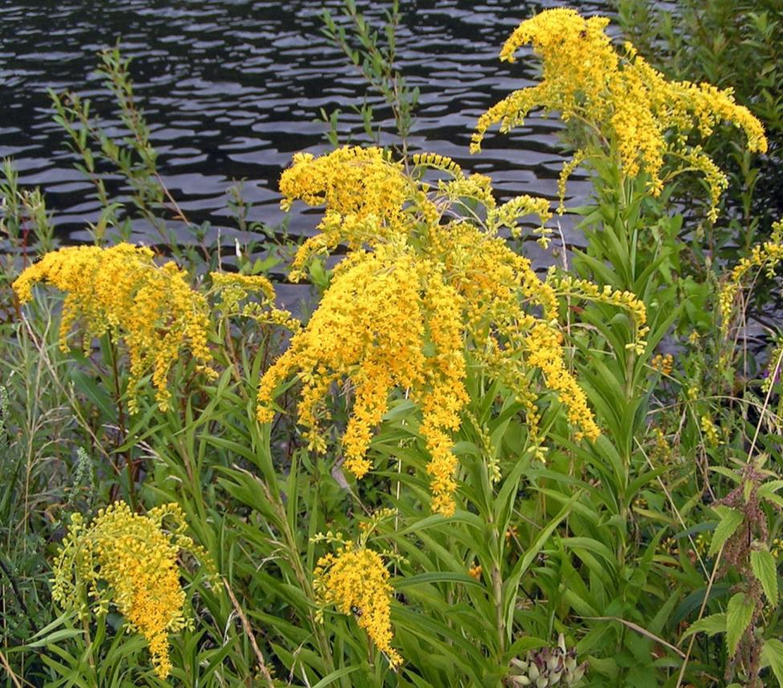
2015 GREEN GUIDE FOR STUDENTS

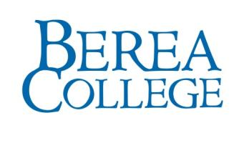
Why Go Green?
Sustainability refers to the capacity of a society to meet current needs without degrading the ecological, social, and economic systems on which the society will rely for meeting future needs.
At Berea College, we believe in fostering personal empowerment to become an agent of change. As you continue your education here, we will give you many opportunities to learn about the causes and consequences of global climate change and have created this resource to give you the starting tools to be more sustainable on a daily basis on campus.

Contents

Out ‘n About 2
Green Printing Services 3
Energy Aware 4
Reduce, Reuse, Recycle: Tips to Be an Eco-Savvy Student 5
Social and Sustainable 8
Getting Involved 9

Out ‘n About
The Ecovillage offers a hybrid Toyota Prius that residents can check out for off-campus needs such as grocery shopping. Car Share and Ride Share programs have been implemented as well for students, faculty, and staff.
Berea College offers sustainable transportation resources such as campus bike racks, bike self-repair stations, a ride matching system, car share service, carpool parking, and a campus shuttle system to surrounding communities.

BC Express: Transportation Service
www.berea.edu/campuslife/bcexpress.asp

Campus Life offers a transportation service called BC Express for Berea College students. This 12-passenger van operates hourly on Tuesdays, Thursdays and Fridays from 5-9 p.m. to provide transportation for students to Berea and Richmond town businesses. Stops are located:
- In front of Wal-Mart
- The middle of the parking lot of the plaza containing Goodwill, Hong Kong Buffet, and Dollar General.
- The front of Save-A-Lot
You must sign up to ride and have your student ID with you. Sign-up Sheets are located at the Front Desk of the Alumni Building.

Berea Bike Repair Stations

There are 5 self-repair bike stations located throughout campus.

Motor Pool Vehicles
www.berea.edu/publicsafety/community/motorpool.asp

The campus motor pool has a fleet of vehicles for rent including hybrids, sedans, minivans, and 10 or 12 passenger vans. These vehicles are available for any Berea College sponsored program or event. The vehicle must be sponsored by a college department and charged to the department’s account number.
All reservation requests must be emailed to motor_pool@berea.edu.

The Motor Pool office is located at Public Safety on the 1st floor of Woods Penn, 859.985.3824

RIDE AND CAR SHARE OPTIONS
Berea College and Enterprise Car Rentals provide all students, faculty, and staff with the opportunity to rent a vehicle for personal use. We have partnered with Zimride to offer an online ride matching system as well.
www.berea.edu/sustainability

Green Printing Services

Copier & Printer Locations & Hours
Alumni Building (black & white MFD)  Main Entrance Lobby/Information Desk Area | Every day, 8:00 a.m.–11:00 p.m.
Draper Building (black & white MFD)  2nd floor Central Study lounge | Every day, 8:00 a.m.–11:00 p.m.
Ecovillage Commons House (laser printer)  Front Lobby | Mon–Fri, 8:00 a.m.–5:00 p.m.
Hutchins Library (black & white MFD)  Main Lobby | Mon–Thu, 7:45 a.m.–Midnight  Fri 7:45 a.m.–7:00 p.m.  Sat 10:00 a.m.–6:00p.m.  Sun 2:00p.m.–Midnight
Hutchins Library (color MFD)  (also accepts black & white prints)  Copy Room off Main Lobby | Mon–Thu, 7:45 a.m.–Midnight  Fri 7:45 a.m.–7:00 p.m.  Sat 10:00 a.m.–6:00p.m.  Sun 2:00p.m.–Midnight
Hutchins Library (black & white MFD)  Lower Level Periodicals Area | Mon–Thu, 7:45 a.m.–Midnight  Fri 7:45 a.m.–7:00 p.m.  Sat 10:00 a.m.–6:00p.m.  Sun 2:00p.m.–Midnight
Science Building (laser printer)  2nd floor Computer Lab, Room 209 | Mon–Fri, 8:00 a.m.–5:00 p.m.
TIA Building (black & white MFD)  Main Lobby | Mon–Fri, 8:00 a.m.–5:00 p.m.
Woods-Penn A (black & white MFD)  CPO Lobby/Lounge Area | Every day, 24 Hours
Woods-Penn B (black & white MFD)  CPO Lobby/Lounge Area | Every day, 24 Hours

Save energy, dorm room space, and money - utilize the environmentally responsible campus Printing Services rather than bringing a personal printer to Berea College. Here you can obtain and refill a Print Card used to activate the various multi-function copiers located around campus. You can check your balance on my.berea.edu by clicking on the My Accounts tab.
Services at the main office include:
- Offset printing
- High-speed duplicating
- Copying, scanning, faxing
- Wide-format printing
- Graphic design

Location:
1st floor of Stephenson Hall
859.985.3166 phone
859.985.3917 fax
printingservice@berea.edu

Hours:
Monday - Friday: 8:00 am–5:00 pm
Closed Saturday and Sunday
Printing Services’ commitment to sustainability:
- The majority of inks used on campus are formulated and manufactured to be environmentally responsible and incorporate the use of renewable resources of vegetable oils (such as soy).

- Most of the waste generated in the facility is recycled through campus recycling & we no longer generate any hazardous waste.

- Chemistry free offset plates used.

- Paper for printers and copiers made from 100% post-consumer waste.

- Printers and copiers are Energy Star Certified.

Energy Aware

Setting up Your New Room
- Before purchasing appliances, check to see if your residence hall has a common area TV, refrigerator, etc. If you do need to purchase an appliance, look for the “Energy Star” logo on TVs, DVD players, computers, and microwaves - they use 10 to 50 percent less energy. Check with your roommate to make sure you are not duplicating items.
- Purchase compact fluorescent light bulbs for your lamps.
- Bring your own reusables – such as reusable grocery bags, mug/coffee cup, and a water bottle.
- Look for toxic free and organic sheets, rugs, and curtains – or other natural fiber products such as those made with hemp or bamboo.
Turning your computer on and off will not harm it. The life of a monitor and computer is related to the amount of time it is in use, not the number of on-and -off cycles. And remember, the best screen saver is no screen saver at all.

- Bring a power strip to mind the “phantom load” — many computers, gaming systems, stereos, TVs, cell phones, cameras and iPod chargers draw electricity even when turned off. Plug all of your electronics into the power strip and turn off when you go to sleep or leave your room for long periods of time.
- Make a sign for your door with your new roommate to remind you to turn off lights and your power strip when you leave the room.

3 Ideas for Smart Purchasing
- Choose products with minimal packaging.
- Have a reusable bag on hand for purchases. Chico Bags are a great low-profile option to throw in a purse or pocket when you are going out.
- Ordering take-out? Tell them ahead of time that you will be providing your own bag, flatware, and napkin and ask for a Styrofoam-free alternative.

Freshman Refrigerator Program
Beginning in 2015, all first year students living in first year residence halls will be provided with one Energy Star room refrigerator that anticipates 36% greater energy savings than a non-Energy Star model. Each refrigerator comes with a magnet designed by the Office of Sustainability to educate students about energy savings and introduce the term Energy Star appliance in the hope that these future consumers will ask for Energy Star items with the understanding they are saving energy and money and reducing CO2 emissions.

3 Simple Ways to Conserve Energy
- Keep thermostats set at 68º during the cold months and 76º during warm seasons.
- Remember that hot water uses more energy. Wash your laundry using the cold water cycle. Try a quick, cool, and refreshing shower instead of long, lazy ones- every 5 minutes spent in a hot shower uses about 35 gallons of water.
A 50 kilowatt solar panel array installed on the south roof line of Deep Green Residence Hall produces 15% of the building’s annual energy usage..
- During the winter, open curtains to allow sunlight in for solar heat gain. In the evenings, close curtains to reduce thermal heat loss.
- Make sure the power management features on your computer are enabled

3 Simple Ways to Conserve Water
- Forget about plastic water bottles and refill your own BPA-free reusable water bottle. It takes three to five liters of water to make just a 1-liter plastic disposable bottle.
- Eat lower on the food chain. It takes 5,000 gallons of water to produce one pound of meat, while producing one pound of certain grains takes only about 25 gallons.
- Turn off the water while you brush your teeth, wash your hair and hands, and shave.

Reduce, Reuse, Recycle: Tips to Be an Eco-Savvy Student
From on-site composting to a robust recycling program, Berea College has many easily accessible options to help you reduce your footprint.

3 Good Ideas for Reuse
- When you need to purchase something, check yard sales, charitable outlets, and resale stores first. Check http://www.half.ebay.com/ for used textbooks, books, music, movies, and games.
- Cash it, don’t trash it. Sell your old products on sites like eBay or Craigslist. There is currently not a separate Craigslist for Berea or Madison/Richmond area. Everyone from the surrounding area will list on the Lexington Craigslist. Lexington Craigslist

Composting on Campus
Berea Dining Services works with the College Gardens to compost 90 percent of pre- and post-consumer food residuals, which diverts an average 160 pounds of waste from the landfill daily (approximately 26 tons per year).
Local products are available at the farmer’s market, college bookstore, and will be available at the planned farm store.

Office of Sustainability
CPO 2211
859-985-3194
Office Hours:
Monday - Friday, 8:00 a.m.–5:00 p.m.

Dining Services, the Office of Sustainability, and Facilities Recycling ensure that well-marked recycling and compost bins are available at all campus-wide events for which they provide catering. The Ecovillage also collects and processes its own compost from resident apartments

Recycling Made Easy
The Recycling Coordinator and student labor team collect and recycle paper, plastic, glass, aluminum, steel, and batteries from bins located in indoor and outdoor locations throughout campus. Self-serve receptacles for collecting cell phones, inkjet printer cartridges, and toner cartridges are also available in the CPO and library.
Berea’s recycling campus-wide program actually began as a student-led grassroots effort in 1989 and operated as a volunteer-run program until the creation of full-time Recycling Coordinator position and a supporting labor department at Facilities Management in the early 1990’s.

Facilities Building
CPO 2202
Office Hours: Mon - Fri, 8:00 a.m. - 5:00 p.m.
Phone: 859-985-3844

Recyclable Items
YES | NO
PAPER (Note: staples are OK)
Notebook and office paper | Paper plates or cups
Newspapers, magazines, and junk mail | Paper Towels or tissues
Envelopes | Candy wrappers or contaminants
Shredded Paper | Plastic wrapped or laminated paper
Notebooks, hardback and paperback books | Remove spiral binding from notebooks
CARDBOARD
Corrugated cardboard and thin paperboard | Cardboard contaminated by food – except pizza boxes that are collected in the residence halls for composting
ALUMINUM/STEEL
Soda cans and steel/tin food cans
Empty aerosol cans
GLASS & PLASTICS
Glass bottles and jars with lids removed | Broken glass
All plastics with the recycling symbol on the bottom | Plate glass (like picture frame glass)

Information Systems and Services (IS&S) recycles electronic media (i.e., CD’s, disks, etc.) as well as electronic equipment by stripping usable parts from obsolete or inoperable equipment and then recycling the rest through an external vendor for further breaking down and processing.

Computer Center
CPO 2208
859-985-3343
Office Hours: M–F, 8:00 a.m.–5:00 p.m.

Social and Sustainable
- Organize a clothing swap and donate unwanted items to charity.
A locavore is a person interested in eating food that is locally produced, not moved long distances to market. The locavore movement in the United States and elsewhere was spawned as interest in sustainability and eco-consciousness became more prevalent.
- Pool your resources, reduce waste, and save money by finding a group of like-minded students to buy dorm-essentials in bulk. Divvy up bulk laundry detergent, etc. into reused glass jars or plastic tubs.
- Hosting a party?
  - Instead of buying disposable plates, go to a local thrift store or neighborhood yard sale and buy an eclectic mix of dishes, cups, and servingware. Those red plastic drink cups take 450 years to decompose!
  - Offer locally produced snacks and locally grown produce.
  - Serve healthy “finger food,” with no plates or utensils necessary.
  - Modify the hours or location to utilize natural day-lighting.
- Try being a locavore and meet your neighborhood farmers:
  - Berea Farmers Market
Year round. Check hours and locations: http://bereafarmersmarket.org/

  - Berea College Farm Store & Farm
    - CPO 2161, Berea, KY 40404
859-985-3591

Farm Store information visit
http://bereacollegefarmstore.com/

College Farm, including visiting hours, visit
http://www.berea.edu/anr/

Getting Involved

Berea College Office of Sustainability
www.berea.edu/sustainability
Comprehensive summary of sustainability initiatives.

Berea College Dashboard
http://buildingdashboard.net/berea/#/berea/

As part of our commitment to sustainability, Berea College is monitoring our resource use in an effort to reduce our consumption and carbon footprint. On the interactive web-based dashboard, you can compare your building's consumption compared to others, check your standings in a reduction competition, make commitments to conserving, or tell others what you're doing to be green.

About the Ecovillage
http://www.berea.edu/sens/ecovillage/
Guided by intertwined educational, environmental, and social goals, the Ecovillage is an ecologically-sustainable residential and learning complex designed to meet housing needs for student families, childcare for campus children, and provide a living/labor opportunity for students interested in sustainability. Rigorous performance goals for the Ecovillage include: reduction of energy use by 75 percent; reduction of per capita water use by 75 percent; recycling, reusing or composting at least 50 percent of waste. To accomplish these and other goals, the Ecovillage incorporates a wide range of "green design" elements including passive solar heating, and photovoltaic panels. Roof-top capture of rainwater contributes to landscape irrigation and production of fruits and vegetables.

SENS
https://www.berea.edu/sens/
The Sustainability and Environmental Studies (SENS) House in the Ecovillage includes a 1,440-watt net-metering solar electric system. Net-metering maximizes power production because power is either used immediately on-site or flows into the grid when the system produces more energy than it is using, which benefits electric utilities because solar panels generate the most power on sunny summer days when demand on the electric grid is often highest. The panels also follow the sun with an automated tracking system that also maximizes the amount of energy they collect.

Local Food Initiative
http://www.berea.edu/localfoodinitiative/
The mission of the Berea College Local Food Initiative is to promote the participation of Berea College in the development of a sustainable food system.

Bereans for Appalachia
https://www.facebook.com/groups/37666774152/
Bereans for Appalachia is a student organization that focuses on social and environmental justice issues in the Appalachian region.

Oxfam
http://www.oxfamamerica.org/
Another student organization is the Berea College chapter of Oxfam, which is “committed to creating lasting solutions to global poverty, hunger, and social injustice.” Berea Oxfam has worked on several awareness-raising events focusing on hunger, Fair-Trade, and the Real Food Challenge.

RecycleMania
RecycleMania is a friendly competition and benchmarking tool for college and university recycling programs to promote waste reduction activities to their campus communities. Over an 8-week period each spring, colleges across the United States and Canada report the amount of recycling and trash collected each week and are in turn ranked in various categories based on who recycles the most on a per capita basis, as well as which schools have the best recycling rate as a percentage of total waste and which schools generate the least amount of combined trash and recycling.

Connecting Through Social Media

https://www.facebook.com/bereacollegesustainability/

http://www.youtube.com/berea

http://twitter.com/#!/bereacollege

Comments or Suggestions
Have an idea for a new club or campus initiative? Had an “ah-ha moment” on how to help Berea College become a greener campus? Tell us your comment and suggestions here:

Office of Sustainability
859-985-3194
paulyj@berea.edu

Plan C for BC. Dr. Richard Olson. The Sustainable Campus, Summer 2007, Volume 3, Issue 3.
https://stars.aashe.org/institutions/berea-college-ky/report/2011-12-22/
http://rs.acupcc.org/ghg/3232/
http://rs.acupcc.org/
Berea receives all of its water supply from Berea Municipal Utilities, which is supplied by four surface water reservoirs.
The pollutant limits used to develop Berea’s water footprint are the Draft Nutrient Limits established by the Kentucky Division of Water based on EPA nutrient criteria (http://water.epa.gov/lawsregs/lawsguidance/cwa/tmdl/upload/day2_fredenburg.pdf).
Plan C for BC. Dr. Richard Olson. The Sustainable Campus, Summer 2007, Volume 3, Issue 3.
Implementation Guide: Information and Resources for Participating Institutions. ACUPCC. Version 1.1, 2009.
This is a parallel effort to Berea’s Initiative 2 around climate neutrality with a focus on the College’s water footprint
A Handbook on Low-Energy Buildings and District-Energy Systems, L.D. Danny Harvey, Earthscan, 2006.
http://www.save-energy.unc.edu/Portals/2/Morrison%20Competition%20Case%20Study.pdf
These emissions do not include students travel to/from Berea at the beginning or end of terms or for holidays. Trips made off-campus (e.g., for groceries or a haircut) are also not included.
Faculty and Staff Commuter Survey, Office of Institutional Research and Assessment, April 2009.
Obama Administration Finalizes Historic 54.5 mpg Fuel Efficiency Standards, National Highway Traffic Safety Administration, http://www.nhtsa.gov/About+NHTSA/Press+Releases/2012/Obama+Administration+Finalizes+Historic+54.5+mpg+Fuel+Efficiency+Standards. These emissions do not include students travel to/from Berea at the beginning or end of terms or for holidays.
Evaluation of Solar-Assisted, Electric and Gas Golf Carts, Toronto region Conservation Authority, 2010.
These emissions do not include students travel to/from Berea at the beginning or end of terms or for holidays.

