March 1, 2020

I affirm that the 2020 Ball State University STARS report has been reviewed in full and that all identified inconsistencies and errors have been successfully addressed prior to submitting it to AASH​E.

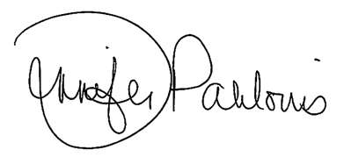

Jennifer Palilonis

Chief Strategy Office Faculty Fellow

Director, Center for Emerging Media Design & Development

Ball State University