# A wide range of eco-initiatives helps us connect with today’s students—and prepare for tomorrow.

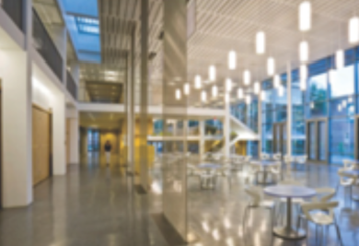

Award-winning environmental design

Tulane’s Lavin-Bernick Center, which houses the school’s bookstore, was recently named one of the top 10 examples of sustainable architecture by the American Institute of Architects Committee on the Environment.

[](http://www.google.com/imgres?imgurl=http://www.promotionalitemsbuzz.com/wp-content/uploads/2011/01/Starbucks-New-Logo-300x300.png&imgrefurl=http://www.promotionalitemsbuzz.com/2011/01/11/a-major-logo-change-for-a-major-company/&usg=__m9Th04pltuvuDZxczjdpajICffo=&h=300&w=300&sz=96&hl=en&start=25&zoom=1&um=1&itbs=1&tbnid=6c3LPtnFIxDZJM:&tbnh=116&tbnw=116&prev=/images?q=new+starbucks+logo&start=21&um=1&hl=en&sa=N&rls=com.microsoft:en-us:IE-SearchBox&rlz=1I7ADBR_en&ndsp=21&tbs=isch:1&ei=gcRJTauHN8X_lge9xNDSDw)  
  
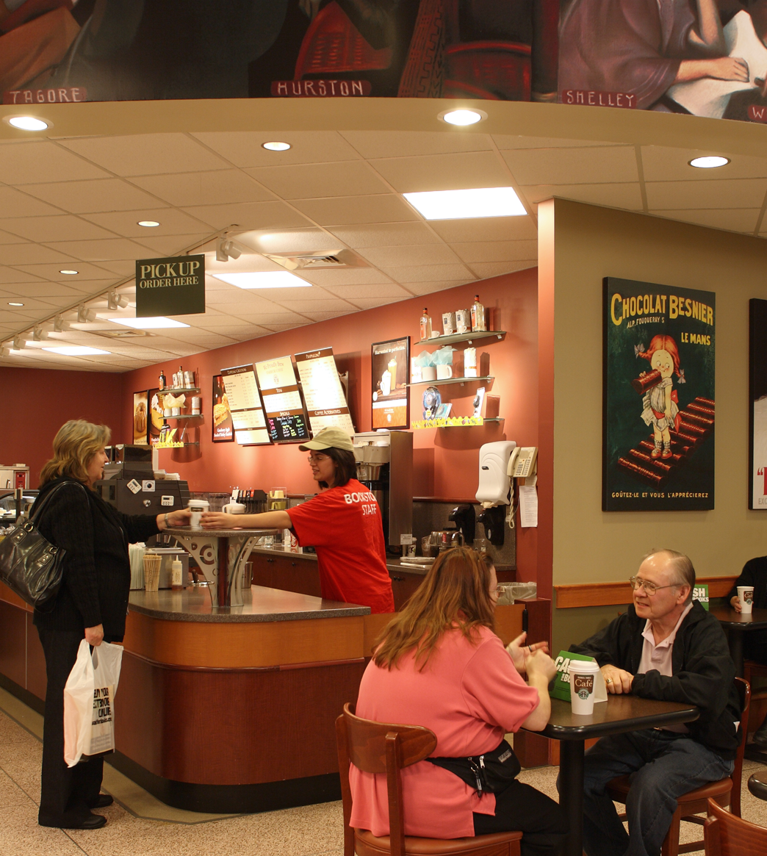

Starbucks

Our coffee vendor, Starbucks, is committed to sustainable business practices, working to conserve biodiversity through the Rainforest Alliance, and helping children get clean water through the Ethos Water Project.

At Barnes & Noble, we hold ourselves to the highest standards when it comes to protecting the environment. We know our students are concerned, as well. We work with each of our college partners to integrate our practices into their own programs and philosophy, and we support our students’ commitment through a variety of in-store, on-campus, and Home Office initiatives.

## GREEN STORES

Whether we’re renovating an existing bookstore or building a new one, we work closely with our college partners to fulfill their green goals and vision. Our experienced architects can help design LEED-certified buildings. For building interiors, we work with manufacturers to recycle old fixtures and construction debris. Our low-impact store features include:

* Recycled floor coverings
* Eco-friendly carpeting made with recycled content and low VOC
* Non-toxic, zero VOC paint
* Mercury-free fluorescent lights
* Eco-friendly merchandising fixtures made with recycled particleboard and non-toxic glues

## GREEN CAFÉS

Our café operations uphold the same environmental principles as our stores. Food is served on reusable ceramic plates. Customers can also choose to receive their beverages in a reusable ceramic mug. Our napkins are made from 99.9% recycled material. Our biodegradable coffee sleeves are made from 60% post-consumer fibers, and we are currently investigating several new types of recycled and biodegradable coffee cups.

To keep up with current trends and tastes, we also offer a growing assortment of local and organic foods. All food offerings are trans-fat free.

## GREEN PRODUCTS

There’s no doubt that students are taking the lead when it comes to sustainable thinking. They are also setting trends with sustainable merchandise. To keep up with evolving student needs and tastes, we’ve made our stores into a campus-wide resource for eco-friendly goods. We work with vendors who are committed to fair trade, ethical labor practices, and sustainability, and we customize our offerings to your specific campus preferences. Our broad, practical selection of merchandise includes:

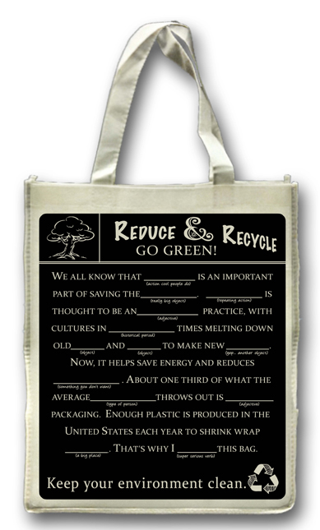

To keep up with evolving student needs and tastes, we’ve made our stores into a campus-wide resource for eco-friendly goods.



Go eco

We encourage our stores to join local campus initiatives to “go green,” and are always exploring and implementing an array of eco-friendly processes.

Second life for furniture and fixtures

We incorporate existing materials, fixtures, and furniture in new store designs whenever possible. But when it’s not, we work with our college partners on plans to reuse items elsewhere on campus or to donate to nonprofits.

* Reusable travel mugs
* CFL light bulbs
* Recycled notebooks
* Sustainable spirit clothing and merchandise
* Recycled, reusable tote bags
* Organic food and snacks
* Graduation gowns made from recycled water bottles

Success story: Your school, your bookstore, your planet

Eco-minded students at the **University of Pennsylvania** got plenty of food for thought last April through the bookstore’s first annual “Sustainability Month.” In honor of Earth Day, the bookstore sponsored a series of fun, educational events to get students engaged for the cause. Ranging from a town hall/debate between the Penn Democrats and College Republicans, to a lecture on locally grown food, to a “Green Festival” with information booths, activities, and music, it helped spark both inspiration and ideas across the campus.

## THE PAPERLESS CLASSROOM

Digital textbooks are more than just an innovative learning tool—they’re also a great way to save trees. All of our stores offer a large and growing selection of digital books. As the industry’s leader, we are committed to driving this initiative and other potential paper-saving applications.

## REDUCE, REUSE…

Used books save students money. They’re also good for the environment, decreasing landfill waste and reducing pollution from the paper production and printing processes required to produce new books. Barnes & Noble facilitates the sale of used books through our comprehensive *Cash For Books* program, which encourages students to sell any books they no longer want.

## SUSTAINABILITY STARTS AT HOME



Our green technology partner



Recyclemania

When our students want to recycle something, they often look to their campus bookstore. Here are just a few initiatives:

* At **Liberty University** bookstore managers collaborate with the local SGA to offer in-store paper recycling.
* At the **University of Pennsylvania’s** in-store café, recycling bins are on hand for the bottles and cans students use.
* Our **Boston University** bookstore equips residence halls with plastic recycling bags that make it easy to tote bottles, cans, and paper to the campus recycling center.

In an ongoing initiative to reduce the volume of paper that we generate at our home office in Basking Ridge, NJ, we use an online reporting tool that eliminates the need to print and circulate monthly P&L and merchandise reports. Our monthly store planner is no longer printed and delivered totally in digital format.This translates to a savings of 312,000 sheets of paper, or 39 trees, each year. We separate and recycle office paper, and have recently teamed up with Office Max to help transition to greener office supplies.

We have paperless invoicing in place with several vendors and have wire payment arrangements with both vendors and colleges to reduce the need to generate printed checks and envelopes.

## Green Technologies

Technology is crucial to our everyday store operations. It also offers a unique opportunity to demonstrate our commitment to green thinking. We’ve already replaced more than 90% of our older desktop computers with newer, more energy efficient models. We have also migrated the majority of our enterprise servers to blade technology to reduce power consumption and cooling requirements. Other initiatives include:

* We’ve partnered with Future Tech Enterprises and Guardian Data, nationwide leaders in technology services, to dispose of obsolete or end-of life computers, peripherals and equipment. Meeting the stringent requirements of the U.S. Department of Defense, their National EPA-Compliant, Non-Landfill Recycling program is recognized as the most effective, secure and environmentally safe asset recycling and disposal service. Bonded and certified technicians perform a 3, 4, or 7-pass DOD overwrite and issue a Certificate of Destruction confirming data has been removed.
* Server Virtualization allows for greater utilization of existing resources. Fewer physical servers are required, saving money both on up-front hardware costs and on maintenance cost. Virtualization allows for the quick creation of different operating system environments enabling the business to run multiple applications and OS workloads on the same server. This virtual environment delivers built-in availability, security and performance across the board from the desktop to the data center. Virtualized servers reduce energy consumption in real time and support the green movement in a significant way.
* Our Data Center is designed as a Dark Room to dramatically reduce energy consumption without sacrificing reliability or service levels. Turning on Power Management features and turning off unused servers increases reliability and up time by reducing stresses on data center power and cooling systems. This lower demand reduces our carbon footprint and the need for expensive infrastructure upgrades.