LSU CAMPUS COMMITTEE ON SUSTAINABILTY (CCS)
SUSTAINABILITY STRATEGIC PLAN
MARCH 2018

GENERAL
- Engage LSU senior administration annually to communicate sustainability progress
- Support and expand Campus Sustainability staff and resources (average in SEC is more than 4.0 FTE)
- Continue the Campus Committee on Sustainability as a mechanism for planning and goal-setting
- Adopt a Sustainability Strategic Plan by October 2017
- Ensure Sustainability goals are included in the Master Plan update
- Participate in the AASHAE STARS rating system
- Update campus-wide greenhouse gas emission inventory annually
- Include and implement sustainability design standards in all new construction and major renovation projects

ENERGY EFFICIENCY & GREEN BUILDING
Goals for 2030:
- Campus-wide 104 energy use intensity (kBtu/sf-yr), a 40% increase in energy efficiency for the campus based on the 2012 baseline
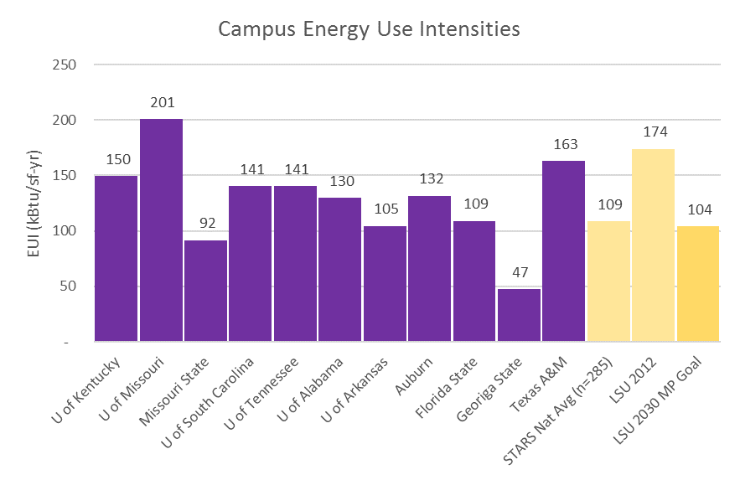
- 5% of overall electricity use with on-site renewable energy generation
- Purchase at least 10% of net electricity demand from renewable sources
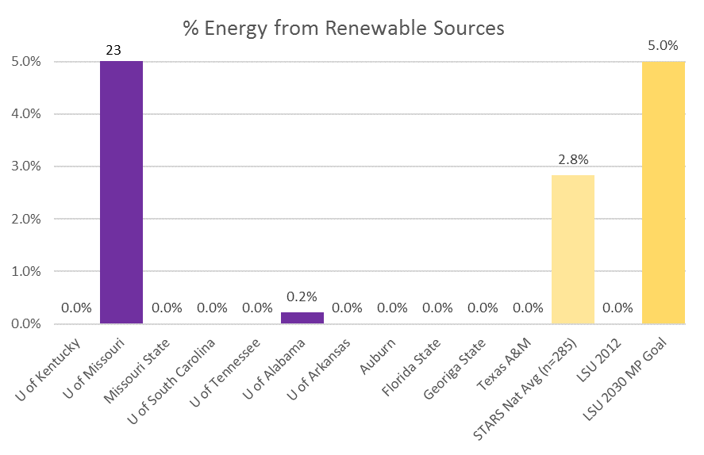
- 30 buildings with at least heating and cooling energy submeters
Strategies:
- Formally sign on to the American College and University Presidents’ Climate Commitment (ACUPCC) – determine net neutrality date and designate committee to work on climate action plan
- Develop a written Energy Conservation Plan for the LSU flagship campus, detailing strategies and a schedule for reducing energy in buildings
- Conduct at least an ASHRAE level 1 audit for existing buildings greater than 25,000 square feet, use to develop targeted lists for efficiency upgrades, to be coordinated with the 2017 Sightlines portfolio report
- Develop an outreach/education program targeting energy use reduction among staff, faculty, and students
- Use the ENERGY STAR Portfolio Manager software to track energy usage in campus buildings, automate meter reading through submetering and building automation systems where possible
- Install submetering on high priority campus buildings
- Conduct at least one energy efficiency competition utilizing benchmarking every year
- Install a public energy dashboard online and in a prominent public lobby
- Achieve the ENERGY STAR certification for buildings for at least 3 office buildings on campus by 2025
- Install solar photovoltaic and thermal systems on the LSU campus to offset conventional electricity usage
- Meet minimum LSU sustainability design requirements for all major capital projects (>5,000 square feet) based on LSU Performance Goals. Meet aspirational requirements for any project identified as a “sustainability feature” project
- Establish a green labs program which encourages best practices for energy conservation in laboratories
- Implement a university-wide IT energy conservation program
- Consider creative funding strategies for energy efficiency projects, using Harvard’s Green Campus Loan Fund as an example
- Explore biomass opportunities combined with sustainable forestry management as a renewable energy source

TRANSPORTATION
Goals for 2030:
- 50% of institution’s fleet non-purely fossil-fuel based*
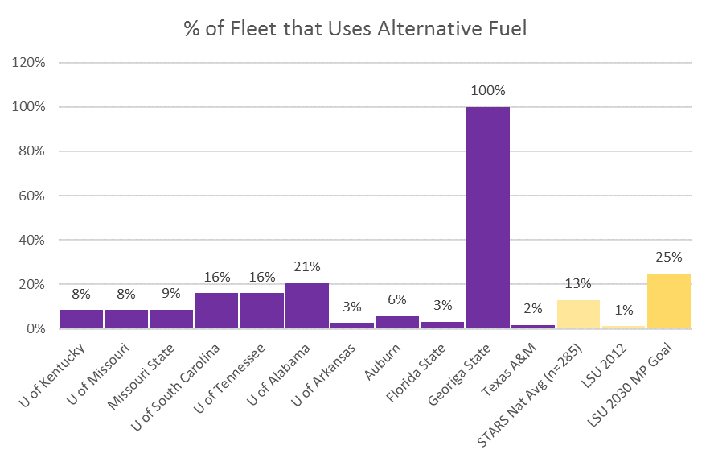
- 50% of students, faculty, staff use sustainable commuting options
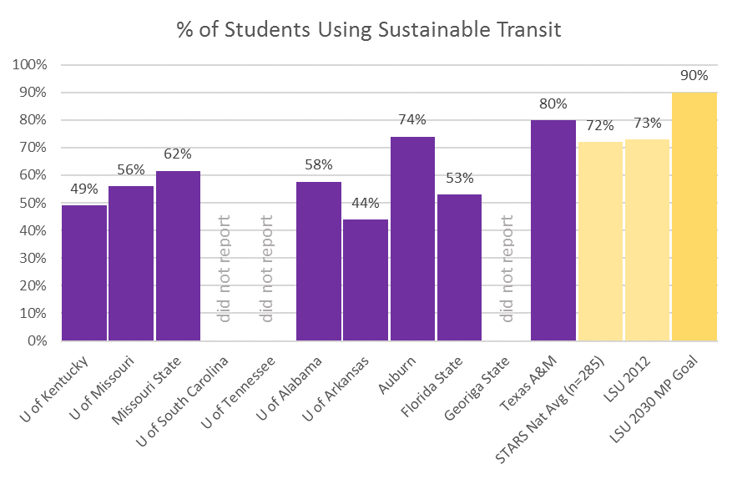

- 50% of faculty and students use sustainable commuting options
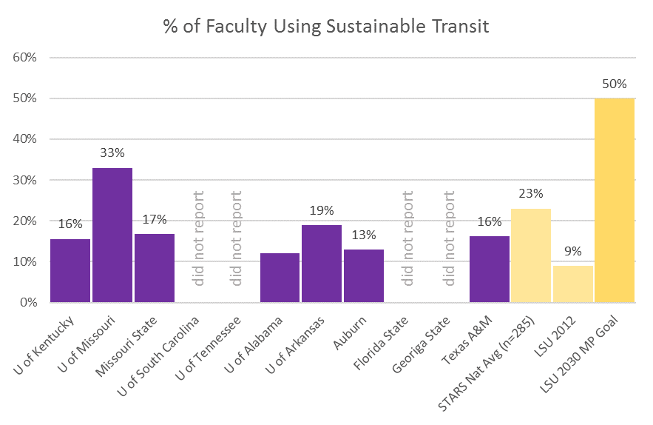

Strategies:
- Continue efforts (e.g. Easy Streets Phase II) to become a more pedestrian-oriented campus and provide safe travel for bicyclists and pedestrians
- Improve bicycle facilities, including the expansion of bike lanes and routes on campus
- Promote awareness among the University community of the environmental, human health, and economic impacts of transportation choices
- Install covered bike storage and shower facilities in new buildings
- Enhance historic core pedestrian experience through adding a “Dismount” signage and bike rack parking along perimeter.
- Support and promote Baton Rouge Bike Share program on LSU campus
- Ensure short term bicycle parking (racks) within 50 feet of all occupied, non-residential buildings. Ensure long term bicycle storage available within 330 feet of all residence halls.
- Achieve Bicycle Friendly University Gold Status from the League of American Bicyclists (Note: Silver status achieved in Fall 2016)
- Decrease the prevalence of single occupancy vehicles on campus through enhanced alternative transportation infrastructure, programs and incentives
- Expand on existing car and rideshare programs available to campus (Geaux Ride, ZipCar)
- Continue to promote the existing electrical vehicle charging stations on campus, and acquire new stations as the number of users grows
- Procure electric vehicles for university fleet
- Continue to switch Tiger Trails fleet to low sulfur diesel and greener technology
- Celebrate National Bike Month annually through campus events or competitions
- Formally track bicycle usage on campus
- Conduct a transportation satisfaction survey with students, faculty and staff
- Increase ratio of bicycle parking to campus population
- Develop a theft prevention program for bicycles
- Develop a formal transportation safety training program for students similar to “my Student body” training (to launch Fall 2017)
- Promote bicycle safety by offering other classes or seminars
- Continue to partner with Bike Baton Rouge to promote bicycling locally and on campus
- Consider financial incentive programs to encourage bicycle use
- Develop alternative transportation education programs for targeted groups on campus
- Get faculty involved with bicycle education
- Convert unnecessary parking lots into pedestrian amenities and open green space.

WASTE REDUCTION & RECYCLING
Goals for 2030:
- 75% of waste diverted (recycled, reused, etc.) from the landfill or incinerator.
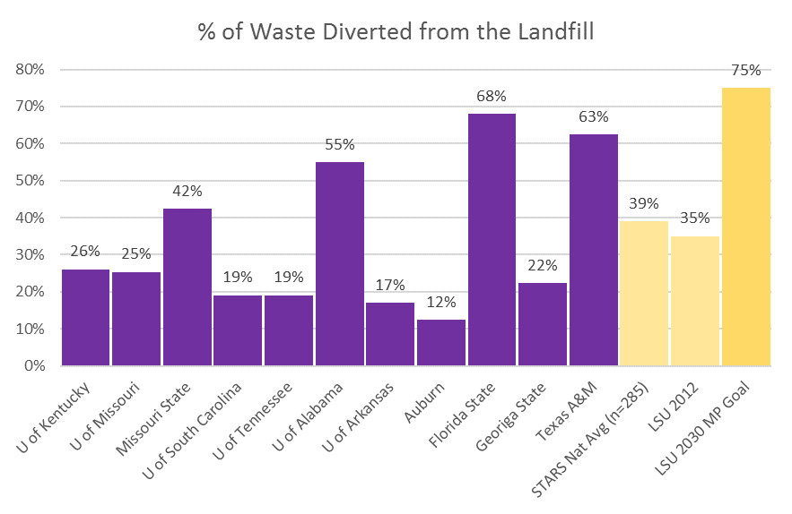
- 90% of construction and demolition materials recycled, donated, or otherwise recovered.
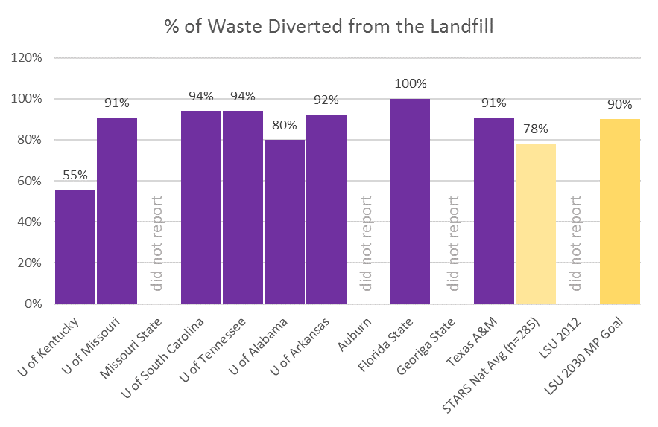
Strategies:
- Develop a campus-wide waste reduction policy, including a comprehensive materials management strategy
- Continue annual educational campaigns (e.g. Litterati, Refills Not Landfills) to reduce waste and increase recycling on campus
- Recycle at least 90% of all construction and demolition waste from projects
- Expand the number of Bigbelly solar units on campus
- Quantify carbon impacts associated with the LSU campus waste stream in order to identify opportunities to better manage waste and reduce emissions.
- Develop a food composting pilot program for Dining Operations. Eventually expand this into other areas such as residence halls
- Develop strategies for improving management of university materials and identify opportunities to utilize recovered materials as inputs for local and non-profit ventures (e.g. a Chuck it for Charity program for Move in/Move out)
- Continue to identify strategies for decreasing waste sent to the landfill as part of game day (football, basketball and baseball) operations
- Continue participating in the GameDay Recycling Challenge each year
- Continue to apply for and receive grants for waste reduction, recycling, sustainability education and awareness programs, and campus beautification

PROCUREMENT
Goals for 2030:
- 25% of total purchases from disadvantaged businesses, social enterprises, and/or local community-based businesses
- 25% of expenditures on cleaning and janitorial products that are 3rd party verified to be healthy and sustainable
  - 2012 AASHE Report for LSU = 9.5%
Strategies:
- Develop University-wide standards for targeted environmentally preferred products by 2019
- Establish a “Product Standards Committee” to pool current data, establish next steps and ultimately issue a master contract that includes standardization for products
- In general, procure commodities that are certified to meet sustainability standards in the areas of paper, electronics, cleaners, lab products, energy and vehicles:
  - Paper and Forest Products:
    - Forest Stewardship Council www.fsc.org
    - Chlorine Free Products Association www.chlorinefreeproducts.org
  - Electronics and Appliances:
    - Continue purchase of Energy Star certified products www.energystar.gov/purchasing
    - Electronic Product Environmental Assessment Tool (EPEAT) - www.epeat.net
  - Green Cleaners and Lab Products:
    - Environmental Choice www.environmentalchoice.com
    - Green Guard www.greenguard.org
    - Green Seal www.greenseal.org
    - Scientific Certification Systems www.scscertified.com
  - Renewable Energy:
    - Green-e www.green-e.org
  - Vehicles
    - Federal Fuel Economy Summary www.fueleconomy.gov

- Reduce waste at point of purchase. Procure recycled content paper, recycled toner cartridges, and items that can be remanufactured, recycled or composted
- Purchase durable and reusable goods
- Use life-cycle cost analysis, rather than automatically choosing goods with the lowest purchase price
- Consider durability and reparability of products prior to purchase
- Invest in goods with extended warranties
- Conduct routine maintenance on products/equipment
- Continue to require ENERGY STAR certified appliances and equipment
- When possible, purchase goods in bulk or concentrated form
- Manage surplus effectively by eliminating excess purchases, reviewing past needs to minimize procurement of unneeded items, and periodically ensuring offices clean out supply cabinets prior to placing new orders
- Ensure all Departments are educated on the resources of both the LSU Surplus Department and the Campus Sustainability office for reuse and recycling of old/unneeded items and equipment

LANDSCAPE & GROUNDS
Goals for 2030:
- 30% reduction of total water use per student
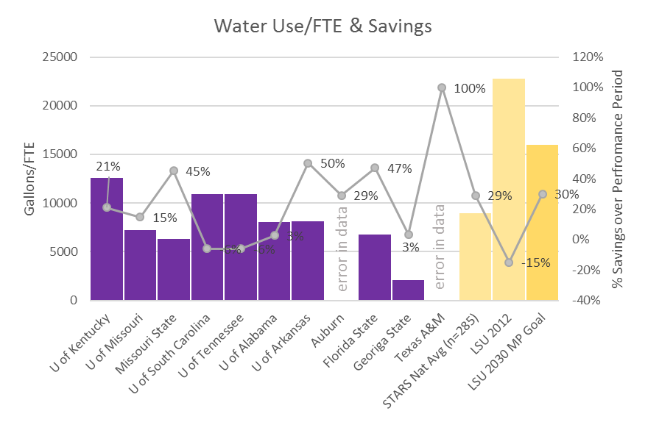
- 5% of water demands met by recycled/reused sources
  - 5% average for universities that report data in AASHE
- 50% reduction of total square footage of pervious surfaces

Strategies:
- Maximize the use of locally-sourced, native plant material that is well suited for the Southeastern Louisiana environment. Such plant material will require less fertilizer, irrigation, or pesticide. Emphasis should be placed upon perennials rather than annuals
- Utilize the widest genetic base among individual species
- Eliminate existing invasive exotic species when possible (e.g. ball moss)
- Include endangered, rare species in plantings to the extent possible
- Include useful plants (e.g., pest deterrents, nitrogen-fixing plants, edibles and medicinals) for pedagogical and practical purposes
- Reduce turf area and monocultures in favor of diverse native ground covers, tree canopies, prairies, understory trees and shrubbery
- Integrate stormwater best management practices (BMPs) into social amenities, transportation infrastructure, and buildings to capture and treat stormwater
- Install green / vegetative roofs to reduce runoff and help buildings cool
- Maintain and update the campus tree inventory on an annual basis
- Support the College of Agriculture Hill Farm Student Research Project if/when needed
- Create signage that provides students, staff, and visitors with opportunities to learn about plant species(uses, functions, details, etc.), as well as planting purposes
- Continue to only use organic fertilizers
- Continue to incorporate integrated pest management practices to deal with seasonal pests
- Continue to work with the LSU Foundation to promote and manage the Endow an Oak program
- Install cisterns for capturing rainwater and reusing on landscape beds, where possible
- Continue to participate in Tree Campus U.S.A. program, and advertise program more with signage, etc.

FOOD

Goals for 2030:

- 75% of dining services food and beverage expenditures that are local and community-based
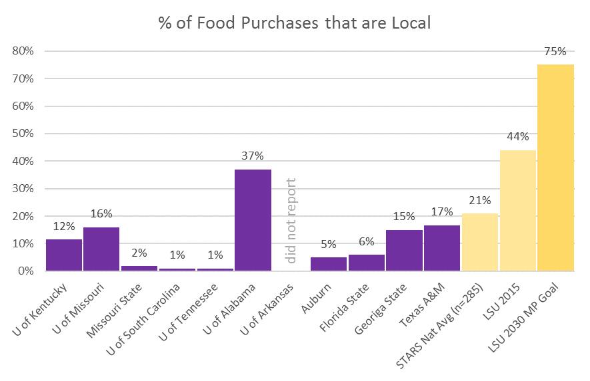
  - 44% in 2015 according to Princeton Review Rankings for LSU
- 25% of total dining services food purchases comprised of sustainably produced animal products

Strategies:
- Continue to support Academic efforts in the development of a Sustainable Agriculture/Food Systems Minor and Major
- Continue to support the Hill Farm Student Research Project, in which fresh/local food is grown on the LSU campus
- Campus Sustainability continue its formal partnership with the Hill Farm Student Research Project
- Continue to expand edible landscape program, such as Student Government satsuma tree groves
- Develop a campus composting pilot program to compost food from Dining waste
- Expand the “trayless” dining program by converting all dining halls to a plate- only dining experience. Market to both current and prospective students the sustainable choice of this program
- Continue to promote “Refills Not Landfills” Campus Sustainability program (in conjunction with grant from Keep Louisiana Beautiful) past the grant period to encourage campus community to reuse containers
- Provide discounts to patrons who use reusable bottles and containers
- Phase out Styrofoam use on campus
- Revamp to-go boxes with durable plastic containers that can be returned for cleaning in exchange for tokens, payment, etc.

