|  |  |  |
| --- | --- | --- |
| SUNY, College at Oneonta Greenhouse Gas Inventory | 2013 | |
| Prepared by sustainability Intern  Crystal Wyllie, Spring 2015 | | SUCO%20Seal.jpg |

**Table of Contents Page**

**Introduction 3**

**Key Terms 4**

**Part I: Carbon calculator 4**

**Part II: Data Collection & Results 5**

**Part III: Comparative Analysis 11**

**Part IV: Recommendations 14**

**Part V: Conclusion 15**

**Introduction**

*“…we can s6rive to expand our college’s commitment to sustainability in all of our activities…Sustainability should infuse our teaching and learning, our construction, maintenance, and landscaping, the food we eat, and the way we use resources.” -Nancy Kleniewski, 20th President of SUNY, College at Oneonta, 2008.*

As part of SUNY Oneonta’s growing commitment to sustainability, a decision was made in 2008 by Dr. Nancy Kleniewski, 20th President of SUNY, College at Oneonta, to conduct a complete greenhouse gas (GHG) inventory and calculate Institutional emissions using the Clean Air-Cool Planet Campus Carbon Calculator. This tool is recommended by the American College and University Presidents Climate Agreement (ACUPCC).

The 2008 GHG Inventory was used as a first step in developing a Climate Action Plan for SUNY Oneonta under the President’s Sustainability Task Force. The Sustainability Task Force, formed in 2008 and chaired by Thomas Rathbone, Associate Vice-President of Facilities, was created to consolidate all SUNY Oneonta sustainability efforts and is the supervisory and consulting body for this project. This baseline data would enable SUNY, College at Oneonta to compare itself to other similarly sized campuses in New York.

In fall 2009, students Katherine Ogut and Maribeth Rubenstein were hired as project Interns and charged with the task of gathering emissions data for the year 2008. The project was directly supervised by Thomas Rathbone and Dr. Gina Keel, Assistant Professor of Political Science. The authors of the 2008 report found that SUNY Oneonta’s overall carbon emissions for 2008 were 33,725.50 eCO2. This report was intended to be used as a template as well as provide valuable baseline data for future greenhouse gas (GHG) Inventory projects.

This report documents the methodology, raw data, and analysis for SUNY Oneonta’s Green House Gas Inventory for 2013. The total carbon emissions for SUNY Oneonta in 2013 were found to be 36,589.90 eCO2. This is 2,864.40 eCO2 more than the 2008 report’s value of 33,725.50 eCO2. The greatest impact on total emissions for 2013 was from scope 2, which includes purchased electricity. Scopes 1 and 3 contributed nearly equal amounts to the college’s total carbon emissions.

The 2013 Green House Gas Inventory Report includes key terms, contact information for data sources, and comprehensive analysis for all data. The author took into consideration many of the recommendations for improving methods that were made in the 2008 GHG report. Throughout this report each scope is broken down so that all raw data can be viewed and interpreted. This report also includes a detailed description for using the Clean Air-Cool Planet Carbon Calculator. The author of this report hopes that the compiled data from this report as well as the 2008 inventory will serve to further sustainability on SUNY Oneonta campus for years to come.

**Key Terms:**

Greenhouse Gas: A greenhouse gas (sometimes abbreviated GHG) is a gas in an atmosphere that absorbs and emits radiation within the thermal infrared range. This process is the fundamental cause of the greenhouse effect. The primary greenhouse gases in Earth's atmosphere are water vapor, carbon dioxide, methane, nitrous oxide, and ozone.

eCO2: CO2 Equivalents. A metric measure used to compare the emissions from various greenhouse gases based upon their global warming potential (GWP). Carbon Dioxide equivalents are commonly expressed as “metric tons of carbon dioxide equivalents (MTCDE).” The carbon dioxide equivalent for a gas is derived by multiplying the tons of the gas by the associated GWP. (MTCDE= (million metric tons of gas) * (GWP of the gas)).

Emissions coefficient: A unique value for scaling emissions to activity data in terms of a standard rate of emissions per unit of activity. Any gas that absorbs infrared radiation in the atmosphere.

**Part I: Carbon Calculator**

Clean Air-Cool Planet is an organization dedicated to “finding and promoting solutions to global warming.” In order to aid institutions in evaluating their carbon footprint this organization created the Campus Carbon Calculator.The calculator is a Microsoft Excel-based spreadsheet tool that is used to investigate sources of emissions on college campuses. Sources of emission are categorized into three major areas or “Scopes”.

* **Scope 1** - includes all direct sources of GHG emissions from sources that are owned or controlled by your institution, including (but not limited to): production of electricity, heat, or steam; transportation or materials, products, waste, and community members; and fugitive emissions (from unintentional leaks).
* **Scope 2** - includes GHG emissions from imports of electricity, heat or steam – generally those associated with the generation of imported sources of energy.
* **Scope 3** - includes all other indirect sources of GHG emissions that may result from the activities of the institution but occur from sources owned or controlled by another company, such as: business travel, outsourced activities and contracts, emissions from waste generated by the institution when the GHG emissions occur at a facility controlled by another company, e.g. methane emissions from landfilled waste, and the commuting habits of community members.

These scopes are further broken down into areas such as

* On Campus energy production
* Purchased electricity
* Transportation
* Waste
* Agriculture
* Refrigerants

Emissions may be modified by “offsets” such as composting, forest preservation and purchased green credits.

The process of the calculator begins with data collection. This process involves working with various departments and campus staff to compile the necessary raw data to enter into the calculator. The software uses a combination of formulas, conversion factors (coefficients) and emission factors to calculate the final emission totals.

The calculator then reports this data in graph, chart and spreadsheet form. These results provide in depth insight about specific sources of emissions. The analysis is based on this output.

**Part II: Data Collection and Results**

Institutional Data

Building physical size information was provided by **Philip Bidwell, Facilities and Safety IT Specialist.**

|  |  |
| --- | --- |
| Total Building Space | 1,955,909 sq. feet |

Budget information was provided by **Julie Roseboom, Budget Control Officer**.

|  |  |
| --- | --- |
| Operational Budget | $ 108,500,000 |
| Research Budget | N/A |
| Energy Budget | N/A |

Population

Population information was provided by **Ernesto Henriquez, Enrollment** **Management**.

|  |  |  |
| --- | --- | --- |
| Population | # | Weeks on Campus |
| Full-time Students | 5,808 | 33 |
| Part-time Students | 226 | 33 |
| Summer Enrollment | 535 | 5-12 |
| Faculty | 493 | 33 |
| Staff | 664 | 52 |

Scope 1

Information regarding refrigerants, residual oil, fertilizers, university fleet, and natural gas was provided by **Hannah Morgan, Sustainability Director.**

|  |  |
| --- | --- |
| Scope 1 |  |
| Refrigerants | 280 lbs |
| LPG (Propane) | 15,312 gallons |
| Residual Oil (#5-6) | 990 gallons |
| Fertilizers | 13,227 lbs. |
| University Fleet | 37,900 gallons |
| Natural Gas | 199,451 MMBtu |

Scope Two

Purchased Electricity information was provided by **Hannah Morgan, Sustainability Director.**

|  |  |
| --- | --- |
| Purchased Electricity | 24,876,750 kWh |

NYISO is the organization that provides the New York State grid with electrical energy. Due to the fact that SUNY Oneonta does not generate any electrical power on campus, the purchase of all electricity is a market-based, SUNY Central decision. This grid-purchased power is generated from a variety of sources including natural gas, biomass, and fossil fuels.

The custom fuel mix option was used in the spreadsheet. The first step in determining the custom fuel blend was finding the campus location in the NYISO zone system. SUNY Oneonta is located within Zone E. The percentages of each generation source of the overall amount of electricity (MW) purchased by Zone E were calculated.

|  |  |
| --- | --- |
| Source | % |
| Fuel Oil | 22 |
| Natural Gas | 55 |
| Biomass | 18 |
| Other | 5 |

Scope Three

Commuter Data was provided by **Philip Sirianni, PH.D Assistant Professor of Economics**. Calculations were made based on the following estimates: students live within a five-mile radius, faculty live within a 25-mile radius and staff live within a ten-mile radius.

|  |  |
| --- | --- |
| **Students** |  |
| Number of students with commuter passes | 1,766 |
| Average Trips/Week | 10 |
| Average Weeks/Year | 33 |
| Average Miles/Trip | 5 miles |
| **Faculty** |  |
| Number of Faculty with commuter passes | 1082 (buying an average of 2-3 decals) |
| Average trips/ week | 10 |
| Average weeks/year | 35 |
| Average miles/trip | 25 miles |
| **Staff** |  |
| Number of Staff with commuter passes | 796 (buying an average of 2 decals) |
| Average trips/week | 10 |
| Average weeks/year | 52 |
| Average miles/trip | 10 miles |

Public transit data was provided by **Bonnie Robinson, Administrative Assistant**. This information is from the SA financed OPT bus route. Mrs. Robinson provided a “Route Summary Report” from January 1, 2013 thru December 31, 2014. This document tabulated the number of card swipes per day on the SUCO Day and night bus routes. The average number of swipes per day and night (assumed 2 swipes per student per day) were used to calculate the percentage of student bus riders of the total number of students.

|  |  |
| --- | --- |
| % of students that ride the bus | 13% |
| Average trips/week | 10 |
| Average weeks/year | 33 |
| Average miles/trip | 7.2 miles |

Directly financed outsourced travel information was provided by **Terri Thomas, Airfare Coordinator, Accounting**. Calculations for bus, train, and taxi and rental car mileage were estimated using MapQuest.

|  |  |
| --- | --- |
| Air Travel | 908,421 miles |
| Train | 1,200 miles |
| Taxi/Rental Car | 68,800 miles |
| Bus | 417,480 miles |

**Katie Bronk, Coordinator of Study Abroad**, provided the student air mileage.

|  |  |
| --- | --- |
| Study Abroad Travel by Students | 908,421 miles |

Solid waste information was provided by **Hannah Morgan, Sustainability Director.** Solid waste is disposed of in a privately owned landfill that does not capture and use methane.

|  |  |
| --- | --- |
| Solid Waste | 857 Tons |

A short ton is a unit of weigh equal to 2000 lbs.

**Emissions by Scope**

The following chart contains information that was calculated by multiplying raw data by co-efficients.

|  |  |
| --- | --- |
| **Scope 1** |  |
| Residual Oil (#5-6), Natural Gas, and Propane | 10,695.8 MT eCO2 |
| Direct Transportation | 467.1 MT eCO2 |
| Refrigerants & Chemicals | 229.9 MT eCO2 |
| Fertilizers | 33.3 MT eCO2 |
| **Scope 2** |  |
| Purchased Electricity | 14,030.1 MT eCO2 |
| **Scope 3** |  |
| Faculty & Staff Commuting | 5,832.7 MT eCO2 |
| Student Commuting | 1,232.3 MT eCO2 |
| Directly Financed Travel | 26.1 MT eCO2 |
| Study Abroad Travel | 461.7 MT eCO2 |
| Solid Waste | 2,656.7 MT eCO2 |

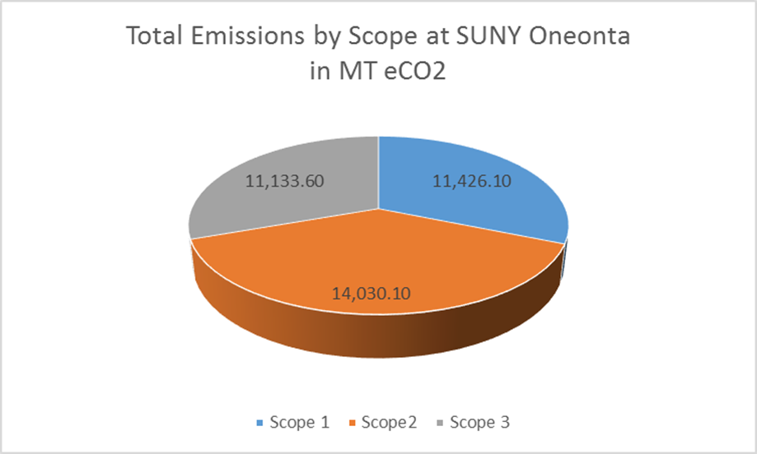

**Figure 1.** Amount of MT eCO2 emissions by scope.

Scope 2 had the largest impact on overall emissions for SUNY Oneonta.

**Part III: Comparative Analysis**

To create a comparative analysis of SUNY Oneonta’s emissions, below there are data from several New York State colleges. These campuses share geographic proximity and similar enrollment data with SUNY Oneonta.

|  |  |  |  |  |
| --- | --- | --- | --- | --- |
| **College** | **Location** | **Full-Time Enrollment** | **Gross Square Foot of Building Space** | **Total Air Mileage Emissions** |
| **Cornell University\*** | Ithaca, New York | 21,087 | 15,805,000 sq ft. | 29,841 MT eCO2 |
| **Buffalo University\*** | Buffalo, New York | 28,119 | 11,186,689 sq ft. | 14,061 MT eCO2 |
| **Binghamton University** | Binghamton, New York | 14,160 | 5,618,087 sq ft. | 1,082.5 MT eCO2 |
| **SUNY Oneonta** | Oneonta, New York | 5,808 | 1,955,909 sq ft. | 461.7 MT eCO2 |
| **SUNY Geneseo\*** | Geneseo, New York | 5,274 | 2,340,581 sq ft. | 293 MT eCO2 |
| **Colgate University** | Hamilton, New York | 2,927 | 2,310,726 sq ft. | 3,681 MT eCO2 |
| **SUNY ESF\*** | Syracuse, New York | 2,191 | 1,122,972 sq ft. | 491.86 MT eCO2 |

|  |  |  |  |  |
| --- | --- | --- | --- | --- |
| **College** | **Scope 1** | **Scope 2** | **Scope 3** | **Total Gross Emissions** |
| **Cornell University\*** | 165,166.00 | 17,497.00 | 41,987.00 | 224,650.00 |
| **Buffalo University\*** | 34,352.00 | 61,226.00 | 43,292.00 | 138,870.00 |
| **Binghamton University** | 24,699.40 | 14,179.70 | 12,039.20 | 50,918.30 |
| **SUNY Oneonta** | 11,426.10 | 14,030.10 | 11,133.60 | 36,589.90 |
| **SUNY Geneseo\*** | 10,280.00 | 12,199.00 | 5,375.00 | 27,854.00 |
| **Colgate University** | 5,891.80 | 1,806.00 | 5,694.00 | 13,391.80 |
| **SUNY ESF\*** | 744.37 | 6,862.65 | 2,789.24 | 10,396.26 |

**Figures 2-3.** All Information was provided by **Second Nature Reporting System**.

All data was obtained from 2013 reports, unless otherwise noted.

*Data obtained from 2014 reports

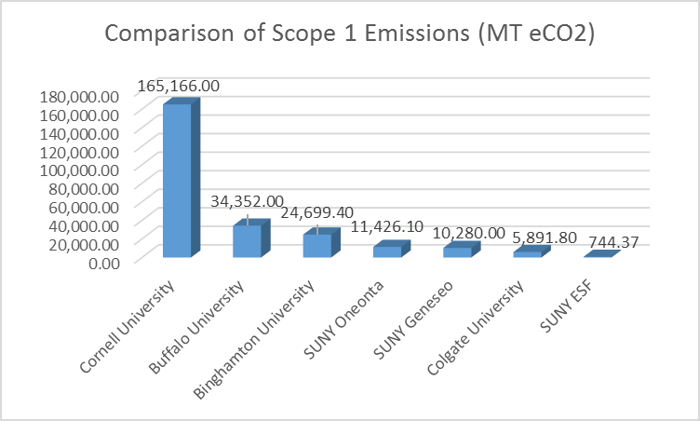

**Figure 4.**

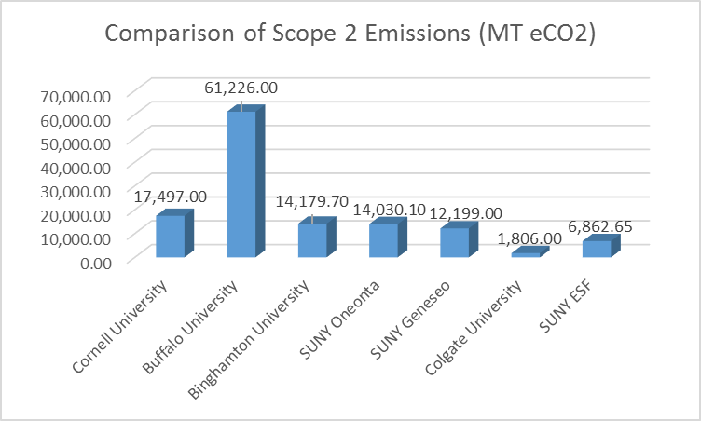

**Figure 5.**

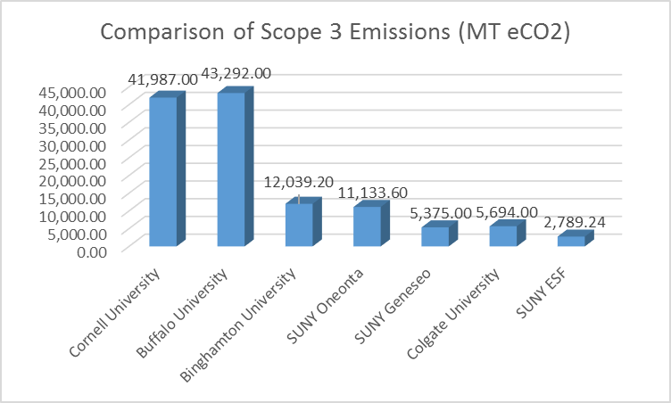

**Figure 6.**

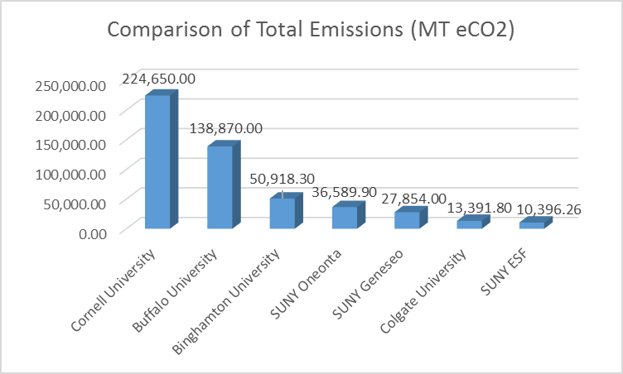

**Figure 7.**

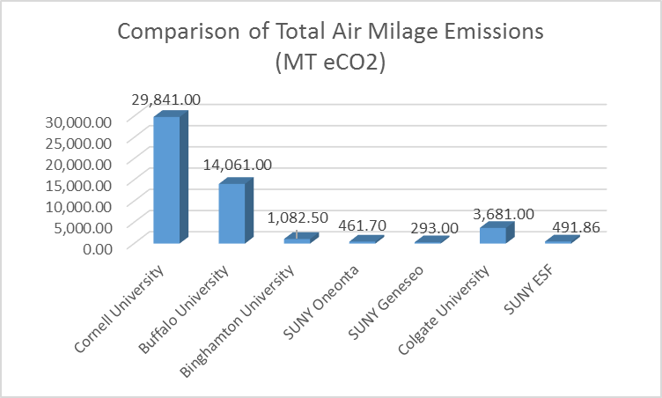

**Figure 8.**

**Part IV: Recommendations for Improving Methods**

Throughout the process of constructing this report, the Carbon Calculator itself was simple to use, however the categories are quite specific and the data needed to get accurate results proved somewhat challenging to obtain.

With using the Carbon Calculator there needs to be room for some prevalent sources of error. The calculations that were made regarding commuter travel were based on generalized assumptions. A commuter survey was utilized by Dr. Philip Sirianni but this only accounted for a fraction of the student body, faculty and staff. Based on the survey data and number of commuter passes issued through the college we were able to estimate our final calculations. It is difficult to gather more accurate information in this category because it is individually based. The use of a larger scale survey would be recommended for future reports.

The most tedious coefficient to calculate in the report was Air Travel. This required manually going through pages of school records that log cities that were traveled throughout the year by both students and faculty and calculating each individual trip’s mileage. After each individual trip’s mileage was complete, they were multiplies by the number of trips taken that year, and how many students and faculty attended. This process resulted in our final calculation for the report. This was the most difficult aspect of the report to complete. The author recommends that the calculations be done over time and double checked to minimize chances of error.

**Part V: Conclusion**

The Carbon Calculator gave insight to SUNY Oneonta’s overall carbon footprint and which aspects of life these emissions are coming from. This report allows us to view each how each scope contributes to our total emissions as a campus. Comparing SUNY Oneonta’s total emissions with other New York State institutions also allows us to see how efficient the college is relative to our student body and the square footage of our campus.

All factors regarding SUNY Oneonta’s carbon footprints can be improved in simple ways such as using organic fertilizers, composting our food waste, and insuring that the campus’s building are well insulated to minimize heating. Education and awareness are going to play a huge role in lessoning factors such as individual commuter mileage and solid waste. Encouraging the student body to utilize the Oneonta Public transit system and to recycle will have a positive impact on lowering the college’s carbon emissions.

SUNY Oneonta’s greatest factor towards its overall emissions was in scope 2, purchased electricity. The university can do serval things to lower its consumption of electricity. Installation of motion sensor lights in all the restrooms and hallways on campus would have a great impact on lowering our electricity consumption. Another way to lower consumption would be to have the outdoor campus lights switched to partial solar power. The campus could also take a more drastic measure and set a light curfew for all strictly academic buildings, this way all lights would be shut off after a certain hour until the building is opened again the following morning. These changes would make an exceptional leap towards sustainability for the college.

Thanks to Hannah Morgan, the Sustainability Director for SUNY Oneonta, the college has already made huge improvements. With recycling, composting, and water runoff projects in place, SUNY Oneonta is making great progress to become more sustainable. The University is currently working towards a solar panel installation on campus that would help meet energy demands and cut our carbon emissions drastically.

With the collective data of the 2008 and now the 2013 Green House Gas Inventory for SUNY Oneonta College, there is a better understanding of what adjustments need to be made in order to improve our efficiency and reduce emissions. Future reports will enable SUNY Oneonta to continue to make strides towards becoming a more sustainable university.