February 12, 2021

STARS Steering Committee
Association for the Advancement of Sustainability in Higher Education
213 ½ North Limestone
Lexington, KY 40507

Dear STARS Steering Committee:

Lehigh University is deeply committed to institutionalizing sustainability throughout the university. Our sustainability efforts are intentional and inventive. The teaching, research and service enacted by members of our campus community contribute to a deeper understanding of our environment and of our responsibilities to it. The methods with which we manage our daily operations reflect the integration of just, equitable, and economically and environmentally responsible solutions into our internal practices. Campus-community partnerships foster a culture that supports sustainability efforts both here on South Mountain and beyond. As you review our report, you will find the data reflects our commitment and progress. We embrace our obligation to create a campus that merges environmentally responsible solutions with just and equitable practices.

As president of Lehigh University, I am confident our score accurately represents the sustainability efforts and values of Lehigh University from July 1, 2019 - June 30, 2020.

Sincerely,
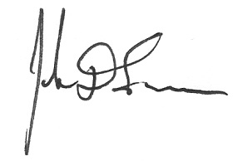
John D. Simon
President, Lehigh University

