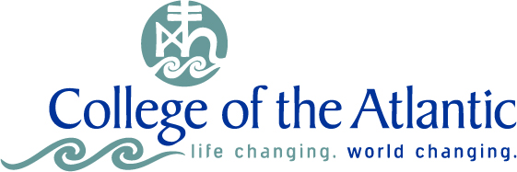

COA Green Cleaning Guidelines

College of the Atlantic has been committed to green products for cleaning and maintenance since its founding. Such practices are intrinsic to the spirit of our campus and community and are fundamental to environmental sustainability. All cleaning products are purchased by a dedicated Buildings and Grounds staff member. These guidelines articulate existing practices and document procedures for present and future COA staff, faculty and students.

In support of COA’s mandate to reduce unnecessary chemicals on campus, reduce our environmental impact, and increase human health and safety on campus, College of the Atlantic continues to actively pursue environmentally friendly cleaning products, recycled and post-consumer paper products, and non-toxic wax and painting products.

- Whenever possible, COA will procure green seal certified cleaning products.

- COA has a long-standing relationship with our supplier, and will continue to foster such relationships, ensuring that as new green cleaning products become available, or as others are taken off the market, we have an industry connection to help facilitate continuity of procurement.

- In accordance with the Wood and Paper Products Procurement Policy, COA will purchase post-consumer, recycled, or tree-free paper products.

