**The Brumbaugh Scholars Showcase**

Please join us in **November 2021** (date to be determined) for student presentations by the 2021 Brumbaugh Scholars, as well as any other students funded by the Brumbaugh Endowment, on their summer research and results.

**For more information**

If you have any questions regarding the 2021 Brumbaugh Scholars program or the Nature Center, please contact Adam Zorn, Program Manager at the Nature Center ([zornas@mountunion.edu](mailto:zornas@mountunion.edu)) or Dr. Chris Stanton, Director of the Nature Center ([stantorc@mountunion.edu](mailto:stantorc@mountunion.edu)).

 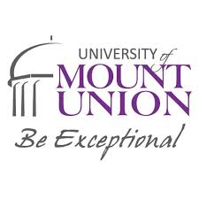

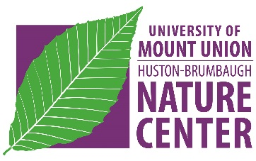**SUMMER 2021 BRUMBAUGH**

**SCHOLARS PROGRAM**

at the Huston-Brumbaugh

Nature Center

**Paid Research Opportunity for Students**

The John T. Huston – Dr. John D. Brumbaugh Nature Center has allocated resources from the Brumbaugh Endowment to foster **research and scholarly activities** among students, staff, and faculty that are related to the mission of the Nature Center, which is to “*provide and support opportunities for enjoying and learning about our natural and cultural heritage.”*

In keeping with that mission, the Nature Center is pleased to invite proposals from **current** **students** at the University of Mount Union to conduct **summer projects**. Student proposals from **any discipline or area of interest** are welcomed and encouraged.The unifying elements of appropriate research or other projects are:

1. **Place-based**. The project should relate to the natural and cultural heritage of northeastern Ohio and be explicitly related to the Huston-Brumbaugh Nature Center and its mission.
2. **Student-centered**. The intent is to provide students with opportunities to engage in meaningful hands-on activities that complement their classroom education.
3. **Collaborative**. Students should identifyaMount Union faculty or staff member who will serve as the project **mentor**. Each project should allow students and mentors to work together in ways that provide genuine experiential learning for the student while also allowing the mentor to further their own scholarly or professional interests.

Summer 2021 Student proposals are due **Friday, January 22, 2021.** **Proposal forms** can be requested from the Nature Center by sending an email to [naturecenter@mountunion.edu](mailto:naturecenter@mountunion.edu).

**Brumbaugh Scholars**

Students who would like to be considered for this program will be selected based on their proposal and possibly an interview with the Selection Committee. Each proposal should identify a faculty or staff member who is interested in working with the student on the project. If selected, students are expected to commit to a minimum of **eight weeks** of work during the summer and develop a schedule that is mutually agreeable to both them and their mentor. A maximum of four students will be supported through a combination of hourly pay and a stipend **up to $3000/student** (based on the number of hours worked). All Brumbaugh Scholars are required to give a final presentation of their work. Final decisions will be announced in **March 2021**.

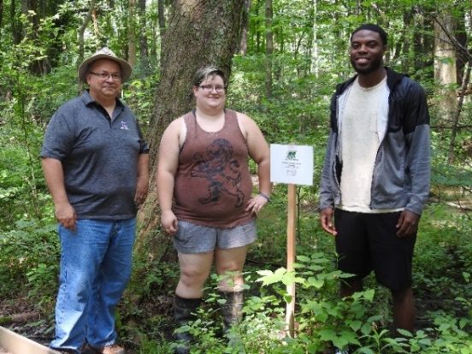

**Brumbaugh Mentors**

Brumbaugh Mentors are expected to work collaboratively with their mentee(s) during the summer—meeting on a **regular basis** and participating in an end-of-the-season **Scholars Showcase** (usually held in November at the Nature Center). Mentors are also encouraged to help their students present their work as a Scholar Day presentation, a formal presentation at a conference, and/or a publication.

Mentors will receive a **stipend of $3000** (regardless of the number of students supervised) payable in two installments—half at the end of June 2021 and the other after the Scholars Showcase presentation. Any equipment purchased for the project with Nature Center funds will remain the property of the Nature Center.

**Nature Center Facilities and Opportunities**

The Huston-Brumbaugh Nature Center includes **285 acres** of forests, fields, ponds, and gardens located just six miles south of campus. The **Visitors Center** includes laboratory space, a library, and a bird observatory. This property has nearly 5 miles of trails and is open to the public free of charge.

In 2019 and 2020, 100 acres were purchased adjacent to the Nature Center to serve strictly as a **Research Reserve** for use by University of Mount Union students, staff, and faculty. This property does not have marked trails and is not open to the public. Habitats found on the property include forests, agricultural fields, vernal pools, and an intermittent stream.

The **Ball Research Forest** is a separate property located in the southern, unglaciated portion of Stark County near Waynesburg, Ohio. This woodlot is 23 acres of mixed forest types and is also available for Brumbaugh Scholars projects.

**Past Projects**

Some examples of past Brumbaugh Scholars projects include:

• *A History of Agriculture and the Brumbaugh family in the Region* (Dept. of History)

• *Calling Frog and Toad Survey at the Huston-Brumbaugh Nature Center* (Dept. of Biology)

• *Paintings Inspired by the Huston-Brumbaugh Nature Center* (Dept. of Art)

• *Place, Purpose, Peace: Discovering Self and Community at the Huston-Brumbaugh Nature Center* (Dept. of Philosophy & Religious Studies)

• *The Presence of Agricultural Pollutants Utilizing Water & Soil Testing and Indicator Species* (Dept. of Earth & Environ. Science)