Sustainable Buildings

Home » Belmont Goes Green » Sustainable Buildings

Wedgewood Academic Center

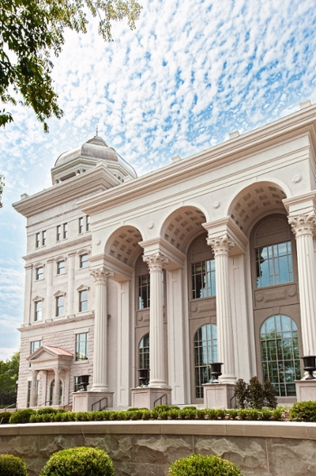
The Wedgewood Academic Center, home to Belmont’s College of Liberal Arts and Social Sciences, College of Sciences and Mathematics and College of Theology and Christian Ministry, was designed and constructed using sustainable practices to help reduce its environmental impact. The building is Platinum LEED certified, making Belmont the first University in Tennessee and the first LEED for New Construction project in Nashville to achieve that level, the highest in the feature-oriented rating system that awards buildings for satisying specific green building criteria.
The Center's sustainable features include:
- An underground parking garage to reduce the urban heat island effect and preserve green space
- Charging stations and parking spaces for car/vanpool and fuel efficient and low emitting vehicles
- Educational and sustainable green roofs
- High-efficiency plumbing fixtures to optimize water savings at an expected rate of 66,000 gallons each year
- Light-emitting diodes (LEDs) that drastically reduce energy usage
- An active chilled beam system that reduces heating and cooling energy and is one of the only HVAC systems of its kind in Nashville
- More than 75 percent of the waste generated during construction was recycled, diverting over 900 tons of waste from local landfills.
- An irrigation system that collects water run-off in underground tanks, comparable in size to Olympic size swimming pools, that is re-used for irrigation and water feature purposes

Randall and Sadie Baskin Center

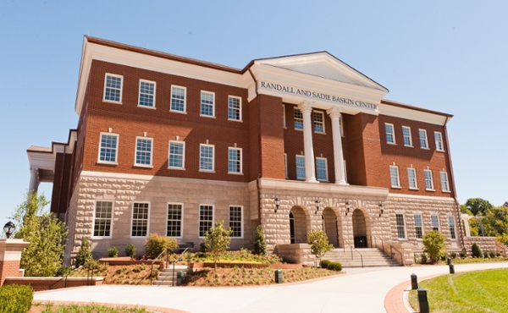
The Gold LEED Certified Baskin Center, a $32 million building, houses the College of Law and features a furnished trail courtroom with state-of-the-art AV equipment, a two-story law library, more than a dozen classrooms, an appellate courtroom and a Grand Lobby Rotunda area. According to information provided by the U.S. Green Building Council, the Baskin Center is the largest LEED certified university academic building in Middle Tennessee and the first LEED certified law school building in the state.
The Center's sustainable features include:
- An underground parking garage to reduce the urban heat island effect and preserve green space
- Charging stations and parking spaces for car/vanpool and fuel efficient and low emitting vehicles
- High-efficiency plumbing fixtures, a drip irrigation system and moisture sensing devices to optimize water savings at an expected rate of 165,000 gallons each year

Dickens Hall

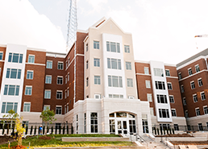In 2011 Belmont built Dickens Hall, a 295-bed residence hall and 560-car parking garage in the Bruin Hills Apartment area, as part of a continuing effort to provide on-campus living experiences for students.
The Hall's sustainable features include:
- A variable flow refrigerant HVAC system
- Generous day lighting to reduce energy costs
- Motion sensors on residence room lighting
- Energy efficient lighting and appliances

McWhorter Hall

McWhorter Hall is a 90,000 square foot facility that is home to Belmont’s College of Pharmacy, College of Physical Therapy and Department of Psychological Science. McWhorter Hall is the Project Innovations 2011 Merit Winner for New Construction.
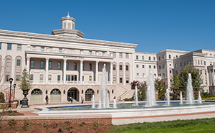The Hall's sustainable features include:
- The only large extensive green roof on an educational facility in Nashville, serving several purposes including a reduction in the heat island effect, natural habitats for wildlife, pollution reduction and irrigation usage
- A 20,000 gallon water storage tank, which has the ability to capture excess ground and storm water for recycling and irrigation that would otherwise be pumped into the storm system
- A total footprint, including the four-story underground garage, of less than an acre

Dining and Academic Complex

Belmont’s Dining and Academic Complex is an $80 million facility that, upon completion, will be home to the campus dining facility, Curb College of Entertainment and Music Business, programs in media studies and one of the University’s newest majors, motion pictures. The 134,000 square foot building sits atop a 1,000+ -space parking garage and will provide students with a number of additional technological opportunities including 30 student edit bays, multiple computer labs, a motion capture facility, a Foley/ADR sound studio, a color correction studio and a video/broadcast studio, among others.
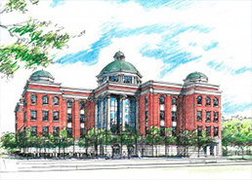The Complex's sustainable features include:
- A pending LEED certification application
- A geothermal heating and cooling system that uses the Earth's natural temperature to regulate interior climate, expected to yield a savings of 40 percent in overall energy costs
- A composting system that converts food and cardboard waste into enriched soil additives through large dehydrators, reducing overall waste from food operations by 45 percent

