|  |
| --- |
| Mobile Action Plan |
| Infrastructure Planning & Facilities @ Michigan State University |
| Synopsis: Best Achievement in Operational Excellence to deliver Business Transformation category. IPF identified (3) primary objectives in the 2016 strategy retreat: 1. Provide employees unprecedented access to information integral to the daily decision-making process. 2. Deployment of mobile platforms and an interconnected environment to advance IPF’s service level agreements through evidence-based strategies. 3. To create a more robust knowledge management system to modernize business processes. Business leaders increasingly seek to build a digitally interconnected environment for the workforce to promote interaction among team members across time and distance to reduce waste-in-process. When properly planned and meticulously implemented, the results can increase shared learning to turn “one-off” improvements into repeatable, systematic approaches. Technology when implemented with action analytics and evidence-based decision making will advance culture, improve results, and foster innovation. The facilities organization at Michigan State University is becoming a leader by deploying over 1,400 mobile devices empowering the front-line workforce with access to information at their fingertips to make better informed daily decisions. The six-part action plan spanning 2.5 years is 60% complete and the results to date are transforming how the facilities organization manages work, communicates with the customer, and engages employees. Over (50) business process changes have been documented to date and an initial $1.2 million investment is forecasting a $763,000 return on investment within the first year of implementation. |
|  |

**MICHIGAN STATE UNIVERSITY**

**OPERATIONAL EXCELLENCE NOMINATION**

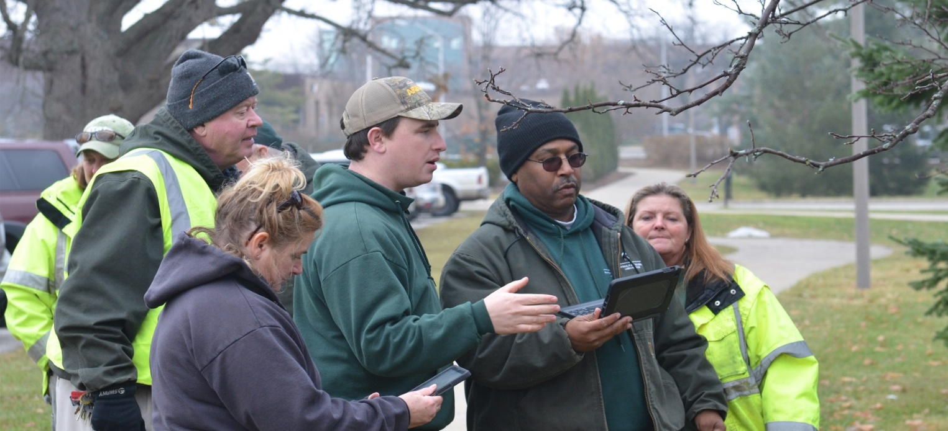

## **Strategic Objectives Alignment –** The IPF organization is a part of the Administrative Services supporting the mission of the university. Organizations must respond and adapt to changes in their environment to continue to be relevant, resilient, and sustainable. Universities are no exception and in fact should be leaders demonstrating the adoption of technological advances in meeting their mission. One of the Bolder by Design’s imperatives for the university is to “advance our culture of high performance”.Each business unit identifies through its strategic planning how it will align with this university imperative. Figure 1-1 provides an overview of how IPF is adapting this philosophy in its operations to advance a high-performance and embedding a sustainable culture throughout the organization.

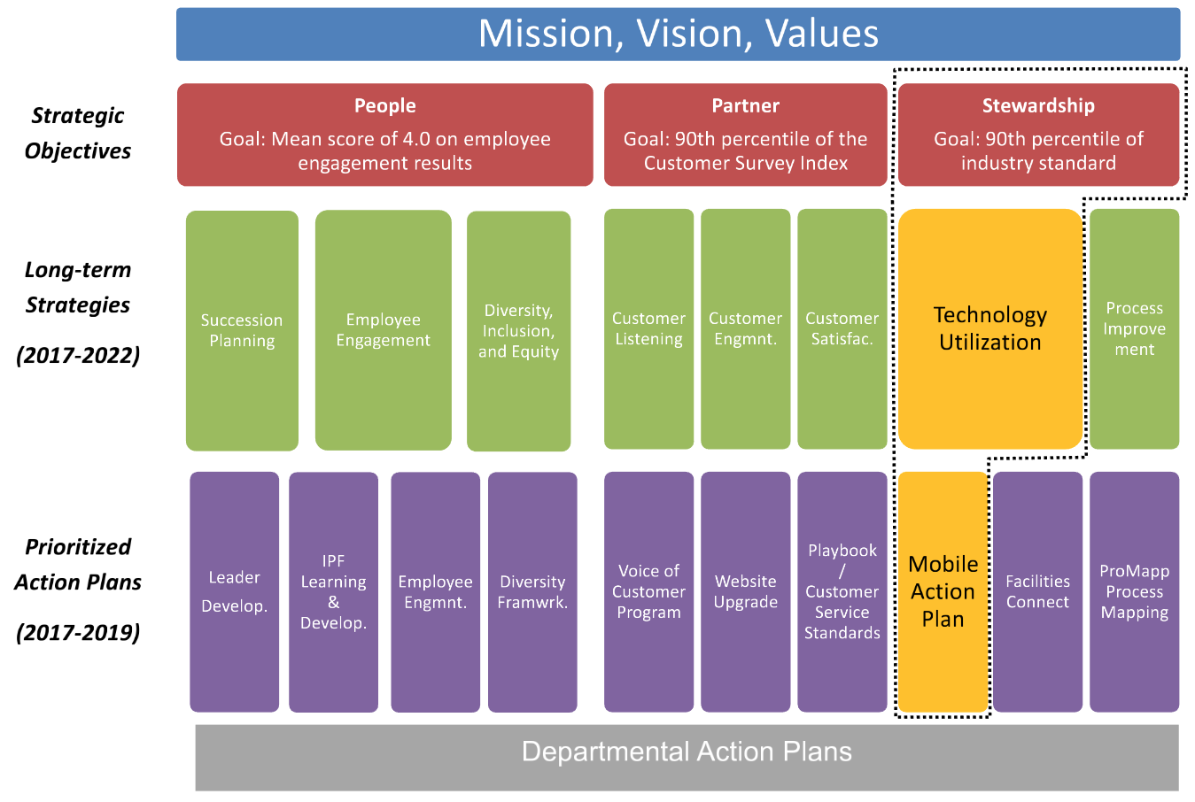

## Figure 1-1

## **Project Scope –** This project has six components. Figure 1-2 depicts the full scope of this Operational Excellence project.

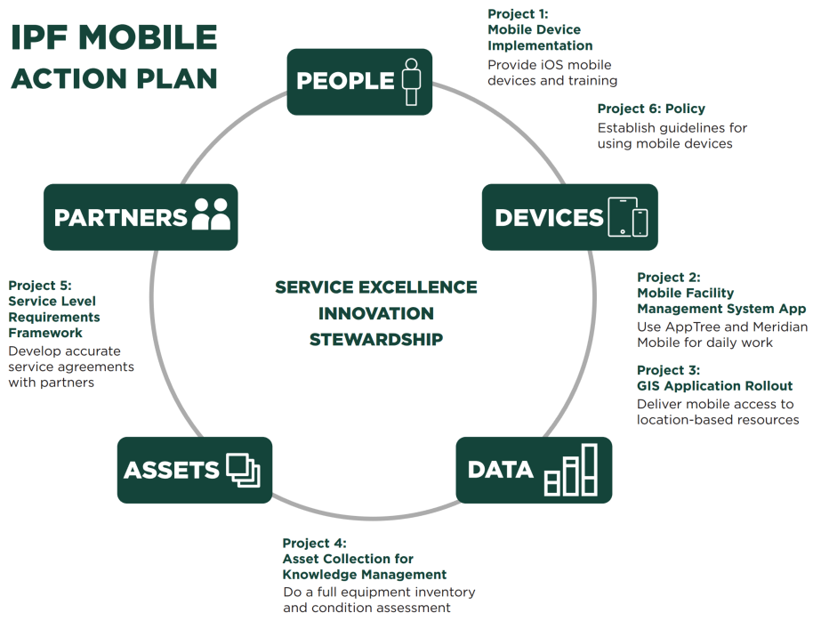Figure 1-2

**Operational Excellence Project Implementation Process and Timeline**

The planning and implementation process leveraged project management institute (PMI) guidelines and ITIL processes.

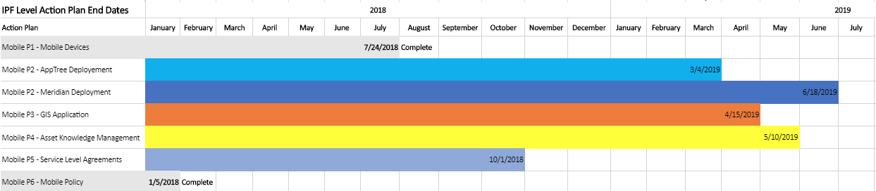

## **Size of the project challenge, use of creative tools, and any organizational development**.

*Business Need and Project Challenge*

* **Mobile Platforms** – Business Leaders increasingly seek to build a digitally interconnected environment for the workforce to promote interaction among team members and optimize efficiency. This project will provide the workforce with mobile access to information at the point of decision making to modernize the paper process and leverage a robust knowledge management database.
* **Asset Collection for Knowledge Management** – Employees need access to asset records that are currently inaccessible from a mobile device nor identified in current databases at this time. This project will define data collection methods and long-term sustainable maintenance processes; improving access to data systems (FAMIS, GIS, Meridian, Etc.) on mobile platforms, and develop web applications using the Web Application Builder (WAB) framework.
* **Service Level Requirements Framework** – IPF businesses have customer requirements already, but many lack a documented evidenced–based strategy. This project creates a framework for each business leader to improve service level requirements with a holistic approach to identify assets and associate maintenance level industry standards. Financial models will be formulated that can be measured and improved over time.

*Use of Creative Tools -* This video <https://youtu.be/GGuZ2fpekVE> provides an overview of IPF pioneered approaches for our organization to develop IT tools necessary to scale-up the deployment of 1000+ mobile devices to our workforce. The tools adopted are also highlighted in figure 1-3.

*Organizational Development -* The mobile action plan is IPF’s first unit-wide action plan that affects every employee in the organization. We developed an in-house training team to teach employees how to use iOS devices, applications, and how to access information critical to improving daily decision making.

## **Impact of the Operational Excellence project - Detail the customer benefit and/or value generation**.

One of IPF’s strategic objectives is to improve Partnerships with campus stakeholders. The mobile action plan is improving the timeliness of work execution by eliminating waste-in-process. We have learned there are three pitfalls that reduce performance: *lack of planning, not having the correct tools and materials to perform the tasks, and lack of communication.*  The mobile action plan has greatly reduced these pitfalls to performance and improved the value we provide to our campus partners. For example, in 2016, Landscape Services implemented mobile technology along with GIS and a Landscape Management Plan to estimate new capital projects during design. This combination of technology implementation paired with a systematic approach to landscape maintenance resulted in improved trust and buy-in from our customer in Residential Education and Housing Services. See video here: <https://youtu.be/bPCOBZRstLU>.

Dan Bollman, Vice-President of IPF, describes the organizational impact: “Implementation our mobile strategy across Infrastructure Planning and Facilities has been truly transformational in how our employees pursue their work.  Communications have increased, our responsiveness to issues is faster, and most importantly; I’ve noticed a great deal of satisfaction among employees who through the mobile devices have gained greater control over their daily work activities.  I believe IPF is leading the way for the entire university in being able to identify, deploy and realize benefits in both productivity and employee engagement through the use of these simple tools.”

## **Business Results of the Operational Excellence Project**

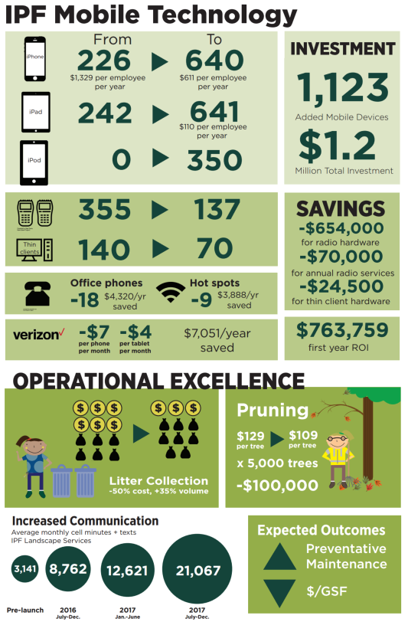

figure 1-3

## Presentation of project given at the 2018 International APPA conference:

<http://prezi.com/-wpqzmo8he7e/?utm_campaign=share&utm_medium=copy&rc=ex0share>

