ANTIOCH COLLEGE LANDSCAPE MASTER PLAN
MISSION
Create a sustainable landscape plan that serves as a living, learning laboratory and emphasizes native and local ecological systems and connects our campus to a broader ecology.
VISION
Develop an intentional campus landscape balanced between well maintained and natural areas, sustainably managed and scaled to the college’s resources.
GOALS
Bio-retention
Bio-retention basins are landscaped depressions or shallow basins used to slow and treat on-site storm water runoff. Storm water is directed to the basin and then percolates through the system where it is treated by a number of physical, chemical and biological processes. The slowed, cleaned water is allowed to infiltrate native soils or directed to nearby storm water drains or receiving waters. Antioch College will use bio-retention methods (rain gardens, prairie swales, etc) in areas where surface water runoff is problematic or flooding occurs.
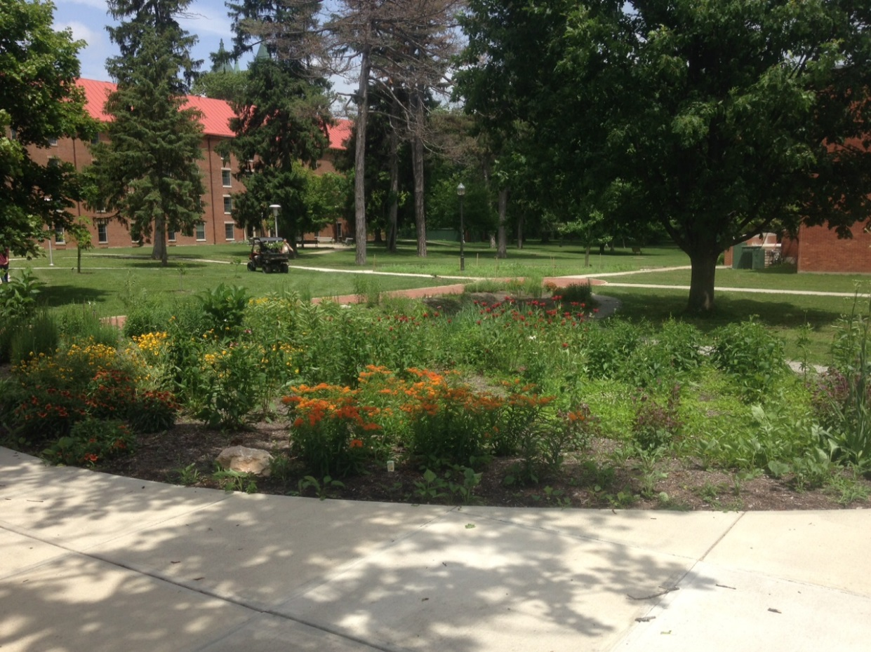

Carbon Sequestration
The carbon cycle is the sequence of transformations whereby carbon dioxide from the atmosphere is converted to organic forms through photosynthesis or chemosynthesis, recycled through the biosphere (with partial incorporation into soils), and ultimately returned to its original state through respiration or combustion. On earth the primary process of fixing atmospheric carbon dioxide is through photosynthesis. By increasing plant diversity and density throughout our college campus environments, and avoiding the use of fossil fuels in their production, people can sequester atmospheric carbon via the plants.

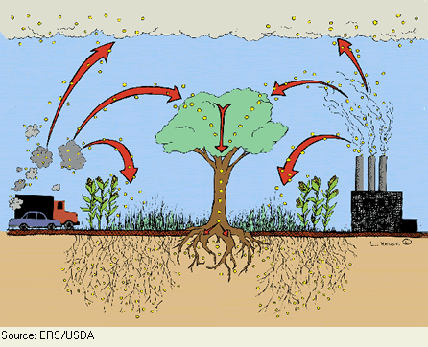

Aesthetics
A goal of the college is to create good first impressions for visitors and perspective students.
Therefore a neat and orderly appearance to the landscape that maintains a seasonal interest is a priority in areas frequently visited by our guests.

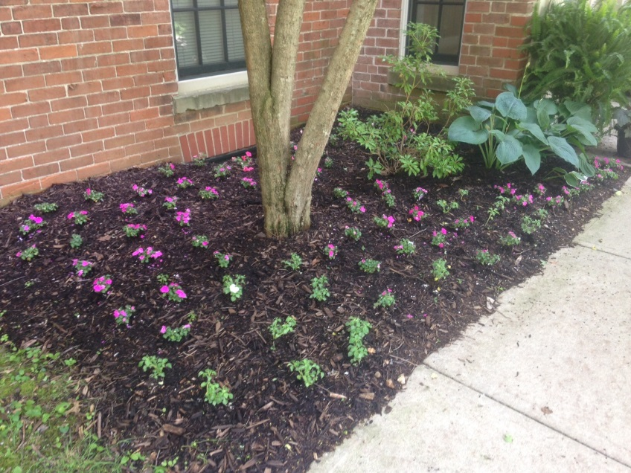

Overwhelmingly Native Plantings
As a rule of thumb, the college will develop a landscape that will have primarily native plantings. Natives will, in most cases, form self-sustaining plant communities that do not require much maintenance. Because they are adapted to a local region, they tend to resist damage from freezing, drought, common diseases, and herbivores if planted in that same local region.
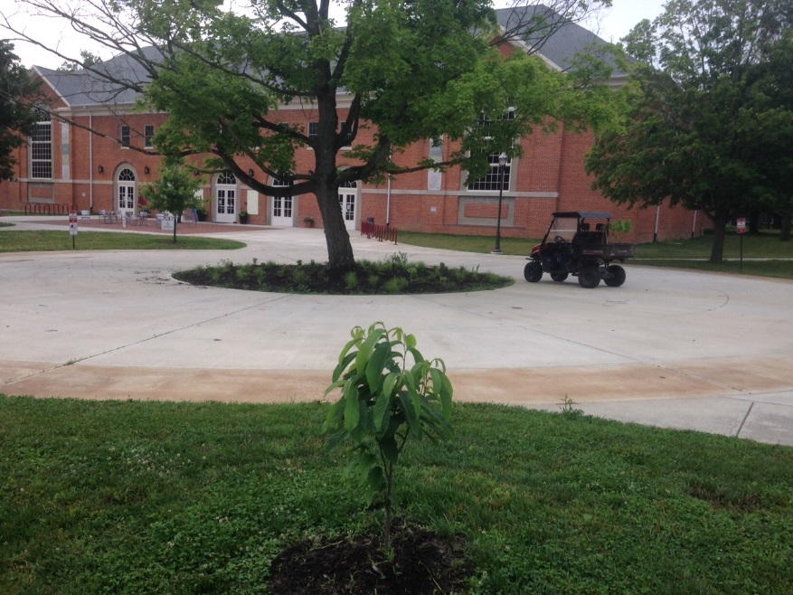
Advantages of native plants:
- add beauty to the landscape and preserve our natural heritage
- provide food and habitat for native wildlife
- serve as an important genetic resource for future food crops or other plant-derived products
- help slow down the spread of fire by staying greener longer
- decrease the amount of water needed for landscape maintenance
- require very little long-term maintenance if they are properly planted and established
- produce long root systems to hold soil in place
- protect water quality by controlling soil erosion and moderating floods and droughts
Remove Invasives (OIPC)
The college will develop a systematic plan to remove invasive plant species from our campus using guidelines from the Ohio Invasive Plant Council. Invasive species are defined by the National Invasive Species Council as species that are “both non-native (or alien) to the ecosystem under consideration and whose introduction causes or is likely to cause economic or environmental harm, or harm to human health." About 5,000 species of plants, animals, and microbes are recognized in the United States as invasive.
Approximately one-fourth of the plant species known to occur in Ohio originate from other parts of the continent or the world, meaning they are not native to the state. Most non-native plant species are not invasive in natural areas. Of the more than 700 non-native plants in Ohio, fewer than 100 are known to be problems in natural areas. But, those that are invasive can cause extensive economic damage and do immeasurable harm to our natural resources and the natural heritage of our state.
Invasive Plants can:
- Displace or crowd native plant species,
- Impact wildlife which rely on native plant communities for food, shelter and breeding habitat, and
- Form monoculture plant communities which reduces biological diversity.
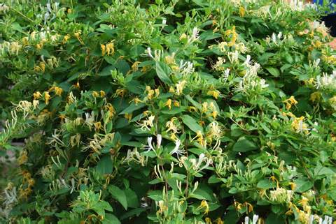
Perennials (Flowers & Herbs)
The planting of perennials will be an important component to our landscaping plan. Perennial plants are wonderful additions to the landscape. While trees and shrubs may act as the bones of a garden, perennials provide muscle. Because they last for more than one season, they are perfect for designing a permanent garden display, unlike annuals that usually provide only a single season of color. Perennials can be less work because they do not require replanting every year. Perennial varieties are available to provide interest for any season of the year, including the winter.
Perennial plants provide pollen, nectar, seeds and nesting material for birds and butterflies. Perennial groundcovers can reduce soil erosion and create interest in pathways, on slopes, along roadsides and ditches.
- Naturally, the greatest advantage that perennials have is that they come back year-after-year.
- Perennials are typically much more hardy than annuals and require less care.
- Most perennials have a deep root system and can tolerate dry spells.
- The extensive root system on most perennials also make them effective at preventing erosion.
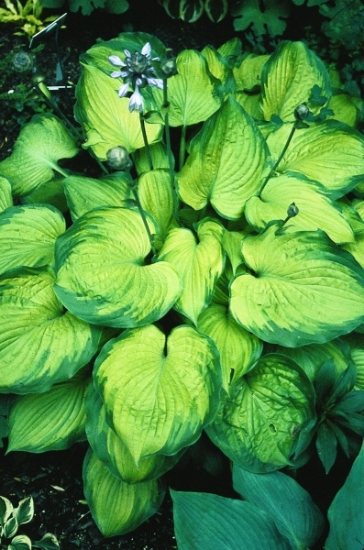

Interpretive Signage

The use of interpretive signage will be installed to explain landscape sustainability on campus. The signage will provide information and insight to our campus community on the intentionality of our plantings.

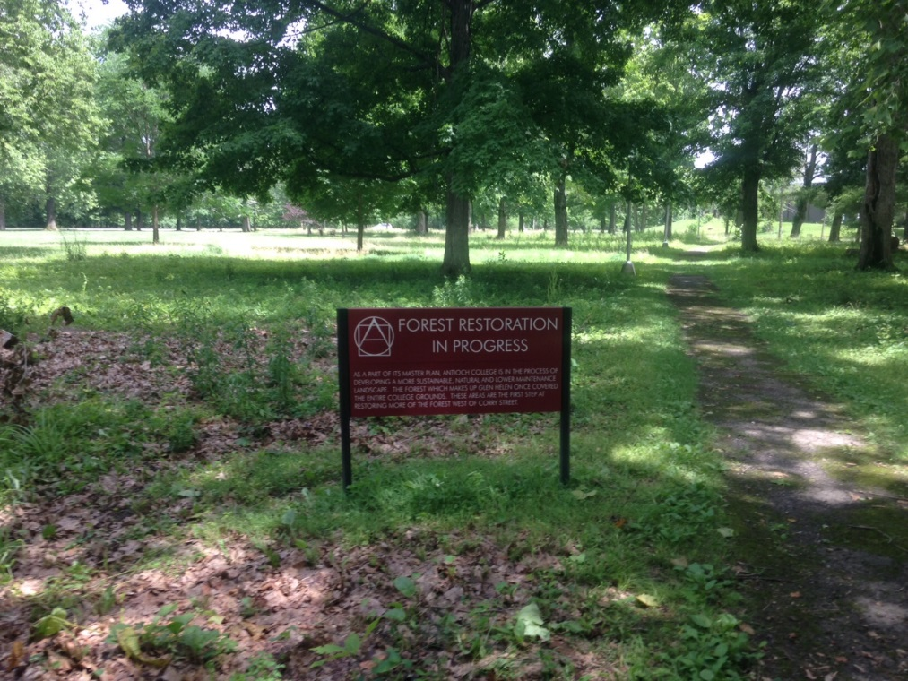

Recreational Areas/Green Space
Open space provides places for recreation, activity and engagement, for peace and enjoyment, and for freedom and relief from the built world. They provide an opportunity for our students, staff and visitors to exercise, give access to sunshine, nature and fresh air, and even encourage people to walk or bike from place to place. They also can have a significant impact on people’s stress levels and overall mental health and can be proven to be actual preventative measures that impact positively on health care and health care costs.

Open space promotes environmental sustainability as well. Natural habitat provides sanctuary for wildlife species ranging from mammals, birds and insects to plants; trees and other types of vegetation provided in open space networks can reduce air pollution; and wetlands can filter contaminants. The walkways and paths of an open space network can also aid in reducing greenhouse gases, by providing alternative transportation routes and promoting bicycling and walking.

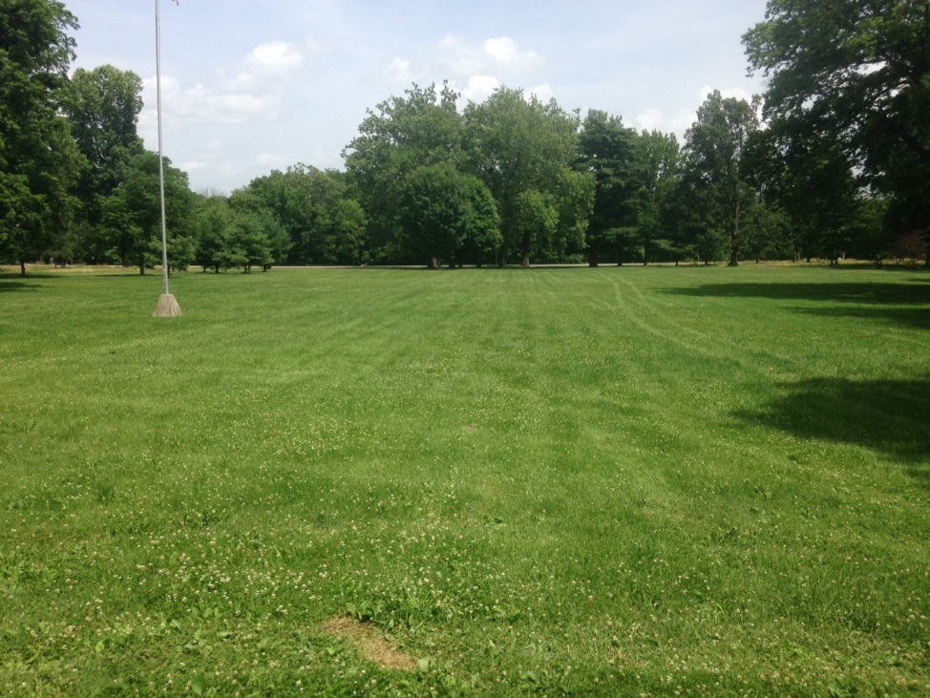

POLICIES/STRATEGIES TO ACHIEVE GOALS
IPM Program
Antioch College will institute Integrated Pest Management program. (IPM) is an ecosystem-based strategy that focuses on long-term prevention of pests or their damage through a combination of techniques such as biological control, habitat manipulation, modification of cultural practices, and use of resistant varieties. Pesticides are used only after monitoring indicates they are needed according to established guidelines, and treatments are made with the goal of removing only the target organism. Pest control materials are selected and applied in a manner that minimizes risks to human health, beneficial and non-target organisms, and the environment.
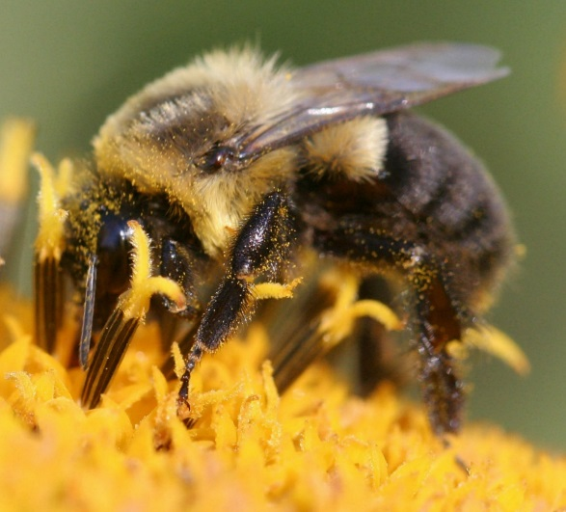
Tree Policy
Antioch College has an approved list of Ohio native trees for planting on campus. All new plantings and placements must be approved by the Physical Plant Department. The following guidelines should be followed:

- A tree's mature size and shape must be of the proper scale to fit the site and surrounding buildings.
- Plant an appropriate sized tree under overhead wires. Avoid planting over under-ground utilities.
- Do not plant trees near building foundations or walls.
- Do not plant trees where canopies will reach over roofs or gutters.
- Determine the necessary root growth space for the species you select.
- Plant deciduous trees on the south side of buildings to shade the building in summer but allow the sun’s warmth to come through its bare branches in winter.
- Trees planted in campus zone 4 (Farm) can be non-native, but must have approval of Farm manager and Physical plant director prior to planting.
- Planting trees in groupings/communities rather than single plantings
- No dedication/donor plaques
- Look at providence of trees, purchase trees within a 25-50 mile radius, unless in zone 4 (Farm)

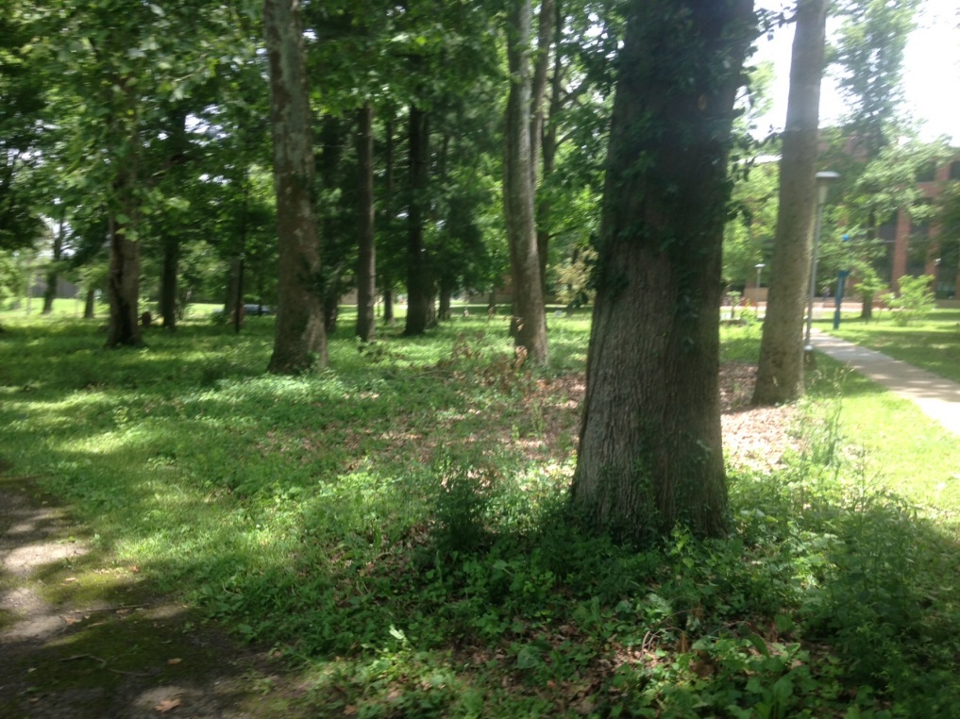

Protection of Trees/landscaping during Construction or Renovation Work
- Inform contractors of policy.
- Ensure that protection zones are established around landscaping and trees drip lines.
- Restoration of site if damaged.
- Replacement of trees if destroyed during construction activity.

DEVELOP SITE PLAN AND ESTABLISH ZONES FOR TYPES OF PLANTINGs
Antioch College wants to have intentionality about what and where we plant. The following zones will be establish to help inform our decisions when creating bio-retention areas, landscape beds or planting trees:
Zone 1
- Intentional
- Public visitation
- Aesthetics
- Interpretive signage
- Formal/manicured
- Informed by sustainability
- Maintain seasonal interest
- Cared for
- We want to control the image
Zone 2
- Low Mow
- Lower intensity
- Native preferred

Zone 3
- No mow
- Naturalistic management
- Natives
- Biodiversity
- Educational and construction priority
Zone 4
- Farm
Zone 5
- Lawn
- Open space
Zone 6 (Glen)
• Naturalistic management
• Natives
• Biodiversity
• Educational priority
- Lawn only as necessary to protect building envelopes and provide instructional spaces
- Permit required for research
- Trail use required, except as allowed by permit
- Active removal of target invasive species
- Under conservation easement

