Exploring Peak Shaving for The University of Montana’s Energy Demand
By Sarah Thompson

Executive Summary
The purpose of this project is to provide UM Facilities with visibility into energy demand in near real-time, enabling them to keep the peak energy demanded below 5500 kW, potentially saving an average of $15,000 a year in energy costs. To do this, a system was created that takes the readings from energy meters on campus and displays the aggregation of the readings in an energy dashboard in near real-time. This visibility into campus energy demand enables UM Facilities to identify when demand is nearing the 5500 kW mark.
The system created by this project utilizes two Python programs, The Meter Scraping Program (MSP) and the Data Uploading Program (DUP), as well as Google Drive (GD), Google BigQuery (GBQ), and Data Studio (DS) to accomplish this goal. Google Drive is used as a storage space for the raw data files, Google BigQuery is a cloud-based data warehouse that keeps the data organized, and Data Studio is a visualization tool connected to Google BigQuery that allows the stream of data to be viewed in near real-time.
As the buildings around campus consume energy, the meters connected to them are monitoring that information. The Meter Scraping Program navigates to each meter and collects the name of the meter (building), the time on the meter (meter_time), and the instantaneous demand reading (watts (kW)). It cycles through the meters continuously, collecting data from each meter every 2-5 seconds. Every five minutes, the MSP stores the collected information in a file in Google Drive. The Data Uploading Program checks Google Drive for new files every two minutes. Once a new file exists, the DUP opens the file and cleans the data in the file, which allows an aggregation of all the meter readings by second, creating estimated demand. The DUP then uploads the data into Google BigQuery. Once in BigQuery, this information can easily be visualized in Data Studio. The University of Montana Energy Dashboard created in Data Studio, shows the current power of campus, the estimated demand, and tracks the current peak demand for the month.
By accumulating the meter readings, aggregating the data by second, and displaying the data in a live dashboard, this project seeks to give UM Facilities all the tools they need to begin the process of peak shaving energy demand. In addition, this stream of data on energy consumption could enable other departments and buildings to be more energy conscious.

Introduction
Like many organizations, the University of Montana’s (UM) energy bill consists of two charges: one for the total amount of energy used in a given month, and one for the maximum amount of energy demanded in a fifteen-minute interval. This project seeks reduce the second part of the bill, or as it is commonly called, to “peak shave” energy demand.
Brian Kerns in the UM Facilities Department has been compiling energy data for the mountain campus of UM since 2011. At the beginning of each month, Northwestern Energy (NWE) emails him a spreadsheet of the previous month’s energy demand in fifteen-minute intervals. Brian has faithfully loaded this data into an Excel spreadsheet, as well as performed analyses on it, and studied it over the years. The problem is that this data is collected and analyzed after the fact, once the bill has gone out and the peak demand for the previous month has long been set.
The goal of this project is to provide Brian with visibility into energy demand in real-time, enabling him to take the necessary measures (e.g. delaying bus charging or HVAC systems in certain buildings) to keep the peak energy demand below a certain threshold. Brian has estimated that keeping peak energy demand below 5500 kW will save the university roughly $15,000 a year.
Although NWE uses a meter that is located on campus to track demand and build the spreadsheet that is emailed to Brian each month, currently, there is no way for Brian to access that data prior to receiving the monthly statements. Fortunately, UM has small Shark® meters connected to many buildings on campus, most of which can be accessed through the local network, allowing for power readings to be collected in real-time.
By collecting data from the available meters, calculating the average demand over fifteen-minute intervals, and displaying the information in a live dashboard, this project gives Brian a much better idea of the current energy demand. Armed with this information, he can utilize the other tools at his disposal to delay electrical usage when UM is nearing the 5500 kW mark.

Overview

UM Meter System
All the electricity utilized by UM is monitored by a meter owned by Northwestern Energy; the data collected by the meter can only be accessed internally. This data would be incredibly useful to UM or any organization interested in controlling electrical demand for environmental or financial reasons. After pressing Dave Mahugh on the issue, the Northwestern Energy Representative for the UM, he shared that NWE is working on providing customers with a secure way to access this data in real-time, but that there currently is no solution for those customers in Montana.
There are, however, individual building meters attached to many buildings on campus. These 42 Shark® 200 meters monitor most of the electrical use on the mountain campus of UM as well as the Missoula College. The best part is that they can be accessed through the UM network. Once accessed, these meters transmit new xml files every second, each containing the instantaneous readings of several metrics. One of the metrics is instantaneous kilowatts and it is used to calculate energy and demand.
These mountain campus meters don’t represent the full picture of UM’s electrical use as there are several buildings without meters connected to them – most notably, the University Center (UC) is not accessible as it uses a different meter, the Shark® MP200. It is possible, however, to estimate energy demand with the meters that are available and compare that estimation to NWE data, once available.

Power, Energy, and Demand Calculations
Understanding the distinction between power, energy, and demand is critical to correctly calculating energy demand at UM. Power (kW) is “an instantaneous reading” which can be thought of as the “present flow of kilowatts” at a given time, according to the Shark® meter manual (Shark, 2012). Many meters consider power to be held constant for a second or minute-long interval, which aids in calculating energy and demand. For this example, assume that power is held constant for one minute, the power readings are displayed in the Power column of Table 1.
Energy is measured in kilowatt-hours and represents the “integration of power over a defined period of time” (Shark, 2012). In Table 1, the energy of a one-minute interval is calculated by dividing Power by 60. Since one minute is a 60th of an hour, one kilowatt is a 60th of a kilowatt-hour. To find the energy for the five-minute interval, sum the energy of each one-minute interval. Thus, in this example, the load served over a five-minute interval, or the energy, is equal to 4.16 kWh (.5 + .83 + .76 + 1.33 + .83 = 4.16).
Demand (kW) is also a time increment, but it is the average rate of energy in a given period of time. Technically, demand is measured in kilowatt-hours/hour, but it is usually reduced to kilowatts. To calculate demand based on the five-minute interval in Table 1, multiply 4.16 by 12, since five minutes is equal to a 12th of an hour. Thus, the demand for this example is 49.92 kW (Shark 2012).
Table 1: An example of power, energy, and demand calculations.
Time Interval (minute) | Power (kW) | Energy (kWh) one-minute interval | Energy (kWh) five-minute interval | Demand (kW) five-minute interval
1 | 30 | .5 | 4.16 | 49.92
2 | 50 | .83 | 4.16 | 49.92
3 | 40 | .67 | 4.16 | 49.92
4 | 80 | 1.33 | 4.16 | 49.92
5 | 50 | .83 | 4.16 | 49.92

This project involves taking the instantaneous readings from the meters (power), and translating them into demand for fifteen-minute intervals. Referring to Table 1 once again, one can see that the average power is 50 (30 + 50 + 40 + 80 + 50 = 250, 250/5 = 50), which is very similar to the demand value of 49.92 kW. After meeting with Dave Mahugh, this methodology was endorsed as a close-enough estimate of demand and it used to calculate demand for this project.

The System
This project created a system that takes data from the meters and cleans, uploads, and displays that data in a near real-time dashboard. To do this, the system utilizes two programs to collect, clean, and upload the data: the Meter Scraping Program and the Data Uploading Program, both of which were written the Python programming language. The MSP connects to the individual building meters, retrieves the power readings, and stores the data in a file in Google Drive. The DUP opens the files in Google Drive, cleans the data within them, and uploads that data into Google Big Query. Once the data are in Google BigQuery, a cloud-based data warehouse, the data are easily stored for future use as well as queried for insights. Google Big Query is also connected to Data Studio, a data visualization tool used to display the data in near real-time. Figure 1 illustrates the system.
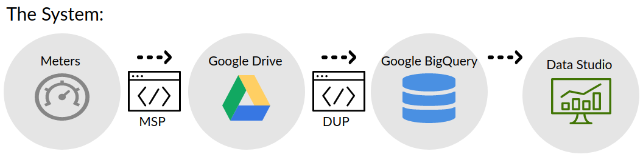
Figure 1: An overview of the system used for peak shaving in real-time.

Google
This project utilizes several Google applications: Google Drive (GD), Google BigQuery (GBQ), and Data Studio (DS). Google was chosen because it is cost-effective, intuitive, and cloud-based. By using cloud-based services, Brian can access the data and visualizations anywhere and he doesn’t have to worry about storing the data constantly flowing in.
Google Drive has 15 gigabytes of free storage, making it capable of housing thousands of files before incurring any costs. Beyond that, it can be mounted to the computer running the program, allowing for files to be created directly in GD, saving the computer’s memory.
Google BigQuery is a pay-as-you-go, cloud-based data warehouse that can be accessed programmatically through Python. Data warehouses effectively organize and store data, making it easy to glean insights by querying the data and create visualizations from the data. This project uses a Python program that takes the files stored in Google Drive, transforms them into complete second intervals, and then uploads them into GBQ. By using Python, these processes can take place automatically. Once in Google BigQuery, the data can easily displayed using Data Studio.
Data Studio is a free visualization tool that is connected to data tables and queries in Google BigQuery. While there are many data visualizations tools that can create better looking graphics, DS was chosen due to the click-and-drag nature of the application, as well its connection to Google BigQuery. A Google plugin, Data Studio Auto Refresh is used to keep the DS dashboard current automatically as new data streams into GBQ.

Set Up
In order for the MSP to connect to each meter on campus, the computer running the program must be connected to the UM network. For this project, a Chrombook located on campus is running the system. The Chrombook uses a Linux operating system, has Google Drive mounted to it, and is accessible via AnyDesk, a remote desktop application. In this way, the files being collected by the MSP are immediately available in Google Drive and if either of the programs crash, they can be restarted using the remote desktop.

The Meter Scraper Program (MSP)
Starting the MSP involves navigating to the main_campus folder of the mounted Google Drive and running it with Python. Each time the program should create a new file, the terminal screen says “should write file” and the time. Figure 2 shows what the terminal looks like once the program is running. Table 2 lists the Python packages utilized by the MSP and Table 3 lists the functions inside the MSP and their purposes.
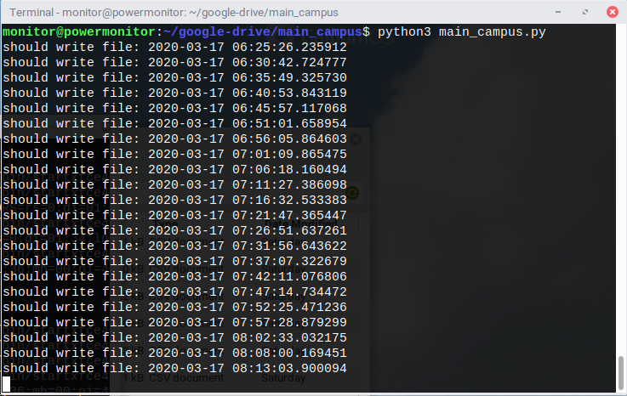
Figure 2: The terminal shell on the Chrombook while it is running the MSP.
Table 2: The Python packages utilized by the MSP; these packages must be installed in order for the MSP to work effectively.
Python Packages:
requests
xml.etree.ElementTree
datetime
timedelta
time
inspect

Table 3: This table lists the functions in the MSP and their purposes.
Functions: | Purpose:
get_data() | This function collects the following metrics from a meter: building name (building), the time on the meter (meter_time), and the current power reading (watts, (kW)). It then stores this information along with the current time (actual_time) the data were collected in a data dictionary. This function has several levels of exception handeling to mitigate errors when there are network conectivity issues with a meter.
write_file() | This function takes the data in the data dictionary, writes it to a file, and saves that file in Google Drive. It names each file based on the time the file was created, following the format: “year.day.month.hour.minute.second.csv.” For example, a file named “2020.3.17.11.56.31.csv,” indicates that it was created on March 17th, 2020 at 11:56 am. A screenshot of a portion of a file created by this function can be seen in Figure 4.
initialize_dict() | This function deletes all the data in the data dictionary.
get_meters() | This function returns a list of all the meter’s IP addresses.
main_function() | This function utilizes the functions listed above to continuously collect metrics from the meters, store those metrics in a data dictionary, write the data dictionary to a file every five minutes, and erase all the data in data dictionary.

A screenshot of the main_function() can be seen in Figure 3. This function sets run_program to True and has a while loop based on this truth, indicating that the program will continue running indefinitely. Before the while loop, however, the initial write_file_time is set to 16 minutes prior to the current time. The for loop instructs the program to iterate through each meter in the list of meters, running the get_data() function on each of them. Once the data has been collected for a meter, the program checks to see if over five minutes has passed since the last write_file_time. If it has, the program uses the write_file() function to create a file in Google Drive, it then uses the initialize_dict() function to delete any data in the data dictionary, and prints “should write file:” and the current time. Before any of this can happen, the program must start with an empty data dictionary by using intialize_dict() and it must get the meters IP addresses using get_meters(). Once these two opperations are complete, the main_function() can run continuously.
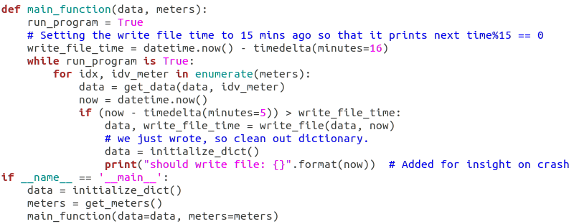
Figure 3: A screenshot of the code in the main_function() of the MSP.

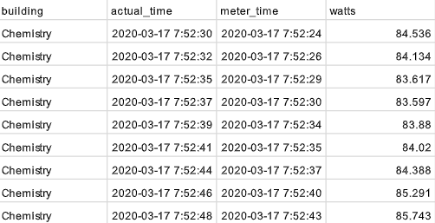
Figure 4: The beginning of a file created by MSP that is stored in the main_campus folder of Google Drive.

The Data Uploading Program (DUP)
Just like the MSP, running the DUP involves navigating to the main_campus folder of Google Drive and launching the program using Python. An example of what the terminal looks like while the program is running can be seen in Figure 6. Table 4 shows the Python packages utilized by the DUP and Table 5 lists the program’s functions and their purposes.
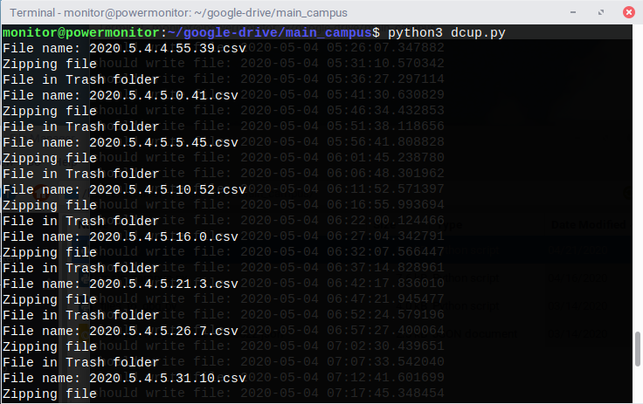
Figure 6: The terminal shell while running the DUP.
Table 4: The Python packages utilized by the DUP.
Python packages:
os
datetime
timedelta
pandas
pyarrow
google.oauth2, service account
pandas_gbq
shutil
numpy
zipfile, Zipfile
time

Table 5: The functions of the DUP and their purposes.
Functions: | Purposes:
clean_df_sec() | This function cleans the data by creating a row for each second of data in the file and adding columns for each meter. See Figure 8 to better understand the new shape of the cleaned data as compared to Figure 4. As seen in Figure 4, the MSP does not collect data from the Chemistry meter, or any meter, every second. In order to create a table with data from each meter for every second, an approximation has to be made. To handle this, this function inserts the last known kilowatts from the meter into any missing seconds. Essentially, it is assuming that if the kilowatt reading for a given second is missing, it is equal to the last known kilowatt reading for that meter. In Figure 8, note the duplicate power readings for each building, these duplicates indicate that the MSP did not pull power readings for each second. By doing this, the clean_df_sec() function is able to aggregate all the meter readings by second, creating estimated power over as second-long interval, this is saved in a column named “Total.” Additionally, if there is no data for a meter, this function will insert a row of 0’s for that meter.
create_file_list() | This function sorts any files in the main_campus folder of Google Drive in chronological order and saves them to a list.
main_function() | This function utilizes the create_file_list() and clean_df_sec() functions to continuously check Google Drive for files, clean the data in the files, and upload that data to Google BigQuery.

A screenshot of the main_function() can be seen in Figure 7. This function also sets run_program to True and has a while loop based on this truth, indicating that the program will continue running indefinitely. The program then creates a list of files that need to be processed using the create_file_list() function. If there are files in the list, it then uses a for loop to iterate through the files. Alternatively, if there are no files in the list, the program prints “No files exist” and rests for two minutes before checking for files again. If there are files in the list, it must check that the files contain data. Recall that when the MSP is restarted, the first file it creates only contains one row of data, cleaning this file would break the DUP program, thus if a file contains less than one hundred rows of data, the data is not added to GBQ. For these files, the program prints out the words “File [insert file name] had little to no data in it.” This file is then stored in the same way as all other files.
If there are more than 100 rows of data in the file, the main_function() turns the file’s data into a dataframe and then uses the clean_df_sec() function to clean the data. Once a file is cleaned, it is uploaded to a table in Google BigQuery. The specific table updated will automatically change each month. Currently, the data is flowing into a table named seconds_2020_5 to represent the second intervals streaming in, the year, and the month. After the main_function() adds a file to its respective table in GBQ, it prints out “File name:” and the name of the file. Next, this function uses the Zipfile package to store this file in a compressed folder named “year_month_day_meter_data_zip”, for example, “2020_5_4_meter_data.zip,” located in the files_uploaded_gbq folder of Google Drive. Once this task is accomplished, the function prints out “Zipping file.” Finally, the function moves the orginal file to the Trash_folder in GD and prints out “File in Trash folder.” A screenshot of a portion of a table in GBQ is shown in Figure 8.
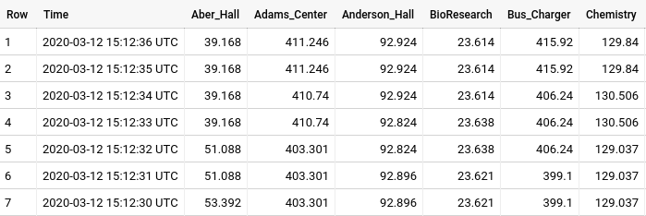
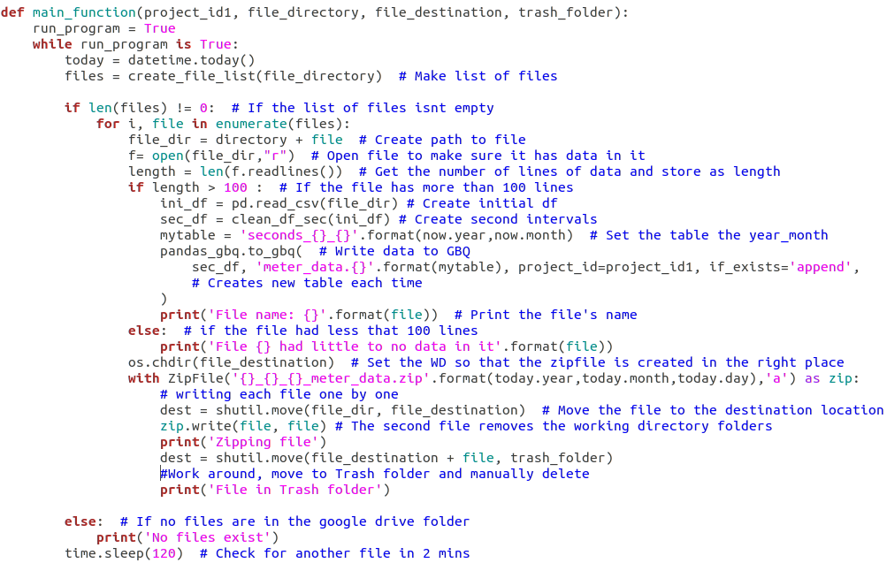
Figure 7: A screenshot of the main_function() in the DUP.
Figure 8: Part of the seconds_2020_3 table in Google BigQuery.

The Data
The dataset created by this system provides a level of granularity that was not previously possible for the University of Montana. Before, Brian received aggregate energy demand data in fifteen-minute intervals the following month. Now, there are seconds of data from every metered building streaming into the dataset in near real-time. While the real-time data allows campus to understand current demand, the ability to see how individual building’s influence demand may also be valuable. Ultimately, this information could be used to monitor UM’s sustainable commitments, to inform interested faculty, staff, and students of the energy use, and to teach big data analytics by providing a large dataset to students in those classes. If this system is maintained, the dataset can add insight and value to UM for years to come.

Data Studio (DS)
As the near real-time data flows into GBQ, a dashboard built in Data Studio automatically displays the data, refreshing every two minutes; Figure 9 shows the dashboard. The Estimated Current Power graph displays the estimated demand in one-minute intervals. Spikes in this graph may indicate that peak shaving is necessary to ensure that the actual energy demand in fifteen-minute intervals remains below 5500 kW. The most recent value on this graph is displayed in the Current Demand box. The Estimated Demand for Today graph shows the estimated energy demand in fifteen-minute intervals. The current peak for the month is displayed in the Month Demand Peak box. The Demand A Year Ago Today graph displays the actual energy demand (in fifteen-minute intervals) from Northwestern Energy on this day last year. The Average Difference box displays the average difference between the estimated energy demand and the actual energy demand from NWE for this day and hour. This snapshot indicates that the user should add an average of 71.22 kW to the current demand estimation to make up for the average deviation. Finally, the checkerboard shows the most recent reading from all meters used in estimated energy demand. In the event that a meter is down, the number on the checkerboard will equal 0 and turn blue, indicating to the user that this particular meter is not being included in estimated current power or estimated demand.
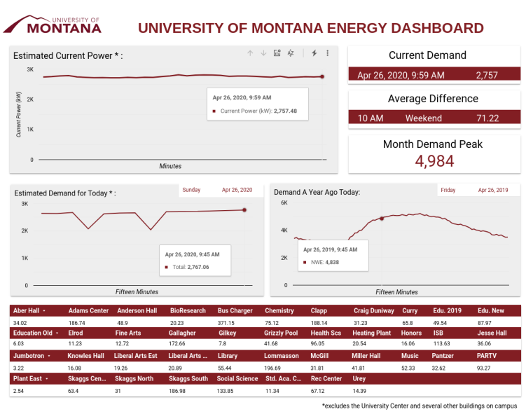
Figure 9: The University of Montana Energy Dashboard auto-refreshes to display the most up-to-date data in Google BigQuery.
The dashboard also has a second page which is useful for visualizing the discrepancies between the NWE data and the data created by the system; this graph is shown in Figure 10. In this graph, the NWE data are represented by maroon bars and the system generated data are shown by a black line. While the system does a fairly decent job calculating estimated demand, the times where the NWE peaks are the highest are when most of the deviation takes place. Because of this, the Average Difference box on the dashboard was created. By adding the average difference to the current estimated demand the user can get a better estimate of the actual current demand.
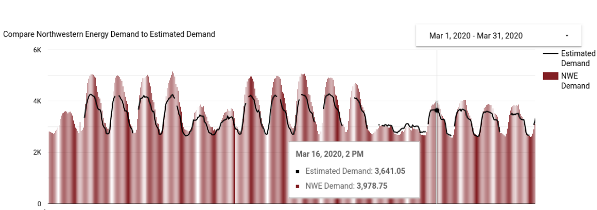
Figure 10: The difference between NWE data and the system generated data for the first half of March, 2020.

Limitations

The Missing Buildings
Along with several other buildings, one very important building is missing in this system’s calculation of demand: The University Center (UC). This three story building houses concessions, vendors such as a small post office and beauty salon, and commonly hosts tabling events. Unfortunately, this building is set up on a more advanced meter which isn’t accessible like the other meters around campus. The only way to access the readings on the meter is to use the Shark proprietary software, Communicator EXT. The software exports historical data into a Microsoft Access Database with thousands of tables that are not connected. Those familiar with Access know that the table connections allow the user to query the database, without them the data is very difficult to work with. The system produced by this project creates an estimate of energy demand excluding the UC and these other buildings.

Programmatic Issues
Both the MSP and DUP crash at times, meaning that they must be monitored to ensure that the system continues to work. When the MSP crashes, the data during that time is lost, resulting in gaps in information. Crashes for the DUP are not as serious, the data in Google Drive can be uploaded later. Thus, the only negative implication of the DUP crashing is a non-current dashboard in Data Studio.
When a meter is not operating correctly, it is not transmitting data to the MSP. In real-time, the checkerboard section of the dashboard will alert the user by highlighting the meter in blue. After the fact, however, the estimate of current demand will be less than expected. If users do not notice the missing readings from individual buildings and instead focus on the estimated demand, analyses of the performance of the system in the future could be incorrect due to this missing information.

Peak Shaving Phase 1
Visibility is only the first step in effectively peak shaving energy demand. Once Brian has determined that UM is nearing the 5500kW mark, he will then have to take other measures in order to actually lower the amount of energy used. While delaying charging for the electric buses may be the easiest solution, this may not always be possible as the logistics behind bus schedules are already ripe with challenges. If Brain wanted to lower the energy of certain buildings, he would have to log in to a proprietary platform, examine the heating and cooling numbers, and decide if that building could handle a pause in HVAC systems. Ultimately, the next step to peak shaving is very time consuming and challenging.

Recommendations
UM should continue to meter all buildings on campus so that those structures can be included in the estimation of current demand and can be monitored on an individual level. After speaking with UM Facilities IT team, it seems that the programmatic issues will be mitigated once they take over monitoring the system. The team plans to run the system on a server with other programs that check the MSP and DUP, automatically restarting them in the event that they crash. Additionally, the dashboard should be changed so that in the event that a meter is not transmitting data, the average reading from that meter by time of day and day of week is inserted into the current demand estimation. Finally, there are several tasks that need to be periodically carried out in order to maintain this system. The following section outlines those procedures.

Maintenance

Google Drive
As mentioned earlier, the DUP stores the files in two folders in Google Drive: the Trash_folder and the files_uploaded_gbq folder. Once a week, those files in the Trash_folder should be manually deleted to make room for more files. Additionally, if UM would like to continue using Google Drive for free, the zip folders containing compressed data in the files_uploaded_gbq folder should be moved to a different storage location every three months to save space in GD.

Google BigQuery
At the beginning of a new month, the user must create a new table with the demand intervals for the previous month. To do this, the user will need to log in to Google BigQuery and select the “Saved queries” tab on the left-hand side. Within that tab, the user should select the “15_min_intervals” query and copy and paste it into the “Query editor.” A snapshot of what this query looks like is shown in Figure 11.
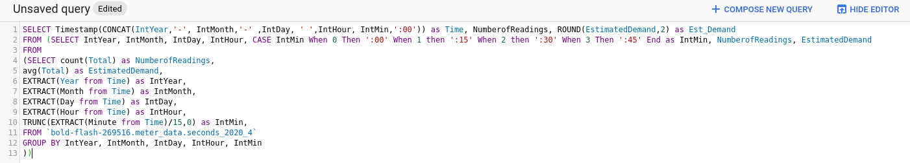
Figure 11: The query used to create fifteen-minute demand intervals in Google BigQuery.
Next, the table name, `bold-flash-269516.meter_data.seconds_2020_4`, will have to be changed depending on which month the user is working with. The last portions of the table name indicate the year and month of data within the table. In order to update the query, the user needs to change the year and month to reflect the previous month. For example, to create fifteen-minute demand intervals for the month of April, 2020, nothing in this query needs to be changed. Once the query is ready, the user should select “Run” and then save the results by selecting “SAVE RESULTS.” The new table should be saved in Google BigQuery with the name min15_year_month, e.g. min15_2020_4. Once this table is created, it will appear on the left-hand side of Google BigQuery with the rest of the tables, see Figure 12.
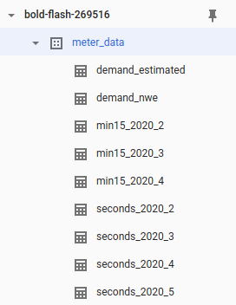
Figure 12: The tables of data in GBQ are listed on the left hand side of the console.
The final step is to update the demand_estimated table to include the new month of demand intervals. To begin, open the demand_estimated table and delete it. Then select the “Create demand_estimated table” query in the “Saved Queries” tab. Copy and paste the query into the “Query editor,” run the query, and save the results in a table named “demand_estimated.”

Data Studio
At the beginning of a new month, certain data sources in the dashboard in Data Studio will have to change. This can be done by using the provided username and password and logging into Data Studio. From there, one can navigate to the University of Montana Energy Dashboard under “Reports” and click “Edit”. To edit the visualizations listed below, click on the visualization, select the “edit” button under “Data source” in the right-hand panel, on the pop-up window select “Edit Connection” in the top right-hand corner, and adjust the name of the table. Just like in GBQ, the table names will have the following format: `bold-flash-269516.meter_data.seconds_2020_4`, with the last portions indicating the year and month of data within the table. In order to update the dashboard the user needs to change the year and month to reflect the current year and month. For example, to update the dashboard for May, 2020 the user should change the table to `bold-flash-269516.meter_data.seconds_2020_5`. The metrics that need to be changed along with the queries being changed are shown below.
Estimated Current Power:
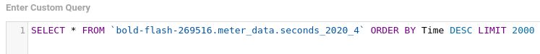
Figure 13: The query used to generate the Estimated Current Power graph.
Current Demand:
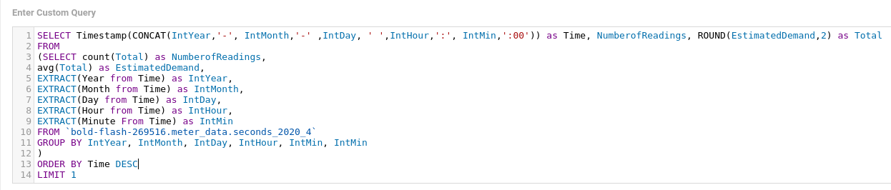
Figure 14: The query for generating the Current Demand box on the dashboard.
Month Demand Peak:
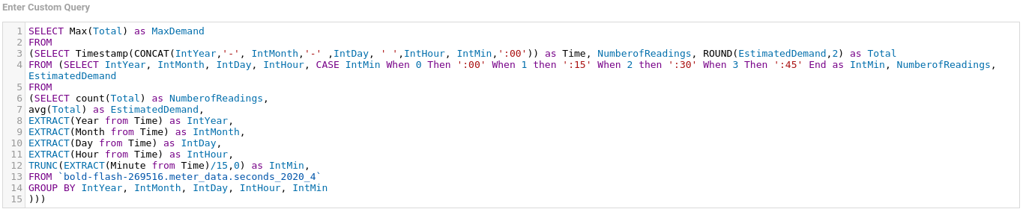
Figure 15: The query for generating the Month Demand Peak box on the dashboard.
Estimated Demand for Today:
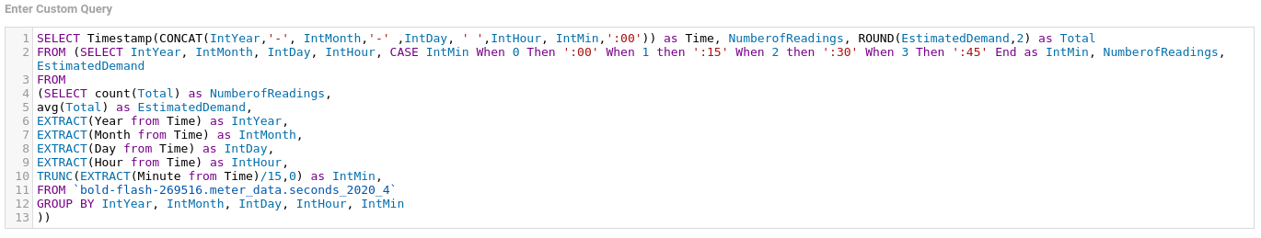
Figure 16: The query for generating the Estimated Demand for Today graph on the dashboard.
The date on the Estimated Demand for Today graph:
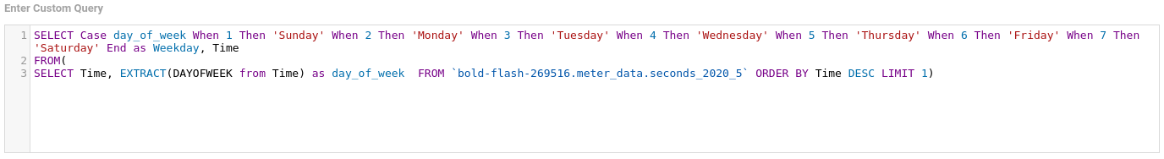
Figure 17: The query for generating the date on the Estimated Demand for Today graph.
The date on the Demand A Year Ago Today graph:
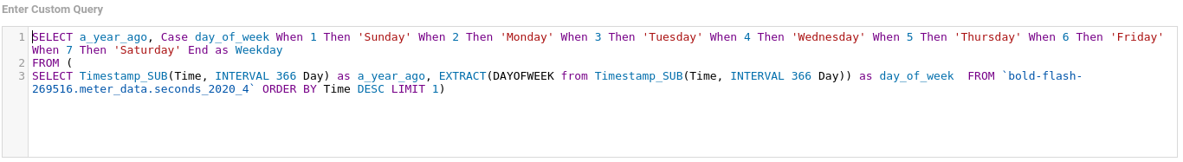
Figure 18: The query for generating the date on the date on the Estimated Demand for A Year Ago Today graph.
The first row of the Checkerboard: Changing the first row will change the query for the entire checkerboard.
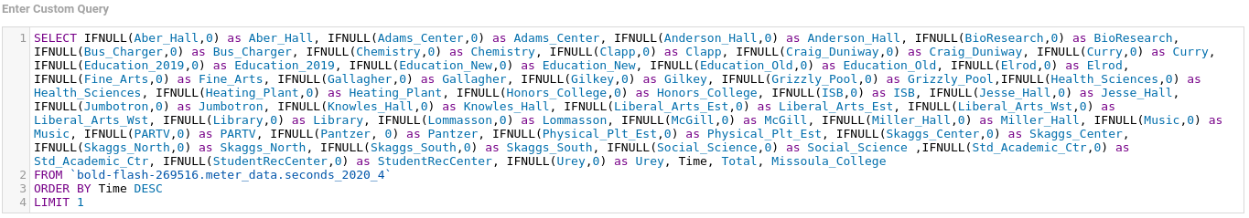
Figure 19: The query used for generating the Checkerboard on the dashboard.

Conclusion
This project gives UM Facilities insight into the current amount of energy being demanded by UM, allowing them to start to process of peak shaving in an effort to reduce energy costs. It utilizes a system that takes data from the energy meters around campus and displays that information in a near real-time dashboard, giving visibility to an otherwise hidden wealth of information. To do this, the meters are scraped by the Meter Scraping Program and this information is saved in a file in Google Drive. The Data Uploading Program then takes the file out of Google Drive, cleans the data, and uploads the data into Google BigQuery. Once in Google BigQuery this information can be used in multitudinous ways including displaying the data with the connected data visualization tool, Data Studio. Within Data Studio, the University of Montana Energy Dashboard was created to give UM Facilities the tools they need to identify peaks in energy demand. While this system does not paint a perfect picture of the real-time energy use on campus, it does do a great job of estimating that metric. Armed with this information and using the other tools at their disposal, UM Facilities may be able to reduce the energy utilized by campus during peak demand times, effectively peak shaving the amount of energy demanded. Ultimately, this project creates a wealth of data that can be utilized by students, faculty, and staff in countless ways, potentially saving money, providing insights, and guiding UM into a more sustainable future.

Sources:
Shark. (2012). Shark® 200 & 200T: Installation & Operation Manual. Westbury, NY: Electro Industries/GaugeTech.

