University of Montana Sustainability
Student, Faculty, and Staff Survey

Thomas Ray l Tony Layton l Will Ramsey
May 10, 2018
Advanced Marketing Research
MSBA, University of Montana

Table of Contents
Executive Summary 2
Introduction 3
Methods 3
Survey Breakdown 4
Gender 4
Campus Affiliation 4
Gender by Campus Affiliation 4
Age 5
Description of Survey Responses 6
Campus Commuting 6
Support for Current Initiatives 7
Adding Sustainability to Core Values 8
Combining Questions for Analysis 8
Attitudes 8
Engagement 9
Support 10
Personal Values 11
Segmentation 12
Clusters 12
Gender in Segments 13
UM Affiliation in Segments 13
Age in Segments 14
Commute Methods in Segments 15
T-Test 15
ANOVA 17
Regression 18
Regression #1 18
Regression #2 18
Regression #3 19
Regression #4 19
Regression #5 21
Regression #6 21
Key Insights 22
Appendix A – Survey 23
Appendix B – Descriptive Statistics 30
Appendix C – Exploratory Factor Analysis 40
Appendix D – Segmentation 43
Appendix E – T-Test 62
Appendix F – ANOVA 62
Appendix G – Regression 63

Executive Summary

Research Objectives
The goal of this study was to learn how members of our campus view sustainability, how they integrate it into their lives, and to gauge support for current and future campus initiatives.

Methods
A survey was developed in coordination with the UM Sustainability office. The intended target for the survey was the students and employees of the UM Mountain and Missoula College Campuses. The UM Sustainability Office sent emails to 1000 randomly selected students, faculty, and staff. In total, we received 156 completed responses.

Summary of Key Findings
The data gathered through our survey tells us that there is a wide range of opinions and perceptions of sustainability on campus. Respondents tended to have positive views when it comes to current initiatives and would like to see sustainability added to our list of core values.

In our analysis, we were able to identify four segments of respondents that possessed unique attributes related to sustainability. These segments ranged from high sustainability-focus to low sustainability-focus.

Key Insights
- When asked about their willingness to pay a carbon offset fee when buying parking passes, we received relatively high likeliness responses up to the $10 range.
- Students tend to care less about the environment when the success of the UM is at stake.
- We found variables that help explain the variance in the following dependent variables:
  - Likeliness to purchase carbon offsets at a range of $6-$10
  - Support for UM’s small-scale rooftop solar panels
  - Willingness to commute to campus by walking
  - Support of implementing more policies to encourage procurement of more sustainably produced goods for campus
  - Support of UM Dining prioritizing sourcing food from local, regional, and Montana producers whenever possible
  - Support of purchasing of carbon offsets to help achieve carbon neutrality

Introduction
The University of Montana’s Sustainability Office currently employees a multitude of initiatives in an ongoing effort to make our university more socially and environmentally sustainable. Aiming to educate UM affiliates on sustainable practices and integrate these ethics into our campus culture, they are currently seeking to expand campus initiatives and gain a better understanding of the UM’s sentiment towards sustainability.

The goal of this study was to learn how members of our campus view sustainability, how they integrate it into their lives, and to gauge support for current and future campus initiatives.

Methods
Our team developed a survey in coordination with the UM Sustainability office. The survey contained 18 questions related to sustainability on the UM campus and 5 demographic questions. The intended target for the survey was the students and employees of the UM Mountain and Missoula College Campuses. The survey was built in Qualtrics and distributed by use of an anonymous link in an email message. Respondents were not restricted from taking the survey multiple times.

We distributed the survey through newsletters published by the College of Business and W.A. Franke College of Forestry & Conservation and by emails sent the College of Health Professions & Biomedical Sciences and the professor teaching STAT 216. The UM Sustainability Office sent emails to 1000 randomly selected students, faculty, and staff. A follow-up email was sent to the randomly selected sample one week after the first email was sent.

We received 156 completed responses from our various efforts to distribute the survey. We received 66 responses prior to the distribution of the random sample and 90 responses after. A comparison of the two groups did not produce a significant difference in the response patterns.

Survey Breakdown

Gender:
The gender distribution of respondents for our survey was 59% female and 36% male, with 5% declining to identify. With the University of Montana’s percentage of females for faculty and students at 52% and 54% respectively, women were slightly over-represented in our survey.

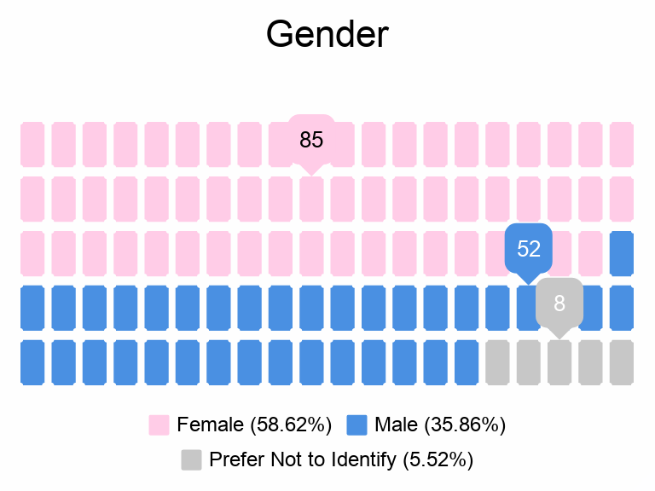
Figure 1: Gender Distribution

Campus Affiliation:
The respondents for our survey were 51% students and 49% Employees. Our survey was distributed to a random sample of UM affiliates, so this could indicate that faculty and staff were more apt to respond.
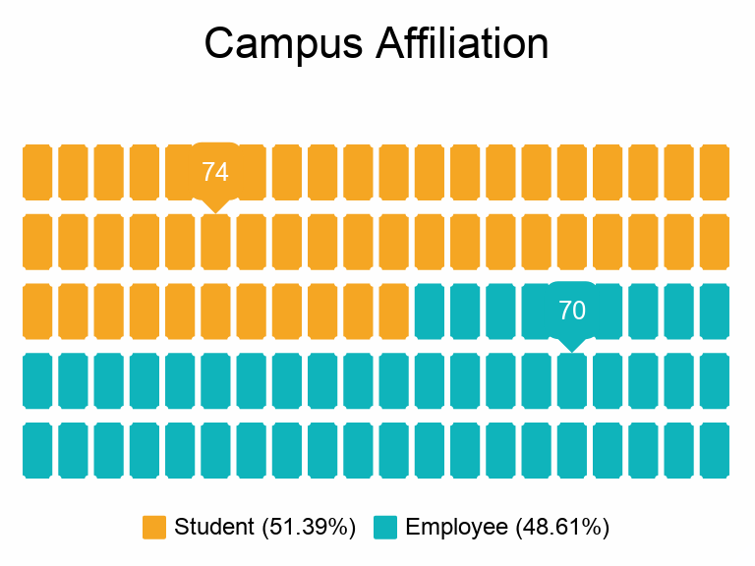
Figure 2: Campus Affiliation of Respondents

Gender By Campus Affiliation:
The largest groups of respondents were female employees and female students. These were followed by male students and male employees.

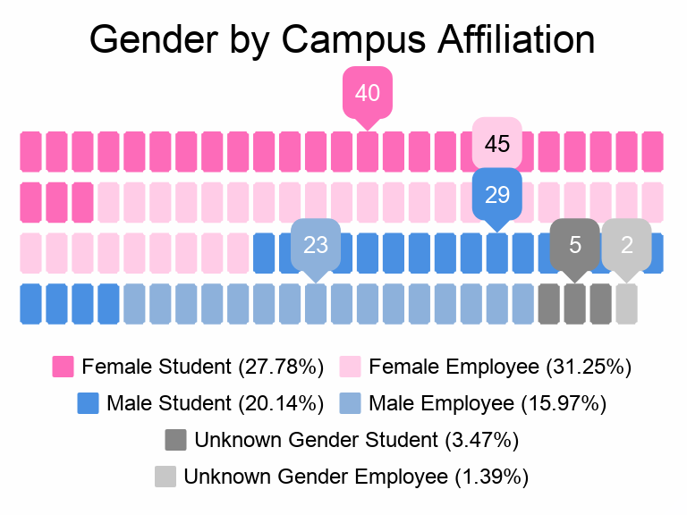
Figure 3: Gender by Campus Affiliation

Age:
Roughly half of our respondents were between the ages of 20 and 35. About 40% fell between the range of 36 and 55, and the responses outside of these ranges came to about 17%.

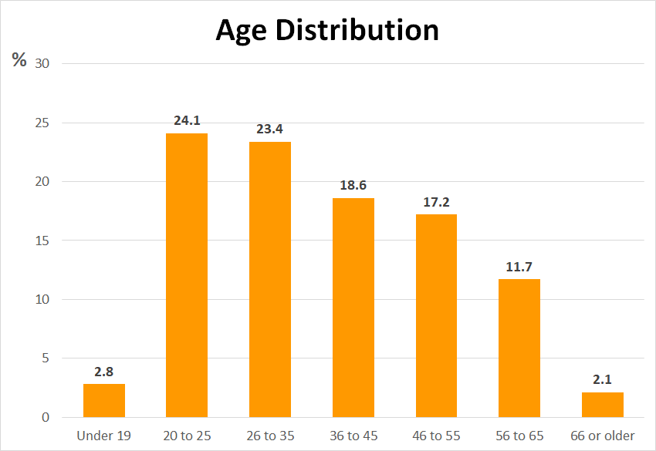
Figure 4: Age Distribution

Description of Survey Responses

Campus Commuting:
Not surprisingly, personal vehicles are the preferred commute method for the majority of UM students. However, there was still a positive response to more sustainable commuting methods. The responses to this question are not mutually exclusive.

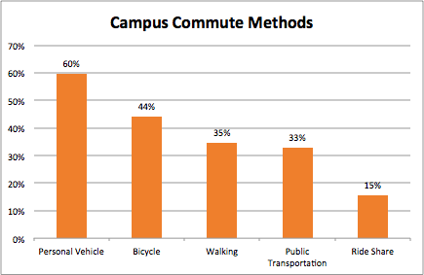
Figure 5: Respondent Commute Methods

Respondents were asked about campus commuting habits and gave us information about how many days per week, how many miles per day, and how many trips per day they take to campus. Included were students who live on campus, effectively bringing their commute times to zero.

 | Min. | Max. | Mean | Median | Stan. Dev.
Days/Week | 0 | 7 | 4.4 | 5 | 1.6
Miles/Day | 0 | 230 | 10.8 | 5 | 23.6
Trips/Day | 0 | 3 | 1.1 | 1 | .56
Table 1: Descriptives For Commuting

While 60% of our respondents use a personal vehicle to commute to campus, only 40% said that they buy a parking pass. We asked those that buy parking passes about their likeliness to pay a carbon offset fee with the purchase of their parking pass at 5 different price points. Figure 6 shows the results.

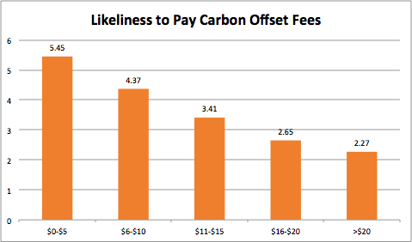
Figure 6: Willingness To Pay For Carbon Offsets

Support For Current Initiatives:
We asked respondents to gauge their support for the initiatives that the Sustainability Office currently pursues across the UM Campus. The initiatives received high marks across the board, however, the lowest rated was the support for the student sustainability fee.

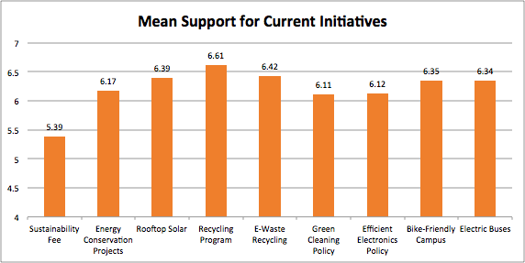
Figure 7: Current Initiative Support

Adding Sustainability To Core Values:
We also asked respondents to rate their level of support for adding sustainability to the UM’s list of core values (Create significant experiences, Build relationships, Be relevant, Act ethically and with integrity, Inspire individuals to thrive). Over half of those surveyed strongly agreed that sustainability should be added.

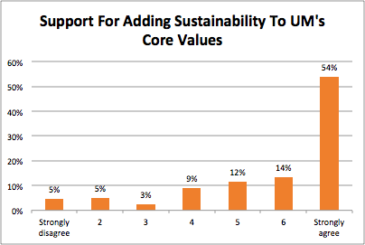
Figure 8: Core Value Support

Combining Questions for Analysis
In order for us to gain a better understanding of our respondents’ attitudes and actions of sustainability, we performed an exploratory factor analysis on the 70 7-point Likert scaled questions in our survey. Though some of these questions stand alone, we were able to combine many of them to create 10 new variables that explained respondents’ attitudes, engagement levels, support, and personal values related to sustainability. These new variables were used in conjunction with the singular variables to paint a better picture of sustainability at the UM.
The questions referenced in this section can be found in Appendix A. The rotated component matrices and Cronbach alphas for factored variables can be found in Appendix C.

Attitudes:
Variable Name: Att_Sust_Overall
Combining all of Question 1, this variable explains our respondents’ overall attitudes towards sustainability. They were asked general questions regarding the importance of protecting the environment, conserving natural resources, and government regulations

Variable Name: Att_Sust_UM
Combining Question 2_1 through Question 2_7, this variable explains overall attitudes toward sustainability at the UM. Questions asked pertained to growing sustainability initiatives on campus, protecting the campus environment, and promoting an environmental ethic on campus.

Variable Name: Att_Econ_Growth
This variable comes from Question 2_8, and asked whether or not the university should strive for economic growth even if it disregards the environment.

Variable Name: Att_Supp_Add_CoreValue
This variable comes from Question 2_9, and gauged support for adding sustainability to the UM’s list of core values.

Figure 9 shows the mean responses for these variables.
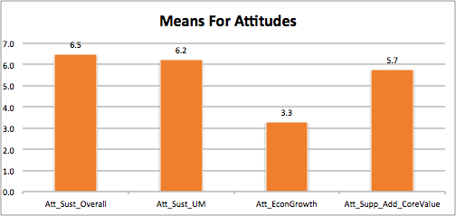
Figure 9: Means For Attitude Variables

Engagement:
Variable Name: Eng_Footprint_Reduction
Combining Question 3_7,8,11,12, and 13, this variable gauges how respondents are trying to reduce their carbon footprint by activities such as recycling, conserving water, and reducing waste.

Variable Name: Eng_Comm_Involv
Combing Question 3_4, 5, 14, 15, and 16, this variable measures respondents’ community involvement in sustainability-related activities. The questions asked pertaining to participation in educational opportunities, volunteering, and support of carbon neutrality at UM.

Variable Name: Eng_Home_Efficiency
This variable combines Question 3_1, 2, 3, and 10. In order to measure how our respondents are trying to make their homes more efficient, we asked questions regarding responsible light usage, heating and cooling practices, and the purchasing of efficient appliances.

Variable Name: Eng_Sust_Food
Combining Question 3_6 and 9, this variable concerns environmental food practices. Respondents were asked how often they compost food waste and whether or not they grow their own food.

Figure 10 shows the mean responses for the engagement variables.

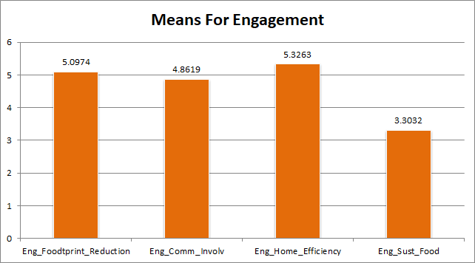
Figure 10: Mean Responses For Engagement Variables

Support:
Variable Name: Supp_PersInv_UM_Sust
Combining Question 4_1 and 3, this question measured desire to get more involved with sustainability efforts on campus. These questions gauged desire to do more to support sustainability on campus and to get involved with the sustainability office.

Variable Name: Supp_UM_Sust_Actions
Combing Q_5 through 9, these variable measures support for some of the UM’s sustainable actions. The questions asked pertained to using local foods and sustainably produced goods on campus, as well as support for carbon neutrality.

Variable Name: Supp_Stdt_Sust_Fee
This variable comes from Question 4_2, and gauges support for the student sustainability fee.

Variable Name: Supp_MorePer_Sust_Transptn
This variable comes from Question 4_4, which gauges commitment to using more sustainable modes of transportation.

Figure 11 shows the mean responses for the support variables.

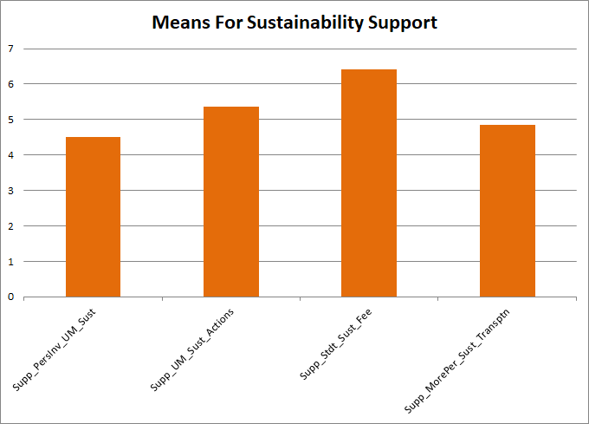
Figure 11: Mean Responses For Support Variables

Personal Values:
Variable Name: Personal_Control
This variable combines Question 5_1 through 5_4 and measures how much personal control respondents feel they have in performing sustainable actions. They were asked questions about how easy it is for them to make sustainable decisions or carry out sustainable actions.

Variable Name: Personal_Future_Involv
This variable combines Question 5_6 and 5_7 and measures personal values related to the intention of being more sustainably active in the future.

Variable Name: Personal_Sust_Averse
This variable was created from Question 5_8, which measured responses to the statement “I do not expect to increase my support for the environment.”

Variable Name: Personal_Sust_SocialNet
This variable came from Question 5_9, and measured how strongly respondents felt they were apart of a sustainably oriented social network.

Figure 12 shows the mean responses for personal value variables.

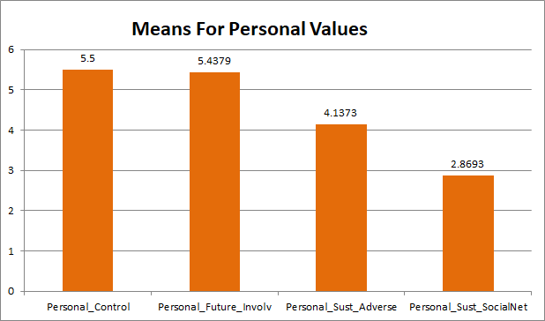
Figure 12: Mean Responses For Personal Values

Segmentation

Clusters:
In an effort to better understand our respondent population, we decided to run a cluster analysis. A cluster analysis can segment the 156 responders into distinct groups based on certain variables. We decided to cluster based on the Engagement variables, and as a result, identified four distinct clusters of UM affiliates. Results are seen in Table 2 and details can be found in Appendix D.

 | Green | Yellow | Amber | Red
Engages: Footprint Reduction | ⬤ 6.1 | ⬤ 5.5 | ⬤ 4.5 | ⬤ 3.1
Engages: Community Involvement | ⬤ 5.9 | ⬤ 5.2 | ⬤ 4.2 | ⬤ 3.1
Engages: Home Efficiency | ⬤ 5.9 | ⬤ 5.3 | ⬤ 5.5 | ⬤ 4.2
Engages: Sustainable Food | ⬤ 5.8 | ⬤ 2.0 | ⬤ 4.1 | ⬤ 1.2
Table 2: Cluster Analysis For Segmentation

The Green and Red clusters are the two extremes of our segments. They represent the highest and lowest engagement levels in all sustainability categories. The Yellow segment includes those who care about practicing their sustainability through their actions more than at home. Relative to the Yellow, the Amber segment ranks lower in outward sustainability practices, but tend to practice more efficiencies at home and are more likely to grow their own food.

Gender In Segments:
In Figure 13 we can see an interesting distribution of gender in our segments. As we move from left to right, we see an increase in the percentage of females and a decrease in the percentage of males until these patterns diverge in the Red segment.
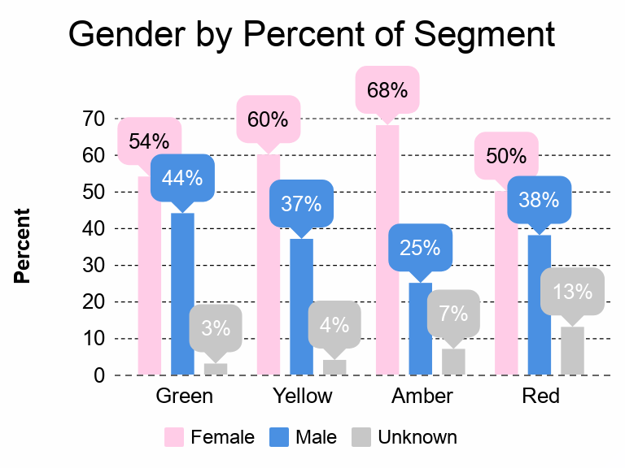
Figure 13: Gender by Percent of Segment

UM Affiliation in Segments:
When looking at the affiliation of segment members we see some interesting trends that will be confirmed by a T-Test in the next section. The Green segment is made up of over twice the amount of employees than students. The Red segment seems to have an inverse relationship with Green, telling us that employees could be more environmentally conscious than students. The Yellow segment is the group that has higher rates of activism and involvement, so it is logical that that more students fall into this segment, since they are often not striving for the home efficiencies that older respondents are prioritizing.
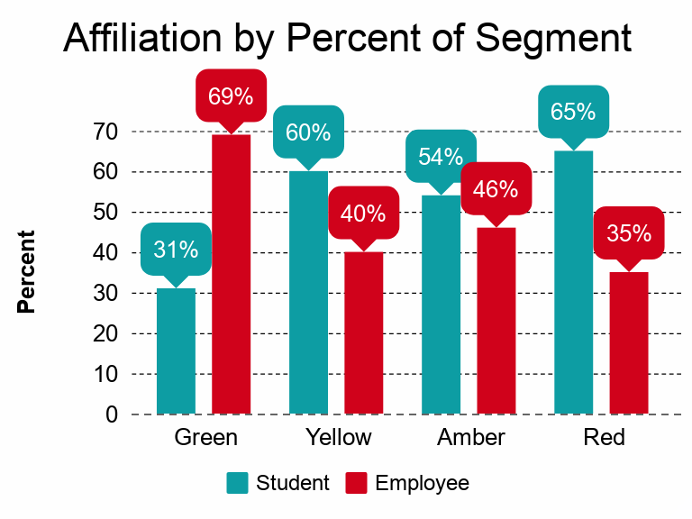
Figure 14: UM Affiliation by Percent of Segment

Age in Segments:
Figure 15 shows the age of respondents by percent of segments. In line with the results from affiliation, we see younger respondents leaning toward the less sustainable segments.

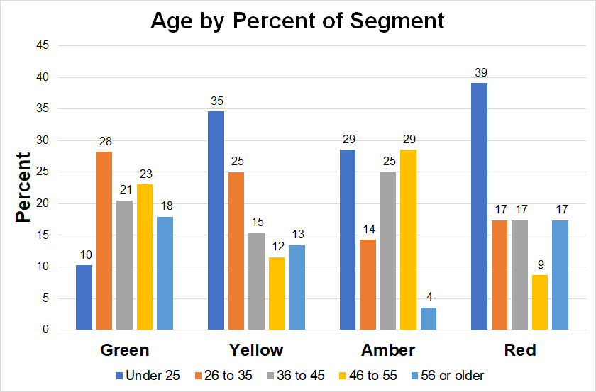
Figure 15: Age by Percent of Segment

Commute Methods in Segments:
Figure 16 shows the commuting methods for our segments. Unsurprisingly, members of the Red segment are the most likely to commute by personal vehicle and rank low in more sustainable forms of transportation. The Green segment ranks highly in all modes of sustainable transportation, with the exception of ridesharing.

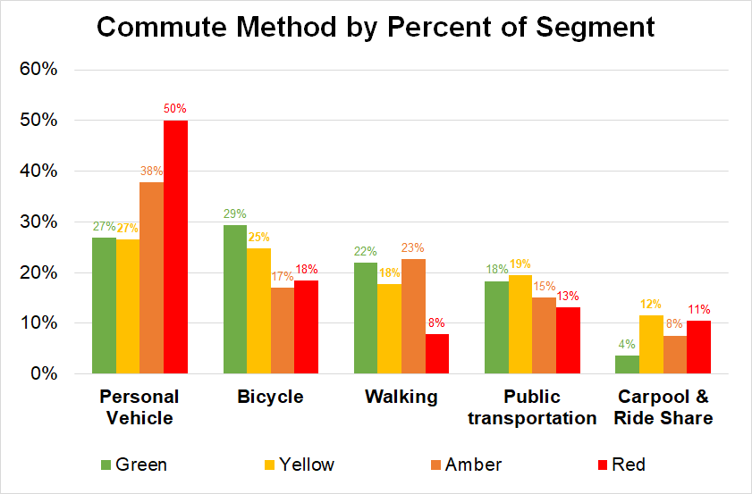
Figure 16: Commute Methods for Segments

T-Test
An interesting result we found regarded our respondents’ attitude towards the UM’s growth disregarding the environment. Seen in Figure 17, about a quarter of respondents strongly agreed that UM should strive for high amounts of economic growth even if it disregards the environment.
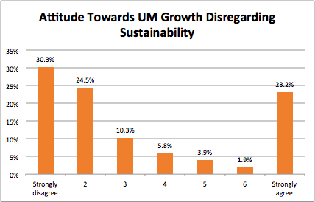
Figure 17: Economic Growth Preference

Many of those who strongly agreed with prioritizing economic growth also responded very positively to questions about sustainable practices at the UM. This indicates that while some respondents care about current sustainability, they will prioritize the growth of our university over the environment in the future.

To dig into this further, we ran a T-test to compare the mean responses of students and employees for this question and there was a statistically significant difference. See Appendix E for T-test results. According to the means plot, it seems that students tend to prioritize economic growth more than employees.

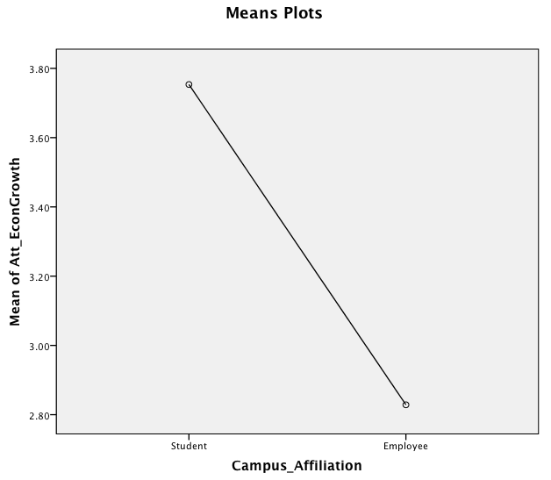
Figure 18: Means Plot For Students and Employees

ANOVA
Another interesting insight concerned gender and the likeliness to commute to campus by bike. According to our ANOVA test that compares mean responses, there is a statistically significant difference in male and female respondents’ willingness to commute to Campus by bicycle. See ANOVA results in Appendix F.

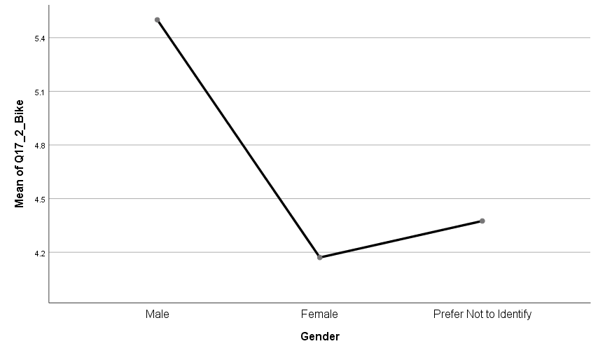
Figure 19: Means Plot For Bike Commuting By Gender

Regression
We attempted to find relationships between variables that would allow the prediction of some of the fundamental questions of the project. Most of the data were highly correlated and most of the relationship that we observed were obvious. The following regressions provide some insight into our project.

Regression #1
For this regression, we wanted to know what would predict the likeliness for support a fee added to parking permits for the purchase of carbon offsets at a rate of $6 to $10. We used questions 3.7, 5.1 and 5.7 as the variables to predict support for the offset fee. The three independent variables are listed below.

- Q3.7: I am conscious of my water footprint (Showering, Washing Dishes, etc.)
- Q5.1: It is easy for me to perform environmentally sustainable activities
- Q5.7: In the future, I plan to look into how I can play a greater role in protecting the environment

Question 5.7 is a dependent variable in of itself but it was used as an independent variable because it shows an attitude about protecting the environment. Our model resulted in an R-Squared of 0.379 indicating the 37.9% of the variance in the Carbon Offset question can be explained by the model. The model had an F-Stat of 9.146 and significance less than the 0.05 threshold indicating that the model is reliable in explaining the variance. The variable Q3.7 has a significance level 0.03 which is below the 0.05 significance threshold, thus we can state that support for the carbon offset will increase 0.5 points on a scale of 1 to 7 with every 1 point increase in the Q3.7 scale with all else being held constant. The other two variables are weakly significant in respect to the model with significance values of 0.58 for Q5.1 and 0.5 for Q5.7. Support for the carbon offsets increases 0.39 of 1 point on the scale for each variable. (The variables affect the model equally). Results of the regression can be found in Appendix G.

Regression #2
For this regression, we wanted to know what would predict the likeliness for support of UM’s Small Scale Rooftop Solar Panels. We used questions 3.1, 3.14 and 5.6 as the variables to predict support for the offset fee. The three independent variables are listed below.

- Q3.1: I switch off the light whenever leaving a room
- Q3.14: I vote for candidates proactive on environmental conservation
- Q5.6: I intend to seek out more opportunities to be more environmentally active in the future
Question 5.6 is a dependent variable in of itself but it was used as an independent variable because it shows an attitude about protecting the environment. Our model resulted in an R-Squared of 0.331 indicating the 33.1% of the variance in the Solar Rooftop question can be explained by the model. The model had an F-Stat of 23.924 and significance less than the 0.05 threshold indicating that the model is reliable in explaining the variance. The variable Q3.1 has a significance level 0.003 which indicates it is highly significant, thus we can state that support for the Solar Rooftop project will increase 0.25 points with every 1 point increase in the Q3.1 scale with all else being held constant. Q3.14 is also highly significant, support for the project will increase 0.24 points with each 1 point increase in Q3.14. Variable Q5.6 is barely significant and support of the project will increase 0.133 points with every 1 point increase in Q5.6. Results of the regression can be found in Appendix G.

Regression #3
For this regression, we wanted to know what would predict the willingness to commute to campus via walking. We used question 13b as the variable to predict the willingness to commute to campus. The independent variable is listed below.

- Q13b: On a typical day, how many minutes per round trip (to and from) do you spend commuting to and from campus via walking?

Our model resulted in an R-Squared of .092 indicating the 9.2% of the variance in a respondents willingness to commute to campus can be explained by our model. The model had an F-Stat of 4.88 and significance less than the 0.05 threshold indicating that the model is reliable in explaining the variance. The variable Q13b has a significance level 0.032 which indicates it is highly significant. With the willingness to commute via walking being constant at 6.261, our model demonstrates the impact of one additional minute to the round trip walking time will increase a respondents willingness to commute via walking by .011 on the 7 point scale. Results of the regression can be found in Appendix G.

Regression #4
For this regression, we wanted to know what would predict support of implementing more policies to encourage procurement of more sustainably produced goods for the campus. We used the independent listed below to predict the support.

- Attitude: Sustainability UM.
- Attitude: Value Economic Growth over Sustainability.
- Engages: Footprint Reduction.
- Engages: Community Involvement.
- Engages: Sustainable Food.
- Support: Personal Involvement in UM Sustainability.
- Willingness to commute to campus via bike.

Our model resulted in an R-Squared of .656 indicating 65.6% of the variance in a respondents support of implementing more policies to encourage procurement of more sustainably produced goods for campus. The model had an F-Stat of 41.044 and significance less than the 0.05 threshold indicating that the model is reliable in explaining the variance.

Each variable was significant as demonstrated in variable “Attitude: Sustainability UM” with a significance level 0.032, the variable “Attitude: Value Economic Growth over Sustainability” with a significance level 0.000, the variable “Engages: Footprint Reduction” with a significance level 0.001, the variable “engages: Community Involvement” has a significance level 0.000, the variable “engages: Sustainable Food” has a significance level 0.040, the variable “support: Personal Involvement in UM Sustainability” has a significance level 0.000, and the variable “willingness to commute to campus via bike” has a significance level 0.008.

With the support of implementing more policies to encourage procurement of more sustainably produced goods for campus being constant at -.332, our model demonstrates the impact of one more point of att_Sust_UM will increase support by .440 on the 7 point scale. The impact of one more point of Att_EconGrowth will decrease support by .134 on the 7 point scale. The impact of one more point ofEng_Foodtprint_Reduction will increase support by .319 on the 7 point scale. The impact of one more point of Eng_Sust_Food will decrease support by .108 on the 7 point scale. The impact of one more point of Supp_PersInv_UM_Sust will increase support by .370 on the 7 point scale. The impact of one more point of Q17_2_Bike will increase support by .111 on the 7 point scale. Results of the regression can be found in Appendix G.

Regression #5
For this regression, we wanted to know what would predict support of UM Dining prioritizing sourcing food from local, regional, and Montana producers whenever possible. We used the independent variables listed below to predict the support of UM Dining prioritizing sourcing food from local, regional, and Montana producers whenever possible.

- Attitude: Sustainability Overall
- Attitude: Sustainability UM
- Engages: Footprint Reduction
- Engages: Community Involvement
- Personal: Control
Our model resulted in an R-Squared of .398 indicating the 39.8% of the variance in respondents support of UM Dining prioritizing sourcing food from local, regional, and Montana producers whenever possible. The model had a significance of less than the 0.05 threshold indicating that the model is reliable in explaining the variance. Each variable was significant as demonstrated in variable “Att_Sust_Overall” with a significance level 0.029, variable “Att_Sust_UM” with a significance level 0.005, variable “Eng Footprint Reduction” with a significance level 0.014, variable “Eng_Comm_Involv” with a significance level 0.54, and variable “Personal_Control” with a significance level 0.004.

With the support of UM Dining prioritizing sourcing food from local, regional, and Montana producers whenever possible being constant at 2.519, our model demonstrates the impact of an increase in one unit of Att_Sust_Overall will decrease support by .384 on the 7 point scale, the impact of an increase in one unit of Att_Sust_UM will increase support by .456 on the 7 point scale, the impact of an increase in one unit of Eng_Foodtprint_Reduction will increase support by .211 on the 7 point scale, the impact of an increase in one unit of Eng_Comm_Involv will increase support by .204 on the 7 point scale, the impact of an increase in one unit of Personal_Controlwill increase support by .234 on the 7 point scale.
Results of the regression can be found in Appendix G.

Regression #6
For this regression, we wanted to know what would predict the support of purchasing of carbon offsets to help achieve carbon neutrality. We used the independent variables listed below to predict the support of purchasing of carbon offsets to help achieve carbon neutrality.

- Attitude: Support Adding it as a Core Value
- Engages: Community Involvement
- Personal: Sustainability Social Network
Our model resulted in an R-Squared of .509 indicating the 50.9% of the variance in respondents support of purchasing of carbon offsets to help achieve carbon neutrality.
The model had an F-Stat of 50.042 and significance less than the 0.05 threshold indicating that the model is reliable in explaining the variance.

Each variable was significant as demonstrated in variable “Personal_Sust_SocialNet” with a significance level 0.000, variable “Att_Supp_Add_CoreValue” with a significance level 0.000, and variable “Eng_Comm_Involv” with a significance level 0.031.

With the support of purchasing of carbon offsets to help achieve carbon neutrality being constant at -.215, our model demonstrates the impact of an increase in one unit of “Personal_Sust_SocialNet” will increase support by .351 on the 7 point scale, the impact of an increase in one unit of “Att_Supp_Add_CoreValue” will increase support by .510 on the 7 point scale, and the impact of an increase in one unit of “Eng_Comm_Involv” will increase support by .146 on the 7 point scale. Results of the regression can be found in Appendix G.

Key Insights
The data gathered through our survey tells us that there is a wide range of opinions and perceptions of sustainability on campus. Respondents tended to have positive views when it comes to current initiatives and would like to see sustainability added to our list of core values. When asked about their willingness to pay a carbon offset fee when buying parking passes, we received relatively high likeliness responses up to the $10 range.

In our analysis, we were able to identify four segments of respondents that possessed unique attributes related to sustainability. These segments ranged from high sustainability-focus to low sustainability-focus.

Through a T-Test, we found that employees tend to have a stronger belief that the university should balance its growth with sustainable practices. Students tend to care less about the environment when the success of the UM is at stake. We were also able to identify statistical differences in how men and women commute. For UM affiliates, men are more likely to be willing to commute by bicycle than women.

In our regression analysis, we were able to find independent variables that help explain the variance in the following dependent variables:

- Likeliness to purchase carbon offsets at a range of $6-$10
- Support for UM’s small-scale rooftop solar panels
- Willingness to commute to campus by walking
- Support of implementing more policies to encourage procurement of more sustainably produced goods for campus
- Support of UM Dining prioritizing sourcing food from local, regional, and Montana producers whenever possible
- Support of purchasing of carbon offsets to help achieve carbon neutrality

Having some insight into these variables can help us identify what informs our community’s view of sustainability.

More in-depth research into activities that influence people to make sustainable decisions would be helpful. Anyone can say that they support sustainability on campus, but it is difficult to gauge what really influences a person to act sustainably.

Appendix

Appendix A - Survey
Q1: What is your attitude toward environmental sustainability in general?

 | Strongly disagree |  |  |  |  |  | Strongly agree
a. In my opinion, it is important to protect the environment | ⌾ | ⌾ | ⌾ | ⌾ | ⌾ | ⌾ | ⌾
b. Everyone is responsible for caring for the environment | ⌾ | ⌾ | ⌾ | ⌾ | ⌾ | ⌾ | ⌾
c. I am concerned about the long-term future of the environment | ⌾ | ⌾ | ⌾ | ⌾ | ⌾ | ⌾ | ⌾
d. In my opinion, it is important to conserve natural resources | ⌾ | ⌾ | ⌾ | ⌾ | ⌾ | ⌾ | ⌾
e. Environmental sustainability in our community must be prioritized now and in the future | ⌾ | ⌾ | ⌾ | ⌾ | ⌾ | ⌾ | ⌾
f. The diversity of nature must be valued and protected | ⌾ | ⌾ | ⌾ | ⌾ | ⌾ | ⌾ | ⌾
g. Regulatory environmental standards are needed to reduce negative impacts on the environment | ⌾ | ⌾ | ⌾ | ⌾ | ⌾ | ⌾ | ⌾

Q2: What is your attitude toward sustainability efforts at UM and in the Missoula community (carbon neutrality, recycling, etc.)?

 | Strongly disagree |  |  |  |  |  | Strongly agree
a. I think that UM should continue to grow its sustainability initiatives and prioritize efforts that support environmental conservation | ⌾ | ⌾ | ⌾ | ⌾ | ⌾ | ⌾ | ⌾
b. UM must aim to protect the campus environment | ⌾ | ⌾ | ⌾ | ⌾ | ⌾ | ⌾ | ⌾
c. UM’s growth and development should strongly consider environmental impacts | ⌾ | ⌾ | ⌾ | ⌾ | ⌾ | ⌾ | ⌾
d. Proper UM growth requires that wildlife and natural habitats be protected at all times | ⌾ | ⌾ | ⌾ | ⌾ | ⌾ | ⌾ | ⌾
e. UM must promote an environmental ethic among the campus community | ⌾ | ⌾ | ⌾ | ⌾ | ⌾ | ⌾ | ⌾
f. UM should also promote environmental ethics throughout the broader Missoula community | ⌾ | ⌾ | ⌾ | ⌾ | ⌾ | ⌾ | ⌾
g. I believe that UM must improve the environment for future generations | ⌾ | ⌾ | ⌾ | ⌾ | ⌾ | ⌾ | ⌾
h. UM should strive to achieve high levels of economic growth even if it disregards the environment | ⌾ | ⌾ | ⌾ | ⌾ | ⌾ | ⌾ | ⌾
i. I think sustainability should be added to the list of UM's core values (Create Significant Experiences, Build Relationships, Be Relevant, Act Ethically and With Integrity, Inspire Individuals to Thrive) | ⌾ | ⌾ | ⌾ | ⌾ | ⌾ | ⌾ | ⌾

Q3: To what extent do you engage in the following behaviors that limit your carbon footprint?

 | Never |  |  |  |  |  | Always
a. I switch off the light whenever leaving a room | ⌾ | ⌾ | ⌾ | ⌾ | ⌾ | ⌾ | ⌾
b. I turn off heating/ air conditioning in unoccupied rooms | ⌾ | ⌾ | ⌾ | ⌾ | ⌾ | ⌾ | ⌾
c. I seal doors and windows to improve the efficiency of spaces at home and at work. | ⌾ | ⌾ | ⌾ | ⌾ | ⌾ | ⌾ | ⌾
d. I enjoy and partake in educational opportunities related to sustainability (articles, books, films, etc.) | ⌾ | ⌾ | ⌾ | ⌾ | ⌾ | ⌾ | ⌾
e. I volunteer for community events that support sustainability | ⌾ | ⌾ | ⌾ | ⌾ | ⌾ | ⌾ | ⌾
f. I grow my own food | ⌾ | ⌾ | ⌾ | ⌾ | ⌾ | ⌾ | ⌾
g. I am conscious of my water footprint when showering, washing dishes, or performing other daily activities | ⌾ | ⌾ | ⌾ | ⌾ | ⌾ | ⌾ | ⌾
h. I recycle as often as possible | ⌾ | ⌾ | ⌾ | ⌾ | ⌾ | ⌾ | ⌾
i. I compost food scraps | ⌾ | ⌾ | ⌾ | ⌾ | ⌾ | ⌾ | ⌾
j. When purchasing electronics or appliances, I intentionally shop for those that are EPEAT or Energy Star certified so that I know I’m buying a more energy efficient product | ⌾ | ⌾ | ⌾ | ⌾ | ⌾ | ⌾ | ⌾
k. I try to avoid disposables and one-use products and opt for buying in bulk or refilling reusable containers whenever possible | ⌾ | ⌾ | ⌾ | ⌾ | ⌾ | ⌾ | ⌾
l. I take reusable bags when shopping | ⌾ | ⌾ | ⌾ | ⌾ | ⌾ | ⌾ | ⌾
m. I prioritize active, sustainable modes of transportation such as biking, walking, or public transportation | ⌾ | ⌾ | ⌾ | ⌾ | ⌾ | ⌾ | ⌾
n. I vote for candidates who take a proactive stance on environmental conservation | ⌾ | ⌾ | ⌾ | ⌾ | ⌾ | ⌾ | ⌾
o. I understand the concept of carbon neutrality and support the city of Missoula and UM in striving to meet this goal | ⌾ | ⌾ | ⌾ | ⌾ | ⌾ | ⌾ | ⌾
p. When purchasing products, I am willing to pay a 10% price premium for products that are produced sustainability. | ⌾ | ⌾ | ⌾ | ⌾ | ⌾ | ⌾ | ⌾

Q4: To what extent do you agree with the following statements about sustainability at UM?

 | Strongly disagree |  |  |  |  |  | Strongly agree
a. I want to do more to support sustainability on campus | ⌾ | ⌾ | ⌾ | ⌾ | ⌾ | ⌾ | ⌾
b. I pay the sustainability fee with my registration bill every semester (students only) | ⌾ | ⌾ | ⌾ | ⌾ | ⌾ | ⌾ | ⌾
c. I’m interested in getting involved with the sustainability office | ⌾ | ⌾ | ⌾ | ⌾ | ⌾ | ⌾ | ⌾
d. I have (or will) commit to taking a more sustainable form of transportation when commuting to campus | ⌾ | ⌾ | ⌾ | ⌾ | ⌾ | ⌾ | ⌾
e. UM should implement more policies to encourage procurement of more sustainability produced goods for campus | ⌾ | ⌾ | ⌾ | ⌾ | ⌾ | ⌾ | ⌾
f. I think it’s important that UM Dining prioritizes sourcing food from local, regional, and Montana producers whenever possible. | ⌾ | ⌾ | ⌾ | ⌾ | ⌾ | ⌾ | ⌾
g. UM should purchase carbon offsets to help achieve carbon neutrality | ⌾ | ⌾ | ⌾ | ⌾ | ⌾ | ⌾ | ⌾
h. All new buildings on campus should be carbon neutral. | ⌾ | ⌾ | ⌾ | ⌾ | ⌾ | ⌾ | ⌾
i. UM should prioritize our sustainability commitments by establishing a “zero net growth” building policy that requires all new construction to be offset by eliminating old or outdated existing square footage. | ⌾ | ⌾ | ⌾ | ⌾ | ⌾ | ⌾ | ⌾

Q5: Please rate your level of agreement with the following statements.

 | Strongly disagree |  |  |  |  |  | Strongly agree
a. It is easy for me to perform environmentally sustainable activities (e.g., energy conservation, recycling) | ⌾ | ⌾ | ⌾ | ⌾ | ⌾ | ⌾ | ⌾
b. I have control over the behaviors that I know improve my ecological footprint | ⌾ | ⌾ | ⌾ | ⌾ | ⌾ | ⌾ | ⌾
c. It is my decision whether or not to perform environmentally sustainable activities | ⌾ | ⌾ | ⌾ | ⌾ | ⌾ | ⌾ | ⌾
d. I have the ability to carry out environmentally sustainable activities | ⌾ | ⌾ | ⌾ | ⌾ | ⌾ | ⌾ | ⌾
e. I strive to be mindful of the activities and choices that impact my carbon footprint (e.g., energy conservation, recycling) | ⌾ | ⌾ | ⌾ | ⌾ | ⌾ | ⌾ | ⌾
f. I intend to seek out more opportunities to be more environmentally active in the future | ⌾ | ⌾ | ⌾ | ⌾ | ⌾ | ⌾ | ⌾
g. In the future, I plan to look into how I can play a greater role in protecting the environment | ⌾ | ⌾ | ⌾ | ⌾ | ⌾ | ⌾ | ⌾
h. I do not expect to increase my level of support for the environment | ⌾ | ⌾ | ⌾ | ⌾ | ⌾ | ⌾ | ⌾
i. I am part of a social network that is sustainability oriented | ⌾ | ⌾ | ⌾ | ⌾ | ⌾ | ⌾ | ⌾

Q6: Please rate your support of UM’s current initiatives and sustainability efforts.

 | Strongly Oppose |  |  |  |  |  | Strongly Support
a. Student Sustainability fee | ⌾ | ⌾ | ⌾ | ⌾ | ⌾ | ⌾ | ⌾
b. Energy conservation projects around campus | ⌾ | ⌾ | ⌾ | ⌾ | ⌾ | ⌾ | ⌾
c. Small scale rooftop solar | ⌾ | ⌾ | ⌾ | ⌾ | ⌾ | ⌾ | ⌾
d. Recycling program | ⌾ | ⌾ | ⌾ | ⌾ | ⌾ | ⌾ | ⌾
e. E-waste recycling | ⌾ | ⌾ | ⌾ | ⌾ | ⌾ | ⌾ | ⌾
f. Green cleaning product policy | ⌾ | ⌾ | ⌾ | ⌾ | ⌾ | ⌾ | ⌾
g. Energy efficient electronics purchasing policy | ⌾ | ⌾ | ⌾ | ⌾ | ⌾ | ⌾ | ⌾
h. Gold-rated bike friendly campus | ⌾ | ⌾ | ⌾ | ⌾ | ⌾ | ⌾ | ⌾
i. Electric buses | ⌾ | ⌾ | ⌾ | ⌾ | ⌾ | ⌾ | ⌾

Q7: In a typical week, how many days per week do you commute to/from campus?
Q8: On a typical day, how many miles do you commute to/from campus? (round trip)
Q9: On a typical day commuting to/from campus, how many round trips do you take to/from campus?

Q10: Which of the following methods do you use to commute to and from the UM campus? (check all that apply)
▢ Personal Vehicle (without other occupants)
▢ Bicycle
▢ Walking
▢ Motorcycle/ ATV/ Scooter (greater than 50cc)
▢ Public transportation
▢ Car pool or ride sharing

Q11a: In a typical week, how many days per week do you commute to/from campus via personal vehicle (without other occupants)?

Q11b: On a typical day, how many minutes per round trip (to and from) do you spend commuting to and from campus via personal vehicle (without other occupants)?

Q12a: In a typical week, how many days per week do you commute to/from campus via bicycle?

Q12b: On a typical day, how many minutes per round trip (to and from) do you spend commuting to campus via bicycle?

Q13a: In a typical week, how many days per week do you commute to/from campus via walking?

Q13b: On a typical day, how many minutes per round trip (to and from) do you spend commuting to and from campus via walking?

Q14a: In a typical week, how many days per week do you commute to/from campus via motorcycle/ ATV/ or scooter (greater than 50cc)?

Q14b: On a typical day, how many minutes per round trip (to and from) do you spend commuting to campus via motorcycle/ ATV/ or scooter (greater than 50cc)?
Q15a: In a typical week, how many days per week do you commute to/from campus via bus or public transportation?

Q15b: On a typical day, how many minutes per round trip (to and from) do you spend commuting to campus via bus or public transportation?

Q16a: In a typical week, how many days per week do you commute to/from campus via carpool or ride-share (2 or more occupants in the vehicle)?

Q16b: On a typical day, how many minutes per round trip (to and from) do you spend commuting to and from campus via carpool or ride-share?
Q16c: Counting yourself, how many people do you typically carpool or ride-share to/from campus with?
Q16d: Whom do you typically carpool or ride-share to campus with? (check all that apply)
⚪ Student
⚪ Employee
⚪ Non-UM affiliated community member

Q17: Please rate your willingness to commute to/from campus via the following methods.

 | Very Unwilling |  |  |  |  |  | Very Willing
a. Automobile (without other occupants) | ⌾ | ⌾ | ⌾ | ⌾ | ⌾ | ⌾ | ⌾
b. Bicycle | ⌾ | ⌾ | ⌾ | ⌾ | ⌾ | ⌾ | ⌾
c. Walking | ⌾ | ⌾ | ⌾ | ⌾ | ⌾ | ⌾ | ⌾
d. Motorcycle/ ATV/ Scooter (greater than 50cc) | ⌾ | ⌾ | ⌾ | ⌾ | ⌾ | ⌾ | ⌾
e. Public transportation | ⌾ | ⌾ | ⌾ | ⌾ | ⌾ | ⌾ | ⌾
d. Car pool or ride sharing | ⌾ | ⌾ | ⌾ | ⌾ | ⌾ | ⌾ | ⌾

Q18: Do you purchase a parking pass?
⚪ Yes
⚪ No

Q18b: Please rate your likeliness to pay the following fees associated with parking permits to purchase carbon offsets that directly offset emissions generated from vehicle commuting to and from campus by UM affiliates.

 | Very Unwilling |  |  |  |  |  | Very Willing
$0-$5 | ⌾ | ⌾ | ⌾ | ⌾ | ⌾ | ⌾ | ⌾
$6-$10 | ⌾ | ⌾ | ⌾ | ⌾ | ⌾ | ⌾ | ⌾
$11-$15 | ⌾ | ⌾ | ⌾ | ⌾ | ⌾ | ⌾ | ⌾
$16-$20 | ⌾ | ⌾ | ⌾ | ⌾ | ⌾ | ⌾ | ⌾
>$20 | ⌾ | ⌾ | ⌾ | ⌾ | ⌾ | ⌾ | ⌾

Q19: What is your gender?
⚪ Male
⚪ Female
⚪ Prefer Not to Identify
Q20: What is your primary affiliation?
⚪ Faculty
⚪ Staff
⚪ Graduate Student
⚪ Undergraduate Student
⚪ Contract Professional

Q21: If “What is your primary affiliation?” Graduate Student Is Selected or “What is your primary affiliation?” Undergraduate Student Is Selected

What is your department?
⚪ College of Humanities and Sciences
⚪ Phyllis J. Washington College of Education and Human Sciences
⚪ W.A. Franke College of Forestry and Conservation
⚪ College of Health Professions and Biomedical Sciences
⚪ Missoula College
⚪ Bitterroot College
⚪ College of Business
⚪ School of Journalism
⚪ Alexander Blewett III School of Law
⚪ College of Visual and Performing Arts
⚪ Other

Q22: If “What is your primary affiliation?” Faculty Is Selected
What is your department?
⚪ College of Humanities and Sciences
⚪ Phyllis J. Washington College of Education and Human Sciences
⚪ W.A. Franke College of Forestry and Conservation
⚪ College of Health Professions and Biomedical Sciences
⚪ Missoula College
⚪ Bitterroot College
⚪ College of Business
⚪ School of Journalism
⚪ Alexander Blewett III School of Law
⚪ College of Visual and Performing Arts
⚪ University Administration
⚪ Other

Q23: What is your age?
⚪ Under 19
⚪ 20 to 25
⚪ 26 to 35
⚪ 36 to 45
⚪ 46 to 55
⚪ 56 to 65
⚪ 66 or older

Appendix B - Descriptives

Q1: What is your attitude toward environmental sustainability in general?

 | Strongly disagree |  |  |  |  |  | Strongly agree | Mean | SD
a. In my opinion, it is important to protect the environment | 2 | 1 | 0 | 3 | 7 | 13 | 130 | 6.66 | 0.974
b. Everyone is responsible for caring for the environment | 1 | 3 | 0 | 7 | 6 | 17 | 122 | 6.54 | 1.086
c. I am concerned about the long-term future of the environment | 4 | 1 | 3 | 5 | 7 | 14 | 122 | 6.46 | 1.292
d. In my opinion, it is important to conserve natural resources | 1 | 0 | 2 | 5 | 16 | 15 | 117 | 6.51 | 1.000
e. Environmental sustainability in our community must be prioritized now and in the future | 3 | 2 | 1 | 8 | 9 | 18 | 115 | 6.41 | 1.259
f. The diversity of nature must be valued and protected | 1 | 3 | 5 | 2 | 12 | 13 | 120 | 6.46 | 1.204
g. Regulatory environmental standards are needed to reduce negative impacts on the environment | 3 | 0 | 7 | 7 | 12 | 20 | 107 | 6.29 | 1.325

Q2: What is your attitude toward sustainability efforts at UM and in the Missoula community (carbon neutrality, recycling, etc.)?

 | Strongly disagree |  |  |  |  |  | Strongly agree | Mean | SD
a. I think that UM should continue to grow its sustainability initiatives and prioritize efforts that support environmental conservation | 3 | 0 | 5 | 6 | 7 | 21 | 114 | 6.42 | 1.239
b. UM must aim to protect the campus environment | 3 | 1 | 1 | 5 | 13 | 25 | 108 | 6.4 | 1.179
c. UM’s growth and development should strongly consider environmental impacts | 3 | 1 | 1 | 8 | 11 | 20 | 112 | 6.4 | 1.217
d. Proper UM growth requires that wildlife and natural habitats be protected at all times | 4 | 4 | 6 | 9 | 27 | 24 | 81 | 5.88 | 1.529
e. UM must promote an environmental ethic among the campus community | 4 | 0 | 4 | 9 | 11 | 23 | 105 | 6.28 | 1.333
f. UM should also promote environmental ethics throughout the broader Missoula community | 5 | 1 | 7 | 9 | 16 | 24 | 94 | 6.06 | 1.501
g. I believe that UM must improve the environment for future generations | 4 | 0 | 7 | 11 | 14 | 21 | 99 | 6.14 | 1.43
h. UM should strive to achieve high levels of economic growth even if it disregards the environment | 47 | 38 | 16 | 9 | 6 | 3 | 36 | 3.27 | 2.35
i. I think sustainability should be added to the list of UM's core values (Create Significant Experiences, Build Relationships, Be Relevant, Act Ethically and With Integrity, Inspire Individuals to Thrive) | 7 | 8 | 4 | 14 | 18 | 21 | 84 | 5.74 | 1.771

Q3: To what extent do you engage in the following behaviors that limit your carbon footprint?

 | Never |  |  |  |  |  | Always | Mean | SD
a. I switch off the light whenever leaving a room | 1 | 0 | 2 | 5 | 22 | 47 | 79 | 6.23 | 1.002
b. I turn off heating/ air conditioning in unoccupied rooms | 7 | 5 | 6 | 19 | 27 | 33 | 58 | 5.48 | 1.668
c. I seal doors and windows to improve the efficiency of spaces at home and at work. | 10 | 6 | 9 | 23 | 21 | 42 | 43 | 5.19 | 1.774
d. I enjoy and partake in educational opportunities related to sustainability (articles, books, films, etc.) | 11 | 12 | 15 | 30 | 40 | 23 | 24 | 4.55 | 1.733
e. I volunteer for community events that support sustainability | 25 | 22 | 18 | 45 | 26 | 12 | 7 | 3.57 | 1.69
f. I grow my own food | 49 | 22 | 12 | 16 | 23 | 18 | 15 | 3.36 | 2.144
g. I am conscious of my water footprint when showering, washing dishes, or performing other daily activities | 3 | 6 | 17 | 27 | 35 | 37 | 30 | 5.04 | 1.516
h. I recycle as often as possible | 3 | 8 | 8 | 12 | 15 | 36 | 73 | 5.76 | 1.616
i. I compost food scraps | 58 | 24 | 11 | 12 | 10 | 14 | 26 | 3.25 | 2.336
j. When purchasing electronics or appliances, I intentionally shop for those that are EPEAT or Energy Star certified so that I know I’m buying a more energy efficient product | 21 | 16 | 9 | 24 | 30 | 29 | 26 | 4.4 | 2.002
k. I try to avoid disposables and one-use products and opt for buying in bulk or refilling reusable containers whenever possible | 6 | 5 | 15 | 23 | 36 | 30 | 40 | 5.12 | 1.635
l. I take reusable bags when shopping | 19 | 7 | 10 | 18 | 26 | 29 | 45 | 4.9 | 2.033
m. I prioritize active, sustainable modes of transportation such as biking, walking, or public transportation | 12 | 15 | 19 | 22 | 25 | 27 | 35 | 4.64 | 1.927
n. I vote for candidates who take a proactive stance on environmental conservation | 8 | 7 | 2 | 21 | 22 | 26 | 69 | 5.55 | 1.755
o. I understand the concept of carbon neutrality and support the city of Missoula and UM in striving to meet this goal | 6 | 3 | 10 | 15 | 32 | 29 | 60 | 5.52 | 1.621
p. When purchasing products, I am willing to pay a 10% price premium for products that are produced sustainability. | 12 | 6 | 6 | 17 | 41 | 35 | 38 | 5.1 | 1.751

Q4: To what extent do you agree with the following statements about sustainability at UM?

 | Never |  |  |  |  |  | Always | Mean | SD
a. I want to do more to support sustainability on campus | 8 | 6 | 4 | 26 | 29 | 30 | 50 | 5.3 | 1.702
b. I pay the sustainability fee with my registration bill every semester (students only) | 21 | 2 | 3 | 10 | 7 | 11 | 43 | 4.91 | 2.411
c. I’m interested in getting involved with the sustainability office | 25 | 24 | 18 | 35 | 14 | 19 | 17 | 3.75 | 1.947
d. I have (or will) commit to taking a more sustainable form of transportation when commuting to campus | 17 | 15 | 7 | 23 | 19 | 16 | 55 | 4.84 | 2.138
e. UM should implement more policies to encourage procurement of more sustainability produced goods for campus | 7 | 5 | 7 | 19 | 29 | 25 | 61 | 5.46 | 1.701
f. I think it’s important that UM Dining prioritizes sourcing food from local, regional, and Montana producers whenever possible. | 2 | 2 | 2 | 8 | 16 | 32 | 91 | 6.23 | 1.233
g. UM should purchase carbon offsets to help achieve carbon neutrality | 14 | 7 | 9 | 28 | 28 | 24 | 40 | 4.87 | 1.891
h. All new buildings on campus should be carbon neutral. | 4 | 2 | 4 | 23 | 23 | 33 | 64 | 5.71 | 1.482
i. UM should prioritize our sustainability commitments by establishing a “zero net growth” building policy that requires all new construction to be offset by eliminating old or outdated existing square footage. | 17 | 11 | 10 | 32 | 19 | 21 | 42 | 4.68 | 2.021

Q5: Please rate your level of agreement with the following statements.

 | Strongly  Disagree |  |  |  |  |  | Strongly Agree | Mean | SD
a. It is easy for me to perform environmentally sustainable activities (e.g., energy conservation, recycling) | 3 | 11 | 13 | 28 | 45 | 30 | 24 | 4.86 | 1.513
b. I have control over the behaviors that I know improve my ecological footprint | 0 | 3 | 11 | 15 | 49 | 37 | 39 | 5.45 | 1.273
c. It is my decision whether or not to perform environmentally sustainable activities | 0 | 2 | 10 | 12 | 31 | 39 | 60 | 5.79 | 1.288
d. I have the ability to carry out environmentally sustainable activities | 0 | 2 | 6 | 7 | 36 | 42 | 61 | 5.9 | 1.17
e. I strive to be mindful of the activities and choices that impact my carbon footprint (e.g., energy conservation, recycling) | 3 | 3 | 7 | 8 | 29 | 53 | 51 | 5.73 | 1.369
f. I intend to seek out more opportunities to be more environmentally active in the future | 6 | 8 | 7 | 27 | 28 | 34 | 44 | 5.21 | 1.668
g. In the future, I plan to look into how I can play a greater role in protecting the environment | 8 | 6 | 7 | 21 | 27 | 34 | 50 | 5.32 | 1.719
h. I do not expect to increase my level of support for the environment | 46 | 38 | 21 | 21 | 5 | 9 | 13 | 2.87 | 1.901
i. I am part of a social network that is sustainability oriented | 17 | 22 | 18 | 28 | 24 | 22 | 22 | 4.14 | 1.93

Q6: Please rate your support of UM’s current initiatives and sustainability efforts.

 | Strongly  Oppose |  |  |  |  |  | Strongly Support | Mean | SD
a. Student Sustainability fee | 13 | 5 | 6 | 25 | 17 | 21 | 60 | 5.25 | 1.947
b. Energy conservation projects around campus | 2 | 2 | 0 | 13 | 17 | 29 | 86 | 6.17 | 1.254
c. Small scale rooftop solar | 3 | 2 | 0 | 4 | 14 | 25 | 101 | 6.38 | 1.211
d. Recycling program | 2 | 0 | 1 | 4 | 8 | 16 | 118 | 6.6 | 0.999
e. E-waste recycling | 2 | 0 | 0 | 9 | 9 | 21 | 105 | 6.47 | 1.077
f. Green cleaning product policy | 4 | 1 | 2 | 13 | 15 | 27 | 87 | 6.11 | 1.391
g. Energy efficient electronics purchasing policy | 4 | 1 | 2 | 11 | 16 | 26 | 89 | 6.14 | 1.376
h. Gold-rated bike friendly campus | 3 | 1 | 1 | 14 | 7 | 28 | 94 | 6.25 | 1.298
i. Electric buses | 2 | 1 | 5 | 8 | 7 | 25 | 101 | 6.33 | 1.26

Q7, Q8, Q9: Travel Questions
 | Valid | Missing | Mean | Median | Std. Deviation | Minimum | Maximum
Q7_DaysWk | 146 | 10 | 4.3699 | 5 | 1.59747 | 0 | 7
Q8_MilesDay | 146 | 10 | 10.8034 | 5 | 23.58883 | 0 | 230
Q9_TripsPerDay | 146 | 10 | 1.1712 | 1 | 0.75301 | 0 | 6.5
Miles per Week | 146 | 10 | 51.2038 | 20 | 116.44726 | 0 | 1150
Miles per Week with Trips | 146 | 10 | 53.9658 | 20 | 118.00267 | 0 | 1150

Q10: Campus Commute Methods

 | N | Frequency | Percent
Personal Vehicle (without other occupants) | 156 | 93 | 59.6
Bicycle | 156 | 69 | 44.2
Walking | 156 | 54 | 34.6
Motorcycle/ ATV/ Scooter (greater than 50cc) | 156 | 1 | 0.6
Public transportation | 156 | 51 | 32.7
Car pool or ride sharing | 156 | 24 | 15.4

Q11-Q16: Commuting Frequency and Time

Commuting Frequency
 | N | Range | Minimum | Maximum | Mean | Std. Deviation
Q11a_PV_Days/Wk | 89 | 7.00 | .00 | 7.00 | 3.1629 | 1.94932
Q12a_Bike_Days/Wk | 66 | 5.00 | .00 | 5.00 | 2.3212 | 1.68208
Q13a_Walk_Days/Wk | 50 | 6.50 | .00 | 6.50 | 2.6400 | 1.90873
Q14a_MC_Days/Wk | 1 | .00 | .50 | .50 | .5000 | .
Q15a_Bus_Days/Wk | 47 | 6.00 | .00 | 6.00 | 2.6277 | 1.97117
Q16a_CarPool_Days/Wk | 24 | 5.00 | .00 | 5.00 | 2.6250 | 1.73988

Commuting Time in Minutes
 | N | Range | Minimum | Maximum | Mean | Std. Deviation
Q11b_PV_Minutes | 88 | 90.00 | .00 | 90.00 | 22.2557 | 18.45700
Q12b_Bike_Minutes | 65 | 120.00 | .00 | 120.00 | 23.7000 | 21.11627
Q13b_Walk_Minutes | 50 | 90.00 | .00 | 90.00 | 28.0900 | 22.35194
Q14b_MC_Minutes | 1 | .00 | 40.00 | 40.00 | 40.0000 | .
Q15b_Bus_Minutes | 47 | 75.00 | .00 | 75.00 | 21.8723 | 18.32154
Q16b_CarPool_Minutes | 24 | 120.00 | .00 | 120.00 | 25.5625 | 30.25447

Descriptive Statistics for the variable describing the number of people in a carpool or rideshare vehicle.
Descriptive Statistics
 | N | Range | Minimum | Maximum | Mean | Std. Deviation
Q16c_CarPool_People | 24 | 4.00 | .00 | 4.00 | 2.2083 | .94313
Valid N (listwise) | 24

Description of the types of people in a carpool or rideshare
 |  | Frequency | Percent | Valid Percent | Cumulative Percent
Valid | Student | 12 | 7.7 | 50.0 | 50.0
 | Employee | 7 | 4.5 | 29.2 | 79.2
 | Non-UM affiliated community member | 5 | 3.2 | 20.8 | 100.0
 | Total | 24 | 15.4 | 100.0
Missing | System | 132 | 84.6
Total |  | 156 | 100.0

Q17: Rate your willingness to commute to/from campus via the following methods.

 | Very Unwilling | 2 | 3 | 4 | 5 | 6 | Very Willing | Mean | Std. Deviation
Q17_1_PV | 18 | 17 | 2 | 12 | 14 | 24 | 56 | 4.98 | 2.234
Q17_2_Bike | 27 | 12 | 3 | 13 | 21 | 16 | 50 | 4.67 | 2.33
Q17_3_Walk | 35 | 14 | 9 | 16 | 15 | 9 | 43 | 4.14 | 2.413
Q17_4_MC | 86 | 20 | 3 | 14 | 7 | 8 | 4 | 2.13 | 1.754
Q17_5_Bus | 18 | 9 | 9 | 24 | 24 | 18 | 41 | 4.71 | 2.054
Q17_6_CarPool | 23 | 8 | 8 | 22 | 23 | 19 | 39 | 4.6 | 2.141

Q18a: Do you purchase a parking pass?

Q18a_Buy_ParkPass
 |  | Frequency | Percent | Valid Percent | Cumulative Percent
Valid | Yes | 56 | 35.9 | 39.2 | 39.2
 | No | 87 | 55.8 | 60.8 | 100.0
 | Total | 143 | 91.7 | 100.0
Missing | System | 13 | 8.3
Total |  | 156 | 100.0

Q18b: Rate your likeliness to pay the following fees associated with parking permits to purchase carbon offsets that directly offset emissions generated from vehicle commuting to and from campus by UM affiliates.

 | Very Unlikely |  |  |  |  |  | Very Likely | Mean | Std. Deviation
$0-$5 | 11 | 0 | 1 | 2 | 4 | 5 | 27 | 5.22 | 2.444
$6-$10 | 17 | 1 | 1 | 4 | 8 | 3 | 16 | 4.16 | 2.558
$11-$15 | 24 | 2 | 3 | 5 | 4 | 3 | 8 | 3.08 | 2.388
$16-$20 | 28 | 5 | 4 | 6 | 2 | 2 | 4 | 2.43 | 1.982
>$20 | 37 | 3 | 3 | 2 | 0 | 0 | 7 | 2.1 | 2.089

Q19: Gender

 |  | Frequency | Percent | Valid Percent | Cumulative Percent
Valid | Male | 52 | 33.3 | 35.9 | 35.9
 | Female | 85 | 54.5 | 58.6 | 94.5
 | Prefer Not to Identify | 8 | 5.1 | 5.5 | 100
 | Total | 145 | 92.9 | 100
Missing | System | 11 | 7.1
Total |  | 156 | 100

Q20: What is your primary affiliation?

 |  | Frequency | Percent | Valid Percent | Cumulative Percent
Valid | Faculty | 18 | 11.5 | 12.5 | 12.5
 | Staff | 42 | 26.9 | 29.2 | 41.7
 | Graduate Student | 43 | 27.6 | 29.9 | 71.5
 | Undergraduate Student | 31 | 19.9 | 21.5 | 93.1
 | Contract Professional | 10 | 6.4 | 6.9 | 100
 | Total | 144 | 92.3 | 100
Missing | System | 12 | 7.7
Total |  | 156 | 100

Campus Affiliation
 |  | Frequency | Percent | Valid Percent | Cumulative Percent
Valid | Student | 74 | 47.4 | 51.4 | 51.4
 | Employee | 70 | 44.9 | 48.6 | 100.0
 | Total | 144 | 92.3 | 100.0
Missing | System | 12 | 7.7
Total |  | 156 | 100.0

Q21/22: What is your department?
Employee Department Affiliation
 |  | Frequency | Percent | Valid Percent | Cumulative Percent
Valid | College of Humanities and Sciences | 20 | 12.8 | 27.0 | 27.0
 | Phyllis J. Washington College of Education and Human Sciences | 3 | 1.9 | 4.1 | 31.1
 | W.A. Franke College of Forestry and Conservation | 9 | 5.8 | 12.2 | 43.2
 | College of Health Professions and Biomedical Sciences | 20 | 12.8 | 27.0 | 70.3
 | College of Business | 11 | 7.1 | 14.9 | 85.1
 | Alexander Blewett III School of Law | 1 | .6 | 1.4 | 86.5
 | College of Visual and Performing Arts | 1 | .6 | 1.4 | 87.8
 | Other | 9 | 5.8 | 12.2 | 100.0
 | Total | 74 | 47.4 | 100.0
Missing | System | 82 | 52.6
Total |  | 156 | 100.0

Student Department Affiliation
 |  | Frequency | Percent | Valid Percent | Cumulative Percent
Valid | College of Humanities and Sciences | 4 | 2.6 | 22.2 | 22.2
 | Phyllis J. Washington College of Education and Human Sciences | 2 | 1.3 | 11.1 | 33.3
 | W.A. Franke College of Forestry and Conservation | 1 | .6 | 5.6 | 38.9
 | College of Health Professions and Biomedical Sciences | 9 | 5.8 | 50.0 | 88.9
 | Missoula College | 1 | .6 | 5.6 | 94.4
 | College of Business | 1 | .6 | 5.6 | 100.0
 | Total | 18 | 11.5 | 100.0
Missing | System | 138 | 88.5
Total |  | 156 | 100.0

Q23: Age

Age
 |  | Frequency | Percent | Valid Percent | Cumulative Percent
Valid | Under 19 | 4 | 2.6 | 2.8 | 2.8
 | 20 to 25 | 35 | 22.4 | 24.3 | 27.1
 | 26 to 35 | 33 | 21.2 | 22.9 | 50.0
 | 36 to 45 | 27 | 17.3 | 18.8 | 68.8
 | 46 to 55 | 25 | 16.0 | 17.4 | 86.1
 | 56 to 65 | 17 | 10.9 | 11.8 | 97.9
 | 66 or older | 3 | 1.9 | 2.1 | 100.0
 | Total | 144 | 92.3 | 100.0
Missing | System | 12 | 7.7
Total |  | 156 | 100.0

Appendix C - Exploratory Factor Analysis

Question 1
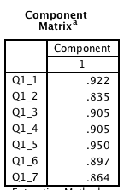

Question 2
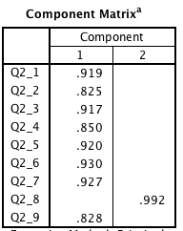

Question 3
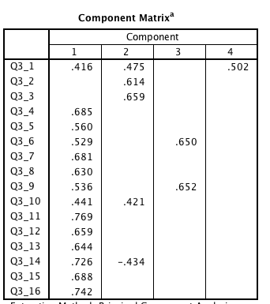

Question 4
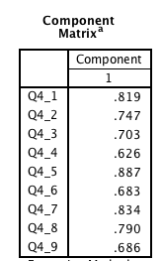

Question 5
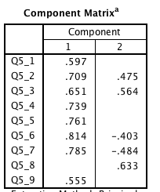

Cronbach Alphas
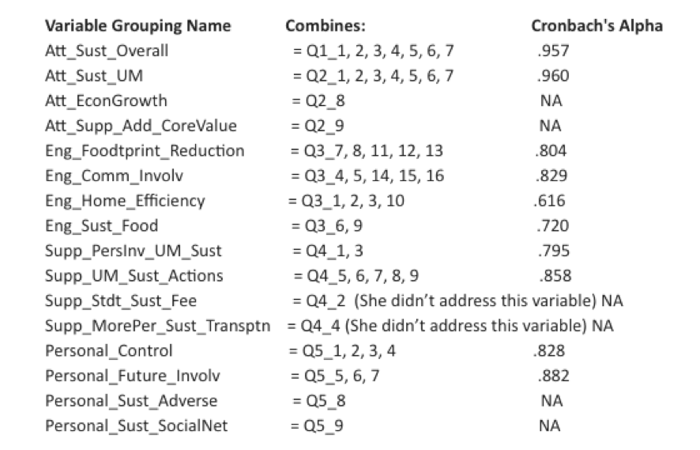

Appendix D - Segmentation
Final Cluster Centers
 | Cluster
 | 1 “Green” | 2 “Yellow” | 3 “Amber” | 4 “Red”
Eng_Foodtprint_Reduction | 6.13 | 5.49 | 4.51 | 3.14
Eng_Comm_Involv | 5.93 | 5.20 | 4.21 | 3.13
Eng_Home_Efficiency | 5.91 | 5.25 | 5.52 | 4.20
Eng_Sust_Food | 5.78 | 2.00 | 4.08 | 1.23

Number of Cases in each Cluster
Cluster | 1 “Green” | 41
 | 2 “Yellow” | 57
 | 3 “Amber” | 31
 | 4 “Red” | 24
Valid |  | 153
Missing |  | 3

Age by Segmentation
Age * Cluster_Fin_Recod Crosstabulation
Count
 |  | Cluster_Fin_Recod |  |  |  | Total
 |  | 1 | 2 | 3 | 4
Age | Under 19 | 1 | 2 | 0 | 1 | 4
 | 20 to 25 | 3 | 16 | 8 | 8 | 35
 | 26 to 35 | 11 | 13 | 4 | 4 | 32
 | 36 to 45 | 8 | 8 | 7 | 4 | 27
 | 46 to 55 | 9 | 6 | 8 | 2 | 25
 | 56 to 65 | 6 | 6 | 1 | 3 | 16
 | 66 or older | 1 | 1 | 0 | 1 | 3
Total |  | 39 | 52 | 28 | 23 | 142

Gender by Segmentation
Gender * Cluster_Fin_Recod Crosstabulation
Count
 |  | Cluster_Fin_Recod |  |  |  | Total
 |  | 1 | 2 | 3 | 4
Gender | Male | 17 | 19 | 7 | 9 | 52
 | Female | 21 | 31 | 19 | 12 | 83
 | Prefer Not to Identify | 1 | 2 | 2 | 3 | 8
Total |  | 39 | 52 | 28 | 24 | 143

Campus Affiliation by Segmentation
Campus_Affiliation * Cluster_Fin_Recod Crosstabulation
Count
 |  | Cluster_Fin_Recod |  |  |  | Total
 |  | 1 | 2 | 3 | 4
Campus_Affiliation | Student | 12 | 31 | 15 | 15 | 73
 | Employee | 27 | 21 | 13 | 8 | 69
Total |  | 39 | 52 | 28 | 23 | 142

Q20 * Cluster_Fin_Recod Crosstabulation
 |  |  | Cluster_Fin_Recod |  |  |  | Total
 |  |  | 1 | 2 | 3 | 4
Q20 | Faculty | Count | 8 | 7 | 2 | 1 | 18
 |  | % within Q20 | 44.4% | 38.9% | 11.1% | 5.6% | 100.0%
 |  | % within Cluster_Fin_Recod | 20.5% | 13.5% | 7.1% | 4.3% | 12.7%
 |  | % of Total | 5.6% | 4.9% | 1.4% | 0.7% | 12.7%
 | Staff | Count | 16 | 9 | 9 | 7 | 41
 |  | % within Q20 | 39.0% | 22.0% | 22.0% | 17.1% | 100.0%
 |  | % within Cluster_Fin_Recod | 41.0% | 17.3% | 32.1% | 30.4% | 28.9%
 |  | % of Total | 11.3% | 6.3% | 6.3% | 4.9% | 28.9%
 | Graduate Student | Count | 7 | 19 | 9 | 7 | 42
 |  | % within Q20 | 16.7% | 45.2% | 21.4% | 16.7% | 100.0%
 |  | % within Cluster_Fin_Recod | 17.9% | 36.5% | 32.1% | 30.4% | 29.6%
 |  | % of Total | 4.9% | 13.4% | 6.3% | 4.9% | 29.6%
 | Undergraduate Student | Count | 5 | 12 | 6 | 8 | 31
 |  | % within Q20 | 16.1% | 38.7% | 19.4% | 25.8% | 100.0%
 |  | % within Cluster_Fin_Recod | 12.8% | 23.1% | 21.4% | 34.8% | 21.8%
 |  | % of Total | 3.5% | 8.5% | 4.2% | 5.6% | 21.8%
 | Contract Professional | Count | 3 | 5 | 2 | 0 | 10
 |  | % within Q20 | 30.0% | 50.0% | 20.0% | 0.0% | 100.0%
 |  | % within Cluster_Fin_Recod | 7.7% | 9.6% | 7.1% | 0.0% | 7.0%
 |  | % of Total | 2.1% | 3.5% | 1.4% | 0.0% | 7.0%
Total |  | Count | 39 | 52 | 28 | 23 | 142
 |  | % within Q20 | 27.5% | 36.6% | 19.7% | 16.2% | 100.0%
 |  | % within Cluster_Fin_Recod | 100.0% | 100.0% | 100.0% | 100.0% | 100.0%
 |  | % of Total | 27.5% | 36.6% | 19.7% | 16.2% | 100.0%

Count of Highest Fee willing to Pay by Segmentation
Highest_Fee * Cluster_Fin_Recod Crosstabulation
Count
 |  | Cluster_Fin_Recod |  |  |  | Total
 |  | 1 | 2 | 3 | 4
Highest_Fee | <$0-$5 | 1 | 2 | 4 | 5 | 12
 | $0-$5 | 1 | 3 | 3 | 1 | 8
 | $6-$10 | 1 | 4 | 3 | 3 | 11
 | $11-$15 | 3 | 2 | 1 | 1 | 7
 | $16-$20 | 3 | 3 | 1 | 1 | 8
 | >$20 | 0 | 4 | 1 | 4 | 9
Total |  | 9 | 18 | 13 | 15 | 55

Count of commuting via Personal Vehicle by Segmentation
Q10_1_PV * Cluster_Fin_Recod Crosstabulation
Count
 |  | Cluster_Fin_Recod |  |  |  | Total
 |  | 1 | 2 | 3 | 4
Q10_1_PV | 0 | 19 | 27 | 11 | 5 | 62
 | Personal Vehicle (without other occupants) | 22 | 30 | 20 | 19 | 91
Total |  | 41 | 57 | 31 | 24 | 153

Count of commuting via Biking by Segmentation
Q10_2_Bike * Cluster_Fin_Recod Crosstabulation
Count
 |  | Cluster_Fin_Recod |  |  |  | Total
 |  | 1 | 2 | 3 | 4
Q10_2_Bike | 0 | 17 | 29 | 22 | 17 | 85
 | Bicycle | 24 | 28 | 9 | 7 | 68
Total |  | 41 | 57 | 31 | 24 | 153

Count of commuting via Walking by Segmentation
Q10_3_Walk * Cluster_Fin_Recod Crosstabulation
Count
 |  | Cluster_Fin_Recod |  |  |  | Total
 |  | 1 | 2 | 3 | 4
Q10_3_Walk | 0 | 23 | 37 | 19 | 21 | 100
 | Walking | 18 | 20 | 12 | 3 | 53
Total |  | 41 | 57 | 31 | 24 | 153

Count of commuting via Bus by Segmentation
Q10_5_PubTran * Cluster_Fin_Recod Crosstabulation
Count
 |  | Cluster_Fin_Recod |  |  |  | Total
 |  | 1 | 2 | 3 | 4
Q10_5_PubTran | 0 | 26 | 35 | 23 | 19 | 103
 | Public transportation | 15 | 22 | 8 | 5 | 50
Total |  | 41 | 57 | 31 | 24 | 153

Count of commuting via Carpool by Segmentation
Q10_6_CarPool * Cluster_Fin_Recod Crosstabulation
Count
 |  | Cluster_Fin_Recod |  |  |  | Total
 |  | 1 | 2 | 3 | 4
Q10_6_CarPool | 0 | 38 | 44 | 27 | 20 | 129
 | Car pool or ride sharing | 3 | 13 | 4 | 4 | 24
Total |  | 41 | 57 | 31 | 24 | 153

Segment 1 “Green” Descriptives
Descriptive Statistics
 | N | Mean
Att_Sust_Overall | 41 | 6.9199
Att_Sust_UM | 41 | 6.7631
Att_EconGrowth | 41 | 2.8293
Att_Supp_Add_CoreValue | 41 | 6.5122
Eng_Foodtprint_Reduction | 41 | 6.1268
Eng_Comm_Involv | 41 | 5.9268
Eng_Home_Efficiency | 41 | 5.9085
Eng_Sust_Food | 41 | 5.7805
Supp_PersInv_UM_Sust | 38 | 5.5789
Supp_UM_Sust_Actions | 39 | 6.1179
Supp_Stdt_Sust_Fee | 41 | 6.8293
Supp_MorePer_Sust_Transptn | 40 | 5.8000
Personal_Control | 40 | 5.8875
Personal_Future_Involv | 40 | 6.1417
Personal_Sust_Adverse | 39 | 2.3077
Personal_Sust_SocialNet | 40 | 5.2500
Valid N (listwise) | 36

Segment 1 “Green” by Campus_Affiliation

Descriptives
 |  | N | Mean | Std. Deviation | Std. Error | 95% Confidence Interval for Mean
 |  |  |  |  |  | Lower Bound | Upper Bound
Att_Sust_Overall | Student | 15 | 5.4286 | 1.50606 | .38886 | 4.5945 | 6.2626
 | Employee | 8 | 5.8036 | 1.04124 | .36813 | 4.9331 | 6.6741
 | Total | 23 | 5.5590 | 1.34972 | .28144 | 4.9753 | 6.1427
Att_Sust_UM | Student | 15 | 5.1714 | 1.71700 | .44333 | 4.2206 | 6.1223
 | Employee | 8 | 5.0000 | 1.19767 | .42344 | 3.9987 | 6.0013
 | Total | 23 | 5.1118 | 1.52952 | .31893 | 4.4504 | 5.7732
Att_EconGrowth | Student | 15 | 4.4667 | 2.03072 | .52433 | 3.3421 | 5.5912
 | Employee | 8 | 3.8750 | 2.29518 | .81147 | 1.9562 | 5.7938
 | Total | 23 | 4.2609 | 2.09366 | .43656 | 3.3555 | 5.1662
Att_Supp_Add_CoreValue | Student | 15 | 4.1333 | 2.29492 | .59255 | 2.8624 | 5.4042
 | Employee | 8 | 3.8750 | 2.23207 | .78916 | 2.0089 | 5.7411
 | Total | 23 | 4.0435 | 2.22544 | .46404 | 3.0811 | 5.0058
Eng_Foodtprint_Reduction | Student | 15 | 3.3200 | 1.12071 | .28937 | 2.6994 | 3.9406
 | Employee | 8 | 2.8250 | 1.11835 | .39540 | 1.8900 | 3.7600
 | Total | 23 | 3.1478 | 1.12042 | .23362 | 2.6633 | 3.6323
Eng_Comm_Involv | Student | 15 | 3.3867 | 1.28612 | .33207 | 2.6744 | 4.0989
 | Employee | 8 | 2.7250 | .83452 | .29505 | 2.0273 | 3.4227
 | Total | 23 | 3.1565 | 1.17389 | .24477 | 2.6489 | 3.6642
Eng_Home_Efficiency | Student | 15 | 3.8333 | 1.12069 | .28936 | 3.2127 | 4.4540
 | Employee | 8 | 5.0000 | 1.17260 | .41458 | 4.0197 | 5.9803
 | Total | 23 | 4.2391 | 1.24881 | .26040 | 3.6991 | 4.7792
Eng_Sust_Food | Student | 15 | 1.2667 | .56273 | .14530 | .9550 | 1.5783
 | Employee | 8 | 1.1250 | .23146 | .08183 | .9315 | 1.3185
 | Total | 23 | 1.2174 | .47257 | .09854 | 1.0130 | 1.4217
Supp_PersInv_UM_Sust | Student | 15 | 3.0667 | 1.34784 | .34801 | 2.3203 | 3.8131
 | Employee | 8 | 2.5625 | 1.26597 | .44759 | 1.5041 | 3.6209
 | Total | 23 | 2.8913 | 1.31388 | .27396 | 2.3231 | 3.4595
Supp_UM_Sust_Actions | Student | 15 | 4.1333 | 1.80106 | .46503 | 3.1359 | 5.1307
 | Employee | 8 | 3.4750 | .86148 | .30458 | 2.7548 | 4.1952
 | Total | 23 | 3.9043 | 1.55021 | .32324 | 3.2340 | 4.5747
Supp_Stdt_Sust_Fee | Student | 15 | 5.4000 | 1.72378 | .44508 | 4.4454 | 6.3546
 | Employee | 8 | 6.1250 | 1.12599 | .39810 | 5.1836 | 7.0664
 | Total | 23 | 5.6522 | 1.55530 | .32430 | 4.9796 | 6.3247
Supp_MorePer_Sust_Transptn | Student | 15 | 3.6667 | 2.35028 | .60684 | 2.3651 | 4.9682
 | Employee | 8 | 1.6250 | .74402 | .26305 | 1.0030 | 2.2470
 | Total | 23 | 2.9565 | 2.16329 | .45108 | 2.0210 | 3.8920
Personal_Control | Student | 15 | 4.9667 | 1.53782 | .39706 | 4.1151 | 5.8183
 | Employee | 8 | 4.9375 | 1.45006 | .51267 | 3.7252 | 6.1498
 | Total | 23 | 4.9565 | 1.47450 | .30746 | 4.3189 | 5.5941
Personal_Future_Involv | Student | 15 | 4.0667 | 1.73297 | .44745 | 3.1070 | 5.0264
 | Employee | 7 | 3.1905 | 1.75179 | .66212 | 1.5703 | 4.8106
 | Total | 22 | 3.7879 | 1.74740 | .37255 | 3.0131 | 4.5626
Personal_Sust_Adverse | Student | 15 | 3.0667 | 2.15362 | .55606 | 1.8740 | 4.2593
 | Employee | 8 | 4.0000 | 2.07020 | .73193 | 2.2693 | 5.7307
 | Total | 23 | 3.3913 | 2.12644 | .44339 | 2.4718 | 4.3108
Personal_Sust_SocialNet | Student | 15 | 2.6667 | 1.83874 | .47476 | 1.6484 | 3.6849
 | Employee | 8 | 2.0000 | .92582 | .32733 | 1.2260 | 2.7740
 | Total | 23 | 2.4348 | 1.59049 | .33164 | 1.7470 | 3.1226

ANOVA
 |  | Sum of Squares | df | Mean Square | F | Sig.
Att_Sust_Overall | Between Groups | .349 | 1 | .349 | 4.644 | .038
 | Within Groups | 2.782 | 37 | .075
 | Total | 3.131 | 38
Att_Sust_UM | Between Groups | .123 | 1 | .123 | .420 | .521
 | Within Groups | 10.845 | 37 | .293
 | Total | 10.968 | 38
Att_EconGrowth | Between Groups | 8.155 | 1 | 8.155 | 1.379 | .248
 | Within Groups | 218.769 | 37 | 5.913
 | Total | 226.923 | 38
Att_Supp_Add_CoreValue | Between Groups | .086 | 1 | .086 | .077 | .784
 | Within Groups | 41.657 | 37 | 1.126
 | Total | 41.744 | 38
Eng_Foodtprint_Reduction | Between Groups | .003 | 1 | .003 | .007 | .935
 | Within Groups | 18.946 | 37 | .512
 | Total | 18.950 | 38
Eng_Comm_Involv | Between Groups | 3.197 | 1 | 3.197 | 9.026 | .005
 | Within Groups | 13.106 | 37 | .354
 | Total | 16.304 | 38
Eng_Home_Efficiency | Between Groups | 2.716 | 1 | 2.716 | 3.085 | .087
 | Within Groups | 32.576 | 37 | .880
 | Total | 35.292 | 38
Eng_Sust_Food | Between Groups | 1.227 | 1 | 1.227 | 1.092 | .303
 | Within Groups | 41.581 | 37 | 1.124
 | Total | 42.808 | 38
Supp_PersInv_UM_Sust | Between Groups | 1.634 | 1 | 1.634 | 1.099 | .302
 | Within Groups | 52.055 | 35 | 1.487
 | Total | 53.689 | 36
Supp_UM_Sust_Actions | Between Groups | 1.818 | 1 | 1.818 | 2.253 | .142
 | Within Groups | 29.041 | 36 | .807
 | Total | 30.859 | 37
Supp_Stdt_Sust_Fee | Between Groups | .410 | 1 | .410 | 1.138 | .293
 | Within Groups | 13.333 | 37 | .360
 | Total | 13.744 | 38
Supp_MorePer_Sust_Transptn | Between Groups | 2.738 | 1 | 2.738 | 1.053 | .311
 | Within Groups | 96.185 | 37 | 2.600
 | Total | 98.923 | 38
Personal_Control | Between Groups | .094 | 1 | .094 | .114 | .738
 | Within Groups | 30.637 | 37 | .828
 | Total | 30.731 | 38
Personal_Future_Involv | Between Groups | 4.042 | 1 | 4.042 | 4.725 | .036
 | Within Groups | 31.650 | 37 | .855
 | Total | 35.692 | 38
Personal_Sust_Adverse | Between Groups | 6.332 | 1 | 6.332 | 2.734 | .107
 | Within Groups | 83.378 | 36 | 2.316
 | Total | 89.711 | 37
Personal_Sust_SocialNet | Between Groups | .035 | 1 | .035 | .013 | .908
 | Within Groups | 96.324 | 37 | 2.603
 | Total | 96.359 | 38

Segment 2 “Yellow” by Campus_Affiliation

Descriptives
 |  | N | Mean | Std. Deviation | Std. Error | 95% Confidence Interval for Mean
 |  |  |  |  |  | Lower Bound | Upper Bound
Att_Sust_Overall | Student | 31 | 6.8986 | .24521 | .04404 | 6.8087 | 6.9886
 | Employee | 21 | 6.9184 | .13226 | .02886 | 6.8582 | 6.9786
 | Total | 52 | 6.9066 | .20573 | .02853 | 6.8493 | 6.9639
Att_Sust_UM | Student | 30 | 6.6143 | .55664 | .10163 | 6.4064 | 6.8221
 | Employee | 21 | 6.6667 | .49350 | .10769 | 6.4420 | 6.8913
 | Total | 51 | 6.6359 | .52707 | .07381 | 6.4876 | 6.7841
Att_EconGrowth | Student | 31 | 4.3871 | 2.77702 | .49877 | 3.3685 | 5.4057
 | Employee | 21 | 1.9048 | .88909 | .19401 | 1.5001 | 2.3095
 | Total | 52 | 3.3846 | 2.52170 | .34970 | 2.6826 | 4.0867
Att_Supp_Add_CoreValue | Student | 31 | 6.4194 | 1.40888 | .25304 | 5.9026 | 6.9361
 | Employee | 21 | 6.0476 | 1.11697 | .24374 | 5.5392 | 6.5561
 | Total | 52 | 6.2692 | 1.30031 | .18032 | 5.9072 | 6.6312
Eng_Foodtprint_Reduction | Student | 31 | 5.5419 | .87055 | .15635 | 5.2226 | 5.8613
 | Employee | 21 | 5.5524 | .76133 | .16614 | 5.2058 | 5.8989
 | Total | 52 | 5.5462 | .82044 | .11377 | 5.3177 | 5.7746
Eng_Comm_Involv | Student | 31 | 5.2581 | .75929 | .13637 | 4.9796 | 5.5366
 | Employee | 21 | 5.1714 | .89952 | .19629 | 4.7620 | 5.5809
 | Total | 52 | 5.2231 | .81134 | .11251 | 4.9972 | 5.4490
Eng_Home_Efficiency | Student | 31 | 4.9274 | .90184 | .16197 | 4.5966 | 5.2582
 | Employee | 21 | 5.6786 | 1.00667 | .21967 | 5.2203 | 6.1368
 | Total | 52 | 5.2308 | 1.00714 | .13967 | 4.9504 | 5.5112
Eng_Sust_Food | Student | 31 | 2.0161 | .91728 | .16475 | 1.6797 | 2.3526
 | Employee | 21 | 2.0952 | .93031 | .20301 | 1.6718 | 2.5187
 | Total | 52 | 2.0481 | .91426 | .12679 | 1.7935 | 2.3026
Supp_PersInv_UM_Sust | Student | 30 | 4.9167 | 1.52045 | .27760 | 4.3489 | 5.4844
 | Employee | 21 | 4.6667 | 1.46913 | .32059 | 3.9979 | 5.3354
 | Total | 51 | 4.8137 | 1.48983 | .20862 | 4.3947 | 5.2327
Supp_UM_Sust_Actions | Student | 30 | 6.2600 | .84552 | .15437 | 5.9443 | 6.5757
 | Employee | 18 | 5.2667 | .87313 | .20580 | 4.8325 | 5.7009
 | Total | 48 | 5.8875 | .97623 | .14091 | 5.6040 | 6.1710
Supp_Stdt_Sust_Fee | Student | 31 | 6.5161 | 1.06053 | .19048 | 6.1271 | 6.9051
 | Employee | 21 | 6.8571 | .35857 | .07825 | 6.6939 | 7.0204
 | Total | 52 | 6.6538 | .86057 | .11934 | 6.4143 | 6.8934
Supp_MorePer_Sust_Transptn | Student | 30 | 6.0667 | 1.36289 | .24883 | 5.5578 | 6.5756
 | Employee | 21 | 4.3810 | 2.08509 | .45500 | 3.4318 | 5.3301
 | Total | 51 | 5.3725 | 1.87575 | .26266 | 4.8450 | 5.9001
Personal_Control | Student | 31 | 5.6855 | .88263 | .15852 | 5.3617 | 6.0092
 | Employee | 21 | 5.5476 | .97986 | .21382 | 5.1016 | 5.9936
 | Total | 52 | 5.6298 | .91621 | .12706 | 5.3747 | 5.8849
Personal_Future_Involv | Student | 31 | 6.1290 | .81503 | .14638 | 5.8301 | 6.4280
 | Employee | 21 | 5.5397 | .87227 | .19034 | 5.1426 | 5.9367
 | Total | 52 | 5.8910 | .87999 | .12203 | 5.6460 | 6.1360
Personal_Sust_Adverse | Student | 31 | 2.7419 | 2.15975 | .38790 | 1.9497 | 3.5341
 | Employee | 21 | 2.6190 | 1.65759 | .36172 | 1.8645 | 3.3736
 | Total | 52 | 2.6923 | 1.95577 | .27122 | 2.1478 | 3.2368
Personal_Sust_SocialNet | Student | 31 | 4.3226 | 1.77740 | .31923 | 3.6706 | 4.9745
 | Employee | 21 | 4.1429 | 1.95667 | .42698 | 3.2522 | 5.0335
 | Total | 52 | 4.2500 | 1.83511 | .25448 | 3.7391 | 4.7609

ANOVA
 |  | Sum of Squares | df | Mean Square | F | Sig.
Att_Sust_Overall | Between Groups | .005 | 1 | .005 | .113 | .738
 | Within Groups | 2.154 | 50 | .043
 | Total | 2.159 | 51
Att_Sust_UM | Between Groups | .034 | 1 | .034 | .120 | .731
 | Within Groups | 13.856 | 49 | .283
 | Total | 13.890 | 50
Att_EconGrowth | Between Groups | 77.143 | 1 | 77.143 | 15.606 | .000
 | Within Groups | 247.164 | 50 | 4.943
 | Total | 324.308 | 51
Att_Supp_Add_CoreValue | Between Groups | 1.730 | 1 | 1.730 | 1.024 | .317
 | Within Groups | 84.501 | 50 | 1.690
 | Total | 86.231 | 51
Eng_Foodtprint_Reduction | Between Groups | .001 | 1 | .001 | .002 | .965
 | Within Groups | 34.328 | 50 | .687
 | Total | 34.329 | 51
Eng_Comm_Involv | Between Groups | .094 | 1 | .094 | .140 | .710
 | Within Groups | 33.478 | 50 | .670
 | Total | 33.572 | 51
Eng_Home_Efficiency | Between Groups | 7.064 | 1 | 7.064 | 7.907 | .007
 | Within Groups | 44.667 | 50 | .893
 | Total | 51.731 | 51
Eng_Sust_Food | Between Groups | .078 | 1 | .078 | .092 | .763
 | Within Groups | 42.551 | 50 | .851
 | Total | 42.630 | 51
Supp_PersInv_UM_Sust | Between Groups | .772 | 1 | .772 | .343 | .561
 | Within Groups | 110.208 | 49 | 2.249
 | Total | 110.980 | 50
Supp_UM_Sust_Actions | Between Groups | 11.101 | 1 | 11.101 | 15.156 | .000
 | Within Groups | 33.692 | 46 | .732
 | Total | 44.793 | 47
Supp_Stdt_Sust_Fee | Between Groups | 1.456 | 1 | 1.456 | 2.005 | .163
 | Within Groups | 36.313 | 50 | .726
 | Total | 37.769 | 51
Supp_MorePer_Sust_Transptn | Between Groups | 35.103 | 1 | 35.103 | 12.214 | .001
 | Within Groups | 140.819 | 49 | 2.874
 | Total | 175.922 | 50
Personal_Control | Between Groups | .238 | 1 | .238 | .279 | .599
 | Within Groups | 42.573 | 50 | .851
 | Total | 42.811 | 51
Personal_Future_Involv | Between Groups | 4.348 | 1 | 4.348 | 6.186 | .016
 | Within Groups | 35.145 | 50 | .703
 | Total | 39.494 | 51
Personal_Sust_Adverse | Between Groups | .189 | 1 | .189 | .049 | .827
 | Within Groups | 194.888 | 50 | 3.898
 | Total | 195.077 | 51
Personal_Sust_SocialNet | Between Groups | .404 | 1 | .404 | .118 | .733
 | Within Groups | 171.346 | 50 | 3.427
 | Total | 171.750 | 51

Segment 3 “Amber” by Campus_Affiliation

Descriptives
 |  | N | Mean | Std. Deviation | Std. Error | 95% Confidence Interval for Mean
 |  |  |  |  |  | Lower Bound | Upper Bound
Att_Sust_Overall | Student | 15 | 5.7143 | 1.94382 | .50189 | 4.6378 | 6.7907
 | Employee | 13 | 5.7802 | .96295 | .26707 | 5.1983 | 6.3621
 | Total | 28 | 5.7449 | 1.54027 | .29108 | 5.1476 | 6.3422
Att_Sust_UM | Student | 15 | 5.4381 | 2.12610 | .54896 | 4.2607 | 6.6155
 | Employee | 13 | 5.5165 | 1.18313 | .32814 | 4.8015 | 6.2314
 | Total | 28 | 5.4745 | 1.72267 | .32555 | 4.8065 | 6.1425
Att_EconGrowth | Student | 14 | 3.2143 | 1.88837 | .50469 | 2.1240 | 4.3046
 | Employee | 13 | 2.9231 | 1.75412 | .48650 | 1.8631 | 3.9831
 | Total | 27 | 3.0741 | 1.79585 | .34561 | 2.3637 | 3.7845
Att_Supp_Add_CoreValue | Student | 15 | 4.9333 | 1.98086 | .51146 | 3.8364 | 6.0303
 | Employee | 13 | 4.9231 | 2.10006 | .58245 | 3.6540 | 6.1921
 | Total | 28 | 4.9286 | 1.99868 | .37771 | 4.1536 | 5.7036
Eng_Foodtprint_Reduction | Student | 15 | 4.6400 | .69775 | .18016 | 4.2536 | 5.0264
 | Employee | 13 | 4.2769 | 1.12706 | .31259 | 3.5958 | 4.9580
 | Total | 28 | 4.4714 | .92250 | .17434 | 4.1137 | 4.8291
Eng_Comm_Involv | Student | 15 | 4.2933 | 1.22327 | .31585 | 3.6159 | 4.9708
 | Employee | 13 | 3.9385 | 1.13250 | .31410 | 3.2541 | 4.6228
 | Total | 28 | 4.1286 | 1.17406 | .22188 | 3.6733 | 4.5838
Eng_Home_Efficiency | Student | 15 | 5.5000 | .94491 | .24398 | 4.9767 | 6.0233
 | Employee | 13 | 5.4423 | .70085 | .19438 | 5.0188 | 5.8658
 | Total | 28 | 5.4732 | .82591 | .15608 | 5.1530 | 5.7935
Eng_Sust_Food | Student | 15 | 3.8333 | .81650 | .21082 | 3.3812 | 4.2855
 | Employee | 13 | 4.3462 | 1.19695 | .33197 | 3.6228 | 5.0695
 | Total | 28 | 4.0714 | 1.02482 | .19367 | 3.6740 | 4.4688
Supp_PersInv_UM_Sust | Student | 15 | 3.9000 | 1.49045 | .38483 | 3.0746 | 4.7254
 | Employee | 13 | 3.6154 | 1.22736 | .34041 | 2.8737 | 4.3571
 | Total | 28 | 3.7679 | 1.35730 | .25651 | 3.2416 | 4.2942
Supp_UM_Sust_Actions | Student | 15 | 4.7733 | 1.10807 | .28610 | 4.1597 | 5.3870
 | Employee | 13 | 4.3692 | .96210 | .26684 | 3.7878 | 4.9506
 | Total | 28 | 4.5857 | 1.04411 | .19732 | 4.1809 | 4.9906
Supp_Stdt_Sust_Fee | Student | 15 | 5.8000 | 2.07709 | .53630 | 4.6497 | 6.9503
 | Employee | 13 | 6.0769 | .86232 | .23916 | 5.5558 | 6.5980
 | Total | 28 | 5.9286 | 1.60851 | .30398 | 5.3049 | 6.5523
Supp_MorePer_Sust_Transptn | Student | 15 | 4.7333 | 2.21897 | .57293 | 3.5045 | 5.9622
 | Employee | 13 | 3.6154 | 1.75777 | .48752 | 2.5532 | 4.6776
 | Total | 28 | 4.2143 | 2.06123 | .38954 | 3.4150 | 5.0135
Personal_Control | Student | 15 | 5.1167 | 1.18347 | .30557 | 4.4613 | 5.7720
 | Employee | 13 | 5.2692 | .76690 | .21270 | 4.8058 | 5.7327
 | Total | 28 | 5.1875 | .99681 | .18838 | 4.8010 | 5.5740
Personal_Future_Involv | Student | 15 | 5.1111 | 1.82429 | .47103 | 4.1009 | 6.1214
 | Employee | 13 | 4.6410 | .82171 | .22790 | 4.1445 | 5.1376
 | Total | 28 | 4.8929 | 1.44317 | .27273 | 4.3333 | 5.4525
Personal_Sust_Adverse | Student | 15 | 3.4000 | 1.91982 | .49570 | 2.3368 | 4.4632
 | Employee | 13 | 3.4615 | 1.33012 | .36891 | 2.6578 | 4.2653
 | Total | 28 | 3.4286 | 1.64268 | .31044 | 2.7916 | 4.0655
Personal_Sust_SocialNet | Student | 15 | 4.0000 | 1.25357 | .32367 | 3.3058 | 4.6942
 | Employee | 13 | 3.3077 | 1.75046 | .48549 | 2.2499 | 4.3655
 | Total | 28 | 3.6786 | 1.51666 | .28662 | 3.0905 | 4.2667

ANOVA
 |  | Sum of Squares | df | Mean Square | F | Sig.
Att_Sust_Overall | Between Groups | .030 | 1 | .030 | .012 | .913
 | Within Groups | 64.025 | 26 | 2.463
 | Total | 64.055 | 27
Att_Sust_UM | Between Groups | .043 | 1 | .043 | .014 | .907
 | Within Groups | 80.082 | 26 | 3.080
 | Total | 80.125 | 27
Att_EconGrowth | Between Groups | .572 | 1 | .572 | .172 | .682
 | Within Groups | 83.280 | 25 | 3.331
 | Total | 83.852 | 26
Att_Supp_Add_CoreValue | Between Groups | .001 | 1 | .001 | .000 | .989
 | Within Groups | 107.856 | 26 | 4.148
 | Total | 107.857 | 27
Eng_Foodtprint_Reduction | Between Groups | .918 | 1 | .918 | 1.082 | .308
 | Within Groups | 22.059 | 26 | .848
 | Total | 22.977 | 27
Eng_Comm_Involv | Between Groups | .877 | 1 | .877 | .627 | .435
 | Within Groups | 36.340 | 26 | 1.398
 | Total | 37.217 | 27
Eng_Home_Efficiency | Between Groups | .023 | 1 | .023 | .033 | .858
 | Within Groups | 18.394 | 26 | .707
 | Total | 18.417 | 27
Eng_Sust_Food | Between Groups | 1.832 | 1 | 1.832 | 1.795 | .192
 | Within Groups | 26.526 | 26 | 1.020
 | Total | 28.357 | 27
Supp_PersInv_UM_Sust | Between Groups | .564 | 1 | .564 | .298 | .590
 | Within Groups | 49.177 | 26 | 1.891
 | Total | 49.741 | 27
Supp_UM_Sust_Actions | Between Groups | 1.137 | 1 | 1.137 | 1.045 | .316
 | Within Groups | 28.297 | 26 | 1.088
 | Total | 29.434 | 27
Supp_Stdt_Sust_Fee | Between Groups | .534 | 1 | .534 | .200 | .658
 | Within Groups | 69.323 | 26 | 2.666
 | Total | 69.857 | 27
Supp_MorePer_Sust_Transptn | Between Groups | 8.704 | 1 | 8.704 | 2.135 | .156
 | Within Groups | 106.010 | 26 | 4.077
 | Total | 114.714 | 27
Personal_Control | Between Groups | .162 | 1 | .162 | .158 | .694
 | Within Groups | 26.666 | 26 | 1.026
 | Total | 26.828 | 27
Personal_Future_Involv | Between Groups | 1.539 | 1 | 1.539 | .732 | .400
 | Within Groups | 54.695 | 26 | 2.104
 | Total | 56.234 | 27
Personal_Sust_Adverse | Between Groups | .026 | 1 | .026 | .009 | .923
 | Within Groups | 72.831 | 26 | 2.801
 | Total | 72.857 | 27
Personal_Sust_SocialNet | Between Groups | 3.338 | 1 | 3.338 | 1.477 | .235
 | Within Groups | 58.769 | 26 | 2.260
 | Total | 62.107 | 27

Segment 4 “Red” by Campus_Affiliation
Descriptives
 |  | N | Mean | Std. Deviation | Std. Error | 95% Confidence Interval for Mean
 |  |  |  |  |  | Lower Bound | Upper Bound
Att_Sust_Overall | Student | 15 | 5.4286 | 1.50606 | .38886 | 4.5945 | 6.2626
 | Employee | 8 | 5.8036 | 1.04124 | .36813 | 4.9331 | 6.6741
 | Total | 23 | 5.5590 | 1.34972 | .28144 | 4.9753 | 6.1427
Att_Sust_UM | Student | 15 | 5.1714 | 1.71700 | .44333 | 4.2206 | 6.1223
 | Employee | 8 | 5.0000 | 1.19767 | .42344 | 3.9987 | 6.0013
 | Total | 23 | 5.1118 | 1.52952 | .31893 | 4.4504 | 5.7732
Att_EconGrowth | Student | 15 | 4.4667 | 2.03072 | .52433 | 3.3421 | 5.5912
 | Employee | 8 | 3.8750 | 2.29518 | .81147 | 1.9562 | 5.7938
 | Total | 23 | 4.2609 | 2.09366 | .43656 | 3.3555 | 5.1662
Att_Supp_Add_CoreValue | Student | 15 | 4.1333 | 2.29492 | .59255 | 2.8624 | 5.4042
 | Employee | 8 | 3.8750 | 2.23207 | .78916 | 2.0089 | 5.7411
 | Total | 23 | 4.0435 | 2.22544 | .46404 | 3.0811 | 5.0058
Eng_Foodtprint_Reduction | Student | 15 | 3.3200 | 1.12071 | .28937 | 2.6994 | 3.9406
 | Employee | 8 | 2.8250 | 1.11835 | .39540 | 1.8900 | 3.7600
 | Total | 23 | 3.1478 | 1.12042 | .23362 | 2.6633 | 3.6323
Eng_Comm_Involv | Student | 15 | 3.3867 | 1.28612 | .33207 | 2.6744 | 4.0989
 | Employee | 8 | 2.7250 | .83452 | .29505 | 2.0273 | 3.4227
 | Total | 23 | 3.1565 | 1.17389 | .24477 | 2.6489 | 3.6642
Eng_Home_Efficiency | Student | 15 | 3.8333 | 1.12069 | .28936 | 3.2127 | 4.4540
 | Employee | 8 | 5.0000 | 1.17260 | .41458 | 4.0197 | 5.9803
 | Total | 23 | 4.2391 | 1.24881 | .26040 | 3.6991 | 4.7792
Eng_Sust_Food | Student | 15 | 1.2667 | .56273 | .14530 | .9550 | 1.5783
 | Employee | 8 | 1.1250 | .23146 | .08183 | .9315 | 1.3185
 | Total | 23 | 1.2174 | .47257 | .09854 | 1.0130 | 1.4217
Supp_PersInv_UM_Sust | Student | 15 | 3.0667 | 1.34784 | .34801 | 2.3203 | 3.8131
 | Employee | 8 | 2.5625 | 1.26597 | .44759 | 1.5041 | 3.6209
 | Total | 23 | 2.8913 | 1.31388 | .27396 | 2.3231 | 3.4595
Supp_UM_Sust_Actions | Student | 15 | 4.1333 | 1.80106 | .46503 | 3.1359 | 5.1307
 | Employee | 8 | 3.4750 | .86148 | .30458 | 2.7548 | 4.1952
 | Total | 23 | 3.9043 | 1.55021 | .32324 | 3.2340 | 4.5747
Supp_Stdt_Sust_Fee | Student | 15 | 5.4000 | 1.72378 | .44508 | 4.4454 | 6.3546
 | Employee | 8 | 6.1250 | 1.12599 | .39810 | 5.1836 | 7.0664
 | Total | 23 | 5.6522 | 1.55530 | .32430 | 4.9796 | 6.3247
Supp_MorePer_Sust_Transptn | Student | 15 | 3.6667 | 2.35028 | .60684 | 2.3651 | 4.9682
 | Employee | 8 | 1.6250 | .74402 | .26305 | 1.0030 | 2.2470
 | Total | 23 | 2.9565 | 2.16329 | .45108 | 2.0210 | 3.8920
Personal_Control | Student | 15 | 4.9667 | 1.53782 | .39706 | 4.1151 | 5.8183
 | Employee | 8 | 4.9375 | 1.45006 | .51267 | 3.7252 | 6.1498
 | Total | 23 | 4.9565 | 1.47450 | .30746 | 4.3189 | 5.5941
Personal_Future_Involv | Student | 15 | 4.0667 | 1.73297 | .44745 | 3.1070 | 5.0264
 | Employee | 7 | 3.1905 | 1.75179 | .66212 | 1.5703 | 4.8106
 | Total | 22 | 3.7879 | 1.74740 | .37255 | 3.0131 | 4.5626
Personal_Sust_Adverse | Student | 15 | 3.0667 | 2.15362 | .55606 | 1.8740 | 4.2593
 | Employee | 8 | 4.0000 | 2.07020 | .73193 | 2.2693 | 5.7307
 | Total | 23 | 3.3913 | 2.12644 | .44339 | 2.4718 | 4.3108
Personal_Sust_SocialNet | Student | 15 | 2.6667 | 1.83874 | .47476 | 1.6484 | 3.6849
 | Employee | 8 | 2.0000 | .92582 | .32733 | 1.2260 | 2.7740
 | Total | 23 | 2.4348 | 1.59049 | .33164 | 1.7470 | 3.1226

ANOVA
 |  | Sum of Squares | df | Mean Square | F | Sig.
Att_Sust_Overall | Between Groups | .734 | 1 | .734 | .392 | .538
 | Within Groups | 39.344 | 21 | 1.874
 | Total | 40.078 | 22
Att_Sust_UM | Between Groups | .153 | 1 | .153 | .063 | .805
 | Within Groups | 51.314 | 21 | 2.444
 | Total | 51.468 | 22
Att_EconGrowth | Between Groups | 1.826 | 1 | 1.826 | .405 | .531
 | Within Groups | 94.608 | 21 | 4.505
 | Total | 96.435 | 22
Att_Supp_Add_CoreValue | Between Groups | .348 | 1 | .348 | .067 | .798
 | Within Groups | 108.608 | 21 | 5.172
 | Total | 108.957 | 22
Eng_Foodtprint_Reduction | Between Groups | 1.278 | 1 | 1.278 | 1.019 | .324
 | Within Groups | 26.339 | 21 | 1.254
 | Total | 27.617 | 22
Eng_Comm_Involv | Between Groups | 2.284 | 1 | 2.284 | 1.711 | .205
 | Within Groups | 28.032 | 21 | 1.335
 | Total | 30.317 | 22
Eng_Home_Efficiency | Between Groups | 7.101 | 1 | 7.101 | 5.481 | .029
 | Within Groups | 27.208 | 21 | 1.296
 | Total | 34.310 | 22
Eng_Sust_Food | Between Groups | .105 | 1 | .105 | .457 | .506
 | Within Groups | 4.808 | 21 | .229
 | Total | 4.913 | 22
Supp_PersInv_UM_Sust | Between Groups | 1.326 | 1 | 1.326 | .760 | .393
 | Within Groups | 36.652 | 21 | 1.745
 | Total | 37.978 | 22
Supp_UM_Sust_Actions | Between Groups | 2.261 | 1 | 2.261 | .938 | .344
 | Within Groups | 50.608 | 21 | 2.410
 | Total | 52.870 | 22
Supp_Stdt_Sust_Fee | Between Groups | 2.742 | 1 | 2.742 | 1.141 | .298
 | Within Groups | 50.475 | 21 | 2.404
 | Total | 53.217 | 22
Supp_MorePer_Sust_Transptn | Between Groups | 21.748 | 1 | 21.748 | 5.624 | .027
 | Within Groups | 81.208 | 21 | 3.867
 | Total | 102.957 | 22
Personal_Control | Between Groups | .004 | 1 | .004 | .002 | .965
 | Within Groups | 47.827 | 21 | 2.277
 | Total | 47.832 | 22
Personal_Future_Involv | Between Groups | 3.664 | 1 | 3.664 | 1.212 | .284
 | Within Groups | 60.457 | 20 | 3.023
 | Total | 64.121 | 21
Personal_Sust_Adverse | Between Groups | 4.545 | 1 | 4.545 | 1.005 | .327
 | Within Groups | 94.933 | 21 | 4.521
 | Total | 99.478 | 22
Personal_Sust_SocialNet | Between Groups | 2.319 | 1 | 2.319 | .913 | .350
 | Within Groups | 53.333 | 21 | 2.540
 | Total | 55.652 | 22

Appendix E - T-Test
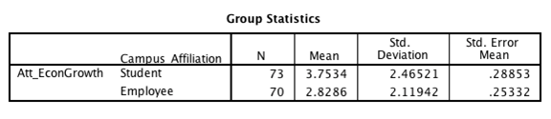
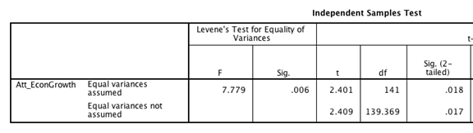

Appendix F - ANOVA
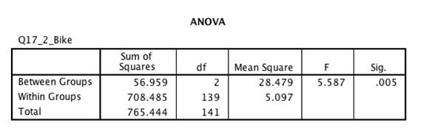

Appendix G - Regression

Regression #1.
Dependent Variable:
Q18.2 Likeliness to pay $6 - $10 fees associated with parking permits to purchase carbon offsets.
Independent Variables
Q3.7: I am conscious of my water footprint (Showering, Washing Dishes, etc.)
Q5.1: It is easy for me to perform environmentally sustainable activities
Q5.7: In the future, I plan to look into how I can play a greater role in protecting the environment

Model Summary
R | R Square | Adjusted R Square | Std. Error of the Estimate
0.575 | 0.331 | 0.317 | 1.000

ANOVA
 | Sum of Squares | df | Mean Square | F | Sig.
Regression | 71.832 | 3 | 23.944 | 23.924 | 0.000
Residual | 145.121 | 145 | 1.001
Total | 216.953 | 148

Coefficients
 | Unstandardized Coefficients | Standardized Coefficients
 | B | Std. Error | Beta | t | Sig.
(Constant) | 2.804 | 0.536 |  | 5.227 | 0.000
Q3_1 | 0.252 | 0.084 | 0.212 | 2.993 | 0.003
Q3_14 | 0.235 | 0.063 | 0.345 | 3.728 | 0.000
Q5_6 | 0.133 | 0.069 | 0.182 | 1.923 | 0.056

Regression #2
Dependent Variable:
Q6.3 Support of UM’s Small Scale Rooftop Solar Panels
Independent Variables
Q3.1: I switch off the light whenever leaving a room
Q3.14: I vote for candidates proactive on environmental conservation
Q5.6: I intend to seek out more opportunities to be more environmentally active in the future

Model Summary
R | R Square | Adjusted R Square | Std. Error of the Estimate
0.575 | 0.331 | 0.317 | 1.000

ANOVA
 | Sum of Squares | df | Mean Square | F | Sig.
Regression | 71.832 | 3 | 23.944 | 23.924 | 0.000
Residual | 145.121 | 145 | 1.001
Total | 216.953 | 148

Coefficients
 | Unstandardized Coefficients | Standardized Coefficients
 | B | Std. Error | Beta | t | Sig.
(Constant) | 2.804 | 0.536 |  | 5.227 | 0.000
Q3_1 | 0.252 | 0.084 | 0.212 | 2.993 | 0.003
Q3_14 | 0.235 | 0.063 | 0.345 | 3.728 | 0.000
Q5_6 | 0.133 | 0.069 | 0.182 | 1.923 | 0.056

Q17_3 Willingness to commute via Walking - Regression
Variables Entered/Removedª
Model | Variables Entered | Variables Removed | Method
1 | Q13b_Walk_Minutes | . | Stepwise (Criteria: Probability-of-F-to-enter <= .050, Probability-of-F-to-remove >= .100).

a. Dependent Variable: Q17_3_Walk

Model Summary^{b}
Model | R | R Square | Adjusted R Square | Std. Error of the Estimate | Change Statistics
 |  |  |  |  | R Square Change | F Change | df1 | df2
1 | .304ª | .092 | .073 | .804 | .092 | 4.880 | 1 | 48

Model Summary^{b}
Model | Change Statistics | Durbin-Watson
 | Sig. F Change
1 | .032 | 2.769

a. Predictors: (Constant), Q13b_Walk_Minutes
b. Dependent Variable: Q17_3_Walk

ANOVAª
Model |  | Sum of Squares | df | Mean Square | F | Sig.
1 | Regression | 3.154 | 1 | 3.154 | 4.880 | .032^{b}
 | Residual | 31.026 | 48 | .646
 | Total | 34.180 | 49

a. Dependent Variable: Q17_3_Walk
b. Predictors: (Constant), Q13b_Walk_Minutes

Coefficientsª
Model |  | Unstandardized Coefficients |  | Standardized Coefficients | t | Sig.
 |  | B | Std. Error | Beta
1 | (Constant) | 6.261 | .184 |  | 34.076 | .000
 | Q13b_Walk_Minutes | .011 | .005 | .304 | 2.209 | .032

a. Dependent Variable: Q17_3_Walk

Q4_5 Regression
Variables Entered/Removedª
Model | Variables Entered | Variables Removed | Method
1 | Q17_2_Bike, Att_EconGrowth, Att_Sust_UM, Eng_Sust_Food, Supp_PersInv_UM_Sust, Eng_Foodtprint_Reduction^{b} | . | Enter

a. Dependent Variable: Q4_5
b. All requested variables entered.

Model Summary
Model | R | R Square | Adjusted R Square | Std. Error of the Estimate | Change Statistics
 |  |  |  |  | R Square Change | F Change | df1 | df2
1 | .810ª | .656 | .640 | 1.037 | .656 | 41.044 | 6 | 129

a. Predictors: (Constant), Q17_2_Bike, Att_EconGrowth, Att_Sust_UM, Eng_Sust_Food, Supp_PersInv_UM_Sust, Eng_Foodtprint_Reduction

ANOVAª
Model |  | Sum of Squares | df | Mean Square | F | Sig.
1 | Regression | 264.871 | 6 | 44.145 | 41.044 | .000^{b}
 | Residual | 138.747 | 129 | 1.076
 | Total | 403.618 | 135

a. Dependent Variable: Q4_5
b. Predictors: (Constant), Q17_2_Bike, Att_EconGrowth, Att_Sust_UM, Eng_Sust_Food, Supp_PersInv_UM_Sust, Eng_Foodtprint_Reduction

Coefficientsª
Model |  | Unstandardized Coefficients |  | Standardized Coefficients | t | Sig.
 |  | B | Std. Error | Beta
1 | (Constant) | -.332 | .511 |  | -.649 | .518
 | Att_Sust_UM | .440 | .086 | .322 | 5.126 | .000
 | Att_EconGrowth | -.134 | .040 | -.178 | -3.365 | .001
 | Eng_Foodtprint_Reduction | .319 | .089 | .249 | 3.597 | .000
 | Eng_Sust_Food | -.108 | .052 | -.122 | -2.071 | .040
 | Supp_PersInv_UM_Sust | .370 | .071 | .355 | 5.182 | .000
 | Q17_2_Bike | .111 | .041 | .151 | 2.694 | .008

a. Dependent Variable: Q4_5

Q4_6 Regression
Variables Entered/Removedª
Model | Variables Entered | Variables Removed | Method
1 | Personal_Control, Att_Sust_Overall, Eng_Foodtprint_Reduction, Eng_Comm_Involv, Att_Sust_UM^{b} | . | Enter

a. Dependent Variable: Q4_6
b. All requested variables entered.

Model Summary
Model | R | R Square | Adjusted R Square | Std. Error of the Estimate | Change Statistics
 |  |  |  |  | R Square Change | F Change | df1 | df2
1 | .631ª | .398 | .377 | .977 | .398 | 19.148 | 5 | 145

ANOVAª
Model |  | Sum of Squares | df | Mean Square | F | Sig.
1 | Regression | 91.386 | 5 | 18.277 | 19.148 | .000^{b}
 | Residual | 138.402 | 145 | .954
 | Total | 229.788 | 150

a. Dependent Variable: Q4_6
b. Predictors: (Constant), Personal_Control, Att_Sust_Overall, Eng_Foodtprint_Reduction, Eng_Comm_Involv, Att_Sust_UM

Coefficientsª
Model |  | Unstandardized Coefficients |  | Standardized Coefficients | t | Sig.
 |  | B | Std. Error | Beta
1 | (Constant) | 2.519 | .613 |  | 4.110 | .000
 | Att_Sust_Overall | -.384 | .174 | -.327 | -2.202 | .029
 | Att_Sust_UM | .456 | .158 | .453 | 2.885 | .005
 | Eng_Foodtprint_Reduction | .211 | .085 | .224 | 2.490 | .014
 | Eng_Comm_Involv | .204 | .105 | .217 | 1.943 | .054
 | Personal_Control | .234 | .081 | .203 | 2.887 | .004

a. Dependent Variable: Q4_6

Q4_7 Regression
Variables Entered/Removedª
Model | Variables Entered | Variables Removed | Method
1 | Personal_Sust_SocialNet, Att_Supp_Add_CoreValue, Eng_Comm_Involv^{b} | . | Enter

a. Dependent Variable: Q4_7
b. All requested variables entered.

Model Summary
Model | R | R Square | Adjusted R Square | Std. Error of the Estimate | Change Statistics
 |  |  |  |  | R Square Change | F Change | df1 | df2
1 | .713ª | .509 | .499 | 1.342 | .509 | 50.042 | 3 | 145

a. Predictors: (Constant), Personal_Sust_SocialNet, Att_Supp_Add_CoreValue, Eng_Comm_Involv

ANOVAª
Model |  | Sum of Squares | df | Mean Square | F | Sig.
1 | Regression | 270.271 | 3 | 90.090 | 50.042 | .000^{b}
 | Residual | 261.044 | 145 | 1.800
 | Total | 531.315 | 148

a. Dependent Variable: Q4_7
b. Predictors: (Constant), Personal_Sust_SocialNet, Att_Supp_Add_CoreValue, Eng_Comm_Involv

Coefficientsª
Model |  | Unstandardized Coefficients |  | Standardized Coefficients | t | Sig.
 |  | B | Std. Error | Beta
1 | (Constant) | -.215 | .432 |  | -.498 | .619
 | Att_Supp_Add_CoreValue | .351 | .082 | .333 | 4.294 | .000
 | Eng_Comm_Involv | .510 | .122 | .358 | 4.166 | .000
 | Personal_Sust_SocialNet | .146 | .067 | .149 | 2.176 | .031

a. Dependent Variable: Q4_7

Q4_8 Regression
Variables Entered/Removedª
Model | Variables Entered | Variables Removed | Method
1 | Personal_Future_Involv, Att_Sust_UM, Eng_Comm_Involv^{b} | . | Enter

a. Dependent Variable: Q4_8
b. All requested variables entered.

Model Summary
Model | R | R Square | Adjusted R Square | Std. Error of the Estimate | Change Statistics
 |  |  |  |  | R Square Change | F Change | df1 | df2
1 | .703ª | .494 | .484 | 1.069 | .494 | 47.813 | 3 | 147

a. Predictors: (Constant), Personal_Future_Involv, Att_Sust_UM, Eng_Comm_Involv

ANOVAª
Model |  | Sum of Squares | df | Mean Square | F | Sig.
1 | Regression | 163.958 | 3 | 54.653 | 47.813 | .000^{b}
 | Residual | 168.028 | 147 | 1.143
 | Total | 331.987 | 150

a. Dependent Variable: Q4_8
b. Predictors: (Constant), Personal_Future_Involv, Att_Sust_UM, Eng_Comm_Involv

Coefficientsª
Model |  | Unstandardized Coefficients |  | Standardized Coefficients | t | Sig.
 |  | B | Std. Error | Beta
1 | (Constant) | .697 | .458 |  | 1.521 | .130
 | Att_Sust_UM | .374 | .104 | .307 | 3.613 | .000
 | Eng_Comm_Involv | .274 | .116 | .241 | 2.373 | .019
 | Personal_Future_Involv | .246 | .100 | .235 | 2.450 | .015

a. Dependent Variable: Q4_8

Q4_9 Regression

Variables Entered/Removedª
Model | Variables Entered | Variables Removed | Method
1 | Q17_6_CarPool, Personal_Sust_SocialNet, Att_Supp_Add_CoreValue, Eng_Foodtprint_Reduction^{b} | . | Enter

a. Dependent Variable: Q4_9
b. All requested variables entered.

Model Summary
Model | R | R Square | Adjusted R Square | Std. Error of the Estimate | Change Statistics
 |  |  |  |  | R Square Change | F Change | df1 | df2
1 | .655ª | .429 | .412 | 1.548 | .429 | 25.147 | 4 | 134

a. Predictors: (Constant), Q17_6_CarPool, Personal_Sust_SocialNet, Att_Supp_Add_CoreValue, Eng_Foodtprint_Reduction

ANOVAª
Model |  | Sum of Squares | df | Mean Square | F | Sig.
1 | Regression | 241.019 | 4 | 60.255 | 25.147 | .000^{b}
 | Residual | 321.082 | 134 | 2.396
 | Total | 562.101 | 138

a. Dependent Variable: Q4_9
b. Predictors: (Constant), Q17_6_CarPool, Personal_Sust_SocialNet, Att_Supp_Add_CoreValue, Eng_Foodtprint_Reduction

Coefficientsª
Model |  | Unstandardized Coefficients |  | Standardized Coefficients | t | Sig.
 |  | B | Std. Error | Beta
1 | (Constant) | -1.152 | .596 |  | -1.933 | .055
 | Att_Supp_Add_CoreValue | .292 | .083 | .265 | 3.506 | .001
 | Eng_Foodtprint_Reduction | .527 | .117 | .353 | 4.513 | .000
 | Personal_Sust_SocialNet | .158 | .080 | .149 | 1.969 | .051
 | Q17_6_CarPool | .160 | .064 | .168 | 2.489 | .014

a. Dependent Variable: Q4_9

