East Carolina University

Facilities Services – Sustainability Program

FINAL REPORT

**ECU Greenhouse Gas Inventory for FY 2016**

August 15, 2016

By

**Chad Carwein, LEED GA**

*University Sustainability Manager*

**TABLE OF CONTENTS**

Preface .......................................................................................................................................... 4

Executive Summary ....................................................................................................................... 5

1 Introduction ....................................................................................................................... 6

2 Clean Air-Cool Planet (CA-CP) Campus Carbon Calculator ….............................................. 7

3 Boundaries of the Inventory …............................................................................................ 7

3.1 Organizational Boundaries ..................................................................................... 7

3.2 Operational Boundaries ......................................................................................... 8

3.3 Temporal Boundaries ............................................................................................. 8

4 Emissions ........................................................................................................................... 9

4.1 Scope 1 Emissions .................................................................................................. 9

4.1.1 Stationary combustion ............................................................................... 9

4.1.2 University Fleet ........................................................................................ 10

4.1.3 Refrigerants ............................................................................................. 11

4.1.4 Agricultural activities ............................................................................... 12

4.2 Scope 2 Emissions ................................................................................................ 13

4.2.1 Purchased Electricity ................................................................................... 13

4.2.2 Purchased steam and chilled water ............................................................. 14

4.3 Scope 3 Emissions ................................................................................................ 14

4.3.1 Directly Financed Outsourced Travel .......................................................... 15

4.3.2 Study Abroad AIR Travel .............................................................................. 15

4.3.3 Commuter travel ......................................................................................... 16

4.3.4 Solid Waste ................................................................................................. 18

4.3.5 Wastewater ................................................................................................ 18

4.3.6 Paper ........................................................................................................... 19

Acronyms ..................................................................................................................................... 20

Appendix A .................................................................................................................................. 21

Appendix B ................................................................................................................................... 22

Appendix C …………………………………….………………………………………………………………………………………. 23

Appendix D ………………….…………………………………………………………………………………………………………. 24

References ................................................................................................................................... 25

**LIST OF FIGURES**

Figure 1 – Map of NERC Regions ................................................................................................... 13

Figure 2 – Map of eGRID Subregions ……………………………………………………………………..................... 13

**LIST OF TABLES**

Table 1 – Population numbers for CY 2011, FY15, and FY16 …………………….……….......................... 8

Table 2 – Summary of stationary combustion data …..……………………........................................... 10

Table 3 – Summary of university fleet data …............................................................................... 11

Table 4 – Summary of refrigerant data ......................................................................................... 11

Table 5 – Summary of agricultural data ........................................................................................ 12

Table 6 – Summary of eGRID 2012 Resource Mix ........................................................................ 14

Table 7 – Summary of electricity data .......................................................................................... 14

Table 8 – Summary of directly financed outsourced travel .......................................................... 15

Table 9 – Summary of calculated commuting distributions ......................................................... 17

Table 10 – Summary of commuting ……….….................................................................................. 17

Table 11 – Summary of solid waste .............................................................................................. 18

Table 12 – Summary of wastewater ............................................................................................. 19

Table 13 – Summary of paper consumption ................................................................................. 19

**Preface**

This report presents the greenhouse gas inventory results for East Carolina University (ECU) for FY 2016.

The author acknowledges the contribution of Les Hewlett and Rebecca Bizzell from the Facilities Services Department of ECU, who provided valuable data that allowed for completion of the inventory. In addition, we sincerely thank all other ECU staff members who provided us data and shared important information regarding their sustainable practices.

**Executive Summary**

The objective of this report is to assess the Greenhouse Gas (GHG) Inventory for the Main and Health Science Campuses of East Carolina University (ECU). The report presents a fiscal year (FY) 2016 GHG emissions inventory from direct and indirect activities of ECU. This is ECU’s second GHG inventory document, which builds on and compares to a baseline “Energy and Greenhouse Gas Emissions Report” prepared by SmithGroupJJR and RMF Engineering (January 2013). Based on energy use data from the 2011 calendar year, this report estimated the GHG emissions associated with the existing Main and Health Science Campuses, predicted the energy use of the proposed development based on current campus building standards, and demonstrated how sustainable design strategies applied to all new development and improvements made on the existing building stock could significantly reduce the carbon footprint of ECU. Results of this study are summarized in Appendix B.

We anticipate that the report will serve as a guideline for any committee or group aiming to reduce the emissions of ECU in the future. Understanding current GHG emissions is a necessary step towards developing strategies to lower future GHG emissions. For this study, fiscal year 2016 was selected as the temporal boundary with the goal of comparing results to the calendar year 2011 GHG inventory. There have been numerous changes in campus infrastructure over the years, with a potential to change source distribution and total amount of GHG emissions. For example, at the West Academic facility, two old chillers were replaced with a single, more efficient chiller with heat recovery capability. Combined with the addition of a heat exchanger between the new chiller and the existing propane-fueled boilers, this project resulted in more than a 70% reduction in propane use at the only ECU facility using propane for heat.

Since the previous inventory only accounted for Scopes 1 and 2 of emission sources, it is difficult to draw a comparison in terms of the overall distribution of GHG emissions. However, when comparing the gross area of total building space and the emissions from just the first two scopes, the previous inventory concluded that ECU produces roughly 14.4 kg CO2e per square foot and the current inventory found a reduction of 0.15 kg CO2e per square foot of building. Of course, this is partly owed to the fact that gross area of total building space increased by nearly 600,000 square feet, from 6,220,312 square feet in calendar year 2011 to 6,804,178 square feet in fiscal year 2016.

The biggest greenhouse gas emitting source for ECU still remains to be Scope 2 purchased electricity, which accounts for about half of all of the university’s emissions. Scope 1 emissions sources including On-Campus Stationary, Direct Transportation, Refrigerants, and Agriculture combined for a little more than 23% of total GHG emissions. Attributing nearly one third of the total GHG emissions, Scope 3 sources include Commuting, Directly Financed Travel, Solid Waste, Wastewater, Paper, and Scope 2 T&D Losses. Taking all three scopes into account, this GHG Inventory finds that ECU produced a total of 140,838.7 MT CO2e. A detailed breakdown of the results for this study can be found in Appendix C.

**1 Introduction**

Universities have the knowledge that is necessary to create a sustainable environment at their campuses. Increasing numbers of student communities and increased enrollment in the sustainability field illustrate the increasing attention directed towards sustainability. Higher education institutions are often responsible for teaching and conducting research on environmental issues such as climate change. Educational institutions have the opportunity to lead society towards the solution of this global problem, which is a common threat for humans regardless of country and location.

This report stems from this understanding and aims to quantify and facilitate strategies that will reduce campus emissions. A GHG inventory is a first step towards effective reduction strategies since one main purpose of the inventory is to identify hotspots among different sources.

There are three stages to the GHG inventory process: data collection; GHG emissions calculation; and data analysis for climate action planning [1].

**Step one: Data Collection** – many items of raw data are required to conduct a GHG inventory, such as purchased electricity, transportation, solid waste, refrigerants, offsets, etc.

**Step two: Emissions Calculations** – collected data is then processed as input into a calculator tool. The American College and University Presidents’ Climate Commitment (ACUPCC) recommends the use of Clean Air-Cool Planet Campus Carbon Calculator (CA‐CP calculator). The CA‐CP calculator is an Excel‐based spreadsheet that uses national inventories and methodologies of the Intergovernmental Panel on Climate Change (IPCC) and calculators of the Greenhouse Gas Protocol, and has been adapted for use with higher education institutions. The CA‐CP calculator covers all emission sources with the defined scopes of the ACUPCC.

**Step three: Data Analysis** – the calculator converts all emissions into CO2 equivalent in order to compare GHG sources and identify ‘hotspots’ within the institution. These areas then form the greatest opportunities for emission reductions.

The report begins by introducing the CA-CP calculator, the study boundaries, and scope. Results are presented under each category together with the various assumptions made during calculations.

**2 Clean Air-Cool Planet (CA-CP) Campus Carbon Calculator**

The CA-CP calculator, specifically designed for educational institutions, is a widely used tool to calculate GHG emissions. The CCC was originally developed by the former non-profit Clean Air - Cool Planet and the Sustainability Institute at UNH in 2001 and released to the public in 2004. Usage grew from a few dozen early adopters to nearly 200 users during the first year. Today, thousands of institutions in the U.S. and abroad use the Calculator to track their institutional greenhouse gas emissions, including more than 90% of the U.S. colleges and universities that publicly report their emissions. In 2014, the Sustainability Institute at UNH assumed ownership of the Calculator and CarbonMAP [2].

The calculator uses standard methodologies and emission factors given by the GHG Protocol Initiative, and is a preferred tool by the ACUPCC [3]. CA-CP calculator version 8.0 tool was used in this project.

**3 Boundaries of the Inventory**

Three boundaries exist for calculating the campus GHG emissions: organizational, operational, and temporal.

**3.1 Organizational Boundaries**

Organizational boundaries are generally the highest-level of the three boundaries, and therefore the first boundaries that are drawn during the creation of the GHG inventory. Organizational boundaries state whether GHG emissions are measured for one department, school, or for the entire campus. Depending on this boundary, the facilities and operations that are to be included into the analysis are determined. For this study, ECU’s main campus and Health Sciences Campus (HSC) were selected as the organizational boundary. Student housing facilities that are located on campus and managed by ECU were included in the analysis. However, buildings managed and resources used by the Coastal Studies Institute, located on Roanoke Island, were excluded. In addition, the ECU School of Dental Medicine has established eight Community Service Learning Centers located throughout North Carolina and these facilities were excluded from the organizational boundary as well.

Using this organizational boundary, the Main Campus consists of 161 buildings and the HSC includes 57 buildings with a combined gross building area of 6,804,178 ft2 in FY 2016.

During the study period, there were 25,065 full-time equivalent (FTE) students enrolled at ECU. Part-time students are accounted for as a half of full-time equivalent student, per CA-CP methodology, and are included in the FTE number above. Additionally, there were 1,792 faculty and 4,128 staff in FY 2016. These numbers are compared to previous years in Table 3.

**Table 1 – Population numbers for CY 2011, FY15, and FY16.**

|  |  |  |  |
| --- | --- | --- | --- |
| **Community** | **CY 2011** | **FY 2015** | **FY 2016** |
| Students (FTE) | _____ | 24,432 | 25,065 |
| Faculty | _____ | 1,821 | 1,792 |
| Staff | _____ | 4,128 | 4,128 |
| **Total** | _____ | 30,381 | 30,985 |

**3.2 Operational Boundaries**

Operational boundaries identify GHG emitting sources to be included in the inventory. The GHG protocol uses a structure in which all emissions are categorized into three scopes [3]. Scope 1 includes direct emissions from sources that are owned and controlled by ECU, such as on-campus electricity generation, natural gas usage, transportation for campus operations, use of refrigerants and chemicals, and agricultural activities. Scope 2 emissions include indirect emissions from sources that are neither owned nor operated by ECU, but whose products are linked to campus energy consumption, such as purchased electricity. Scope 3 emissions are other sources that are neither owned nor operated by ECU, but are either directly financed (e.g. waste removal and commercial air travel paid for by ECU) or are otherwise linked to the campus via influence or encouragement (e.g. daily commuting by faculty, staff, and students). Emissions associated with paper consumption, solid waste disposal, and wastewater treatment are also included in Scope 3.

Emissions that fall under Scopes 1 and 2 are mandatory and must be included in the inventory by the GHG protocol. Although Scope 3 emissions are deemed optional by the GHG protocol, researchers are encouraged to include as many emission sources as possible to obtain a realistic inventory for the institution.

**3.3 Temporal Boundaries**

The final boundary is the temporal boundary. The calculator uses fiscal years instead of calendar years since most schools function on a fiscal year basis. Fiscal years at ECU begin on July 1st and end on June 30th of the following calendar year. This study focused on evaluating fiscal year 2016, beginning on July 1, 2015 and ending on June 30, 2016. Previous GHG inventories included calendar year 2011 and fiscal year 2015. One aim of this work was to understand the change in ECU’s carbon footprint since the baseline was established.

**4 Emissions**

The context of each emission source, results obtained, and assumptions made during calculations are detailed under each section below.

**4.1 Scope 1 Emissions**

Scope 1 emissions cover sources that are fully owned and managed by East Carolina University.

**4.1.1 Stationary combustion**

Scope 1 stationary combustion emissions include any activities where fuel is burned or gasses are directly released into the atmosphere. This includes any on-campus electricity generation, steam generation, and gas usage. Historic energy consumption records were also analyzed to understand trends in campus energy use. In fiscal year (FY) 2002, the campus emissions were estimated to have been 81,191 MT eCO2. Energy use over the past decade has slowly crept upward, as the campus grows and more energy-intensive activities occur within the built environment.

Energy use data normalized by both campus size and weather conditions show a more steady decrease in campus energy intensity and GHG emissions intensity. The campus has made aggressive strides in energy conservation by participating in a UNC system-wide lighting upgrade performance contract. Envelope upgrade projects and window replacements have also improved the performance of older campus buildings. Upgrades to building HVAC system, including a VFD replacement effort, added economizer cycles, and retrofit commissioning have improved building performance as well. Blow down heat recovery and chiller upgrades have improved the performance of campus central plants. Each of these measures have contributed to the reduction in the campus’ energy impacts. These reductions also demonstrate the cumulative impact of smaller energy conservation measures that can add up and yield a noticeable savings.

On-campus stationary sources at ECU also include natural gas and propane used in individual buildings. This natural gas is typically used for air heating, water heating, backup generators, and laboratory purposes. The total natural gas usage in FY 2016 accounted for 439,003 MMBtu, and translated into 23,340 MT CO2e (16.6% of total emissions).

Propane is used for fueling three boilers at the West Academic Building on the West Research Campus. The total propane usage in FY 2016 was 9,003 gallons, which is a reduction of more than 70% from the previous fiscal year. That amount of propane translated into 47.3 MT CO2e, but it is not a significant contribution to total emissions.

**Table 2 – Summary of stationary combustion data.**

|  |  |  |  |
| --- | --- | --- | --- |
| **On-Campus Stationary Sources** | **CY 2011** | **FY 2015** | **FY 2016** |
| Distillate Oil #2 (gallons) | _____ | 225,680 | 114,053 |
| Natural Gas (MMBtu) | 492,066 | 457,050 | 439,003 |
| Propane (gallons) | _____ | 30,174 | 9,003 |
| **Energy Consumption (MMBtu)** | _____ | 490,904 | 455,583 |
| **Total Emissions (MT CO2e)** | _____ | 26,786 | 24,564 |

**4.1.2 University Fleet**

Another source of scope 1 emissions is the university fleet fuel use. This includes all of the fuel used and financed by the University for campus-wide transportation and select off-campus land transportation. This includes fuel used by the facilities services, materials management, ECU Transit and other units, but does not include chartered bus service.

ECU currently uses two tracking systems for its fleet fuel use. The PORT tracking system is used for fuel purchased strictly on ECU’s campus, while the WEX tracking system includes all the rest of the fuel consumed, including purchases made off campus using a fuel card. Additional fuel consumption records were obtained from ECU Transit and therefore not included in the Scope 3 – Commuting category of emissions sources. The same records were available in calendar year 2011, but it is assumed that this information was not accounted for.

ECU uses diesel as well as a blended biodiesel instead for appropriate vehicles. CO2 emitted during biodiesel combustion is theoretically offset by the carbon sequestered during the life of the fuel source, such as soybean or vegetable matter from which the biodiesel was derived. Biodiesel can be mixed with petroleum diesel to create different blends suitable for different vehicle engines and performance. A mix of 5% biodiesel and 95% petroleum diesel is labeled as a B5 mix, whereas pure biodiesel is labeled as B100. Although different grades of biodiesel are currently available in the market, only two biodiesel mixtures were used in the University Fleet, B5 or B20. The following types of fuel were also reported for Direct Transportation Sources: gasoline, diesel, and E85. Based on data obtained from these sources, total fuel consumption is reported in gallons in Table 5 below.

**Table 3 – Summary of university fleet data.**

|  |  |  |  |  |  |
| --- | --- | --- | --- | --- | --- |
|  | **Gasoline** | **Diesel** | **E85** | **B5** | **B20** |
| **WEX** | **19,470** | **20,442** | **39** | **88** | **-** |
| **ECU Transit** | **-** | **15,512** | **11,183** | **388** | **194,327** |
| **Facilities Services** | **142,490** | **160,973** | **-** | **-** | **-** |
| **TOTAL (gallons)** | **161,960** | **196,927** | **11,222** | **476** | **194,327** |

**4.1.3 Refrigerants**

Hydrofluorocarbons (HFCs) and perfluorocarbons (PFCs) are greenhouse gases that are often used for refrigeration and are accounted under Scope 1 emissions. Under ideal conditions, these gases are used in a closed loop system and do not contribute to GHG emissions once they are input into the system. However, leaks in the system result in fugitive emissions and are included in the GHG inventory since some of these refrigerants have high global warming potentials (GWP). The amount of fugitive emissions was assumed to be equal to the amount of refrigerants needed to recharge the systems during maintenance activities.

ECU used total of 698 lbs of refrigerants in FY 16, translating to GHG emissions of 416 MT CO2e (0.3% of total emissions). This exceeds the 62.5 pounds of refrigerants used in the previous fiscal year; however, it is difficult to compare refrigerant use between GHG inventories due to the nature of refrigerant leakage, disposal, and replenishment. Most of the refrigerants used are associated with annual fluctuations in demand for refrigerant maintenance and cannot be attributed to any change in facilities or campus policies. Table 3 presents the type and amount of refrigerant used at ECU together with the GWP of each refrigerant and a comparison to the previous inventory.

**Table 4 – Summary of refrigerant data [4, 5].**

|  |  |  |  |  |  |
| --- | --- | --- | --- | --- | --- |
|  | **Quantity Used (lbs.)** | |  |  |  |
| **Type** | **FY 2015** | **FY 2016** |  | **GWP 100** | **Source** |
| **R-123** |  | 200 |  | 77 | IPCC |
| **R-22** | 81 | 298 |  | 1,700 | EPA |
| **R-410a** |  | 200 |  | 1,980 | Calm et al |
| **GHG Emissions (MT CO2e)** | 62.5 | 416.4 |  |  |  |

**4.1.4 Agricultural activities**

Scope 1 agricultural sources of GHG emissions account for animal herding or fertilizer, pesticide, or herbicide use for crop growth and landscaping. Since there are no herding animals on any university-owned property, there are no emissions associated with this source; however, ECU does use herbicides for landscaping activities. Synthetic herbicides are labeled with their chemical makeup using three numbers to represent the percentages of nitrogen (N), phosphorus (P), and potassium (K). For example, Momentum, a pre-emergent crabgrass herbicide used on campus, is identified by the numbers 21-0-11 and consists of 21% nitrogen, 0% phosphorus, and 11% potassium. Fertilizers and herbicides contribute towards GHG emissions when a portion of their nitrogen content volatizes and forms the compound N2O.

Different commercial fertilizers have different nitrogen percentages. A weighted average was calculated based on the amount of fertilizer used and its specific nitrogen content. This Scope 1 emissions category was not previously tracked so there was only data available for the most recent fiscal year and it is important to note that the final figures include applications on both HSC and Main Campus as well as significant sources applied at the North Recreation Complex and Blount Fields. The resulting average was approximately 35,000 lbs of fertilizer having an average nitrogen content of 18.85%. By using the emission factors present in the CA-CP calculator, 2,771 MT CO2e was obtained for GHG emissions from fertilizers.

**Table 5 – Summary of agricultural data.**

|  |  |  |
| --- | --- | --- |
| **Weight (lbs)** | **Nitrogen (%)** | **TOTAL** |
| 2,726 | 21% | 572 |
| 510 | 10% | 51 |
| 1,921 | 5% | 96 |
| 262 | 21% | 55 |
| 1,428 | 14% | 200 |
| 2,006 | 20% | 401 |
| 787 | 21% | 165 |
| 2,400 | 20% | 480 |
| 250 | 16% | 40 |
| 250 | 21% | 53 |
| 250 | 16% | 40 |
| 250 | 21% | 53 |
| 10,000 | 20% | 2,000 |
| 12,000 | 20% | 2,400 |
| **35,040** | **18.85%** | **6,606** |

**4.2 Scope 2 Emissions**

Scope 2 emission sources cover purchased electricity and steam that are vital for the activities of ECU. These two items usually make up the majority of emissions for many institutions.

**4.2.1 Purchased Electricity**

Scope 2 purchased electricity category includes all electricity not generated on ECU’s campus and purchased from outside suppliers. This category has the most impact on the total GHG emissions, as it has accounted for about half of all ECU emissions in all inventoried years. These emissions are calculated based on the reported electricity usage, and the electricity generation fuel mix reported by suppliers. The CA-CP calculator uses regional fuel mix information from the EPA’s e-GRID program for its calculation. The CA-CP calculator categorizes electricity generation fuels into the following ten categories: coal, natural gas, distillate oil, residual oil, nuclear, waste-to-energy, hydroelectric, biomass, renewable (wind, solar), and other.

Electricity purchased by ECU comes from the SERC Virginia/Carolina (SRVC) electrical grid. The national electric grid is divided into regions, and the fuel mix used to produce electricity varies by region. Within the SERC Virginia/Carolina region, nuclear is the largest fuel source, accounting for over 41% of the fuel mix, and coal is the second largest fuel source, accounting for nearly 35% of the fuel mix. The national average fuel mix uses approximately 19% nuclear and 37% coal. The larger reliance on nuclear energy to produce electricity results in a lower rate of GHG emissions per kWh of electricity in the SRVC region compared to the National Average.

**Figure 1 – Map of NERC Regions [6]. Figure 2 – Map of eGRID Subregions [6].**

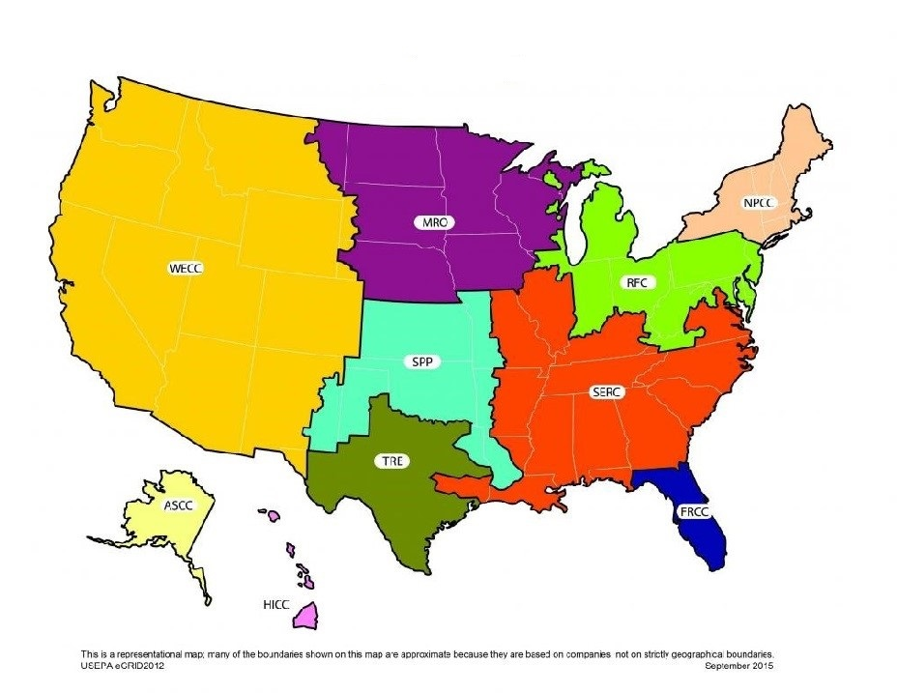

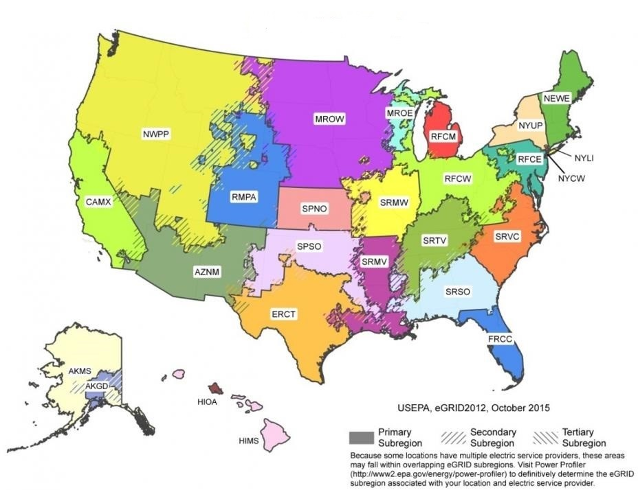

**Table 6 – eGRID 2012 Summary Resource Mix [6].**

|  |  |  |  |
| --- | --- | --- | --- |
| **Area of Focus** | **Coal** | **Gas** | **Nuclear** |
| National Average | 37.42 | 30.29 | 19.02 |
| Southeast Reliability Corporation (SERC) | 41.11 | 28.26 | 25.50 |
| ***SERC Virginia / Carolina (SRVC)*** | ***34.75*** | ***20.21*** | ***41.16*** |
| State of North Carolina | 43.54 | 16.50 | 33.67 |

The FY 2016 inventory used the default fuel mix for the SRVC region, which was dominated by nuclear and coal power, 41% and 35% respectively. The total ECU electricity consumption comprised nearly 64,089 MT CO2e, which makes up approximately 49% of the GHG Inventory.

**Table 7 – Summary of electricity data.**

|  |  |  |  |
| --- | --- | --- | --- |
|  | **CY 2011** | **FY 2015** | **FY 2016** |
| Electricity Usage (MWh) | 116,516 | 114,720 | 131,062 |
| Total Building Space (ft2) | 6,220,312 | 6,827,898 | 6,804,178 |
| Energy Use Intensity (kWh/ft2) | 18.73 | 16.80 | 19.26 |
| GHG Emissions (MT CO2e) | 56,976 | 56,098 | 64,089 |

**4.2.2 Purchased steam and chilled water**

ECU does not purchase any steam or chilled water.

**4.3 Scope 3 Emissions**

Sources that emit greenhouse gasses but are indirectly related to ECU are account for under scope 3. This includes any financially sponsored or outsourced activities such as travel, waste management, paper purchasing, etc.

**4.3.1 Directly Financed Outsourced Travel**

ECU finances different modes of transportation for its faculty and staff, which include air travel, rental car, bus, train, and personal mileage reimbursement. Detailed information for such travel financing comes from different sources within the university, but the data was obtained from the Systems Coordination Office.

Once all travel expense data was aggregated, it was then separated into the following three modes: air travel, personal vehicle, and ground transportation (including bus, taxi, rental car, and rail). Personal mileage was readily available for the purposes of reimbursement; however, air travel and ground transportation data was only available in the form of dollar amounts spent. Monetary values were converted into miles traveled using industry estimates. For air travel the revenue passenger mile (RPM) for FY 2016 obtained from Airlines for America (AA) was 14.94 cents per mile [7]. The Association for the Advancement of Sustainability in Higher Education (AASHE) recommends adding 20% to this value to account for taxes and fees associated with airfare, which brought the RPM to 17.93 cents per mile [7]. Bus and rail estimates were obtained from the American Public Transportation Association and were 92 cents per mile and 57 cents per mile respectively [8]. Using the monetary data and the industry conversion suggestions, it was estimated that ECU financed about 20 million air miles and just over 1 million land miles in FY16, resulting in total emissions of 10,066 MT CO2e. The CA-CP obtains its emission factors from the US Department of Transportation and the US Department of Energy and updates them each year.

**Table 8 – Summary of directly financed outsourced travel.**

|  |  |  |  |
| --- | --- | --- | --- |
| **Air Travel** | | **Other Forms of Travel** | |
| Faculty / Staff | Students | Taxi / Rental Car | Personal Mileage |
| 19,184,132 | 894,048 | 1,071 | 1,004,484 |

**4.3.2 Study Abroad AIR Travel**

Like many universities, ECU offers students the chance to complete one or two terms of academic studies in other countries, called the Study Abroad program. The CA-CP calculator separates these miles from the Directly Financed Outsourced Travel section, but they carry the same weights, and are calculated the same way, using the same monetary value to miles conversion, and using the same emission factors. Unfortunately, this category was not included in the FY 2016 inventory due to lack of data.

**4.3.3 Commuter travel**

Commuting can be a significant contributor to greenhouse gas emissions as shown in previous inventories and other studies; however, it is difficult to assess without either a traffic data or a commuter survey data, none of which were available for this inventory. Generally, several important factors influence commuter habits, such as distance between destinations, road infrastructure, traffic patterns, public transportation access and reliability, parking availability, and others. At ECU it is access to public transportation, biking infrastructure, student housing, parking capacity, and others.

In FY16 there were 10,728 permitted parking spaces within ECU parking lots, 480 service spaces, 70 visitor spaces, 155 metered spaces, 574 spaces reserved for patients, and 565 other spaces totaling 12,572 parking spaces at East Carolina University. ECU Parking & Transportation Services issued 4,828 parking permits to students and 4,924 parking permits to faculty and staff. There were also 224 bikes registered with more than enough rack space available on campus. On-campus residence hall capacity at ECU was approximately 5,561 students.

In order to calculate commuting related emissions, the CA-CP calculator asks for faculty, staff, and student travel distributions by mode, the average distance traveled by each mode, number of one way trips each week, and the number of weeks in a fiscal year. The documented data therefore had to be supplemented with some general assumptions listed below:

* There are 46 weeks in a fiscal year for staff, 36 for faculty, and 30 for students
* 2 one way trips per day, taken 5 days a week, equals 10 one way trips each week
* Student Commuters = Total Students – On Campus Residents
* Staff comprise 70% of employee FTEs so they hold 70% of faculty / staff permits
* Faculty comprise 30% of employee FTEs so they hold 30% of faculty / staff permits
* 5% of faculty and staff bike and the average trip distance is 2 miles, while 25% of students bike and the average trip distance is 2 miles
* 5% of faculty and staff walk and the average trip distance is 1 mile, while 25% of students walk and the average trip distance is 1 mile
* 5% carpool and the average trip distance is 0 miles to avoid double counting since passenger miles have already been accounted for via “drive alone”
* % Drive Alone = Permits / Commuters and the average Trip Distances are calculated by measuring the distance from each permit holder’s zip code to main campus, which was estimated to be 23 miles for students and 10 miles for faculty and staff
* It is assumed that the remaining % of commuters ride the bus, but the average trip distance is reported as 0 because ECU Transit’s fuel consumption has already been accounted for in “University Fleet”

**Table 9 – Summary of calculated commuting distributions.**

|  |  |  |
| --- | --- | --- |
|  | **Commuting Mode** | **FY 2016** |
| **Students** | Bike | 25% |
| Walk | 25% |
| Drive Alone | 21% |
| Carpool | 5% |
| Bus | 24% |
| **Faculty** | Bike | 5% |
| Walk | 5% |
| Drive Alone | 83% |
| Carpool | 5% |
| Bus | 2% |

Although some of these assumptions may grossly generalize the different ECU populations’ commuting behaviors, they provide a firm relationship between estimated modal distributions the calculated mileages summarized in Table 12.

**Table 10 – Summary of commuting.**

|  |  |  |
| --- | --- | --- |
|  | **Carbon-Free Modes (miles)** | **Automobile Commuting (miles)** |
| Students | 5,454,720 | 35,128,397 |
| Faculty / Staff | 381,600 | 20,165,016 |
| GHG Emissions (MT CO2e) | 0 | 20,793 |

**4.3.4 Solid Waste**

The majority of solid waste is managed by in-house by ECU Recycling Services, but there are four compactors located on campus that are collected by GDS Republic Service. Everything that doesn’t get recycled on campus is hauled to the Pitt County Landfill, which no longer has a methane recovery system in place. Methane recovery is the process of trapping and storing methane before it is emitted to the atmosphere and then having it processed for use in electricity generation. Recycling Services reported that 2,586 short tons were sent to the landfill in FY 2016.

Solid waste stream data was also reported by Prospective Health Services, which is on the Health Sciences Campus. A waste management company called Stericycle handles hazardous waste, which is required to be burnt. Stericycle reported that 24 short tons of waste was incinerated and that waste used to be converted into on-campus power, but the methane recovery system was too expensive to maintain. The total emissions due to methane release from landfills accounted for approximately 8,016 MT CO2e or 6% of the overall GHG Inventory.

**Table 11 – Summary of solid waste.**

|  |  |  |
| --- | --- | --- |
|  | **FY 2015** | **FY 2016** |
| **Landfilled (tons)** | 2,488 | 2,586 |
| **Recycled (tons)** | 675 | _____ |
| **% of Waste Recycled** | 27% | _____ |
| **GHG Emissions (MT CO2e)** | 8,016 | 7,712 |

**4.3.5 Wastewater**

Based on data from ECU Facilities Services, wastewater was assumed to be equal to the amount of water consumed in almost all campus buildings. It is not clear whether there is a possibility to measure the actual contribution of ECU to the central treatment system, which was assumed to use aerobic treatment of wastewater. This problem has been stated by other researchers as well, but a solution to the problem could not be found. Even if the assumption made here is an overestimation of the actual situation, it results in 782 MT CO2e from wastewater, which does not have a significant impact on the GHG Inventory (0.6% of total emissions).

**Table 16 – Summary of wastewater.**

|  |  |  |
| --- | --- | --- |
|  | **FY 2015** | **FY 2016** |
| **Wastewater (gallons)** | 134,275,755 | 135,894,991 |
| **GHG Emissions (MT CO2e)** | 773 | 783 |

**4.3.6 Paper**

Paper is vital for almost any type of business establishment. It is perhaps more important for educational facilities where printed material in great quantities is consumed daily. Therefore, capturing this potentially significant emission source was another objective of the study, although not mandatory based on ACUPCC guidelines. Information regarding the quantity of purchased regular and recycled paper was obtained through the Materials Management Department as well as University Printing and Graphics.

Approximately 99% of paper purchased through the Materials Management Department contained 30% post-consumer waste recycled content. The weight of paper purchased through Materials Management was 221,550 pounds and the associated 263 MT CO2e did not have a significant impact on the GHG Inventory (0.2% of total emissions).

**Table 17 – Summary of paper consumption and emissions.**

|  |  |  |
| --- | --- | --- |
|  | **FY 2015** | **FY 2016** |
| **Total Paper (lbs.)** | 279,500 | 221,550 |
| **Overall Recycled Content** | 30% | 30% |
| **GHG Emissions (MT CO2e)** | 332 | 263 |

**Acronyms**

AASHE – Association for the Advancement of Sustainability in Higher Education

ACUPCC – American College and University Presidents Climate Commitment,

AA – Airlines for America

BBP – Bellefield Boiler Plant

CA-CP calculator – Clean Air-Cool Planet Campus Carbon Calculator

CO2 – Carbon dioxide

CSSP – Carrillo Street Steam Plant

FTE – Full Time Equivalent

GHG – Greenhouse Gas

GWP – Global Warming Potential

IPCC – Intergovernmental Panel on Climate Change

MMBtu – Million British thermal unit

MT CO2e – Metric ton of carbon dioxide equivalent

ECU – East Carolina University

WRI – World Resources Institute

**Appendix A**

Meetings and communication with the following ECU staff were necessary to gather data.

**Table 20. List of Contacts, Departments, and Data Collected.**

|  |  |  |
| --- | --- | --- |
| Contact | Department | Data Collected |
| Kelly Harding | IPAR | Operating Budget |
| Steve Ayers | Financial Services | Research Budget |
| Rebecca Bizzell | Facilities Administration | Energy Budget  University Fleet  Wastewater – Septic System |
| Dan Blumberg | Human Resources | FTE Staff |
| Kim Higdon | IPAR | Building Space |
| Les Hewlett | Energy Manager | Purchased Electricity  On-Campus Stationary |
| Wood Davidson | ECU Transit | University Fleet |
| Adam Lamareaux | WEX | University Fleet |
| Ken Yarnell | HSC Facility Services | Refrigerants & Chemicals |
| John Gill | Campus Grounds | Fertilizer Application  Offsets - Forest Preservation |
| Tommy Walston | North Rec Complex | Fertilizer Application |
| Tom Brandon | Blount Fields | Fertilizer Application |
| Joey Perry | Athletics | Fertilizer Application |
| Debra Garfi | Parking & Transportation | Parking Permits  Commuting Modes |
| Amanda Pantelidis | Systems Coordination | Study Abroad Air Travel  Directly Financed Air Travel  Directly Financed Ground Transportation  Personal Vehicle Mileage Reimbursement |
| Eddie Johnson | Prospective Health | Incinerated Waste – Mass Burn |
| Terry Little | Recycling Services | Landfilled Waste – No CH4 Recovery |
| Ann Weingartz | University Printing & Graphics | Paper – University Printing & Graphics |
| Stacey Schley | Materials Management | Paper – Materials Management |

**Appendix B**

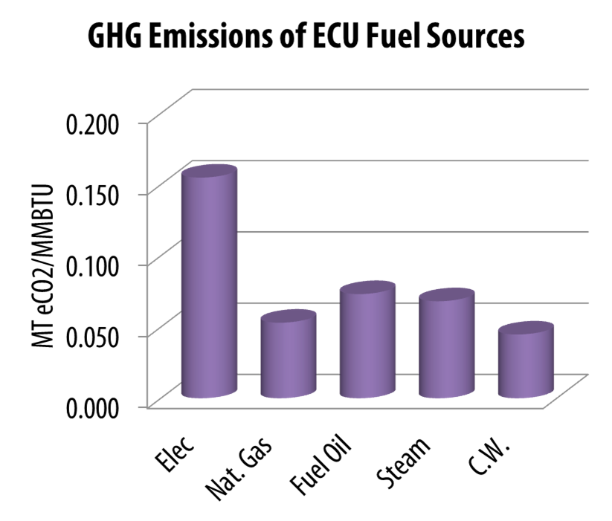

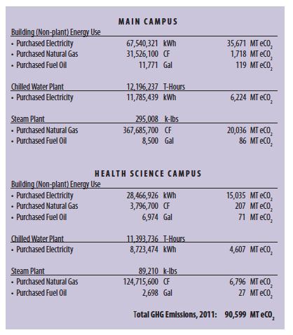

**Appendix C**

|  |  |  |  |  |  |  |
| --- | --- | --- | --- | --- | --- | --- |
| **MODULE** | **Summary** |  |  |  |  |  |
| **WORKSHEET** | **Overview of Annual Emissions** |  |  |  |  |  |
| **UNIVERSITY** | **East Carolina University** |  |  |  |  |  |
|  |  |  |  |  |  |  |
| **Select Year -->** | **2016** | **Energy Consumption** | **CO2** | **CH4** | **N2O** | **eCO2** |
|  |  | MMBtu | kg | kg | kg | Metric Tonnes |
| **Scope 1** | Co-gen Electricity | - | - | - | - | - |
|  | Co-gen Steam | - | - | - | - | - |
|  | Other On-Campus Stationary | 455,583.1 | 24,492,815.9 | 2,237.6 | 51.0 | 24,564.0 |
|  | Direct Transportation | 75,049.3 | 5,041,349.4 | 545.4 | 208.7 | 5,117.2 |
|  | Refrigerants & Chemicals | - | - | - | - | 416.4 |
|  | Agriculture | - | - | - | 9,299.7 | 2,771.3 |
| **Scope 2** | Purchased Electricity | 446,857.1 | 63,827,098.8 | 1,240.4 | 773.6 | 64,088.6 |
|  | Purchased Steam / Chilled Water | - | - | - | - | - |
| **Scope 3** | Faculty / Staff Commuting | 103,556.6 | 7,389,108.9 | 1,554.8 | 519.9 | 7,582.9 |
|  | Student Commuting | 180,400.4 | 12,872,171.8 | 2,708.5 | 905.6 | 13,209.8 |
|  | Directly Financed Air Travel | 49,494.0 | 9,652,821.5 | 95.7 | 110.0 | 9,688.0 |
|  | Other Directly Financed Travel | 5,164.0 | 368,467.6 | 77.5 | 25.9 | 378.1 |
|  | Study Abroad Air Travel | - | - | - | - | - |
|  | Student Travel to/from Home (OPTIONAL) | - | - | - | - | - |
|  | Solid Waste | - | (976.8) | 320,664.0 | - | 8,015.6 |
|  | Wastewater | - | - | 28,904.9 | 201.1 | 782.6 |
|  | Paper | - | - | - | - | 263.0 |
|  | Scope 2 T&D Losses | 27,619.3 | 3,945,014.7 | 76.7 | 47.8 | 3,961.2 |
| **Offsets** | Additional |  |  |  |  | - |
|  | Non-Additional |  |  |  |  | - |
| **Totals** | Scope 1 | 530,632.4 | 29,534,165.3 | 2,783.0 | 9,559.5 | 32,868.9 |
|  | Scope 2 | 446,857.1 | 63,827,098.8 | 1,240.4 | 773.6 | 64,088.6 |
|  | Scope 3 | 366,234.3 | 34,226,607.7 | 354,082.1 | 1,810.3 | 43,881.2 |
|  | All Scopes | 1,343,723.9 | 127,587,871.7 | 358,105.5 | 12,143.4 | 140,838.7 |
|  | All Offsets |  |  |  |  | - |
|  |  |  |  |  | **Net Emissions:** | **140,838.7** |

**Appendix D**

**References**

1. *ACUPCC Greenhouse Gas Inventory Brief*. 2009: American College & University Presidents' Climate Commitment.

2. *Campus Carbon Calculator*. Available from: <http://www.sustainableunh.unh.edu/calculator>

3. Andrews, J., *Clean Air‐Cool Planet Campus Carbon Calculator User's Guide*. 2008, University of New Hampshire: Portsmouth, NH.

4. Calm, J.M., Hourahan, G.C, Refrigerant Data Update-HPAC Engineering. 2007.

5. Global Warming Potentials of ODS Substitutes. Available from: <http://www3.epa.gov/ozone/geninfo/gwps.html>.

6. *Emissions & Generation Resource Integrated Database (eGRID).* Released October 2015. Available from: <https://www.epa.gov/energy/egrid>

7. America, A.f. *A4A Monthly Passenger and Cargo Yield (Fares per Mile)*. [cited 2016 June 10th]; Available from: <http://airlines.org/data/a4a-monthly-yield/>.

8. John Neff, M.D., *2015 Public Transportation Fact Book*. [cited 2016 June 10th]; Available from: <http://www.apta.com/resources/statistics/Documents/FactBook/2015-APTA-Fact-Book.pdf>