CSU Fullerton
Shelter in Place: Classroom & Student Area Lock Conversions

The CSU Fullerton Lock Shop was asked to convert door hardware in classrooms and labs throughout the campus in case of an active threat. This conversion would enable any student, faculty or staff to secure a door from the inside without a key or any specialized knowledge. We were allocated $250,000 to begin the process. To date, the campus has secured over 400 rooms and has approximately 40 areas left to secure. The remaining areas and rooms require either a door replacement or are too large for individuals in the lock shop to accomplish in house.
The campus uses Sargent hardware. In classrooms and areas that are secured with cylindrical lever locks, we were able to convert the classroom function to an office function. This eliminated the locking of the room with a key. A button was added in the handle. When the button was pressed, it secured the outside handle. The cost of this conversion was approximately $125.00 per door. If a new lever was required, the cost was approximately $315.00 per door.
For rooms with Mortise lock hardware, the lock body and trim needed replacement. This cost was approximately $415.00 per door.
For rooms with panic hardware, the conversion required replacing the current panic hardware and installing hardware that had electronic dogging. We chose the Detex10 series for single door openings, Detex20 or 21 series surface mount rods for double door openings, and Detex70 or 80 series for concealed vertical rod double door openings. All the hardware is fire rated for doors 10” or under.
Power is supplied to these doors from 3:00 am to 10:00 pm. Our custodial crew is tasked with unlocking the rooms with a key and pressing in the rails after 3:00 am. This keeps the bars in a dogged position until 10:00 pm. Then, a timer attached to a centrally-located power supply activates a trigger, removes power and secures the doors. At that point, the hardware works as a mechanical panic bar and will secure the door behind a person leaving the room. An emergency button is placed near the door. When pressed, the button will cut the power momentarily and allow the hardware to lock. When the emergency is over, pressing in the bar to exit will put the bar back into the dogged position. The door will then remain in the unlocked status until 10:00 pm when the power is cut.
We are working with the Fire Marshal to certify the installation. To keep the door unlock when converting to an electronic dogging panic hardware, the latch portion is retracted inside the door. This is the Fire Marshal’s concern. To address this, we will connect the fire alarm panel to the door panel. When a fire signal is activated, it will activate the door control panel and push out the latch mechanism to secure the fire doors. All fire doors should have a fire sticker rating. This is required by code and the Fire Marshal is looking for that sticker.
This project took $300,000, three people, and approximately 950 labor hours to complete.

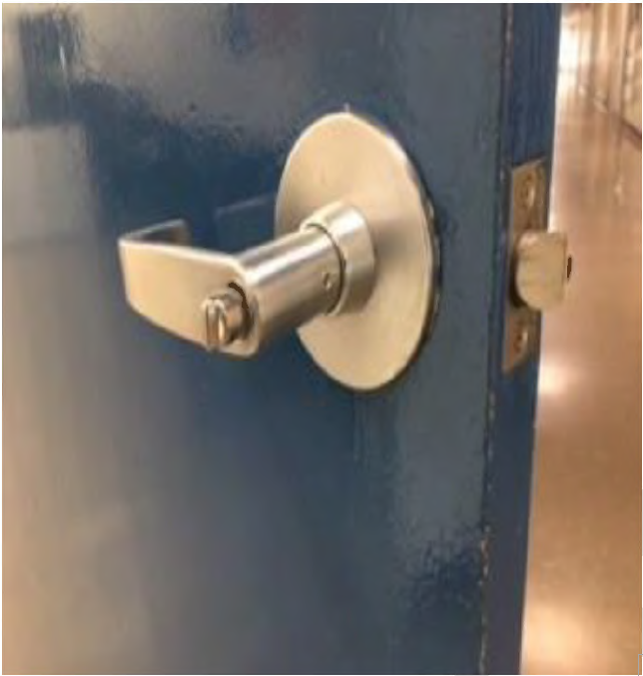
Cylindrical lock inside handle
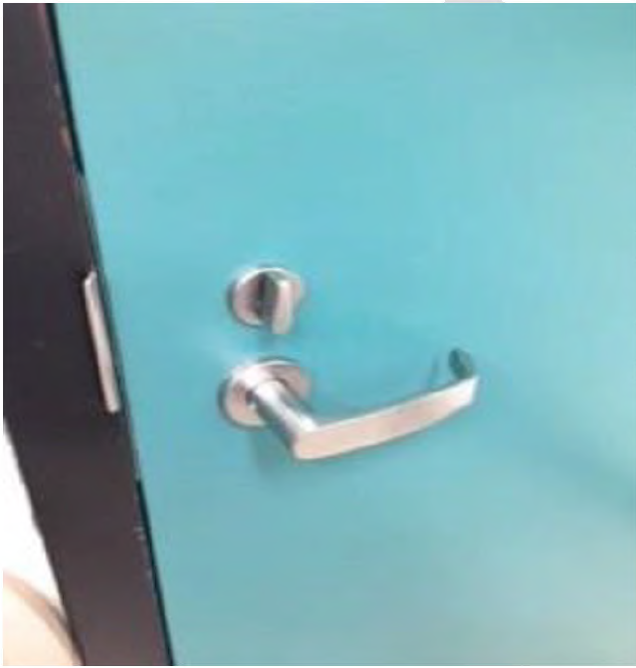
Mortise lock inside trim

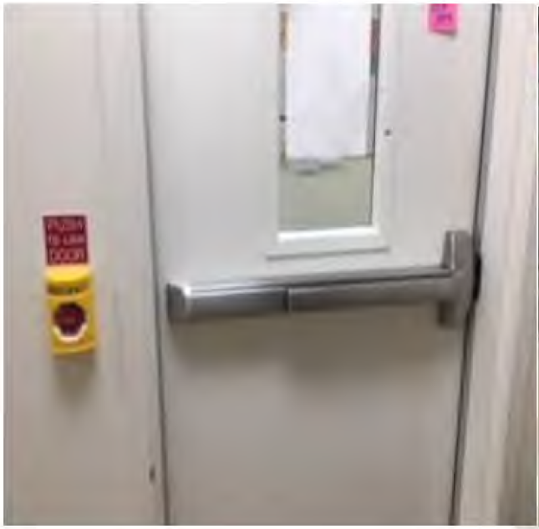
Inside panic hardware and emergency button
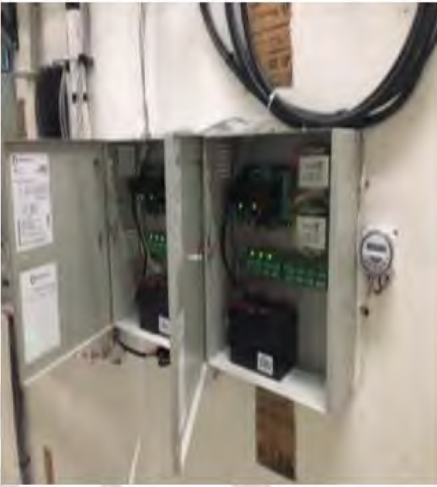
Power supplies and timer
Each unit will power 8 doors. One timer can power as many power supplies as you need in one location.
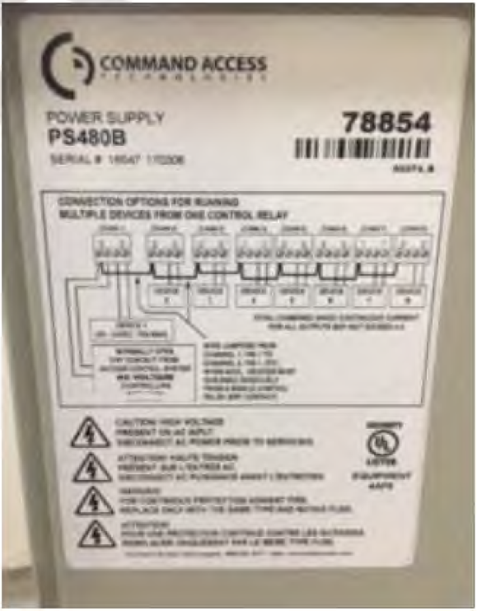
Make and model of power supply used

