Indiana State University Climate Action Plan
American College & University Presidents' Climate Commitment

April 28th, 2010

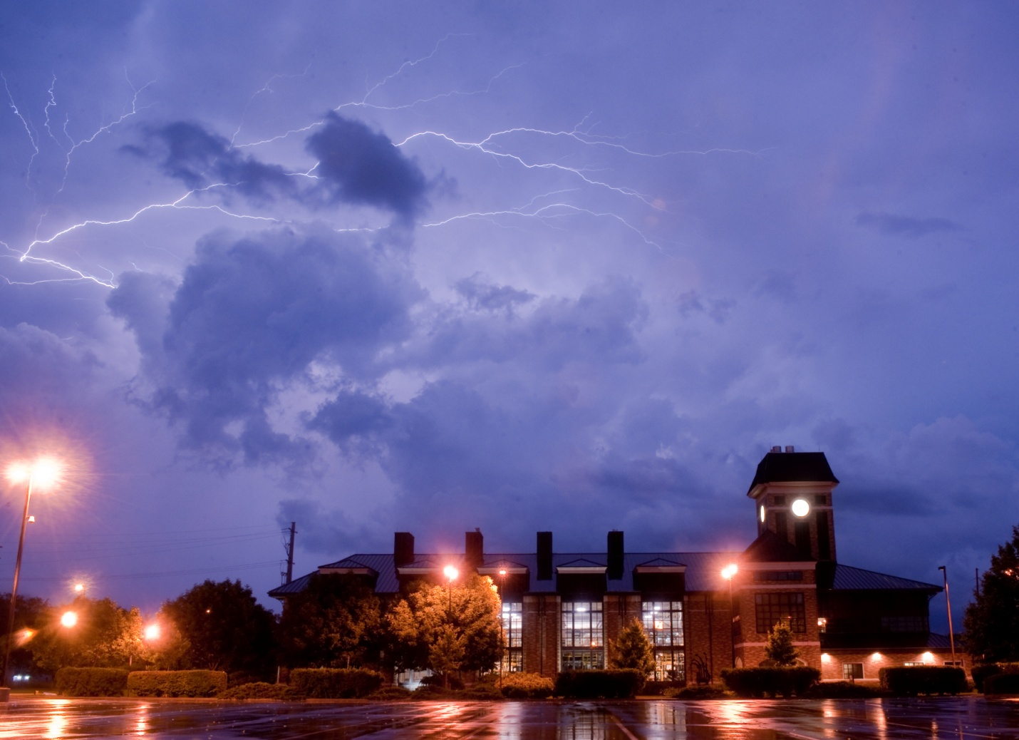

Table of Contents

ISU’s Sustainable Campus Initiative 4
The President’s Council on Sustainability 6
Sustainability Working Groups 6
Executive Summary 8
Summary of the ISU Carbon Footprint Analysis 10
Group 1 – Academics, Curriculum, and Research 13
Group 2 – Built Environment 18
Group 3 – Energy & Transportation 24
Group 4 – Food 31
Group 5 – Resource Use, Recycling, & Procurement 33
Group 6 – Community Outreach & Engagement 38
References 41
Appendix A – Self-Reporting of Utility Inefficiencies 42
Appendix B – Energy Reduction Competition between Dorms 43
Appendix C – Increasing Bus Ridership 44

Table of Figures
Figure 1: Social, environmental, and economic needs can be balanced to achieve sustainability. 8
Figure 2: Historical emissions of CO2 for Indiana State University from 1990-2007 11
Figure 3: Emissions by activity at Indiana State University in 2007 12
Figure 4: The Introduction to Environmental Science classes during a field trip at the riverSCAPE. 13
Figure 5: Proposed master plan for ISU in the next 10-15 years. 18
Figure 6: The multi-modal parking garage at the corner of 8th and Cherry with a fleet of city buses. 19
Figure 7: The flag proclaiming ISU as a Tree Campus USA. 21
Figure 8: The natural gas fired Central Steam Plant constructed in 2001. 22
Figure 9: Steam generation from a coal power steam plant before 2001 (left) versus steam generation from a natural gas powered plant after 2001 (right). 24
Figure 10: Sodexo at ISU makes an effort to source local food that reduces the miles that it has traveled to make it to our events. 31
Figure 11: Sycamore Sam raising awareness for recycling. 33
Figure 12: The amount of material recycled at Indiana State University since the 1989-1990 academic school year. 34
Figure 13: The number of compacted (16 Cu. Yd.) loads sent to the landfill. 34
Figure 14: A break down by item of the materials recycled through the ISU Recycle Center. 35
Figure 15: Recycling during Donaghy Day. 37
Figure 16: Volunteers helping during an E-scrap event. 37
Figure 17: The Terre Foods Cooperative Market sponsoring a Salsa Contest at the Downtown Terre Haute Farmer’s Market. 38
Figure 18: The ISU Recycling E-scrap program. 39

Table of Tables
Table 1: Greenhouse gas emissions from ISU in the equivalent metric tons of CO₂. 11
Table 2: Summary of off-campus green space. 12
Table 3: Faculty that teach or do research in the area of sustainability 14
Table 4: Courses in the area of Sustainability 15
Table 5: Extra Curricular Activities Dealing with Sustainability 15
Table 6. ISU Campus Statistics as reported on the ACUPCC Website downloaded December 2009. 26

ISU’s Sustainable Campus Initiative
Indiana State University (ISU) recognizes its vulnerability to the impacts of climate change as well as the need to reduce the use of fossil fuels and our carbon footprint. This University also recognizes that state institutions like (ISU) are major consumers of energy and natural resources, and should recognize the need to reduce the use of non-renewable resources and to increase energy efficiency. ISU recognizes its obligation to be wise stewards of scarce resources, and to promote the continued economic and ecological viability of the State.
In September of 2007, ISU’s 10th university president, Dr. Lloyd Benjamin III, solidified ISU’s interest in becoming a sustainable campus by signing the American College & University Presidents Climate Commitment. Our 11th president, Dr. Dan Bradley, reinforced our commitment to sustainability and directed the Sustainability Team Members to explore a climate action plan.
The Climate Action Plan is consistent with and has completed the requirements of the President’s Climate Commitment including:
- Hosting a forum on sustainability to include campus and community leaders, politicians, and other local universities (Held 2/20/2008).
- The establishment of the overall coordinating structure including the formation of a council, steering committee, task force, or focus group to help the Sustainability Office communicate with campus, both inviting input and publishing goals and accomplishments (see www1.indstate.edu/facilities/sustainability/index.html).
- Initiating the development of a comprehensive plan to achieve climate neutrality as soon as possible (this plan).
- The creation of institutional structures to guide the development and implementation of the neutrality plan (see www1.indstate.edu/facilities/sustainability/index.html).
- The completion of a comprehensive inventory of all greenhouse gas emissions (including emissions from electricity, heating, commuting, and air travel; See the ISU Carbon Footprint Analysis). Updates to the inventory will be completed every other year thereafter.
- Completing a 10-year historic emission inventory for ISU’s campus, including remote properties (see the ISU Carbon Footprint Analysis).
- Development of a target date for achieving climate neutrality (2050).
- Defining targets for goals and actions that will lead to climate neutrality (this plan).
- Develop actions to make climate neutrality and sustainability a part of the curriculum at ISU (this plan).
- Expand research or other efforts necessary to achieve climate neutrality (this plan).
- Development of mechanisms for tracking progress on goals and actions (this plan).

The American Colleges and Universities President’s Climate Committee (ACUPCC)
The ACUPCC has identified seven initiatives that participating universities may adopt in a coordinated effort to reduce stress to the environment. Indiana State University has committed to initiatives 1, 2, 4, and 7 as identified below by bold typeface.
- Establish a policy that all new campus construction will be built to at least the U.S. Green Building Council's LEED Silver standard or equivalent.
- Adopt an energy-efficient appliance purchasing policy requiring purchase of ENERGY STAR certified products in all areas for which such ratings exist.
- Establish a policy of offsetting all greenhouse gas emissions generated by air travel paid for by our institution.
- Encourage use of and provide access to public transportation for all faculty, staff, students and visitors at our institution.
- Within one year of signing this document, begin purchasing or producing at least 15% of our institution's electricity consumption from renewable sources.
- Establish a policy or a committee that supports climate and sustainability shareholder proposals at companies where our institution's endowment is invested.
- Participate in the Waste Minimization component of the national RecycleMania competition, and adopt 3 or more associated measures to reduce waste.
ISU’s President’s Council on Sustainability will continue to provide leadership as campus sustainability efforts move forward. Working with key ISU leadership, we will continually share insights and help determine processes that will engage faculty, students, staff and our community in sustainability efforts across the campus.
ISU will also consider ways to develop partnerships and funding to support the educational, research, and public service missions of higher education as they relate to sustainability. ISU’s hallmark strengths in teaching, applied research, and community service advocate for a special role for ISU in sustaining the continued economic and ecological viability of the state – not only through best institutional practices, but through applied research, education, and service.

The President’s Council on Sustainability
The President's Council oversees the progress of the Working Groups and will be responsible for developing and implementing ISU's Climate Action Plan.
COUNCIL MEMBERS:
President Daniel J. Bradley
Provost Jack Maynard
Vice President Diann McKee
Vice President John Beacon
Dean Brad Balch
Lee Ellingson
Kelly Hall
Jim Jensen
Ed Kinley
Kevin Runion
Sue Sluyter
Jim Speer

Sustainability Working Groups
The following Sustainability Working Groups have been established to inventory current sustainability practices at ISU. Work within these groups has identified and gathered the information contained within this report.
Group 1--Academics, Curriculum, and Research
Debra Israel, co-chair Jennifer Latimer
Jim Speer, co-chair John Reposa
Sue Berta Yasenka Peterson
Robert English Tom Sauer
Rusty Gonser Virgil Sheets
Eric Hampton Elaina Tuttle
Group 2--Built Environment
Bryan Duncan, co-chair Kevin Runion
Lee Ellingson, co-chair Virgil Sheets
Andrew Conner Jim Speer
Stephanie Krull Mary Sterling
John Reposa Pat Teeters

Group 3--Energy & Transportation
Jeff Jacso, co-chair Steven Flowers
Pat Teeters, co-chair Mark Green
Kevin Barr Jim Speer
Andrew Conner Jeff Williamson
Brendan Corcoran
Group 4--Food
Sue Sluyter, co-chair Al Perone
Bob Jefferson, co-chair Donald Richards
Eliezer Bermudez Tony Askins
Andrew Conner Marah Butler
Frederica Kramer Andrew Pyle
Stephanie Krull Brady Werne
Mary Ellen Linn Mitchell White
Cindy McClain
Group 5--Resource Use, Recycling, & Procurement
Kevin Barr, co-chair Cindy McClain
Paul Reed, co-chair Al Perone
Eliezer Bermudez Josh Powers
Sue Berta Bill Redmond
Andrew Conner Virgil Sheets
Judy Conner Deanna Tyler
Jeff Jacso Ashley Davis
Frederica Kramer
Group 6--Community Outreach & Engagement
Yancy Phillips, co-chair Marlene Lu
Chris Pfaff, co-chair Cindy McClain
Brad Balch Davison Mupinga
Eliezer Bermudez Al Perone
Sue Berta Yasenka Peterson
Andrew Conner Donald Richards
Judy Conner Dave Taylor
Rusty Gonser Angela Borchelt
Report Writers & Editors
Ed Kinley
Jim Jensen
Jim Speer
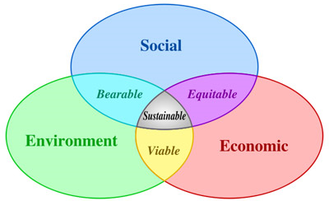
Figure 1: Social, environmental, and economic needs can be balanced to achieve sustainability.

Executive Summary
We adopt the UN World Commission on the Environment and Development 1987 definition of sustainability as “Sustainable development… meets the needs of the present without compromising the ability of future generations to meet their own needs.” We need to realize the triple bottom line of balancing social, environmental, and economic needs to obtain sustainable solutions for ISU (Figure 1).
Indiana State University has been working to reduce carbon emissions and its overall carbon footprint since the 1990s. In 2001, ISU switched from a coal powered steam plant on campus to a central steam heating plant fired by natural gas boilers, which has reduced our emissions by approximately 1.4 million pounds of greenhouse gases annually (Ney 2008). ISU established the recycling center in 1989, which has reduced our deliveries to the landfill so that ISU is only sending 15% of the solid waste to the landfill that it did in 1990 (Ney 2008). In its 20 year history the ISU recycling facility has diverted over 9,000 tons of trash from the landfill, which has saved over 3,000 loads (16 Cu. Yd.) from the landfill. ISU has transformed an urban campus with many impermeable streets to a green campus with extensive canopy cover and named green spaces, planting over 4,000 trees since 1984. Indiana State University is presently at 61% of its 1990 carbon emission levels (Ney 2008). We have come a long way in improving efficiency and reducing carbon emissions. To achieve carbon neutrality, we need to integrate sustainability into all of our activities and to make it a part of campus culture. This can be a unifying theme across campus that may help to build community and a respect for the local environment. Sustainability is also industry driven (i.e. LEED certification) which creates a need for well educated students. Our education programs in sustainability are providing an advantage to our students through training in green construction, the environmental sciences, business, and psychology associated with sustainable issues. By incorporating sustainability into our teaching, the foundational studies program, and learning communities, we can engage a large portion of our undergraduate students and make sustainability part of ISU culture. This academic direction can be a unique selling point for ISU that can set us above other institutions. By incorporating sustainability into our academic programs our impact will be larger than just the university-level changes. We will change student behavior and awareness of the environment around them and they will take these lessons to their professional careers. Also, by incorporating sustainability into campus facilities and activities, we provide teaching moments with real-world consequences for our students. All of our sustainability activities should be located on campus or on ISU landholdings and these activities and improvements should be promoted so that students are aware of our efforts to become sustainable. As we improve the infrastructure on campus we also develop learning venues that fit into our mission for experiential learning and community engagement.
This action plan was developed from the efforts of over 60 administrators, faculty, staff, and students. Six working groups identified ISU’s sustainability efforts in the past and present and made suggestions for future efforts to improve sustainability on campus and in our local community. This report is a culmination of those efforts.
Recommendations in this report are the best suggestions from the committees and are being explored for economic feasibility. Every effort will be made to follow through with these recommendations, but budget and resource implications may affect the timing of their implementation. ISU’s target date for carbon neutrality is set for 2050, although depending upon the rate at which we are able to achieve these recommendations this date may be advanced.

Summary of the ISU Carbon Footprint Analysis conducted by Sebesta Blomberg on July 31, 2008

Indiana State University has been working to reduce carbon emissions and its overall carbon footprint since the 1990s. In 2001, ISU switched from a coal powered steam plant on campus to a central steam heating plant fired by natural gas boilers, which has reduced our emissions by approximately 1.4 million pounds of greenhouse gases annually (Ney 2008). Emissions from decay of solid waste materials deposited in the landfill also decreased substantially due to the University’s efforts at reduced the waste streams. Waste tonnage in 2007 was only 15 percent of the waste deposited in 1990. Because of these past efforts, ISU is presently at 61% of its 1990 carbon emission levels (Table 1, Figure 2: Ney 2008). Emissions from the steam plant were reduced from 65,168 metric tons CO₂ to 19,509 metric tons CO₂ over the time period from 1990 – 2008. Electricity use has decreased 3.6% over the same time period, and overall emissions from the steam plant and electricity decreased 35.5%.
Purchase of electricity from off-campus sources is still ISU’s greatest output of greenhouse gas emissions (Figure 3; Ney 2008). Future work to reduce our greenhouse gas emissions can be focused on electricity conservation to reduce this demand. The current Carbon Footprint Analysis does not count our campus trees and off-campus green spaces (Table 2) as sequestration of campus carbon output. In the future, a determination of this sink will be conducted to determine how much carbon we are sequestering. Also current estimates of electrical usage were quantified based on regional averages rather than specific choices made by ISU. By making clearly sustainable energy choices, we can greatly reduce our carbon footprint. Emissions from the landfill will also be reduced into the future because the landfill has recently installed systems to collect and burn the methane-laden gas that emanates from the landfill.
The Sebsta Blomberg report was a good first approximation of ISU greenhouse gas emissions and shows that the university is far ahead of other universities and institutions that are making efforts to reduce their greenhouse gas emissions to 1990 levels. ISU can take advantage of this good position to innovate and incorporate sustainability education on campus to reach carbon neutrality.

Table 1: Greenhouse gas emissions from ISU in the equivalent metric tons of CO₂.

Figure 2: Historical emissions of CO2 for Indiana State University from 1990-2007
Figure 3: Emissions by activity at Indiana State University in 2007

Table 2: Summary of off-campus green space.
50

Group 1 – Academics, Curriculum, and Research
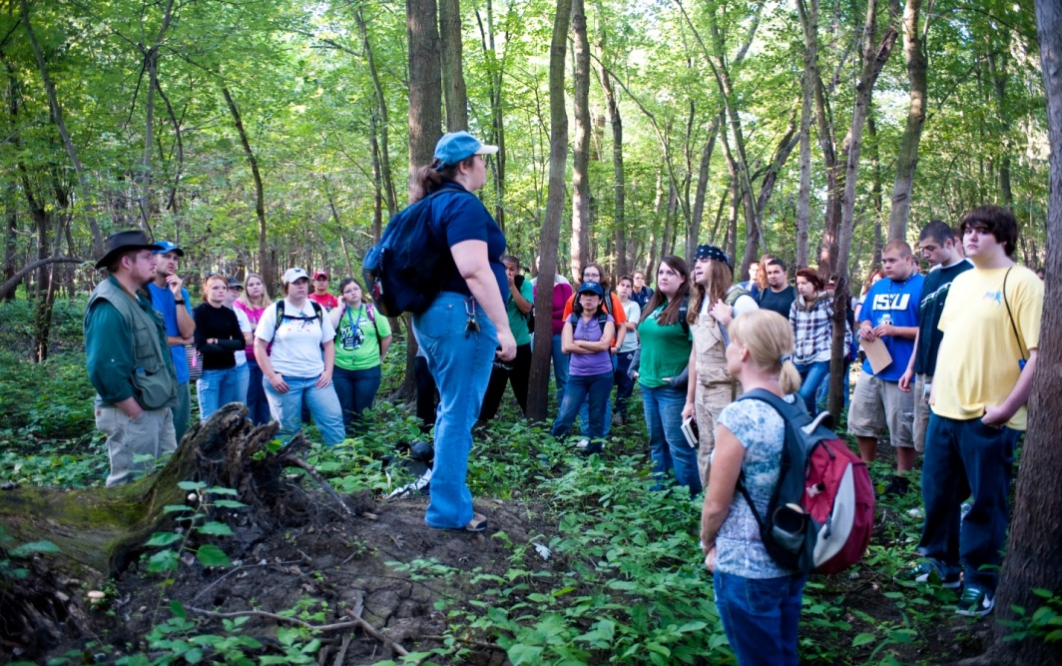
Figure 4: The Introduction to Environmental Science classes during a field trip at the riverSCAPE.
Past and Present
Indiana State University has excelled at teaching courses that deal with sustainability, but until this year, we have not completed a catalog of classes that deal with sustainability and the faculty that teach those classes and conduct research in the area of sustainability. We have identified 39 faculty that conduct research in or teach about sustainability (Figure 4, Table 3). This information is based on an informal poll and the number of active faculty is likely to grow once we organize a sustainability emphasis and advertise that emphasis across campus. We have also identified 22 courses that deal with the environment and sustainability (Table 4). These courses cover economics, psychology, political science, technology, and the environmental sciences. Currently, five student organizations deal with environmental issues and have community service events on a regular basis (Table 5).

ISU has demonstrated a strong commitment to the environment and sustainability through the change of the department of Geography, Geology, and Anthropology to the department of Earth and Environmental Systems. This new department provides a focus for environmental efforts on campus while these faculty work to integrate their teaching with others departments across campus to provide a truly interdisciplinary approach to environmental science. This department has integrated project based learning, experiential learning, and community engagement into many of its classes including a focus on research and education at the riverSCAPE (the 6,500 acre Wabashiki wetland preserve along the west bank of the Wabash River).

Table 3: Faculty that teach or do research in the area of sustainability (39 total). CAS = College of Arts and Sciences; COB = Scott College of Business; COT = College of Technology. No sustainability courses have been identified in the Bayh College of Education or the College of Nursing.
Kathleen Heath | CAS Anthropologist: Human evolution and behavior
Russ Stafford | CAS Archaeologist
Rusty Gonser | CAS Biology
Bill Mitchell | CAS Biology
Peter Scott | CAS Biology
Elaina Tuttle | CAS Biology
Paul Burkett | CAS Economics
John Conant | CAS Economics
Debra Israel | CAS Economics
Rick Lotspeich | CAS Economics
Don Richards | CAS Economics
Brendan Corcoran | CAS English
Tom Derrick | CAS English
Jim Speer | CAS Geography and Geology: Environmental Reconstruction
Greg Bierly | CAS Geography: Climatology
Steve Aldrich | CAS Geography: GIS and developing countries
Nancy Obermyer | CAS Geography: GIS and Environmental Policy
Mohameden Ould-Mey | CAS Geography: Globalization and religious studies
Basil Gomez | CAS Geography: Fluvial Geomorphologist
Sue Berta | CAS Geography: Paraglacial Geomorphologist
Qihao Weng | CAS Geography: Urban Heat Island Effect
Sandy Brake | CAS Geology: Acid Mine Drainage
Jen Latimer | CAS Geology: Environmental geochemistry and reconstruction
Tony Rathburn | CAS Geology: Marine ecology and pollution
Michael Chambers | CAS Political Science
Virgil Sheets | CAS Psychology
Tom Steiger | CAS Psychology
Eric Anderson | CAS Psychology and Honors
Art Sherwood | COB Business
Joe Harder | COB College of Business
Anita Gabbard | COT Technology
Affan Badar | COT Technology: Renewable Energy, Photovoltaic panels/cells
Denis Shchepetov | COT Technology: Renewable Energy, Photovoltaic panels/cells
Thomas Stersioulas | COT Technology: Renewable Energy, Photovoltaic panels/cells
Ming (Joe) Zhou | COT Technology: Renewable Energy, Photovoltaic panels/cells
Lee Ellingson | COT Technology: Sustainability in Construction
Patricia Polastri | COT Technology: Sustainability in Construction
John Reposa | COT Technology: Sustainability in Construction (USGBC LEED)
James Smallwood | COT Technology: Sustaining Green Manufacturing

Table 4: Courses in the area of Sustainability (22 Total)
ANTH 498: Human Discovery
BIO 455: Humans and the World Environment
BIO 491/691: Special Topics in Biology – Community Ecology
CNST 414: Construction Sustainability
ECON 303: Environmental Economics
ECON 498: Food, Hunger, and Agricultural Sustainability
GEOG 130: World Geography
GEOG 242: Introduction to Geographic Information Systems
GEOG 411: Conservation and Sustainability
GEOG 444/544: Processing of Data for Geoscientists
GEOL 110: Introduction to Environmental Science
GEOL 361 Oceanography
GEOL 457/557 Environmental Geology
GEOL 4**/5** Global Biogeochemical Cycles
GEOL 6** Environmental Geochemistry
Honors 111: Dreaming Large – Sustainable Development in the 21st Century
PSCI 199: Global Politics and Global Warming
PSY 270: Social Psychology
PSY 350: Environmental Psychology
PSY 485: Psychology and Society – Theme Ecology and Human Responsibility
SOC 324: Population Problems
BUS Sycamore Business Advisors with sustainable projects like Terre Foods

Table 5: Extra Curricular Activities Dealing with Sustainability
Earth Day Organized by Rusty Gonser - Biology
Environmental Club Environmental service events
Gamma Theta Upsilon Environmental Service Events - Geography Honors Society
Anthropology Club Environmental Service Events
Geology Honors Society Environmental Service Events
ISU Construction Club Design and Built a Wind Turbine - 2008-2009
SME Student Chapter Renewable Energy Projects with Photovoltaic Cells
Our Green Valley Alliance ISU faculty are part of the founding members for this sustainability group in the Wabash Valley
Economics Two undergraduate fellowships involving survey research in Environmental Economics

Concerns with our ability to sustain the current path of economic and social development are emerging as defining issues for the 21st century. Resources are becoming more limited; urbanization is increasing our demand for these resources; population growth is increasing; and the world has become more connected through globalization. This connection has driven an interest in obtaining the standard of living that can be identified from areas around the world, driving an increase in consumption of electricity and goods throughout the world. Our students are coming of age in a world that has become increasingly connected, more heavily populated, and the realization of the earth’s limited resources is starting to sink in. Our present curriculum covers classes in sustainability in technology, political science, economics, geography, geology, biology, psychology, and construction. Our students need to understand sustainable development as they prepare to enter the work force whether that job is the construction of buildings, the behavior and psychology of the human population, or environmental management. Limited resources and a growing population are two constraints that this generation of students will have to face.

As we gather our resources and identify the classes where we already teach about sustainability, it seems evident that the concept of “sustainable” will spread across all major academic units on all university campuses. Environmental sciences and ecology have the longest relationship with the study of sustainability, followed by the social sciences (principally economics and psychology), with engineering, technology, and business beginning to address the issue. Literature, film, and the arts are also addressing sustainability as well.

Given the scope of change that is involved in transforming current practices into sustainable ones, the range of skills and knowledge needed is beyond any single discipline or broad academic unit. Indeed, sustainable may have to become the defining criteria for development on par or even superseding profitable. To that end, ISU’s current resources to address both student needs as well as the looming human challenges are at best a patchwork. There is considerable interest, expertise, and resources on campus. We propose to organize these resources and to build on them in order to educate ISU graduates who are aware of the challenges involved in achieving a sustainable future, literate in the ideas, methods, and controversies surrounding sustainable policies, and able to connect individual decisions to global relationships.

ISU’s historical strengths and the focus of our mission is experiential learning and community engagement. The issue of sustainability provides many opportunities to involve students in finding the solutions to these modern issues. Many of the above listed classes actively involve students in project based learning organized around sustainable concepts that already draw upon issues from ISU and the Riverscape. This teaching model is embedded in the strategic plan (Goal 2 Initiative 2) of applying the science of learning to the learning of science. The SENCER Teaching Model engages students with project based learning through community engagement projects. In summer 2009, members of ISU attended their first conference on the SENCER Teaching Model and have been holding faculty development workshops ever since that encourage faculty to fully integrate this teaching model.

We suggest that ISU organize and advance these classes as part of campus community awareness. Furthermore, we suggest that all faculty work to integrate project based learning around the concept of sustainability so that the entire university starts thinking about its environmental impact. The best way to achieve carbon neutrality is through not only education of the ISU community, but through buy-in of that same community so that all aspects of the University focus on this question of sustainability. When we start to construct LEED Silver buildings on campus, those buildings themselves become the laboratories and educational venues for construction and environmental science students on campus. ISU has been very active in the last twenty years with its recycling program and by involving students more completely in that program, it also becomes a teaching tool where students learn the importance of recycling and integrate it into their daily lives.

These efforts to incorporate sustainability into our academic programs tie into all of the goals set forth in the strategic plan.
- Goal 1: Increase Enrollment and Student Success
- Goal 2: Advance Experiential Learning
- Goal 3: Enhance Community Engagement
- Goal 4: Strengthen and Leverage Programs of Distinction and Promise
- Goal 5: Diversify Revenue through Philanthropy, Contracts and Grants
- Goal 6: Recruit and Retain Great Faculty and Staff
- PARTNERING FOR SUCCESS: Develop partnerships to advance the university and community

Recommended Best Practices
We make the following suggestions for ways to incorporate sustainability more completely into the curriculum. Many of these activities are already taking place but can be further enhanced with a concerted effort by the faculty and administration. Some involve the pursuit of external funds (such as a minor in sustainability that could be funded through an NSF CCLI grant). We have already identified a strong core of faculty who are completely engaged in sustainability. Many students are also conducting research in this area and taking classes with this theme. ISU simply needs to provide the framework to make this a more distinct aspect of campus life.
- Develop a minor in sustainability.
- Have a learning community around the concept of sustainability to create more connections for students across disciplines.
- Develop more partnering activities with local land management agencies especially with the riverSCAPE.
- Develop a website to report energy waste in an effort to reduce energy cost and provide buy-in for the campus community (see Appendix A for further details).
- Develop a competition between dorms or other monitored buildings to reduce energy consumption. Provide an incentive for those groups by giving them 10% of the money saved to reinvest in their building (see Appendix B for further details).
- Have classes conduct project based learning around sustainability issues at ISU.
- Enable facilities management to purchase mobile electricity monitoring units for educational purposes and to buy heat sensors that can be used in classroom projects to help monitor buildings.
- Develop a sustainability or environmental club on campus to help drive a grassroots student effort towards sustainability.
- Increase communications across campus on sustainability issues so that the campus community can be aware of all sustainability efforts.
- Gather all available data for campus for future analysis in classes.

Group 2 – Built Environment

ISU Master Plan
December 18th, 2009 Ratio Architects from Indianapolis in conjunction with the ISU community developed ISU’s master plan which has the implementation of sustainability as a goal (Figure 5).
Figure 5: Proposed master plan for ISU in the next 10-15 years.

This is the first external review of our master plan in decades and includes a prominent presence on the riverfront that will preserve wetland and forested areas and further green our campus. ISU is also working towards developing more downtown housing that will lower the urban footprint for campus (or close to campus) housing.
Landscaping and Groundwater
Indiana State University has been working at greening its campus for many decades. In 1966, ISU closed 6th ½ Street in front of the library when the library was built. The 1985 Sasaki master plan made many suggestions for a more livable campus that was implemented over the following years. Sixth Street and Chestnut Street were closed in 1989 when the Hulman Student Union Building and Dede Fountain were built. Sycamore Street was also closed by the library and these areas were changed from impervious roads to pervious walkways.
Originally, the only outdoor space was the Quadrangle as the central open space on campus. Today ISU has 17 named outdoor spaces for the enjoyment of the students and that are used in outdoor instruction with many more planned. These efforts to improve the student experience at ISU have greatly helped improve the look and experience that ISU provides.
Indiana State University has been working with the City of Terre Haute to develop more than 12 miles of bike trails that go through campus and connects with downtown and other universities in the area. We helped develop the multi-modal parking facility on campus that ties bus transportation with automobile traffic, bicycling, walking, and other potential transportation modes such as long range greyhound (Figure 6). This structure also reduced the need for surface parking spaces on campus by building multiple levels of parking garage offering 632 spaces (from Sustainability Forum PowerPoint presentation 2/20/08).
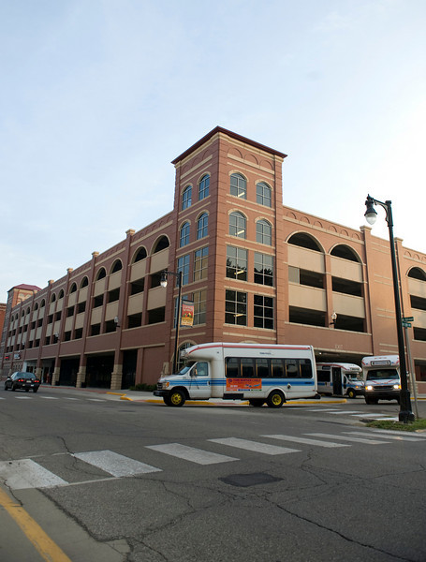
Figure 6: The multi-modal parking garage at the corner of 8th and Cherry with a fleet of city buses.
Many parking lots now drain into dry wells, recharging the ground water and preserving our sewer system from these high flow events. Only Terre Haute and Northwestern Indiana could accomplish this as they posses sandy soils that allow the needed rate of infiltration of groundwater. Root Hall, Erickson Hall, and Burford Hall all drain gutter water into dry wells. All university parking lots also drain into dry wells for infiltration of that water back into the ground. ISU also currently uses five deep well pumps to draw about 75% of the ground water for irrigation which helps the vegetation because this water does not have the chlorine treatment used for municipal water. ISU also uses deep wells for the boiler plant and chiller plant which enables us to use untreated water which creates less burden on the municipal water treatment plant. ISU has been working with innovative materials such as pervious asphalt parking lots at the baseball field which were installed by Wabash Valley Asphalt.

ISU has decreased the local urban footprint by purchasing old homes in the areas to the east and north of campus and removed those homes creating green space. These efforts have improved safety, visual appeal, the permeability of the sites, and the carbon footprint for those locations. In addition to the 200 acres of main campus ISU also owns over 235 acres surrounding campus.

ISU has been increasing the green space and creating a buffer around campus through the installation of small and easily manageable tree farms. ISU currently has nine tree farms that are maintained around campus. In September 2009 there were 818 trees total in the farms that range in size from <2" diameter to 6.5" diameter. Three of the nine farms were added in spring 2009, and four additional farms will be planted this spring. This spring ISU will add approximately 500 trees, but will use saplings from the nursery for the first time, whereas in the past whips 5-6' tall were used. ISU have about 15 acres now and will expand to another 3 acres in the spring. ISU is favoring native trees that include many oak species (Quercus sp.), serviceberry (Amelanchier canadensis), white pine (Pinus strobus), American holly (Ilex opaca), black walnut (Juglans nigra), black cherry (Prunus serotina), maple (Acer sp.), elm (Ulmus sp.), and sweet gum (Liquidambar styraciflua). This spring ISU will add two new species of oak, shagbark hickory (Carya ovata), bald cypress (Taxodium distichum), and dogwood (Cornus florida).

In 2008 ISU eliminated chemical treatment from 80% of our turf areas, spending about 1/3 less on applying organic fertilizer 2-3 times a season. The remaining 20% around the athletic fields are still being managed in the traditional fashion. ISU has been through two growth seasons, and haven't yet experienced intolerable weed levels. As the soil strength builds, we anticipate being able to cut back on fertilization to every second or third year in less critical areas.
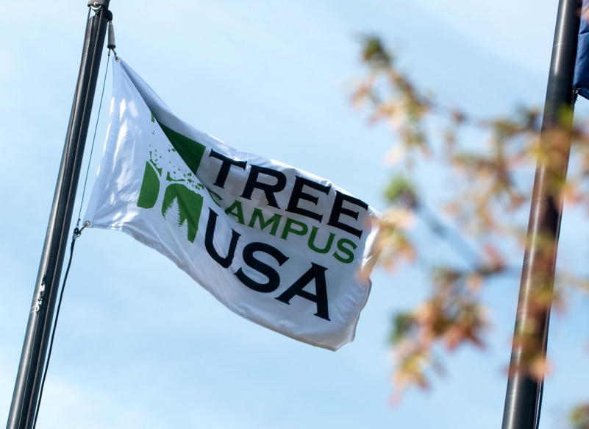
Figure 7: The flag proclaiming ISU as a Tree Campus USA.
In December 2008, ISU became a Tree Campus USA which is only one of two Tree Campuses in Indiana (Figure 7). Our Grounds Department is currently conducting a tree inventory to be completed in February 2010. This inventory will locate all trees on campus with a GPS and also photograph all trees providing a health and history inventory for the campus. As part of becoming a Tree Campus USA, we have made a public commitment to spend a percentage of money on tree canopy based on number of students enrolled (~$3/student) totaling $30,000 a year. Daveys iTree database (http://itreetools.org/utilities/SpeciesSelector.shtm) is a useful tool for checking the carbon sequestration potential of individual tree species and other environmental impacts. In November of 2009 ISU began building our complete tree inventory and once that inventory is complete the data will be entered into iTree to compute the relevant statistics (such as carbon sequestration), which will then become part of our Campus Tree Care Plan.
ISU is examining the American Society of Landscape Architects Sustainable Sites Initiative as it is being developed by the Lady Bird Johnson Wildflower Center and the United States Botanic Garden. This initiative is working to create voluntary national guidelines for sustainable land design and maintenance practices. This rating system was developed over the past four years and just released in Fall 2009. It is currently in the testing and refinement stage. ISU plans to employ their standards to both analyze our day to day operations and rate our new development.

Buildings
Because of our past efforts at sustainability, ISU is currently at 61% of our 1990 carbon emissions (Ney 2008). In 2009, we advanced to a commitment for all new construction to be completed under LEED silver certification.
ISU has made efforts to preserve older buildings on campus and have done renovations and building maintenance needed to persevere buildings such as Stalker Hall, HHP Building (Arena), University Hall, and Federal Building. Building preservation imposes less stress on the environment than erecting new ones and adds to the charm of the campus.
The greatest change at ISU for approaching carbon neutrality was to change from a coal fired steam plant to a natural gas boiler steam plant in 2001 (Figure 8). Many other changes have been made to ISU to reduce our expenditure for electricity (see the University Energy Initiative Report (Jensen et al. 2006) for a summary of these efforts).
Figure 8: The natural gas fired Central Steam Plant constructed in 2001.
Currently ISU is using economies of scale by hooking up the New Chiller Plant to the Student Recreation Center and other stand alone buildings that are currently on independent cooling systems. This work was bid in December of 2009 and construction should be completed in 2010 based on approval of state funding. The Condenser Heat Exchange Project at the Central Steam plant is planning on using preheated water recycled back into the boilers, which will lower energy costs and extend the life of the equipment. The construction contract was awarded in December of 2009 and construction will start in 2010.
It has been currently standard practice for the past 10 years to install HVAC systems on direct digital control. This provides more efficient control, better air quality, and also measures CO2 levels. The energy tunnels are currently lighted with timed light switches to save energy costs by making sure that the lights are off when the tunnels are not in use.
ISU became a member of EPA’s Green Lights program and has retrofit many of our light fixtures to low energy lights. This effort involved a large investment by ISU along with grants from the EPA and others. ISU participated in Public Service Indiana Demand Side Management Program which allowed the installation of a variable-air-volume HVAC system for the Cunningham Memorial Library with aid from Cinergy (now Duke Energy).

Recycling
ISU has committed to extensive recycling and reuse throughout campus (See Group 5 below for more on our recycling program) which extends to the built environment. The Grounds Department works to preserve and reuse much material including architectural features from old buildings and building materials as well. The new Condit House garage is made from bricks salvaged from 12th Street church. Our purchasing department and central stores organizes recycling and reuse of old furniture and other items from across campus.

Recommended Best Practices
The Built Environment Committee of the Sustainability Working Groups has a series of recommendations as we move forward and work to achieve carbon neutrality.
- Make all storm water from buildings drain into dry wells or surface retention ponds.
- Require that renovations of existing buildings or during the demolition of old buildings that the materials be recycled. Part of this requirement would be to order recycling of demolished materials as part of our master specifications given to all consultants in the future. ISU needs to keep track of all materials and report out on those numbers.
- Participate in energy efficiency webinar produced by Duke Energy (Pat Teeters is already participating). The Blue Print to Energy Savings requires regular building energy audits and building walk-around to check for leaks and efficiency. As part of this goal, we suggest that facilities management purchase the tools need (infrared heat detectors and electricity flow monitors) that could be used by facilities and borrowed by students to conduct further analyses.
- All new construction as LEED silver will add a 5.7% premium to construction costs, but save 10% in future utilities (USGBC 2009).
- The Bayh College of Education has moved into the renovated University Hall and the Donald C. Scott College of Business will move into the Federal Building once it is remodeled. With these moves, ISU will be able to raise the old College of Education and College of Business towers on the north side of campus. This will lower the overall skyline of ISU and save approximately $1 million in utilities and maintenance costs. The current plan is for those buildings to come down in 2013-2014 based on state appropriations. ISU’s long term plan is to keep the current urban footprint of ISU static with any new construction being balanced by the demolition of inefficient buildings.
- Develop a history of construction on campus which could be provided by a GIS class that could do a change detection analysis from aerial photography of buildings and roads through time. We need to get very old aerial photography from the 1930s, 1940s, 1950s, 1960s, 1970s, and 1980s. We have imagery from 1996, 2001, 2006, and 2008. Removal of asphalt and increase in green space should count as carbon capture.

Group 3 – Energy & Transportation
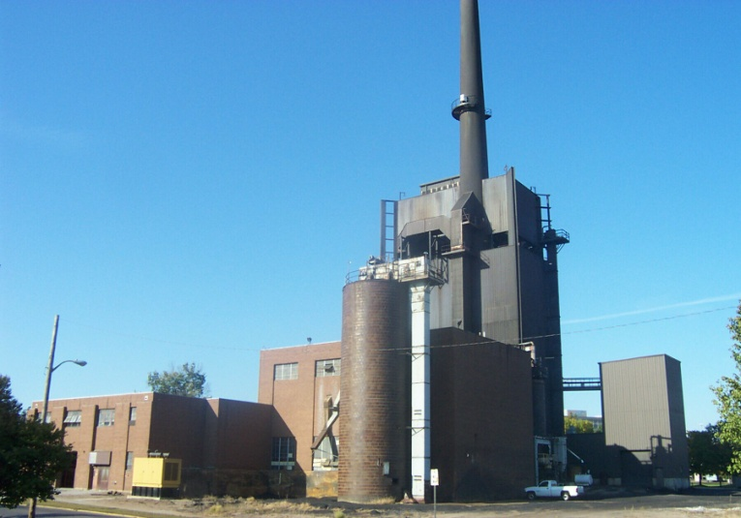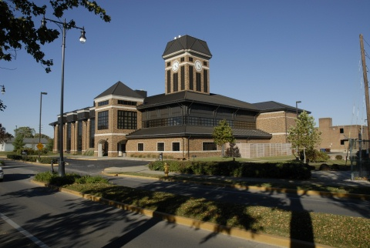
Figure 9: Steam generation from a coal power steam plant before 2001 (left) versus steam generation from a natural gas powered plant after 2001 (right).

Past
In 2001, we switched from a coal powered steam generation plant on campus to a natural gas boiler which has probably been our greatest single reduction in greenhouse gasses (Figure 9). ISU completed an external energy audit that cost $300,000 to examine energy use at ISU. In January of 2006, the Energy Reduction Committee completed the University Energy Initiative which was a 33-page report that discussed past energy use and efforts to reduce expenditures on energy. This report identified the continued effort at ISU to reduce our expenditure on electricity. Our past efforts have paid off, but electricity continues to be 69% of our carbon footprint. One item that was identified in the University Energy Initiative report is that faculty and students need to become aware of their energy usage and an ethic of energy conservation needs to become a standard part of university life. The 2006 report started the “Be Energy Aware” campaign, although because of inadequate promotion and not working energy efficiency into our university classes, this campaign was not able to change the behavior of faculty, staff, and students in the campus community. We will discuss our recommendations later in this report on how to revive this program and to incorporate it into the ISU community awareness.
Education of our faculty, staff, and students on energy conservation is a continuing process. Facilities management staff are attending webinars that are conducted by Duke Energy dealing with energy conservation. Many of our recommendations for energy conservation come from discussions during those meetings and from advice provided by the experts from Duke Energy.

We can capitalize on our past success and put those forward to help motivate the current ISU community. Some of those successes include designing and constructing an award winning natural gas fired steam plant which cut GHG emissions in excess of 182,000,000 pounds since 2001. We changed our lighting from incandescent bulbs to compact florescence which has reduced our electricity consumption by a third. We have partnered with the EPA GreenLights program to install energy efficient lighting and controls. We also work with the Demand Side Management (DSM) program which provided rebates for upgrading existing facilities to energy efficient equipment.
Energy Efficient Design Standards developed by Facilities Management Staff have included a lighting retrofit which replaced T-12 Fluorescent lamps with T-8 lamps and replacing magnetic ballasts with electronic ballasts. Facilities Management has also installed Adjustable Frequency Drives (AFD) on mechanical equipment and Variable Air Volume (VAV) HVAC Systems. They also rewrote all ISU Design Standards and Specifications to require Energy Star rated materials and equipment. Our current efforts to incorporate LEED Silver guidelines into all new construction will build off of these past efforts.
Since 1990 these Electrical Energy Conservation programs have saved the University in excess of $6,950,000 in electrical costs, 196,500,000 in kilowatt hours (KWH) consumed, 3.86 billion pounds of CO2 emissions, and 3.8% of the 2006 Campus GHG emissions. We now need to take the next step and make energy conservation part of the campus wide culture.
Present
Facilities Management is now providing historical energy usage and cost data to classes so that students can start to analyze this data and become part of the solution. This ongoing communication between Facilities Management and the faculty and students at ISU through a series of courses is one way to incorporate an energy conservation ethic on campus. We suggest more programs in the recommendations section at the end of this report.
On campus stationary sources take up 19.9% of our carbon footprint (Table 6). These sources include the central heating plant as well as individual boilers in stand-alone buildings such as the African American Center, University apartments (4 boilers), the federal building, art annex, brazil field campus, HMSU commons (15-20 roof top units), Kieweg house, Landsbaum home, Michael Simmons student activity center, Morge building (hazardous waste storage on the back of the new powerhouse), football stadium, university club, WISU Tower, baseball field, soccer field, and softball field (furnaces for the last three).

Table 6. ISU Campus Statistics as reported on the ACUPCC Website downloaded December 2009.
Building Space
Gross square feet of building space | 4,341,089 sq ft
Net assignable square feet of laboratory space | 150,000 sq ft
Net assignable square feet of health care space | 20,000 sq ft
Net assignable square feet of residential space | 1,175,200 sq ft
Population
Total Student Enrollment (FTE) | 10,568
Residential Students | 3,298
Full-time Commuter Students | 3,767
Part-time Commuter Students | 1,237
Non-Credit Students | 0
Full-time Faculty | 412
Part-time Faculty | 136
Full-time Staff | 1,159
Part-time Staff | 326

Scope 1 Emissions
Stationary Combustion | 19,509 metric tons of CO2e
Mobile Combustion | 3,049 metric tons of CO2e
Process Emissions | 0 metric tons of CO2e
Fugitive Emissions | 0 metric tons of CO2e
Total Scope 1 emissions | 22,558 metric tons of CO2e
Scope 2 Emissions
Purchased Electricity | 67,804 metric tons of CO2e
Purchased Heating | 0 metric tons of CO2e
Purchased Cooling | 0 metric tons of CO2e
Purchased Steam | 0 metric tons of CO2e
Total Scope 2 emissions | 67,804 metric tons of CO2e
Scope 3 Emissions
Commuting | 4,909 metric tons of CO2e
Air Travel | 2,349 metric tons of CO2e
Solid Waste | 92 metric tons of CO2e
Refrigerants | 354 metric tons of CO2e
Total Scope 3 emissions | 7,704 metric tons of CO2e

 | Total | Per Full-Time Enrollment | Per 1000 Square Feet | % Offset
Gross emissions (Scopes 1 + 2) | 90,362 metric tons of CO2e | 8.6 metric tons of CO2e | 20.8 metric tons of CO2e | 0%
Gross emissions (Scopes 1 + 2 + 3) | 98,066 metric tons of CO2e | 9.3 metric tons of CO2e | 22.6 metric tons of CO2e | 0%
Net emissions | 98,066 metric tons of CO2e | 9.3 metric tons of CO2e | 22.6 metric tons of CO2e | N/A

Facilities Management continues to be proactive in energy conservation at ISU. Currently they are undertaking a $1 million project in steam reduction using condensing heat exchangers. ISU has developed a number of deep wells for irrigation which saves on our Indiana American Water bills and helps to reduce demand from them.
Residence Life is also proactive in reducing energy consumption in the dorms when students are not on campus. They examine all rooms and follow an extensive check list to make sure that the dorms are pulling the least amount of energy necessary for basic operation during winter break and when not in use in the summer. Part of this check list includes shutting down and unplugging all appliances during the break. There are regulations in place for the energy consumption of appliances so that appliances are only allowed to draw one amp. Current renovation of the dorms also improve energy conservation by using Low Energy windows that have a double pain of glass that is filled with Argon to reduce energy loss through the windows. These are currently being installed in Sandison Hall and are planned for Pickerel Hall renovations in 2010-2011. Energy conservation continues to be an issue with older buildings. For example, energy loss through gaps in insulation in the Sycamore Towers is a major energy cost, yet it would cost $1 million to caulk all four towers to seal up these cracks.

Future Recommendations
We have developed many recommendations on how to become more energy efficient in the future. Our main goals are to reduce energy consumption, raise awareness of energy conservation, and incorporate energy conservation into the campus culture. Part of this effort will include a very public presentation of our current energy use and plans for energy conservation so that all faculty, staff, and students on campus know about our efforts to reduce energy consumption. To this end, we should have a website dedicated to energy consumption at ISU. We should post our electrical bills each month, identify areas of energy waste, and post real time energy metering on a building by building basis.
The Energy Committee of the Sustainability Working Groups has a series of recommendations as we move forward and work to achieve carbon neutrality.
- Cogeneration at the central heating plant should be a priority, although it will cost from $4-5 million. New alternative fuel source boilers with heat recovery systems would be the most efficient that are currently available.
- We could develop a wind turbine farm on a remote site (possible along the banks of the Wabash on the new river campus). Such a wind farm would be educational and provide a visible symbol of our efforts at energy conservation and pursuing new technology. Such windmills should be studied and designed by our own technology and construction classes.
- Reduce peak usage which will lower our overall costs with Duke Energy. Peak months are in August and September when students return to campus and temperatures are still hot. January and February create a secondary peak as these are our months with the greatest need for heating.
- Personal refrigerators on campus consume a large amount of energy year round. We need to think of ways to replace this service with a convenient but energy efficient solution. One possibility is to prohibit personal refrigerators and provide high efficiency centrally located refrigeration units.
- We suggest a bicycling initiative to develop a healthier campus and to reduce fuel consumption across the University. The university could support such an initiative by reducing the cost of parking permits for faculty, staff, and students that agree to bike to campus two days a week (during non-hazardous weather). Other incentives to encourage bicycling would be to increase parking costs and to provide priority parking for people that have signed on to the bicycling plan.
- Use of Enterprise Rental Car has replaced our old fleet with newer leased vehicles with better mile per gallon efficiency. We should push Enterprise to offer more hybrids and high efficiency vehicles to the ISU community. We could create a new agreement with a reduction in miles per gallon for the average vehicle rental.
- Investigate sources for local fuels including alternative energy, ethanol fuel, and other alternative fuels. Methane gas from the landfill is one potential fuel source that has been identified already.
- Soda machines are a large energy drain. Removing all soda machines from campus would result in less energy use and a healthier student population. Alternatively, we could require that the companies that vend through these machines use energy conservation designs and pay to offset the energy consumption of these machines through donations toward alternative energy efforts at ISU. There is also some energy miser technology that uses energy more efficiently to maintain the proper temperature in vending machines.
- Use ethanol fuels for our on-campus automobile fleet.
- Use electric vehicles for those that have short travel distances. This energy would preferably be based on a solar or wind powered electrical production. We could locate covered parking bays behind facilities management that have roof-mounted solar panel charging stations with electrical backups.
- Increase energy conservation awareness on campus. We need a full push on energy conservation awareness on campus. This includes incorporation of energy issues in our classes, energy efficiency activism by our student clubs, and a full advertising program by the university to highlight our successes and future direction for energy conservation. It is possible to change behavior, but it will take a concerted and sustained effort. It must be accompanied with incentives and clear publication of our efforts and successes.
- Create a competition between dorms (or individual buildings or building groups that we can monitor). A percentage of the reduction in energy usage costs could be made available to the dorm residents to decide how to spend it on dorm maintenance or renovation. Lincoln Quads have considered such a competition with Rachel Barrett being the contact person.
- Look into the potential for geothermal heating for ISU. There are 3-4 contractors that do geothermal heat in Terre Haute. This effort can start with individual pilot projects for some buildings rather than a whole campus conversion to geothermal.
- ISU can promote webinars rather than travel to seminars. We also need to track webinar use so that we can quantify how we have used this resource. The working group is aware of many webinars that ISU personnel have participated in. Part of this effort should include a technology webinar room or conference center where moderate sized groups can participate in webinars and get away from their daily duties.
- Signage to promote energy conservation needs to be developed and deployed across campus. This includes notices at light switches to turn off the lights when leaving a room. Also signs should be posted that the automatic door openers on each building are only to be used by the handicapped or in case of necessity (moving large loads).
- Facility Management needs a new Energy Management Systems for central control where we can reduce energy use during off times. We need to set a schedule for temperature control and shut backs on heating during holidays.
- We could shut down some buildings in the summer that do not have much activity in them. We can centrally locate classes and establish temporary office space for those that need to continue to work while those buildings are in stasis.
- Facility Management needs to purchase equipment that will make temporary monitoring by department possible. This will raise awareness of energy use, provide immediate feedback on energy consumption by department, and locate areas of waste. Such intensive energy monitoring can also contribute to energy conservation competitions across campus, where individual floors of a dorm could compete to reduce their energy usage which would make the competition more personal for the students.
- Investigate the feasibility of using Zimride at ISU. Zimride is a carpool organizing web service that may reduce parking pressure on campus, reduce pollution, and build community (http://www.zimride.com/). The cost is $9,500/year for administering the website. We advise conducting a survey of students to see who would take advantage of such a service.
- Enterprise Rent-A-Car has piloted a program to rent cars by the hour in some locations. We should discuss this option with our Enterprise to help reduce car parking and use on campus. If students know that they could get access to a car when they needed it, we might be able to reduce the parking burden and encourage students to leave their cars at home. This should also reduce the miles that are traveled.
- Currently our carbon footprint analysis does not take into consideration any efforts by faculty and students to carpool, bicycle, or walk to campus. We need a website to take information about how often the ISU community uses these alternative methods of transportation which would allow the calculation of a carbon reduction based on alternative transportation. Once we have quantified this use, we can encourage more of the ISU community to take advantage of alternative transportation.

Finally, see the Blueprint for Energy Management report for further suggestions and a systematic approach to implementation of an energy management plan. The President’s Council on Sustainability needs to identify the most economical and achievable recommendation for energy reduction. These efforts to reduce energy consumption at ISU need to be part of a general educational component of campus awareness of energy conservation. As part of this plan, ISU needs to make a fresh start in the Fall of 2010 to raise awareness of energy conservation on campus.

Group 4 – Food
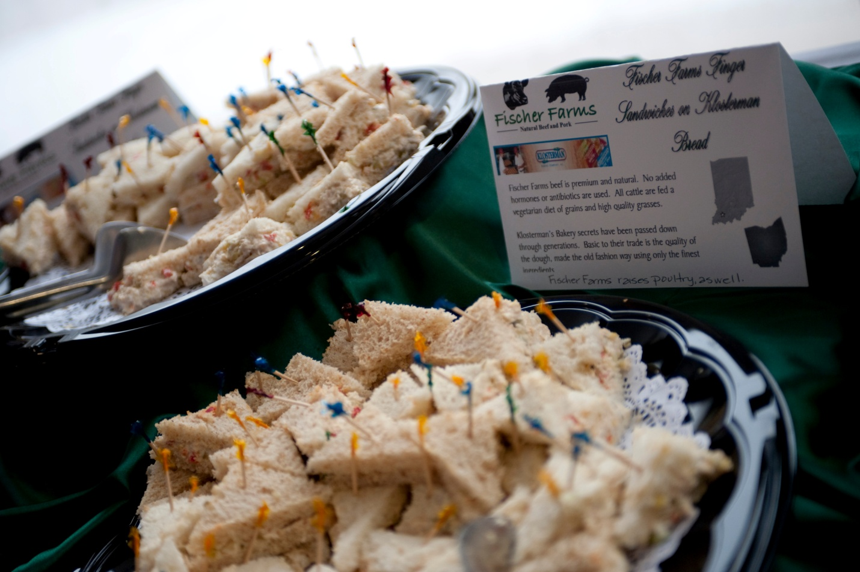
Figure 10: Sodexo at ISU makes an effort to source local food that reduces the miles that it has traveled to make it to our events.
Present
Today, we are engaged in two types of sustainability initiatives as they regard our campus food services. Social (civic) Initiatives include efforts to make good use of all food that is generated at ISU and our efforts to support local philanthropic efforts. All excess food is sent to Catholic Charities in Terre Haute so that no food goes to waste and we can provide food for those in need. We conduct service projects associated with the STOP Hunger Foundation on a yearly basis. For the last three years, Sodexo’s STOP Hunger Foundation has awarded a $24,000 food grant for school age children for summer feeding programs in the Wabash Valley. Environmental Initiatives include recycling all traditional items such as cardboard, cans, and grease. Our campus food services participate in all University initiatives in regards to energy conservation and together with Facilities Management, Resident Dining gathers food waste for compost. Today, roughly 10% of our purchases are from sustainable, local, and organic sources (Figure 10).

Future
In the future we will be engaged in three primary climate action goals of reduce landfill shipments (R), increase local product sourcing (L), and developing community awareness (D) for sustainable issues.

Actions to reduce ISU’s Green House gas emissions
- Preprocessing of biodegradables by investing in a pulp/compost system (R)
- Explore recycling of consumer plastic and glass (R)
- Conduct an extensive study of our waste streams (R)
- Decrease transportation related emission with net improvement in local product sourcing (L)
- Share the responsibility of recycling with the consumer by promoting “self sorting” (D)
- Provide Educational materials for distribution through various means and media (D)

Actions to make part of curriculum and other educational experiences
- Explore “garbology” studies of Dining Services waste streams (R)
- Plan and assist with events that generate interest i.e.-Earth Day/guest speakers (D)
- Form relationships with faculty teaching Sustainability related courses (D)
- Provide experiential learning opportunities for student sin Sustainability related courses (D)
- Visit with local peer institutions and/or businesses to collect information and guidance (L)
- Engage with community seminars and activities related to topic (L)

Actions to expand research on climate change and potential solutions
- Work with peer institutions and corporate resources to evaluate efficacy of new developments (R)
- Work with peer institutions to discover, evaluate and adapt promising programs, where feasible (L)
- Work with classes, clubs and community to identify new direction (D)

Interim targets for goals and actions
- Reduce landfill tonnage by 500 tons in 4 years (R)
- Increase local purchases to 20% of total purchases over 4 years (L)
- Establish relationships with student focus, setting targets with their cooperation (D)

Mechanisms for tracking progress on goals and actions
- Develop tonnage matrix, track monthly, post quarterly (R)
- Determine baseline with help of Sodexho procurement and track net growth via invoice tracking (L)
- Detail meetings, events and affiliations showing net growth in effectiveness related to student leadership, participation and culture (D)

Group 5 – Resource Use, Recycling, & Procurement
Figure 11: Sycamore Sam raising awareness for recycling.
The mission of the Recycling & Purchasing Sustainability Committee is to promote and model wise sustainability practices through the purchase, use, and the disposal of property (Figure 11).
Past and Present
Measurable Achievements:
Over the past twenty years Indiana State University has successfully increased the volume of materials recycled (Figure 12). In the most recent calendar year ending 2009, ISU effectively recycled 1,432 tons of materials.
Additionally, over the same twenty year period Indiana State University has been able to reduce the number of compacted loads taken to the landfill. The number of loads taken to the landfill declined from 370 loads per year to 61 loads per year, which represents an 84% reduction in landfill use (Figure 13). The dramatic reduction in landfill use has been achieved through the combined use of three operations, ISU’s Recycling Center, ISU’s Surplus Operation - which facilitates the redeployment and reuse of items on campus, and through ISU’s Surplus Auction. ISU’s Surplus Auction occurs on average seven times a year.

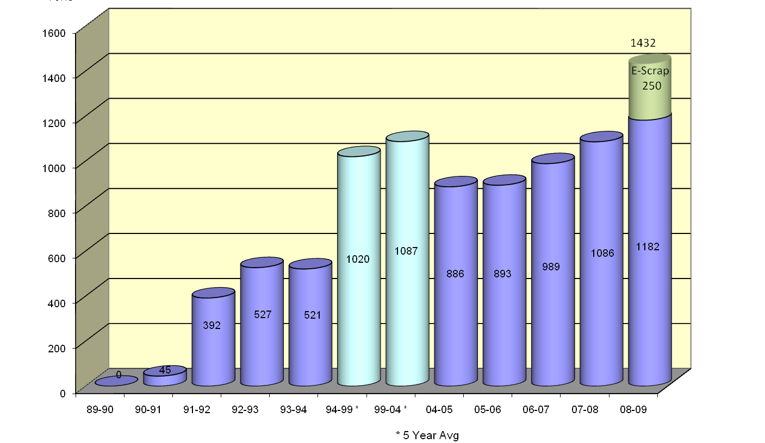
Figure 12: The amount of material recycled at Indiana State University since the 1989-1990 academic school year.
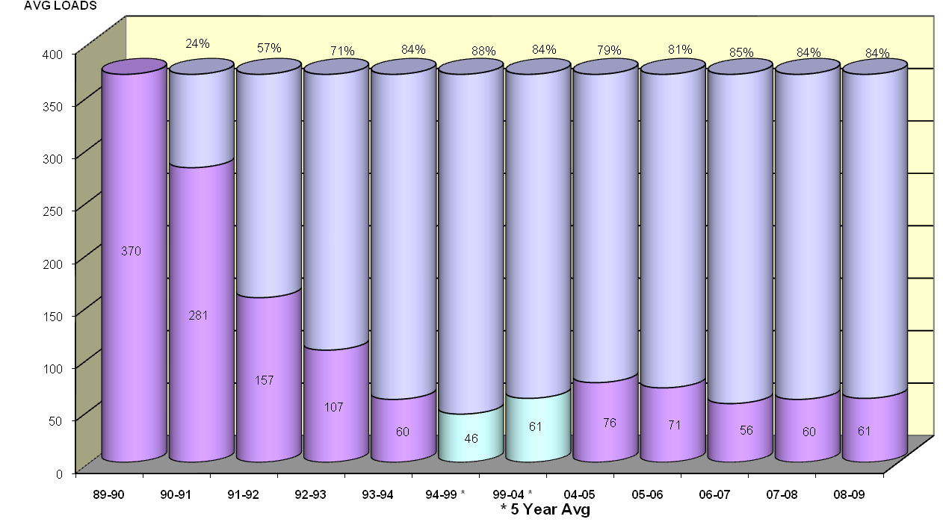
Figure 13: The number of compacted (16 Cu. Yd.) loads sent to the landfill.

Materials are received from the campus, local businesses, school corporations and individuals from the surrounding area (Figure 14). The current interest in recycling is at an all time high and use of our drive through facility has tripled within the last 18 months. New markets are becoming available, which allows for additional items to be accepted and recycled, i.e. plastic bags and plastic film, as well as large plastic items. Composting of materials from the campus waste stream is being considered and implementation will take place in the near future.
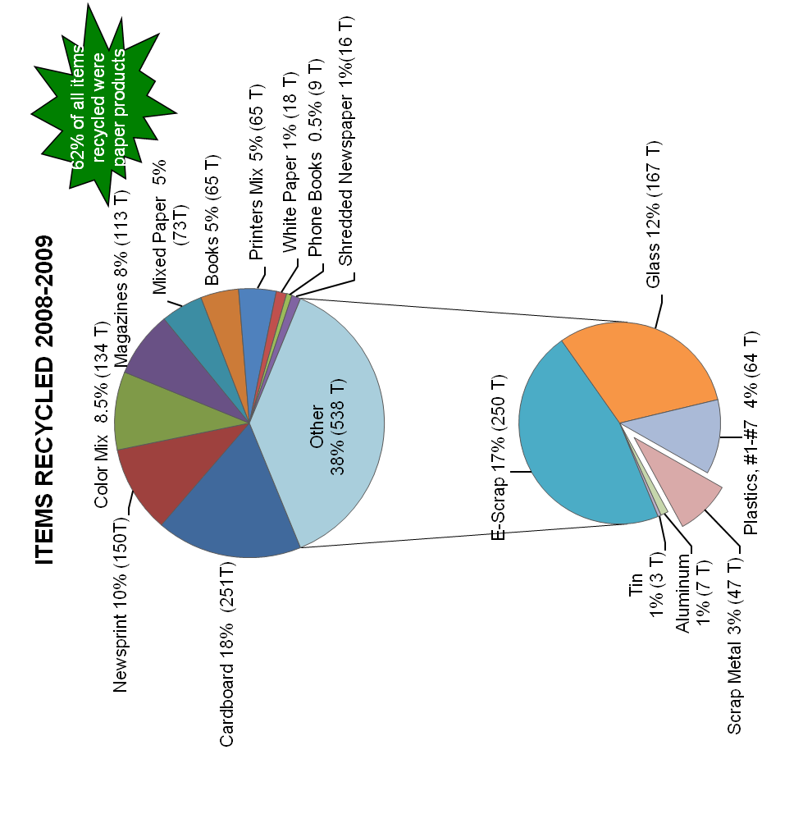

Figure 14: A break down by item of the materials recycled through the ISU Recycle Center.
Future Recommendations
Purchasing Goals & Objectives:
- To communicate sustainability options and best practices to departments who are seeking the procurement of certain goods and services. Communications to be through direct interaction with purchasing staff, through periodic sustainability tips and best practice suggestions via email, training, and web pages.
- To encourage the use of durable and reusable products, giving some weight to the best long-term value.
- To give some weight to vendors who are willing to receive their products back for recycling at the end of their useful life.
- To procure in bulk when feasible, in order to save fuel in transportation.
- To give some weight to procuring items produced closer geographically, in order to save fuel in transportation.
- To buy "Energy Star" rated electronics when practical.
- To give some weight to hybrid and alternative renewable fuel vehicles.
- To give some weight to "Leeds Certified" buildings.
- To give some weight to vendors who are environmentally conscientious.
Surplus Goals & Objectives:
- To relocate and reuse surplus items on campus, whenever possible.
- To auction surplus items which are no longer acceptable for use on campus, as opposed to sending to a landfill.
- To avoid as many trips to the landfill as possible through the sale of items for reuse, or the sale of items as scrap metal.
Recycling Goals & Objectives:
- To educate departments and students about recycling opportunities on campus (Figure 15).
- Engage all members of the campus community in the recycling process.
- Inform the campus of the impact that recycling at ISU has on the environment and landfill savings.
- Work with departments outside of Facilities Management in order to expand recycling on campus.
- Work with student groups that are interested in involvement in campus recycling and sustainability efforts.
- Provide recycling opportunities for members of the Terre Haute Community (Figure 16).

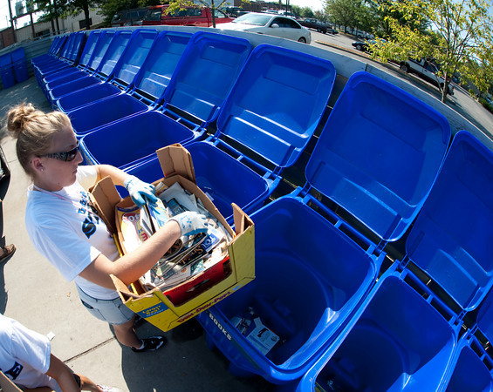
Figure 15: Recycling during Donaghy Day.
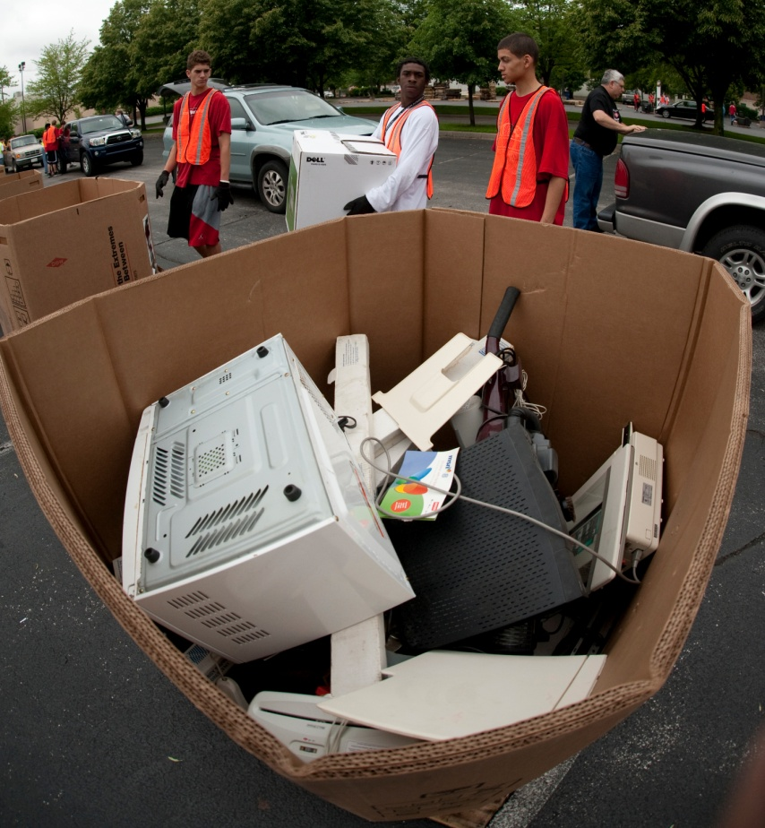
Figure 16: Volunteers helping during an E-scrap event.

Group 6 – Community Outreach & Engagement
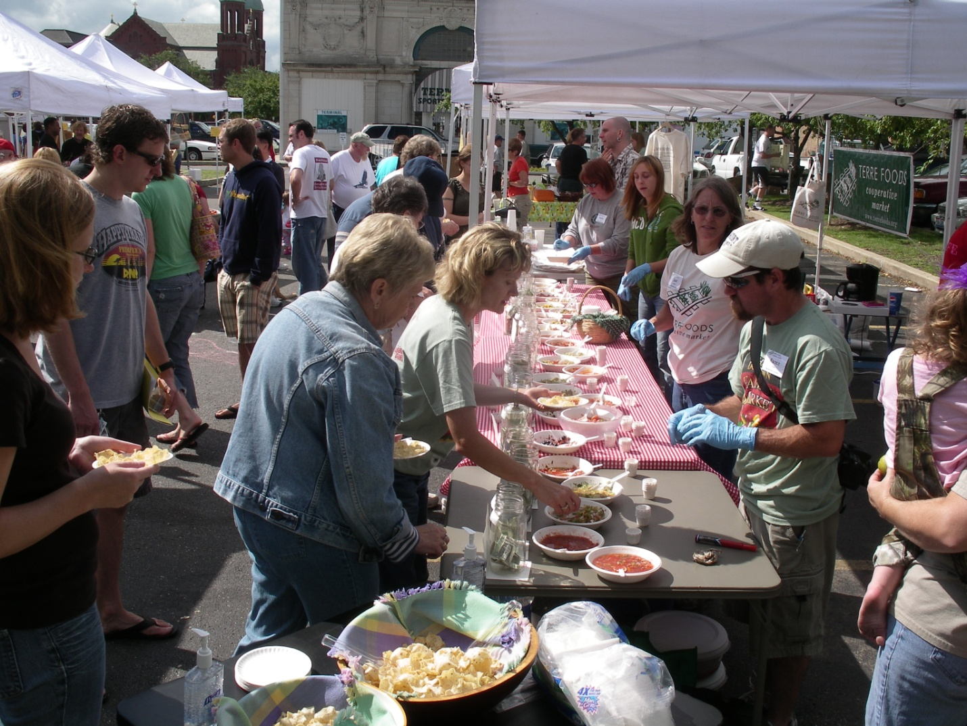
Figure 17: The Terre Foods Cooperative Market sponsoring a Salsa Contest at the Downtown Terre Haute Farmer’s Market.
Present
Indiana State University students, faculty and staff are heavily involved in community outreach efforts related to sustainability. A community garden located on university-owned property east of the campus, a weekly Farmer’s Market at Ninth and Cherry streets and Terre Foods Cooperative Market all promote the use of locally-grown produce, thereby reducing reliance on fossil fuels to transport produce great distances (Figure 17). Sodexo/ISU Dining Services donates food daily to the local Catholic Charities Food Bank.
The university is a leader in campus and community recycling efforts and now has an ongoing e-scrap collection program that helps protect the environment by keeping potentially hazardous materials out of landfills by promoting the “de-manufacturing” of televisions, computers and related components (Figure 18).
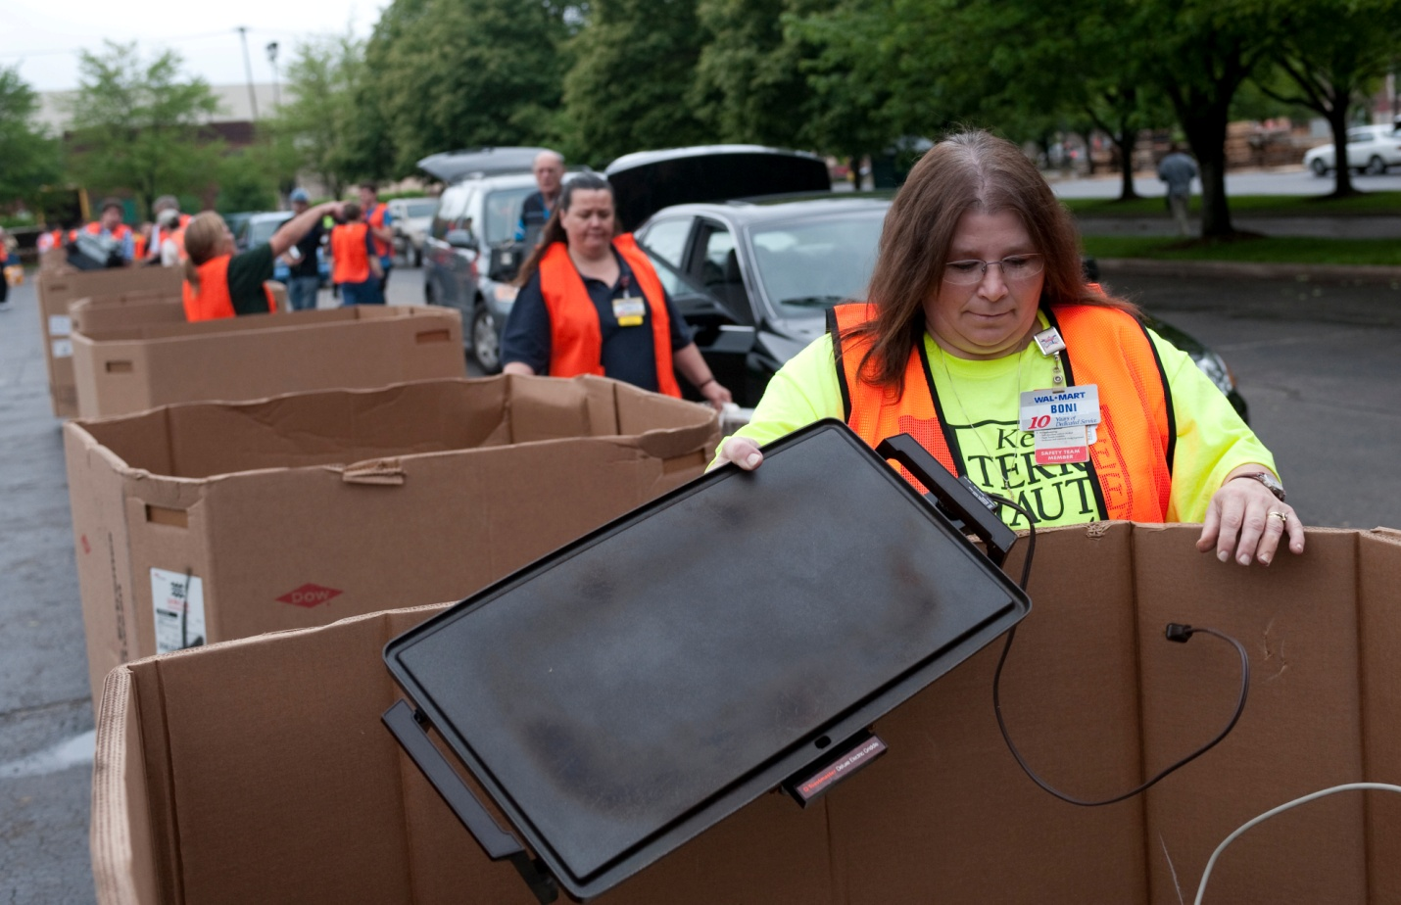
Figure 18: The ISU Recycling E-scrap program.
The recent renovation of University Hall to house the College of Education incorporated “green” construction initiatives including extensive use of recycled steel, heavy reliance on natural lighting and energy efficient windows, variable heating and air conditioning controls, dimmers for classroom lighting, sensors on restroom lavatories to reduce water flow and even occupancy sensor controls to ensure that classrooms and restrooms are lit only when occupied.
Consistent with the university’s commitment to incorporate community engagement into the classroom, various faculty have launched sustainability courses in such areas as economics, interior design, and technology. Faculty in the sciences incorporate Earth Day activities into their courses and feature speakers on global warming and sustainability topics, which are open to the public.
ISU’s designation as a Tree Campus USA, the university’s partnership with the city of Terre Haute on the Riverscape Initiative and the National Road Heritage Trail, which promotes walking and bicycling as alternatives to motorized vehicles, are other examples of an ongoing commitment to community engagement in the area of sustainability.
While the university’s community outreach in this area is commendable, members of the Community Outreach and Engagement Working Group discussed several additional ideas. These include a service initiative related to the environment, an invitation to student organizations to share information about their service organizations and a sustainability focus for the annual Donaghy Day community service day in conjunction with the start of the fall semester.
Recommended Best Practices
- A centralized approach to promoting sustainability programs
- A carpool page on the university’s Web site to match workers with fellow commuters
- Re-examining the university’s bicycle policy and providing on-campus bike storage
- A recycling competition for students during Spring Week
- A recycling partnership with the Vigo County School Corp.
- Allowing students to donate food credits to a charitable cause at the end of each semester
- A focus on sustainability in conjunction with an annual Earth Day ceremony built around the annual start-up of the Dede Plaza Fountain. Activities might include an e-scrap and Goodwill drive – events that would complement rather than compete with the existing Earth Day program of the White Violet Center for Eco-Justice at St. Mary-of-the-Woods College.

References
James Jensen, Pat Teeters, Tim Barsic, James Elslager, James Gregg, Mary Ellen Linn, John Little, Diann McKee, Charlie Potts, Mark Pupilli, and Jeff Williamson. 2006. University Energy Initiative. Energy Reduction Committee Members Final Report. 33pp.
Richard Ney. 2008. Indiana State University Carbon Footprint Analysis. Consulting report by Sebesta Blomberg. Completed July 31st, 2008. 17pp.
U.S. Green Building Council (USGBC). 2009. LEED 2009 for New Construction & Major Renovations, Washington, D.C. 237pp.

Appendix A – Self-Reporting of Utility Inefficiencies

The Academic Sustainability Working Group for the President's Climate Commitment suggests that ISU develop a website where the university community can report energy wasting issues so that facilities management can be made aware of these issues. This concept is modeled after a program that has been developed for Boston that uses an IPhone App (http://www.npr.org/templates/story/story.php?storyId=120999393) where you can call in city maintenance issues (such as pot holes, graffiti, broken street lights). You can take a picture of the problem and send it in to the website. It records the GPS coordinates of the issue, the website maps the report, and then shows once it has been fixed. For ISU, we would recommend that the IT department develop a website to catalog ideas to increase the energy efficiency of the University. This should save money, provide buy-in for the university community, and hopefully reduce the University’s carbon footprint. Some possible complaints could be locations where lights are always on, ADA doors where double doors are open causing warm air to leak out of the building, or leaky pipes. This website could create a database of campus complaints and a member of facilities management could make decisions about which are high priorities to fix.

Appendix B – Energy Reduction Competition between Dorms

Currently we have energy monitoring on a building or building cluster basis. With the historical data at this level extending back at least three years, we have a baseline with which to compare energy use. We suggest that we involve residents’ life and the student organizations to conduct a competition to see which dorm could most reduce their energy usage for a semester. The dorms themselves would be in charge of advertising the competition and the dorms would share in any savings accrued due to the competition. We recommend that the students in each building get to use 10% of the money saved in energy use for improvements to their building that they suggest. If these funds are put back into energy saving programs (such as solar panels or green roofs), then they can become the basis for future class projects and provide an energy saving advantage for future competitions.

Appendix C – Increasing Bus Ridership

Tangible Action #4 that has been adopted by ISU is to encourage use of public transportation. ISU took a big step in this direction in October 2007, when the Student Government Association initiated cooperation between ISU and the Terre Haute city bus system began. This “bus initiative” allows all university faculty, staff and students to ride the City of Terre Haute buses for free when they show their university ID. This offers a terrific opportunity to reduce our carbon footprint when we ride the bus instead of driving our cars, either when commuting to campus, or for on-campus students, when going to different places in Terre Haute. Utilizing a public transit system requires a change in thinking for many of us, since we are used to the convenience of our cars. In addition, not everyone is aware of this opportunity. Becoming accustomed to utilizing public transportation here in Terre Haute can have a long term beneficial impact on our students’ habits when they graduate, thus impacting their future contributions to reducing greenhouse gas emissions through increased willingness to utilize public transportation. Faculty can disseminate information about the bus system and incorporate study of public transit into their classes. For example, one faculty member requires that her Econ 100 students ride the city bus and then report on their experiences. She has found a diversity of reactions to this assignment, but some of the students say that they found it convenient and plan to ride the bus again. Recently ISU engaged Walker Parking Consultants to conduct a study of this bus initiative, however, the results have not been publicly disseminated.

