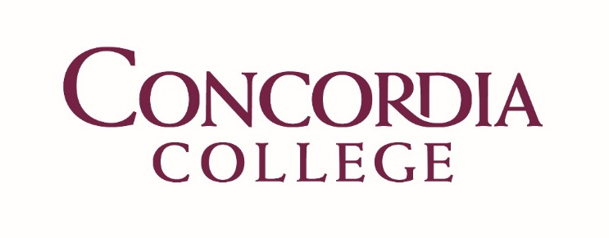

Green Revolving Fund Overview

In the spring of 2018 a group of sustainability minded alumni launched an initiative to create Concordia College’s Green Revolving Fund. Through the help of many within the college and community, the alumni team was able to raise over $5,000 to launch the initiative. Following the success of this campaign, the college indicated that it would seek to continue to grow and manage the fund. This proposal provides an example of how the college might go about doing that.

What is a Green Revolving Fund?
A Green Revolving Fund, or GRF, is a financial model that allows for colleges and universities to pay for cost savings projects and retain the savings from those projects as a way to encourage future projects. GRFs are common amongst colleges and universities.
A GRF starts with seed money. This seed money is capital that will go toward funding inaugural projects. Projects that can utilize the funds should focus on energy savings, carbon savings, or result in cost savings through the reduction of utility consumption. The projects are evaluated and selected by committee and must fall under predetermined criteria. Once the money is given out and the project completed, the money must be paid back in full using either an estimate of savings or actual payback (method varies based on the model used). According to the 2012 “Greening the Bottom Line” Report, the median payback period for GRF projects was 3.5 years. Many schools will put a payback cap on project proposals, meaning they will only accept projects that are shown to have a payback with in “x” number of years. As of 2012, the average maximum payback period was six years.²

Why Would This Fund Be Beneficial to Concordia College?
In April of 2017, Concordia College signed on to the Climate Commitment. As a result, Concordia is seeking to reach carbon neutrality by a date which will be specified in the 2021 Climate Action Plan. In order to reach carbon neutrality, Concordia will need to reduce its consumption of utilities such as natural gas, electricity, water, waste, etc., and unfortunately these reductions usually come at a cost. Through the establishment of a Green Revolving Fund, Concordia will ensure that these projects can be completed via a self-sustaining financial model. The nature of a GRF makes investing into renewable energy and carbon reducing technology a benefit rather than a burden. Having a GRF will help reduce operating expenses, reduce greenhouse gas emissions, and create funding for future projects.¹
One can look to the recent installation of geothermal at the EcoHouse to see how a GRF would be beneficial to the college. In the fall of 2018, Concordia spent over $30,000 on this positive move toward using more renewable energy sources on campus. The money spent on the project primarily came from income from metal recycling that has been set aside for use on sustainability projects. This project, which has great potential for energy and cost savings, was installed without a means of measuring and reinvesting the savings into other projects. If Concordia had a GRF in place, the savings from this project would be tracked and reinvested into the fund. These savings would allow and incentivize Concordia to continue implementing carbon reducing projects that help the college reach its carbon reduction goal and stand out as a school that prioritizes the values of sustainability.

Where Would the Money Come From?
As stated earlier, Concordia alumni have already collected about $5,000 to establish the fund. The Billion Dollar Green Challenge encourages institutions to strive for having $1 million (or 1% of the institutions endowment value) in their GRF within 6 years of establishment. As of 2012, the median fund size was $400,000. This value may seem high, but it is important to remember that this fund is an investment fund, not something that is just set aside for spending.
I would propose that all money from metal recycling and solar rebates be allocated to the fund. Over time these inputs, combined with the payback from projects, would result in a growing fund. Once the fund demonstrates success, I would encourage the college to invest more money into it.

How Would Projects Be Selected?
Project submissions would be expected to conform to a predetermined set of guidelines. These guidelines could include things such as a maximum payback period, amount of money that can be requested, and measurable impact on carbon reduction. The applicants would have to fill out a proposal form, which would then be reviewed by an approval board.

A governing body would be charged with allocating the funds. This group can include students, faculty, staff, and administrators to encourage involvement and to integrate various expertise. The group would be expected to allocate funds to projects based on their alignment with fund qualifications. Projects can be accepted on a rolling basis or on specific deadlines.

What Would be the Project Criteria
Projects can be selected based on a wide array of criteria. Some of these include:
- Payback duration
- Capital cost
- Specific environmental benefits – e.g. greenhouse gas reduction
- Cost-effectiveness metrics such as GHG reduction per dollar of capital cost
- Potential for community engagement and collaboration
- Educational benefits
It is important for project criteria to promote the mission of the fund and to be tailored to the projects that are available for investment. In order to do this, flexibility may need to be built into the project criteria.

How Would the Projects be Paid Back?
GRFs generally operate under one of two models. One is the loan model and the other is the accounting model.
Under the loan model, applicants sign an agreement to borrow money from the fund and pay back that loan through budget transfer initiated by the borrower. This model is generally used in cases where the project initiator has the ability to make transfers between budgets. It may also be beneficial if departments or divisions operate their own utilities budget.
Under the accounting model, applicants are given money from the fund, but repayment to the GRF is made from the budget in which the savings are seen. For example, a project that results in energy savings would be paid back by the budget out of which the energy bills are paid. This model is typically utilized in institutions that have more centrally managed budgets.
A small number of schools will allow applicants to use the payback model of their choosing.
Other aspects of the payback model:
- Payback amount and timing can be established by the school
- Payees can be charged interest on their loan or can be expected to pay back more than 100% of the loan
- An admin fee can be added to the project in order to cover GRF operating costs
The savings resulting from a project can be measured in two ways. One, is that a front-end analysis of potential cost savings is done through investigating the technologies used and assumed usage patterns. Although less cost intensive, this method does not account for performance based on real world circumstances. The second method is to calculate savings on the back-end. This method is more intensive and requires one to meter the savings and account for possible conflicting factors such as weather and usage patterns. If desired a school can integrate both methods, using option one to calculate savings and option two to verify them.

Sources
- http://greenbillion.org/about/
- http://greenbillion.org/wp-content/uploads/2012/11/Greening-the-Bottom-Line-2012.pdf

