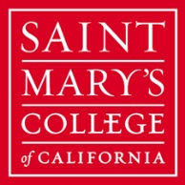

Sustainability Research Faculty Total full-time faculty in 2012 = 194
Brenda Hillman English
Chris Sindt English
Richard Carp TRS
Alice Baldridge Biology
Joel Burley Chemistry
Carla Bossard Biology
Michael Marchetti Biology
Roy Allen Economic
Steven Bachofer Chemistry
Asbjorn Moseidjord Economics
Gretchen Lemke-Santangelo History
Myrna Santiago History
Elena Songster History
Stephen Woolpert Politics
Nicolas Dahan Business Administration
Saroja Subrahmanyan Business Administration

