SIMAP DATA 2019
https://unhsimap.org/cmap/footprint

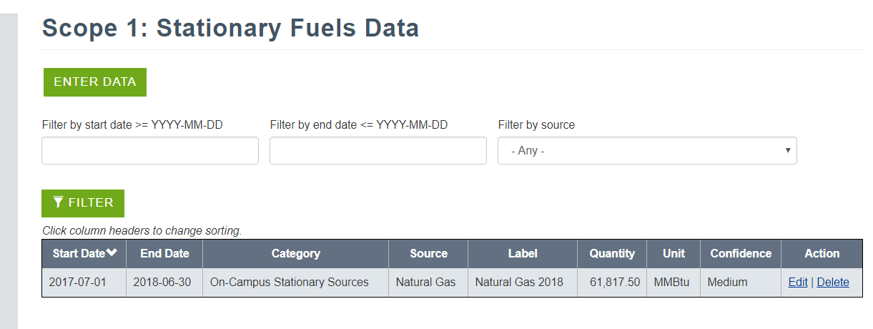
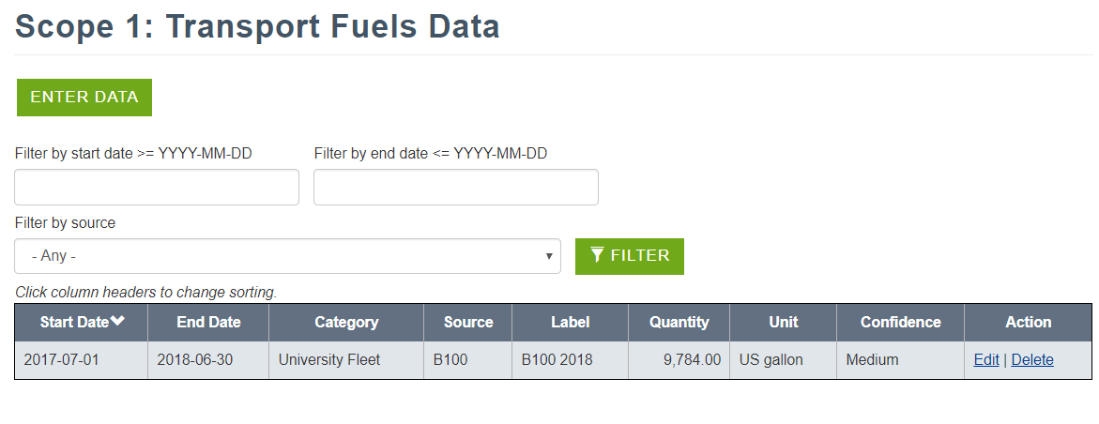
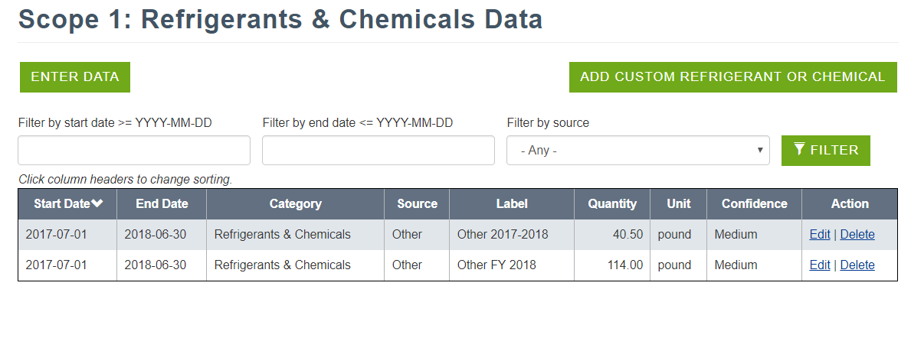
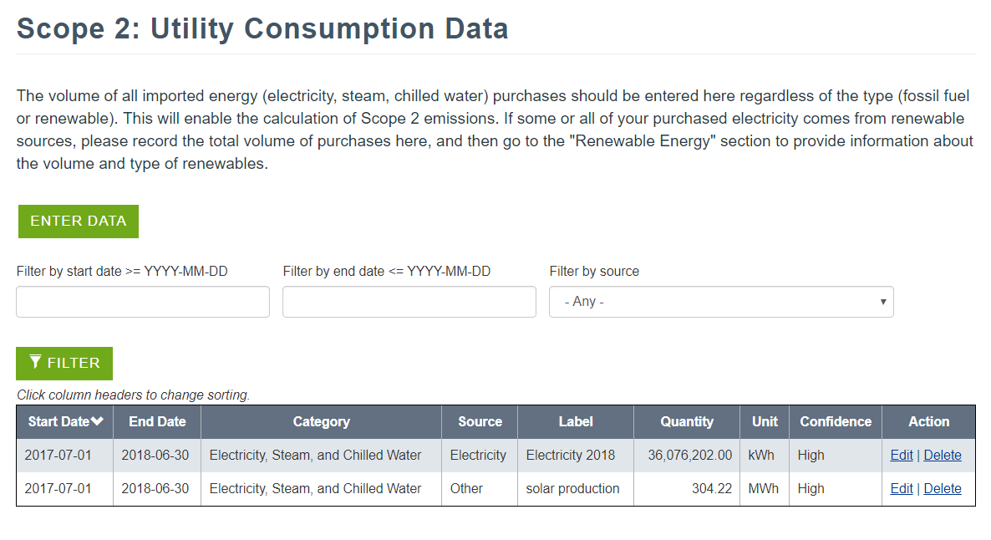

RESULTS
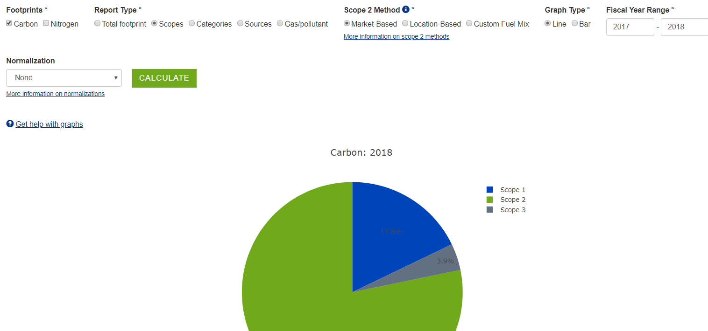
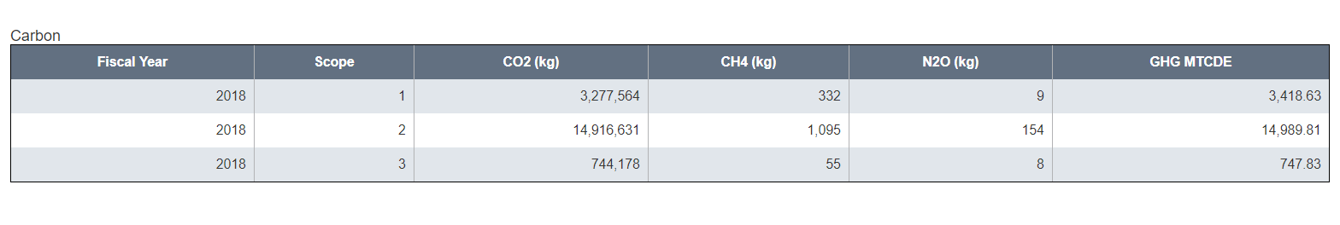
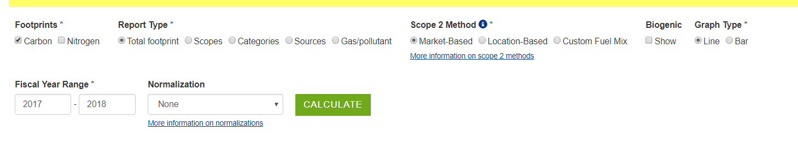
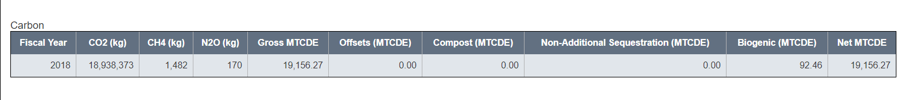
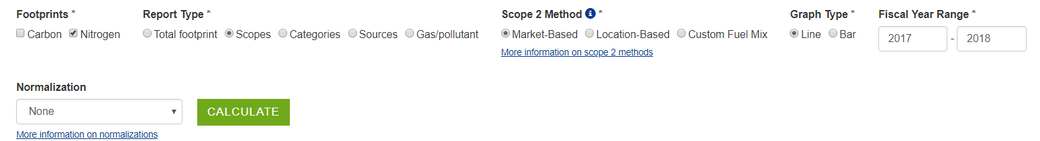
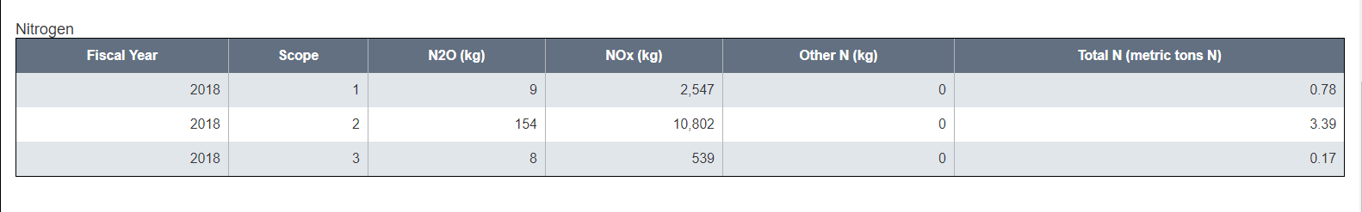
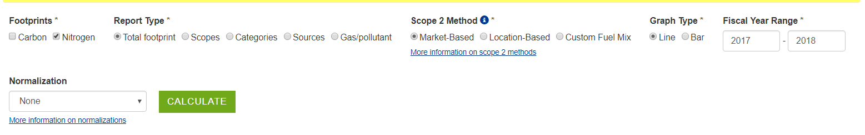
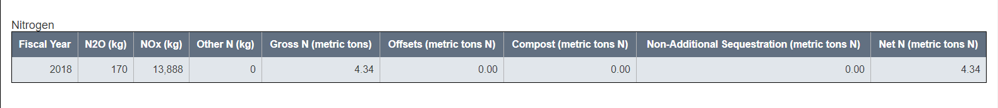

These were entered into Scope 1 and Scope 2 as directed in 2017 by UNH SIMAP rep (Yulia), so followed same criteria for STARS entries.

No normalizations

