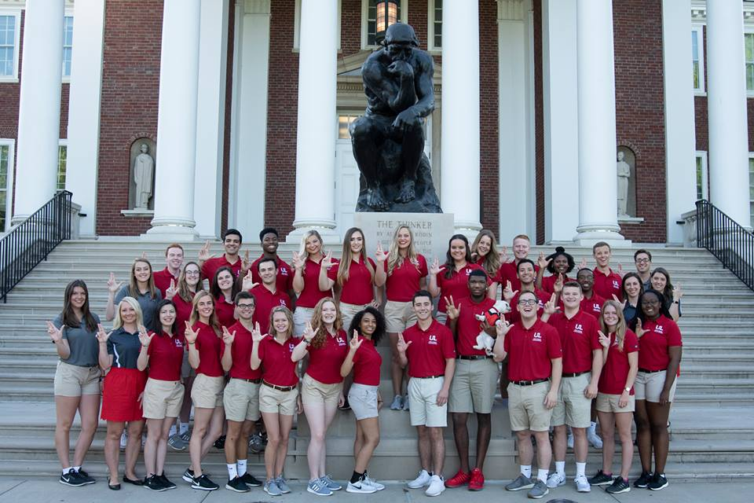

Sustainability Research Grants at the University of Louisville

2016-2018

The University of Louisville has researchers from a wide spectrum of disciplines working on sustainability research. In the years 2016-2018 researchers submitted 73 grant proposals and were awarded $37,927,966 on approx. 53 of them. This is a decline from 2012-2015 by 42% as both state and federal grants have declined over this 6-year period. The scope and breadth of research has included faculty from eight of the University’s 12 schools/colleges, including: School of Medicine, School of Nursing, School of Public Health and Information Science, Speed School of Engineering, Brandeis School of Law, Kent School of Social Work, College of Business, and the College of Arts and Sciences. The University has focused its research efforts in environmental cardiology, environmental health, stream restoration, ecosystems, pollution prevention, and urban sustainability. To encourage and promote these areas the University has created and supported research centers and institutes that bring together multi-disciplinary teams to work on complex urban sustainability issues. The largest such institute is Envirome, which in 2018 secured over $10 million in grants and $5 million in gifts to further its research in Environmental Cardiology. The full list of Centers and Institutes are:

|  |  |  |
| --- | --- | --- |
| Envirome Institute | Conn Center for Renewable Energy Research | Environmental Genomics & Integrative Biology |
| Superfund Basic Research | Hazards Research & Policy Devl | Infrastructure Research |
| Diabetes and Obesity Center | Regulatory & Env. Analytical Metabiomics | Muhammad Ali Inst. for Peace & Justice |
| Tobacco and Addiction Center | Land Use & Env. Responsibiity | Race & Inequality |
| Healthy Air, Water and Soil | Sustainable Urban Neighborhoods | Anne Braden Inst. for Social Justice Research |
| Integrative Environmental Health | Environmental Engineering | Inst. for Sustainable Health & Optimal Aging |
| Environmental Policy and Mang. | Pollution Prevention | Stream Institute |
|  | Environmental Science |  |

Environmental Sustainability Clusters

2016-2018

Subject of Grant Proposals

# Grants Awarded/Total Proposed

Total $ Awarded

Totals=

53/73

$37,927,966

Urban Sustainability, u

Urban Sustainability,

Brownfields, Revitalization

6/13

$144,375

Ecosystem Research

6/7

$896,378

Environmental and Public Health

15/22

$8,286,803

Environmental Cardiology

5/7

$25,227,744

Pollution Prevention

6/7

$547,874

Ecosystem Research

6/7

$896,378

Stream Restoration, Water Quality, Water Resources

15/16

$2,824,792