<http://louisville.edu/greenheart>

Telephone: 502-852-4236

Email: [greenheart@louisville.edu](mailto:greenheart@louisville.edu)

The lead researchers for this project are Dr. Aruni Bhatnagar and Dr. Rachel Keith (University of Louisville).

Our goal is to enhance human health by improving our environment.  Chronic diseases such as obesity, diabetes, and heart disease are the leading cause of death and disability in our communities. We believe that these diseases arise from living in unconducive urban environments and by being in a state of constant dyssynchrony with the rhythms of nature.   Therefore, increasing neighborhood greenness could decrease the risk of chronic disease by reducing exposure to environmental pollutants and promoting greater interaction with nature.   It is our hope that the project will improve the health of our community, and that it would teach us how to live healthier lives in better environments worldwide.

Research shows that neighborhoods with low air quality and many busy streets also have a higher risk of heart disease. The Green Heart study will look at the connections between a green environment and human health. We will be studying air quality, innovative landscape design, the qualities of a friendly, healthy neighborhood, and human health.

The Health Environment, and Action in Louisville (HEAL) project is a part of this work and is being conducted by the University of Louisville Department of Medicine. HEAL will measure the health of residents in a particular neighborhood, add more trees, shrubs and greenery to the neighborhood, and then take the same measurements again. The goal is to test the idea that a green neighborhood is a healthy neighborhood.

The specific aims of the project are:

* Examine baseline heart health in two similar neighborhoods with low green space
* Determine how increasing green space affects neighborhood characteristics
* Assess the impact of increasing neighborhood green space on cardiovascular health

We plan to request funding from the National Institute of Environmental Health Sciences of the National Institutes of Health to support a five-year study. After recruiting the initial group of participants, we will measure changes in the following factors each year for five years:

* Ambient air pollution
* Built environment
* Cardiovascular health
* Hospital Admissions
* Increase in green space
* Neighborhood demographics
* Pollutant levels
* Socioeconomic position
* VOC exposure

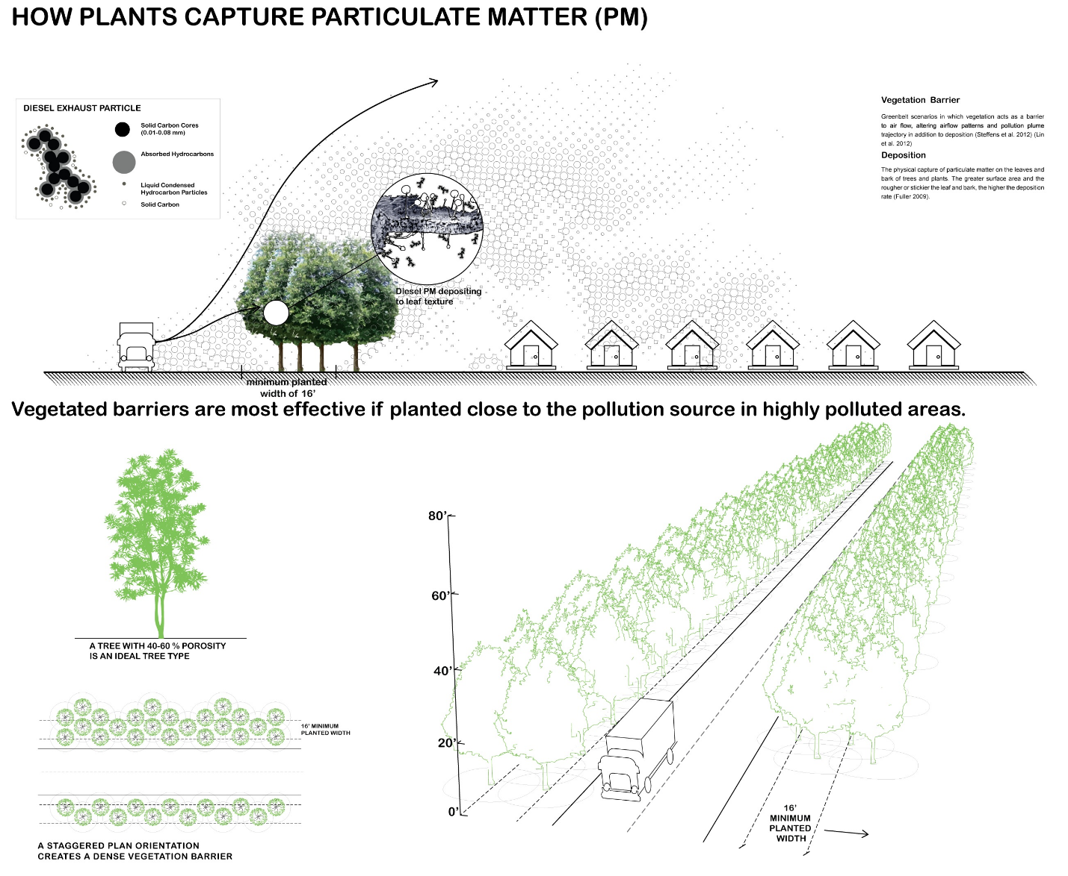

The Green Heart Coalition will use data from the city’s Urban Tree Canopy Assessment and Urban Heat Island Mitigation Plan to identify neighborhoods with few trees and high temperatures. Selection criteria include:

* Size of the neighborhood
* Current tree population
* Available space to plant new shrubs, trees and other plants
* Proximity to a roadway

The current tree canopy in Louisville is 37%, lower than the 44% recommended for a healthy city. The city’s trees currently remove over 4 million pounds of ground level ozone and over 1 million pounds of particulate matter from the air our citizens breathe each year. The health value is estimated at more than $10 million in protective benefits every year.

Neighborhood residents may see these benefits from participating in the study:

* Improved property values
* More green spaces in the neighborhood
* Stronger sense of community

The early work on this project is funded by grants from Partners for Places, an anonymous funder in Louisville and the Owsley Brown II Family Foundation.

# Partners

[](http://louisville.edu/doc)

### [The Diabetes and Obesity Center](http://louisville.edu/doc)

Using a multidisciplinary and collaborative approach to research, our work ranges from cardiovascular metabolism and inflammation to stem cell biology and environmental cardiology, all while maintaining a cohesive theme and common goal. We believe that, coupled with community outreach and expert clinical care, our research can help stem the tide of these growing epidemics.

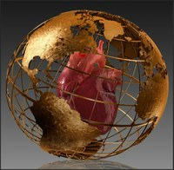

### Environmental Cardiology

This group was formed in October 2000 in order to foster collaborative research focused on the Cardiovascular Toxicity of Environmental Pollutants.

[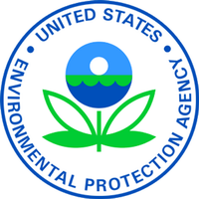](https://www3.epa.gov/)

### [Environmental Protection Agency](https://www3.epa.gov/)

When Congress writes an environmental law, we implement it by writing regulations. Often, we set national standards that states and tribes enforce through their own regulations. If they fail to meet the national standards, we can help them. We also enforce our regulations, and help companies understand the requirements.

[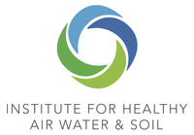](http://instituteforhealthyairwaterandsoil.org/)

### [Institute for Healthy Air Water and Soil](http://instituteforhealthyairwaterandsoil.org/)

Together let’s preserve our World’s Sacred Air, Water, and Soil, so as to create the healthy communities that are essential for the survival of all of life!

[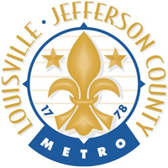](https://louisvilleky.gov/government/sustainability)

### [Louisville Metro Office of Sustainability](https://louisvilleky.gov/government/sustainability)

Mayor Greg Fischer formed the Louisville Metro Office of Sustainability in 2012 with a mission of promoting environmental conservation, the health, wellness and prosperity of our citizens, and embedding sustainability into the culture of the Louisville community. Creating a culture of sustainability will be achieved through broad-based education and awareness efforts as well as implementation of projects and initiatives to influence behavior change.

[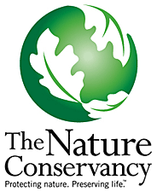](http://www.nature.org/)

### [Nature Conservancy](http://www.nature.org/)

A leading conservation organization in the United States and around the world, The Nature Conservancy works with public and private partners to ensure our lands and waters are protected for future generations.

[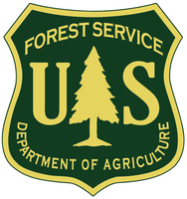](http://www.fs.fed.us/)

### [United States Forest Service](http://www.fs.fed.us/)

The mission of the USDA Forest Service is to sustain the health, diversity, and productivity of the Nation’s forests and grasslands to meet the needs of present and future generations.

[](http://urbanbiofilter.org/)

### [Urban Biofilter](http://urbanbiofilter.org/)

As a collaborative team of ecological engineers, designers and community organizers, Urban Biofilter creates environmental systems appropriate to each site and community. We foster community participation by translating the technical language and bureaucratic processes used by government.