**University of Delaware**

**Greenhouse Gas Inventory for the**

**2017 – 2018 Academic Year**

**June 30, 2019**

**Introduction**

The University of Delaware (UD) became a signatory to the Second Nature Presidents’ Climate Leadership Commitment (formerly the American College & University Presidents’ Climate Commitment - ACUPCC) in 2008. The Presidents’ Climate Leadership Commitment is a voluntary program designed to address the “pace and intensity of global climate change and the potential for unprecedented detrimental impacts” by documenting institutional commitments from college and universities to increase awareness around climate change and eliminate net greenhouse gas (GHG) emissions from their own operations. UD, as part of its Presidents’ Climate Leadership Commitment requirements, submitted an initial GHG inventory report detailing its carbon emissions for the 2007-2008 academic year in 2009 and, in 2010, filed a Climate Action Plan specifying future emissions reduction targets.

As part of its commitment to Second Nature, and in order to measure progress towards its Climate Action Plan targets, UD works with Siemens to compile greenhouse gas emissions inventory reports annually beginning with the 2011-2012 academic year. Each annual report contains a snapshot of annual emissions and a comparison against the baseline established by the initial 07-08 GHG inventory. This report has been prepared to address UD’s commitment to the ACUPCC to submit a GHG emissions inventory for the 2017-2018 academic year. Although University emissions have fallen, these reductions are primarily linked to scope 2 reductions resulting from changes in the power industry and scope 3 reductions. The scope 3 emission reductions are driven primarily by changes in student, faculty, and staff commuting behaviors identified through the 2017 Transportation Survey update.

**Overview of 2017-2018 GHG Inventory Approach and Results**

Siemens worked with UD personnel to compile the 2017-2018 academic year GHG inventory. The aim of this effort was to replicate the scope and approach of the 2007-2008 GHG inventory and generate a brief, written update for comparison to the 2007-2008 benchmark. This process allows for direct correlations between the two records while measuring the benefits of carbon mitigation actions taken during the intervening ten years.

Direct data records were compiled for building energy use, UD owned fleet vehicles, organic waste outputs, and fertilizer used. Estimates were utilized to assess fuel consumption associated with commuting activities as was required for the 2007-2008 academic year GHG inventory. The Campus Transportation Survey was updated in 2017 and this new information and associated analysis was leveraged to refresh the scope 3 mobile combustion emission models for the 2017-2018 GHG Inventory Report.

Emission factors for the combustion of natural gas, fuel oil, gasoline, diesel fuel, and jet fuel were obtained from the U.S. EPA Mandatory Reporting Rule for Greenhouse Gases (MRR),Table C-1, in keeping with the accounting methodology specified by The Climate Registry’s *General Reporting Protocol (GRP)*. This represents a slight departure from the 2007-2008 approach which relied upon emission factors from the U.S. Energy Information Administration (EIA). Another change is that methane (CH4) and nitrous oxide (N2O) emissions associated with fuel combustion were considered in the 2017-2018 report while only CO2 emissions were documented in the 2007-2008 report. These modifications are warranted however, because they align UD’s GHG accounting approach with current best practices and the resulting difference is less than 1% for all commodities, so this change does not substantially impact the emission totals.

Emission factors for purchased electricity, in keeping with *GRP* methodology, were derived from the U.S. EPA eGRID2016 tables. UD is located within the RFC East Subregion, so the published GHG emission factors representing the fuel mix used in generating electricity in this region were used. This source differs from the one used for the 2007-2008 report, but the eGRID system is a universally accepted source which is regularly updated so, adopting this standard will facilitate future emissions inventory calculations. Scope 3 transmission and distribution losses associated with purchased electricity were calculated based on the loss percentages published in the eGRID2016 for the East region.

Scope 3 GHG emissions from the disposal of mixed waste, food waste, and food composting were calculated using emission factors obtained from the U.S. EPA WARM Model, version 14. This is an updated version of the same source used in the 2007-2008 report.

GHG emissions resulting from usage of nitrogen fertilizer were calculated with an emission factor derived from the U.S. EPA’s Inventory of U.S. Greenhouse Gas Emissions and Sinks: 1990-2001 (April 2003). This is the same value that was used in the 2007-2008 report.

UD emitted a total of 99,612 Metric Tons of CO2e from Scope 1 and Scope 2 sources during the 2017-2018 academic year. The largest emission source was purchased electricity, which accounted for 57% of the combined Scope 1 and 2 totals. The other significant source was natural gas, at 38%. The remaining sources were UD’s fleet (1%), heating oil (2%), and landscaping fertilizer (less than 0.25%).

UD’s reported Scope 3 emissions totaled 27,873 Metric Tons of CO2e. Scope 3 sources included student/staff commuting and trips home (76% of Scope 3 total), electric transmission and distribution losses (21%), municipal solid waste (3%), and air travel from student trips home (less than 0.09%.)

Grand total (all scopes) emissions were 127,485 Metric Tons of CO2e.

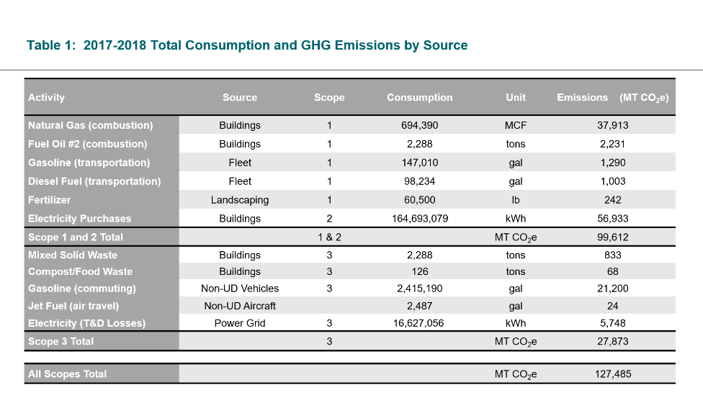

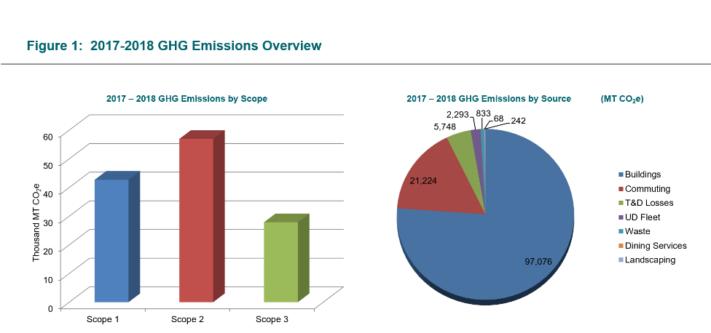

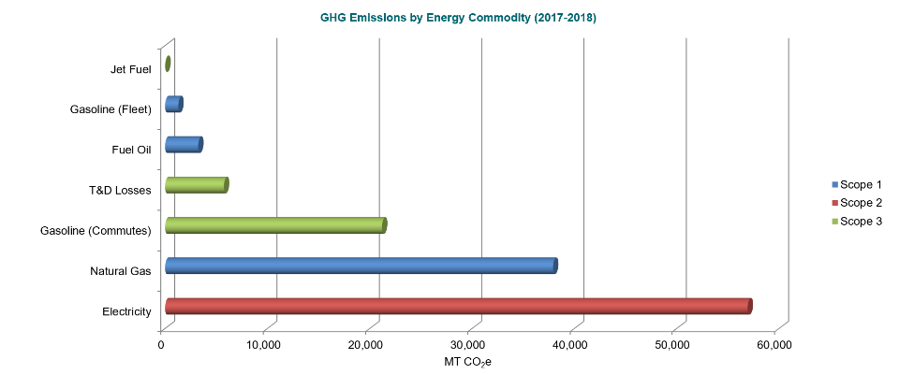

**Comparison of 2017-2018 Results to 2007-2008 Results**

UD’s measured GHG emissions declined from 149,207 MT CO2e during the 2007-2008 academic year to 127,485 Metric Tons of CO2e during 2017-2018. This GHG emissions reduction of 21,722 MT CO2e represents an approximate 14.5% decline.

A net emissions reduction was achieved despite the fact that student enrollment at the University increased from 17,631 Full-Time Equivalents (FTE) in 2007-2008 to 22,168 FTEs in 2017-2018. In 2007-2008, 8.5 MTCO2e were emitted for each FTE student. In 2017-2018 that ratio dropped to 5.8 MTCO2e per FTE student, a decrease of 27%.

Newark Campus’s aggregate building area also increased from 6,863,991 square feet in 2007-2008 to 9,391,978 square feet in 2017-2018. However, efficiencies caused the GHG emissions rate per building square foot to outpace this facility growth and emissions intensity fell by 42% for electricity (from 23.0 lbs. CO2e per square foot to 11.3) and fell by 21% for natural gas (11.3 to 8.9 lbs. CO2e per square foot). These results are summarized in Figure 2.

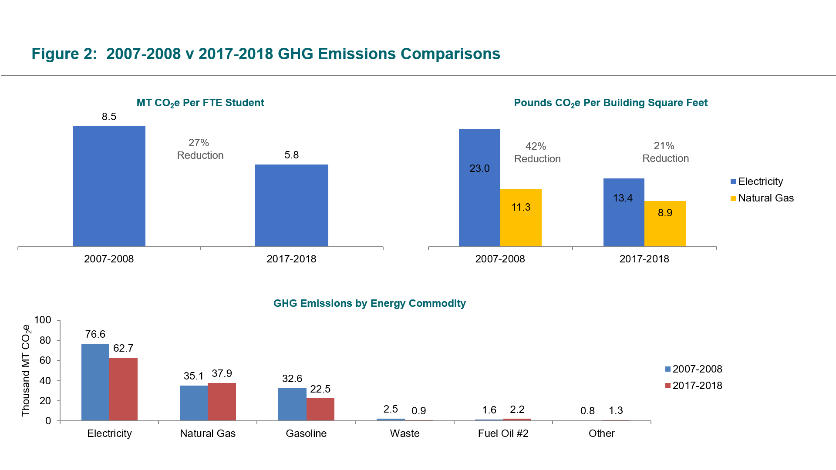

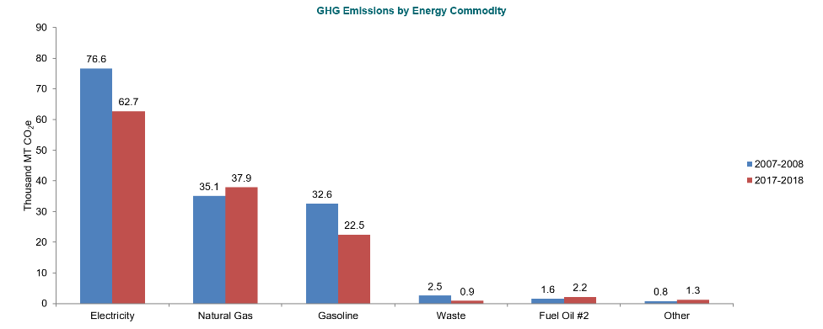

*Notes:*

*1 - “Electricity” includes emissions from both consumption (Scope 2) and T&D losses (Scope 3)*

*2 - “Gasoline” includes emissions from both UD fleet (Scope 1) and student/staff commuting (Scope 3)*

*3 - “Other” category includes emissions from fleet diesel fuel and nitrogen fertilizer (Scope 1) and jet fuel (Scope 3)*

**Student/Staff Commuting and Trips Home**

UD conducted an initial transportation survey in 2008 and, in 2017, this survey was updated. Based on the results from the updated survey, it was estimated that students and staff consumed approximately 3,470,617 2.4 million gallons of gasoline and a share of 2.5 thousand gallons of jet fuel during daily commutes and trips home to permanent residences. This equates to 21,224 metric tons CO2e, which is down 31% from the 2008 total of 30,609 metric tons.

**Mixed Solid Waste/Composting**

UD compiles data annually on quantity of mixed solid waste generated and wasted diverted to a digester project. Mixed Solid Waste generation has declined from 2,937 short tons in 2008 to 2,288 short tons in 2017-2018. 506 short tons of compost were generated in 2008 (126 in 2018.) Combined GHG emissions from these sources during this period have declined from 1,301 Metric Tons CO2e to 901 (~30% decrease.)

**Electricity Transmission and Distribution Losses**

As electricity is transmitted from the power plant to the final consumer, a portion is lost along the way.

This means that, in order to generate a kilowatt-hour of electricity for the end user, slightly more than a kilowatt-hour must be produced by the power plant. Most published electricity emission factors, like those from eGRID, are based on generated, rather than delivered electricity.

In previous annual inventories (though not originally in the base year) UD reported the emissions from grid losses as part of its Scope 3 total. This was calculated based on the eGRID RFC East subregion GHG emission factor and the eGRID East Region grid loss %.

While electricity consumption has increased 19.4% from 2008 to 2018, the grid emissions factor has decreased by ~40% and grid losses have decreased from 6.47 % to 4.97 %. As a result, estimated scope 3 emissions from transmission and distribution losses have increased slightly from 4,958 metric in 2008 to 5,748 metric tons in 2018.

**Comparison Against Climate Action Plan**

UD, as part of the ACUPCC Climate Action Plan, adopted emission reduction target milestones to be achieved by 2013 (a 5% reduction target from 2007-2008), 2015 (10%), and 2020 (20%).

The results of the 2017-2018 GHG inventory report demonstrate that the UD emission totals are below the 2013 and 2015 reduction targets (5% and 10%, respectively). Presently, with an estimated 14.5% reduction from the baseline, the 2017-2018 academic year emissions remain above the 2020 20% GHG reduction target.

It is important to note that largest component of the university’s absolute emissions reduction was a result electricity supply generation shifts from coal to natural gas and renewable resources due to state, regional, and national policy changes. Also significant is the updated information associated by commuting behaviors as detailed within the 2017 update to the Campus Transportation Survey. Emissions from electricity T&D losses were slightly higher compared to the 2007-2008 baseline year (+16%), but the net contribution to the university totals were similar (4% in 2007-2008 compared to 5% in 2017-2018).

Finally, due to increases in enrollment, UD’s FTE-normalized emissions declined by a much greater proportion than did absolute emissions.

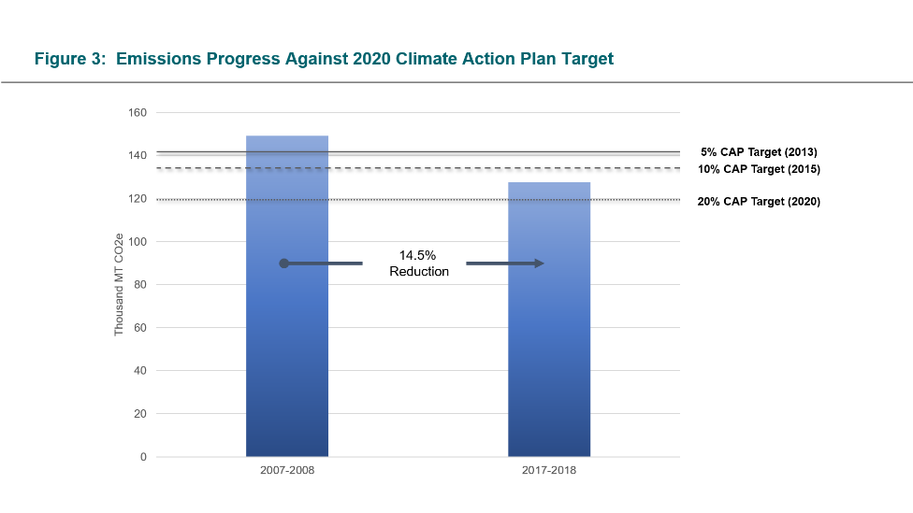

**Peer Analysis**

During the development of the 2017-2018 GHG inventory report, UD’s sustainability program and key performance metrics were benchmarked against a defined set of peer institutions. Secondary research was performed to evaluate peer institutions for comparison to UD. The results of this research are summarized herein, but details are provided only for institutions for which information was readily available. Some peer institutions had little, publicly available information so, UD was not benchmarked against these campuses.

Table 2 provides an overview of campus sustainability programmatic activities. Most institutions evaluated have set a carbon reduction goal and many have established a zero-carbon goal for 2050. Approximately half of the evaluated peers are signatories to the Second Nature Presidents’ Commitment and hold an AASHE STARS rating of Gold or higher.

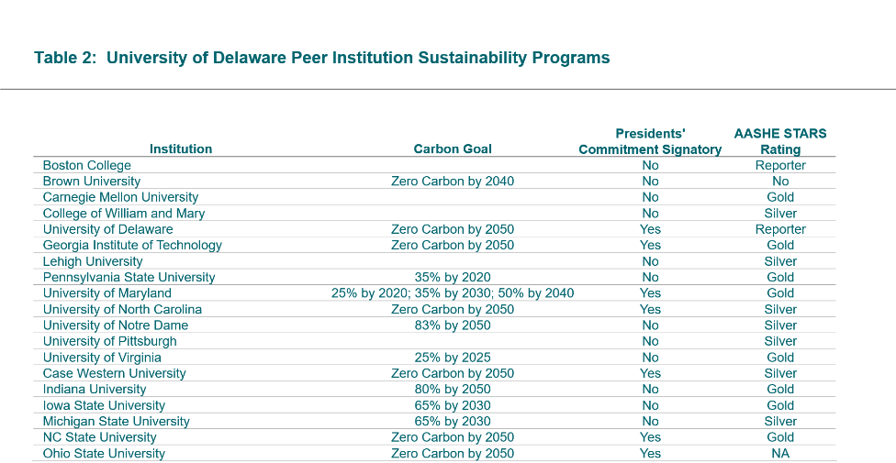

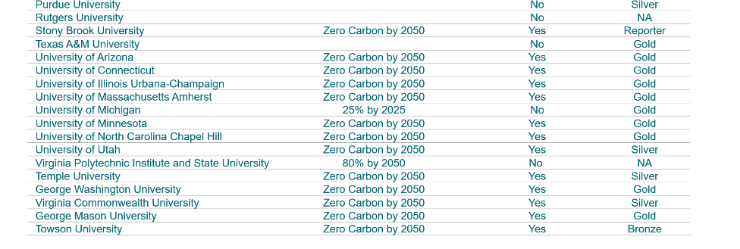

*Notes:*

*NA – Denotes that the institution is an AASHE STARS “member” but either has not reported or has not reported in recent years. “*

*No – Denotes that the institution is not a member or a reporter to the designated organization.*

Figures 4 and 5 charts UD’s energy and carbon performance along with those peers for which similar data was available. Figure 4 provides absolute energy usage and GHG emissions along with each institution’s building square footage. Figure 5 considers energy and GHG emissions normalized against building square footage. For the EUI comparison charts, two average EUI lines were drawn for the entire peer group and a subset of “regional” peers. Energy usage at UD compares favorably compared to the entire peer group, but energy intensity is higher at UD compared to regional peers. UD’s carbon performance compares favorably against peers, regional weather differences and the generation mix associated with electricity supplies appear to be the significant drivers of this result.

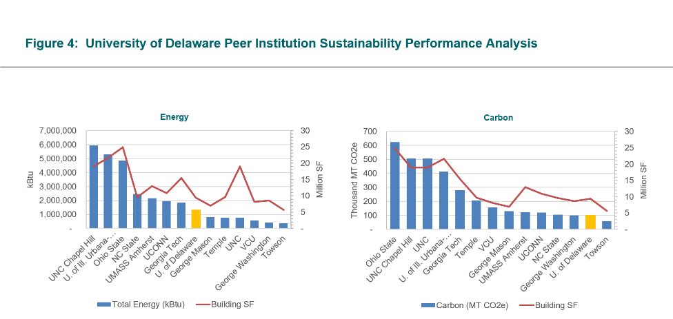

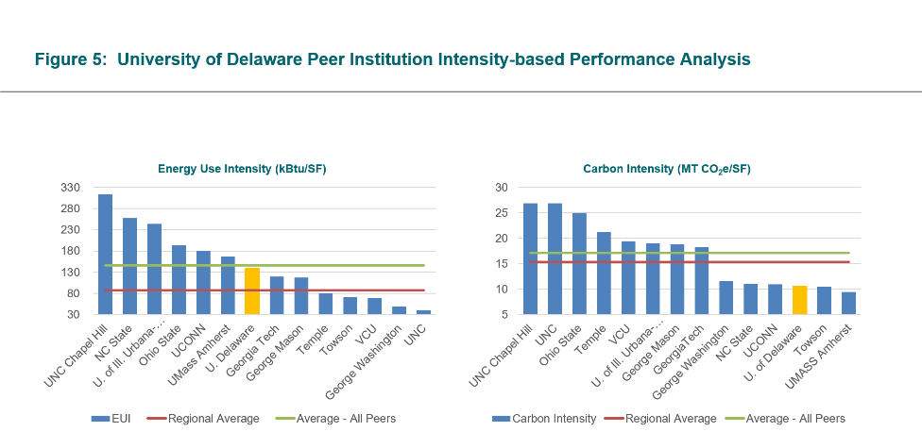

*Notes:*

*The “Regional” Peer group includes George Mason, Temple, Towson, VCU, George Washington, and University of Delaware*

**Appendix A: Data**

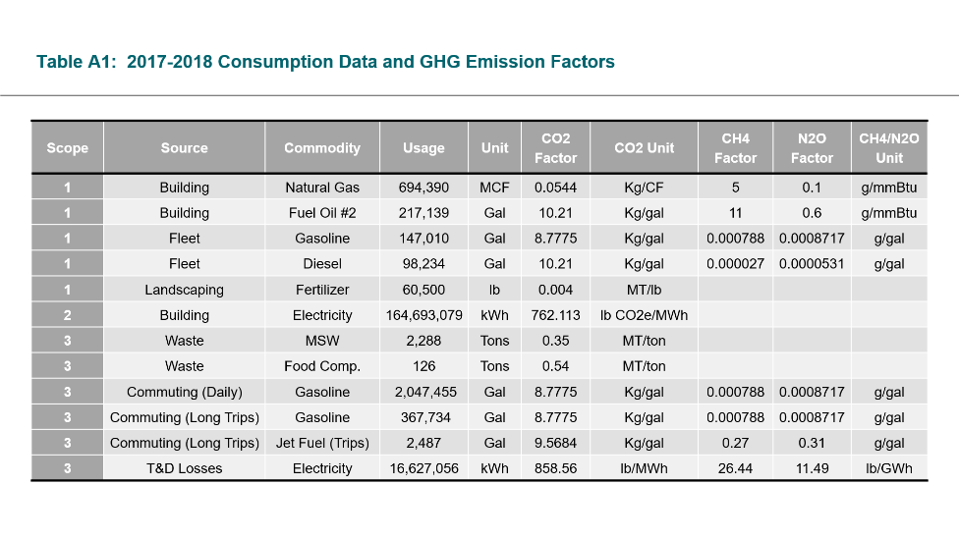

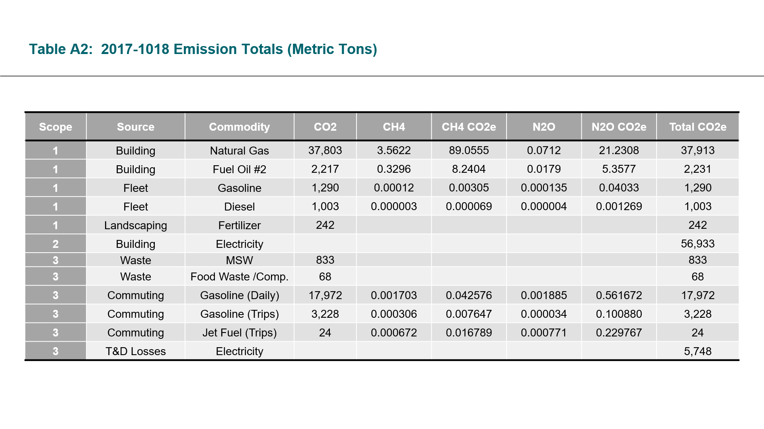

Notes:

*Sources: EPA Final Mandatory Reporting of Greenhouse Gases, Table C-1 (CO2 factors for Natural Gas, Fuel Oil, Gasoline, Diesel, Jet Fuel), EPA Climate Leaders (CH4/N2O factors for Gas, Fuel Oil, Gasoline, Diesel, Jet Fuel), EPA Inventory of Emissions and Sinks (Fertilizer), EPA WARM Model v14 (MSW Waste, Food Waste), EPA eGRID (Electricity)*

*CO2e calculations are based on IPCC Global Warming Potential Factors (CH4 = 25; N2O = 298)*

*Fertilizer and Waste emission factors are expressed in their source documents terms of CO2e.*

*For Natural Gas and Fuel Oil #2, heat content values of 1.026 mmBtu/MCF and 0.138 mmBtu/gal, respectively, were assumed (EPA).*

*CH4 and N2O factors for transportation emissions are mileage-based in sources, and have been converted to volume-based factors based on national average fuel economy.*

**Appendix B: Emissions Without Scope 3**

While the ACUPCC reporting protocol encourages the reporting of Scope 3 emissions, many other reporting programs do not require these to be reported. This is in part due to the inherent difficulties associated with quantifying these types of emissions.

Below is a comparison of only UD’s Scope 1 and Scope 2 emission sources between the 2007-2008 and 2017-2018 academic years.

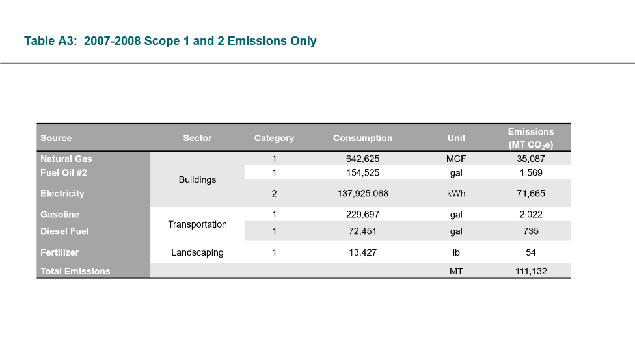

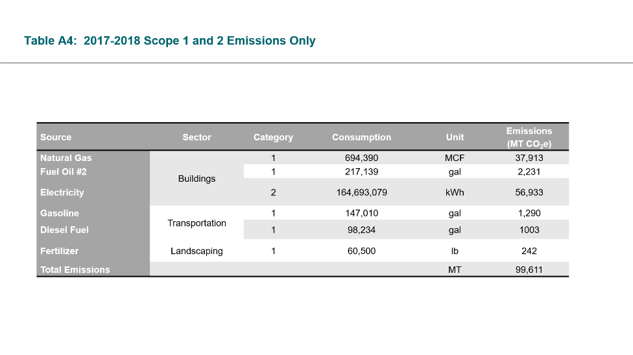

**Appendix C: ACUPCC GHG Report Inputs**

Below are the input values for 2017-2018 for the ACUPCC GHG Report:

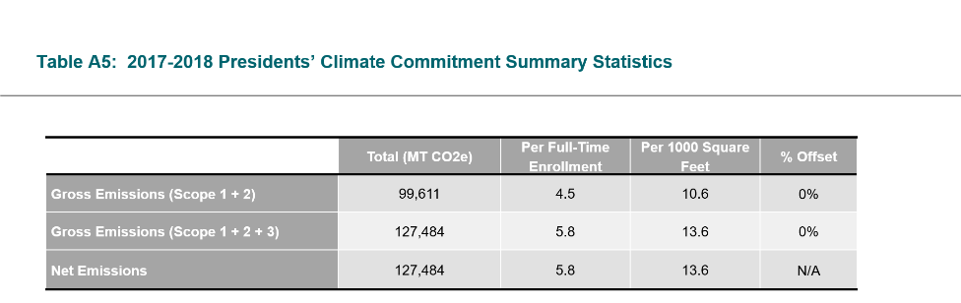

**Emissions Inventory Methodology and Boundaries:**

*Start date of the 12-month period covered in this report:*

July 1, 2017

*Consolidation methodology used to determine organizational boundaries:*

The University of Delaware greenhouse gas inventory covered all buildings which the university controls operations at on its Newark Campus.  
  
Emissions inventoried in this study address activities at the Newark Campus of the University of Delaware. This includes Laird Campus, the Main Campus, and South Campus. UD’s off campus farm facilities were outside of the scope of this inventory, as were its Dover, Wilmington, Lewes and Georgetown satellite campuses.

*Emissions calculation tool used:*

ecolinkTM by Siemens was used for the 2007-2008 base year calculations. 2017-2018 calculations were performed offline in Excel spreadsheets.

*Please describe why this tool was selected.*

Siemens’ ecolink® tool was leveraged to assist with data management and emissions calculations. This platform ensures that all emissions factors are clearly documented and correctly applied. This tool also provides safe and transparent data warehousing which will allow UD to re-analyze its organizational carbon footprint or solicit external validation of the UD carbon accounting practices.

*Please describe the source(s) of the emissions coefficients used.*

Emission factors for the combustion of natural gas, fuel oil, gasoline, diesel fuel, and jet fuel were obtained from the U.S. EPA Mandatory Reporting Rule for Greenhouse Gases (MRR),Table C-1, in keeping with the accounting methodology specified by The Climate Registry’s *General Reporting Protocol (GRP)*.

Emissions factors for purchased electricity, in keeping with *GRP* methodology, were derived from the U.S. EPA’s eGRID2012 tables. Specifically, UD is located within the RFC East Subregion, so the published GHG emission factors representing the fuel mix used in generating electricity in this region were used.

Scope 3 GHG emissions from the disposal of mixed waste, food waste, and food composting were calculated using emission factors obtained from the U.S. EPA WARM Model, version 14.

GHG emissions resulting from usage of nitrogen fertilizer were calculated with an emission factor derived from the U.S. EPA’s Inventory of U.S. Greenhouse Gas Emissions and Sinks: 1990-2001 (April 2003).

*Which version of IPCC's list of global warming potentials did you use?*

Second Assessment Report

*Who primarily conducted this emissions inventory?*

Siemens

*Please describe the process of conducting this inventory.*

Siemens worked with UD personnel to compile the 2017-2018 academic year GHG inventory. The aim of this effort was to replicate the scope and approach of the 2007-2008 GHG inventory and generate a brief, written update for comparison to the 2007-2008 benchmark. This process allows for direct correlations between the two records while measuring the benefits of carbon mitigation actions taken during the intervening five years.

Direct data records were compiled for building energy use, UD owned fleet vehicles, organic waste outputs, and fertilizer used. Estimates were utilized to assess fuel consumption associated with commuting activities as was required for the 2007-2008 academic year GHG inventory and, in 2017, this Survey process was updated.

Please see the formal inventory for further detail.

*Please describe any emissions sources that were classified as* de minimis *and explain how a determination of the significance of these emissions was made.*

No emissions sources were excluded due to being classified as *de minimis*.

*Please describe any data limitations related to this submission and any major assumptions made in response to these limitations.*

Several sources of UD’s emissions are excluded because of a lack of sufficient data. The omitted activities include UD related ground travel for which the UD fleet was not used; and UD related air travel. At UD, it is common for individuals to make their own travel arrangements, which precludes any ability to collect data on number of miles traveled or frequency of trips. Furthermore, the UD transportation survey scope only extended to travel around campus.

In addition, data limitation prevented UD from estimating the potential value of carbon sinks due to UD vegetation.

|  |  |
| --- | --- |
| **Emissions Data** |  |
| *all values in MT CO2e* |  |
| Scope 1 Emissions |  |
| Stationary Combustion | 40143.5 |
| Mobile Combustion | 2293.4 |
| Process Emissions | 0.0 |
| Fugitive Emissions | 242 |
| **Total Scope 1 Emissions** | **42678.9** |
|  |  |
| Scope 2 Emissions |  |
| Purchased Electricity | 56932.5 |
| Purchased Heating | 0.0 |
| Purchased Cooling | 0.0 |
| Purchased Steam | 0.0 |
| **Total Scope 2 Emissions** | **56932.5** |
|  |  |
| Scope 3 Emissions |  |
| Commuting | 21200.0 |
| Air Travel | 25.0 |
| Solid Waste | 901.0 |
| Transmission & Distribution Losses | 5747.8 |
| **Total Scope 3 Emissions** | **27872.9** |
|  |  |
| Biogenic Emissions |  |
| Biogenic Emissions from Stationary Combustion | 0.0 |
| Biogenic Emissions from Mobile Combustion | 0.0 |

**Mitigation Data:**

N/A

**Normalization and Contextual Data:**

|  |  |
| --- | --- |
| Building space |  |
| Gross square feet of building space | 9,391,978 |
| Net assignable square feet of laboratory space | 1,464,799 |
| Net assignable square feet of health care space | 27,265 |
| Net assignable square feet of residential space | 2,510,473 |
|  |  |
| Population |  |
| Total Student Enrollment (FTE) | 22,168 |
| Residential Students | No information provided |
| Full-time Commuter Students | No information provided |
| Part-time Commuter Students | No information provided |
| Non-Credit Students | No information provided |
| Full-time Faculty | No information provided |
| Part-time Faculty | No information provided |
| Full-time Staff | No information provided |
| Part-time Staff | No information provided |
|  |  |
| Other Contextual Data |  |
| Endowment Size | No information provided |
| Heating Degree Days | 4,632 |
| Cooling Degree Days | 1,310 |

**Supporting Documentation:**

(link to inventory here)

**Auditing and Verification:**

These emissions data have not been audited, verified, or peer-reviewed.

**Appendix D: UD Historical Enrollment Data**

|  |  |  |  |  |  |  |  |  |
| --- | --- | --- | --- | --- | --- | --- | --- | --- |
| **FY** | **Total – All** | **FTE - All** | **Full Time - All** | **Part Time - All** | **Total - Newark** | **FTE - Newark** | **Full Time - Newark** | **Part Time - Newark** |
| FY08 | 20,342 | 18,567 | 17,679 | 2,663 | 18,723 | 17,596 | 17,033 | 1,691 |
| FY09 | 20,500 | 18,754 | 17,881 | 2,619 | 18,855 | 17,767 | 17,223 | 1,632 |
| FY10 | 21,138 | 19,359 | 18,469 | 2,669 | 19,391 | 18,272 | 17,713 | 1,678 |
| FY11 | 21,176 | 19,472 | 18,620 | 2,556 | 19,556 | 18,429 | 17,866 | 1,690 |
| FY12 | 21,489 | 19,844 | 19,022 | 2,467 | 19,957 | 18,851 | 18,298 | 1,659 |
| FY13 | 21,856 | 20,257 | 19,458 | 2,398 | 20,363 | 19,262 | 18,712 | 1,651 |
| FY14 | 22,166 | 20,512 | 19,685 | 2,481 | 20,550 | 19,426 | 18,864 | 1,686 |
| FY15 | 22,680 | 21,153 | 20,389 | 2,291 | 21,141 | 20,124 | 19,616 | 1,525 |
| FY16 | 22,852 | 21,325 | 20,562 | 2,290 | 21,327 | 20,306 | 19,795 | 1,532 |

**Appendix E: Historical Degree Day Data (Wilmington Airport)**

|  |  |  |  |  |  |  |  |  |
| --- | --- | --- | --- | --- | --- | --- | --- | --- |
| **FY** | **Date** | **HDD** | **CDD** |  | **FY** | **Date** | **HDD** | **CDD** |
| FY09 | Jul-08 | 0 | 412 |  | FY13 | Jul-12 | 0 | 478 |
| FY09 | Aug-08 | 0 | 255 |  | FY13 | Aug-12 | 0 | 358 |
| FY09 | Sep-08 | 18 | 163 |  | FY13 | Sep-12 | 42 | 139 |
| FY09 | Oct-08 | 301 | 12 |  | FY13 | Oct-12 | 239 | 27 |
| FY09 | Nov-08 | 592 | 0 |  | FY13 | Nov-12 | 675 | 0 |
| FY09 | Dec-08 | 818 | 0 |  | FY13 | Dec-12 | 700 | 0 |
| FY09 | Jan-09 | 1128 | 0 |  | FY13 | Jan-13 | 905 | 0 |
| FY09 | Feb-09 | 794 | 0 |  | FY13 | Feb-13 | 849 | 0 |
| FY09 | Mar-09 | 674 | 0 |  | FY13 | Mar-13 | 761 | 0 |
| FY09 | Apr-09 | 351 | 39 |  | FY13 | Apr-13 | 342 | 16 |
| FY09 | May-09 | 108 | 66 |  | FY13 | May-13 | 125 | 89 |
| FY09 | Jun-09 | 19 | 190 |  | FY13 | Jun-13 | 0 | 251 |
| FY10 | Jul-09 | 0 | 277 |  | FY14 | Jul-13 | 0 | 452 |
| FY10 | Aug-09 | 0 | 367 |  | FY14 | Aug-13 | 0 | 266 |
| FY10 | Sep-09 | 34 | 87 |  | FY14 | Sep-13 | 72 | 104 |
| FY10 | Oct-09 | 304 | 5 |  | FY14 | Oct-13 | 229 | 49 |
| FY10 | Nov-09 | 463 | 0 |  | FY14 | Nov-13 | 629 | 0 |
| FY10 | Dec-09 | 914 | 0 |  | FY14 | Dec-13 | 844 | 0 |
| FY10 | Jan-10 | 1008 | 0 |  | FY14 | Jan-14 | 1164 | 0 |
| FY10 | Feb-10 | 949 | 0 |  | FY14 | Feb-14 | 938 | 0 |
| FY10 | Mar-10 | 527 | 0 |  | FY14 | Mar-14 | 824 | 0 |
| FY10 | Apr-10 | 277 | 20 |  | FY14 | Apr-14 | 377 | 7 |
| FY10 | May-10 | 101 | 116 |  | FY14 | May-14 | 76 | 59 |
| FY10 | Jun-10 | 3 | 352 |  | FY14 | Jun-14 | 2 | 236 |
| FY11 | Jul-10 | 0 | 460 |  | FY15 | Jul-14 | 0 | 345 |
| FY11 | Aug-10 | 0 | 374 |  | FY15 | Aug-14 | 0 | 245 |
| FY11 | Sep-10 | 7 | 184 |  | FY15 | Sep-14 | 39 | 146 |
| FY11 | Oct-10 | 254 | 10 |  | FY15 | Oct-14 | 218 | 16 |
| FY11 | Nov-10 | 546 | 0 |  | FY15 | Nov-14 | 635 | 0 |
| FY11 | Dec-10 | 1023 | 0 |  | FY15 | Dec-14 | 769 | 0 |
| FY11 | Jan-11 | 1128 | 0 |  | FY15 | Jan-15 | 1069 | 0 |
| FY11 | Feb-11 | 814 | 0 |  | FY15 | Feb-15 | 1126 | 0 |
| FY11 | Mar-11 | 701 | 0 |  | FY15 | Mar-15 | 838 | 0 |
| FY11 | Apr-11 | 295 | 29 |  | FY15 | Apr-15 | 331 | 1 |
| FY11 | May-11 | 76 | 119 |  | FY15 | May-15 | 56 | 164 |
| FY11 | Jun-11 | 0 | 277 |  | FY15 | Jun-15 | 18 | 266 |
| FY12 | Jul-11 | 0 | 494 |  | FY16 | Jul-15 | 0 | 372 |
| FY12 | Aug-11 | 0 | 317 |  | FY16 | Aug-15 | 0 | 335 |
| FY12 | Sep-11 | 32 | 180 |  | FY16 | Sep-15 | 1 | 230 |
| FY12 | Oct-11 | 278 | 8 |  | FY16 | Oct-15 | 288 | 3 |
| FY12 | Nov-11 | 459 | 0 |  | FY16 | Nov-15 | 425 | 6 |
| FY12 | Dec-11 | 727 | 0 |  | FY16 | Dec-15 | 478 | 1 |
| FY12 | Jan-12 | 859 | 0 |  | FY16 | Jan-16 | 1015 | 0 |
| FY12 | Feb-12 | 725 | 0 |  | FY16 | Feb-16 | 822 | 0 |
| FY12 | Mar-12 | 424 | 3 |  | FY16 | Mar-16 | 504 | 2 |
| FY12 | Apr-12 | 356 | 13 |  | FY16 | Apr-16 | 383 | 11 |
| FY12 | May-12 | 52 | 121 |  | FY16 | May-16 | 175 | 78 |
| FY12 | Jun-12 | 13 | 239 |  | FY16 | Jun-16 | 5 | 222 |

|  |  |  |  |  |  |  |  |  |
| --- | --- | --- | --- | --- | --- | --- | --- | --- |
| **FY** | **Date** | **HDD** | **CDD** |  | **FY** | **Date** | **HDD** | **CDD** |
| FY17 | Jul-16 | 0 | 433 |  | FY18 | Jul-17 | 0 | 417 |
| FY17 | Aug-16 | 2 | 441 |  | FY18 | Aug-17 | 0 | 277 |
| FY17 | Sep-16 | 30 | 245 |  | FY18 | Sep-17 | 25 | 183 |
| FY17 | Oct-16 | 225 | 45 |  | FY18 | Oct-17 | 145 | 75 |
| FY17 | Nov-16 | 496 | 4 |  | FY18 | Nov-17 | 558 | 0 |
| FY17 | Dec-16 | 835 | 0 |  | FY18 | Dec-17 | 924 | 0 |
| FY17 | Jan-17 | 832 | 0 |  | FY18 | Jan-18 | 1037 | 0 |
| FY17 | Feb-17 | 628 | 4 |  | FY18 | Feb-18 | 671 | 0 |
| FY17 | Mar-17 | 731 | 5 |  | FY18 | Mar-18 | 788 | 0 |
| FY17 | Apr-17 | 242 | 55 |  | FY18 | Apr-18 | 440 | 8 |
| FY17 | May-17 | 168 | 77 |  | FY18 | May-18 | 36 | 117 |
| FY17 | Jun-17 | 27 | 295 |  | FY18 | Jun-18 | 8 | 233 |