DRAFT REPORT

FLORIDA TECH FY-2019 GHG REPORT

Principal Author:
Quinn A. Duffy,
Planning & Sustainability Specialist
(321) 674-7247
qduffy@fit.edu

Submission: XX/XX/XXXX

Submitted to:
Mischka Maxwell, AVP Operations
Eric Kledzik, SVP Operations

Special Acknowledgement

Florida Tech would like to recognize students Hannah Vest, Iven Webb, and Joseph Luya for their dedication and efforts to perform the very first GHG Inventory for their 2019 Senior Design Capstone Project. The commitment that is shown by the students of the Institution to better their community, environment, and future is what separates them from their peers in the rest of the world. They have truly embodied the relentless pursuit of greatness we instill in our alumni.

About the Authors & Contributors

Quinn Duffy, Planning & Sustainability Specialist

Serves as the Sustainability Coordinator in the Facilities Operations department at Florida Tech since 2019. A recent graduate of Florida Tech with a B.S. in Civil Engineering and a minor in Sustainability who is continuing with his education at Florida Tech where he hopes to transform the campus environment and mindset.

Ana Castañeda, Student

Ana Castañeda is a student from Colombia studying sustainability, working as a Sustainability Technician for Facilities Operations, and serving in the Student Organization for Sustainable Action (SOSA). Ana is absolutely dedicated to sustainability and the pursuit of best practices, greater action, and thoughtful planning.

Suzy Daigle, Business Manager

Mrs. Daigle is a graduate of the University of Louisiana at Lafayette with B.S. in General Studies and serves as the Secretary of the University Sustainability Council. Suzy is a huge supporter of sustainability and assists in the tracking, collection, and validation of the data collected for our certifications, programs, and award proposals.

Student Federal Work Study Technicians

Vinai Balroop, Dylan Hall, Vicky Peña, Caroline Morales

Florida Tech Faculty, Staff, and Contributors

Dr. K. Lindeman, Student Organization for Student Action, Taylor Greene, Lee Martucci, Damon Hart, Jeff Sherman, Steve Czagas, Dr. G. Dewey Yeatts, Chad Shoultz, Cheryl LeBlanc, Carlos Rivera, Chrystal Hillary, and many more.
Table of Contents

Special Acknowledgement 2
About the Authors & Contributors 2
Executive Summary 4
Inventory Parameters & Boundaries 5
Methods 5
Institutional Parameters 6
Scope 1 Emissions Inventory 7
Scope 2 Emissions Inventory 11
Scope 3 Emissions Inventory 12
Carbon Sinks & Sequestration 18
Summary 19
References 20
Appendix 21

Figure 1: FY-2019 Food Weight Breakdown 15
Figure 2: FY-2019 Food Carbon Emissions Breakdown 16
Figure 3: Total FY-2019 Carbon Emissions Breakdown 19
Figure 4: Total FY-2019 Carbon Emissions by Category 21
Figure 5: total FY-2019 Carbon Emissions by Gas 22

Table 1: Executive Summary of Emissions 4
Table 2: FY-2019 Raw Data 23
Table 3: FY-2019 Emissions Per Scope 23
Table 4: FY-2019 Total Emissions & Net Emissions 23

Executive Summary

Florida Tech FY-2019 Greenhouse Gas Emission Report

The Florida Institute of Technology remains committed to the relentless pursuit of greatness through our sustainability initiatives. In order to provide some sort of quantitative benchmark for our success to be measured against and operate within best practices, the University has performed its first official Greenhouse Gas Inventory (GHG) for the 2019 Fiscal Year (May 1st, 2018 to April 30th, 2019). The following report will outline and define the values collected from our Campus Operations and recorded in the University of New Hampshire Sustainability Indicator Management & Analysis Program (SIMAP). This allows the University to have our data verified by a 3rd party in order to utilize it as a published report for the Association for Advancement of Sustainability in Higher Education (AASHE) Sustainability Tracking Assessment & Reporting System (STARS).

The University Produced 34,345 MTCO₂ during the reporting period, and this period will serve as the baseline year until the previous year can be completed. According to the United States Environmental Protection Agency (EPA) Energy Utilization Index (EUI, Zone-6 Education) the university is about 40% below the mean index number. Table 1 outlines the overall summary of Scope 1, Scope 2, and Scope 3 reported data.

Table 1: Executive Summary of Emissions
Source | Amount (Unit) | Emissions (MTCDE)
Scope 1 (Total)
Stationary Fuels | 10,346 MMBtu | 550.36
Transport Fuels | Varies | 87.12
Fertilizer | 5,250 lb | 2.83
Refrigerants & Chemicals | Varies | 314.21
Scope 2 (Total)
Utilities | 28.0 GWh | 13,993.88
Renewable Energy | -31 MWh | -17.36
Scope 3 (Total)
Commuting | Varies | 15644.75
Food | 1,068,707 lb | 2548.42
Paper | 5,642 reams | 33.49
Waste | 2,486,400 lb | 431.64
Wastewater | 49,072,400 gal | 21.20
Sinks (Total)
Non-Additional Sequestration | 26.2 acres | 3,864
Total Emissions | 34,345

Inventory Parameters & Boundaries

Methods

Boundaries
This inventory’s parameters were defined using The Greenhouse Gas Protocol (World Resources Institute, 2004). This report is centered around a financial control approach, meaning data was collected on items, entities, and operations that Florida Institute of Technology has financial control over, including FIT Aviation and FIT Museums. Some data was not able to be collected due to the lack of or inaccurately maintained records, leading to slightly deviated final results. Efforts will be made to correct the reporting standards for the next reporting period.

Baseline year
The baseline year for this inventory is Fiscal Year 2019 (FY-19). The Fiscal Year at Florida Tech runs from May 1st to April 31st each year. FY19 was chosen because at the start of the initial data collection it was the only complete fiscal year with appropriate data. Historic data will be included when available to show trends over the long term.

Boundary Conditions and Limitations
This report will take a financial control approach to the inventory. Under a financial control approach the inventory would include anything that Florida Tech “has the full authority to introduce and implement its operating policies at the operation”. (World Resources Institute, 2004)

Definition of Scopes
The categorization of various emission sources is outlined by The Greenhouse Gas protocol:
Scope 1
- These are direct campus emissions that arise for on-site sources.
- Includes items such as: fossil fuels, fertilizer, refrigerants, & chemicals.
Scope 2
- Purchased electricity & Renewable Energy Credits (RECs) makes up the whole of this scope.
Scope 3
- Indirect emissions from activities associated with travel, user experience, and day-to-day operations
- Includes items such as: commuting, food, paper, etc.

Institutional Parameters

Florida Institute of Technology, Inc. and its subsidiaries are a private not-for-profit Doctoral Granting Research University located in and around Melbourne, FL. The Educational Institution is located in a mid-size city classified as IECC Zone-2 (hot) and classified as an independent educational facility in the State of Florida (International Code Council, 2015).
The Main Campus and Melbourne Sites are considered to incorporate over 135 acres of land, 2 million square feet of gross building space, and a Full Time Enrollment (FTE) student population of 4,685, 775 employees, and 357 faculty members. The total operating budget for FY-19 was $197 million with $2.6 million for research and $3.5 million for energy (Florida Institute of Technology, Inc. , 2020).
Florida Institute of Technology, Inc. is a 501(c)3 charitable educational organization under IRS Tax Law and operates with subsidiaries, primarily FIT Aviation, Inc. and FIT Museums, Inc. as separate entities under operational and financial control of the University (State of Florida Department of State, 2020).

Scope 1 Emissions Inventory

Stationary Fuels -Natural Gas
Initial natural gas information was only available as an amount purchased. Historic records of natural gas price were used to estimate the amount used by Florida Tech. These values can be found on the U.S. Energy Information Administration (EIA) website (“Natural Gas Prices”).The conversion factors for finding the equivalent CO₂ emissions from the natural gas can also be found on the U.S. EIA website (“U.S. Energy Information Administration - EIA - Independent Statistics and Analysis.”). Natural gas was assumed as Non-cogenerated natural gas. These numbers reflect usage for HVAC, back-up generators, and laboratory use.
Conversion Factors
CO₂ 53.02 kg CO₂ / MMBtu
Calculation Method
$$\left(\text{10,346 MMBtu}\right) \text{×}\left( \frac{\text{53.02 kg C}{\text{O}}_{\text{2}}}{\text{1 MMBtu}}\right) \text{=} \text{548,545 kg C}{\text{O}}_{\text{2}}$$

Generated Alternative Energy – Solar Production
Emissions related to sold alternative-produced electricity are calculated with respect to how much kWh the campus produces and returns to the grid. Florida Institute of Technology produces solar energy utilizing two arrays: a small array on the Facilities Transportation Depot and a larger on the Olin Engineering Complex roof. The annual capacity of each array are 14,773 and 16,782 kWh respectively. Data on the Average production of the panels utilizing weather, location, and historical trends was calculated using PVWatts Calculator from the National Renewable Energy Laboratory (Alliance for Sustainable Energy, LLC, 2020).

Conversion Factors
CO₂ 0.55000 kg CO₂ /kWh
Calculation Method
$$\left(\text{-31,555 }\text{kWh}\right)\text{ × }\left(\frac{\text{550 }\text{g C}{\text{O}}_{\text{2}}}{\text{1}\text{ kWh}}\right)\text{ × }\left(\frac{\text{1}}{\text{1,000,000} {\text{g}}/{\text{eMT}}}\right) \text{= -17.35 }\text{eMT C}{\text{O}}_{\text{2}}$$

Transportation Fuels – Campus Fleet Gasoline
Florida Tech owns and operates many gasoline-fueled vehicles. The exact fuel usage of each vehicle is unknown so emissions were calculated based on the total fuel purchased. All campus gasoline vehicles draw the gas they need from one central tank.
Conversion Factors
CO₂ 8.86650 kg CO₂ /gal
Calculation Method
$$\left(\text{36,076.00 }\text{gal}\right)\text{ × }\left(\frac{\text{8.86650 kg C}{\text{O}}_{\text{2}}}{\text{1 gal}}\right) \text{=} \text{319,867 }\text{kg C}O_{2}$$

Transportation Fuels – Campus Fleet Diesel
Florida Tech owns and operates many diesel-fueled vehicles. The exact fuel usage of each vehicle is unknown so emissions were calculated based on the total fuel purchased. All campus diesel vehicles draw the gas they need from one central tank.
Conversion Factors
CO₂ 10.2570 kg CO₂ /gal
Calculation Method
$$\left(\text{1,000.00 }\text{gal}\right) \text{×} \left(\frac{\text{10.2570 }\text{kg C}{\text{O}}_{\text{2}}}{\text{1 }\text{gal}}\right) \text{=} \text{10,257 }\text{kg C}{\text{O}}_{\text{2}}$$

Transportation Fuels – Campus Generators
Florida Tech owns and operates diesel emergency power back-up generators. These generators are serviced and filled with diesel regularly from the same fuel vendor that services the campus diesel tank.
Conversion Factors
CO₂ 10.2570 kg CO₂ /gal
Calculation Method
$$\left(\text{785 }\text{gal}\right)\text{ × }\left(\frac{\text{10.2570}\text{ kg C}{\text{O}}_{\text{2}}}{\text{1 }\text{gal}}\right) \text{=} \text{8,052 kg C}{\text{O}}_{\text{2}}$$
Transportation Fuels – Campus Fleet Other Fuels
Florida Tech owns and operates many vehicles other than typical campus fleet gasoline, diesel, generator, or aviation fueled units. These numbers reflect the off-road vehicles utilized by University Facilities Operations to maintain our campus day-to-day operations. These vehicles include heavy equipment, golf carts, lifts, etc.
Conversion Factors
CO₂ 10.2570 kg CO₂ /gal
Calculation Method
$$\left(\text{399.50 }\text{gal}\right) \text{× }\left(\frac{\text{10.2570 }\text{kg C}{\text{O}}_{\text{2}}}{\text{1 }\text{gal}}\right) \text{=} \text{4098 }\text{kg C}{\text{O}}_{\text{2}}$$

Transportation Fuels – FIT Aviation Fuel
Emissions related to the flight school are calculated based on the amount of fuel burned in order to operate all airplanes in service. This calculation does not take into account the different efficiencies of different aircrafts or the type of engine used in each plane. AvGas Fuel use information was provided by the accounting department of FIT Aviation for fiscal years 15 through 18.
Conversion Factors
CO₂ 8.30543 kg CO₂ /gal
Calculation Method
$$\left(\text{65,600 gal}\right)\text{ × }\left(\frac{\text{8.30543 kg C}{\text{O}}_{\text{2}}}{\text{1 gal}}\right)\text{ = 544,836 kg C}{\text{O}}_{\text{2}}$$

Fertilizer
Fertilizer usage primarily releases traceable amounts of CO₂. Florida Tech minimizes the use of fertilizers by adhering to a strict schedule for its use. Fertilizers are used twice yearly to maintain the campus greenery.
Conversion Factors
CO₂ 0.00053 kg CO₂ /lb
Calculation Method
$$\left(\text{5,250 lb}\right)\text{ × }\left(\frac{\text{0.00053 kg C}{\text{O}}_{\text{2}}}{\text{1 lb}}\right)\text{ = 2.83 kg C}{\text{O}}_{\text{2}}$$

Refrigerants
Refrigerants and chemicals that are used on campus in the operations of HVAC systems include multiple refrigerant agents that comply with current laws and standards. The inventory of these refrigerants is based on the capacity of the current building HVAC unit inventory, our chilled water plants, and other refrigeration units.
Conversion Factors
CO₂ 0.86084 kg CO₂ /lb
Calculation Method
$$\left(\text{365 lb}\right)\text{ × }\left(\frac{\text{0.86084 kg C}{\text{O}}_{\text{2}}}{\text{1 lb}}\right) \text{=} \text{314.21 kg C}{\text{O}}_{\text{2}}$$

Scope 2 Emissions Inventory

Purchased Electricity
Emissions related to purchased electricity are calculated with respect to how much kWh the campus consumes. Florida Institute of Technology acquires their electricity from Florida Power and Light (FPL), more specifically the Cape Canaveral Plant, which runs on Natural Gas.

Conversion Factors
CO₂ 0.49956 kg CO₂ /kWh
Calculation Method
$$\left(\text{28,012,030 kWh}\right)\text{ × }\left(\frac{\text{499.56 g C}{\text{O}}_{\text{2}}}{\text{1 kWh}}\right)\text{ × }\left(\frac{\text{1}}{\text{1,000,000 }{\text{g}}/{\text{eMT}}}\right)\text{ = 13,993.88 eMT C}{\text{O}}_{\text{2}}$$

Generated Alternative Energy – Solar Production
Emissions related to sold alternative-produced electricity are calculated with respect to how much kWh the campus produces and returns to the grid. Florida Institute of Technology produces solar energy utilizing two arrays: a small array on the Facilities Transportation Depot and a larger on the Olin Engineering Complex roof. The annual capacity of each array are 14,773 and 16,782 kWh respectively. Data on the Average production of the panels utilizing weather, location, and historical trends was calculated using PVWatts Calculator from the National Renewable Energy Laboratory.

Conversion Factors
CO₂ 0.49956 kg CO₂ /kWh
Calculation Method
$$\left(\text{-31,555 kWh}\right)\text{ ×} \left(\frac{\text{499.56 C}{\text{O}}_{\text{2}}}{\text{1 kWh}}\right)\text{ ×} \left(\frac{\text{1}}{\text{1,000,000} {\text{g}}/{\text{eMT}}}\right)\text{ = -17.35 eMT C}{\text{O}}_{\text{2}}$$

Scope 3 Emissions Inventory

Faculty & Staff Commuting
This category of emissions is based on the best available data, campus experience, and professional recommendations that several departments on campus were able to provide. We estimate that of our faculty, staff, and students whom commute to and from campus daily that the below conversion factors are as accurate as possible.
Conversion Factors
Automobile: 92.5% - 20 mi/trip
Bicycle: 4% - 5 mi/trip
Carpool: 1% - 20 mi/trip
Commuter Rail: 0% - 0 mi/trip
Light Rail: 0% - 0 mi/trip
Public Bus: 2% - 15 mi/trip
Walk: 0.5% - 5 mi/trip
Faculty Commuters (400)
Staff Commuters (800)
Student Commuters (2286)
Weekly Commuting Trips (10)
Commuting Weeks (45)

Total Estimated GHG MTCDE: 7,573.54

Student Travel
This category of emissions is based on the best available data, campus experience, and professional recommendations that several departments on campus were able to provide. We have estimated the average yearly traveling methods of our on-campus student population who travel to and from home between semesters.
Conversion Factors
Air Travel: 67%
Automobile: 20% - 900 mi/trip - 6 trips annually
Carpool: 10% - 900 mi/trip - 6 trips annually
Rail: 2% - 900 mi/trip - 6 trips annually
Public Bus: 1% - 900 mi/trip - 6 trips annually
Student Commuters (1648)

Total Estimated GHG MTCDE: 3,766

Food Purchasing & Usage
The food purchasing and overall usage by a university campus is substantial, and it’s very difficult to track the exact amount of meats, fruits, and vegetables arriving from multiple vendors at multiple sites. Utilizing data from Dining Services, we were able to account for 80% of our food purchasing for the fiscal year in a semi-detailed format with general shipped weights of the food stuffs ordered. The conversion factors are listed below:
Conversion Factors
Beans: 0.78000 kg eCO₂/kg food
Beef: 26.45000 kg eCO₂/kg food
Cheese: 9.78000 kg eCO₂/kg food
Coffee & Tea: 5.05000 kg eCO₂/kg food
Eggs: 3.54000 kg eCO₂/kg food
Fish: 3.83000 kg eCO₂/kg food
Fruits: 0.36000 kg eCO₂/kg food
Grains: 0.86000 kg eCO₂/kg food
Liquids: 1.03000 kg eCO₂/kg food
Milk: 1.34000 kg eCO₂/kg food
Nuts: 1.17000 kg eCO₂/kg food
Pork: 6.87000 kg eCO₂/kg food
Potatoes: 0.21000 kg eCO₂/kg food
Spices: 0.73000 kg eCO₂/kg food
Sugars: 0.93000 kg eCO₂/kg food
Vegetables: 0.73000 kg eCO₂/kg food

Overall food purchased: 1,068,707 lb $\text{×}$ 0.453592 kg/lb = 484757.341
Overall GHG MTCDE: 2,548.42
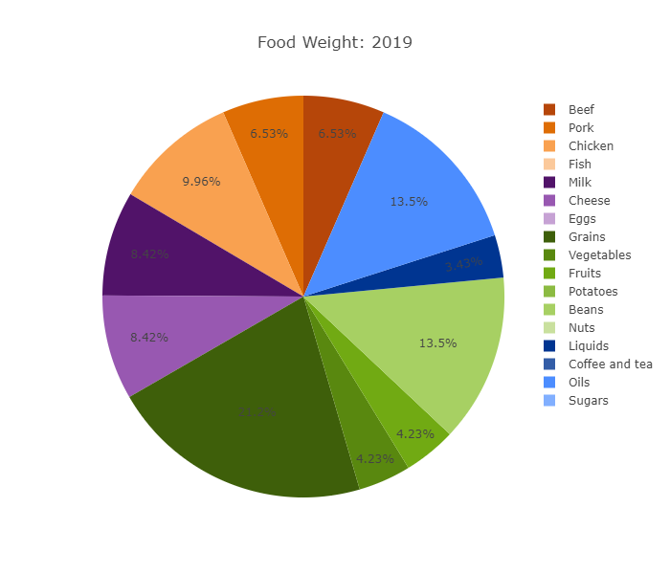
Figure 1: FY-2019 Food Weight Breakdown
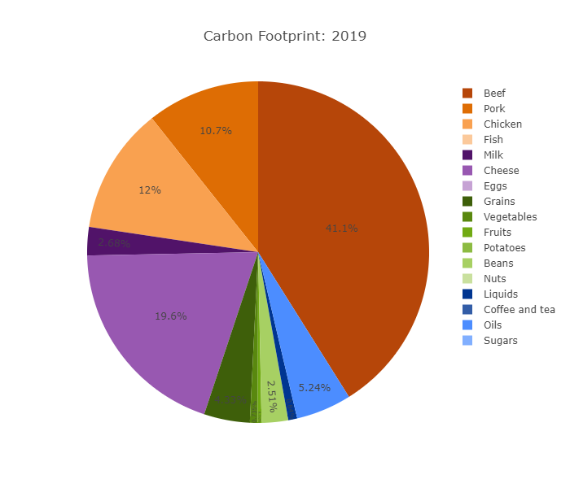
Figure 2: FY-2019 Food Carbon Emissions Breakdown

Paper Purchasing
The data collected from the campus community on paper purchasing is reflected by the total quantity of paper used by the University in reams. Data was collected from our campus printer/copier fleet and the Copy Center ordering information. We are confident that this will account for more than 90% of our paper purchasing less the units that are not registered on the campus system. Below are the conversion factors for paper purchasing.
Conversion Factors
CO₂ 0.00593 kg CO₂ /ream
Calculation Method
$$\left(\text{5642 reams}\right)\text{ × }\left(\frac{\text{0.00593 kg C}{\text{O}}_{\text{2}}}{\text{1 ream}}\right)\text{=} \text{34 eMT C}{\text{O}}_{\text{2}}$$

Waste & Wastewater
Waste and wastewater data is collected from the production and collection of landfill waste and central treatment bound wastewater. Our primary sources of data are the City of Melbourne and Waste Management. The treatment plant is classified as aerobic and the landfill in our county is a non-CH₄ recovery landfill. The conversion factors are listed below.

Conversion Factors
CO₂ 0.000000432 kg CO₂ /gallon
CO₂ 0.0001736 kg CO₂ /pound
Calculation Method
$$\left(\text{49,072,400 gallon}\right)\text{ × }\left(\frac{\text{0.000000432 kg C}{\text{O}}_{\text{2}}}{\text{1 gal}}\right) \text{=} \text{21.21 kg C}{\text{O}}_{\text{2}} \text{Wastewater}$$

$$\left(\text{2,486,400 lb}\right)\text{ × }\left(\frac{\text{0.0001736 kg C}{\text{O}}_{\text{2}}}{\text{1 }\text{lb}}\right) \text{=} \text{431.64 kg C}{\text{O}}_{\text{2}} \text{Waste}$$

Carbon Sinks & Sequestration

Non-Additional Sequestration
The Florida Tech Campus is situated in a geographic location that straddles a small flowing body of water called Crane Creek which feeds into the Indian River Lagoon. This means that a significant portion of wetlands exist on campus (26.02 acres), a portion of which is protected within the Gordon & Joy Patterson Botanical Gardens (19.4 acres). These wetlands serve as a carbon sequestration for our campus footprint and a sponge for any emissions that occur. Although it does not subtract from the overall footprint, it is non-additional sequestration. The conversion factors are listed below.
Conversion Factors
CO₂ 148.50000 kg CO₂ /acre
Calculation Method
$$\left(\text{26.02 acres}\right)\text{ ×} \left(\frac{\text{-148,50000 kg C}{\text{O}}_{\text{2}}}{\text{1 acre}}\right)\text{= -3864 eMT C}{\text{O}}_{\text{2}}$$

Summary

This is the first of what will become annual reporting of the Florida Institute of Technology’s greenhouse gas emissions (GHG) for our entire campus operations. The first year will serve as an inaugural exercise of the collection of data, encouraging the participation of various campus departments and the involvement of our management system to recognize the significance of understanding the numbers that back up our operational qualities. Florida Tech has produced a net 34,345.34 metric tons carbon dioxide equivalent (MTCDE) of emissions for the 2019 fiscal year.
In comparison to universities of similar size, Florida Tech emits at a less than average rate. For example, Rice University in Houston, Texas has about 4,000 undergraduate students and Gross Scope 1 & Scope 2 Emissions from FY 2018 were 108,443 MTCDE (27.11 MTCDE/student). University of Florida, which is one of the sustainability leaders in Florida incurred about 363,581 MTDCE from scope 1 & Scope 2 sources for 51,887 students (7.01 MTCDE/Student). Florida Tech produced a total of 14,948.40 Scope 1 & Scope 2 emissions for the same year for 4,685 students (3.19 MTCDE/Student).
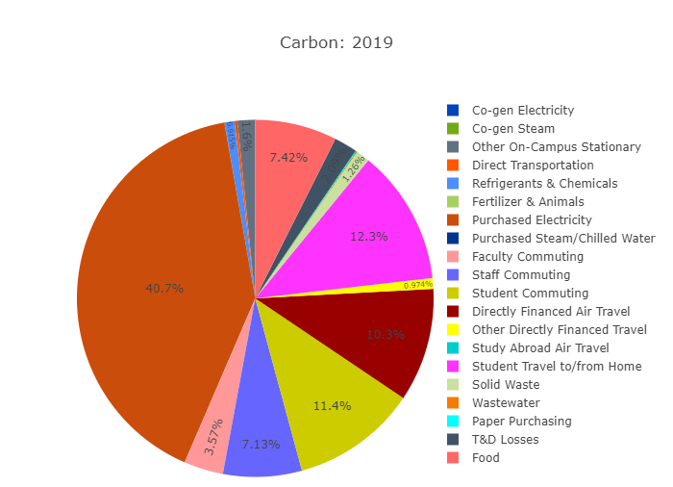
Overall, Florida Tech can always do better to lessen the impact it has on the local community, environment, and overall health of the university, but it has made significant improvements in the last few years to be one of the cleanest universities in Florida.

Figure 3: Total FY-2019 Carbon Emissions Breakdown

References
Alliance for Sustainable Energy, LLC. (2020, March 23). PVWatts Calculator. Retrieved from National Renewable Energy Laboratory: https://pvwatts.nrel.gov/
Florida Institute of Technology, Inc. . (2020, March 24). Office of Institutiional Research . Retrieved from Florida Tech Website: https://www.fit.edu/institutional-research/
International Code Council. (2015). International Energy Conservation Code. New York, NY: ICC Publishing.
State of Florida Department of State. (2020, March 23). Corporate Detail by Entity Name. Retrieved from Division of Corporations: http://search.sunbiz.org/Inquiry/CorporationSearch/SearchResultDetail?inquirytype=EntityName&directionType=Initial&searchNameOrder=FLORIDAINSTITUTETECHNOLOGY%207086701&aggregateId=domnp-708670-d60ca048-8a13-4dec-8d09-f351578cc493&searchTerm=Florida%20Inst
United States Department of Energy, EIA. (2020, March 23). Independent Statistics & Analysis. Retrieved from US Energy Efficiency Administration: https://www.eia.gov/
Vest, H., Webb, I., & Luya, J. (2019). Florida Institute of Technology Capstone Greenhouse Gas Inventory. Melbourne, FL: Florida Institute of Technology College of Engineering.
World Resources Institute. (2004). Greenhouse Gas Protocol. Washington, D.C.: WRI.

Appendix

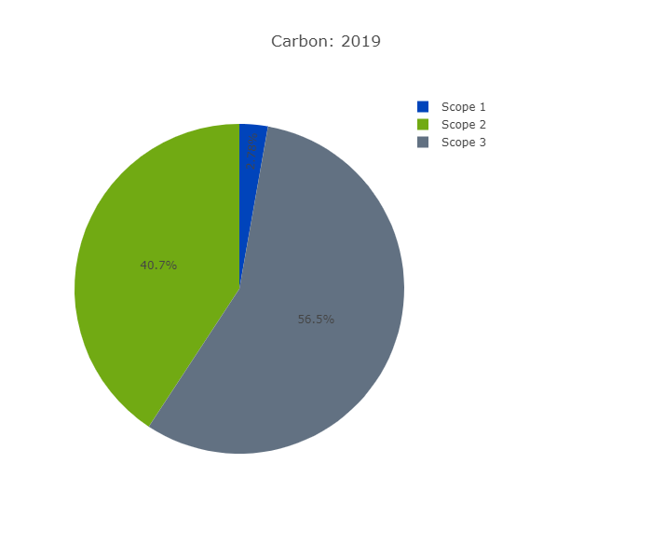
Figure 4: Total FY-2019 Carbon Emissions by Category
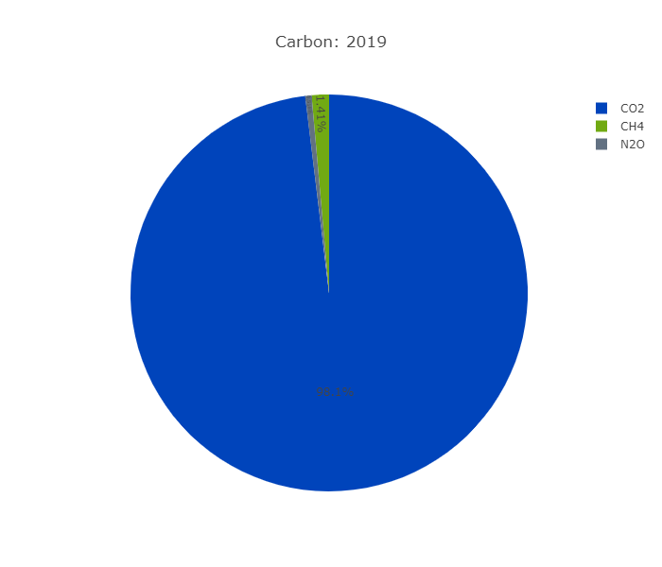
Figure 5: total FY-2019 Carbon Emissions by Gas

Table 2: FY-2019 Raw Data
Source | CO₂ (kg) | CO₂ (MTCDE) | CH₄ (kg) | CH₄ (MTCDE) | N₂O (kg) | N₂O (MTCDE) | GHG MTCDE
Other On-Campus Stationary | 548,545 | 548.54 | 55 | 1.53 | 1 | 0.29 | 550.36
Direct Transportation | 74,999 | 75 | 36 | 1 | 42 | 11.12 | 87.12
Refrigerants & Chemicals | 0 | 0 | 0 | 0 | 0 | 0 | 314.21
Fertilizer & Animals | 0 | 0 | 0 | 0 | 11 | 2.83 | 2.83
Purchased Electricity | 13,924,581 | 13,924.58 | 1,030 | 28.85 | 153 | 40.45 | 13,993.88
Faculty Commuting | 1,211,680 | 1,211.68 | 64 | 1.81 | 42 | 11.1 | 1,224.59
Staff Commuting | 2,423,360 | 2,423.36 | 130 | 3.65 | 84 | 22.21 | 2,449.22
Student Commuting | 3,858,572 | 3,858.57 | 206 | 5.76 | 134 | 35.4 | 3,899.73
Directly Financed Air Travel | 3,517,693 | 3,517.69 | 38 | 1.07 | 39 | 10.42 | 3,529.18
Other Directly Financed Travel | 330,858 | 330.86 | 18 | 0.5 | 12 | 3.07 | 334.43
Student Travel to/from Home | 4,190,700 | 4,190.70 | 64 | 1.79 | 57 | 15.11 | 4,207.60
Solid Waste | 0 | 0 | 15,416 | 431.64 | 0 | 0 | 431.64
Wastewater | 0 | 0 | 0 | 0 | 80 | 21.2 | 21.2
Paper Purchasing | 0 | 0 | 0 | 0 | 0 | 0 | 33.49
T&D Losses | 713,881 | 713.88 | 53 | 1.48 | 8 | 2.07 | 717.43
Food | 2,548,421 | 2,548.42 | 0 | 0 | 0 | 0 | 2,548.42

Table 3: FY-2019 Emissions Per Scope
Scope | CO₂ (kg) | CH₄ (kg) | N₂O (kg) | GHG MTCDE
1 | 623,544 | 90 | 54 | 954.52
2 | 13,924,581 | 1,030 | 153 | 13,993.88
3 | 18,795,166 | 15,989 | 455 | 19,396.93

Table 4: FY-2019 Total Emissions & Net Emissions
CO₂ (kg) | CH₄ (kg) | N₂O (kg) | Gross MTCDE | Offsets (MTCDE) | Compost (MTCDE) | Non-Additional | Biogenic (MTCDE) | Net MTCDE
33,343,291 | 17,110 | 661 | 34,345.34 | 0 | 0 | 3,864.00 | 150.27 | 34,345.34

Source: Facilities Operations Electrical Department
Source: Facilities Operations Transportation Department
Source: Facilities Operations Transportation Department
Source: Facilities Operations Transportation Department
Source: Facilities Operations Transportation Department
Source: Facilities Operations Transportation Department
Source: Facilities Operations Grounds Department
Source: Facilities Operations HVAC Department
Source: Facilities Operations Accounts Payable Specialist
Source: Facilities Operations Sustainability Coordinator
Source(s): Florida Tech Human Resources, OIR, Student Life, & Facilities Operations
Source(s): Florida Tech Human Resources, OIR, Student Life, & Facilities Operations
Source(s): Florida Tech Dining Services & Facilities Operations Sustainability Coordinator
Source: Florida Tech Copy Center
Source: Facilities Operations Accounts Payable Specialist
Facilities Operations Grounds Department & Sustainability Coordinator

