1. Project Goals and Objectives

The following project description is in response to the Michigan Department of Environmental Quality Recycling Infrastructure Grant Program. Michigan Technological University is located in the Keweenaw Peninsula of the Upper Peninsula of Michigan. This is a remote area with few options for effective recycling. Despite our remote location, Michigan Tech has a recycling program and a desire to improve it through improvements in our single stream recycling and a complimentary program to increase composting. Our goals are to increase recycling of our single stream recycling program from ~15% diversion rate to a diversion rate of ~25%. We also plan to increase our composting rate which today only includes the reuse of yard waste (grass and leaves) in our campus gardens, to include the composting of food waste from our dorms. Our goal in composting is to go from a few pounds of yard waste per day to >250 pounds of food waste daily. With the combination of increased recycling in our single stream program and adding composting to that mix, our overall target for the diversion rate from the landfill will be 30%. This is a clear and measurable goal since we have data from our waste and recycling hauler and we will measure the amount we compost daily.

1. Current Michigan Tech Recycling Program
   1. Michigan Tech has a single stream recycling program. Our waste and recycle hauler is a local company, Waste Management. They are under contract to haul our trash from approximately 26 buildings on our main campus and a few more buildings off the main campus. On the main campus, they also service three recycling compactors located adjacent to our Memorial Union Building (MUB), the Wadsworth dormitory and dining hall (WADS), and our Electrical Energy Resource Center (EERC). The process is slightly different in each building but in general the flow of trash and recycle material is outlined in these steps:
      1. Faculty, Staff, or Student puts trash in one container and recycle material in a recycle container marked appropriately with the International Recycle Symbol. In most cases the recycle bin is blue and comes in various sizes ranging from 3 gallon to 50 gallons to 95 gallons. In some cases the recycle containers are near the person’s desk, dorm room, or centrally located near a common area like a copy machine, dorm reception area, or nearby hallway.
      2. Building Custodians empty the recycle material into larger bins (typically 95 gallons) which are located near loading docks in the various buildings. Trash is emptied into larger trash dumpsters outside the building.
      3. Facilities Management has a staff of students who (using a large truck) take the 95 gallon recycle material to the recycle compactors. They travel from building to building each day checking and emptying the recycle bins and replacing them to the appropriate loading dock. In a few cases, the recycle material is directly put into the recycling compactors by dining staff or custodians.
      4. When the recycling compactor is full, Waste Management is called to remove and empty the recycled material
      5. Waste Management hauls the recycle material to a Material Recovery Facility (MRF), typically Eagle Waste in Eagle River, Wisconsin, approximately two hours from Houghton.
   2. The volume of recycle containers used on campus is 3 gallons in dorm rooms and in offices, 50 gallons located centrally in office areas, and 95 gallons at loading docks. There are three (3) recycling compactors that hold approximately 2 to 3 tons of compacted recycle material each.
   3. The collection frequency of recycled material is approximately monthly or more often if we contact Waste Management.
   4. This list of acceptable material includes metal cans, plastic bottles and containers, paper, cardboard, dairy and juice containers, and glass bottles and jars. See Figure 1 below.

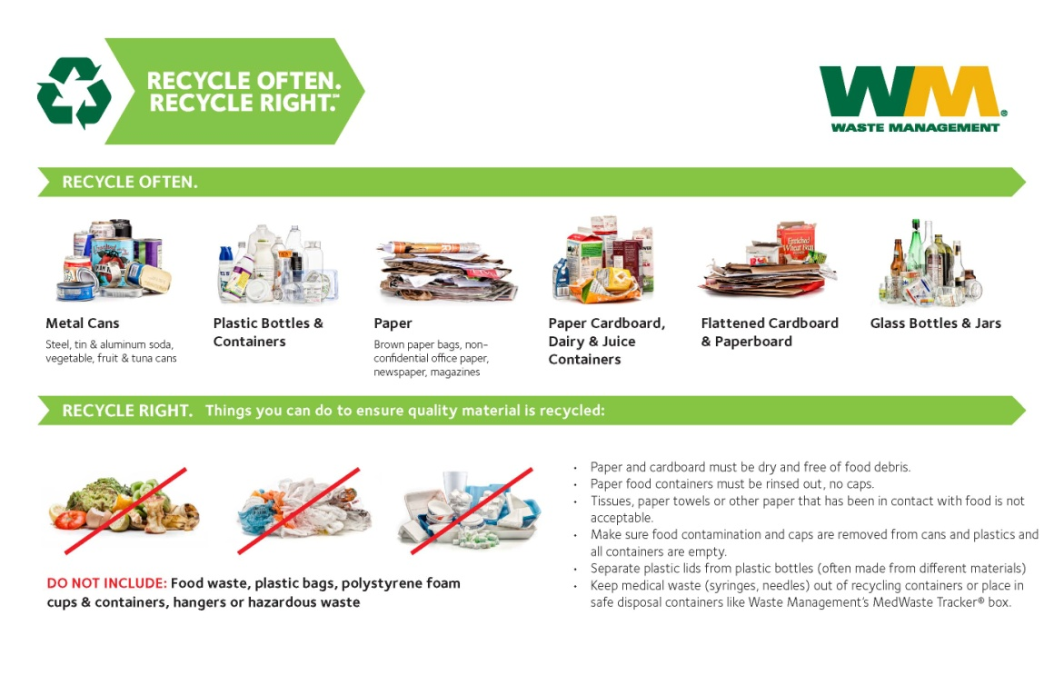Figure 1

* 1. Michigan Tech creates roughly 1000 tons of trash annually. Of this amount, 15% is diverted from the landfill. This data is reported annually by Waste Management. Independently, we have reviewed invoices from Waste Management which details the tonnage of each pickup of trash and recyclables. The actual total tonnage ranges from 900 ton to 1050 tons and the diversion rate has ranged from ~14% to ~16%. Internal audits of some of the buildings on campus have been performed for 8 week intervals. In these audits the amount of recycled material diverted ranged from 15% in one dormitory to 30% in the Library and Fisher Hall. Additional audits are planned to get a better overall picture of where improvements in recycling could be made.
  2. Michigan Tech has 26 buildings on the main campus including academic buildings, student development complex, and dormitories. The student population is approximately 7000 and has remained relatively constant over the past several years. The Faculty and staff population is approximately 1600.
  3. Waste Management collects our recycled material and decides where to take of for processing. The closest location to Houghton is Eagle Waste in Eagle River Wisconsin, approximately 90 miles. Other locations are Marquette, Michigan which is 100 miles from Houghton, and Bellaire, Michigan which is ~260 miles from Houghton.
  4. The education and outreach program for recycling at Michigan Tech is the responsibility of the Executive Director of Sustainability. Working closely with Facilities Management flyers are placed in strategic locations and on recycle containers to explain what items can be recycled. Incoming students are informed by their Resident Advisors in the dorms of the recycling process. Videos are currently in production to spread the word to students , faculty, and staff to remind them that we have a recycling program, and it starts with them.
  5. Houghton has a group of individuals named the Copper Country Recycling Initiative (CCRI). They provide suggestions and assistance to local communities that want to increase recycling. Michigan Tech students, faculty, and staff attend their meetings and we cooperate with them on special recycling initiatives. The most recent was an e-waste event held last fall in cooperation with MTU, Goodwill Industries, Compuserve, and DEQ. CCRI also assisted MTU in identifying where recycle containers were located throughout the 26 buildings on campus. From this information, we have determined where we could use more recycle containers.
  6. The funding source for Michigan Tech’s recycling program is though the Facilities Management (FM) budget which is part of the General Fund allocations. FM hires about 20 students to drive the truck and empty the 95 gallon recycle bins in the recycle compactors. They also assist with the placement of and service of recycle containers for special campus events.

1. Planned Recycling Program- The single stream recycling program at Michigan Tech will remain the same as above. The only exception is that we will increase composting.
   1. The items to be purchased with this grant include an industrial sized composter which has the capacity to reduce 250 pounds of food waste to about 25 pounds of compost daily. We will also purchase additional recycle containers of various sizes for the campus community. The new recycle containers will range in size from 3 gallons for dorm rooms and offices, 50 gallons for central office locations, and 95 gallons for the campus mall and special events.
   2. The infrastructure items will be owned by Michigan Tech.
   3. The collection method is single stream for our recyclables. The collection method for food waste will be by dining service staff in the Wadsworth Dining Hall. The food waste will be processed by the Ecovim composter. Rather than disposing of this compost it will be stored on campus for use in the campus gardens.
   4. The volume of containers to be purchased will range from 1 to 94 gallons.
   5. Collection frequency is daily on campus and weekly from our waste and recycle hauler.
   6. The list of recycle material is the same as above. The organic material will be food waste from student breakfast, lunch, and dinner plates as well as waste from food preparation.
   7. Waste Management in Houghton, MI is our recycle hauler and collects our recycled material and decides where to take of for processing. The closest location to Houghton is Eagle Waste in Eagle River Wisconsin, approximately 90 miles. Other locations are Marquette, Michigan which is 100 miles from Houghton, and Bellaire, Michigan which is ~260 miles from Houghton.
   8. Our goal is to increase recycling from 15% to 25% by brining attention to our recycling program in many ways including additional recycling bins, providing temporary bins for special events on campus during the year in areas where recycle bins are not normally place due to space or inclement weather. The calculation of our diversion rate is provided by Waste Management and can be verified by auditing our invoices. Recycled material and waste are measured in tons. We will also be able to count the compost material at the rate of approximately 250 pounds per day that we previously disposed of as waste. Our goal is that this will increase our diversion rate to 30%.
   9. In addition to bins, a marketing campaign is currently underway to “train the trainers” on the existence of our recycling program with increased signage, video training for students, faculty, and staff, as well as training of dorm hall Resident Advisors. Audits of individual buildings and dorms have been performed for a few of our buildings. Additional buildings and dorms will be audited to increase awareness. Of individual building diversion rates. We plan to use the Recycle, MI logos on our education and outreach material
   10. We are fortunate to have community support for our recycling initiative with the Copper Country Recycling Initiative (CCRI). With their help we have found a legal and local e-waste collection service.
   11. Recycling at Michigan Tech will continue and grow beyond the grant timeline.
2. The evaluation of this project will be monitored monthly be reviewing Waste Management invoices noting our diversion rate and also weighing the amount of compost material we process daily. Success will be measured by increasing our diversion rate. An attempt will be made to determine participation rates in our dorms and in our buildings through surveys. A final report will be written after the new systems are in place and in accordance with the grant timeline requirements.
3. The results will be shared with the campus community on our website in our Sustainability section <https://www.mtu.edu/research/about/areas/energy-sustainability/> . We will also publish results in our Tech Today newsletter as well as our student paper, the Lode.