# Annual Comparison by Site

## Annual Comparison by Site - All Sources

|  |  |  |
| --- | --- | --- |
|  | **t CO2e, GHG, All** | |
|  | **2019** | **2020** |
| Langara College |  |  |
| Stationary Energy Use | 1,374 | 1,269 |
| Mobile Energy Use | 1.65 | 1.77 |
| Office Paper | 115 | 33.8 |

*Calculated: 05.05.2021 14:21, Cache: 05.05.2021 02:00*

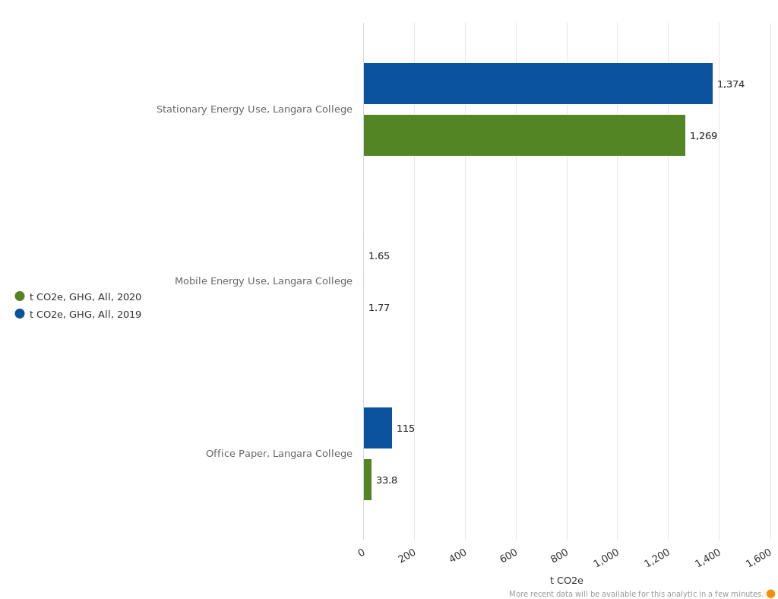

## Annual Comparison by Site - Stationary Fuels

|  |  |  |  |  |
| --- | --- | --- | --- | --- |
|  | **GJ** | | **t CO2e, GHG, All** | |
|  | **2019** | **2020** | **2019** | **2020** |
| Langara College |  |  |  |  |
| Natural Gas (Standard) | 25,152 | 23,562 | 1,254 | 1,175 |
| Electricity - BC - Integrated Grid - BC Hydro | 39,982 | 31,349 | 120 | 94.0 |

*Calculated: 05.05.2021 14:21, Cache: 05.05.2021 02:00*

## Annual Comparison by Site - Mobile Fuels

|  |  |  |  |  |  |  |
| --- | --- | --- | --- | --- | --- | --- |
|  | **kg** | | **l** | | **t CO2e, GHG, All** | |
|  | **2019** | **2020** | **2019** | **2020** | **2019** | **2020** |
| Langara College |  |  |  |  |  |  |
| Diesel Mobile Use |  |  | 120 | 120 | 0.346050 | 0.346050 |
| Gasoline Mobile Use |  |  |  | 600 |  | 1.43 |
| Propane Mobile Use | 434 |  | 850 |  | 1.30 |  |

*Calculated: 05.05.2021 14:21, Cache: 05.05.2021 02:00*

## Annual Comparison by Site - Office Paper

|  |  |  |  |  |
| --- | --- | --- | --- | --- |
|  | **unit** | | **t CO2e, GHG, All** | |
|  | **2019** | **2020** | **2019** | **2020** |
| Langara College |  |  |  |  |
| 8.5 x 11 Paper | 19,600 | 5,696 | 111 | 32.3 |
| 8.5 x 14 Paper | 330 | 90.0 | 2.40 | 0.647744 |
| 11 x 17 Paper | 135 | 78.0 | 1.57 | 0.923357 |

*Calculated: 05.05.2021 14:21, Cache: 05.05.2021 02:00*

## Annual Comparison by Site - Fugitive

|  |  |  |  |  |
| --- | --- | --- | --- | --- |
|  | **kg** | | **t CO2e, GHG, All** | |
|  | **2019** | **2020** | **2019** | **2020** |
| Langara College |  |  |  |  |

*Calculated: 05.05.2021 14:21, Cache: 05.05.2021 02:00*