**EMERSON**

**ECO-REPS**

MANUAL

Office of Sustainability

Welcome to Emerson Eco-Reps

Emerson Eco-Reps promote campus sustainability through peer-to-peer education, outreach and awareness. By informing their peers and leading activities within residence halls, academic departments, athletics, and off-campus living, Eco-Reps drive Emerson’s commitment to sustainability.

The work of the Eco-Rep program is based on the value of individual, day-to-day change in improving our relationship with the environment. Currently, the Eco-Rep program includes all of Emerson’s residential halls and campus populations and is recognized as an influential student group on campus.

As an Eco-Rep, you will become a sustainability leader on campus by increasing your own environmental literacy and educating your peers. You will build foundational knowledge surrounding sustainability issues and discuss how to best raise awareness of these issues among your peers. While increasing overall campus awareness of environmental, economic and social justice issues, the Eco-Rep program advances environmentally responsible campus initiatives such as energy efficiency, recycling and composting, sustainable food, and efficient resource use.

Eco-Reps Mission:

The Eco-Reps work to bring environmental awareness to the Emerson community through events, activities and campaigns.

Eco-Reps Structure:

**On-Campus Eco-Reps:** Students living in the Residence Halls apply for the Eco-Rep position of their Residence Hall through Emerson Student Employment. There are 6 On-Campus Eco-Reps that are appointed as follow: Piano Row (2), the Little Building (2), the Colonial Building (2), and the Paramount Center (2).

Eco-Reps meet weekly with Emerson’s sustainability coordinator to discuss campus sustainability issues and goals, plan activities and events for campus housing, and share challenges, solutions, and successes towards raising awareness.

Eco-Reps Letter of Support

Congratulations on becoming an Emerson College Eco-Rep! By applying for being selected to be an Eco-Rep, you have shown your dedication to and passion for improving the world around you.

The Office of Sustainability is excited to see how you will develop the Eco-Rep program to encourage and support your peers to make more environmentally responsible decisions in their everyday lives on campus. We hope you view the Eco-Rep position not only as an opportunity to be an integral part of Emerson’s sustainability goals, but also an opportunity to develop yourself as a program organizer, marketing coordinator, and leader in the community.

You have the unique role of teaching peers how they can become responsible citizens. The knowledge and training you will impart to your fellow on- and off-campus students will leave a lasting positive impression which will lay the foundation for lifelong behavior changes.

We look forward to working with you over the coming months to as you help make Emerson cleaner, greener and healthier for us all.

Sincerely,

Amy Elvidge

Sustainability Coordinator

Duncan Pollock

Assistant Vice President of Campus Services

Erik Muurisepp

Associate Dean of Housing and Residence Life

Table of Contents

WELCOME TO ECO-REPS 3

Eco-Reps Letter of Support 4

Commitment and Expectations 5

RESOURCES FOR EMERSON ECO-REPS 7

Tools 8

Events 9

Programming Ideas 11

Being an Effective Eco-Rep 12

Key Contacts 13

SUSTAINABILITY AT EMERSON COLLEGE 15

Green Building 16

Energy at Emerson 17

Recycling & Composting at Emerson 20

Water at Emerson 23

Food at Emerson 26

Transportation at Emerson 28

Consumerism at Emerson 29

GLOSSARY 31

Commitment and Expectations

**General responsibilities:**

* Attend bi-weekly Eco-Rep meetings
* Attend Eco-Rep offsite learning trips: [Save that Stuff](http://www.savethatstuff.com/) plant in Charlestown, [Veolia Plant](http://www.veolianorthamerica.com/en/boston-cambridge-mass) in Cambridge, [Arnold Arboretum](http://www.arboretum.harvard.edu/) in Jamaica Plain, and [ReVision Urban Farm](http://www.vpi.org/revision/) in Dorchester
* Serve as representative for Office K-Cup recycling program and regularly collect K-Cups for recycling (biweekly)
* Bring collected plastic bags from Little Building lobby to Whole Foods Ink Block for recycling
* Assist in the planning and execution of Eco-Rep events
  + RecycleMania events including the Pledge, Office Competition and Residence Hall Competition
  + Cirque de De-Stress
  + Move-Out Shop & Swap
  + LED Bulb Swap
  + St. Francis House Food Donations
  + Green Gala Film Competition
* Promote sustainability-related events on and off-campus via social media, classroom announcements and posters
* Be available for student inquiries via email and in person
* Send out emails, Facebook events and Facebook posts/messages to update peers about sustainability initiatives at Emerson and beyond
* Collaborate with other sustainability-related student groups, fellow students, and departments to integrate sustainability initiatives into existing events

**Residence-life specific responsibilities:**

* Put on introductory meeting at first Residence Hall Council meeting for your residence hall
* Attend one Residence Hall Association (RHA) meeting per month
* Attend one OHRL meeting per month and present Eco-Rep agenda
* Meet once per month with Residence Director of your residence hall to present Eco-Rep agenda and coordinate collaborative efforts
* Work with Hall Council and RHA members, RA’s and RD’s to make activities more eco-friendly
* Lead one initiative on your floor to promote sustainability and environmental awareness (you may partner with RA or get the staff support of another Eco Rep)
* Encourage participation in the Emerson Green Room Certification (GRC) and present GRC certificates to certified residents
* Notify sustainability coordinator when Residence Hall K-Cup collection bins are full

**RESOURCES**

for Emerson Eco-Reps

Tools

Green Room Certification

The Green Room Certification program allows students to assess how ‘green’ they are and work towards improving their environmental footprint. Students can participate by filling out a checklist online and certification awarded to students who meet criteria outlined in the checklist. Students can earn one of two certification levels based on the number of points they receive: Level I (65 pts) and Level 2 (100 pts).

Why participate?

* Reduce your impact on the environment.
* Help Emerson achieve its goal of being carbon neutral by 2030.
* Learn to save money by cutting energy and water use and changing consumption habits.

Prizes

* Receive a certificate celebrating your achievement to display on your door.
* Gain entry into the biannual Green Room Certification Raffle to win $50 to a sustainability-related store of your choice (Patagonia, Fjallraven, LL Bean, Whole Foods, Apple).

Certified Level II participants get entered twice

* Earn a Chipotle or sweetgreen party for your residence hall floor! When half or more of the rooms on your floor have been certified, the Office of Sustainability will treat the whole floor to dinner.

Green Apartment Checklist

The Green Apartment Checklist provides off-campus students with environmentally-focused questions to ask landlords before choosing their next apartment or house.

Office of Sustainability Calendar

The [calendar](http://www.emerson.edu/about-emerson/sustainability-emerson/community/calendar) features sustainability-related events on campus and in the community.

Recycling at Emerson

Learn what you can [recycle at Emerson](http://www.emerson.edu/about-emerson/sustainability-emerson/recycling-composting), including single stream recycling, plastic bags, k-cups, personal care & beauty products, ink cartridges, batteries, light bulbs, and electronic waste (e.g. computers, wires, cell phones, etc.)

Eco-Reps are in charge of collecting the plastic bags from students, staff and faculty in the Little Building Lobby and taking them to Whole Foods for recycling.

Eco-Reps also collect used k-cups from participating offices during the academic year.

For more information about recycling off-campus, please see the links for [Boston](http://www.cityofboston.gov/publicworks/wastereduction/curbside.asp) (includes Allston, Brighton, Jamaica Plain, Hyde Park, Roxbury, Mattapan, Dorchester, South Boston, East Boston, and Charlestown), [Cambridge](https://www.cambridgema.gov/theworks/ourservices/recyclingandtrash), [Somerville](http://www.somervillema.gov/trash), and [Brookline](http://www.brooklinema.gov/1239/Brookline-Sanitation-Recycling).

Maintenance Requests

For all maintenance requests on campus such as a broken lightbulb, leaky faucet, temperature problem, or lost keys, please [place a work order](http://www.emerson.edu/facilities-management).

Events

RecycleMania

[RecycleMania](http://recyclemaniacs.org/) is an annual friendly competition between colleges and universities across the US and Canada. Over an 8-week period each spring, colleges report the amount of recycling, compost and trash collected each week.

RecycleMania Survey + Pledge

The [RecycleMania Survey](http://www.emerson.edu/recyclemania-survey) serves to educate students, staff and faculty on recycling at Emerson and assess their waste habits and needs. After completing the survey, participants can take the [RecycleMania Pledge](http://www.emerson.edu/recyclemania-pledge) to commit to recycling more. Pledge entries are entered into a weekly raffle for prizes. The Pledge is online and can be accessed at any time, prizes are awarded on Fridays at 3pm.

RecycleMania Office Competition

The [Office Competition](https://www.emerson.edu/about-emerson/sustainability-emerson/waste-reduction/recyclemania) is open to all Emerson offices and lasts one work week. Participating offices are given additional signage to promote recycling and the total office trash and recycling are measured twice during the week (Wednesday and Friday). The office with the highest recycling rate per capita wins a catered lunch from Whole Foods Market.

RecycleMania Residence Hall Competition

The [Residence Hall Competition](https://www.emerson.edu/about-emerson/sustainability-emerson/waste-reduction/recyclemania-residence-hall-competition) takes place in the all residence halls and lasts one week (Sunday-Saturday). The trash and recycling are visually measured every day before waste collection. The floor with the highest recycling rate per capita wins 3-day passes to Equinox luxury gym in the Ritz Carlton. The building with the highest recycling rate per capita wins the opportunity to design the ‘meal of their dreams’ with Dining Hall Chefs.

RecycleMania Basket Ball Game

The Men’s Emerson vs. MIT basketball game is RecycleMania themed and includes a fun and interactive waste management half time show, prizes and recycling facts.

Earth Hour

[Earth Hour](https://www.earthhour.org/) is a worldwide movement for the planet organized by the World Wide Fund for Nature (WWF). The annual event is held worldwide on one day in March and encourages participants to turn off non-essential lights for one hour, from 8:30 to 9:30pm, as a symbol of their commitment to the planet.

Cirque de De-Stress

The [Cirque de De-Stress](http://www.emerson.edu/library/cirque-de-de-stress) is a biannual event held during finals week in the library. The event is a collaboration with many offices and departments. The Eco-Reps have a table at the event and promote sustainability with fun and environmentally-conscious gifts.

LED Bulb Swap

The LED Bulb Swap is sponsored by Needham Supply Electric Company, who provide free LED bulbs to the Emerson Campus. Visitors are encouraged to bring their old dead bulbs to trade in. LED bulbs last ~21 years and are much more energy efficient. The event is held in the Campus Center lobby.

Move-Out Shop & Swap

The Move-Out Shop & Swap is held in one common room in each residence hall during move out week. The Shops are open for students to donate quality items that they no longer want and for students to come and ‘shop’ the items there. The Shops are organized by category and items collected are: Clothing & Shoes, Bedding & Linens (no mattress pads), Appliances, Storage & Shelving, Kitchen & Dining, Lamps & Lighting, Books, and Personal Care Items (nearly full).

Quality items are only excepted (something you would give to a friend) and broken items and food are not allowed.

Leftover items are donated to St. Vincent De Paul, American Red Cross, the Pine Street Inn, and More Than Words.

St. Francis House Food Donations

In partnership with the Sodexo Catering Services, the Eco-Reps help package and transport leftover food from events to the St. Francis House for donation. Events occur throughout the year and all donations are to be recorded by date and number of trays donated.

Green Gala and Film Competition

The Green Gala is an annual event held on or around Earth Day to celebrate the earth through student performance, sustainable food, and environmentally-conscious fashion. The event is open to the Emerson Community and surrounding colleges and is held in the Paramount theater. Tickets can be purchased for $5 in-person at the Paramount Center Box Office. The winning performance and the winning film are both judged by professionals in the field and each win $1,000 cash prize.

Eco Reps help organize and promote the event. Additionally, the Eco Reps have a table to interact with students and bring awareness to campaigns.

The Eco Reps sponsor the Film Competition for the Green Gala. The Film focuses on what Emerson is and could be doing on campus to be more sustainable and acts as an education piece for new students. The Film is to last 2-3 minutes and is critiqued based on the judges’ discretion.

Programming Ideas

We can always use more sustainability events during the year! You are encouraged to network with other organizations to start news events and collaborate on existing ones. There’s always room for a green touch.

* Talk to students about environmental issues
  + In Residence Hall Council meetings
  + In Greek Chapter meetings
  + In Class
* Bike or walk to the [Boston Public Market](https://bostonpublicmarket.org/), the [Copley Farmers’ Market](http://www.massfarmersmarkets.org/FMFM_MARKET1.aspx?MKTID=41), or the [Dewey Square Farmers’ Market](http://www.farmfresh.org/food/farmersmarkets_details.php?market=69) for delicious local fare.
* Rent a [Hubway Bike](https://www.thehubway.com/) and ride along the [Charles River Esplanade](http://www.esplanadeassociation.org/) or take your own bike for a ride on the [Minute Man Trail](http://minutemanbikeway.org/) for a trip out to historic Arlington, Lexington and Concord.
* Update your wardrobe by hosting a clothes swap with other students to swap for new looks.
* Volunteer with the [Trustees of the Reservation](http://volunteer.thetrustees.org/) to help maintain farms, gardens, houses and trails.
* Rent a [Zipcar](http://www.zipcar.com/universities/emerson-college) vehicle for a group outing to visit the beautiful [Arnold Arboretum](http://www.arboretum.harvard.edu/) or hike in the nearby [Blue Hills Reservation](http://www.mass.gov/eea/agencies/dcr/massparks/region-south/blue-hills-reservation.html).
* Take the T to celebrate in the [Wake Up the Earth](http://www.spontaneouscelebrations.org/) festival and parade in Jamaica Plain. Get ready for powerful performances and an array of earth-friendly craft, non-profit and food vendors.
* Take the T on a green restaurant tour in one of Boston’s many neighborhoods. Check out this [Yelp page](http://www.yelp.com/search?find_desc=Organic+Healthy+Restaurants&find_loc=Boston%2C+MA) to hear about others are raving about.

**Advertising Tips for Events**

* Make classroom announcements with instructor approval
* Post ads in the Campus Center by contacting Director [Joshua Hamlin](http://www.emerson.edu/campus-center/building-staff)
* Post ads in the Dining Hall by contacting [Business Services](http://www.emerson.edu/business-services)
* Get featured in the Berkeley Beacon (contact early on and be prepared to be interviewed)
* Facebook/Tweet the events to student groups
* Hang up posters on campus bulletin boards and distribute flyers with [Student Life](http://www.emerson.edu/campus-center/campus-center-offices) stamp of approval
* [Book a Table](http://www.spacebook.com/) in the Piano Row Campus Center or outside the Little Building Dining Hall
* Chalk up he Boylston and Tremont sidewalk with approval from [Property Management](http://www.emerson.edu/property-management)

How to be an effective Eco-Rep

(adapted from the [Northwestern University Eco-Rep Handbook](https://issuu.com/allison.potteiger/docs/eco-rep_handbook_2012-2013))

Network – Make you and your event more visible by working with other people and campus groups. Working with others increases attendance, fosters support, expands resource capacity and creates relationships.

Be Resourceful – Try to reuse materials and host zero waste events. Ask others about how they effectively advertise and host successful events while producing little trash.

Repeat, Repeat, Repeat – Help others form good habits by repeating messages and events to encourage behavior changes.

Innovate – Bring sustainability into your classwork. Spread environmentally-inspired messages to your colleagues and instructors.

Be Unique – What will get your message noticed? Get outside the box by using art, working with prominent people, or interacting with others to create an exciting and interesting experience.

Be Positive – Engage your peers in healthy and respectful conversations. Encourage others to keep up the good work or make small changes without lecturing or chastising.

Be Smart – Look for ways that sustainability plays out in our everyday lives. Find connections between the larger issues of climate change, resource abuse and landscape degradation and everyday actions. Highlight these linkages in conversations and during events.

Be a People Person – Get to know your neighbors and make friends. Peers will listen and learn from you if you have a relationship with them.

Be Curious – Learn what’s going on around you and share with others. Where does our energy come from and where does our trash go? How about our food and furniture? What is Emerson doing that makes us an environmental leader? How can we improve?

Identify Barriers – What is holding peers back from participating in eco-friendly behavior? Is it lack of knowledge, opportunity, interest, time, money or motivation? How can you help address break these barriers to improve our campus?

Key Contacts

Office of Sustainability

Amy Elvidge – Sustainability Coordinator and Eco-Reps Advisor

Phone: 617-824-8994

[Amy_elvidge@emerson.edu](mailto:Amy_elvidge@emerson.edu)

Save that Stuff (Recycling, Compost & Trash Hauler)

617-241-9998

[info@savethatstuff.com](mailto:info@savethatstuff.com) and [www.savethatstuff.com](http://www.savethatstuff.com)

Facilities Management

Office Phone: 617-824-8645

Place a work order: facilities.emerson.edu

Campus Center

Office Phone: 617-824-8680

[campuscenter@emerson.edu](mailto:Joshua_hamlin@emerson.edu)

Student Life

Office Phone: 617-824-8637

[studentlife@emerson.edu](mailto:studentlife@emerson.edu)

Housing and Residence Life

Office Phone: 617-824-8620

[reslife@emerson.edu](mailto:reslife@emerson.edu)

Off-Campus Student Services

Office phone: 617-824-7863

[ocss@emerson.edu](mailto:ocss@emerson.edu)

Emerson Dining/Sodexo

Office phone: 617-824-8060

[foodservice@emerson.edu](mailto:foodservice@emerson.edu)

Student Government Association

[SGA_President@emerson.edu](mailto:SGA_President@emerson.edu)

Earth Emerson

Natalia Meneses – Chair

[Natalia_meneses@emerson.edu](mailto:Natalia_meneses@emerson.edu)

City of Boston Office of the Environment

Office Phone: 617-635-3850

[environment@cityofboston.gov](mailto:environment@cityofboston.gov) and [www.cityofboston.gov/environment](http://www.cityofboston.gov/environment)

**SUSTAINABILITY**

at Emerson College

Green Building

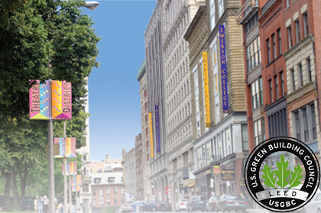

Emerson College is committed to sustainable design and environmental best practices across its campus infrastructure. Our new buildings are built to strict environmental standards and our existing buildings are regularly upgraded.

Located in the famous theater district alongside the Boston Common gardens, Emerson’s buildings retain historic charm while being the some of the greenest in the neighborhood.

**Emerson aims for all of its campus buildings to meet the internationally recognized** [**LEED**](http://www.usgbc.org/leed) **(Leadership in Energy and Environmental Design) standards.**

[Piano Row](http://median.emerson.edu/player.php?mid=3714) (150 Boylston Street)

One of the first educational buildings in the city of Boston to receive LEED Certification for new construction, Piano Row is LEED Silver and houses the [Living Green Floor](http://www.emerson.edu/housing-dining/learning-communities/living-green), a floor devoted to environmental awareness and sustainability.

The [Colonial Building](http://www.emerson.edu/news-events/emerson-college-today/emerson-recognized-green-practices) (100 Boylston Street)

This LEED Gold building features conscious materials made from recycled content and manufactured locally.

The [Paramount Center](http://www.emerson.edu/housing-dining/residence-halls/paramount-center) (559 Washington Street)

Nestled in the heart of Boston's historic Theatre District, the Paramount is a first-of-its-kind mixed-use residential, academic, and performance venue. The Paramount Center was built with sustainable best practices and strict environmental code while preserving the historic facade. Plans are underway to install a roof-top garden on the Paramount to restore green space in the city center and serve as a model of urban agriculture.

The [Little Building](http://www.emerson.edu/housing-dining/residence-halls/little-building) (80 Boylston Street)

Originally constructed in 1917, the Little Building is being upgraded to LEED Gold by 2019.

Emerson's [Los Angeles campus](http://www.emerson.edu/ela/facility)

Located on Sunset Boulevard in Hollywood, ELA is Emerson's newest addition and serves as a novel icon in LA architecture. The LEED Gold campus has rooftop solar panels to heat hot water for the entire complex, an automated temperature and sunshade system connected to weather stations, and a valence system to provide radient heating and cooling in each dorm room.

Upcoming: 2 Boylston Place

Emerson's newest building at 2 Boylston Place is scheduled to be completed as LEED Gold by 2017.

Energy at Emerson

**Our Yearly Energy Profile**

|  |  |  |  |
| --- | --- | --- | --- |
| Source | Avg. consumption  (MMBTU) | Cost  (US dollars) | CO2 emissions (metric tons) |
| Electricity | 72,000 | $3,000,000 | 6,900 |
| Natural Gas | 26,000 | $420,000 | 1,400 |
| Steam | 45,000 | $1,300,000 | 3,300 |
| **Total** | **143,000 MMBTU** | **$4,720,000** | **11,600 metric tons** |

Emerson College uses roughly 143,000 million British thermal units (BTUs) of energy annually—costing the college about $4.7 million dollars and releasing 11,600 metric tons of carbon dioxide (or 255,664,000 pounds) into the atmosphere. Emerson’s energy consumption *is equivalent to that of 1,300 average homes* in the United States.

Emerson is continuously working to improve energy efficiency in buildings and even offsets 114% of electricity consumed by purchasing renewable energy credits and promoting the wind energy market. We purchase a surplus of wind energy certificates to offset additional leased property in Boston, the new facility in Los Angeles and the upcoming 2 Boylston Place building. The College purchases its renewable energy certificates (RECs) from [Renewable Choice Energy](http://www.renewablechoice.com/).

Emerson continues to be one of the largest purchasers of Green Power among U.S. colleges and universities and is recognized as a leader by the [U.S. EPA’s Green Power Partnership](http://www3.epa.gov/greenpower/).



* Emerson ranks as the [No. 24](https://www.epa.gov/greenpower/green-power-partnership-top-30-college-university) largest green power user for 2015-16.
* Emerson College has been recognized by the EPA for using more green power than any other school in the New England Women’s and Men’s Athletic Conference (NEWMAC) in the 2014–2015 academic year.

**Energy Efficiency**

* Campus updated to energy-efficient lighting.
* Campus-wide, motion detectors have been installed in offices so overhead lights shut off automatically when people leave the rooms.
* The College purchases Energy Star-rated computers and other appliances whenever possible.
* The majority of campus buildings are heated using [Veolia’s “green steam” system](http://www.veolianorthamerica.com/en), reducing their carbon footprint.

Energy Use Tips

* **Swap bulbs**: trade your incandescent bulbs for LED or CFL bulbs which use 75% less energy.
* **Turn out the lights**: leaving a room for more than 5 minutes? Shut the lights. And use natural sunlight when possible.
* **Buy Energy Star**: get everything from TV’s to computers to mini fridges with the label for maximum energy savings.
* **Beware of Vampire Power**: electronics suck power even when off or on standby/sleep mode. Turn off and unplug electronics, even chargers! Or better yet…
* **Get a Power Strip**: plug your items into a power strip or smart strip to prevent vampire energy and then turn off everything at once.
* **Be a Power Manager**: update your laptop’s power management settings to reduce energy consumption and prolong battery life (see [Windows](https://www.energystar.gov/products/low_carbon_it_campaign/power_management_computer/windows_7) and [Mac](https://support.apple.com/en-us/HT201714)).
* **Climb the Stairs**: skip the elevator and take the stairs.
* **Keep Windows Tight**: Close windows when heat and A/C are on and report drafts and leaks to [facilities](http://www.emerson.edu/facilities-management).
* **Shorten Your Shower**: keep showers to 5 minutes or less.
* **Cold Wash**: wash clothes in cold water to [conserve energy](http://energy.gov/energysaver/laundry) and only do full loads.
* **Share Your Stuff**: share appliances like Keurigs, refrigerators, TVs and printers with roommates to maximize use and minimize energy.

*The energy consumption of [gaming systems](http://wpweb2.tepper.cmu.edu/ceic/index.htm) is close to that of a large refrigerator!

Ways to save:

* + Newer consoles are more energy efficient
  + Play games from the hard drive instead of the disc
  + Turn off (standby) consoles when not in use
  + Use a DVD player instead of a gaming console for watching movies

Power draw during HD video play

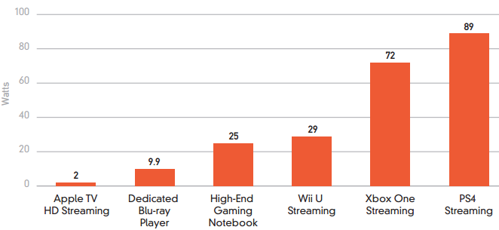

*Source:* [*National Resource Defense Council*](https://www.nrdc.org/sites/default/files/video-game-consoles-IP.pdf)

**How many pounds of CO2 does your stuff generate in 1 day?**

About 25% of all residential energy consumption is used by devices in idle/standby/sleep mode or off.

In the U.S., this uses the equivalent of 50 large power plants’ worth of electricity and costs more than

$19 billion in electricity bills every year.

Overall **electricity production represents 37% of all carbon dioxide emissions** in the U.S., the driving contributor of climate change.

*Numbers are in pounds of CO2 (based on information provided by Lawrence Berkeley Lab and energy.gov)

**Computer equipment** **Kitchen equipment**

|  |  |  |  |
| --- | --- | --- | --- |
| Product | Active | Idle | Off –  plugged in |
| Apple Macbook | 9.6 | 9.6 | 5.2 |
| Desktop computer | 28.8 | 6.5 | 0.38 |
| LCD 15” monitor | 3.8 | 0.2 | 0.2 |
| LCD 19” monitor | 6.7 | 0.2 | 0.2 |
| Inkjet printer | 2.5 | 0.6 | 0.3 |
| All-in-one printer | 3.5 | 1.7 | 1.2 |

|  |  |  |  |
| --- | --- | --- | --- |
| Product | Active | Idle | Off – plugged in |
| Mini-fridge | 5.8 | n/a | n/a |
| EnergyStar mini-fridge | 4.6 | n/a | n/a |
| Microwave | 288 | n/a | 0.6 |
| Toaster | 211.2 | n/a | n/a |
| Keurig | 76.8 | 1.2 | 1.2 |

**Chargers**

|  |  |  |  |
| --- | --- | --- | --- |
| Charger type | Charger plugged in – no device | Charger plugged in – device fully charged | Charger plugged in – charging device |
| Cell phone charger | 0.05 | 0.1 | 0.5 |
| Digital camera charger | 0.08 | 0.08 | 0.6 |
| Toothbrush charger | 0.3 | 0.3 | 0.3 |
| Shaver charger | 0.05 | 0.13 | 0.4 |
| Cordless vacuum charger | 0.15 | 0.7 | 0.9 |

**Entertainment equipment**  **Light bulbs**

|  |  |  |  |
| --- | --- | --- | --- |
| Product | Active | Idle | Off – plugged in |
| TV – average plasma | 57.6 | n/a | 0.2 |
| DVD player | 3.3 | 1.9 | 0.4 |
| Clock radio | 0.4 | n/a | 0.3 |
| Stereo | 4.4 | 3.1 | 1.3 |
| PlayStation | 37.8 | n/1 | 0.2 |
| Xbox 360 | 32.6 | n/a | 0.2 |
| Wii | 3.6 | n/a | 0.2 |
| Apple TV | 4 | n/a | 3.3 |

|  |  |  |  |
| --- | --- | --- | --- |
| Light produced (lumens) | Incan-descent | CFL | LED |
| 450 | 7.7 | 1.3 | 0.4 |
| 800 | 11.5 | 2.9 | 1.3 |
| 1,100 | 14.4 | 3.8 | 2.1 |
| 1,600 | 19.2 | 4.4 | 3.5 |
| 2,600 | 28.8 | 6.7 | 5 |

**Don’t be an energy drain! Plug your appliances into a power strip or**

**smart strip and switch it off when they’re not in use.**

Recycling & Composting at Emerson

Emerson’s average diversion rate into recycling and composting is 25%. We recycle and compost 300 tons of the roughly 1,200 tons of waste generated each year. Emerson is consistently working towards increasing our diversion rate and reducing our overall waste. Recycling significantly reduces greenhouse gases and water pollutants and saves energy compared to making things from raw materials.

There are recycling areas on every residence hall floor and in every classroom and hallway. There are composting bins in all dining areas and in the Little Building Lobby and the Bordy Meeting Room.

Remember, Emerson has single stream recycling, so all plastic, glass, metal, paper and cardboard can go into the same bin. For more information on recycling do’s and don’ts see the [Recycling & Composting page](http://www.emerson.edu/about-emerson/sustainability-emerson/recycling-composting).

**Recycling in the Residence Hall Recycling and Trash Rooms**

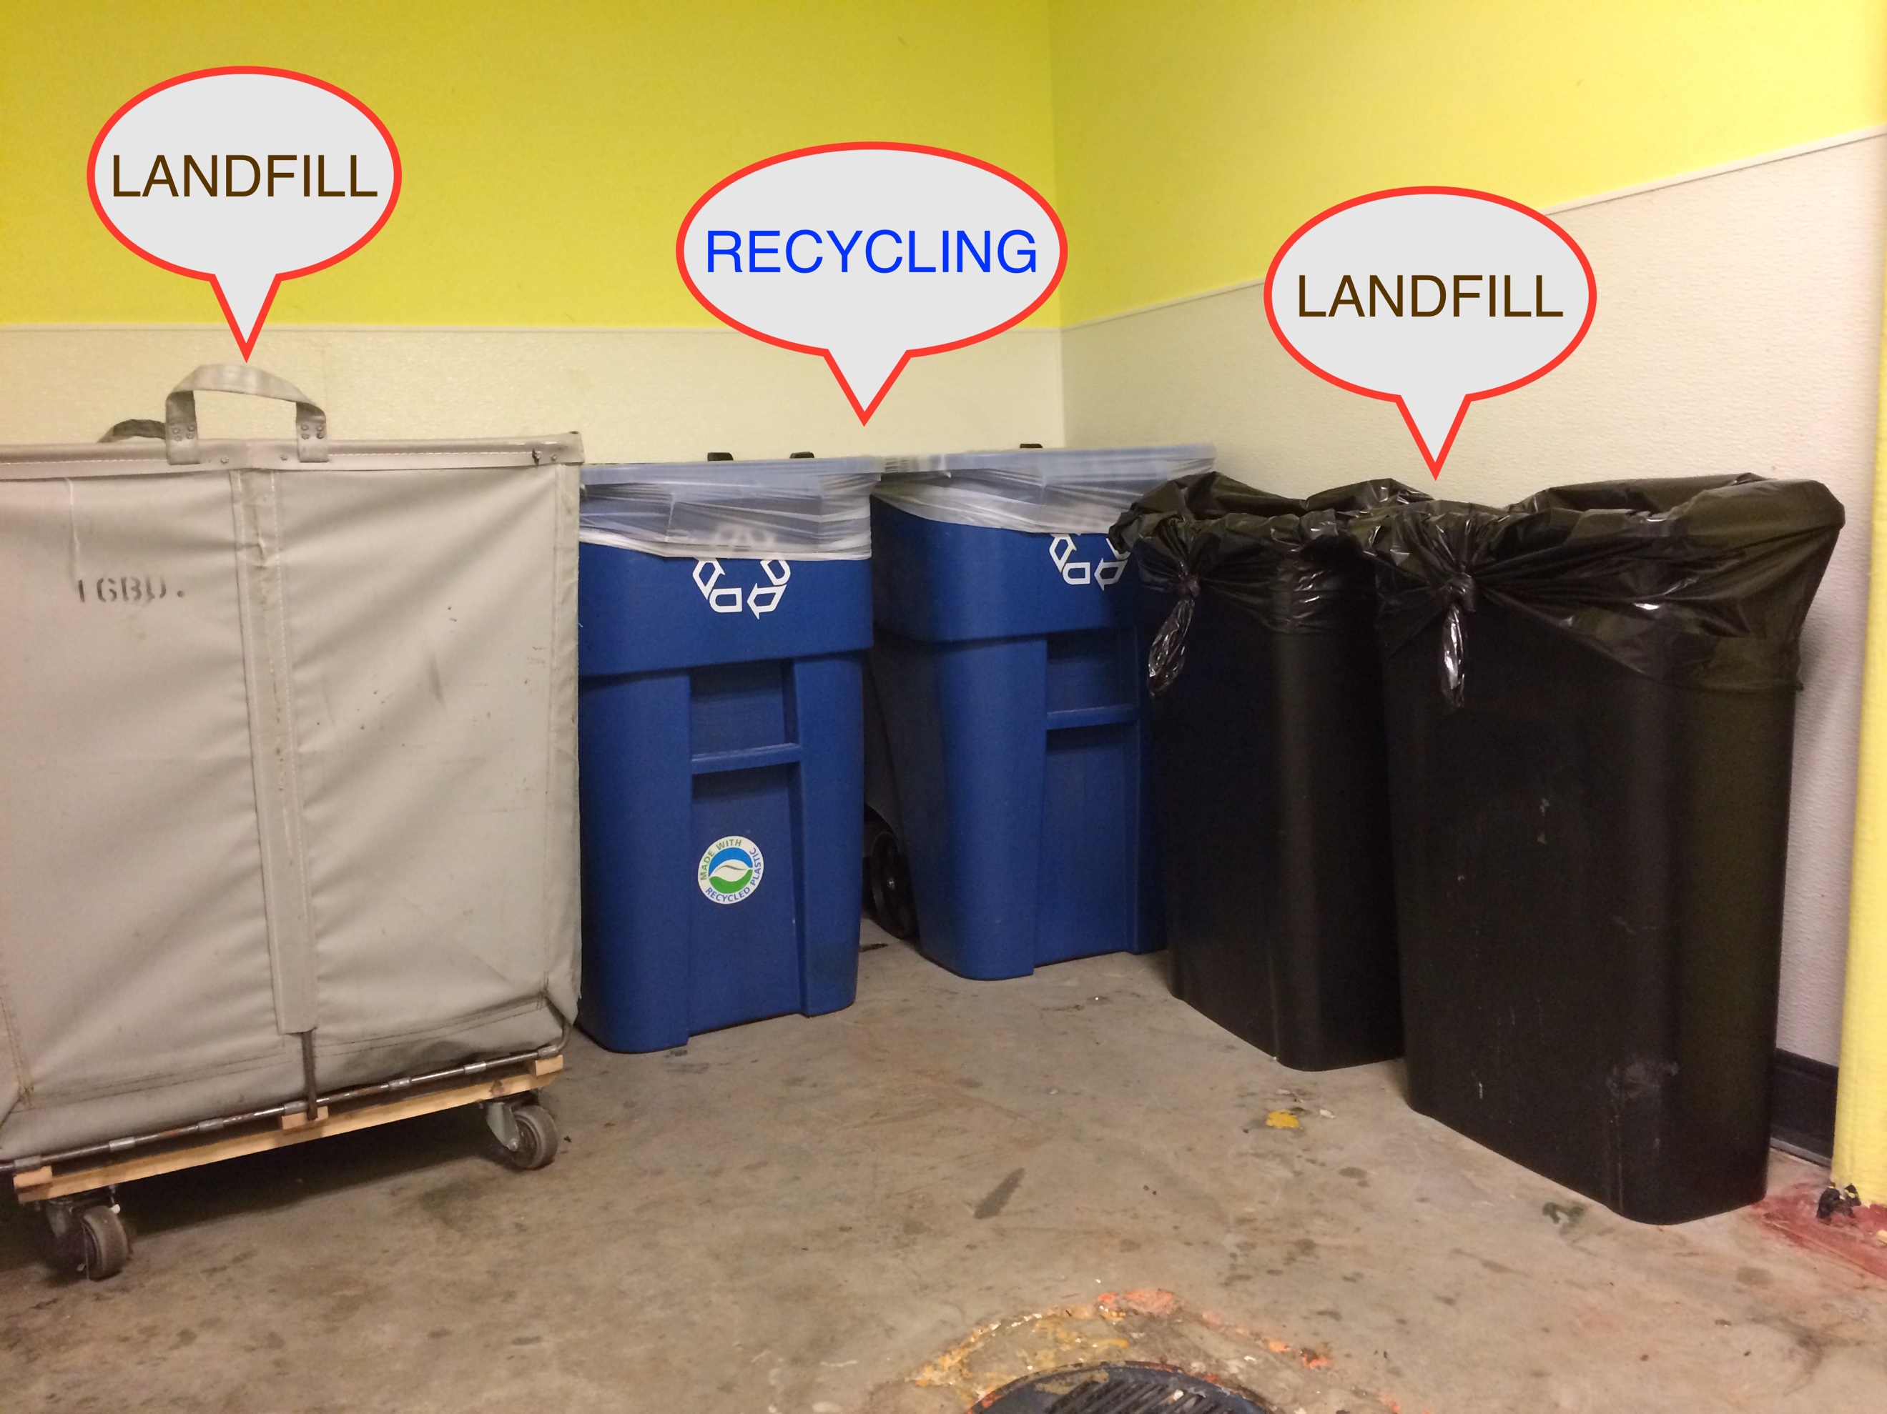

In your room/suite:

* put all landfill waste into black bags
* put all recyclables (paper, plastic, cans/bottles) into clear bags

In recycling/trash rooms:

* put all landfill waste into black/brown bins and hamper
* put all recyclables into blue bins

Batteries & Bulbs

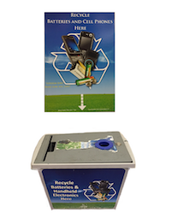

Batteries are collected for recycling in designated blue boxes found in the lobbies of **each** residence hall. Look for the wall poster and the distinctive box below.

Bulbs can be safely disposed of through the help of facilities, please put in a work order to have your bulbs collected. To put in a ticket for a work order, you must sign in to our [work order system](https://connectauth.emerson.edu/adfs/ls/?wa=wsignin1.0&wtrealm=https%3a%2f%2flogin.schooldude.com%2fSSO.STS%2f&wctx=wa%3dwsignin1.0%26wtrealm%3dhttps%253a%252f%252fwww.myschoolbuilding.com%252fsso%252f%26wctx%3dacctnum%253d1491213824%26wct%3d2014-04-07T15%253a26%253a33Z) using your ECNet username and password.

E-Waste

E-waste, or electronic equipment including computers, monitors, printers, used ink cartridges and electronics, can be safely recycled with the help of the[IT Help Desk](https://it.emerson.edu/page/helpdesk/). Please bring your items to the desk to have them safely disposed of or recycled.

Books

Sell your textbooks back to the [Emerson Bookstore](http://emerson.bncollege.com/webapp/wcs/stores/servlet/BNCBHomePage?storeId=35055&catalogId=10001&langId=-1) or donate books to [More than Words](https://www.mtwyouth.org/) to empower disadvantaged youth. Trade books with peers to avoid greenhouse gas emissions associated with shipping books.

Clothes

Donate unwanted clothing to a local charity or save it for the annual move-out Shop & Swap during Spring finals week. Check out this [Yelp page](http://www.yelp.com/search?find_desc=Clothes+Donation&find_loc=Boston%2C+MA) for nearby charities.

Waste Reduction Tips

* Bring reusable bags and containers when shopping, traveling, or packing lunch or leftovers.
* Choose products that are reusable, returnable, or refillable over single-use items.
* Buy in bulk or large containers of items when practical, skip the individually wrapped items, snack pack, and single serve containers.
* Avoid double-packaged items (i.e. individually wrapped items in larger package sold as bulk).
* Buy dish soap and laundry detergent in concentrate forms.
* Compost food scraps, napkins and compostable food packaging in the eateries’ compost bins, in the Little Building lobby or in the Bordy room.
* Stop receiving junk mail by going to [Catalog Choice](https://www.catalogchoice.org/) or [Paper Karma](https://www.paperkarma.com/) and unsubscribing.
* Shop second-hand stores at a low cost to you and the environment.
* Buy items made of recycled content and reuse them as much as you can (i.e. use both sides of paper from a recycled content notebook).
* Make events Zero Waste by encouraging BYO cups, plates and utensils.
* Contact the [sustainability coordinator](http://www.emerson.edu/about-emerson/sustainability-emerson) to get a recycling or compost bin at your next Emerson event.
* Recycle plastic bags in LB lobby and K-Cup capsules in residence hall laundry rooms.

Waste Facts  ***Emerson Waste Audit Results (Nov 2015)***

* Roughly 80% of what we throw away in the U.S. is recyclable, yet the recycling rate is only 30%.
* The average American receives over 30 pounds of junk mail per year.
* Packaging makes up 30% of the weight and 50% of trash by volume for food items.
* Americans throw out 2.5 million plastic bottles every hour. Plastic bottles take 400 to 1000 years to degrade.
* In Boston, we send all of our waste to an incineration plant that makes electricity as a byproduct by [generates harmful toxins](http://www.no-burn.org/downloads/Incinerator_Myths_vs_Facts%20Feb2012.pdf).
* GHGs are generated by waste decomposing in landfills and contributes around 10% of a household’s total emissions.
* Recycling saves energy, money and natural resources.

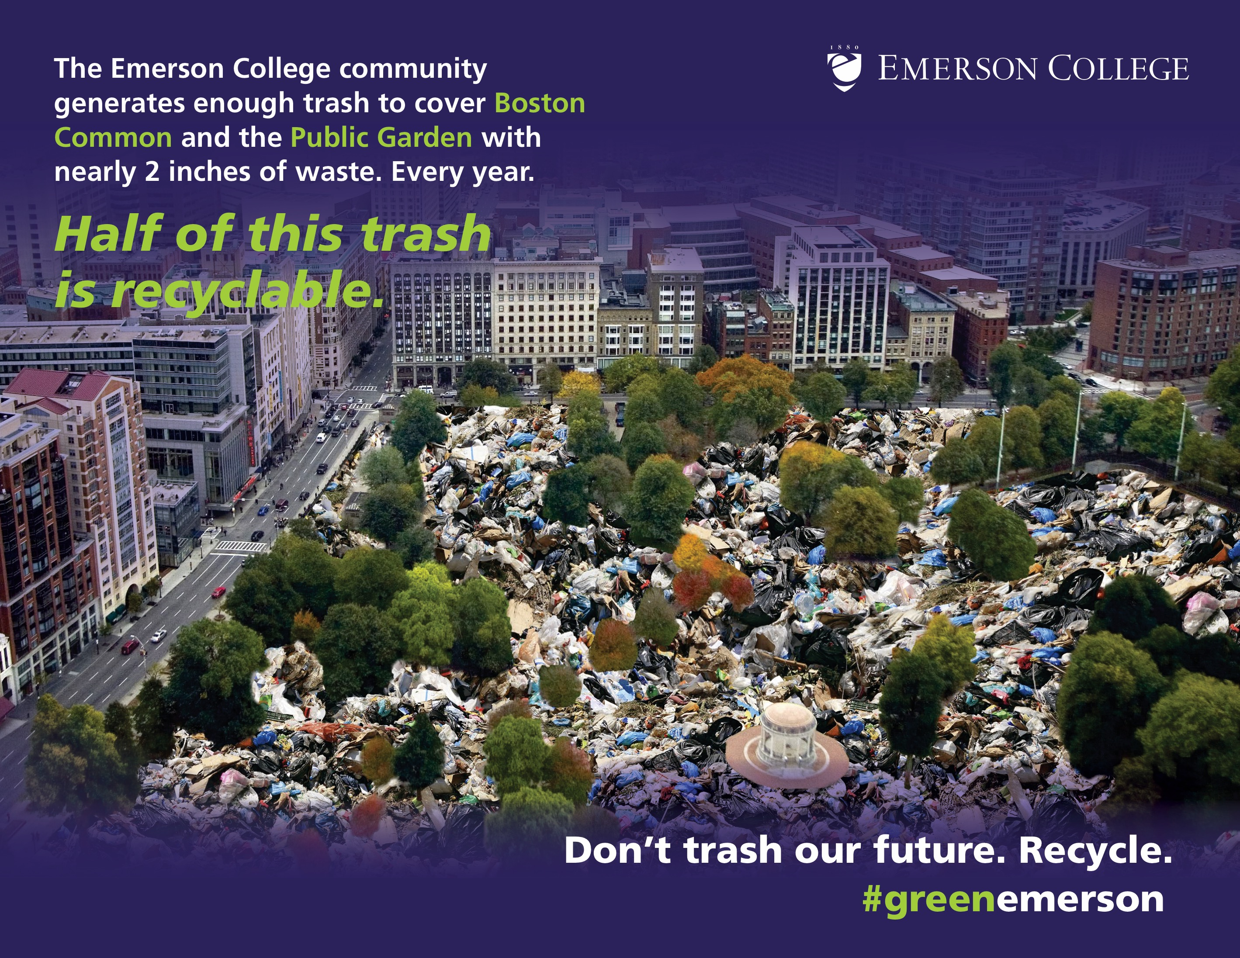

Water at Emerson

Emerson College uses more than 5 million gallons of water each year. While New England gets more precipitation than much of the world, potable water is a scarce and critical resource not to be wasted.

Emerson continually works to conserve water through building infrastructure. Our LEED buildings reduce water consumption by at least 20% from baseline. Hands-free sink faucets, dual-flush and sensor-based toilets, and water efficient shower heads have helped us prevent excess water usage.

Piano Row (150 Boylston) and the Colonial Building (100 Boylston) have rain water capture systems that provides non-potable water for campus, which is used for dorm bathroom toilets. And tray-less dining in Emerson’s Dining Hall saves thousands of gallons of water each week.

Reusable bottle-friendly [Hydration stations](http://www.emerson.edu/about-emerson/sustainability-emerson/waste-reduction) throughout campus eliminate waste associated with disposable bottles and highlight Boston’s excellent public tap water.

**Water Use Facts**

* 780 million people lack access to clean water.
* An American taking a 5 minute shower uses more water than the average person in a developing country uses for a whole day.
* Europeans use half the amount of water that Americans use each day.
* Only 0.3% of the earth’s fresh water is accessible.
* More than 25% of bottled water comes from a municipal water supply—the same place tap water comes from.
* Of all foods, beef and chocolate use the most water to make.

*Source:* [*Environmental Protection Agency*](https://www3.epa.gov/watersense/pubs/indoor.html)

Water Reduction Tips

* Stop all the leakage by reporting leaking faucets and shower heads to [facilities](http://www.emerson.edu/facilities-management)!
* Go on a shower diet—for every minute in the shower[, 3-7 gallons of water are used](https://livegreen.recyclebank.com/water-diet-changing-world). You can save as much as 35 gallons of fresh water by cutting your shower time from 10 minutes to 5 minutes!
* Turn the tap off while brushing teeth and shaving.
* Do full loads of laundry for water and energy savings. You use [25-40 gallons](http://conserve2enhance.org/node/7) of water per load of laundry.
* Every toilet flush uses [~1.6 gallons](http://www.conserveh2o.org/toilet-water-use) of water, don’t flush when you can throw away instead.

**How much water to make your favorite foods?** *(Source:* [*Water Footprint Network*](http://waterfootprint.org/en/)*)*



1,056 gallons water to make 1 gallon brewed coffee

VS.

108 gallons water to make 1 gallon brewed tea

**WINNER: TEA**



296 gallons water to make 1 gallon beer

VS.

872 gallons water to make 1 gallon wine

**WINNER: BEER**



1,847 gallons of water to make 1 lb of beef

VS.

518 gallons of water to make

1 lb of chicken

**WINNER: CHICKEN**

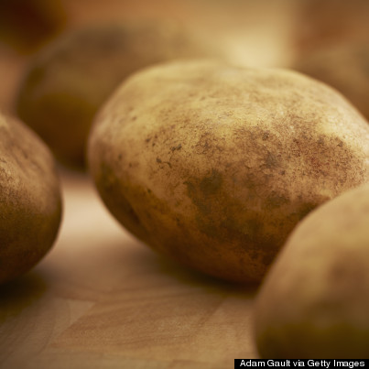

299 gallons of water to make 1 lb of rice

VS.

34 gallons of water to make 1 lb of potatoes

**WINNER: POTATOES**

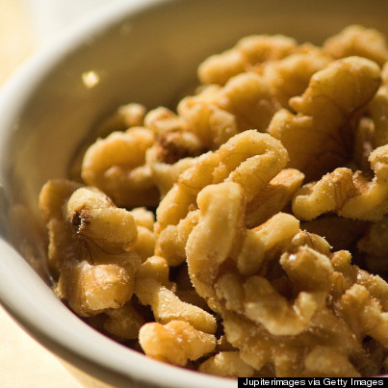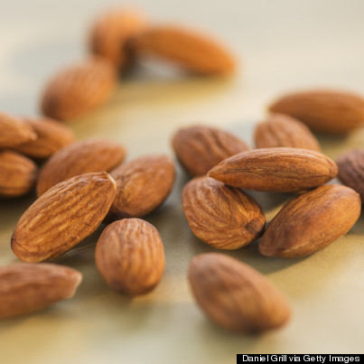

1,112 gallons of water to make 1 lb of walnuts

VS.

1,929 gallons of water to make 1 lb of almonds

**WINNER: WALNUTS**



175 gallons of water to make 1 lb stone fruit (plums, apricots, peaches)

VS.

65 gallons of water to make 1 lb citrus (oranges, grapefruit, lemons)

**WINNER: CITRUS**

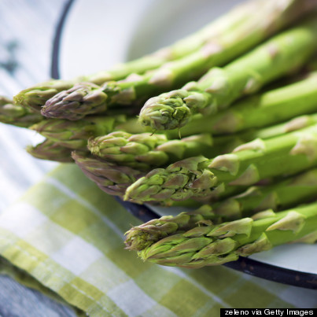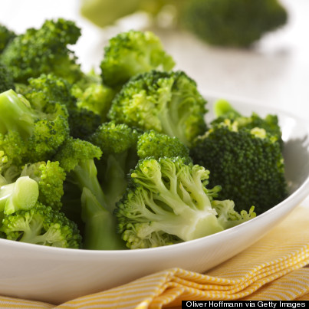

258 gallons of water to make 1 lb asparagus

VS.

34 gallons of water to make 1 lb broccoli

**WINNER: BROCCOLI**



1,729 gallons of water to make 1 lb of olive oil

VS.

309 gallons of water to make 1 lb of corn oil

**WINNER: CORN OIL**

Food at Emerson

Serving more than 2,000 meals per day, [Emerson Dining Services](http://www.emerson.edu/housing-dining/dining-services) has made important strides in reducing food, water and energy waste through structural innovation and sustainability education.

Trayless Dining Halls

Like numerous other U.S. college campuses, Emerson has implemented [trayless dining halls](http://www.emerson.edu/news-events/emerson-college-today/trayless-dining-comes-emerson#.VjzM1rerSUk), which helps conserve energy, water, and food. In fact, students waste about 30% less food when they go trayless. Additionally, water and electricity are saved, since washing trays requires one-third to a one-half gallon of water per tray, as well as electricity. A limited number of trays are always available for those who require them due to disability or other circumstance.

Reusable Container Program

[Reusable containers](http://www.emerson.edu/news-events/emerson-college-today/reusable-containers-new-trend-campus#.VjzNbLerSUk) offer convenience and another way for the College to reduce its environmental footprint. Reusable containers are available to students at the Dining Hall’s entrance and in both cafes. Students can drop off used containers (to be cleaned) and pick up new ones, or return the containers and get rainchecks for new containers the next time they want a meal to go. Emerson’s Einstein Bagel Café (80 Boylston Street) uses [compostable serviceware](http://www.emerson.edu/news-events/emerson-college-today/emerson-institutes-composting-program#.VjzNMberSUk) and offers a beverage discount when using a reusable mug.

Organic and Fair Trade Products

Dining Services offers organic and fair trade products, as well as [cage-free eggs](http://www.emerson.edu/news-events/emerson-college-today/emerson-dining-hall-switches-cage-free-eggs#.VjzNBberSUk). The dining hall features a vegan stir-fry station and all facilities have daily plant-based offerings.

Composting

Emerson partners with [Save that Stuff](http://www.savethatstuff.com/) to remove all food, compostable dishware, and paper napkins from the dining facilities’ waste streams. Dining facility staff compost food scraps in the kitchen and dining facility guests can compost any uneaten food, compostable dishware, and paper napkins in containers across from the dish return area. The collected organic material is then brought to Brick Ends Farm in Hamilton, MA to be processed into high-quality, nutrient-rich compost. The compost is re-sold to support youth arts programming and medical research. Students are currently working to bring composting to the residence halls and departmental offices.

Sustainable Food Tips

1. Meatless Mondays: Meat production creates significant greenhouse gas emissions and environmental impact, try going meatless at least once a week. A more plant-based diet is not only prettier but healthier too.
2. Look for local: Farmers’ Markets are plentiful and Boston and provide you with an outlet go get fresh produce and meet the people who produce your food. Make sure to get recipe tips!
3. Shop green: Bring your reusable bags and buy items with less packaging.
4. Eat mindfully: Only take what you will eat and focus on what you’re eating. Satisfy your hunger and eliminate food waste.
5. Get involved: Volunteer at a local farm or garden like [ReVision Urban Farm](http://www.vpi.org/revision/careers-volunteers/) or the

[Food Project](http://thefoodproject.org/volunteer).

Sustainable Food Spotlights in the Dining Hall 2016-2017

Emerson Sustainability is partnering with Sodexo, our dining service provider, and Business Services to bring guest chefs, farmers, fishers and nutritionists into the dining hall for sustainability events. Each month will spotlight a different sustainable food topic, providing students with tools and knowledge about how to improve their food print while eating delicious and nutritious food.

As a sustainability student leader, you are encouraged to participate in any and all of the monthly spotlights. Your ideas, input and questions will help craft a better experience for you and your peers.

September: Healthy Eating 101

October: Composting & Food Donation

November: Farm to Fork

December: Organic & Fair Food

January: Cook Smarter

February: Water Wise Eating

March: Sustainable Seafood

April: Earth Day Dinner

Stop Hunger Campaign

Sodexo will also be leading a Stop Hunger campaign on the Emerson campus with activities including: canned food drives, Cereal-in-a-cup promotions, and a “Take a Bite Out of Hunger” sweepstakes for $1,500 for the food charity of choice.

We will be working on activities and events to promote Sodexo’s campaign both inside and outside of the dining hall.

Transportation at Emerson

Emerson is a leader in sustainable transit—both the majority of students and employees get to Emerson by public transit, walking or biking.

By the T

Emerson is located at the nexus of several major transportation lines—the Green and Orange [MBTA](http://www.mbta.com/) lines, as well as several bus routes—greatly reducing the need for students and staff members to travel by car and saving tons of carbon emissions with each trip.

Emerson employees are eligible for pre-tax MBTA public transit purchases and offers employees assistance in finding carpool partners. Emerson students can buy monthly and semester-long passes for MBTA public transit through the College at a reduced rate.

By Bike

Emerson also provides two indoor [bicycle parking areas](http://www.emerson.edu/about-emerson/offices-departments/property-management/bicycle-parking)—the Boylston Place Bike Room holds 50 bicycles, and the Ansin Building Bike Parking facility holds about 20.

The [Hubway](http://thehubway.com/stations) bike-share program has two stations located adjacent to the Emerson campus at Boylston St/Washington St and Stuart St/Charles St.

By Car

**Zipcar for Universities**

Zipcar is a car sharing program that lets members use cars by the hour. Simply reserve online, let yourself in with your Zipcard and drive. Members of the Emerson College community are eligible for a Zipcar discount program.

To sign up, please go to [www.zipcar.com/emerson](http://www.zipcar.com/emerson). You will be required to enter a user name and your Emerson e-mail address to receive the discounted rates. Details concerning available rate programs and how to arrange for rentals are available through the site.

Existing members should email [cfranzen@zipcar.com](mailto:cfranzen@zipcar.com) with their Zipcar card number to be added to the benefit.

This program provides discounts on the annual fee and weekday rates as well as easy access.

**Carpool/Vanpool**

Emerson College, in conjunction with [TransAction Ridematching](http://www.transactionassoc.com/), offers eligible employees assistance in finding a carpool/vanpool partner. You can register online to find carpool/vanpool partners who live in your area and are traveling to your destination.

Consumerism at Emerson

Emerson considers the environmental impact when making purchasing decisions. The college often makes use of furniture and equipment that we already own and recycled materials that are no longer needed. At the same time, there are many hidden environmental costs associated with purchasing new things, such as raw material extraction, manufacturing, transportation, packaging, and final product disposal. It’s hard to see the resources and energy associated with every stage of the product, as well as the environmental impacts such as greenhouse gas emissions, pollution and toxic manufacturing by-products. The best way to eliminate all of the harmful consequences from consumerism is to reuse materials and purchase second hand materials.

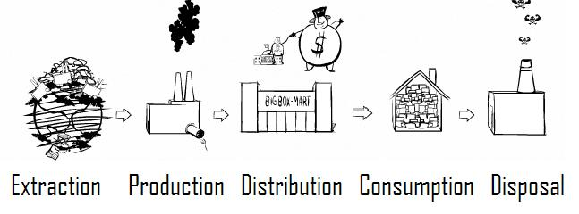

*Source:* [*The Story of Stuff*](http://storyofstuff.org/movies/story-of-stuff/)

**At Emerson:**

Emerson’s [Facilities Management](http://www.emerson.edu/about-emerson/offices-departments/facilities-management) staff uses Green Seal-certified cleaning products for campus-wide housekeeping. [Green Seal](http://www.greenseal.org/GreenLiving.aspx) is a nonprofit organization that promotes the manufacture, purchase, and use of environmentally responsible products and services.

Emerson purchases Energy Star-rated computers and other appliances as applicable, and the paper that is purchased is composed of post-consumer recycled material.

The College magazine (*Expression*) and most College promotional material is certified by the [Forest Stewardship Council](http://www.fsc.org/about-fsc.html). Publications bearing the FSC seal are produced and printed according to the highest social and environmental standards available. The College’s Creative Services Office sources much of its printing work to local vendors.

Green Purchasing Tips

* Reuse, reuse, reuse: purchase reusable items over single use items (e.g. dish rags over paper towels, face wash over face wipes).
* Digitize your library: Buy digital or used books.
* Be a thrifty hipster: Shop second-hand and thrift stores that carry items with lesser environmental impact and more unique style. See this [article](http://archive.boston.com/lifestyle/blogs/thenextgreatgeneration/gallery/thrift_stores_boston_area/) for the best Boston-area thrift stores.
* Buy [Energy Star](https://www.energystar.gov/): Purchase Energy Star electronics and appliances that save energy.
* Eliminate toxins: Buy natural and less toxic cleaning and personal care products. Avoid detergents with [phosphates and products with chlorine bleach](https://www.organicconsumers.org/news/how-toxic-are-your-household-cleaning-supplies).
* Ban the bottle: Avoid bottled water and drink Boston’s [nationally acclaimed tap water](http://voices.nationalgeographic.com/2014/06/18/boston-wins-annual-tap-water-taste-contest/)!
* Fix it first: Try to repair items before throwing them away and finding a replacement.

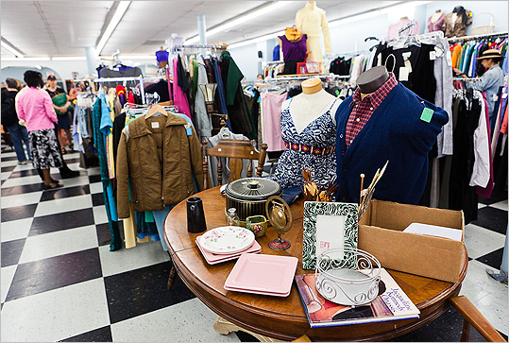

[Boomerangs](http://action.aac.org/site/PageServer?pagename=boom_home) in Jamaica Plain with branches in the South End and Central Square, Cambridge donates all profits to support AIDS/HIV prevention and wellness services.

Consumerism Facts

* In the past 30 years, one-third of the planet’s natural resources have been consumed.
* In the U.S., we have less than 4% of our original forests left.
* 40% of waterways in the U.S. have become undrinkable.
* The U.S. has 5% of the world’s population but consumes 30% of the world’s resources and creates 30% of the world’s waste.
* U.S. industry admits to releasing over 4 billions pounds of toxic chemical each year.
* Americans spend 3-4 times as many hours shopping as Europeans do.

For more facts see: [Story of Stuff](http://storyofstuff.org//wp-content/uploads/movies/scripts/StoryofStuff_FactSheet.pdf)

Glossary

[Carbon Dioxide Equivalent (CDE)](https://en.wikipedia.org/wiki/Carbon_dioxide_equivalent) – measure for describing how much global warning a given type of greenhouse gas may cause using the equivalent amount of carbon dioxide (CO2) as the reference (often expressed in pounds of CO2).

[Compact Fluorescent Light Bulb (CFL)](https://www.energystar.gov/products/lighting_fans/light_bulbs/learn_about_cfls) – energy saving bulbs that use 25-80% less energy and last 2-35 times longer than traditional incandescent bulbs.

[Climate Change](https://www3.epa.gov/climatechange/) – also called global warming, is the rise in average surface temperatures on Earth. Science attributes the change due to human use of fossil fuels, which releases carbon dioxide and other greenhouse gases into the air.

[Composting](http://study.com/academy/lesson/what-is-composting-definition-and-examples.html) – collecting organic (carbon containing) waste such as food and yard waste in a controlled environment to help breakdown the materials into fertilizer or soil. The process greatly reduces the overall amount of waste going to landfills and incinerators and creates a usable product.

[Energy Star](https://www.energystar.gov/) – U.S. government rating program that designates energy efficient appliances and electronics.

[E-Waste](http://www.mass.gov/eea/agencies/massdep/recycle/reduce/electronics-recycling.html) – also called electronic waste, is any electrical or electronic device that should be disposed of separately to prevent hazardous metals and chemicals in the device from polluting the environment.

[Footprint (carbon or ecological)](http://www.footprintnetwork.org/pt/index.php/GFN/page/carbon_footprint/) – total amount of resources an individual uses or how much greenhouse gas emissions their indirect or direct activities contribute to the atmosphere, usually expressed in CDEs.

Green Gala – an annual night of sustainable food, fashion, student performances and film at Emerson’s Paramount Theater to celebrate Earth Day. Cash prizes awarded for winning performance and film.

[Greenhouse gas (GHG)](https://www3.epa.gov/climatechange/ghgemissions/) – gas in the atmosphere that absorbs and emits radiation; this process is the fundamental cause of ‘global warming’. The primary GHGs in our atmosphere are water vapor, carbon dioxide, methane, nitrous oxide and ozone.

[Heating, Ventilation and Air Conditioning (HVAC) system](https://www.epa.gov/indoor-air-quality-iaq) – a building’s system of heating and cooling infrastructure go to provide thermal comfort and acceptable indoor air quality.

[Kilowatt Hour (kWh)](http://www.energylens.com/articles/kw-and-kwh) – one kilowatt of power delivered for one hour; common unit of energy used for billing consumers by utility companies.

[LEED](http://www.usgbc.org/leed) – Leadership in Energy and Environmental Design (LEED) is one of the most popular green building certification programs worldwide. Buildings are rated on their design, construction, operation, and maintenance with respect to the environment and resource use.

[LED lighting](https://www.energystar.gov/products/lighting_fans/light_bulbs/learn_about_led_bulbs) – LEDs, or light emitting diodes, are more efficient, durable, versatile, and longer lasting than incandescent and CFL lighting.

[Lifecycle Assessment (LCA)](http://www.gdrc.org/uem/lca/lca-define.html) –a technique to assess environmental impacts associated with all the stages of a product’s life from cradle to grave (i.e. from raw material extraction through materials processing, manufacture, distribution, use, repair and maintenance, and disposal or recycling).

[Low flow](http://challengeforsustainability.org/toolkit/water-efficiency/office-fixtures/) – toilets, faucets and shower heads that use less water to help conserve energy, water and money.

Move-out Shop & Swap – program run by Emerson Housing & Residence Life and Facilities that aims to promote the reuse of items through swapping and donating and reduce the amount of materials going into the landfill.

[Rainwater harvesting](http://rainwaterharvesting.tamu.edu/rainwater-basics/) – collecting rain water in containers for reuse on-site rather than allowing it to run off. Emerson has rainwater capture systems on the roofs of Piano Row and Colonial.

[RecycleMania](http://recyclemaniacs.org/) – an 8-week friendly competition hosted in the U.S. and Canada each spring to promote waste reduction.

[Renewable energy certificates (RECs)](http://apps3.eere.energy.gov/greenpower/markets/certificates.shtml) – certificates that represent proof that a certain amount of energy has been produced by renewable energy and can be sold or traded by the owner.

[Smart strip](http://science.howstuffworks.com/environmental/green-tech/sustainable/smart-power-strip.htm) – a power strip that reduces power usage by shutting down power to products that go into standby mode, thereby significantly saving energy and money.

[Sustainability](https://www.epa.gov/sustainability/learn-about-sustainability#what) – the ability of the current generation to meet their present needs without compromising future generations’ abilities to meet their own needs.

[Vampire energy](http://energy.gov/articles/are-energy-vampires-sucking-you-dry) – electricity consumed by electronic devices and appliances even when they are turned off or in standby/sleep mode.

[Zero waste event](http://sustainableconnections.org/bizdev/tzw/pdfs/TZW08_insert_v4.pdf) – an event that is planned and carried out to create no additional waste from the event itself. Organizes reuse materials like banners and set up Zero-Waste Stations to recycle and compost materials like paper cups and food scraps.

[Zipcar](http://www.zipcar.com/universities/emerson-college) and [Enterprise](https://www.enterprisecarshare.com/us/en/programs/university/ela.html) car-sharing – car sharing programs in the Boston area where vehicles can be rented for hours or days and can be picked up and dropped off at nearby sites.