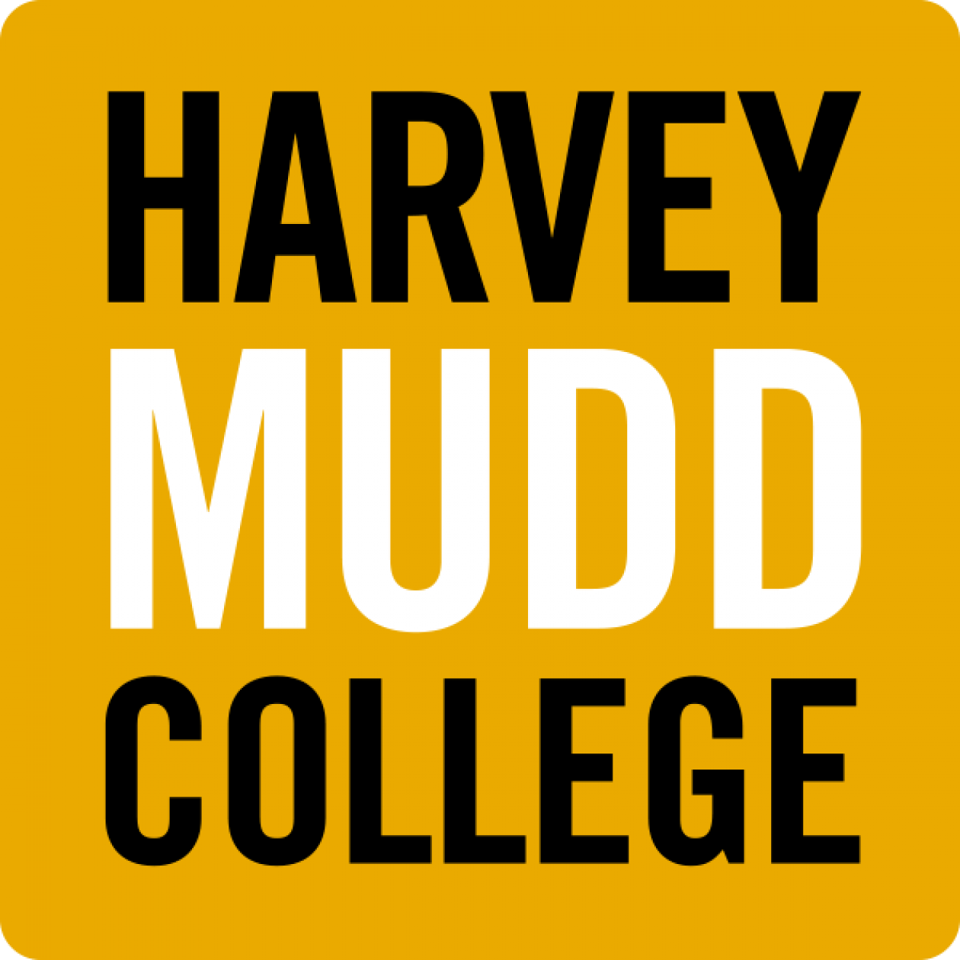 Hixon Center for Sustainable Environmental Design

Position: Sustainability Program Manager (administrative classification to be checked with HR)

Title: Sustainability Program Manager
Location: Harvey Mudd College, Claremont, CA
Department: Hixon Center for Sustainable Environmental Design / Engineering Department
Hours: Full-time, 40 hrs./week, year-round
Schedule: Typically, Monday – Friday with occasional evenings or weekend commitments
Travel: Less than 10% per year
Salary: $45,000-$60,000 commensurate with education and prior experience

POSITION SUMMARY

The Hixon Center for Sustainable Environmental Design has an outstanding opportunity for a full-time Sustainability Program Manager. The primary purpose of this position is to support the center and its director in the development, implementation, evaluation, and further improvement of programs and activities aimed at enhancing sustainability at Harvey Mudd College. Specifically, this position will coordinate and guide a variety of activities that integrate sustainability theory and practice into the curriculum, research, and campus-wide operations and that serve to achieve measurable impacts in these domains.

The position is integral to HCSED’s progress on key development goals during its launch phase and the production of deliverables such as original research and policy reports, development of teaching materials, implementation of sustainability projects on campus, and representation at relevant conferences. Progress toward these project goals and delivery on objectives is crucial to HCSED’s continuous success at engaging with faculty, students and staff and increasing the visibility of Harvey Mudd College in the sustainability domain.

This position has an initial term appointment of 24 months; extensions are subject to funding.

REPORTS TO
Director of the Hixon Center for Sustainable Environmental Design

DUTIES AND RESPONSIBILITIES

The individual in this role is expected to exhibit high levels of integrity, self-motivation and initiative, the ability to communicate effectively, and successfully manage multiple projects and deadlines under pressure. S/he must regularly communicate and interact with the following:

- HCSED director,
- faculty, students, and senior researchers, and professional staff at Harvey Mudd, the other Claremont Colleges, as well as other academic and research organizations,
- vendors and suppliers
- donor organizations and agencies.

General Responsibilities
- Coordinate the development and implementation of programs that promote campus sustainability initiatives created by HCSED and manage their effective communication
- Liaise with the intercollegiate Environmental Analysis program to advance the EA curriculum and student enrollment in EA courses
- Work closely with the HCSED director to develop a consistent multi-year sustainability programming plan for the center and associated timelines, resource and budget estimates, and staffing requirements for their successful implementation
- Support the HCSED director in developing new internship, clinic, and professional opportunities for students
- Establish and maintain communication with administration, faculty, students, and staff
- Serve as a liaison, support, mentor, and advocate for student sustainability projects and initiatives. Directly engage with students on a day-to-day basis.
- Develop and manage new on-campus sustainability initiatives in close cooperation with the HCSED director, Facilities and Management, and Administration.
- Contribute and support greenhouse gas emission inventories and other collection and reporting of campus sustainability indicators. Work with the Facilities and other relevant departments to obtain sustainability rankings and certifications as agreed upon by the Administration. Implement monitoring and evaluation procedures to quantify in physical and monetary terms avoided environmental impacts on an ongoing basis.
- Be an active and enthusiastic supporter of awareness, appreciation, and participation in campus sustainability programs and identify “best practices” based on research and exchange with other academic institutions.
- Facilitate the development of new research proposals, including creating budgets to match proposed scopes of work, developing project management plans, and editing scientific narratives.

Project management
- Develop and coordinate diverse sustainability projects in close collaboration with the HCSED director, including student research, course and material development, campus initiatives, and other events.
- Understand the resource and infrastructure requirements of these projects and manage their timely and efficient procurement and deployment, including the creation of timelines and project implementation plans.
- Expertly carry out communications, relationship-building, and project management with the HCSED director, Advisory Board, faculty and senior leaders in campus administration and operations as well as in cooperation with external project partners from other academic and research institutions, governmental, and non-profit agencies in order to attain project goals and facilitate productive collaboration.
- Turn intellectual agendas set by researchers into action plans that can be implemented effectively across multiple project participants to achieve demanding and time-sensitive project milestones. Must confidently and effectively participate in project assignments with a solid grounding in project specifics and current status. Track progress and manage coordination and communication across the team.
- Prepare, interpret, and manage budgets and financial reports and participate in the budgeting process in collaboration with the HCSED director and Advisory Board.
- Contribute to the preparation of presentations, donor reports, scientific progress reports, and other related materials using existing resources and guidelines.
- Facilitate the process for the publication of research findings, working with authors, and external journal editors
- Work with Harvey Mudd’s communications, IT, and web design teams to maintain a current, accurate public presence.

Event management
- Organize, coordinate, and manage events, including speaker events and series, conferences, workshops, sustainability competitions, and student engagement actions.
- Select and manage vendors for event organizations.
- Provide logistical support and help with materials creation prior and during events.
- Help with post-event logistics and evaluation, including analysis of feedback surveys and other data

Supervisory responsibilities

- Support the HCSED director in managing student assistants and researchers, including assisting with schedule development, regular meetings, and mentoring activities.

Perform additional duties as assigned that fall within the reasonable scope of this position as a member of the Hixon Center for Sustainable Environmental Design.

REQUIRED QUALIFICATIONS:

Education:
- Bachelor’s degree in environmental science, policy, sustainable development, business or public administration, urban planning, or other discipline relevant to the mission of the Hixon Center for Sustainable Environmental Design
Experience:
- At least 2 years of experience directly in sustainability program support and management at an academic institution, an environmental organization, or in the private sector

Knowledge, skills and abilities:
- Knowledge of Microsoft Office Suite, Adobe Creative Suite, WordPress or other blogging platforms, brand curating on social media (Facebook, Twitter, LinkedIn, Instagram)
- Highly organized and detail-oriented
- Excellent verbal and written communication skills
- Creative and collaborative problem solving skills
- Consistently professional demeanor
- Calm presence in a fast-paced environment

REQUIRED LICENSES/CERTIFICATES: None

PREFERRED QUALIFICATIONS:

- Master’s degree in environmental science, policy or management, sustainable development, urban ecology, planning or development, environmental or energy economics, environmental engineering, public affairs or administration or other relevant discipline.
- Familiarity with campus sustainability initiatives and organizations
- Substantial event organization experience
- Experience in grant writing and administration

POSITION CHARACTERISTICS:
- Classification: exempt, regular, full-time, benefits eligible
- Work schedule: Monday-Friday, some weekends and evenings

POSITION OPEN: Applications accepted until June 30, 2015

POSITION START DATE: September 1, 2015

INFORMATION: For more information please contact tsrebotnjak@g.hmc.edu

