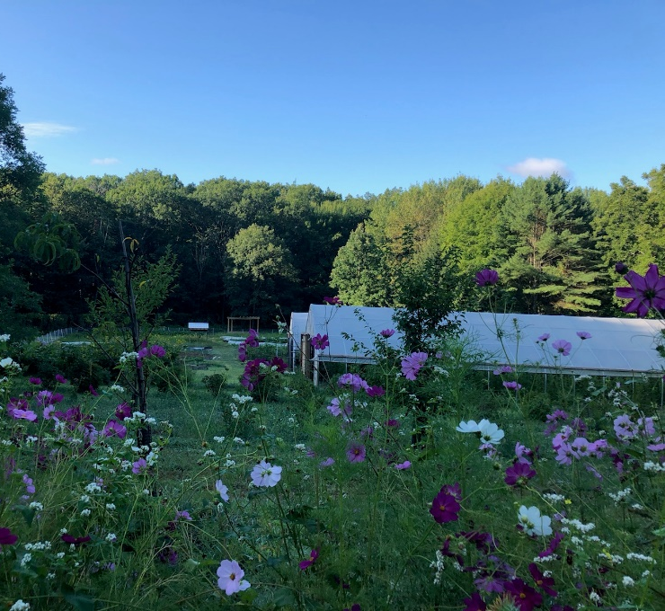
How do I get Involved?

One of the many amazing things about Saint Michael’s is that we are a caring community that respects one another and the campus environment. This is a perfect fit for how the sustainability program runs. Everyone has a part to play, whether it’s simply recycling, remembering to turn off your office lights and other electronics when not in use, being an active member of the Sustainability Committee or getting involved in one of the many sustainability efforts or programs that are available throughout the year. We can all make a huge difference together.
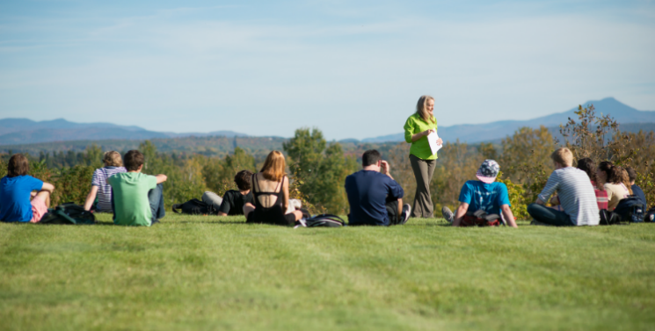


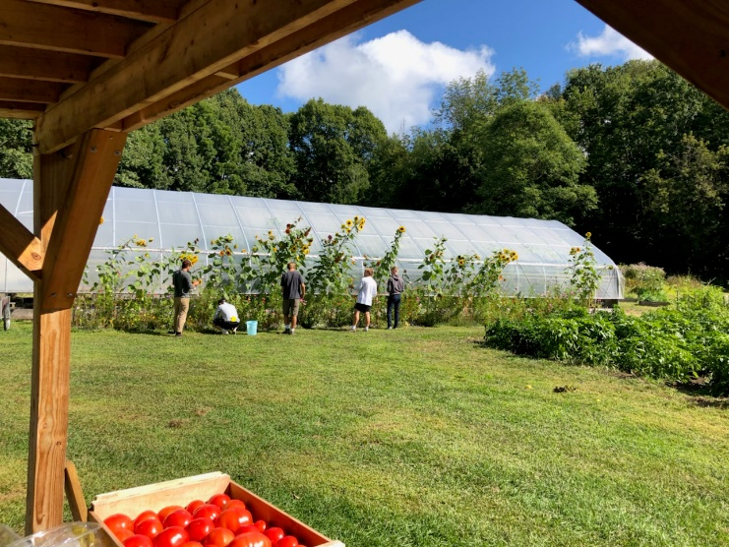

Contact Info:
Doug Facey, Ph.D.
Professor of Biology
Chair, Sustainability Committee
dfacey@smcvt.edu 802.654.2625

Kristyn Achilich, M.S.
Director, Center for the Environment
Director, Farm Program
kachilich@smcvt.edu
802.654.2730

Sustainable Campus
an overview for employees

www.smcvt.edu/pages/center-for-the-environment/sustainability



A Sustainable Campus
At Saint Michael’s College, sustainability encompasses more than just the typical “green” operational initiatives. Its reach extends across all disciplines and areas of the College and includes everything from what we consume to the rich and diverse culture in which we live. The campus is committed to strengthening our obligation to a socially and ecologically responsible world by connecting students, staff and faculty with opportunities to create a sustainable future. The establishment of a new institutional Center for the Environment is an indication of the level of commitment we have to making a difference in the lives of our community and the world.

How do we define sustainability?
A framework for living that focuses on interconnections and requires us to act responsibly in light of them…to make decisions informed by ethical reasoning that is grounded in a holistic approach. It is this definition that helps guide our sustainability programs at Saint Michael’s College.
Sustainability is not an end goal; rather, it is a process that should guide us all in our interactions with one another and the Earth.

Perks for Employees

Employees have free access (with your knight card) to the local GMT bus routes. For information on bus routes: http://ridegmt.com/gmt-schedules/

The College provides free reusable water bottles, coffee mugs and tote bags. Throughout the buildings on campus, you will find water bottle refill stations. Also, if you utilize a reusable mug at the campus cafes, you will receive a discount on your purchase.

If you are doing local work-related travel, your department/office may utilize one of the college’s 3 Honda Civic hybrids. Have an electric vehicle of you own?
We have two charging stations, powered by solar panels, just for you at the Klein Hall parking lot. If you’re interested in carpooling to work, checkout: http://www.connectingcommuters.org . The commercial stars some past SMC employees.

A Few Highlights
SMC has made it into the Princeton’s Review Green Guide to Colleges for the past 10 years (and counting!)
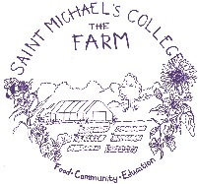
- The college has a robust and productive 1.75 acre Farm behind Pomerleau Alumni Center. During the growing season be sure to visit our self-serve farm stand in Alliot or join our CSA.
- Thanks to various efficiency upgrades and initiatives, the college has saved over 3.1 million kWh annually
- Our HVAC department has installed 55 dual flush handles throughout the restrooms on campus
- Recycling and composting is the law in Vermont (see Act 148 brochure). Every building on campus has recycling, food scrap and landfill containers for proper waste management
- We were named the 23rd certified Bee Campus in the nation
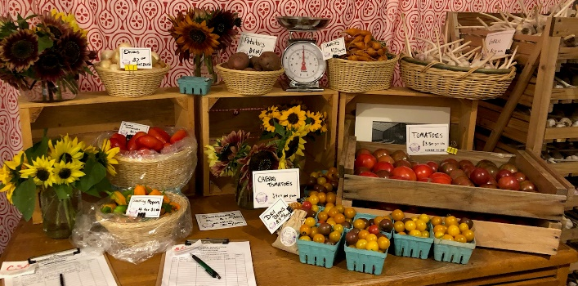
- We are the first Fair Trade college in Vermont

