UCC Air Quality Monitoring Report

- Monitoring Period: 01/03/2016 – 31/03/2016
- Monitoring Location: Mobile Monitoring Station, Kane Building Car Park
- Pollutants Monitored: PM_{2.5}, NO_{x} (NO₂ & NO), Ozone

Results
PM2.5 mass concentration did not breach limits set by the World Health Organization. The levels are typical for those observed in Cork and other towns/cities around the country.
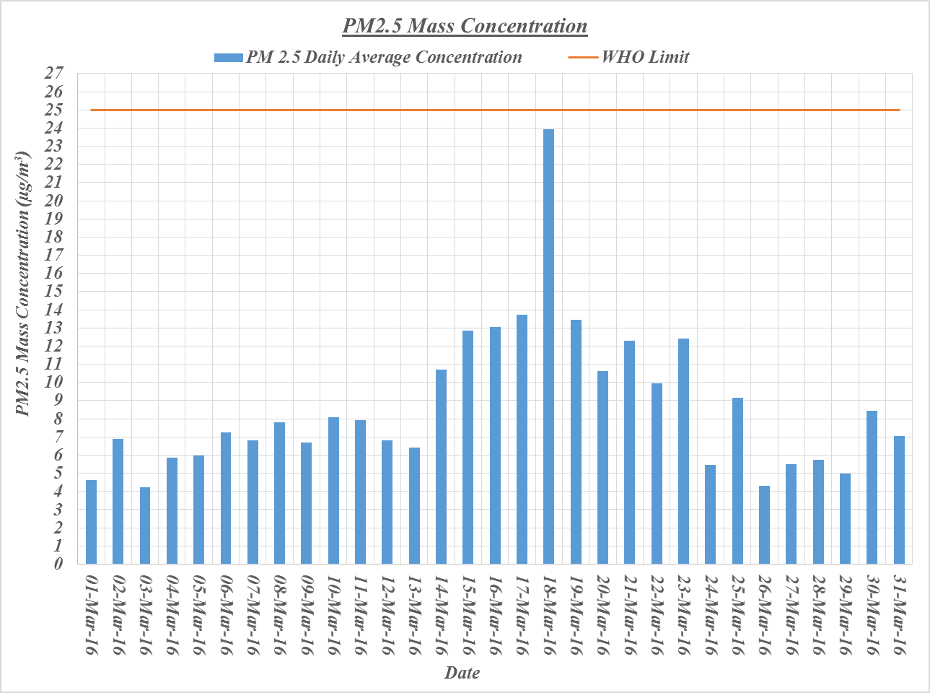

The concentrations of nitrogen oxides (NO and NO2) are also below the WHO limit guidelines and are typical for those observed in Cork and other towns/cities.

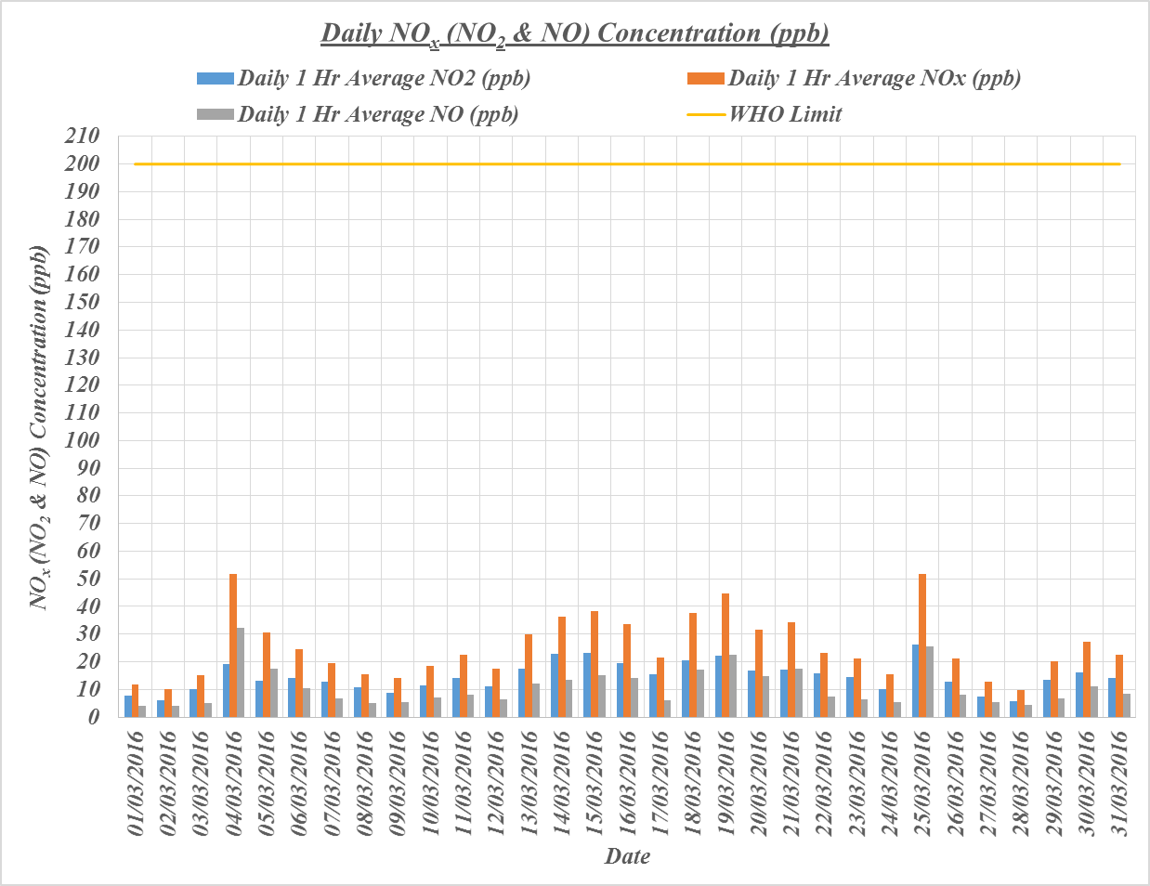

Ozone levels are also low.

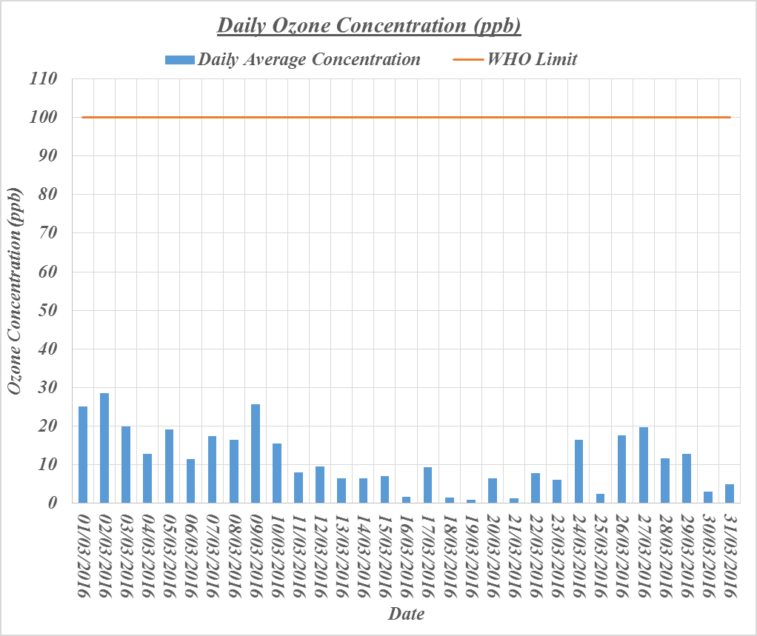

The results above are daily average values. But concentration varies throughout the day. It is interesting to look at any spikes in concentration and see if they coincide with any particular time of day, weather pattern etc.
Here are the peak concentrations for NOx during each of the days. The only days where spikes were observed were 4th March, 5th March, 19th March, 21st March, 25th March. All but one of these days experienced winds from a northerly direction (highlighted).
There is some indication that northern winds bring higher levels of nitrogen oxides to the monitoring site. But not all the time.

Table of Results highlighting peaks in NO_{x} concentration and the weather at the time
Date | Time of Spike | Max. Concentration NO_{x} (ppb) | Notes
01/03/2016 | 09:00 | 34.1 | Mild, Light South Westerly winds
01/03/2016 | 10:45 | 23.7
01/03/2016 | 17:15 | 19.9
02/03/2016 | 10:15 | 20.6 | Cold, North Westerly Wind
02/03/2016 | 14:15 | 19.7
02/03/2016 | 15:30 | 20.1
02/03/2016 | 16:30 | 20.1
03/03/2016 | 08:15 | 37.6 | Cold, Light South Westerly winds
03/03/2016 | 10:30 | 59.2 | Cold, Southerly winds
03/03/2016 | 11:45 | 42.7
04/03/2016 | 09:15 | 42 | Cold, Northerly winds
04/03/2016 | 12:45 | 130.3
04/03/2016 | 14:30 | 164
04/03/2016 | 16:30 | 229.3 | Stronger winds
04/03/2016 | 18:00 | 201.6
05/03/2016 | 10:30 | 112 | Cold, Northerly winds
05/03/2016 | 11:00 | 143.2
05/03/2016 | 12:15 | 193.5
05/03/2016 | 13:15 | 165.6
05/03/2016 | 15:30 | 120.4
05/03/2016 | 16:45 | 91.8
06/03/2016 | 10:45 | 35.3 | Cold, South Westerly winds
06/03/2016 | 12:15 | 69.9
06/03/2016 | 13:45 | 55.7 | Cold, South Easterly winds
06/03/2016 | 17:30 | 38.2 | Cold, Easterly winds
06/03/2016 | 19:15 | 81.8
06/03/2016 | 22:30 | 42.3
07/03/2016 | 08:00 | 46.9 | Cold, Northerly winds
07/03/2016 | 09:00 | 31.8
07/03/2016 | 12:00 | 67.9
07/03/2016 | 13:15 | 47.5
07/03/2016 | 16:15 | 54.3
07/03/2016 | 18:15 | 20.9
07/03/2016 | 20:45 | 25.4 | Cold, Westerly winds
07/03/2016 | 23:30 | 33
08/03/2016 | 08:30 | 26.6 | Cold, Westerly winds
08/03/2016 | 09:30 | 27.2
08/03/2016 | 11:00 | 19.3
08/03/2016 | 13:00 | 19.9
08/03/2016 | 14:30 | 24.6
08/03/2016 | 15:15 | 24.4
08/03/2016 | 16:45 | 22.1
08/03/2016 | 18:15 | 29.1 | Cold, South Westerly winds
08/03/2016 | 19:00 | 28.4
08/03/2016 | 19:45 | 21.9
08/03/2016 | 21:15 | 25.2
08/03/2016 | 23:15 | 13.6 | Cold, Westerly winds
09/03/2016 | 09:15 | 17.7 | Cold, Westerly Winds
09/03/2016 | 13:15 | 17.4
09/03/2016 | 14:00 | 27.3
09/03/2016 | 14:30 | 51.8
09/03/2016 | 15:45 | 26.7
09/03/2016 | 17:00 | 45.7
09/03/2016 | 19:00 | 25.1
09/03/2016 | 22:00 | 16
09/03/2016 | 23:30 | 36.7
10/03/2016 | 08:45 | 54.8 | Cold, Westerly winds
10/03/2016 | 10:00 | 41.8
10/03/2016 | 18:30 | 23.3 | Mild, Southerly winds
10/03/2016 | 21:30 | 38.1
10/03/2016 | 23:15 | 34.9
11/03/2016 | 03:45 | 24 | Mild, Southerly winds
11/03/2016 | 07:45 | 43.7
11/03/2016 | 08:45 | 42.9
11/03/2016 | 11:45 | 24.8
11/03/2016 | 12:45 | 26.5
11/03/2016 | 13:45 | 25.9
11/03/2016 | 15:03 | 38.1
11/03/2016 | 16:00 | 48
11/03/2016 | 16:45 | 30.9
11/03/2016 | 19:45 | 30.6 | Mild, South Westerly winds
11/03/2016 | 22:15 | 21.3
12/03/2016 | 08:00 | 23.7 | Mild, South Westerly winds
12/03/2016 | 09:15 | 28.3 | Mild, Southerly winds
12/03/2016 | 13:30 | 30.7
12/03/2016 | 14:30 | 40.9
12/03/2016 | 16:00 | 24.4
12/03/2016 | 17:00 | 22.2
12/03/2016 | 19:30 | 25.8
12/03/2016 | 20:30 | 21.3
12/03/2016 | 21:45 | 19.9
12/03/2016 | 23:30 | 17.7
13/03/2016 | 08:45 | 23.4 | Mild, South Easterly winds
13/03/2016 | 12:00 | 108.5
13/03/2016 | 13:45 | 58.9
13/03/2016 | 14:45 | 50.7
13/03/2016 | 15:45 | 54.2
13/03/2016 | 18:00 | 49.3
13/03/2016 | 19:00 | 35.9
13/03/2016 | 21:00 | 28.9 | Mild, Easterly winds
13/03/2016 | 21:30 | 27.6
13/03/2016 | 22:15 | 30.1
13/03/2016 | 23:00 | 39.1
14/03/2016 | 09:45 | 63.8 | Mild, Easterly winds
14/03/2016 | 12:15 | 95.1
14/03/2016 | 13:00 | 66.9
14/03/2016 | 15:30 | 65.9
14/03/2016 | 16:30 | 83.9
14/03/2016 | 17:00 | 67.9
14/03/2016 | 18:00 | 66.6
14/03/2016 | 19:15 | 49.2
14/03/2016 | 20:15 | 51.2
14/03/2016 | 21:00 | 51.6
14/03/2016 | 21:30 | 54.9
15/03/2016 | 09:45 | 60 | Mild, Easterly winds
15/03/2016 | 11:00 | 62.6
15/03/2016 | 12:00 | 60.7
15/03/2016 | 12:30 | 80.8
15/03/2016 | 13:30 | 59.1
15/03/2016 | 14:15 | 73.2
15/03/2016 | 14:45 | 66.1
15/03/2016 | 15:15 | 64.3
15/03/2016 | 15:45 | 58.7
15/03/2016 | 16:45 | 76.3
15/03/2016 | 18:00 | 60.9
15/03/2016 | 22:00 | 86.5 | Mild, Northerly winds
15/03/2016 | 22:30 | 89.1
16/03/2016 | 09:45 | 112.7 | Mild, North Easterly winds
16/03/2016 | 10:45 | 71
16/03/2016 | 13:15 | 52.7
16/03/2016 | 14:45 | 63.7
16/03/2016 | 16:00 | 56
16/03/2016 | 18:45 | 47
16/03/2016 | 19:00 | 48.8
16/03/2016 | 21:15 | 31.6
17/03/2016 | 12:00 | 49.2 | Mild, South Easterly winds
17/03/2016 | 13:15 | 35.7
17/03/2016 | 14:00 | 29.2
17/03/2016 | 16:15 | 41.7
17/03/2016 | 18:15 | 25.8
17/03/2016 | `19:30 | 26.5
17/03/2016 | 21:15 | 33.1 | Cold, Easterly winds
17/03/2016 | 22:15 | 32.8
18/03/2016 | 01:15 | 67.9 | Cold, North Easterly winds
18/03/2016 | 02:45 | 53.5
18/03/2016 | 04:30 | 31.5
18/03/2016 | 09:30 | 63.1 | Cold, Northerly winds
18/03/2016 | 12:45 | 63.3
18/03/2016 | 14:15 | 57.9 | Mild, South Easterly winds
18/03/2016 | 15:15 | 54.4
18/03/2016 | 16:00 | 54.4
18/03/2016 | 19:00 | 27.2
18/03/2016 | 22:30 | 86.8
19/03/2016 | 00:00 | 99 | Cold, Easterly winds
19/03/2016 | 02:45 | 42.6
19/03/2016 | 09:30 | 35 | Mild, North Easterly winds
19/03/2016 | 11:30 | 97.8
19/03/2016 | 12:00 | 74.1
19/03/2016 | 13:00 | 100.5
19/03/2016 | 13:45 | 98.6
19/03/2016 | 14:15 | 99.2
19/03/2016 | 15:45 | 61.7
19/03/2016 | 16:30 | 55.8
19/03/2016 | 20:30 | 61.9
19/03/2016 | 22:30 | 78.3
20/03/2016 | 09:15 | 61.2 | Cold, North Easterly Winds
20/03/2016 | 10:15 | 61
20/03/2016 | 11:00 | 69.1 | Mild, North Easterly winds
20/03/2016 | 12:00 | 58.4
20/03/2016 | 13:45 | 53.3
20/03/2016 | 14:15 | 55.6
20/03/2016 | 15:00 | 74.7 | Mild, Northerly winds
20/03/2016 | 15:45 | 59.2
20/03/2016 | 16:15 | 57.6
20/03/2016 | 17:15 | 47.5
20/03/2016 | 19:15 | 36.2
20/03/2016 | 21:15 | 54.2
20/03/2016 | 22:45 | 75.6
21/03/2016 | 09:15 | 19.3 | Cold, North Westerly winds
21/03/2016 | 10:45 | 25.1 | Mild, North Westerly winds
21/03/2016 | 13:15 | 42.8
21/03/2016 | 14:45 | 47.1
21/03/2016 | 16:30 | 43.2
21/03/2016 | 18:30 | 96 | Mild, Northerly winds
21/03/2016 | 20:00 | 98
21/03/2016 | 21:15 | 104.7
22/03/2016 | 09:00 | 44 | Mild, Easterly winds
22/03/2016 | 10:00 | 37.6
22/03/2016 | 12:45 | 35.3
22/03/2016 | 13:30 | 40.2
22/03/2016 | 14:30 | 42.4
22/03/2016 | 16:30 | 51.9
22/03/2016 | 17:30 | 52.2
22/03/2016 | 19:15 | 38.1
23/03/2016 | 06:00 | 19.1 | Mild, Westerly winds
23/03/2016 | 09:45 | 42.5 | Mild, Southerly winds
23/03/2016 | 12:30 | 45.3
23/03/2016 | 15:30 | 24.7
23/03/2016 | 18:30 | 24 | Mild, Westerly winds
24/03/2016 | 09:30 | 29.9 | Mild, South Westerly winds
24/03/2016 | 14:45 | 21.7 | Mild, North Westerly winds
24/03/2016 | 16:45 | 23.7
24/03/2016 | 19:30 | 29.7
24/03/2016 | 21:45 | 17.6
24/03/2016 | 23:15 | 28.4
25/03/2016 | 09:30 | 107.1 | Mild, South Westerly winds
25/03/2016 | 10:45 | 47.6
25/03/2016 | 12:00 | 56.2
25/03/2016 | 13:15 | 51.9
25/03/2016 | 15:00 | 94.7
25/03/2016 | 17:30 | 138.9
25/03/2016 | 18:30 | 119.3
25/03/2016 | 20:45 | 81.8
25/03/2016 | 23:00 | 77.3
26/03/2016 | 08:00 | 41.6 | Mild, Southerly winds
26/03/2016 | 09:45 | 69.9
26/03/2016 | 10:45 | 67
26/03/2016 | 12:30 | 31.4
26/03/2016 | 13:00 | 35
26/03/2016 | 14:30 | 97.8 | Mild, South Westerly winds
27/03/2016 | 08:00 | 17.6 | Cold, South Westerly winds
27/03/2016 | 11:00 | 17.4 | Mild, South Westerly winds
27/03/2016 | 15:00 | 16.1
27/03/2016 | 18:15 | 13.7
27/03/2016 | 19:30 | 25.5
27/03/2016 | 21:15 | 35.1 | Cold, Northerly winds
27/03/2016 | 22:00 | 34.9
28/03/2016 | 08:15 | 23.9 | Mild, Westerly winds
28/03/2016 | 09:45 | 14.1
28/03/2016 | 17:15 | 10.6
28/03/2016 | 18:15 | 12.5
28/03/2016 | 22:15 | 18.7
29/03/2016 | 08:30 | 49.5 | Cold, Southerly winds
29/03/2016 | 09:15 | 48.6
29/03/2016 | 10:45 | 42.1
29/03/2016 | 11:15 | 51
29/03/2016 | 12:15 | 54.5 | Mild, South Westerly winds
29/03/2016 | 13:00 | 39.4
29/03/2016 | 14:00 | 34.9
29/03/2016 | 14:45 | 25.3
29/03/2016 | 16:30 | 22.1
29/03/2016 | 17:30 | 26.1
29/03/2016 | 20:00 | 16.9
29/03/2016 | 23:00 | 31.4
30/03/2016 | 09:00 | 41.3 | Mild, Westerly winds
30/03/2016 | 10:00 | 43.2
30/03/2016 | 15:00 | 123.2 | Mild, Southerly winds
30/03/2016 | 15:45 | 63
30/03/2016 | 17:00 | 49.1
30/03/2016 | 17:45 | 48.5
30/03/2016 | 21:30 | 56.4 | Cold, North Westerly winds
30/03/2016 | 23:00 | 70.6
31/03/2016 | 08:00 | 45.6 | Mild, North Westerly winds
31/03/2016 | 08:45 | 43.4
31/03/2016 | 09:30 | 47
31/03/2016 | 12:00 | 22.5 | Mild, South Westerly winds

