

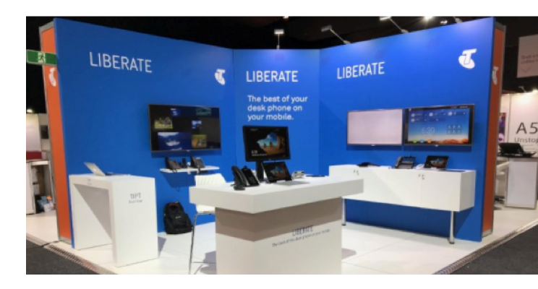

**How to guide for:**

**Liberate and Comms Recording (on TIPT)**

**The Loadsheet**





**Important information to note first!**

* **All** phone numbers in the Load Sheet, mobile **and** fixed, must be in **10 digit format** with **NO SPACES.**
* Complete **only** the worksheets relevant to the products you are ordering and leave unrelated worksheets alone.
* Mandatory fields only apply to the product you are ordering
* ONLY refer to the **BLUE** tabs in the Loadsheet ignoring all others.

|  |  |  |  |  |  |  |
| --- | --- | --- | --- | --- | --- | --- |
| Load Sheet worksheets to be completed | | | | | | |
| Product | **Customer Action** | **Order Info** | **Comms Rec New Customer** | **Comms Rec Professional Services** | **Liberate & Comms Rec Mobile** | **Comms Rec UC Services** |
| Liberate | **New** | **✓** | **🗶** | **🗶** | **✓** | **🗶** |
| **Add, Remove** | **✓** | **🗶** | **🗶** | **✓** | **🗶** |
| CCR on Mobile | **New** | **✓** | **✓** | **🗶** | **✓** | **🗶** |
| **Add, Remove** | **✓** | **🗶** | **🗶** | **✓** | **🗶** |
| CCR on UC | **New** | **✓** | **✓** | **🗶** | **🗶** | **✓** |
| **Add, Remove** | **✓** | **🗶** | **🗶** | **🗶** | **✓** |
| CCR on Mobiles & UC | **New** | **✓** | **✓** | **🗶** | **✓** | **✓** |
| **Add, Remove** | **✓** | **🗶** | **🗶** | **✓** | **✓** |
| CCR Prof Services | **New** | **✓** | **✓** | **✓** | ***As above*** | ***As above*** |
| **Add, Remove** | **✓** | **🗶** | **✓** | ***As above*** | ***As above*** |

**Sheet: Order Info**

**PURPOSE**: Displays a Summary of all orders being submitted on each worksheet.

Indicator revealing completion status of Loadsheet. Must be GREEN and say COMPLETE BEFORE submitting Loadsheet

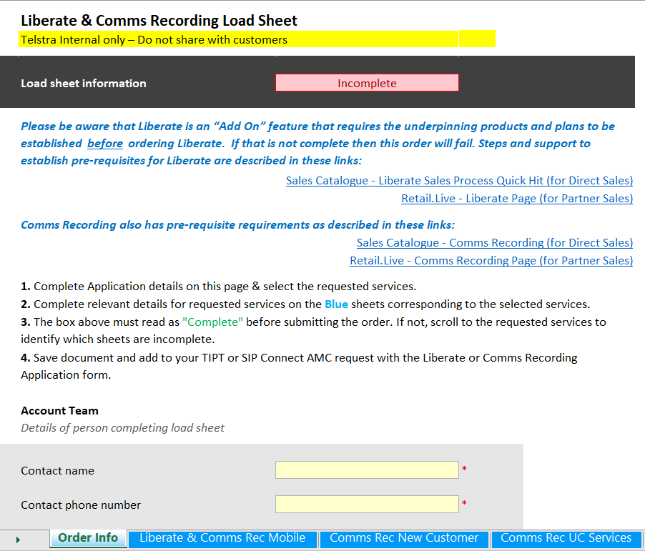

Enter customer contact name here **(no spaces)**

Contact number here **(no spaces)**

**Sheet: Order Info (continued)**

Enter customer number here **(no spaces)**

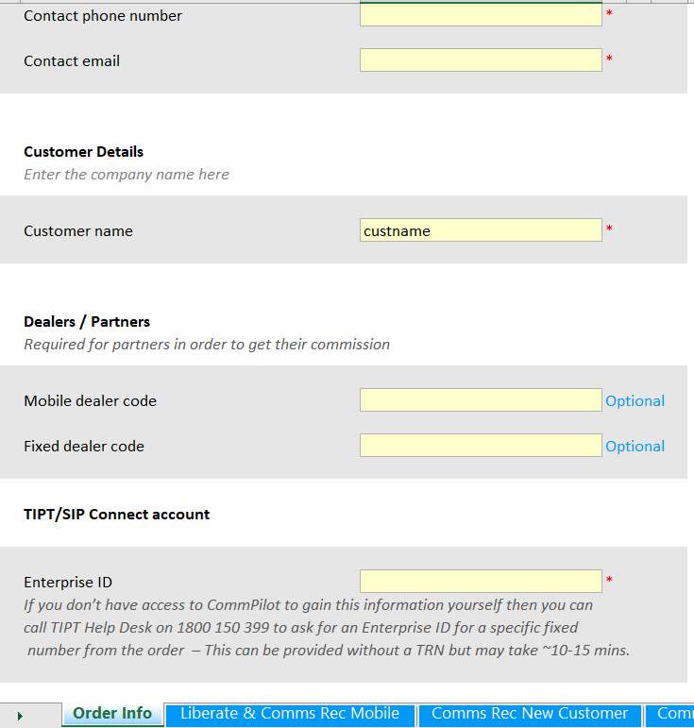

Enter customer contact email here **(no spaces)**

Enterprise ID is essential and will be used to populate subsequent sheets **(no spaces)**

Fixed number dealer code is 5 characters. **(no spaces)**

Mobile dealer code is 4 characters. **(no spaces)**

Enter company name here **(no spaces)**

**Sheet: Order Info (continued)**

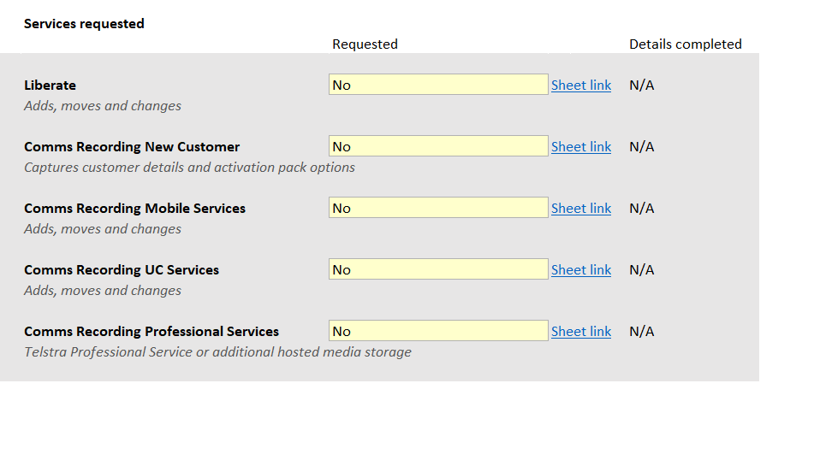

SELECT Sheet link to go to the corresponding sheet and fill it out.

SELECT from dropdown box YES if service is required.

Status showing if the corresponding sheet has been completed.

Each Must be GREEN and say COMPLETE (or left as N/A) BEFORE submitting Loadsheet

This status comes from the corresponding sheet

**Sheet: Liberate & Comms Rec Mobile**

**PURPOSE**: This sheet is used to enter Liberate and/or Comms Recording information. This sheet is mandatory but not all sections are. Only the sections pertaining to the product being ordered.

**If only Liberate is being ordered – this is the only worksheet to be completed after the Order info & Summary worksheet**

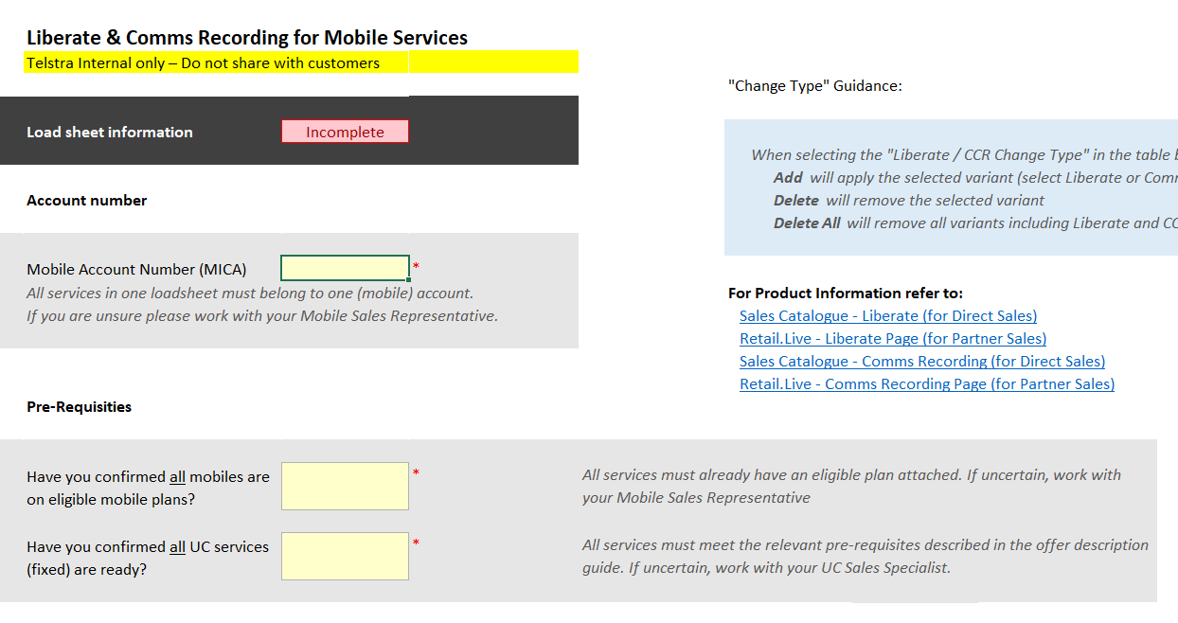

When you have confirmed this, enter ‘YES’ here.

More details available in ‘Product Information’ links above

When you have confirmed this, enter ‘YES’ here.

More details available in ‘Product Information’ links above

This will be presented on the Order Info sheet if this service has been requested

Enter mobile account number here. All mobile services must belong to the one MICA account number.

**Sheet: Liberate & Comms Rec Mobile (continued)**

**LIBERATE LOADSHEET SECTION**

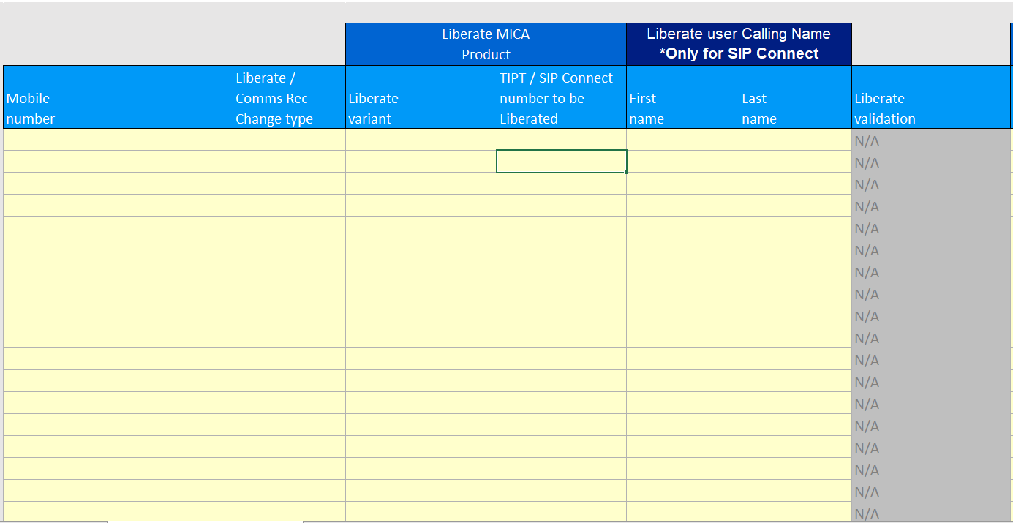

Choose from options:

**“**Add” to apply the variant you select further across this row

“Delete” will remove the selected variant you select

“Delete All” will remove all variants including Liberate and CCR - you do not need to select any variant for this option

**NOT TO BE FILLED IN**

This gives you a status to confirm if the details entered in the row are valid or provides an errro message if invalid

IGNORE - ONLY SIP CONNECT

Enter TIPT number to link to mobile number

IGNORE - ONLY SIP CONNECT

Enter mobile number to be liberated here

Choose Liberate product type –

“TIPT Liberate”

**Sheet: Liberate & Comms Rec Mobile (continued)**

**COMMS RECORDING LOADSHEET SECTION**

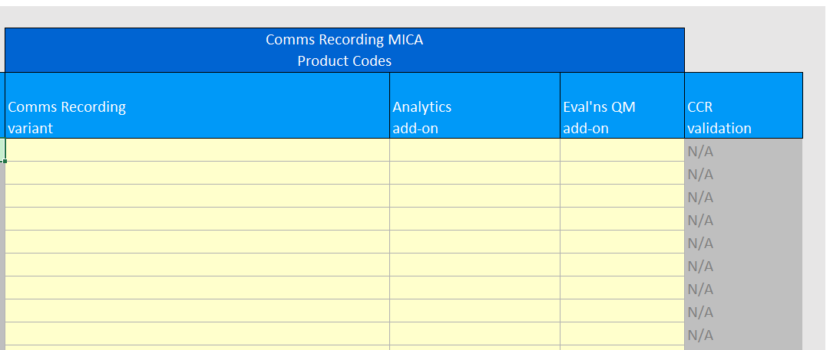

Choose the only product item from the dropdown list if the customer requested said add-on:

Evaluations QM

**NOT TO BE FILLED IN**

This gives you a status to confirm if the details entered in related columns

Choose one of the following product items from the dropdown list:

Audio and Mining Basic

Audio and Mining Advanced

Choose one of the following product items from the dropdown list:

Comms Rec Mobile – Voice and Messaging

Comms Rec Mobile Rec Always – Voice and Messaging

Note: If you are applying Comms Recording to a Liberated TIPT/SIP Connect service then you will see an extra warning message appear:

“If you want Comms Rec Add-ons (Analytics or Eval QM) these must be applied using 'Comms Rec UC Services' sheet.

You must also Select 'Comms Rec UC Services' in the 'Order Info' sheet.”

**Sheet: Comms Rec New Customer**

**PURPOSE**: This sheet is to register a new customer on Comms Recording product. If customer only wants Liberate OR the customer already has a Comms Recording product, then this sheet should be left blank.

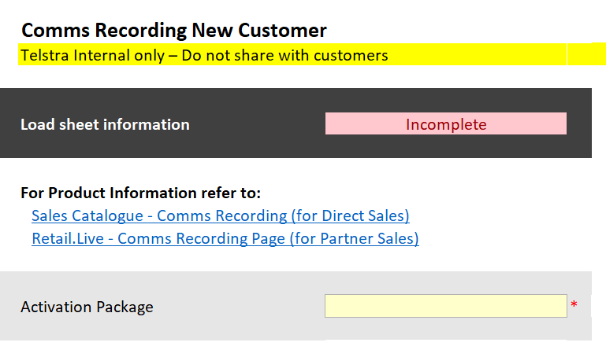

Choose one of the following product items from the dropdown list.

These correspond to the options in the table below and more details available in the “Product Information” links above

This will be presented on the Order Info sheet if this service has been requested

**Sheet: Comms Rec New Customer (continued)**

Summary of Comms Recording Activation packages on offer.

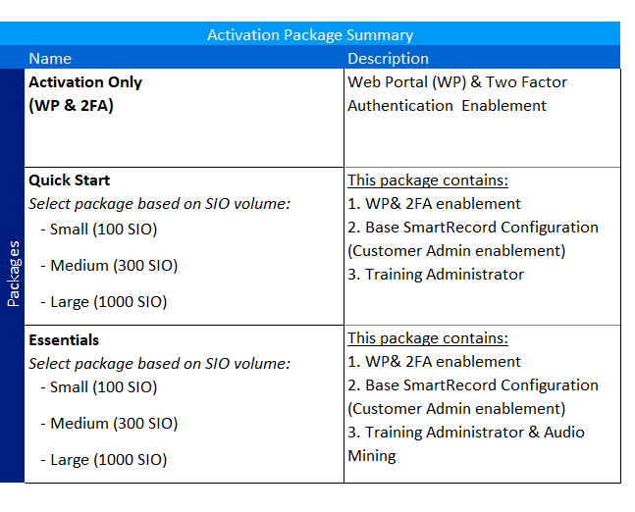

**Sheet: Comms Rec New Customer (continued)**

Here the names and email addresses of customer adminitrators for the Comms Recording product are entered..

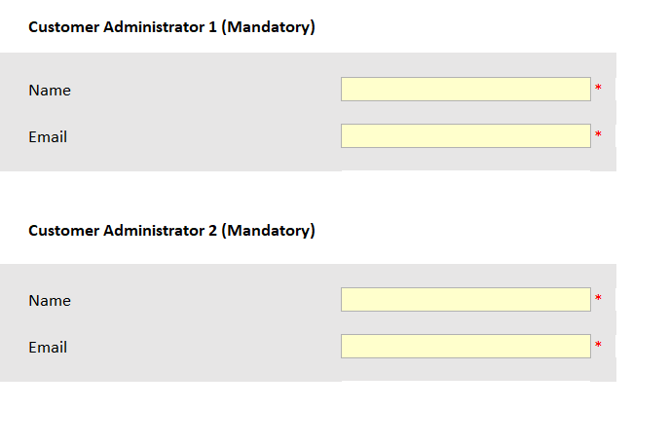

It is mandatory to include two Customer Administrators.

**Sheet: Comms Rec UC Services**

**PURPOSE**: This sheet is to be completed when Comms Recording is required on TIPT or SIP Connect (non-liberated).

This sheet must also be used to apply the Comms Recording Add-Ons ( Analytics and Eval QM) to a Liberate TIPT or SIP Connect service. In this case make sure to also select “Comms Rec UC Services” on the Order Info sheet.

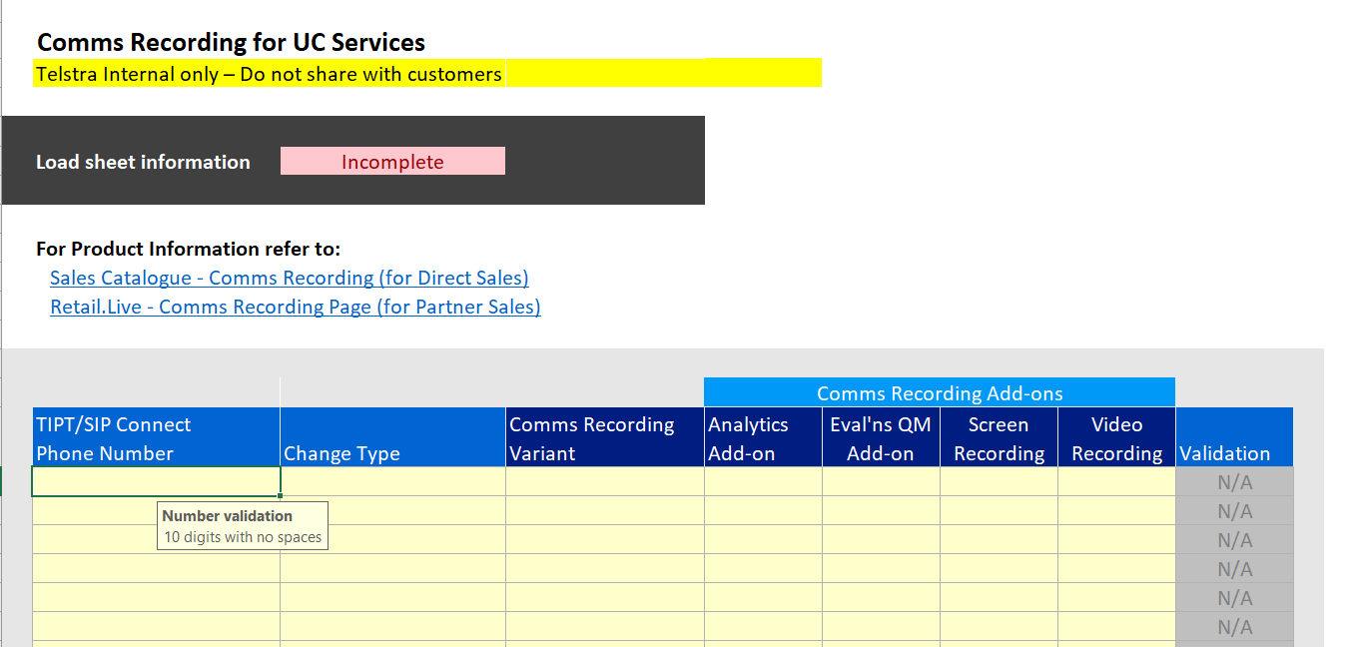

This will be presented on the Order Info sheet if this service has been requested

NOT REQUIRED TO FILL IN.

Information only.

Select “YES” in the dropdown list IF customer ordered add-on

Select “YES” in the dropdown list IF customer ordered add-on

Select “YES” in the dropdown list IF customer ordered add-on

Select from one of the options in the dropdown list:

Basic

Advanced

For TIPT select from one of the options in the dropdown list:

TIPT Basic

TIPT Record Always

Select from one of the options in the dropdown list:

Add

Delete

Delete All

Enter 10 Digit TIPT number

**Sheet: Comms Rec Professional Services**

**PURPOSE**: This sheet is to be used for ordering Professional Services for Comms Recording.

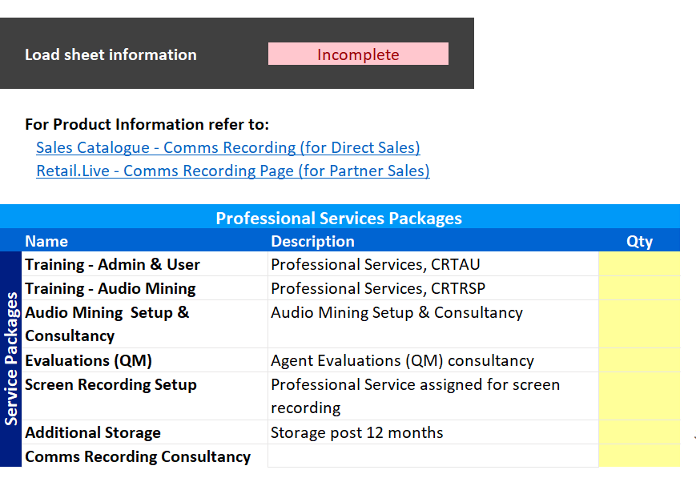

All fields:

Use numeric value to indicate the number of services customer wants to order

This field only:

Choose from storage options in the dropdown list

This will be presented on the Order Info sheet if this service has been requested

**Sheet: Data Validation Values**

**PURPOSE**: This sheet contains background calculations used by spreadsheet and to be IGNORED BY USERS.



**DO NOT CLICK ON THIS TAB - DO NOT CHANGE ANYTHING HERE OTHERWISE YOU WILL BREAK PROVISIONING!**

**ALSO IGNORE ALL OTHER NON-BLUE TABS IN THE SPREADSHEET.**

**OFFICE USE ONLY:**

|  |  |  |
| --- | --- | --- |
| **Version** | **Date** | **Comment** |
| 2.01 | 10/04/2018 | Corresponding to version 2.01(32) of the loadsheet |