2020



**Mission Trip Planning &**

**Fundraising Packet**

Showing and sharing the Gospel of Jesus beyond the walls of our campus into our city and to the ends of the earth

**Fundraising Through Faith**

**Missional Living Purpose**

Missional Living is Stonebriar Community Church responding to God and His Word by showing and sharing the Gospel of Jesus beyond the walls of our campus into our city and to the ends of the earth.

Our church is committed to loving our neighbors across the street and around the world. In 2020, we are asking you to PRAY and RESPOND to God as He leads you to be an AMBASSADOR for Him this year. (2 Corinthians 5:17-21; Matthew 22:37-40)

Pray to the Lord of the Harvest; “Lord, we know through your Word and the working of the Holy Spirit that you are working all over the world to bring glory to your Name. How/where can we join you? (Luke 10:1-3a)

Listen to the Lord. Once we pray to the Lord, listen to the Lord as He reveals to Stonebriar Community Church where we should get involved and join Him in that specific work. (Bible, People, Circumstances - Psalm 27:7-14)

Respond to the Lord. Once we identify where God is inviting us to join Him specifically, we begin to respond by equipping, training, preparing and educating ourselves for the ministry God is preparing us for. To fulfill the Great Commission of God and go into all the world (locally, nationally and internationally) and share Jesus. (Matthew 28:19-20; Acts 1:8)

GO! As we are going - Represent the Lord - As we respond, be reconciled to God representing Christ and the message of forgiveness and new life for all who believe. (2 Corinthians 5:17-21; Matthew 22:37-40)

**Responding to the call of going on a Mission Trip**

As you respond to God’s call on your life to go on a short-term Mission Trip, we realize the flood of questions and decisions you will have to make from this point forward. There could be barriers to cross, obstacles to overcome, and questions that might not have answers. This is all a part of the process, so we ask you to be patient, trust God and remember God has called you to go and share. He will provide you with the means for you to do His will, but we must do our part and faithfully follow Him on the journey.

This packet will help you as you faithfully answer the call to follow God and as you show and share the Gospel. I am excited for you as you walk with the Lord and prepare to “19 ...Go and make disciples of all nations, baptizing them in the name of the Father and of the Son and of the Holy Spirit, 20 and teaching them to observe all things I have commanded you. And low I am with you always, even to the very end of the age.” Matthew 28: 19, 20)



**The Faith of Fundraising**

**The Faith of Fundraising**

**FAITH:** The Ability to Trust God “Now faith is being sure of what we hope for and certain of what we do not see. This is what the ancients were commended for...And without faith it is impossible to please God, because anyone who comes to Him must believe that He exists and that He rewards those who earnestly seek Him.” Hebrews 11:1, 2, 6

**BIBLICAL PRINCIPLES FOR FUNDRAISING**

The Bible identifies three ways in which a Christian ministry can be supported financially.

**1. SELF-SUPPORT**—There were times in Paul’s ministry when he provided for his own financial needs by making tents. Some are called, like Paul, to support themselves. “And because he was a tentmaker as they were, he stayed and worked with them.” Acts 18:3. Also, read I Thessalonians 2:9.

**2. LOOKING TO GOD ALONE**—This means making one’s needs known to no one but God. There seems to be no text specifically describing this method, but we do have His promise of provision. “And my God will meet all your needs according to his glorious riches in Christ Jesus.” Philippians 4:19

**3. MAKING NEEDS KNOWN** —This means sharing the vision and ministry with friends and asking them to prayerfully consider supporting the ministry financially. Some Biblical examples are:

* *In Exodus 12:35, God instructed Israel to ask the Egyptians for articles of silver, gold and for clothing. In verse 36, we are told, “The Lord made the Egyptians favorably disposed toward the people and gave them what they asked for ....”*
* 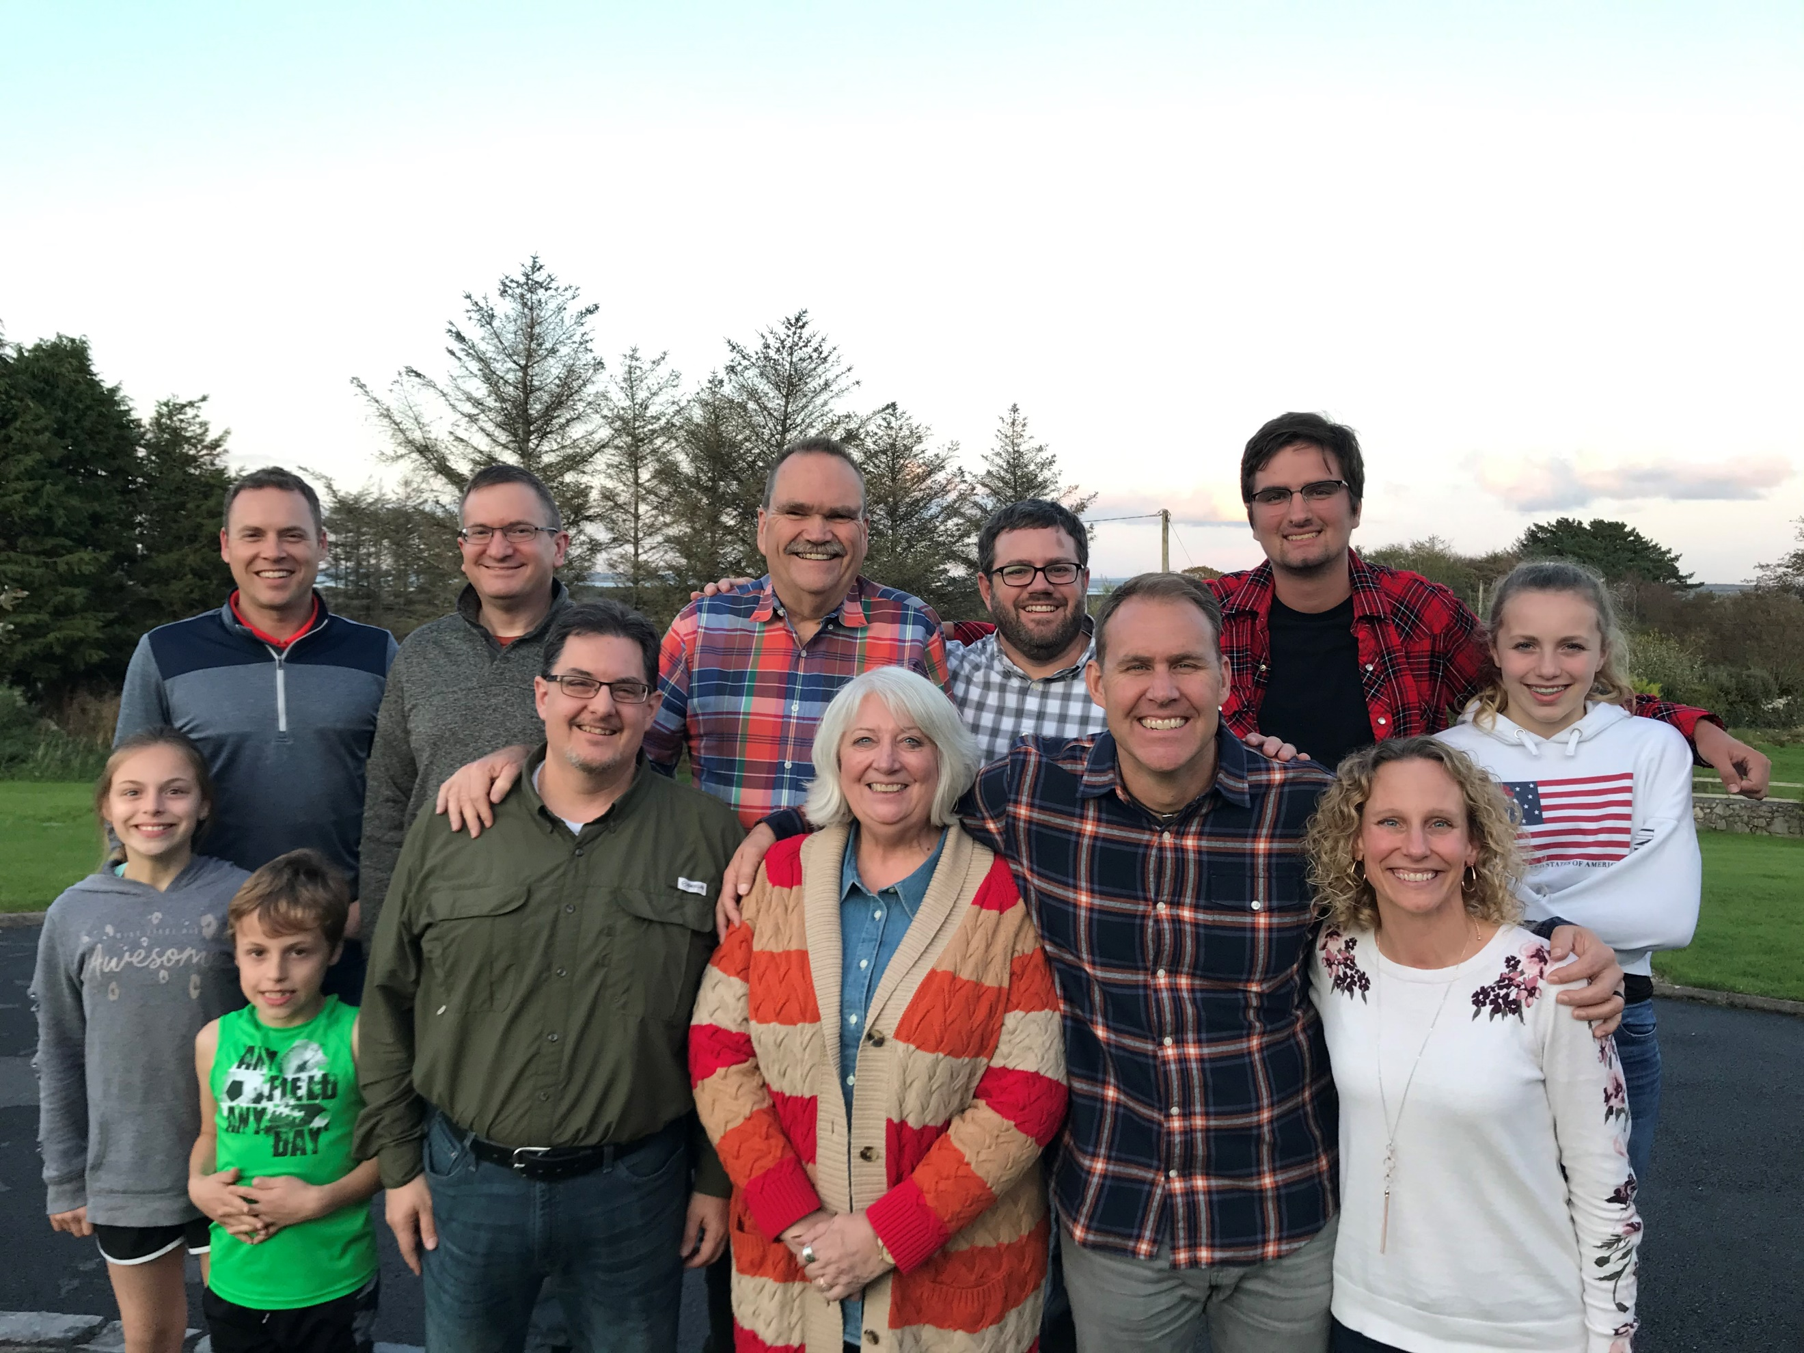*In 1 Kings 17 the Lord instructed Elijah to make his needs known to a widow living at Zarephath. As a result, she provided food and lodging for Elijah for as long as he needed.*
* *In Acts 11:28-29, a prophet by the name of Agabus came making a need known in a manner that prompted the following response. “The disciples, each according to his ability, decided to provide help for the brothers living in Judea.”*



**Foundations of Fundraising**

**Foundations of Fundraising**

**# 1 PRAYER**

Some aspects of the Lord’s work seem to require more prayer than others. Evangelism is probably one of these, as is fundraising. Perhaps more than any other single factor, prayer can be the key to raising funds. In fundraising, it is necessary that we admit we need God and begin to bring our prayers before Him. The Lord can work without us obviously, but He desires that we ask Him. “Until now you have not asked for anything in my name. Ask and you will receive, and your joy will be complete” (John 16:24, NIV).

* Moses understood this principle. Exodus 17:11 says, “When Moses held up his hand, that Israel prevailed: and when he let down his hand, Amalek prevailed.” Prayer made the difference.
* Jesus endorsed this principle when He taught His disciples to pray, “Thy kingdom come, thy will be done.”
* Prayer gives God an opportunity to work in the hearts of those with whom you will be sharing. Proverbs 21:1 tells “The king’s heart is in the hand of the Lord; he directs it like a watercourse wherever he pleases” (NIV). We should pray that God will lay it on the people’s hearts to give in response to our solicitation.

An important aspect of prayer is faith: faith that God has led us to be a part of Missional Living, faith that He has chosen us for this particular trip, faith that He desires us to make our needs known and that He will provide our needs, faith that He will provide us with the time and energy to assume the responsibility He wants us to take. We can have Sarah’s attitude as it is described in Hebrews 11:11, “Through faith also Sarah herself received strength to conceive seed, and was delivered of a child when she was past age, because she judged him faithful who had promised.” Sarah believed God and trusted Him to do the impossible, and He did it.

PRAY that your own commitment to fundraising will be wholehearted. If you secretly hope to put in a minimum of effort, you should reevaluate your commitment.



**Foundations of Fundraising**

**#2 SPIRITUAL PREPAREDNESS**

The most important element in success in raising support is our spiritual life. Set aside time every day to get alone with the Lord (John 15). Spend time reading the Scriptures, praising God and claiming His promises. He promises:

* He will give you what it takes to develop your support team. (1 Thes. 5:24)
* He will guide and direct you. (James 1:5)
* He will give you a joyful time of raising support. (John 15:10-11)
* He will protect you from the enemy’s lies, such as: “You’re a beggar.” “These people don’t want to see me.” “I’m not good enough for Christian work.” (2 Tim. 1:7)
* He will not allow anything to happen to His child that is not for your best. (Rom. 8:28)
* He will not fail or forsake you. (Rom. 8:35)
* Abide in Christ (John 15)

**# 3 PLANNING AND PREPARATION FOR MAKING NEEDS KNOWN**

If the Lord directs you to make your needs known, ask the Lord how to plan and prepare. In the process of developing plans, it is always necessary to set clear-cut objectives. Claim that the primary objective of a fundraising program is money. To claim otherwise, would be devious, disguising fundraising behind a cloak to make it more palatable. But money is not an end in itself. Money is simply a resource, an indispensable one for achieving one of the objectives Jesus gave you, which is “to go and make disciples of all nations.”

**#4 THE PRESENTATION**

Remember that people give to people. It is not a fancy brochure or a clever presentation that evokes a gift as much as it is **who asks** and **how they do it**. Keep in mind that you are not going for the person’s money, but you are going for Christ. Avoid the approach that communicates “I’m here to get something.” Emphasize the idea that “I want you to join me in this exciting ministry of helping to fulfill the Great Commission.” This places the emphasis where it ought to be–on developing friendships rather than on getting money. Answer questions like: Why are you doing this? What has God laid on your heart? What do you hope to see the Lord do in and through you? What difference will this ministry make in the lives of the people you are serving?

*If you create the impression that you are only after their money, they will never forget it. The point is to emphasize that they will be part of a ministry that is helping win the world to Christ. Our role is to present. This is very important to understand: If the Lord has called you, and if you are responsible to share Jesus every opportunity you have on the field, then you are not sharing your need. You are asking for the people on the field.*



**Strategies for Fundraising**

**Strategies for Fundraising**

**PERSONAL SACRIFICIAL GIVING**

Before asking for support from anyone else, ask yourself what you will sacrificially give to your own support. You cannot ask others to sacrifice financially if you are not willing to do the same. What are you willing to alter in order to give sacrificially? Are you willing to give up eating out, seeing movies or buying clothes? Part-time jobs can help provide personal support. Consider baby-sitting, house-cleaning, or mowing lawns. You may also have money in savings that could be contributed.

**PARTNERS IN MISSIONS - *Involve others in fundraising***

Individuals who are preparing to go on a Missional Living mission trip are encouraged to put together a support team, called “Partners in Missions”, to sponsor them. Your “Partners in Missions” support team will be made up of people who pledge to give and those that pledge to pray for you. Both are needed. Even if you are able to supply all your own funds a support team for prayer is still a vital aspect of your ministry. Support teams are a means of accountability. Students who have other people investing in their lives tend to be more accountable for their time, attitudes, and service while on a mission project.

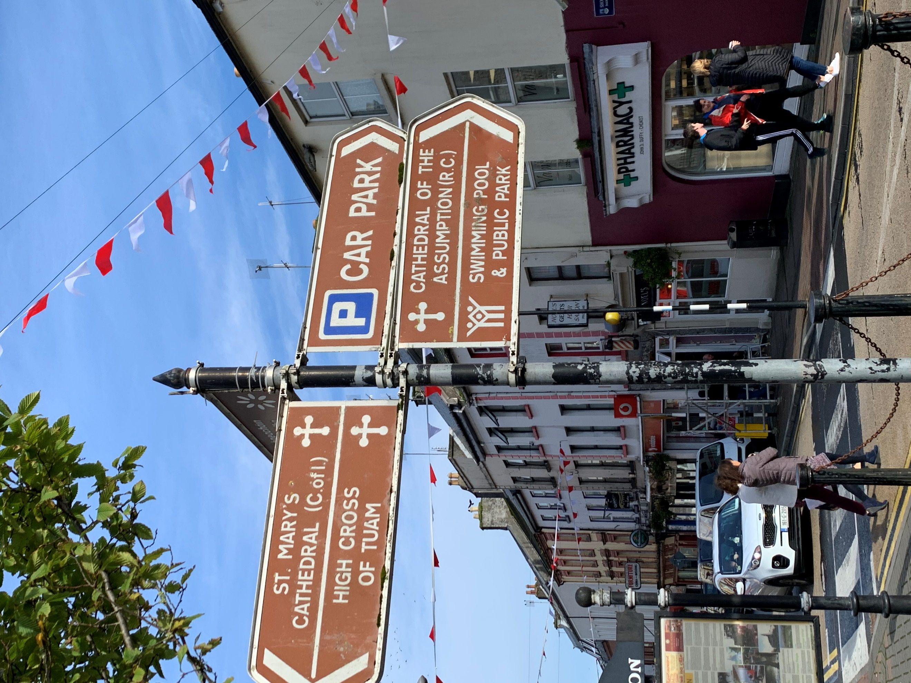On the next page, list below individuals you can contact to be a part of your “Partners in Missions” team. Write their name, contact information beside each name.



**Partners in the Journey of Missions**

**Partners in the Journey**

**FAMILY**

It is a good idea to find out if your family will be able to contribute to your missions trip. Consider asking not only your immediate family but your extended family as well. Consider asking for the trip as a gift rather than Christmas or birthday gifts.

**CORPORATE GIFTS**

Some companies set aside money for philanthropic activities. See this as a chance to share God’s work with the community.

**FUNDRAISING EVENTS**

Some people may not be able to give money, but they could give time to a car wash, garage sale, bake sale or spaghetti dinner. Ask them to join you in a fundraising event.

**PRAYER TEAMS**

Recruit 5 prayer teams of 5 people each. Each team commits to meet and pray for you once a week for at least 15 minutes. Each time they meet, they bring $2.00 each. In ten weeks, you would have $500. Designate a team leader to get the group together and collect the money. These groups can be made up of: family, friends, church staff, etc.

**PERSONAL CONTACT**

Support letters are an effective way to receive prayer and financial support. Use the “Partners in Missions” worksheet to write down every name you can think of; be creative. Phone calls and face to face conversations are typically the most effective. Invite people to coffee or a meal to develop relationships, but also present the partnership opportunity.

*Next, pray about them. Do not be too casual in this, the Holy Spirit may lead you to unlikely prospects!* ***You are not limited to asking only Christians either!*** *Remember in Exodus 12:35, God used the unbelieving Egyptians to supply the Israelites needs.*

*SPECIAL NOTE – Do not use online fundraising platforms like GoFundMe. You do not have permission to use the Stonebriar Community Church name or logo on these sites. The gifts are not tax-deductible, and the sites take a percentage of the donation as a fee.*



**Partners in Ministry Worksheet**

FAMILY MEMBERS: ______________________________________________________________________________

_______________________________________________________________________________________________

_______________________________________________________________________________________________

PEOPLE I’VE GOTTEN TO KNOW IN THE PAST YEAR: ___________________________________________________

_______________________________________________________________________________________________

_______________________________________________________________________________________________

PEOPLE I’VE MINISTERED TO IN THE PAST YEAR: _____________________________________________________

_______________________________________________________________________________________________

_______________________________________________________________________________________________

FRIENDS FROM CHURCH: ________________________________________________________________________

_______________________________________________________________________________________________

_______________________________________________________________________________________________

FRIENDS FROM HOME: ___________________________________________________________________________

_______________________________________________________________________________________________

_______________________________________________________________________________________________

PARENT’S FRIENDS: _____________________________________________________________________________

_______________________________________________________________________________________________

_______________________________________________________________________________________________

OTHERS:



**Support Letters**

**Support Letters**

**WHAT TO INCLUDE:**

* Introduction: make the letter warm and personal.
* Present your ministry/short term mission trip location: emphasize your call, your vision and your passion, share specifics of the work you will be involved in, the training you will receive, and the dates.
* Present your need: explain the role of a support team and your financial needs.
* Follow-up: whenever possible follow-up letters with a personal call or visit. Tell them of your plans to write after your trip is over.
* Finish your letter with a personal touch and express appreciation for the friendship of the person you are writing.

**HELPFUL HINTS:**

E-mail can be an effective way to communicate however many people may be more likely to respond to snail-mail.

* Keep it positive and personal.
* Keep it short and to the point (one page).
* Be bold and communicate clearly.
* Use the English language correctly. Have someone else read it to help with editing.
* Try to get face to face meetings as much as possible.

Social Media can also be an effective way of communicating your vision and passion for the short-term trip you are taking and promoting your purpose for going.

* Share your heart and ask your followers to join you in prayer and support
* Keep is simple and short
* Keep post to a minimum
* Put a link to where you are serving



**Support Letters Example**

**SAMPLE LETTER EXAMPLE 1**

Dear family and friends,

I hope this letter finds you and your family well. Things are going wonderful and smooth here for me at Dallas Baptist University as I am entering into my junior year. I’ve continued to pursue my degree in Business, and I know this is what the Lord has called me to.

Baseball is going great! I have been so blessed by this program. This fall our team has been given an opportunity to travel to Curacao to serve and share the Gospel the week of October 4th-8th. This is the first time I will be traveling with the team and am really looking forward to this opportunity. We will be hosting baseball clinics in the community and using that as a tool to reach across cultural differences and share the Gospel. I am very excited to be able to use some of the gifts, skills, and passions that the Lord has give me to reach people for Christ.

One of the most important things I will need from my friends and family is prayer. Things we would be needing prayer for: safety in travel, our boldness to share the Gospel, for the Lord to draw hearts to Him, for us to seek first His Kingdom instead of our own, and for God to get every bit of the glory while we are there. A second important thing I will need is financial support. The total cost of the trip including all traveling fees is $2000, and I would greatly appreciate your help getting there. The Lord has given me a special call to “go” and I believe he gives those that cannot go a special call to “send”. With saying that, please understand I realize that not everyone is called to help in every ministry and cause. I would ask that you would pray about supporting me financially and trust God’s voice in whether or not this is something you and your family can do at this time.

If you can support me with anything from $20, $50, or more, I would be more than grateful and blessed. If you are able to help financially, you may send checks to: Stonebriar Community Church, 4801 Legendary Dr, Frisco, TX 75034. Include your trip and name in the memo line. Also add any other way they may be able to donate (online).

The deadline for financial support is (DATE). All donations are tax-deductible.

I want to thank you in advance for supporting me however the Lord leads you. I am looking forward to this opportunity and partnering with those who will help me get there. When I return, I will send you a letter about how God has worked during the trip.

If you have any questions or would like any more information regarding this trip, you can contact me at: [insert your email address]

With my sincerest regards,

YOUR NAME



**Support Letters Example**

**SAMPLE LETTER EXAMPLE 2**

Dear ,

This summer I will be going on a mission trip to the Dominican Republic. This trip will take place July 13 through 20.

We will be working with the local church ministries in the Puerto Plata area. We will visit several areas to support the local churches with their evangelistic outreaches and church services. During the outreaches, we will help distribute food, seeds, clothing, school supplies and other basic needs to the needy families. We will also help the local churches with some light construction projects to help needy families living in their communities. We hope to have many opportunities to share the gospel of Jesus Christ with the people we meet.

Will you consider helping me in two ways? Praying. Please pray for the mission team to step out of our comfort zone and be bolder for Christ. Also for the people who live in the areas we visit, with whom we will be helping and sharing the love of Christ. Financial support. The cost for me to go on this trip will be $2,100. Would you prayerfully consider being one of my partners for this trip? I will follow up with you by (date) to see if there are any questions I may answer for you.

If you can be one of my partners for this trip, please make your check payable to Stonebriar Community Church (also list any other ways to donate). There is an envelope enclosed for you to return your check to me so that I can keep track of my progress.

I am looking forward to the new things that God will teach me through this experience. When I return, I will send you a letter about how God has worked during the trip and would love to have an opportunity to share more about my experience.

Very truly yours,

YOUR NAME



**Creative Fundraising Ideas**

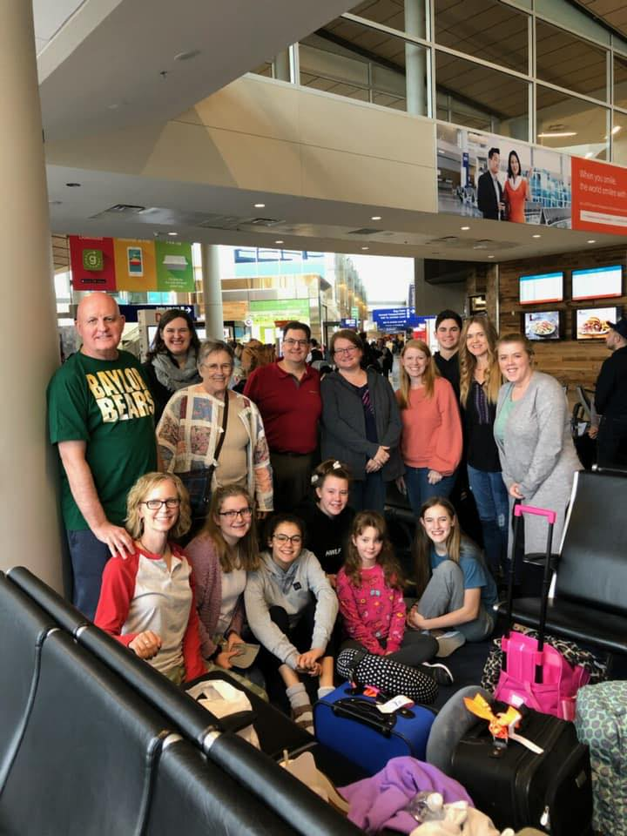**Creative Fundraising**

Think outside the box and have fun with it. There are numerous ways to raise money, along with sending our support letters. Here are just a few:

• BAKE SALES: Find the best recipe in the world for cookies and not just chocolate chip but cookies like snickerdoodles and oatmeal raisin clusters and have bake sales.

• CAR WASHES: Places like Wal-Mart will let you have it on their property but you have to plan it about a month in advance. And the best part is they even match what you raise.

• GARAGE SALES: Your fundraising comes at the most perfect time. Right now many people are doing lots of spring cleaning. Get some of your friends to help gather items and have a sale.

• DONATE YOUR SERVICES: Remember this summer is all about service so get started early. Start babysitting, lawn service, cooking or whatever you’re good at for donations. Your service will be blessed.

• SELL T-SHIRTS: I have seen many create their own t-shirt to promote the trip and to raise money for a trip.

• RAFFLE: Invite your friends and neighbors over for a potluck dinner after selling raffle tickets for a prize to be given away to the winner. Work with local organizations to donate a TV or gift cards

• Share Ideas with others on your team that are not listed here! Google CREATIVE FUNDRAISING IDEAS



**Thank You and Follow Up**

**Thank You Notes and Follow-up Letters**

“Thank you” cards should be sent to members of your support team whether they have committed to pray or to give financially. Handwrite these notes personally. Ask also for their prayer support as you serve in missions.

Here is a sample thank you note:

*Dear (Contributor’s name), Thank you for joining my “Partners in Missions” team with your financial gift. I greatly appreciate the affirmation you have given to me in my commitment to missions. I pray that my service will be an honor to your investment and to the Lord Jesus Christ.*

*Please keep me in your prayers as I serve this (DATE) in (LOCATION). Your prayers are also an important part of my ministry. When I am back from my mission trip, I will send you a report of my work.*

*Again, thank you.*

*Sincerely,*

**FOLLOW-UP LETTERS/PICTURES**

Send a letter to your “Partners in Missions” after you return from your mission trip. In your letter, be specific. Tell the person how your life was affected, the people you met, special experiences you had and the long- range effect on your work and on your life personally. Do not be vague: be real, honest and specific. Include pictures. If you have many people to write, you might want to adapt a newsletter-type way of sharing with each individual about the mission experience. Enclose a personal note in the newsletter. Again, thank your support team for its gifts and prayers. Such follow-up will make your support team feel it is and was important to your mission experience.

**VISIT ADULT FELLOWSHIP**

Many of your support came from the community groups you are a part of. Some of these groups might have even sponsored your trip through the GOLDEN TICKET. Make sure you report back to them your experience and what God did in and through your life and the life of others on the trip.



**Partners in Ministry Worksheet**

**Fundraising Plan**

My Personal Sacrificial Giving $  ____________

Family Support $  ____________

Prayer Teams $  ____________

Support Letters/Visits $  ____________

Home Church $  ____________

College Church $  ____________

Other Churches $  ____________

Fundraising Events $  ____________

Corporate Gifts $  ____________

TOTAL $  ____________

Remember you reap what you sow. So work hard and START EARLY!! God will bless your hard work when you serve wholeheartedly. Remember that the sacrifice and commitment involved is for the purpose of seeing God glorified among all of the peoples of the world!



**Contact Information**

**For more information…**

**Church Address**

4801 Legendary Drive, Frisco, Texas 75034

**Church Phone**

469-252-5200

**Website:**

[www.stonebriar.org/missiontrips](http://www.stonebriar.org/missiontrips)

**Facebook – LIKE US!!**

[https://www.facebook.com/gro ups/MissionalLiving/](https://www.facebook.com/gro%20ups/MissionalLiving/)

**Missional Living Team**

Keith Tyler, Pastor of Missional Living - keitht@stonebriar.org

Brandon Boyd, Associate Pastor of Missional Living - brandonboyd@stonebriar.org

Jean Allen, Ministry Coordinator for Missional Living - jeana@stonebriar.org