**The Talent Show**

**Тема:** Театралізація казок на англійській мові.

**Мета:** - розвивати творчі здібності учнів, креативне мислення, самостійність, естетичні смаки;

- вдосконалювати знання, вміння та навички, набуті на уроках іноземної мови;

- розширювати світогляд учнів;

- виховувати любов та повагу до людей свого рідного краю та країни, мова якої вивчається; виховувати бережливе ставлення до навколишнього середовища та тварин.

**Обладнання:** костюми тварин, декорації до казок, аудіозаписи англійських

пісень, магнітофон, плакат з темою виховного заходу.

**Хід заняття:**

Виходять учасники шоу талантів і співають пісню “Hello, how are you?”, вітаючись з гостями.  ***Song***

Hello, good morning.

How are you?

How are you?

Hello, good morning.

Hello, hello.

How are you?

How are you?

I am fine, thank you.

I am fine, thank you.

I am fine, thank you.

I am fine, thank you.

Hello, good morning.

Hello, hello.

How are you?

How are you?

I am fine, thank you.

I am fine, thank you.

I am fine, thank you.

I am fine, thank you.

**Compere 1:** Good morning, dear pupils, teachers and guests! We are very glad to see you at our party. The pupils of the fourth and second forms have prepared a very interesting programme for you. They will show their talents in staging, singing, reciting poems. Hope you will have a wonderful time together with our little actors and singers.

**Translator:** Доброго ранку, любі учні, вчителі та гості. Ми дуже раді бачити вас на нашому святі. Учні четвертих та других класів приготували дуже цікавий виступ для вас. Вони покажуть свої таланти в театралізації, співах, декламуванні віршів. Сподіваємося, що ви чудово проведете час разом з нашими маленькими акторами та співаками.

**Compere 2:** So welcome to our “Talent show”. By the way, what season is it now? Yes, it is autumn. So let’s invite the pupils of the 2-B form who will recite the poems about autumn.

**Translator:** Тож, ласкаво просимо до нашого «Шоу талантів». До речі, яка зараз пора року? Так, осінь. Тому давайте запросимо учнів 2-Б класу, які продекламують вірші про осінь.

**Pupil 1:**

Yellow, red and green and brown,

See the little leaves come down.

Dancing, dancing in the breeze,

Falling, falling from the trees.

We”ll be the wind, and blow today,

We”ll be the leaves, and dance away.

**Pupil 2:**

Autumn, autumn, autumn!

The summer is over,

The trees are bare,

There’s mist in the garden

And frost in the air.

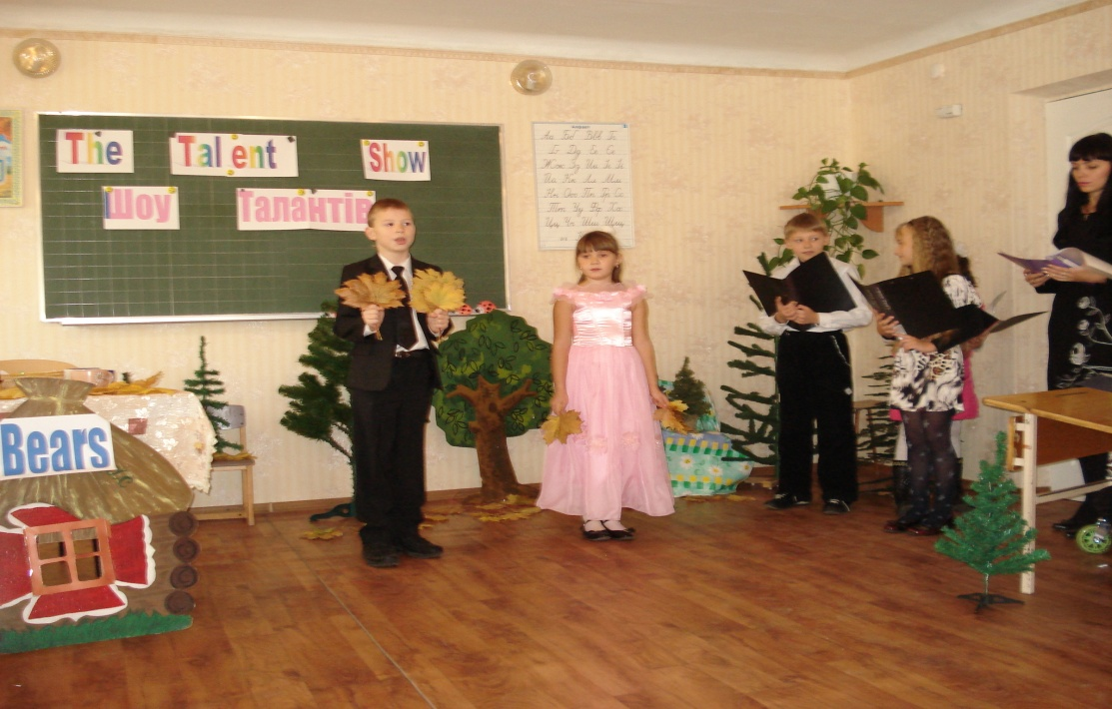

**Compere 1:** As you see, autumn is a nice season,but I like summer more. I like to swim in the river, go to the forest to pick flowers, gather berries and mushrooms.

**Translator:** Як ви бачите, осінь – гарна пора року, проте я більше полюбляю літо. Я люблю плавати в річці, ходити до лісу збирати квіти, ягоди та гриби.

**Compere 2:** Oh, but it’s rather dangerous. Don’t you know what happened to a girl who went to the wood?

**Translator:** Ах, але ж це доволі небезпечно. Ти не знаєш, що трапилося з дівчинкою, яка пішла до лісу?

**Compere 1:** No, I don’t.

**Translator:** Ні.

**Compere 2:** Then let’s see a play “The Three Bears” prepared by the pupils of the forth forms.

**Translator:** Тож, давайте подивимось виставу “Три ведмеді”, підготовлену учнями четвертих класів.

**The three bears**

Characters:

*Narrator*

*Father Bear*

*Mother Bear*

*Baby Bear*

*A Little Girl*

**Narrator:** The scene is taking place in the wood in the house of the three bears. They are sitting at the table and drinking milk.

**Mother Bear:** Take your cup, Father!

**Father Bear:** Thank you!

**Mother Bear:** Take your little cup, Baby!

**Baby Bear:** Thank you, Mummy, dear… Mother, it’s too hot!

**Father Bear:** Then let’s go for a walk.

**Narrator:** The three bears go out of the room.In a while a little girl comes in and looks around. (A little girl walks in the forest singing the song “I want to ride my bicycle” and then she sees the house of the three bears).

***Song***

I want to ride my bicycle,

I want to ride my bike.

I want to ride my bicycle,

I want to ride my bike.

**Little girl:** Whose room can it be? (Looking at the table) I am hungry.

**Narrator:** The girl sits down at the table and takes a cup of milk.

**Little girl:** Oh, this milk is too hot for me! Oh, this milk is too cold for me! This milk is just right for me! Oh, what is the noise?

**Narrator:** The girl hears the bears’ steps and quickly hides under the table. The bears enter the room and take their places at the table.

**Father Bear:** My cup is not full!

**Mother Bear:** My cup is not full either!

**Baby Bear:** And my cup is empty!

(They look around.)

**Father Bear:** Oh, who is this? It’s a little girl!

**All together:** Let’s eat her up!

**Little girl:** No, you won’t!

**Narrator:** The girl jumps out of the window and runs away. She’ll never come to the wood alone any more!

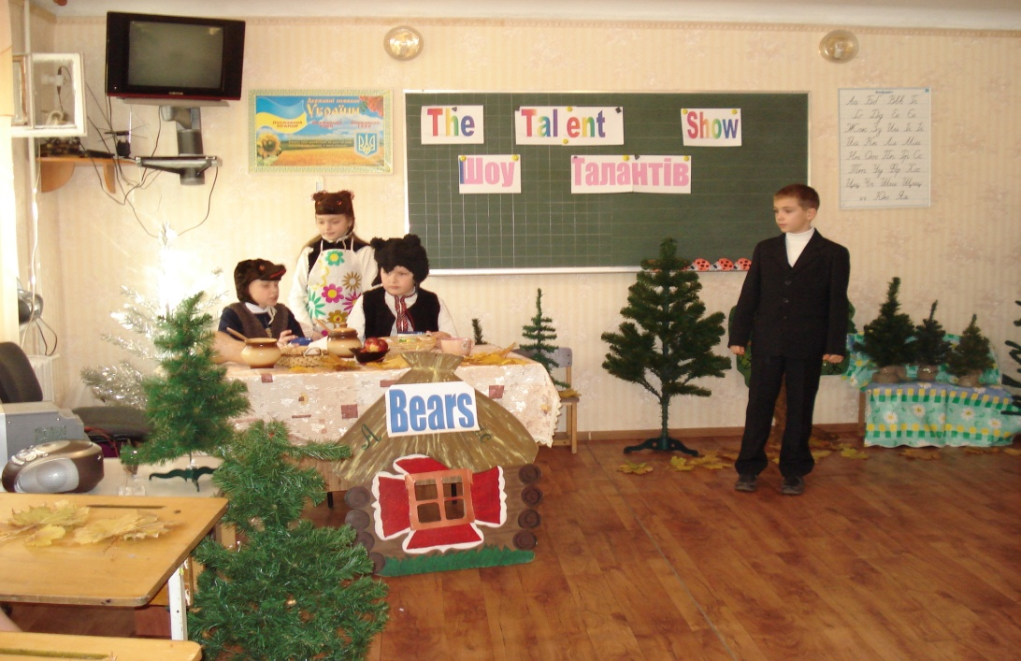

**Compere 1:** By the way, I know one more girl who went to the wood. Her name is The Red Riding Hood. Let’s see a Fairy tale prepared by our pupils.

**Translator:** До речі, я знаю ще одну маленьку дівчинку, яка пішла до лісу. Її звуть Червона Шапочка. Давайте подивимося казку про цю дівчинку, підготовлену нашими учнями.

**Little Red Riding Hood**

*Characters:*

Storyteller

Little Red Riding Hood

Wolf

Hunter

Granny

Mother

*( The storyteller appears on the stage.)*

**Storyteller:** Once upon a time there lived a small girl. Her name was Little Red Riding Hood because she had a small red cap on the head. One day…

**Mother:** Come here, Little Red Riding Hood. Your Grandmother is ill. You must go to see her. Take this cake to your Granny. Go quickly and don’t stop anywhere!

**Little Red Riding Hood:** All right, Mummy.

**Storyteller:** Little Red Riding Hood said “Goodbye” to her mother and left home. It was a lovely summer day, and the way to the Granny’s house lay through the wood. Little Red Riding Hood stopped to pick some flowers when suddenly she saw a Wolf.

**Wolf:** Good morning, Little Red Riding Hood!

**Little Red Riding Hood:** Good morning, Mister Wolf!

**Wolf:** Where are you going so early?

**Little Red Riding Hood:** I’m going to my Granny.

**Wolf:** And what is there in your basket?

**Little Red Riding Hood:** It’s a cake for my Granny, she’s very ill.

**Wolf:**  And where does your Grandmother live?

**Little Red Riding Hood:**  Her house stands under three very big trees in the forest. But excuse me, Mister Wolf, my mother told me not to stop anywhere. Goodbye, Mister Wolf!

**Wolf:** Goodbye, Little Red Riding Hood, see you soon!

**Storyteller:** The Wolf went away, and Little Red Riding Hood continued her walk. Soon she came to the Granny’s house and knocked at the door.

**Wolf:** Who is there?

**Little Red Riding Hood:** It’s me, Little Red Riding Hood.

**Wolf:** The door is open, come in, dear! Come nearer to me, I’m very ill, and I can’t see or hear you. Sit beside me on the bed.

**Little Red Riding Hood:** Granny, what big ears you have got!

**Wolf:** The better to hear you, my dear!

**Little Red Riding Hood:** Granny, what big eyes you have got!

**Wolf:** The better to see you, my dear!

**Little Red Riding Hood:** Oh, Granny, what sharp teeth you have got!

**Wolf:** The better to eat you up, Little Red Riding Hood!

**Storyteller:** With these words the Wolf jumped out of the bed and was ready to swallow the girl when suddenly a Hunter appeared.

**Hunter:** What’s the noise? Oh, it’s a Wolf!

**Storyteller:**  The Hunter took his rifle and shot the Wolf. The Granny appeared from the Wolf’s stomach.

**Granny:** Oh, my dear child, I’m so glad to see you!

**Little Red Riding Hood:** I’m glad to see you too, Granny. Here is a cake for you.

**Granny:**  Thank you, darling. (She hugs and kisses Little Red Riding Hood.)

**Storyteller:** This is the end of the story about Little Red Riding Hood, her sick Granny and a cunning hungry Wolf, who was finally shot by the brave Hunter.

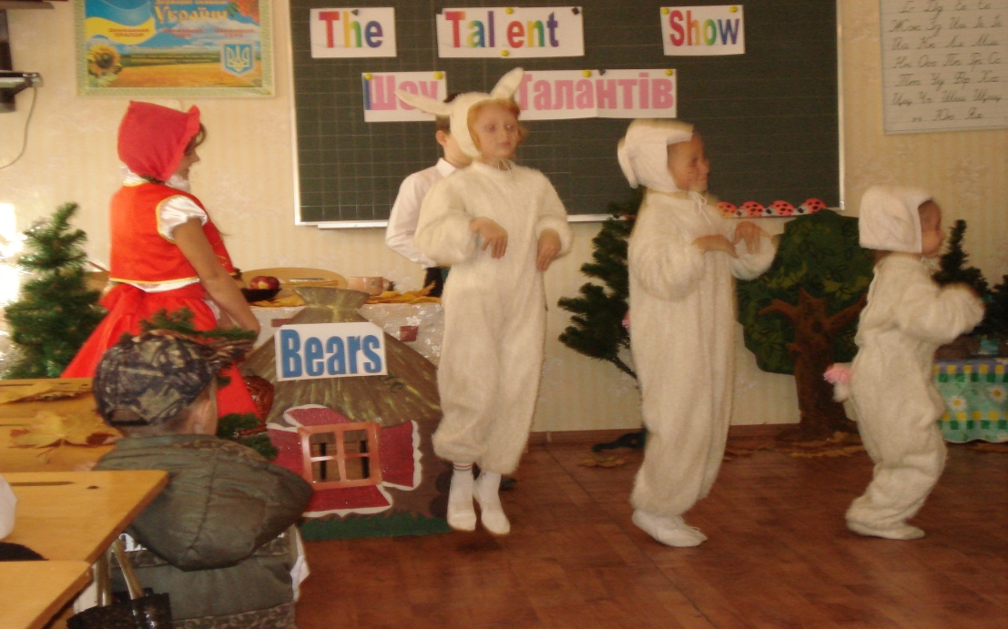

**Compere 1:** Did you like the fairy tale?

**Translator:** Тобі сподобалася казка?

**Compere 2:** Of course, I did. But frankly speaking, I’m a little bit tired of plays and fairy tales. How do you like the idea of listening to a song?

**Translator:** Звичайно сподобалася. Але відверто кажучи, я трішки втомився від казок. Чи ти не проти послухати пісню?

**Compere 1:** That’s great!By the way, the pupils of the fourth forms have prepared a beautiful song about Old Macdonald. Would you like to listen to it?

**Translator:** Це чудово! До речі, наші учні підготували гарну пісню про Старого Макдональда. Ти б хотів послухати її?

**Compere 2:** Certainly. Let’s invite our singers to the stage. (The pupils sing the song “Old Macdonald had a farm”.)

**Translator:** Звичайно. Давайте запросимо наших співаків на сцену.

**Old Macdonald had a farm (*Song*)**

Old Macdonald had a farm – EIEIO

And on his farm he had some chicks – EIEIO.

With a CHICK, CHICK here,

And a CHICK, CHICK there,

Here a CHICK, there a CHICK,

Everywhere a CHICK, CHICK.

Old Macdonald had a farm – EIEIO.

And on his farm he had some ducks – EIEIO.

With a QUACK, QUACK here,

And a QUACK, QUACK there,

Here a duck, there a duck,

Everywhere a QUACK, QUACK.

Old Macdonald had a farm – EIEIO.

And on his farm he had some pigs – EIEIO.

With an OINK, OINK here,

And an OINK, OINK there,

Here a pig, there a pig,

Everywhere an OINK, OINK.

Old Macdonald had a farm – EIEIO.

And on his farm he had some cows – EIEIO.

With a MOO, MOO here,

And a MOO, MOO there,

Here a cow, there a cow,

Everywhere a MOO, MOO.

Old Macdonald had a farm – EIEIO.

With a CHICK, CHICK here,

And a QUACK, QUACK there,

With an OINK, OINK here,

And a MOO, MOO there.

Old Macdonald had a farm – EIEIO.

**Compere 1:** Such a lovely song. I’m really love domestic animals: chicks, ducks, cows, pigs.

**Translator:** Така гарна пісня! Я дійсно люблю домашніх тварин: курчат, качок, корівок, поросят.

**Compere 2:** I agree with you. I love animals too. You know, not only people can be clever, our friends animals are clever too.

**Translator:** Я згоден з тобою. Я люблю домашніх тварин також. Ти знаєш, не лише люди можуть бути розумними, наші друзі-тварини розумні також.

**Compere 1:** Unfortunately, time flies quickly, and our show is coming to the end.

**Translator:** Нажаль,час летить швидко, і наше шоу добігає кінця.

**Compere 2:** We want to thank all the participants for their wonderful presentations, all the teachers for help in organizing such a performance and all the guests for visiting our show.

**Translator:** Ми хочемо подякувати всім учасникам за їх чудові виступи, нашим вчителям за їх допомогу у створенні такої прекрасної вистави та всім гостям за те, що відвідали наше шоу.

**Compere 1, 2:** Thank you. (They are bending)

**Translator:** Дякуємо.

**Compere 1:** We are really happy that the pupils of the fourth and second forms like to recite English poems, sing English songs and speak this language so well.

**Translator:** Ми дуже щасливі, що учні четвертих та других класів люблять декламувати англійські вірші, співати англійські пісні, та розмовляють цією мовою так гарно.

**Compere 2:** And our teachers are happy to have such talented pupils. By the way, do you know what people usually do when they are happy?

**Translator:** А наші вчителі щасливі, що мають таких талановитих учнів. До речі, чи ти не знаєш, що за звичай роблять люди, коли вони щасливі?

**Compere 1:** I guess they sing a song.

**Translator:** Я здогадуюся, що вони співають пісні.

**Compere 2:** Exactly! So, let’s invite the pupils for their final song which is called “A Happy Song”.

**Translator:** Точно! Тому давайте запросимо учнів для нашої фінальної пісні, яка називається «Пісня Щастя».

**If you’re happy… (*Song)***

If you’re happy and you know it, clap your hands.

If you’re happy and you know it, clap your hands.

If you’re happy and you know it,

Then you really ought to show it

If you’re happy and you know it, clap your hands.

If you’re happy and you know it, stamp your feet.

If you’re happy and you know it, stamp your feet.

If you’re happy and you know it,

Then you really ought to show it

If you’re happy and you know it, stamp your feet.

If you’re happy and you know it, slap your knees.

If you’re happy and you know it, slap your knees.

If you’re happy and you know it,

Then you really ought to show it

If you’re happy and you know it, slap your knees.

If you’re happy and you know it, click your fingers.

If you’re happy and you know it, click your fingers.

If you’re happy and you know it,

Then you really ought to show it

If you’re happy and you know it, click your fingers.

If you’re happy and you know it, do all four: clap, stamp, slap, click. (2 times)

If you’re happy and you know it, do all four: clap, stamp, slap, click. (2 times)

If you’re happy and you know it,

Then you really ought to show it

If you’re happy and you know it, do all four.

**Compere 1:** Our talent show is over. Thank you for your attention. Goodbye!

**Translator:** Наше шоу талантів підійшло до завершення. Дякуємо за вашу увагу. До побачення!

**Compere 2:** Goodbye!

**Translator:** До побачення!