**The Best of The Best**

**Інтелектуальний марафон для учнів**

**6 класів**

**Вчитель: Кривонос Т.В.**

**Практична мета:**

* актуалізація вивченого лексичного та граматичного матеріалу.

**Розвиваюча мета:**

* Розвиток монологічного мовлення на рівні мікровисловлювань
* формування навичок усного мовлення по темі.
* розвиток комунікативних навичок, мовної здогадки, уяви та творчості

**Виховна:**

* Виховувати пізнавальний інтерес до вивчення англійської мови
* Виховувати культуру спілкування.
* Сприяти загальонокультурному розвитку учнів

Обладнання: Картки, таблиці, презентація, малюнки, медалі, грамоти

***Хід уроку***

І. Організаційний момент

1. Підготовка до сприйняття іншомовного мовлення

T: Good morning, boys and girls! How do you do!

It’s really cool to see you today, because it’s an intellectual show **“Best of the Best”** and the motto of our game **is “We want to be the best, we try to be the best…”**

Today we’ll get to know who are the cleverest and the smartest pupils in English. You can see six pairs – twelve smart and good pupils. Welcome them. I’m sure you love learning English and we want to discover how good your knowledges are. Are you ready? Then let’s start.

2. Meeting Pairs

Our gamers are going to tell you something interesting about them. (кожна пара учасників представляється)

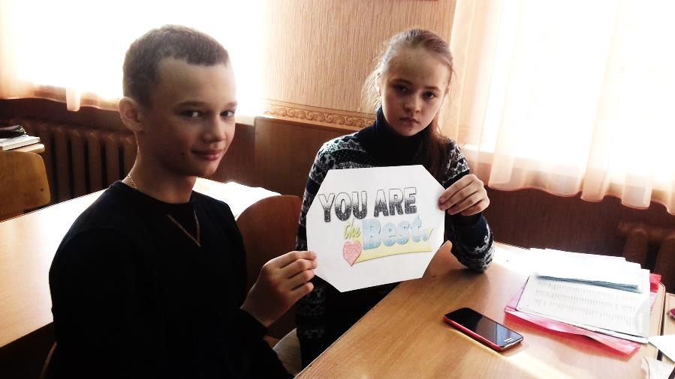

**Contest #1. How smart you are!**

The first contest is to guess the word. You should listen to the description and say what it is. You can see …. – if you know the answer ….

**Morning**—it is time, when you get up

**Ice-cream**--- it is cold and frozen, it can melt, children like to eat it

**Book**—you can read it

**Summer**--- it is a favourite season of all children

**New Year**—it is a holiday, means the beginning of all, year

**Computer game**—it is a game on computer

**Subject**—pupils learn it at school

**Teacher**—this person learns pupils at school

**Blackboard**- pupils write with a chalk on it at school

**Winter**- it is a cold season

**Summer holidays**---they last two month, it is a favourite period of all children

**Traveling**---it is a visiting of different countries

**Flower**—it is very beautiful, it can be of bright colours, it smells wonderfully

**Yesterday**—the previous day, the day before today

**Pet**---people have it at home, feed and walk it

Team can get 1 point for 1 correct answer.

**Contest #2 How is your Grammar?**

T: The next contest is “Grammar Blitz”. Your answers should be very quick. Your task is to choose the correct variant.

**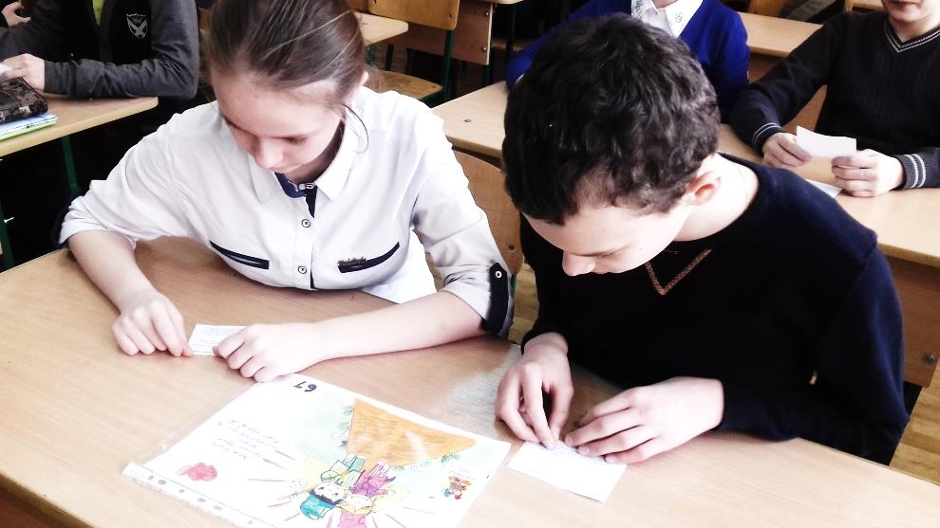**

1. I ….. a green karate belt already.
2. has got b) got c) have got
3. During the school year Kevin ….. live at home.
4. doesn’t b) don’t c) isn’t
5. Jill ….. a new computer.
6. Is wanting b) don’t want c) wants
7. …. does it look like? – oh, it’s very big.
8. Who b) What c) How
9. … you show us your new skates? – Sure, I can.
10. Can b) Do c) Are
11. Listen! Someone …. The piano in the house.
12. play b) plays c) is playing
13. What … you usually … at weekends?
14. are … doing b) do … do c) does … do
15. She speaks Italian …
16. Fluent b) fluently c) most fluent
17. She … be at home in time.

a) should b) might c) must

1. … I have some cookie, please?
2. may b) might c) can

Team can get 1 point for 1 correct answer.

**Contest #3. How quick you are!**

T: Now you should choose one of the topic and answer as many question as you can during one minute

|  |  |  |
| --- | --- | --- |
| images (1) | depositphotos_11418762-Kids-with-hobbies | weather |
| images | holiday-games-for-kids | maxresdefault |

SCHOOL

1. When does the school year star? (in September)
2. What age do Ukrainian pupils start going to school? (6 years)
3. Where do you learn about the things and people in the past? (History)
4. What do we learn to do in PE lessons? (to do sports)
5. When do English pupils have lunch at school? (12:30)
6. Where do pupils put their school things? (in the bags)
7. How are your friends called at school? (classmates)
8. Who gives you knowledge? (teacher)
9. What room do you have your lessons in? (classroom)
10. What helps you to do your homework? (computer)

HOBBIES ANS SPORTS

1. What can you be a member of? (club)
2. What can you do with coins, stamps and comics? (collect)
3. When can we do our hobby? (in our free time)
4. What can you do with musical instruments? (play)
5. What is the symbol of the Olympic Games? (fire)
6. What sport is Yana Klochkova famous for/in? (swimming)
7. Where did the first Olympic Games take place? (in Greece)
8. How is a group of players called in sport? (team)
9. What is the national British sport? (cricket)
10. What hobby can you have outside/ in nature? (camping)



WEATHER

1. What tells us the weather? (weather forecast)
2. What is the opposite for sunny weather? (cloudy)
3. When it is wet and muddy? (in rainy weather)
4. What season comes after autumn? (winter)
5. How many months in the year? (twelve)
6. What are summer months? (June, July, August)
7. What do we need when it’s raining outside? (an umbrella)
8. Where can we go only in summer? (to the seaside)
9. What is the shortest month of the year? (February)
10. What is the opposite for warm? (cool, chilly)

FOOD

1. Which drink is good for your teeth and bones? (milk)
2. What’s bad for your teeth? (sweets)
3. How many food groups do we know? (four)
4. What is the most famous Italian food (pizza and pasta)
5. How do we call food between meals? (snack)
6. What do Englishmen like to eat? (fish and chips)
7. What is Japanese popular food? (sushi)
8. What dish is karri? (Indian)
9. How do we call our national soup? (borsch)
10. What food group do eggs belong to? (meat)

HOLIDAYS

1. What do we decorate at New Year? (Tree)
2. When do we celebrate Victory Day? (May, 9)
3. What do we paint at Easter? (eggs)
4. What is the symbol of St. Valentine’s Day? (heart)
5. Who brings presents at Christmas? (Santa)
6. What holiday do families gather on Thursday and thank each other and the God? (Thanksgiving day)
7. Which holiday is for witches, ghosts and holly things? (Halloween)
8. What is the symbol of Easter in England? (bunny)
9. ****When do we celebrate women’s day? (March, 8th)
10. A special day for every people (birthday)

FAMILY

1. Your parents parents? (grandparents)
2. Children of your aunts and uncles? (cousins)
3. Your mother is for your father? (wife)
4. Who is your sister for your brother? (sister)
5. How do we call a small kid? (baby)
6. Where can the family live? (In the house)
7. Where does the family keep photos? (in the album)
8. When family gather in the living-room and watch TV? (spend time together)
9. How do we call a family party outside? (picnic)
10. A day of the family birth? (wedding day)

Team can get 1 point for 1 correct answer.

**Contest #4. How is your Speaking!**

**Say what shop it is? What can we buy there?**

Clothier's shop

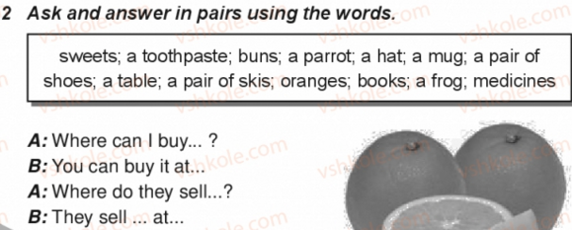

Toy’s shop

Butcher's shop

Newsagent's shop

Chemist's

Footwear

Baker's

Bookstore

Fishmonger’s

Dairy’s

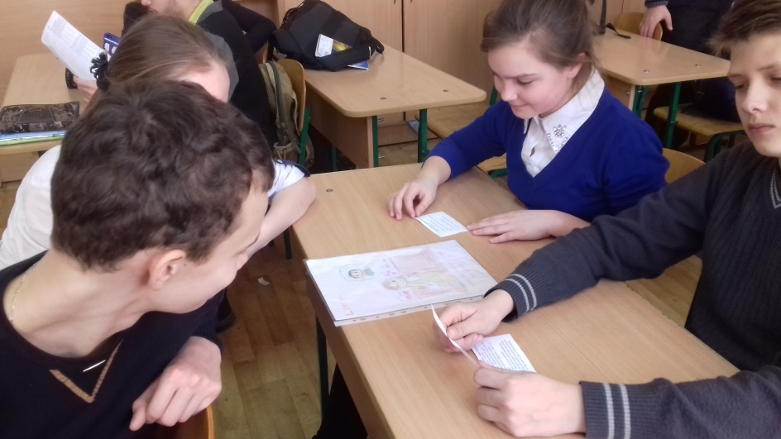

**Contest #5. How is your Vocabulary!**

**Match**

1. **To go out a) for guests**
2. **To have b) fluently**
3. **To make invitations c) with friends**
4. **To spend d) the world**
5. **To do sports e) in the gym**
6. **To play games f) a birthday party**
7. **To travel around g) free time**
8. **To speak languages h) outside**

**Make up sentences with them**

**Contest #6. How imaginative you are!**

Complete the rhyme.

This is a word which rhymes with cat,

It goes on your head because it's a \_\_\_\_\_\_\_\_\_\_\_ **(HAT.)**

I'm useful for journeys when you're going far,

I need lots of petrol because I'm a \_\_\_\_\_\_\_\_\_\_ **(CAR.)**

This is a word which rhymes with up.

You can drink out of me bcause I'm a \_\_\_\_\_\_\_\_\_ **(CUP).**

This is a word which rhymes with bake,

I'm nice to eat because I'm a \_\_\_\_\_\_\_\_\_\_ **(CAKE.)**

This is a word which rhymes with spoon,

I shine at night because I'm the \_\_\_\_\_\_\_\_ **(MOON.)**

A neverending circle, a bright shiny thing,

It's on my fourth finger because it's a \_\_\_\_\_\_\_ **(RING.)**

**Think of five words that can rhyme (cat, hat, sat, fat, bat)**

Team can get 2 points for 1 correct answer.

**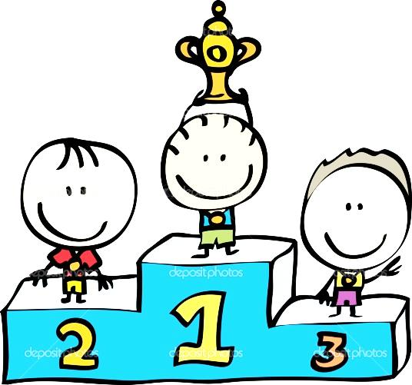**

**Summarizing**

T:    I’m happy to announce the results of our competition.

Team 1 has got ….. points.

Team 2 ….

Team 3…

Team 4 ….

Team 5 …

Team 6 …

Thus  you have finished with the score….. in favour of the

team … But you did your best to win and you will get awards now!