Відділ освіти Павлоградської міської ради
Павлоградська загальноосвітня школа І-ІІІ ступенів №9

Узагальнюючий урок-змагання
з теми:
«Їжа та напої»
7 клас,
англійська мова

Учитель іноземної мови:
Юровських Світлана Миколаївна

м. Павлоград
2017

ТЕМА: Їжа та напої.
ПІДТЕМА: «Приготування їжі».
МЕТА УРОКУ:
1. Систематизувати лексичний матеріал з теми, практикувати учнів у монологічному та діалогічному мовленні, використовуючи активну лексику та вивчені структури.
- Продовжувати формування навичків усного мовлення, розвивати комунікативні здібності учнів.
- Розвивати пам’ять, мовну здогадку, логічне мислення учнів
4.Виховувати в учнів культуру харчування та інтерес до кулінарних традицій України та Великобританії .
МОВНИЙ МАТЕРІАЛ: лексика, структури з теми.
ОБЛАДНАННЯ: підручник А. Несвіт «Англійська мова 7 клас»; картки з завданнями для парної роботи та груповими завданнями; тематичні ілюстрації.
ХІД УРОКУ
1. Організаційний момент.
Т. Good morning, children! I am glad to see you! How are you?
Ps. We are super!
T. Ok! Let's sit down and start our work.
2. Введення в iншомовну атмосферу.
Food places an important role in our life. Food makes us strong and gives us enough
energy during the day. Our daily menu must contain all the things we need to be
healthy. Our food must be a source of nutrients and provide us the things we need to
live, to grow and to keep fit.
Запитання до учнів:
T. Do уоu кеер to a balanced diet?
P1) Yes, I do. I keep to a balanced diet.
T. Do you prefer eating healthy food?
P2. Yes, I do. I prefer eating healthy food
T. Why do you prefer eating healthy food?
P3. I prefer eating healthy food, because I want to be strong and healthy, active and lively, to keep fit, to look good.
3. Повідомлення теми та мети уроку.
Our today’s topic is "Food and drinks". Today we'll continue our talk about food and cooking, we `ll remember the words on the topic and practise them in texts, games, dialogues and exercises. Our today's lesson is the competition between your 3 teams. At the end of our lesson we’ll know the winner.
4. Мовна зарядка.
Фонетичне відпрацювання римування.
Listen and repeat after me.
"Fish and chips is English,
Sushe's Japanese,
Pizza is Italian,
So is Mozzarella cheese.
In Spain they eat paella,
In China they eat rice,
The Russian thing potatoes
Are really, really nice"
5. Мовна вправа
Match the proverbs about food with their translations.
Учні читають прислів'я про їжу, поєднують їх з перекладом. Змагання між командами.

1. Appetite comes with eating | a. He красна изба углами, а красна пирогами
2. Taste differ | b. Маслом кашу не испортишь
3. Porridge and cabbage soup is our native food | с. Аппетит приходит во время  еды
4. Too much butter won't spoil the porridge | d. Щи да каша - пища наша
5. A home is made by pies not by wall | є. О вкусах не спорят
6. Not enough salt is hardly a fault, but too much salt is cook's fault | f. На вкус и цвіт товарищей нет
7. Every man to his taste | g. Кто не работает - тот не ест
8. No song, no supper | h. Словами сыт не будешь
9. Fine soft words butter no parsnips | і. Недосол на столе, пересол на спине
10.After dinner sit a while, after supper walk a mile | j. Кто быстро ест, тот быстро работает
11.Breakfast like a king, lunch like a queen, and dinner like a pauper | к. После завтрака немного посиди, после ужина милю пройди.
12.Quick at meat, quick at work | І. Завтрак съешь сам, обед раздели с другом, а ужин отдай врагу.
Key: 1-е 2-е 3-d 4-b 5-а 6-і 7-f 8-g 9-h 10-k 11-1 12-j

6. Лексична вправа.
And now let's repeat our words. Every day we usually have 3 or 4 meals a day: breakfast, lunch, dinner and supper. What do you usually have for breakfast? For dinner?For supper? Fill in this table.Учні заповнюють таблицю, записують назви страв, які вони їдять на сніданок, обід, вечерю. (Варіанти відповідей учнів)

Breakfast | Dinner | Supper
Cereal with milk | Soup or borsch | Spaghetti with sausage
В acon with eggs | Potatoes or vegetables | Fish or meat
Omelet with vegetables | Fish or meat | Mashed potatoes
Sandwiches with cheese | Vegetable salad | Pancakes with cream
Fruit salad | Cakes or biscuits | Meat salad
Toasts with jam | A glass of juice or compote | A glass of yogurt or cocoa
A cup of tea/coffee | Sweets or fruit | Fruit or cookies

Змагання між командами. Учні виправляють помилки на дошці. Вчитель рахує бали, оголошує, яка команда набрала найбільшу кількість балів на даному етапі уроку.

7. Тренувальна вправа. Використання інтерактивного методу«Мікрофон».
Imagine that a reporter came to you. He wants to interview you about your eating preferences. Use the words from the table and answer his questions. Reporter:
• What do you usually have for breakfast? For dinner? For supper?
Учні відповідають на запитання репортера. Вони складають речення з опорою на таблиці попередньої вправи. Кожна вірна відповідь - один бал. Вчитель рахує бали командам.
Варіанти відповідей учнів:
- І usually have some cereal with milk, toasts with jam, a cup of tea for breakfast.
- I usually have a plate of borsch, mashed potatoes with meat, a glass of compote with cakes for dinner.
- I usually have some spaghetti with sausage, pancakes with cream, a glass of cocoa for supper.
8. Рольова гра "Мій новий друг з листування».
Використання інтерактивного методу «Панель».
And now we have a role-play. Imagine that Kate is your new pen-friend. Ask your questions about her eating preferences?
Учні ставлять запитання “новому другові”. Кожне вірне запитання - один бал. Вчитель рахує бали командам. Варіанти запитань учнів:
- What is your name?
- How old are you?

- What kind of food do you eat?
- How many meals a day have you got?
- What do you usually have for breakfast? For dinner? For supper?
- What does your mother usually cook for your family holidays?
- What are your favourite dishes?
- What are your favourite drinks?
- What is your favourite dessert?

- Do you like to cook?
- Can you make any dishes?
- Who usually cooks meals in your family?
- What is yummy for you?
- Why do you prefer eating healthy food?- Nice to meet you!
9. Аудіювання тексту "Potato cakes".
Listen to the text "Potato cakes", do the tests.
The first test: Put the sentences into the correct order.
The second test: True or false.
1) Етап підготування до аудіювання
Ознайомлення з новими словами
We write 400 g potatoes, but we say: four hundred grams of potatoes.
- Етап аудіювання. Учитель двічі читає текст
Listening comprehension
"Potato cakes"
Ingredients:
400 g potatoes, 125 g flour, 40 g grated cheese, 40 g butter or margarine, salt.
Instructions:
- Peel the potatoes and slice them.
- Put the potatoes into a saucepan with some water and a bit of salt and boil for 20 minutes.
- Mash the potatoes.
- Put the mashed potatoes, the flour, and the butter or margarine into the bowl and mix them with a fork.
- Make 12 potatoes cakes with the mixture.
- Fry the potato cakes in a frying pan until they are brown on both sides.
- Cover the cakes with the grated cheese. Put them in a dish and keep them warm in the oven.
Test 1.
Put the mashed potatoes, the flour, and the butter or margarine into the bowl and mix them with a fork.
Mash the potatoes.
Make 12 potatoes cakes with the mixture.
Peel the potatoes and slice them.
Fry the potato cakes in a frying pan until they are brown on both sides.
Put the potatoes into a saucepan with some water and a bit of salt and boil for 20 minutes.
Cover the cakes with the grated cheese. Put them in a dish and
keep them warm in the oven.
Put the sentences into the correct order: 1-7 points

Key: 1-d, 2-f, 3-b, 4-а, 5-е, 6-е, 7-g
Test 2.True or false: 8-12 points
1)This is a fruit dish
- It consists of 5 ingredients
- First you peel, slice and fry the potatoes.

- You can use some butter in this recipe.
5) You can make 20 potato cakes with this mixture.
Key: 1-F, 2-T, 3 - F, 4 – T, 5 – F.
10. Рольова гра. Майстер-клас «Найкращий рецепт».
Today we organize "Master-class "The best recipe ever!". The best cooks of the world will tell us how to make the best dishes. Listen to their recipes attentively and then answer the questions:
- What country is this dish from?
- What are the main ingredients?
- How much time do we need to make this dish?
Учні слухають рецепти-діалоги «куховарів» та відповідають на запитання. Кожна вірна відповідь - 1 бал. Вчитель зараховує додаткові бали командам.
Dialogue 1 "Pasta with sauce and cheese"
- This dish tastes delicious, Ann!
- Thanks. I was trying to do my best. Besides it is easy to make.

- How do you make it?
- Look! First, peel the tomatoes and slice them into long strips. Clean and chop 2 onions. Then fry them on a frying pan on cooking oil for 10 minutes. Add some pepper. After that boil some pasta with a bit of salt for 8 minutes. Then drain the water and pour tomato sauce over pasta. Finally, sprinkle some grated cheese on the top. Pasta with sauce and cheese is ready. Enjoy your meal!
1. Thank you!

Dialogue 2 "Muffins"
1. Good morning. What are you doing?
2. I'm making muffins.
1. May I help you?
2. Yes, you may. Thank you. Mix 3 eggs, 200 grammes of sugar, 200 grammes of cottage cheese, 150 grammes of butter, 200 grammes of flour in a large bowl. Pour dough into the baking cups. Mix the brown sugar and cinnamon together. Sprinkle this mixture on the muffins. Put the muffins into the oven to bake for 20 minutes. Enjoy your meal!
1.Thank you!
Dialogue 3 "Ukrainian borsch"
1. Your borsch tastes delicious, Jane!
2.Thanks. I was trying to do my best. Besides it is easy to make.
1. How do you make it?
2. Look! I take a big casserole, pour 3 litres of water and put it on the cooker. I put 500 grammes of meat into the casserole and boil it for 30 minutes. Then I clean and chop 3 potatoes, 2 onions, 4 tomatoes, 1 carrot, 1 beet, 1 garlic, a cabbage. I put potatoes into a casserole and boil them. Then I fry onions, tomatoes, a carrot, a beet on a frying pan on cooking oil for 10 minutes. 1 mix well. I add this mixture into a casserole. I put a garlic, a cabbage, some pepper, some salt into a casserole, too. After that I boil my borsch for 10 minutes. Enjoy your meal!
2.Thank you!
11. Ситуативні діалоги. «В кафе» "In a cafe".
Make up dialogues. Show us what to say when you are in a cafe, how to ask for a menu, how to make an order, how the meals are called in the menu.
Dialogue 1.
- Good morning. Can I help you?
- Can I have the menu?_
- Here you are. Are you ready to order your meal?
- I'd like mashed potatoes, fried fish, a vegetable salad.
- Anything else?
- A sandwich with ham and cheese.
- Would you like any drinks?
- A cup of tea, please
- That's 11,85.
- Here you are.
- Thank you. This is your change and this is your order. Enjoy your meal!
- Thank you.
Dialogue 2.
- Good morning! Welcome to our cafe!
- Thank you. Can I have the menu?
- Here you are. Are you ready to order your meal?
- Yes, I am. A two-egg omelet with bacon, a roast duck with apples, some pasta.
- Good. Any dessert?
- Yes, a chocolate cake with strawberries.
- Would you like any drinks?
- A cup of coffee, please.
- That's 14,75.
- Here you are.
- Thank you. This is your change and this is your order. Enjoy your meal!
- Thank you.
Dialogue 3.
- Good morning!
- Morning!
- What would you like to have?
- I'd like to have fried potatoes, a roast chicken, a vegetable salad.
- Anything else?
- A pizza with tomatoes, ham and cheese.
- Would you like any drinks?
- Yes, a glass of orange juice.
- Good! Any desert?
- Yes, some ice-cream.
- That's 15.85.
- Here you are.
- Thank you. This is your change and this is your order. Enjoy your meal!
- Thank you.
Кожна команда готує діалог. Вчитель зараховує додаткові бали командам.
12.Розповідь на тему. Захист міні-проектів «Моя улюблена справа».
Tell us about your favourite dish, describe the process of cooking. Учні розповідають про свою улюблену страву, описують процес її приготування. Кожен учень приносить своєї команді додаткові бали. Варіанти відповідей учнів:
1) My favourite dish is an apricot pie. I take 250 miligrammes of milk, 100 grammes of sugar, 1 egg, 125 grammes of butter, 500 grammes of flour, 1teaspoon of vanilla, some salt. I mix well all ingredients and bake a cake for 30 minutes in a hot stove. I use some sugar powder and 500 grammes of apricots for decoration. Enjoy your meal!
2) Pizza is my favourite dish. I mix 250 grammes of sour cream, 2 eggs, 400 grammes of flour, some salt, some oil. I knead and roll out dough. Then I cut an onion, 2 tomatoes, 1 salted cucumber, some ham, some cheese, some sausage. I put some mayonnaise and ketchup on dough and add all filling. I bake my pizza for 30 minutes. Enjoy your meal!
3) My favourite dish is chicken soup. I cut 500 grammes of chicken and boil it. I clean and chop 3 potatoes, 1 carrot, 1onion. I put potatoes into a casserole and boil them. I add 100 grammes of rice. Then I fry a carrot and an onion on a frying pan on cooking oil. I add this mixture into a casserole. I put some pepper and some salt into a casserole. My chicken soup is ready. Enjoy your meal!
13. Робота з підручником.
Open your book,read the text about Mc.Donnald's and answer the questions.
Введення граматичного матеріалу The Present Simple Passive Voice.
Виконання тренувальних вправ
14.Домашнє завдання.
15.Підведення підсумків уроку.
Вчитель рахує бали, оголошує, який ряд (група) набрав найбільшу кількість балів, виставляє оцінки.

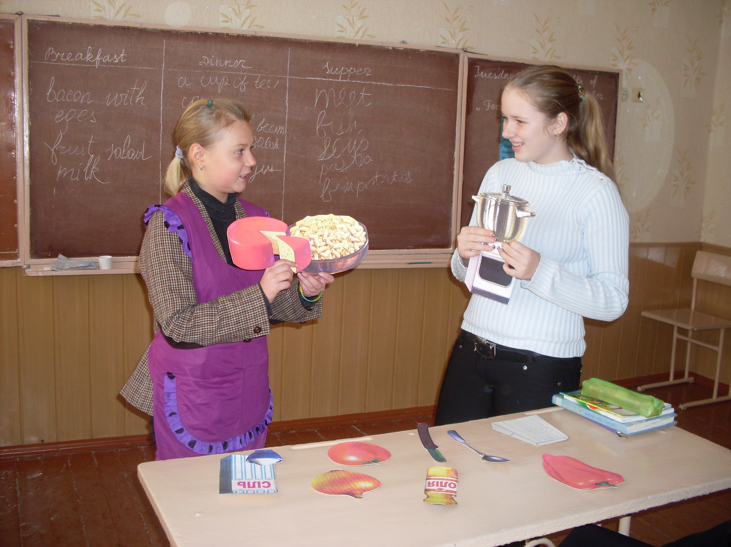
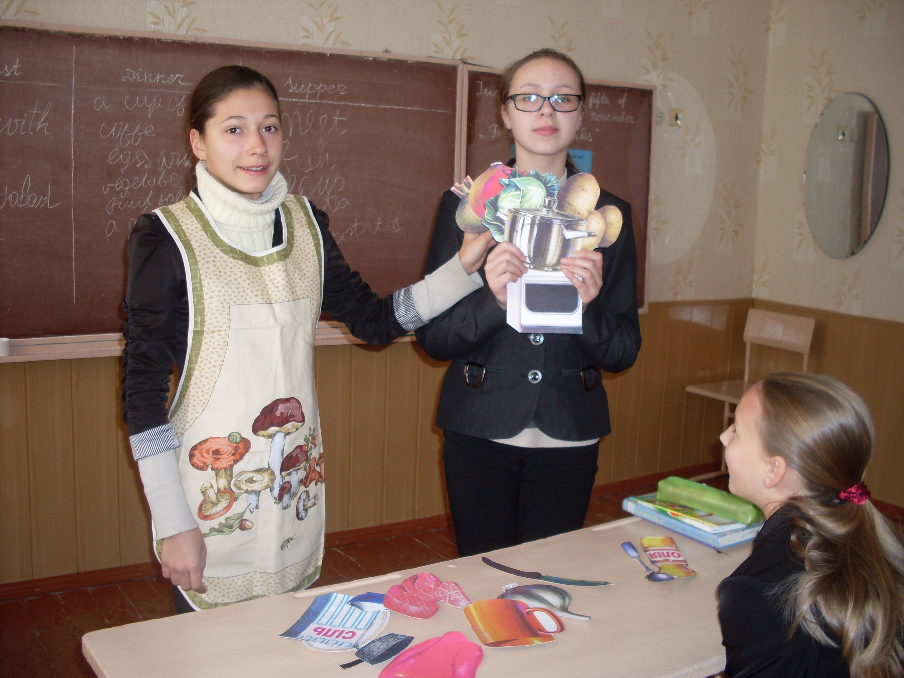
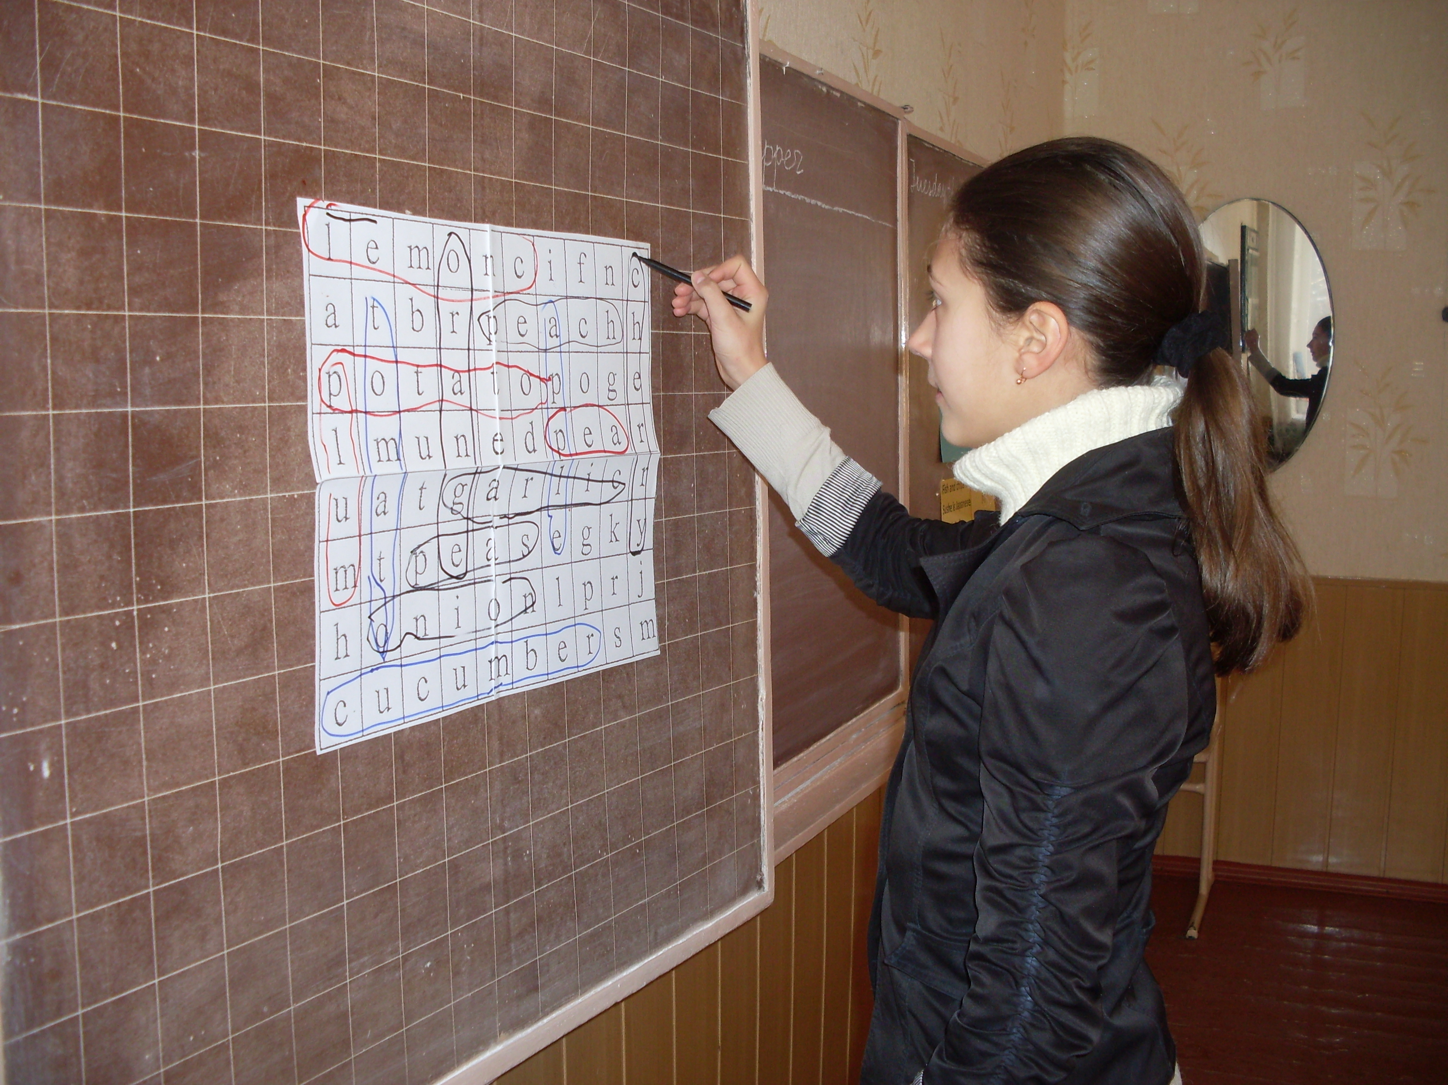
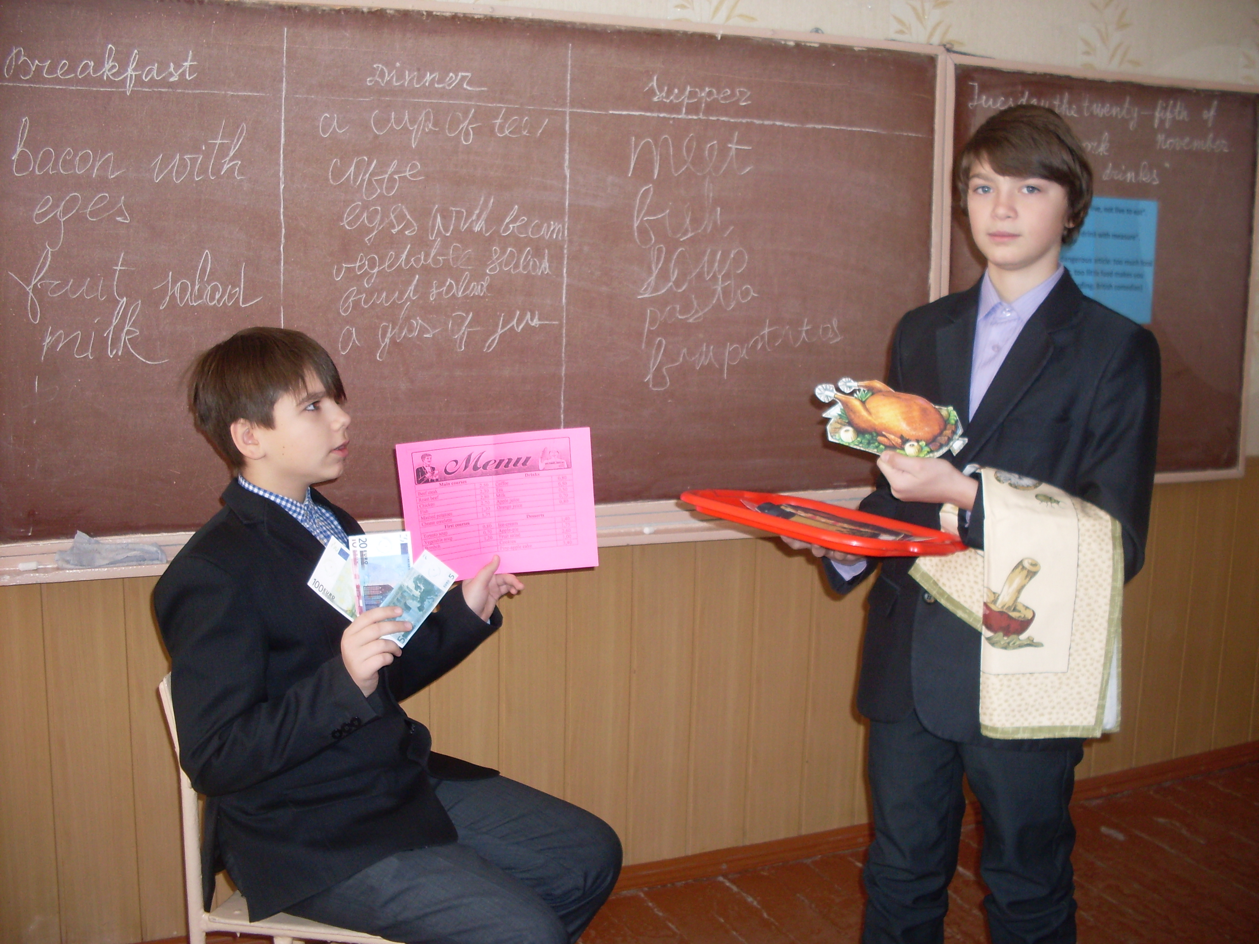
Рольова гра з теми «Їжа та напої»: «Рецепт улюбленої справи» 7 клас
Лексична гра з теми «Їжа та напої». 7 клас
Рольова гра з теми «Їжа та напої»: «В кафе». 7 клас

