Ukrainian standards of living.

Objectives:
- to broaden students` knowledge of the topic
- to develop students` creative abilities
- to help learners consolidate and develop their vocabulary by active using the words, expressions and proverbs given
- to practise students` reading and speaking skills.
Equipment: the map of Ukraine, pictures of the types of the houses in Ukraine, projector.

Lesson procedure
- Introduction
Introducing the theme and the aim of the lesson
T. Hello everybody! I hope you are very well. You can see a map of Ukraine on the board and many beautiful pictures (video file).Today we`re going to concentrate on the different interesting facts about Ukraine. Good luck and let`s start.
Warming-up
T. Read and explain the proverbs.
- East or West, home is best.
P. Your home (i.e. your house, your home town, etc.) is where you are likely to be happiest, especially in comparison with other places you may be at the time.
- There is no place like home.
P. Home is the best, the most pleasant place, however humble one`s home may be, it is the place where one feels happiest.

- Main part of the lesson.
Project Work
Work in groups. You want to design a typical Ukrainian house.

Mention the following:
- the rooms of the house
- the furniture and other thing
- what Ukrainians usually do there.

Describe the typical Ukrainian houses using the pictures.

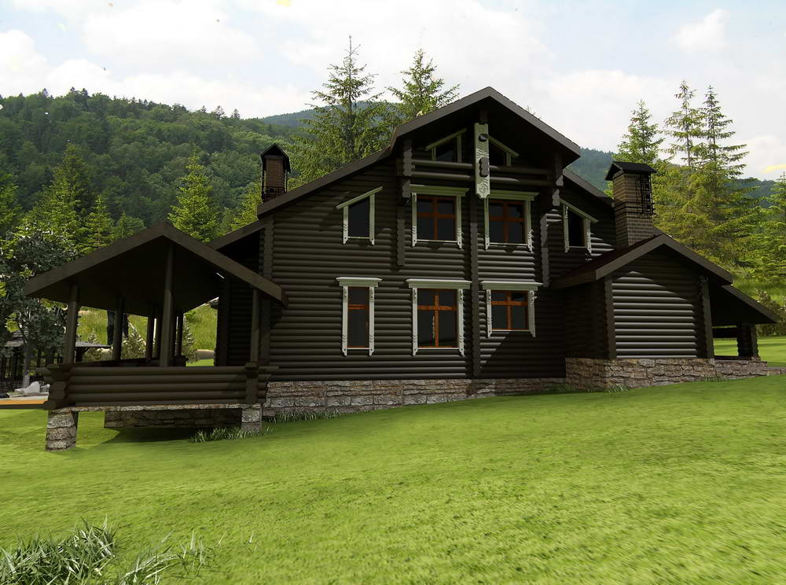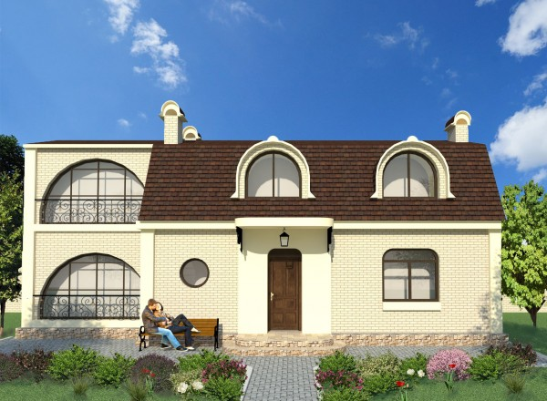

Match the types of the houses in Ukraine to their names.
1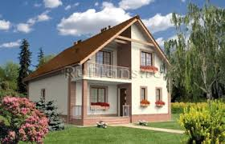 2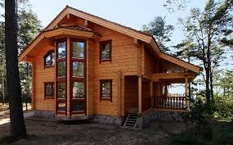 3 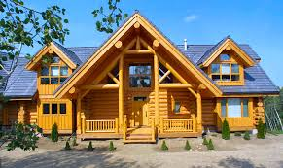 4 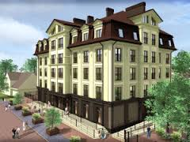
- block of flats c) terraced houses
- semi-detached houses d) detached house

Conversation Lab
Tell about Ukraine using the plan and the map:
- Is situated… - Consists…
- Lies… - Capital…

Relaxation
Guess the riddle: What is the worst sort of weather for mice and rabbits?
(A storm when it rains cats and dogs).
Speak in class. Describe the level of living of the British and the Ukrainian people using the diagrams.


Car – 64% Car – 33%
Central heating- 73% Central heating-68%
Freezer – 74% Freezer-94%
Washing machine-83% Washing machine-80%
Telephone-83% Telephone-126%
Bath/shower-98% Bath/shower-56%
TV-98% TV-90%

Speaking
Students discuss the text «Ukrainian Families».

III. Summing-up
It`s time we finished our lesson. You`ve worked hard; I am satisfied with your work. Your marks today are good. Thank you very much. Good-bye.

IV. Homework
Your task for the next lesson is to write a composition about your favourite Ukrainian town.

