A project is an extended piece of work on a particular topic where the content and the presentation are determined principally by the learners. The teacher or the textbook provides the topic, but the project writers themselves decide what they write and how they present it. This learner-centred characteristic of project work is vital, as we shall see when we turn now to consider the merits of project work. It is not always easy to introduce a new methodology, so we need to be sure that the effort is worthwhile. Students do not feel that English is a chore, but it is a means of communication and enjoyment. They can experiment with the language as something real, not as something that only appears in books. Project work captures better than any other activity the three principal elements of a communicative approach.
These are:
a) a concern for motivation, that is, how the learners relate to the task.
b) a concern for relevance, that is, how the learners relate to the language.
c) a concern for educational values, that is, how the language curriculum relates to the general educational development of the learnerA project is an extended task which usually integrates language skills through a number of activities. These activities combine in working towards an agreed goal and may include planning, gathering of information through reading, listening, interviewing, discussion of the information, problem solving, oral or written reporting, display, etc.
Learners' use of language as they negotiate plans, analyse, and discuss information and ideas is determined by genuine communicative needs. At the school level, project work encourages imagination and creativity, self-discipline and responsibility, collaboration, research and study skills, and cross-curricular work through exploitation of knowledge gained in other subjects. Successful use of project work will clearly be affected by such factors as availability of time, access to authentic materials, receptiveness of learners, the possibilities for learner training, and the administrative flexibility of institutional timetabling. Project work leads to purposeful language use because it requires personal involvement on the part of the students from the onset of a project, students, in consultation with their instructor, must decide what they will do and how they will do it, and this includes not only the content of the project, but also the language requirements. So from this point project work emerges as a practical methodology that puts into practice the fundamental principles of a communicative approach to language teaching. It can thus bring considerable benefits to our language classroom, like:
· Increased motivation - learners become personally involved in the project.
· All four skills, reading, writing, listening and speaking, are integrated.
· Autonomous learning is promoted as learners become more responsible for their own learning.
· There are learning outcomes -learners have an end product.
· Authentic tasks and therefore the language input are more authentic.
· Interpersonal relations are developed through working as a group.
· Content and methodology can be decided between the learners and the teacher and within the group themselves so it is more learner centred.
· Learners often get help from parents for project work thus involving the parent more in the child's learning. If the project is also displayed parents can see it at open days or when they pick the child up from the school.
· A break from routine and the chance to do something different.
· A context is established which balances the need for fluency and accuracy It would be wrong to pretend that project work does not have its problems. Teachers are often afraid that the project classroom will be noisier than the traditional classroom and that this will disturb other classes in the school, but it does not have to be noisy. Students should be spending a lot of the time working quietly on their projects: reading, drawing, writing, and cutting and pasting. In these tasks, students will often need to discuss things and they may be moving around to get a pair of scissors or to consult a reference book, but this is not an excuse to make a lot of noise. If students are doing a survey in their class, for example, there will be a lot of moving around and talking. However, this kind of noise is a natural part of any productive activity. Indeed, it is useful to realize that the traditional classroom has quite a lot of noise in it, too. There is usually at least one person talking and there may be a tape recorder playing, possibly with the whole class doing a drill. There is no reason why cutting out a picture and sticking it in a project book should be any noisier than 30 or 40 students repeating a choral drill. The noise of the well-managed project classroom is the sound of creativity.
Project work is a different way of working and one that requires a different form of control. Students must take on some of the responsibility for managing their learning environment. Part of this responsibility is learning what kind of, and what level of noise is acceptable. When we introduce project work we also need to encourage and guide the learners towards working quietly and sensibly.
This kind of work is time-consuming of course, it takes much longer to prepare, make, and present a project than it does to do more traditional activities. When we are already struggling to get through the syllabus or finish the textbook, we will probably feel that we do not have time to devote to project work, however good an activity it may be. There are two responses to this situation:
1. Not all project work needs to be done in class time. Obviously, if the project is a group task, most of it must be done in class, but a lot of projects are individual tasks. Projects about My Family, My House, etc. can be done at home.
2. When choosing to do project work we are making a choice in favour of the quality of the learning experience over the quantity. It is unfortunate that language teaching has tended to put most emphasis on quantity. And yet there is little evidence that quantity is really the crucial factor. What really matters in learning is the quality of the learning experience.
3. Project work provides rich learning experiences: rich in colour, movement, interaction and, most of all, involvement. The positive motivation that projects generate affects the students’ attitude to all the other aspects of the language programme. Learning grammar and vocabulary will appear more relevant because the students know they will need these things for their project work.
The students will spend all their time speaking their mother tongue. This is true to a large extent. It is unlikely that most students will speak English while they are working on their project. However, rather than seeing this as a problem, we should consider its merits:
a) it is a natural way of working. It is a mistake to think of L1 (the mother tongue) and L2 (the language being learnt) as two completely separate domains. Learners in fact operate in both domains, constantly switching from one to the other, so it is perfectly natural for them to use L1 while working on a L2 product. As long as the final product is in English it does not matter if the work is done in L1.
b) project work can provide some good opportunities for realistic translation work. A lot of the source material for projects (leaflets, maps, interviews, texts from reference books, etc.) will be in the mother tongue. Using this material in a project provides useful translation activities.
c) there will be plenty of opportunities in other parts of the language course for learners to practice oral skills. Project work should be seen as a chance to practice that most difficult of skills, writing.
Some teachers are concerned that without the teacher’s firm control the weaker students will be lost and will not be able to cope. But not all students want or need the teacher’s constant supervision. By encouraging the more able students to work independently we are free to devote our time to those students who need it most. One group may have ‘finished’ the project after a couple of hours and say they have nothing to do than remind them that it is their responsibility to fill the time allocated to project work and discuss ways they could extend the work they have already completed. Assessment of project work is another difficult issue. This is not because project work is difficult to assess, but because assessment criteria and procedures vary from country to country. So there are two basic principles for assessing project work:
a) not just the language
The most obvious point to note about project work is that language is only a part of the total project. Consequently, it is not very appropriate to assess a project only on the basis of linguistic accuracy. Credit must be given for the overall impact of the project, the level of creativity it displays, the neatness and clarity of presentation, and most of all the effort that has gone into its production. There is nothing particularly unusual in this. It is normal practice in assessing creative writing to give marks for style and content, etc. Many education systems also require similar factors to be taken into account in the assessment of students’ oral performance in class. So a wide-ranging ‘profile’ kind of assessment that evaluates the whole project is needed.
b) not just mistakes
If at all possible, we should not correct mistakes on the final project itself, or at least not in ink. It goes against the whole spirit of project work. A project usually represents a lot of effort and is something that the students will probably want to keep. It is a shame to put red marks all over it. This draws attention to the things that are wrong about the project over the things that are good. On the other hand, students are more likely to take note of errors pointed out to them in project work because the project means much more to them than an ordinary piece of class work. There are two useful techniques to handle the errors:
• Encouraging the students to do a rough draft of their project first. Correcting this in their normal way. The students can then incorporate corrections in the final product.
• If errors occur in the final product, correcting in pencil or on a separate sheet of paper attached to the project. A good idea was suggested by a teacher in Spain to get students to provide a photocopy of their project. Corrections can then be put on the photocopy. But fundamentally, the most important thing to do about errors is to stop worrying about them. Projects are real communication. When we communicate, we do the best we can with what we know, and because we usually concentrate on getting the meaning right, errors in form will naturally occur. It is a normal part of using and learning a language. Students invest a lot of themselves in a project and so they will usually make every effort to do their best work. Project work provides an opportunity to develop creativity, imagination, enquiry, and self-expression, and the assessment of the project should allow for this.
Project work must rank as one of the most exciting teaching methodologies a teacher can use. It truly combines in practical form both the fundamental principles of a communicative approach to language teaching and the values of good education. It has the added virtue in this era of rapid change of being a long- established and well-tried method of teaching
Project work involves multi-skill activities which focus on a theme of interest rather than specific language tasks. In project work, students work together to achieve a common purpose, a concrete outcome (e.g., a brochure, a written report, a bulletin board display, a video, an article for a school newspaper,etc). Haines identifies four types of projects:
1. Information and research projects which include such kinds of work as reports, displays, etc.
2. Survey projects which may also include displays, but more interviews, summaries, findings, etc.
3. Production projects which foresee the work with radio, television, video, wall newspapers, etc.
4. Performance/Organizational projects which are connected with parties, plays, drama, concerts, etc What these different types of projects have in common is their emphasis on student involvement, collaboration, and responsibility. In this respect, project work is similar to the cooperative learning and task-oriented activities that are widely endorsed by educators interested in building communicative competence and purposeful language learning. However, it differs from such approaches, it typically requires students to work together over several days or weeks, both inside and outside the classroom, often in collaboration with speakers of the target language who are not normally part of the educational process.
Students in tourism, for example, might decide to generate a formal report comparing modes of transportation; those in hotel/restaurant management might develop travel itineraries. In both projects, students might create survey questionnaires, conduct interviews, compile, sort, analyze, and summarize survey data and prepare oral presentations or written reports to present their final product. In the process, they would use the target language in a variety of ways: they would talk to each other, read about the focal point of their project, write survey questionnaires, and listen carefully to those whom they interview. As a result, all of the skills they are trying to master would come into play in a natural way.
Let us consider, for example, the production of a travel brochure. To do this task, tourism students would first have to identify a destination, in their own country or abroad, and then contact tourist agencies for information about the location, including transportation, accommodations in all price ranges, museums and other points of interest, and maps of the region. They would then design their brochure by designating the intended audience, deciding on an appropriate length for their suggested itinerary, reviewing brochures for comparable sites, selecting illustrations, etc. Once the drafting begins, they can exchange material, evaluate it, and gradually improve it in the light of criteria they establish. Finally, they will put the brochure into production, and the outcome will be a finished product, an actual brochure in a promotional style. Projects allow students to use their imagination and the information they contain does not always have to be factual.
One of the great benefits of project work is its adaptability. We can do projects on almost any topic. They can be factual or fantastic. Projects can, thus, help to develop the full range of the learners’ capabilities. Projects are often done in poster format, but students can also use their imagination to experiment with the form. It encourages a focus on fluency.
Each project is the result of a lot of hard work. The authors of the projects have found information about their topic, collected or drawn pictures, written down their ideas, and then put all the parts together to form a coherent presentation.
The projects are very creative in terms of both content and language. Each project is a unique piece of communication, created by the project writers themselves. This element of creativity makes project work a very personal experience. The students are writing about aspects of their own lives, and so they invest a lot of themselves in their project.
Project work is a highly adaptable methodology. It can be used at every level from absolute beginner to advanced. There is a wide range of possible project activities, and the range of possible topics is limitless.
Positive motivation is the key to successful language learning, and project work is particularly useful as a means of generating it.
Another point is that this work is a very active medium like a kind of structured playing. Students are not just receiving and producing words, they are:
• collecting information;
• drawing pictures, maps, diagrams, and charts;
• cutting out pictures;
• arranging texts and visuals;
• colouring;
• carrying out interviews and surveys;
• possibly making recordings, too.
Lastly, project work gives a clear sense of achievement. It enables all students to produce a worthwhile product. This feature of project work makes it particularly well suited to the mixed ability class, because students can work at their own pace and level. The brighter students can show what they know, unconstrained by the syllabus, while at the same time the slower learners can achieve something that they can take pride in, perhaps compensating for their lower language level by using more photos and drawings.
A foreign language can often seem a remote and unreal thing. This inevitably has a negative effect on motivation, because the students do not see the language as relevant to their own lives. If learners are going to become real language users, they must learn that English is not only used for talking about British or American things, but can be used to talk about their own world.
Firstly, project work helps to integrate the foreign language into the network of the learner’s own communicative competence. It creates connections between the foreign language and the learner’s own world. It encourages the use of a wide range of communicative skills, enables learners to exploit other spheres of knowledge, and provides opportunities for them to write about the things that are important in their own lives.
Secondly, it helps to make the language more relevant to learners’ actual needs. When students use English to communicate with other English speakers, they will want, and be expected, to talk about aspects of their own lives – their house, their family, their town, etc. Project work thus enables students to rehearse the language and factual knowledge that will be of most value to them as language users.
Another important issue in language teaching is the relationship between language and culture. It is widely recognized that one of the most important benefits of learning a foreign language is the opportunity to learn about other cultures and English, as an international language, should not be just for talking about the ways of the English – speaking world, but also as a means of telling the world about one’s own culture.

THE PROJECT WORK

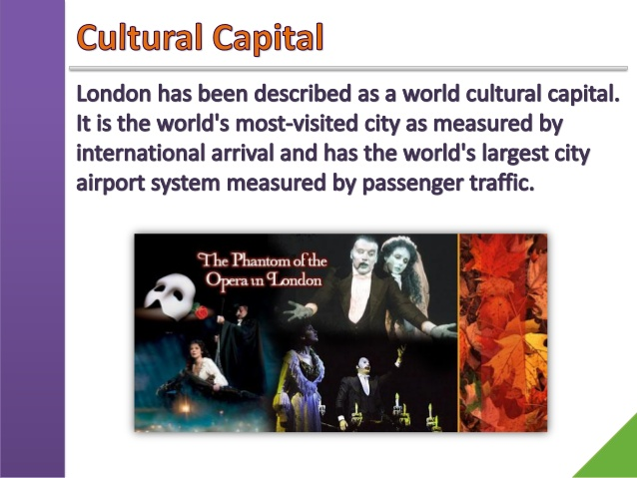





I would like to visit in London :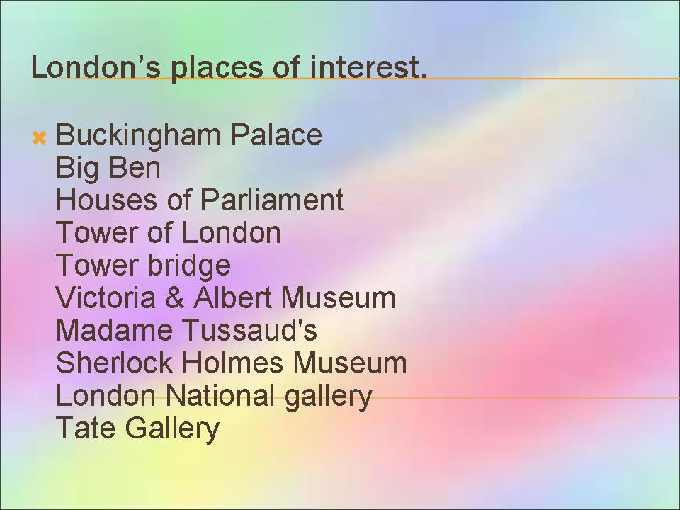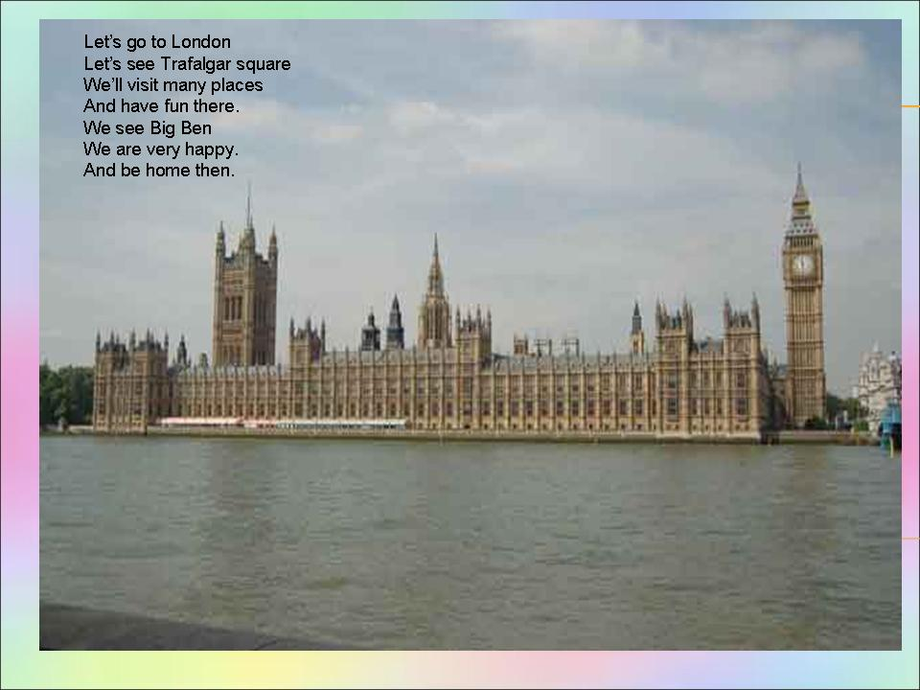 


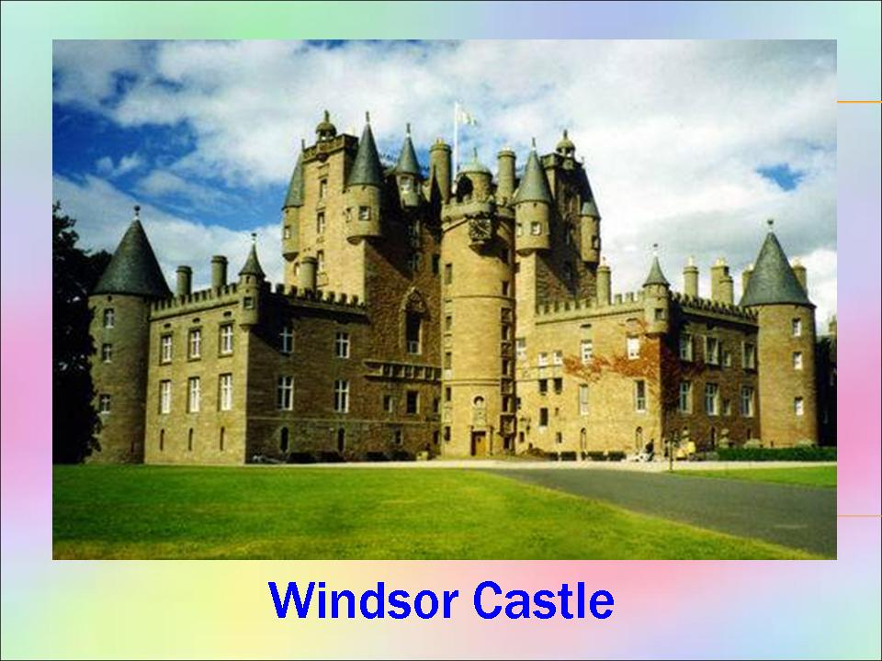

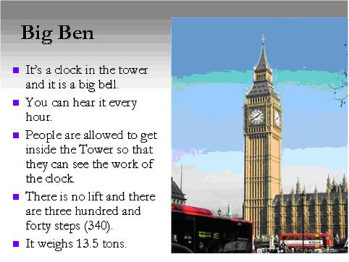
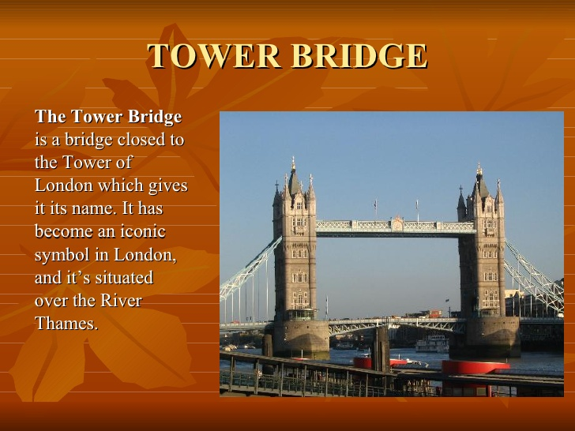

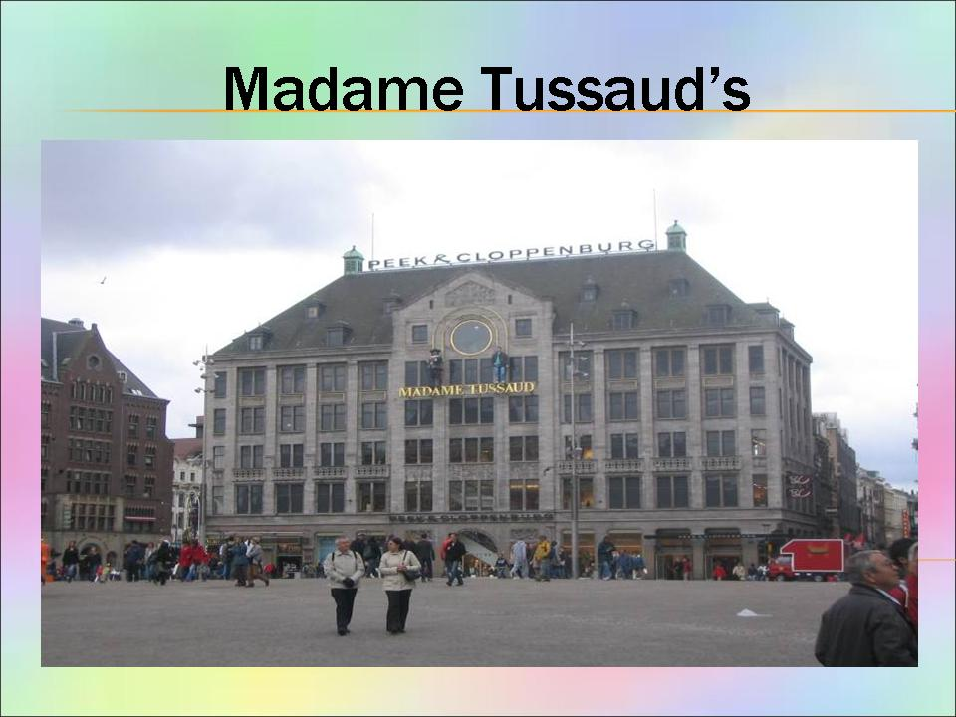

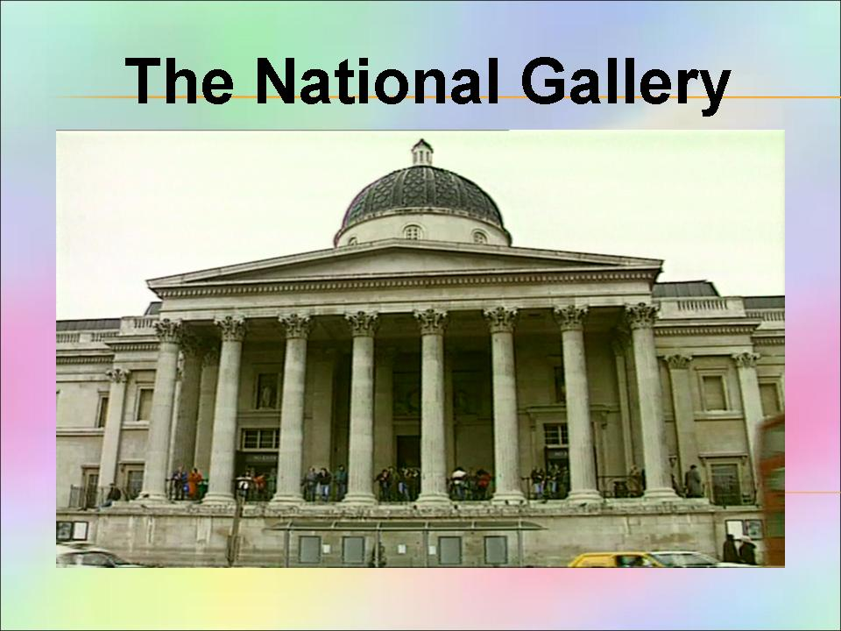

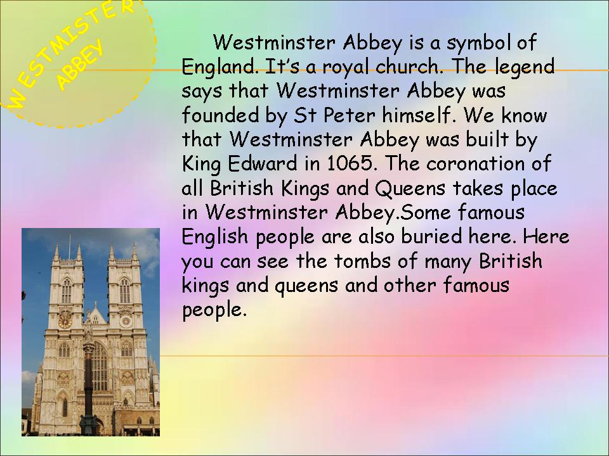



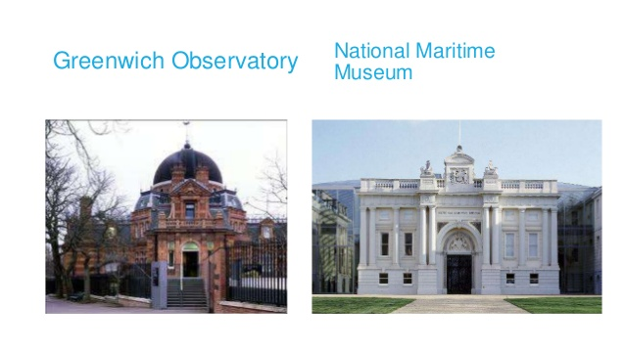

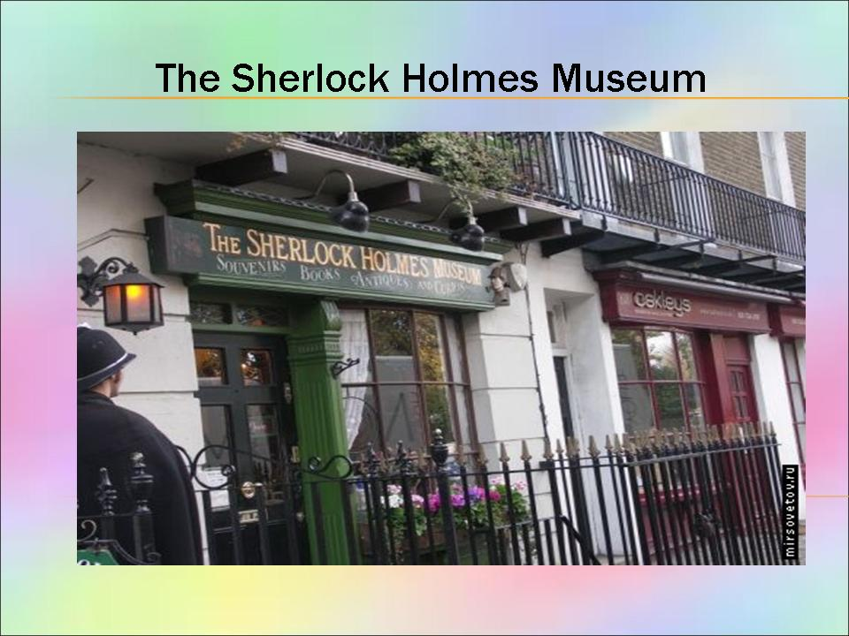
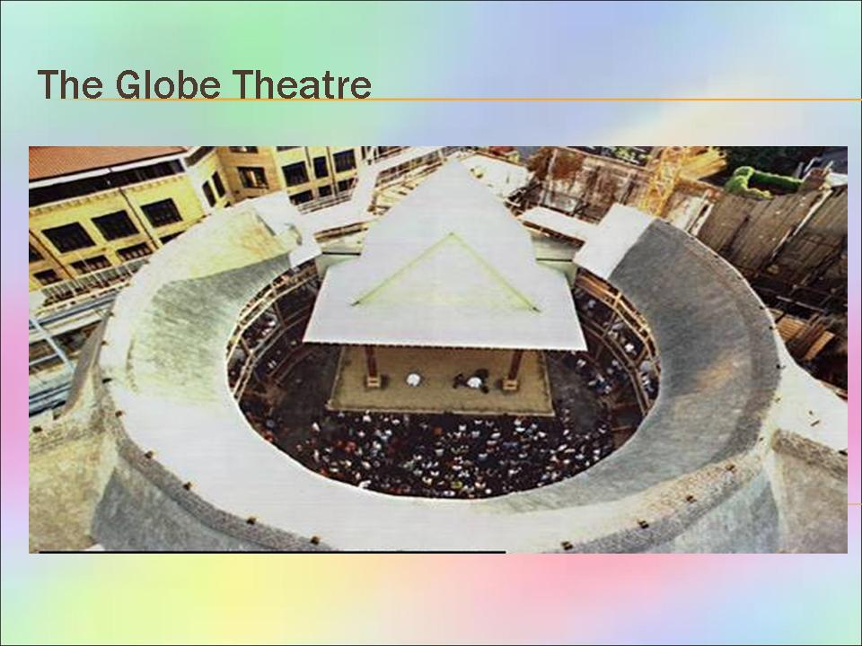








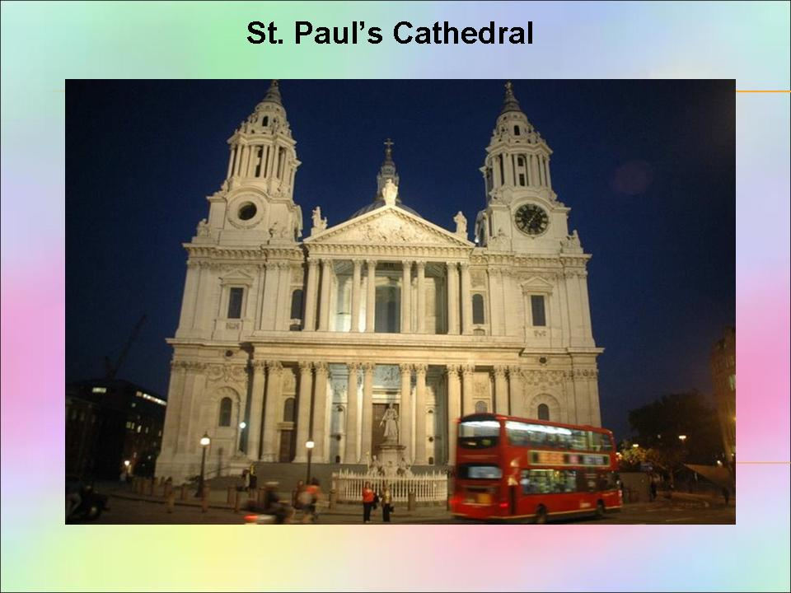

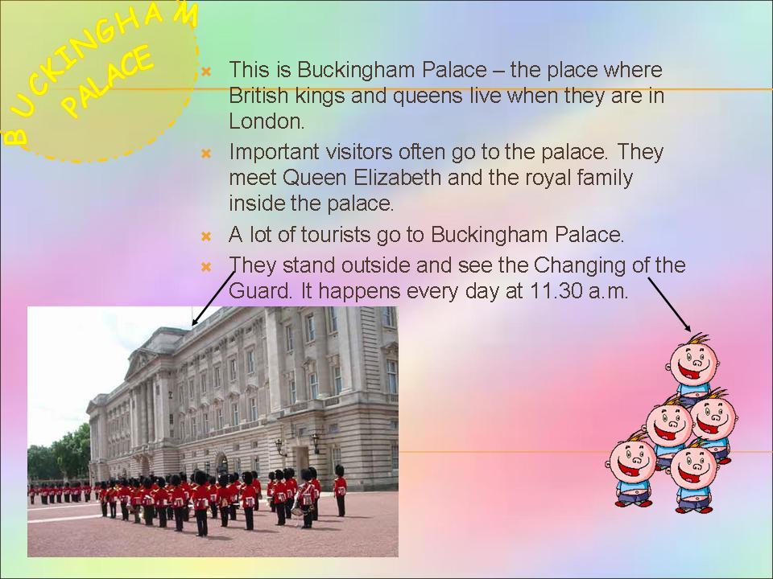
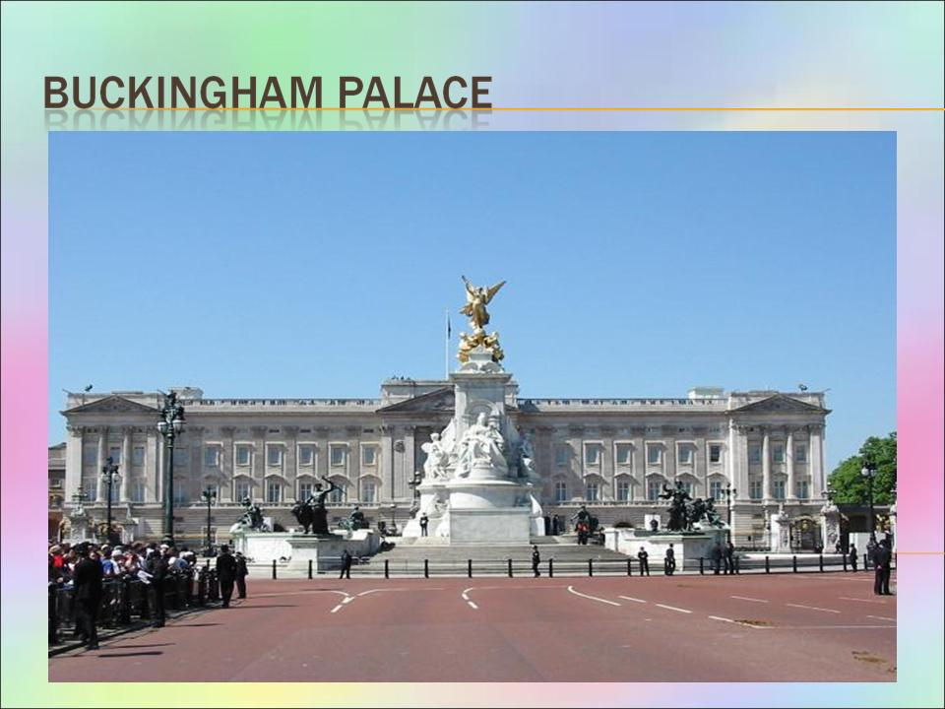
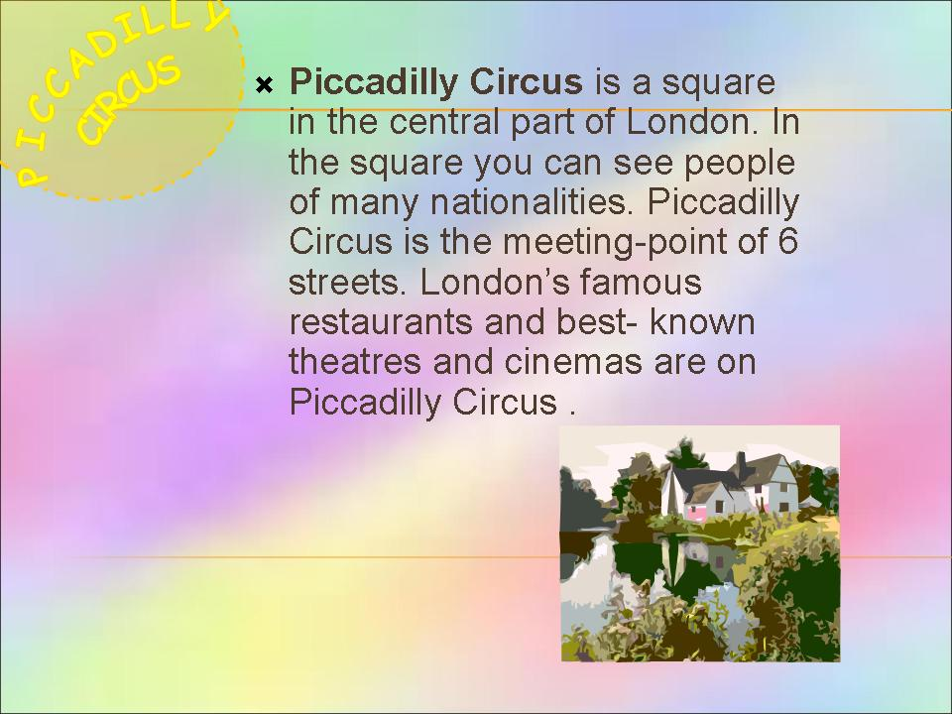
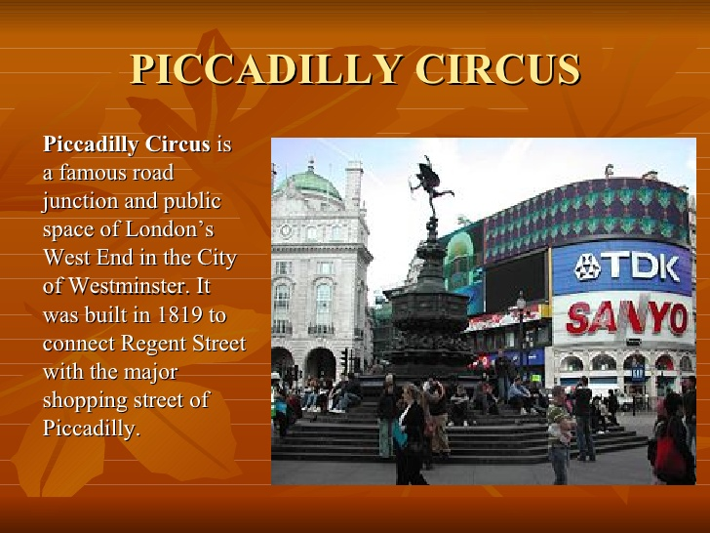

The most interesting place for me is Tower of London

- Every British associates these words with the Tower of London. And I know that these words can be heard every night just before 10 o` clock. They mean that the Tower`s been locked up for the night. More than that, the Ceremony of the Keys is at least 700 years old. But do you know what the Tower is? It has been many things: a palace, a fortress, a prison, a place of execution, a Zoo. Today the Tower is best known as a historical museum.
- Probably, everybody knows about the symbols of the Tower. One of them is ravens. There are always at least 6 ravens at the Tower. Most of all, they bring good luck to Britain, if they stay at the Tower. That`s why they get “paid” meat and biscuits every day. Besides, their wings are cut so that they can`t fly away. But ravens are not very friendly.
- The next important peculiarity of the Tower is the Beefeaters. They used to guard the Tower and its prisoners. Today they work mostly as guides. Moreover, they show people around and tell stories about all the terrible things that have happened here. The beefeaters wear special uniform .Of course, they respect Queen Elizabeth the second.
- In conclusion, I can say that British people are proud of traditions of their country. They love Great Britain so much and can not imagine their life without the Tower, because this famous historical place is the heart of Britain. 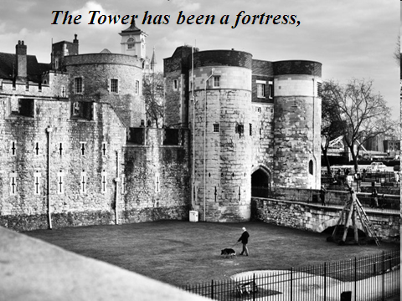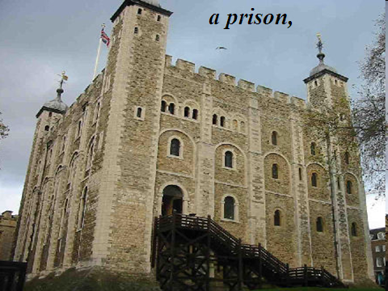
- Ravens
The Ravens are one of the 'must sees' for a trip to the Tower of London. Legend says that if the ravens ever leave then the monarchy will fall, the White Tower at The Tower of London will crumble and a great disaster will befall England. Ever superstitious, we don't take any chances and Ravens have lived at the Tower since Charles II was told this tale. They are even protected by a royal decree. Each of the ravens has a color-coded leg band.
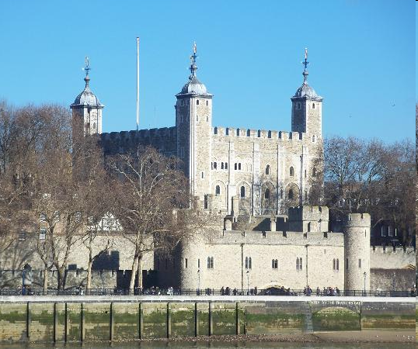

The City is the oldest part of the capital. Among the first historic buildings is the Tower of London, built in 1087.
The history of London is closely connected with the Tower. They say that London is the key to England and the Tower is the key to London. The Tower of London was founded by William the Conqueror. It was begun with the aim of protecting Londoners from invasion by the river. Since then the Tower has served as fortress, palace, state prison and royal treasury, now it is a museum. During the reign of Henry VII part of it became a menagerie, and it was one of the citizens’ entertainments to watch a bear being led to the water’s edge to catch salmon. It is now over a century since a Thames salmon was caught – although as late as the 1820s the fish sold at Billingsgate were all caught locally.
Tower Bridge is close by the Tower of London and also is St. Paul’s Cathedral, the greatest of English churches. 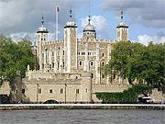
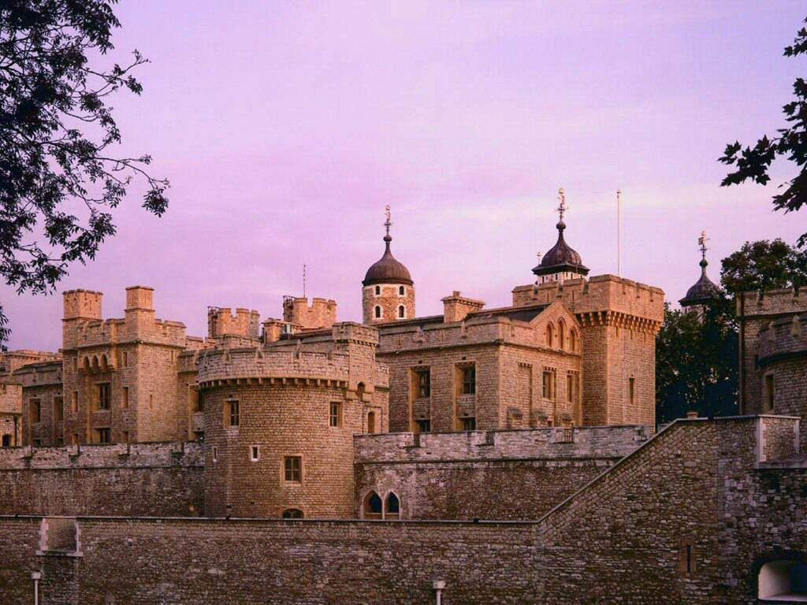 The Tower of London is a very old building in London. It is nine hundred years old. The Tower of London stands on the Thames.
In the early days of the history of England the English kings lived in the Tower. Then it was a prison where many people died, black ravens had much food near the walls of the Tower in those years.
The black ravens live in the gardens of the Tower now. The English people like them very much. A man looks after the ravens and gives them meat in the morning and in the evening.
Now the Tower of London is a museum and many people from other countries come to see it. They see the dark stone halls with small windows and thick doors. The walls of the Tower are five metres thick. In the museum they can see many old guns.
At ten o’clock every evening the guards lock the big doors of the Tower for the night.





Crossword puzzle "London"
Down:
1.Lord Nelson was an ...... .
3. London is the capital of Great ...... .
4. A ...... is one of the large black birds that live in the Tower of London.
5. The largest park in London is ...... Park.
6. ...... Square is in the centre of London.
7. The famous English architect Sir Christopher ...... built a lot of churches in London.
9. ...... Square is the literary part of the city. Many writers and critics live there.
11. In the middle of Trafalgar Square is a monument to Lord ...... .
12. The political centre of London is ...... .
13. The name of London in Roman times was ...... .
17. The ...... is the oldest part of London. There are a lot of banks and offices there.
19. The British Prime Minister lives at number 10 ...... Street.
20. Big Ben got its name after Sir Benjamin ...... .
21. Before William the Conqueror came to England he lived in ...... .
25. In front of Buckingham Palace is the Queen ...... Memorial.
26. The Tower of London was a fortress, a ......, a prison and the King's Zoo.
27. The ...... Museum was founded in 1753.
29. One of the famous London cinemas is the ...... .
30. Now the Tower of London is a ...... . You can see a lot of interesting things there.
32. The Royal ...... House is in the centre of the former fruit and vegetable market.
Across:
2. Until 1749, there was only one bridge over the Thames: ...... Bridge.
3. The Great Fire of London started in the house of the king's ...... .
6. William the Conqueror built the White ...... to live in it.
8. Westminster ...... is one of the most famous churches in London. it is more than 900 years old.
10. In Westminster you can see a long grey building with towers which is the Houses of ...... .
12. ...... the Conqueror came to England in 1066.
14. On 2nd September 1666 the Great ...... of London began.
15. There are four bronze ...... at the foot of Nelson's Column.
16. Big ...... is the name of the clock and the bell in the clock tower of the Houses of Parliament.
17. It took 35 years to build St. Paul's ...... .
18. ...... Street is London's main shopping centre.
22. There are two fountains in front of the ...... Gallery, which is one of the best picture galleries in the world.
23. The ...... left Britain soon after 400.
24. London stands on the River ...... .
27. The Queen of England lives in ...... Palace.
28. William the Conqueror came to England from ...... .
31. Many great writers are buried in the ......' Corner in Westminster Abbey.
33. ...... Garden is one of the most famous London theatres.
34. The British Museum is in Great ...... Street.



Quiz. London.
Choose the best variant:
1. This park is famous for its outdoor entertainments and Speaker’s Corner.
a) Green Park b) Hyde Park c) St James’s Park
2. It’s the popular museum of the famous detective and his friend.
a) MOMI b) Science Museum c) Sh. Holmes Museum
3. It’s a symbol of England, the coronation of all British kings and queens takes place there.
a) the Tower of London b) Big Ben c) Westminster Abbey
4. This park is famous for the popular London Zoo, a boating lake and an open-air theatre.
a) Regent’s Park b) St James’s Park c) Kensington Gardens
5. It’s the famous waxworks museum which has one of the largest collections of wax models in the world.
a) Science Museum b) MOMI c) Madam Tussaud’s Museum
6. It’s really a bell, you can hear it every hour.
a) Big Ben b) the Tower of London c) the Houses of Parliament
7. This park is beautiful with its trees, flowerbeds and the view of Buckingham Palace.
a) St James’s Park b) Green Park c) Regent’s Park
8. It’s the museum of the history and magic of cinema and TV.
a) MOMI b) Sh. Holmes Museum c) Science Museum
9. You can see the statue of the famous fairytale hero Peter Pan in this park.
a) St James’s Park b) Kensington Gardens c) Regent’s Park
10. It’s a popular museum in London which has big collections of airplanes and microchips, here you can visit interesting scientific exhibitions.
a) Madam Tussaud’s Museum b) Science Museum c) MOMI

- Hyde Park
- Sh. Holmes Museum
- Westminster Abbey
- Regent’s Park
- Madam Tussaud’s Museum
- Big Ben
- St James’s Park
- MOMI
- Kensington Gardens
- Science Museum




