**Глашатай:** Citizens of the fairy-tail country! Do you hear me? The King and the Queen welcome you to our party.

**Перекладач:** Городяни чарівної країни! Ви чуєте мене? Запрошуємо Короля і Королеву на наше свято.

*(Вихід Короля і Королеви)*

**Глашатай:** The guest from Great Britain, Canada, The USA and Australia will arrive at our party. Be in a hurry! You’ll have the opportunity to know as much as possible about these countries.

**Перекладач:** Гості з Великобританії, Канади, США та Австралії прибудуть на наше свято. Поспішайте! У вас є унікальна можливість побувати на святі і дізнатися багато цікавого про різні країни світу.

*(Виходять Король і Королева)*

**King:** Didn’t you forget, my dear, that we have a fairy ball today?

**Перекладач:** Сподіваюся ти не забула про свято сьогодні?

**Queen:** No, my dear King. I like ball and guests.

**Перекладач:** Ні ,Ваша світлість, я обожнюю свята і гостей.

**King:** But the guests unusual today. They come from many English-speaking countries: The beautiful Britain, the exotic Australia, the attractive lakes of Canada and the colours of the USA.

**Перекладач:**Але сьогодні гості незвичайні. А з’їхались вони з усіх англомовних країн. З мальовничої Британії, екзотичної Австралії, чарівної Канади та барвистих Сполучених Штатів Америки.

**Queen:** Oh, I can’t wait.

**Перекладач:** Я вже не можу дочекатися.

**Глашатай:** Our party has begun. At first, we will meet our little pupils with their songs.

**Перекладач:** Наше свято почалося. І для початку, зустрічаймо наших молодших учнів з піснею.

*(Пісня 2-4 класів)*

**Глашатай:** Now we welcome guest from **Great Britain!**

**Гість з Британії:**

Great Britain is a highly developed industrial country. The Head of state is **Queen Elizabeth**. (мал.1)

**National flag** (мал.2) is called Union Jack, a combination of the banners of England, Scotland and Ireland.

The largest cities of Great Britain are: London, Glasgow, Liverpool, Manchester, Edinburg, Cardiff.

The capital of Great Britain is **London** (мал.3). It consists of 4 parts: the City, Westminster, the West End and the East End.

There are a lot of sights and places of interest in London. One of the main sights is **Big Ben**(мал.4). Big Ben is the nickname for the Great [Bell](https://en.wikipedia.org/wiki/Bell" \o "Bell).A [British cultural icon](https://en.wikipedia.org/wiki/Culture_of_the_United_Kingdom), the tower is one of the most prominent symbols of the United Kingdom and is often in the [establishing shot](https://en.wikipedia.org/wiki/Establishing_shot) of films set in London.

You can see the famous **double-deckers** (мал.5) on the London streets. A double-decker bus is a [bus](https://en.wikipedia.org/wiki/Bus) that has two [storeys](https://en.wikipedia.org/wiki/Storey" \o "Storey) or decks. Double-decker buses are used for mass transport in the United Kingdom, the most iconic example being the red London bus.

The most popular British celebrities:

**Adele** (мал.6) is a famous singer, who has 10 Grammy Awards and Oscar for the best soundtrack.

**David Beckham** (мал.7) is an English former professional [footballer](https://en.wikipedia.org/wiki/Association_football).

**Stephen Hawking** (мал.8) is an English [theoretical physicist](https://en.wikipedia.org/wiki/Theoretical_physics), [cosmologist](https://en.wikipedia.org/wiki/Cosmologist), author and Director of Research at the [Centre for Theoretical Cosmology](https://en.wikipedia.org/wiki/Centre_for_Theoretical_Cosmology) within the [University of Cambridge](https://en.wikipedia.org/wiki/University_of_Cambridge).

**Sean Connery** (мал.9) is a retired Scottish actor and producer who has won an [Academy Award](https://en.wikipedia.org/wiki/Academy_Award), two [BAFTA Awards](https://en.wikipedia.org/wiki/BAFTA_Awards) and three [Golden Globes](https://en.wikipedia.org/wiki/Golden_Globes).

**Глашатай:** Now we welcome our pupils with the beautiful dance**!**

**Перекладач:** Зустрічаймо наших учнів з прекрасним танцем!

*(Танець 2 класу)*

**Глашатай:** Welcome guests from the United States of America!

**Гість з США:**

USA is a highly developed industrialized country. It has very powerful industries, advanced technologist and science. The USA is the richest and one of the most developed countries of the world.

**The Stars and Stripes** (мал.1) is a popular name for the red, white and blue of the USA. The 50 stars on the flag represent the 50 [states of the United States of America](https://en.wikipedia.org/wiki/U.S._state), and the 13 stripes represent the [thirteen British colonies](https://en.wikipedia.org/wiki/Thirteen_Colonies) that declared independence from the [Kingdom of Great Britain](https://en.wikipedia.org/wiki/Kingdom_of_Great_Britain), and became the first states in the US.

The largest cities are New York, Los Angeles, Chicago and Detroit.

The capital of the USA is **Washington** (мал.2)**.** Named in honor of President [George Washington](https://en.wikipedia.org/wiki/George_Washington).

There are a **White House** (мал.3). It is the [official residence](https://en.wikipedia.org/wiki/Official_residence) and principal workplace of the [President of the United States](https://en.wikipedia.org/wiki/President_of_the_United_States).  It has been the residence of every U.S. president since [John Adams](https://en.wikipedia.org/wiki/John_Adams) in 1800.

**The Statue of Liberty** (мал.4) is a colossal [neoclassical sculpture](https://en.wikipedia.org/wiki/Neoclassical_sculpture) on [Liberty Island](https://en.wikipedia.org/wiki/Liberty_Island) in [New York Harbor](https://en.wikipedia.org/wiki/New_York_Harbor) in New York City. It was a gift to the United States from the people of France.

**The Grand Canyon** (мал.5) is a steep-sided [canyon](https://en.wikipedia.org/wiki/Canyon) carved by the [Colorado River](https://en.wikipedia.org/wiki/Colorado_River) in the state of [Arizona](https://en.wikipedia.org/wiki/Arizona) in the United States. President [Theodore Roosevelt](https://en.wikipedia.org/wiki/Theodore_Roosevelt) was a major proponent of preservation of the Grand Canyon area, and visited it on numerous occasions to hunt and enjoy the scenery.

The most popular American celebrities:

**Beyonce** (мал.6) is an American singer, songwriter and actress, who has 20 Grammy Awards

**Michael Phelps** (мал.7)is an American former competitive swimmer and the [most decorated Olympian of all time](https://en.wikipedia.org/wiki/List_of_multiple_Olympic_medalists), with a total of 28 medals.

**Leonardo DiCaprio**(мал.8) is an American actor and film producer. In 2016, he won the [Oscar](https://en.wikipedia.org/wiki/Academy_Award_for_Best_Actor) as the best male actor for «The Revenant».

**Steve Jobs** (мал.9) was an American businessman, inventor, and industrial designer. He was the co-founder of [Apple Inc.](https://en.wikipedia.org/wiki/Apple_Inc.)

**Глашатай:** Now we welcome our girls with the beautiful dance**!**

**Перекладач:** Зустрічаймо наших дівчат з прекрасним танцем!

*(Танець дівчат 8-9 класів)*

**Глашатай:** Welcome guests from Canada!

**Гість з Канади:**

Canada is a magnificent land. It is one of the biggest countries of the world. It has an area of nearly 10 millions square kilometers and population about 28 millions. Canada has two official languages: English and French.

**The National Flag** (мал.1) was adopted by Parliament on October, 1964. It is a red flag containing in the center a white square with a single red maple leaf.

The largest cities are Toronto, Quebec, Montreal, Vancouver and Ottawa.

**Ottawa** (мал.2) is the capital of Canada. It lies on hills along the south bank of the Ottawa River. Attractive parks, stately government buildings add beauty to the city. Upper Town and Low Town are the oldest parts of Ottawa.

There are many sights and places of interest in Ottawa. **CN-tower** (мал.3) is the [world's tallest free-standing structure](https://en.wikipedia.org/wiki/List_of_tallest_freestanding_structures_in_the_world) and [world's tallest tower](https://en.wikipedia.org/wiki/List_of_tallest_towers_in_the_world) at the time.

As for nature, Canada has a lot of places with beautiful views. The **Great Lakes** (мал.4) are a series of [interconnected](https://en.wikipedia.org/wiki/Great_Lakes_Waterway) [freshwater](https://en.wikipedia.org/wiki/Freshwater) [lakes](https://en.wikipedia.org/wiki/Lake) located on the [Canada–United States border](https://en.wikipedia.org/wiki/Canada%E2%80%93United_States_border). Consisting of Lakes [Superior](https://en.wikipedia.org/wiki/Lake_Superior), [Michigan](https://en.wikipedia.org/wiki/Lake_Michigan), [Huron](https://en.wikipedia.org/wiki/Lake_Huron), [Erie](https://en.wikipedia.org/wiki/Lake_Erie), and [Ontario](https://en.wikipedia.org/wiki/Lake_Ontario), they form the largest group of freshwater lakes on Earth, containing 21% of the world's surface fresh water.

**Niagara Falls** (мал.5) is the collective name for three [waterfalls](https://en.wikipedia.org/wiki/Waterfall) that straddle [the international border](https://en.wikipedia.org/wiki/Canada%E2%80%93United_States_border) between [Canada](https://en.wikipedia.org/wiki/Canada) and the [United States](https://en.wikipedia.org/wiki/United_States). The Niagara Falls are famed both for their beauty and as a valuable source of [hydroelectric power](https://en.wikipedia.org/wiki/Hydroelectric_power).

The most popular Canadian celebrities:

**Justin Bieber** (мал.6) is a Canadian singer and songwriter. He has won numerous fan-voted awards, including [American Music Award](https://en.wikipedia.org/wiki/American_Music_Award) for Artist of the Year in [2010](https://en.wikipedia.org/wiki/American_Music_Awards_of_2010) and [2012](https://en.wikipedia.org/wiki/American_Music_Awards_of_2012). In his career, he has received three Grammy nominations.

**Lennox Lewis** (мал.7) is a Canadian former [professional boxer](https://en.wikipedia.org/wiki/Professional_boxer).  He is regarded by many as one of the greatest heavyweight boxers of all time.

**John Fields** (мал.8) was a [Canadian](https://en.wikipedia.org/wiki/Canadians) [mathematician](https://en.wikipedia.org/wiki/Mathematician) and the founder of the [Fields Medal](https://en.wikipedia.org/wiki/Fields_Medal) for outstanding achievement in [mathematics](https://en.wikipedia.org/wiki/Mathematics).

**Ryan Reynolds** (мал.9) is a Canadian actor and producer. The most popular by the title character in «Deadpool».

**Глашатай:** Now we welcome our pupils with the dance**!**

**Перекладач:** Зустрічаймо наших учнів з танцем!

*(Танець 5-го класу)*

**Глашатай:** Welcome guests from beautiful Australia!

**Гість з Австралії:**

Australia is a country comprising the mainland of the [Australian continent](https://en.wikipedia.org/wiki/Australia_(continent)), the island of [Tasmania](https://en.wikipedia.org/wiki/Tasmania) and numerous [smaller islands](https://en.wikipedia.org/wiki/List_of_islands_of_Australia). It is the world's [sixth-largest country by total area](https://en.wikipedia.org/wiki/List_of_countries_and_dependencies_by_area).

**The National flag** (мал.1) of Australia is the only one to fly over the whole continent. The small Union Jack in the upper left corner represents the historical link with Britain. The large seven-pointed star represents the six states. The small stars form the Southern Cross.

The largest cities are Sydney, Melbourne, Brisbane and Adelaide.

**Canberra** (мал.2) is a capital of Australia. It is also administrative center of New South Wales.

There are a lot of places of interest in Australia. The **Sydney Opera House** (мал.3) is a multi-venue [performing arts centre](https://en.wikipedia.org/wiki/Performing_arts_center) in [Sydney](https://en.wikipedia.org/wiki/Sydney). It is one of the 20th century's most famous and distinctive buildings.

**Tasmania** (мал.4) is an island [state](https://en.wikipedia.org/wiki/States_and_territories_of_Australia) of the [Commonwealth of Australia](https://en.wikipedia.org/wiki/Commonwealth_of_Australia). The island is believed to have been occupied by Aboriginals for 40,000 years before British colonisation. The state was the founding place of the first environmental party in the world.

**Kangaroo** (мал.5) is an unofficial symbol of Australia. **Koala** (мал.5) is a marsupial bear inhabit the forests of eastern Australia.

The most popular Australian celebrities:

**Kylie Minogue** (мал.6) is an Australian singer, songwriter, and actress. She is recognised as the highest-selling Australian artist of all time.

**Patrick Cash** (мал.7) is a retired [Australian](https://en.wikipedia.org/wiki/Australian) professional [tennis player](https://en.wikipedia.org/wiki/Tennis_player). Cash won 6 top-level singles titles and 12 top-level doubles titles during his career.

**Barry James Marshall** (мал.8) is an Australian physician, Nobel Prize laureate in [Physiology](https://en.wikipedia.org/wiki/Physiology) or Medicine, and Professor of Clinical [Microbiology](https://en.wikipedia.org/wiki/Microbiology) at the [University of Western Australia](https://en.wikipedia.org/wiki/University_of_Western_Australia).

**Margot Robbie** (мал.9) is an Australian actress. She was called The Most Popular Actress in 2016 for her roles in «[The Legend of Tarzan](https://en.wikipedia.org/wiki/The_Legend_of_Tarzan_(film))» and the [superhero film](https://en.wikipedia.org/wiki/Superhero_film) «[Suicide Squad](https://en.wikipedia.org/wiki/Suicide_Squad_(film))».

**Глашатай:** Our pupils sing songs very well. And we can hear it today. New Year and Christmas are coming. So let’s listen to the famous New Year song.

**Перекладач:** Наші учні дуже добре співають пісні. І ми маємо змогу почути це сьогодні. Наближаються Новий Рік та Різдво. Тож давайте послухаємо знамениту новорічну пісню у виконанні наших учнів.

*(Пісня 8 класу «Jingle Bells»)*

**Queen**: Dear guests, today we were in the very fairy countries. We saw a lot of interesting things.

**King:** At the end of our party we wish you to visit these fine places in your life.

**Перекладач:** Дорогі гості, сьогодні ми побували в декількох прекрасних країнах та дізналися багато цікавого. Наостанок ми бажаємо Вам відвідати багато прекрасних місць. Дякуємо за увагу.

Малюнки до розповіді про Великобританію

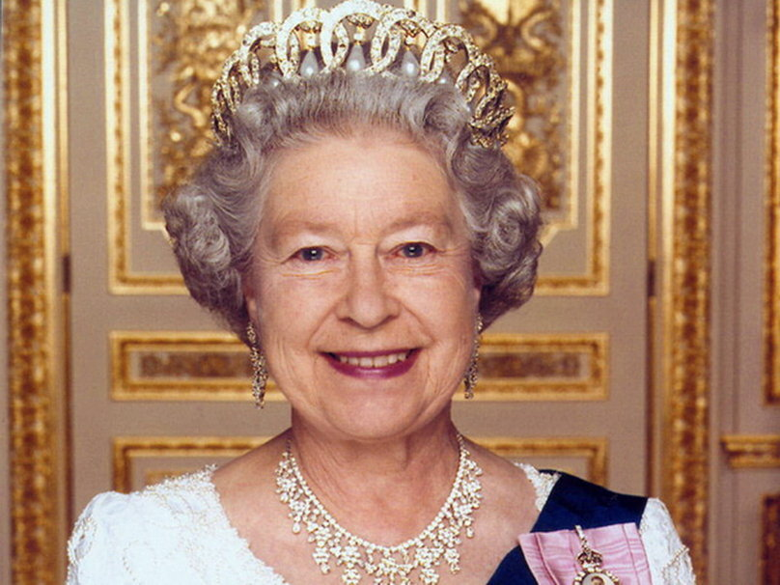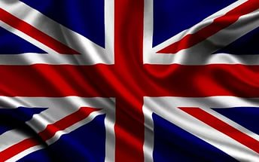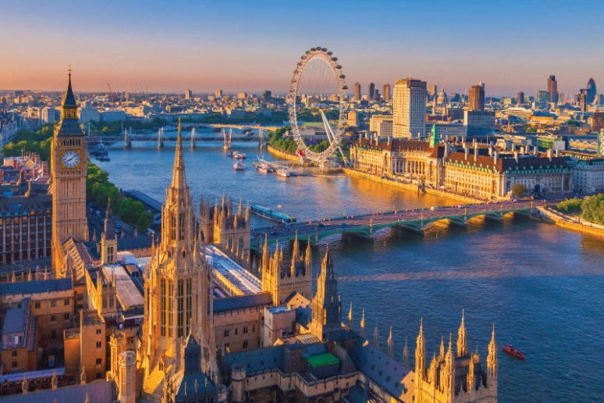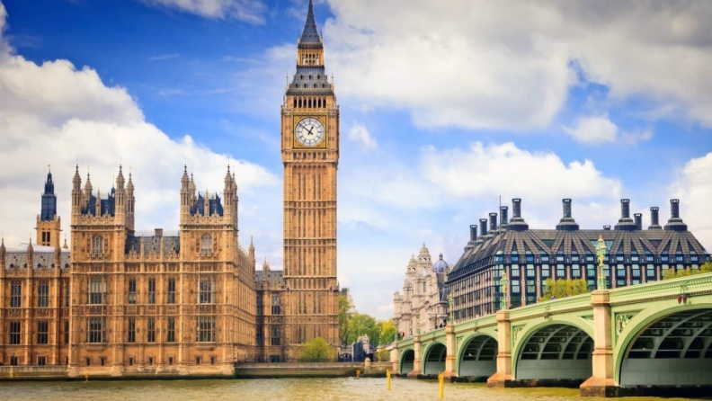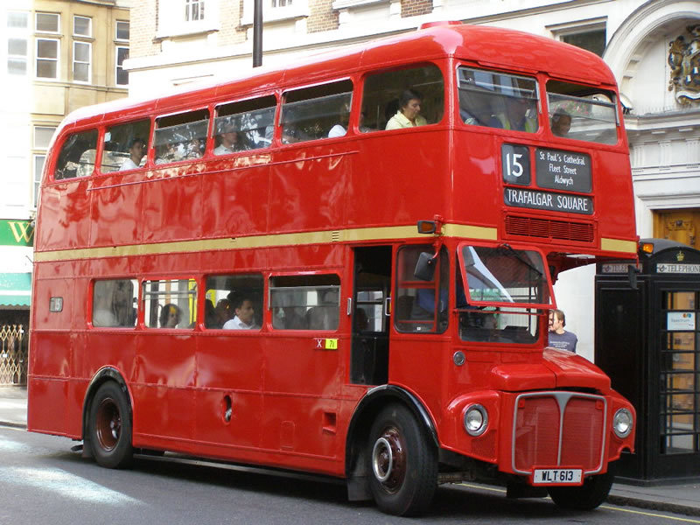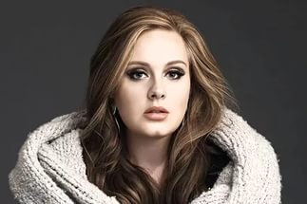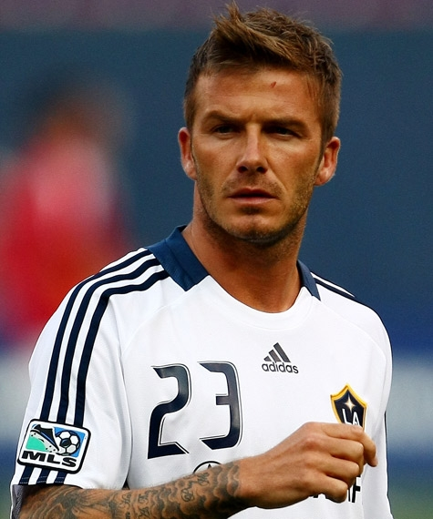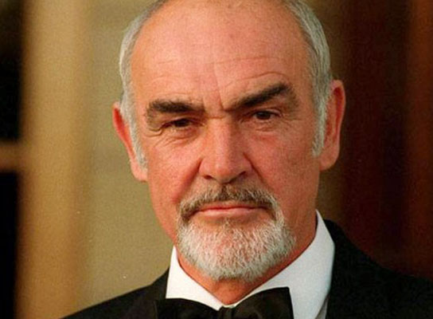

Малюнки до розповіді про США

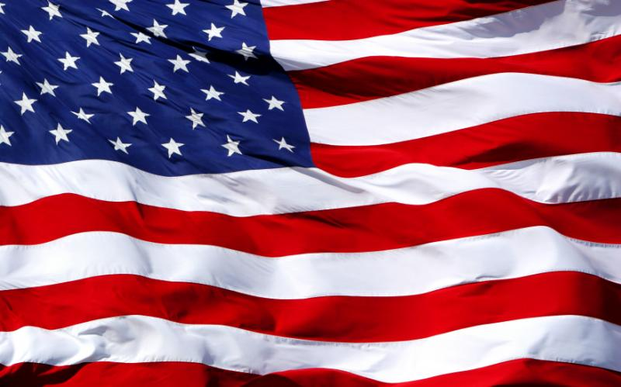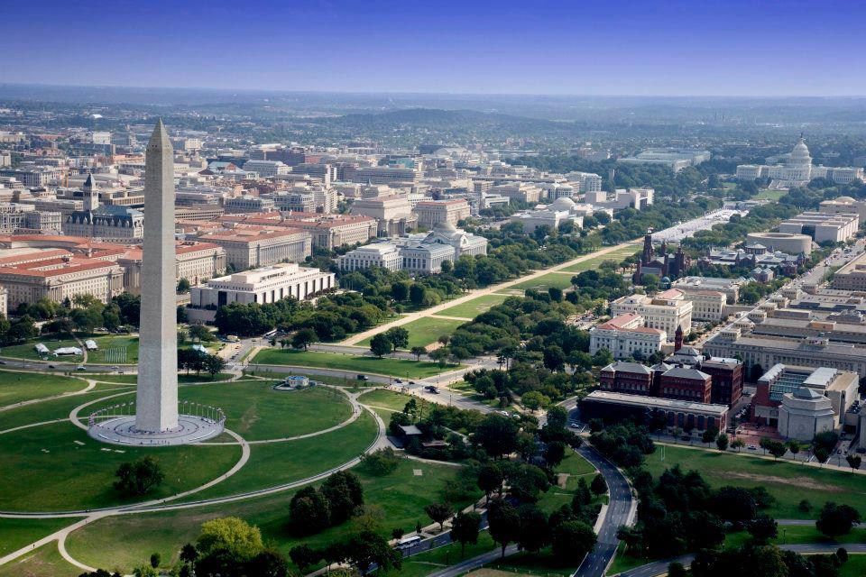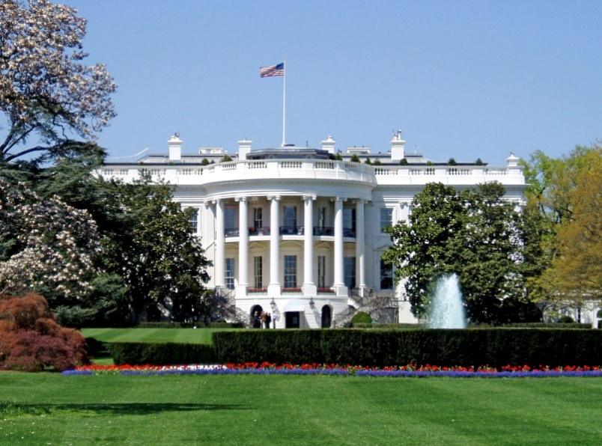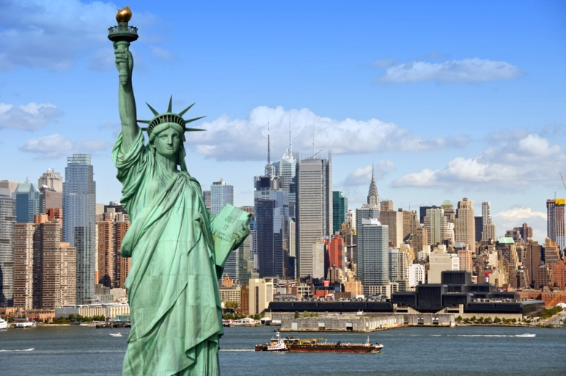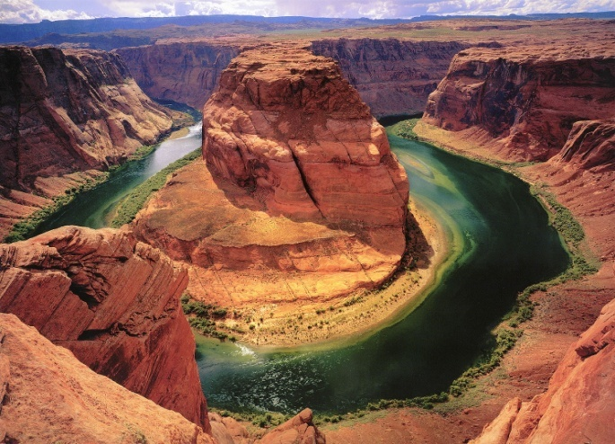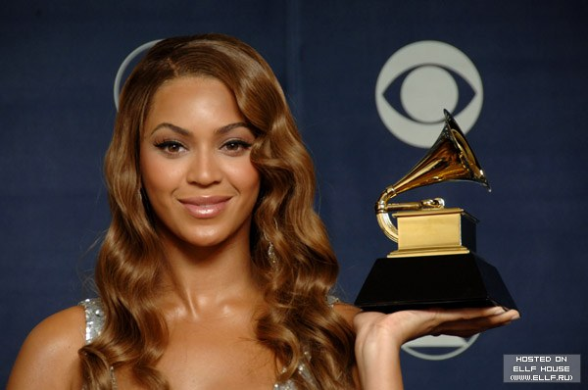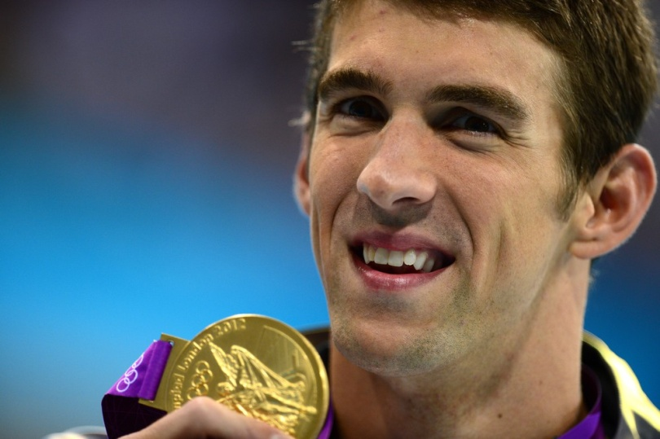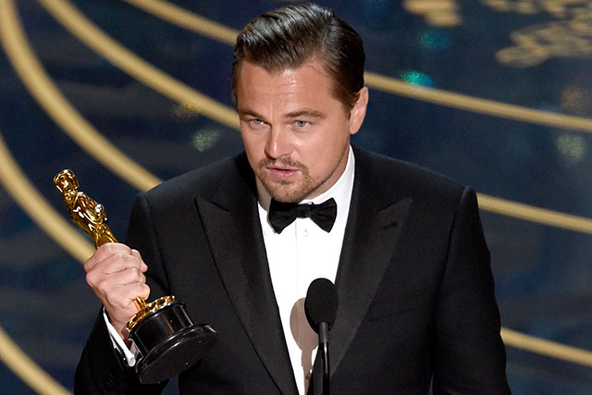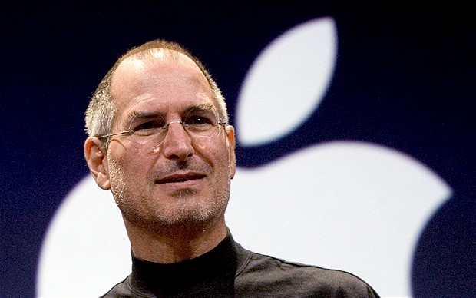

Малюнки до розповіді про Канаду

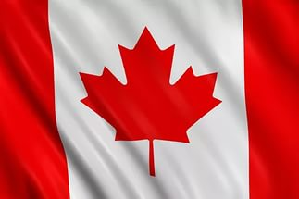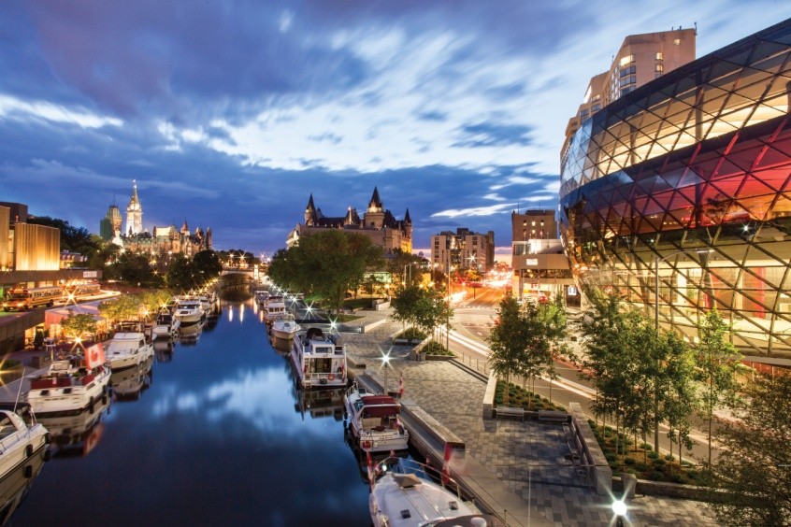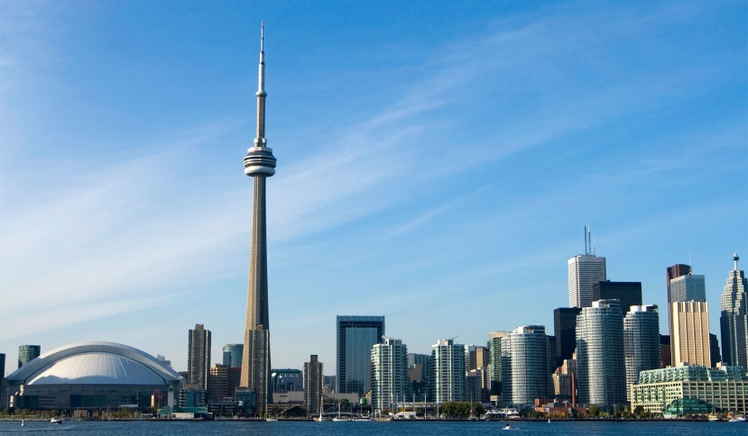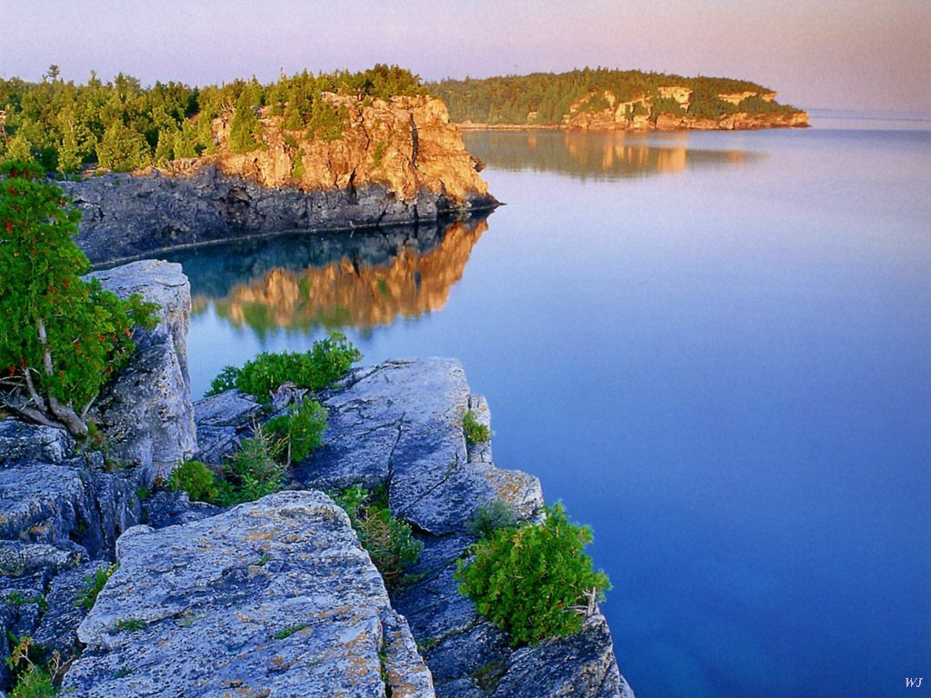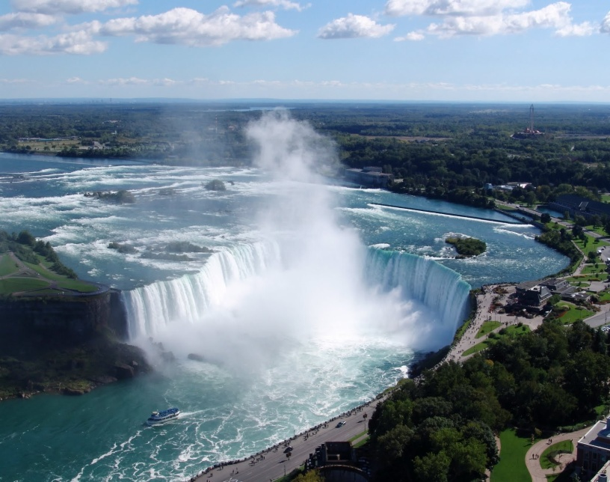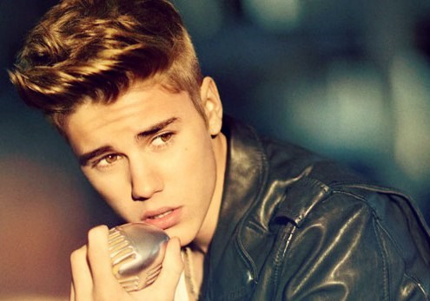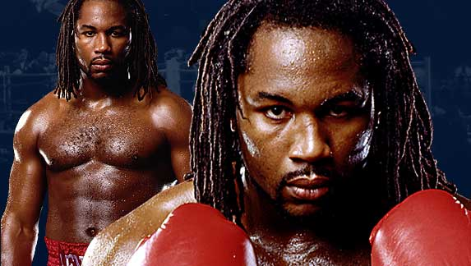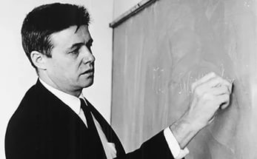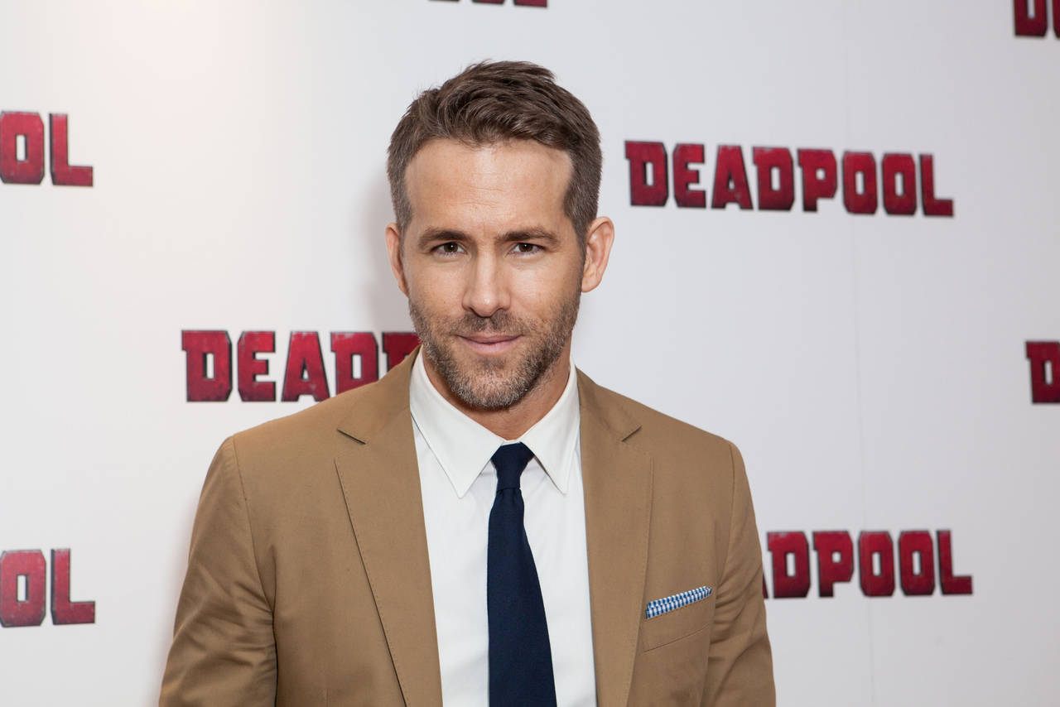

Малюнки до розповіді про Австралію

