The seven ages of man

___________________Мічуріна Т.В., Чорнобаївський НВК, Херсонська обл.

Aims and objectives: to develop pupil’s speaking, listening and reading skills; to teach students to solve problems and to use new words; to teach students to realize the necessity of being respective to the older people; to work out the positive attitude to the oldest.
Equipment: handouts; texts for reading, pictures.

PROCEDURE
I. Introduction
Greeting
T. Good morning! I am glad to see you. How are you today?
I hope, you’ll enjoy our lesson today. I’m sure you want to be clever and well-bred. So you should do your best to be active at the lesson. I think you are ready.
The topic of our lesson is “The seven ages of man”.
II.Warming up
T. To begin with let’s revise the knowledge about the age of a man. People in developed countries can expect to live for about seventy years. Suggest age groups for the following people and ages.

0 - a baby (babyhood)
- 13 a child (childhood)
13 - a teenager (the teenage years)
- an adult (adulthood)

- a middle-aged person (middle age)

- an old person (old age)

What are some of the joys and problems of each age?
Are you happy with your present age?
How do you feel about growing older?

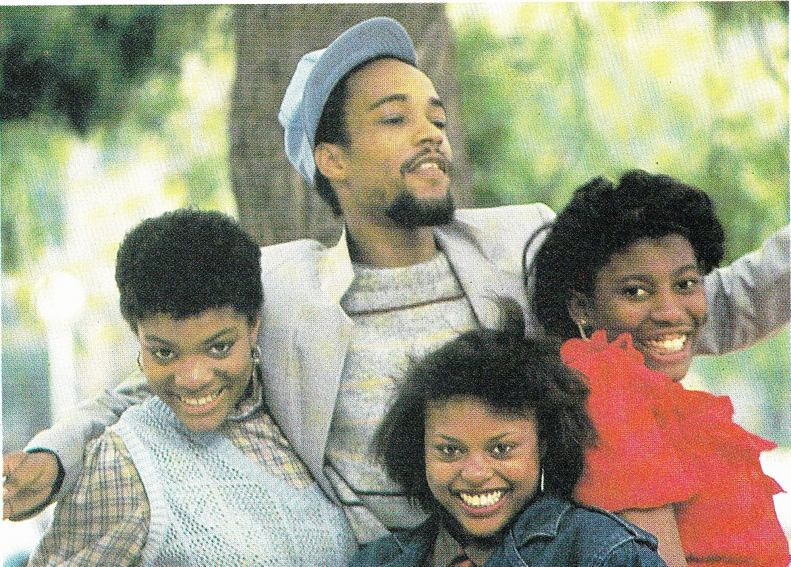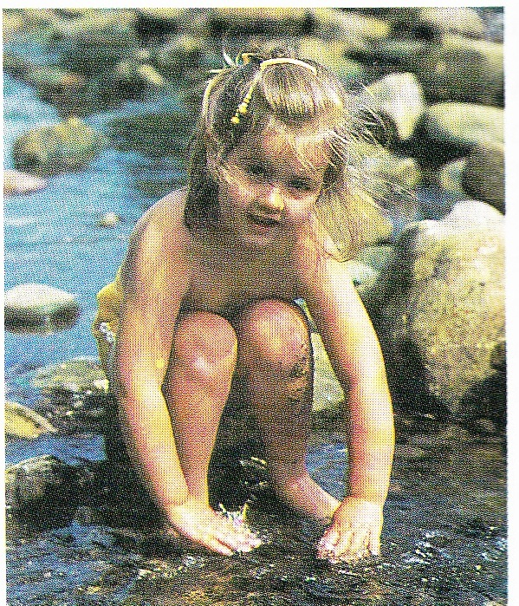
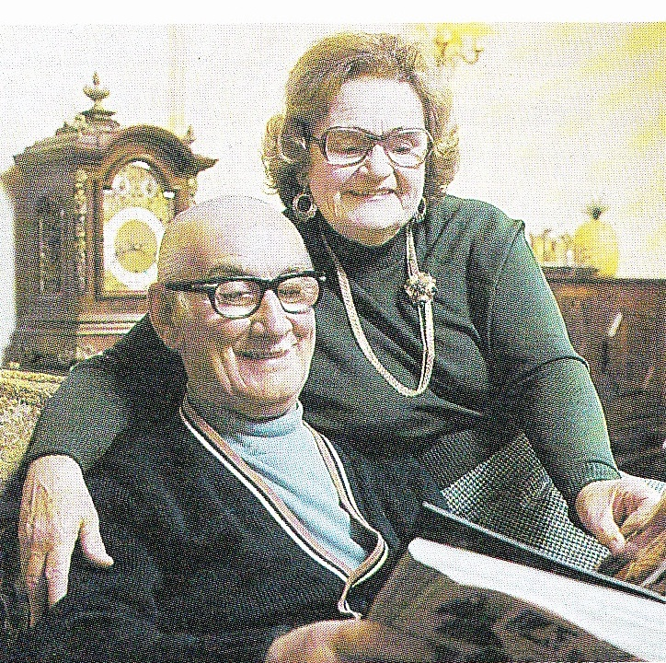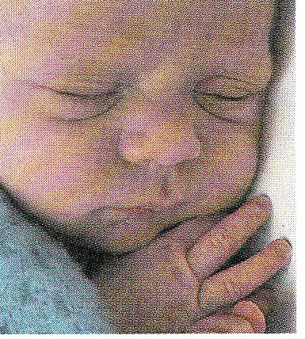

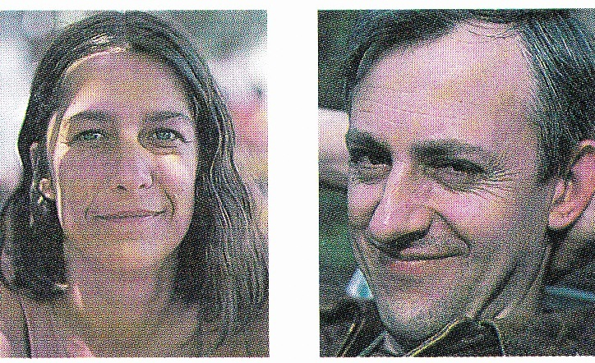

III. The main part
Reading
Pre-reading task
T. Work in pairs. With which age or ages do you associate the following? Use your dictionary and discuss together.
- nappies - comics
- a pension - false teeth
- wrinkles - swings and roundabouts
- moo cows and gee gees - a satchel
- a mortgage

- swotting - going bald
- going grey - playing truant
- expecting a baby
- an inability to sleep
- an inability to get up

wise
innocent
mature
being responsible
ambitious
naughty
absent-minded
While-reading
T. This is an extract from a Shakespeare play “As You Like It”. It is a famous speech, known as The seven ages of man, by a character called Jaques.

AS YOU LIKE IT (by W.Shakespeare) Act II, Scene 7

Jaques
All the world's a stage,
And all the men and women merely players:
They have their exits and their entrances;
And one man in his time plays many parts,
5 His acts being seven ages. At first, the infant,
Mewling and puking in the nurse's arms.
And then the whining school-boy, with his satchel
And shining morning face, creeping like snail
Unwillingly to school. And then the lover,
10 Sighing like furnace, with a woeful ballad
Made to his mistress' eyebrow. Then a soldier,
Full of strange oaths and bearded like the pard,
Jealous in honour, sudden and quick in quarrel,
Seeking the bubble reputation
15 Even in the cannon's mouth. And then the justice,
In fair round belly with good capon lined,
With eyes severe and beard of formal cut,
Full of wise saws and modern instances;
And so he plays his part. The sixth age shifts
20 Into the lean and slipper'd pantaloon,
With spectacles on nose and pouch on side,
His youthful hose, well saved, a world too wide
For his shrunk shank; and his big manly voice,
Turning again toward childish treble, pipes
25 And whistles in his sound. Last scene of all,
That ends this strange eventful history,
Is second childishness and mere oblivion,
Sans teeth, sans eyes, sans taste, sans everything.

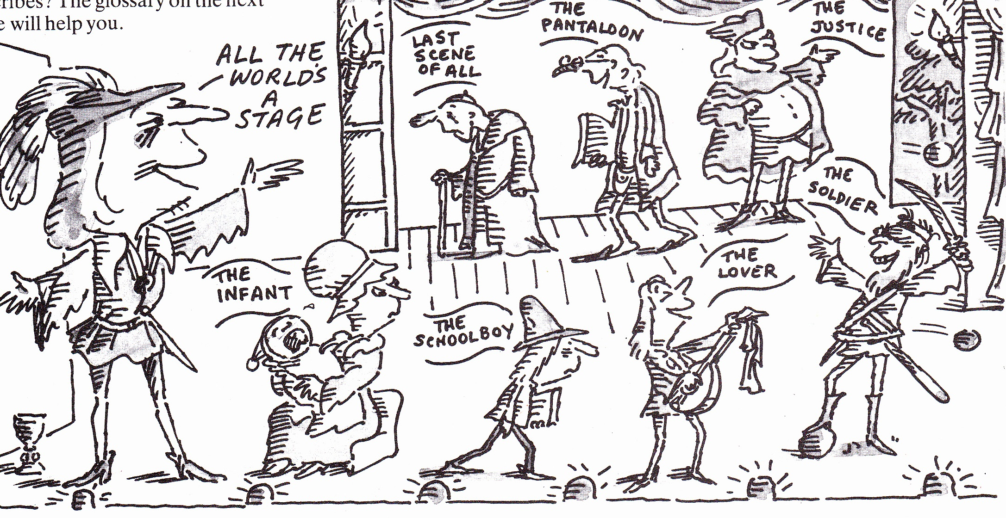

Post-reading task
T. What are the seven ages that Jaques describes? The glossary will help you.
Glossary (by line number)
6 mewling and puking 20 lean
crying and being sick thin
7 whining slipper`d
making a complaining, miserable noise with slippers on
8 creeping like a snail 22 hose
moving slowly like a snail kind of trousers
10 furnace 22/23 The trousers which were saved
enclose fireplace for heating metals from when he was young are
woful now much too big for his body
sad (poetic; modern spelling woeful) which has shrunk.
12 oaths 27 oblivion
swear words, rude words forgetfulness
bearded like the pard 28 sans
with a beard like a priest without (French word)
15 justice
judge
16 belly
stomach
capon
male chicken fattened for eating
18 saws
sayings or proverbs
instances
examples
Comprehension check
- What is the modern word for players? (line2)
- What are exits and entrances, parts and acts in the theatre? What are they in
a person’s life?
3. Does the baby seem attractive? What doesn’t the schoolboy want to do?
What is the lover doing? Do all of these words describe the soldier? (violent, quick-tempered, clever) What does the judge like doing? How old is the man in the sixth age?
What can’t the man in the seventh age do?
- There is a negative criticism of each of the seven people.
Who…
- keeps on complaining?
- wants fame so much that he’ll probably kill himself?
- looks rather ridiculous?
- sounds and smells awful?
- probably wouldn’t notice either the sound or the smell?
- will probably mature with age?
- sounds a real bore?
- The lover writes a ballad ‘to his mistress’ eyebrow. What point is Shakespeare making about the lover?
- Explain the phrase bubble reputation.
What do you think?
- As You Like It was written nearly four hundred years ago. How much are Shakespeare’s descriptions of people still true today? Do you know anyone that resembles one of the characters?
- Shakespeare describes the ages of man very cynically. How could each person and age be described in a more flattering way?

IV. Summarizing
T. The lesson is coming to the end. What useful information have you learned today? Thank you very much for the lesson. You all worked well. I’ll put you …marks.
Wish you good luck and take care of yourselves. See you next time.

