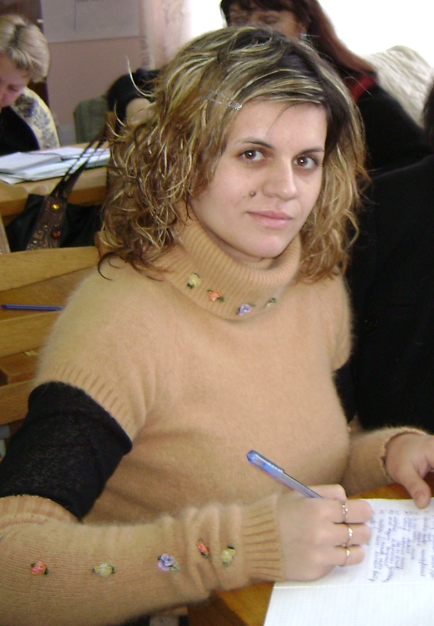
Michurina T., teacher of English, school of Chornobayivka, Kherson region.

Topic: Do you know Britain? (A quiz among the 5th forms)

Objectives:
Practical: to check pupils on the given topic, do tasks, solve the riddles, answer the questions.
Educational: to enrich and broad the pupils’ world as to the Great Britain.
Developing: to develop the skills of speaking, to enhance their cognitive abilities and memory pairs and group co-operation.
Moral: to respect the class-mates.
Equipment: map of Great Britain, a box for cards, crossword, theme cards, and poster with the names.
Lesson Procedure
1. Lead-in
T: We are going today to check and find out who knows Britain best. We have three teams; each team must work hard and show their knowledge.

2. Warm- up.
T: As you know, Britain consists of four parts: England, Scotland, Wales and Northern Ireland. ( показати на карті країни). And every country has its capital. Please, tell me
1) What is the capital of England? (London)
2) What is the capital of Wales? (Cardiff)
3) What is the capital of Scotland? (Edinburgh)
4) What is the capital of Northern Ireland? (Belfast)
Учні показують на карті столиці.

T: Britain is very beautiful country. There are more than 55 mln people there: 46 mln of them live in England, 5 mln - live in Scotland, 3 mln - live in Wales and 2 mln - live in Northern Ireland. So, Britain’s parts differ from each other and have different culture and life of styles.

1. TASK
T: You must choose one card with the name of one country. So, the task is to show this country on the map and tell us some facts about it. For the most interesting answer, a team will get 2 points, and our guests will put you marks.
Cards:
England
England is the largest part of Great Britain. The capital of England is London. England is washed by the North Sea, Irish Sea, and the English Channel. The longest river in England is Thames. England is very beautiful country. England has an interesting transport – double-decker buses, underground and a taxi.

Northern Ireland
The capital of Northern Ireland is Belfast. It is the cleanest place in the world. Northern Ireland has beautiful green fields. It is also the beautiful part of Great Britain. It also has interesting places where people can rest in the parks.
Scotland
Scotland is one of the parts of Great Britain. Edinburgh is the capital of Scotland. It is a very beautiful country. Scottish people like to dance and sing. Scotland has hills and mountains. The famous Scottish lake is Loch Ness.
Wales
The capital of Wales is Cardiff. It is a small country, but it has stronger tradition. Wales has a festival of Welsh music. Welsh is the official language of the festival. Wales is one of the most beautiful countries, too.

T: Dear guests! The children will answer and you must put your marks. Here are the marks` papers for you. Please, be attentive and kind!
( The children must choose the card with the name of the country and tell about it.)

2. TASK
T: Next, our round is a game «Happy chance». Your task is to answer the questions. For the right answer, you will get 1 point.

Questions
1. What is the official name of the country that we call Great Britain?
2. What are the main colors of the Union Flag? (blue, red and white)
3. Who is the Head of the United Kingdom of Great Britain and Northern Ireland?
(Queen Elizabeth 2)
4. Where was Princess Elizabeth educated? (She was educated at home with Princess Margaret, her younger sister)
5. What is the name of queen’s husband? (his name is Prince Philip)
6. How many children have the Royal family? (Four children: Prince Charles, Princess Anna, Prince Andrew, Prince Edward)
7. Who lived in Sherwood Forest? (Robin Hood)
8. Where was the famous Britain group Beatles born? (In Liverpool)
9. What is the favorite hot drink in Britain? (Tea)
10. What is the difference between English and Russian tea? (English- with milk,
Russian- with lemon)
11. Who was called an iron Lady? (M.Thatcher)
12. What is the name of London’s bus? (Double-decker)
13. What historical places of London do you know?
14. What is the official language of the Britain? (English)
15. What English parks do you know? (Hyde park, Green park, St. Jame`s park)
(Five questions to each team).
3. TASK
T: So, the head of Britain is Queen Elizabeth II. She is one of the members of the Royal family. She is one of the world’s richest women. And our next round is about likes and dislikes of the Queen. You will get a box. You must choose what queen likes and what dislikes and put your cards on the blackboard. For this task, you will get 2 points.
(Calm music is playing)

The Queen likes: | The Queen dislikes:
1. Horseracing | 1. Tennis Wimbledon.
2. Scottish country dancing | 2. Milk pudding.
3. Jigsaw puzzles | 3. The cold.
4. Bright red dresses | 4. Charles Dickens.
5. Deerstalking | 5. Dictating letters
6. Champagne. | 6. Cigar smoke.
7. Red roses. | 7. Sailing.
8. Quiet evenings at home dinner speeches | 8. Listening to after dinner speeches
9. Fresh salads | 9. Ivy
10. The Beatles films. | 10. Snails.

4. TASK
T: Let’s do a crossword. You must find 7 words. The words are the things which queen takes when she travels.

1. It is a thing used to make photos. (Camera)
2. It is a thing for the head, especially in a bed. (Pillow)
3. Dried leaves of a plant can get in China, India. (Tea)
4. It is a metal thing for boiling water for drinking tea. (Kettle)
5. It is food what we add to our tea or coffee. (Sugar)
6. It is a thing that helps us to keep our body clean. (Soap)
7. It is very precious metal. (Jewellery)
в | E | P | A | S | U | G | A | R
о | K | I | M | P | K | N | S | Q
D | F | L | E | R | E | D | О | L
N | M | L | R | D | T | E | A | M
P | s | 0 | A | K | T | В | P | F
J | E | W | E | L | L | E | R | Y
K | T | F | D | M | E | 0 | U | D

5. TASK
T: Next, our task is as follows. Look at the blackboard. You must guess the riddles. For the right answer, you will get 1 point.
(The teacher reads the riddles and the children guess.)

1. He is a man who lives in Sherwood Forest. (Robin Hood)
2. His monument stands in the centre of Trafalgar Square. (Nelson)
3. It is a monastery where all the kings and queens were crowned. (Westminster Abbey)
4. It is a famous picture house in Trafalgar Square. (National gallery)
5. It is the most famous cathedral in England. (St. Paul’s Cathedral)
6. This woman was the queen of Britain. (Queen Elizabeth II)
7. The square, which is named in commemoration of the battle. (Trafalgar Square)
8. The official London residence of the Queen. (Buckingham Palace)
9. The most famous museum of wax figures. (Madam Tussard`s Museum)
10. This flower is yellow and white. It is the symbol of Wales. (Daffodil)
11. This bird is very beautiful. It is white, but sometimes it can be black. (Swan)
12. These flowers are red, yellow, pink and white. It is the symbol of England. (Rose)
13. This animal you can see in the Green Park. It is small, has small ears and legs, when he sees people, he is afraid. (A hedgehog)
14. There is a rosy garden in this park and people can go boating in the lake. (Hyde Park)
15. This park has a wonderful lake, you can see swans there. (St. Jame`s Park)
16. It is a very quiet place where you can see funny animals. (Green Park)

6. TASK
Teacher: Next, our round is Short names. Match full names with the short ones. For the right answer, you will get 2 points.
(In every day life we never call each other by the full name, we use short names. That’s why you must know well as full names and short ones)
I.Elizabeth a) Mike
- Peter b) Bobby
- Thomas c) Pam
- William d) Pat
- Susan e)Tony
6. Robert f) Bill
- Pamela g) Tom
- Patrick or Patricia h) Pete
9. Anthony i) Liz
10. Michael j) Sue
7. Summing up
T: Dear guests! Count, please the points of the three teams and announce the winners.
8. Putting marks.

