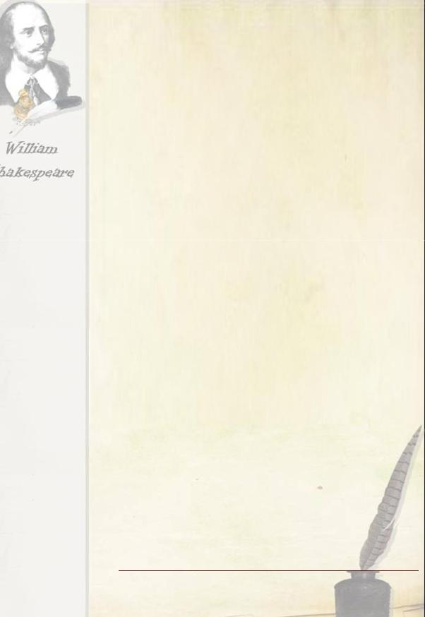

After classes activity

Theme:

"William Shakespeare is a brilliant individual"

8-11 classes

Prepared and conducted by English teacher, qualification category I

Mariupol technical lyceum

Kurilenko O.A.

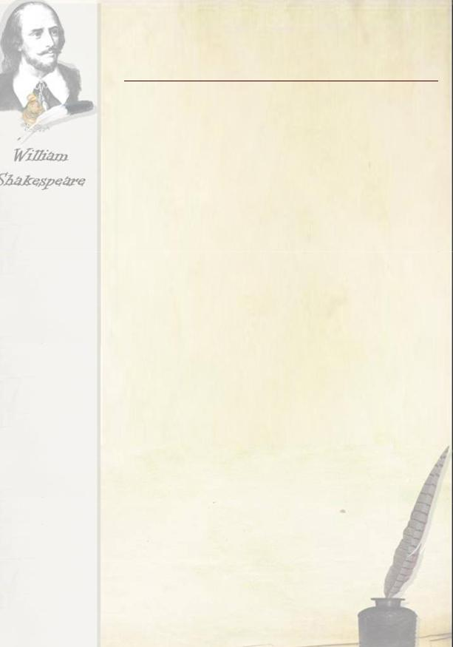
Plan outdoor activities (8-11 class)

Prepared and conducted by English teacher Kurilenko O. A.

Topic: William Shakespeare is a brilliant individual.

OBJECTIVES

- to develop in students the skills of group discussion on the basis of monological utterances.

- to develop the ability of students to converse in a foreign language, to master different types of monologue and dialogical speech, to learn to independently select and analyze material;

- To contextualise the balcony scene (Act 2, Scene 2) in

Shakespeare’s Romeo and Juliet in order to increase students’ interest in and awareness of drama in general and Shakespeare in particular

- To practise both reading for gist and close reading

- introduction to the life and work of English writer and playwright William Shakespeare;

- further consolidating the skills of adequate perception of foreign speech at the hearing;

- expanding horizons of high school students (increase of knowledge about the works of William Shakespeare and the history of England of the XVI century).

- the development of aesthetic ideas and acting abilities in children

- further development of memory, observation, imagination, fantasy, self-reliance;

- to continue to foster a culture of feelings;

- to develop skills of recitation.

- to develop respect and understanding of culture of England.

MATIRIALS: a computer, projector and screen, SMART BOARD, butcher paper, costumes.

PROCEDURE

І. WARM-UP

1.1. Read the epigraph of the lesson on the slide:

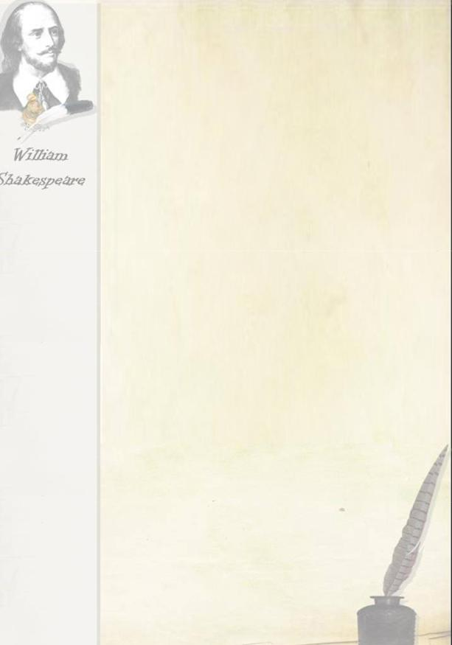
“He Was Not of an Age but for All Time”.

Benjamin Johnson

- What way do you understand these words?

(Pupils discuss the epigraph.)

Е.g.: He was the greatest of the greatest, the genius among geniuses, born in the heart of England.

1.2. Shakespeare's legacy is enormous. Do you know that...

...William Shakespeare was born on April 23, 1564 & died on the same date, April 23, 1616?

...John Shakespeare, the great playwright's father, could not write?

...William Shakespeare left the Grammar School where he studied when he was 13 years old & never went to school again?

...William Shakespeare travelled up to London on foot without much money in his pocket because he wanted to become an actor?

...William Shakespeare began to work in London holding horses of those Londoners who came to see the plays at the theatre?

...The signatures of the greatest English men & women cover the walls and the ceiling of the room in which Shakespeare was born?

...William Shakespeare is called the Bard of Avon?

1.3He wrote 37 plays, 154 sonnets and two poems. Which of them have you read? Which are your favourite?

What do they teach us?

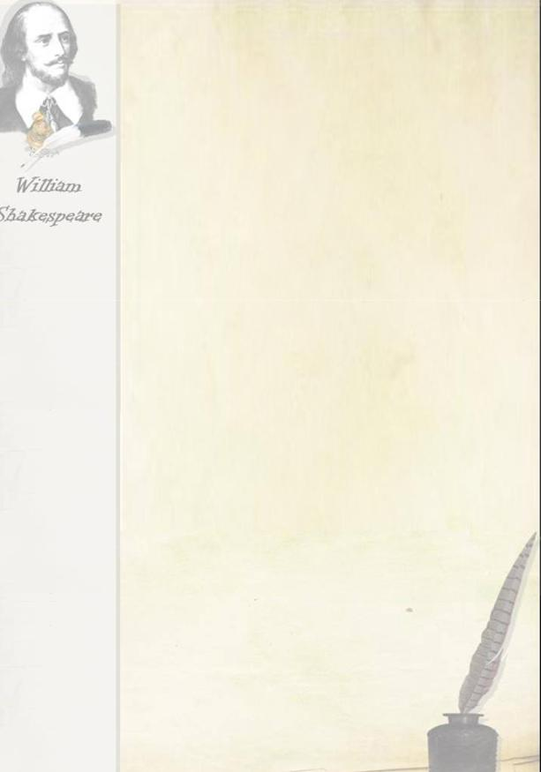
Введення в іншомовну атмосферу.

Match the quotations from Shakespeare’s work with their translation.

- All’s well that ends well.

- All that glitters is not gold.

- Much ado about nothing.

- Cowards die many times before their death.

- All the world’s a stage. All the men and women are merely players.

- Delays have dangerous ends.

- Brevity is a soul of wit. a) Много шума из ничего.

- Все хорошо, что хорошо кончается.

- Жизнь наша - игра, а люди в нем лишь актеры.

- Не все то золото, что блестит.

- Краткость - душа (сестра) таланта.

- Трус умирает много раз до смерти.

- Промедление в смерти подобно.

ІІ. LISTENING

1.1. Split in groups. You’ll listen to the poem. Try to concentrate on the idea of it. (Presentation. Slide with pictures of ENGLAND with sound) Entry with audio file

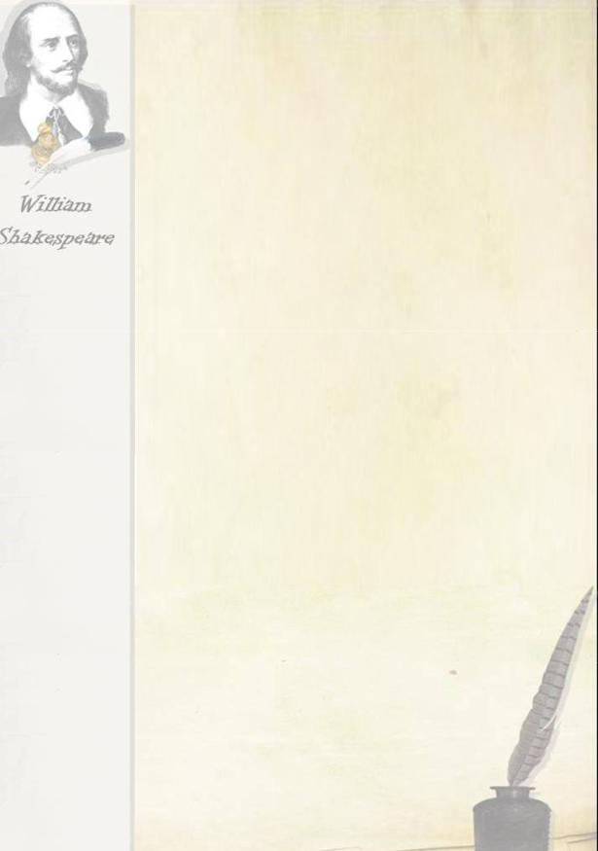
THIS ENGLAND

This lovely land that Shakespeare praised so well; That Wordsworth worshiped for her magic spell; This land of specious cities, and of fames

Pointing to Heaven, amid green — pastured plains; This land of quiet rivers moving to the sea;

Of wooded grandeur, nigh to majesty;

Of highways rambling over hills and dales,

Of rose — crowned hedgerows in sequestered vales; This land of gentle seasons that bestow

Surpassing beauty as they come and go; Unfettered still it shall remain and free, This land that shows what loveliness can be! Allan Junior

1.2. After-listening activities:

Each group makes up three sentences with the words from the text. (Proposed words: worshiped, praised, shows.)

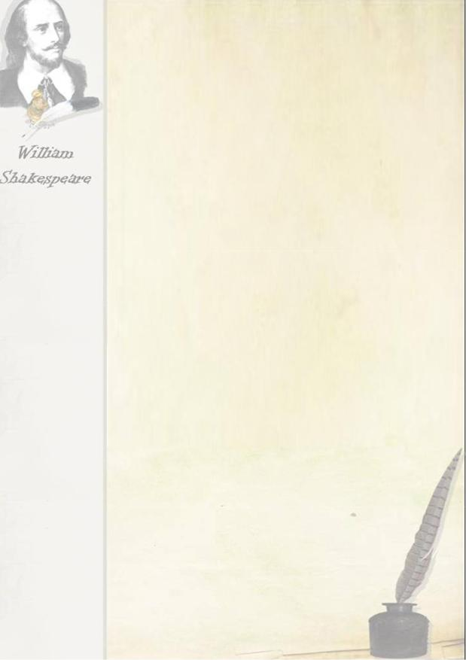

1.3. Listen to the texts and do the tests. Entry with audio file

A. Stratford

Stratford is a very interesting town in the central part of England. Around Stratford, there are beautiful forest, green fields and a quiet little river — the Avon.

Stratford was Shakespeare's birthplace, a small house in the center of the town with a small room in it. This is a very small room where Shakespeare was born.

In one of the rooms, there is a little wooden desk, just the very desk that Shakespeare sat at when he went to study at school in Stratford. And it was the garden behind the house that drew our attention There are planted all the flowers and trees that are mentioned in Shakespeare's plays.

Task I

Presentation slide .Fill in gaps with the missing words: l. Stratford is a town in the central part of ... .

- Around Stratford there are ... .

- Stratford was a birthplace of ...

- The house is in the ... of the town.

- In one of the room, there is a ... .

- Behind the house there was a ... .

B. William Shakespeare

William Shakespeare is one of the world's great writers. He was born in Stratford-on-Avon. He was born on April 23, 1564. His mother, Mary Arden, was a daughter of farmer. His father, John, was a glover who had an office m Stratford. He got his education at the Grammar School.

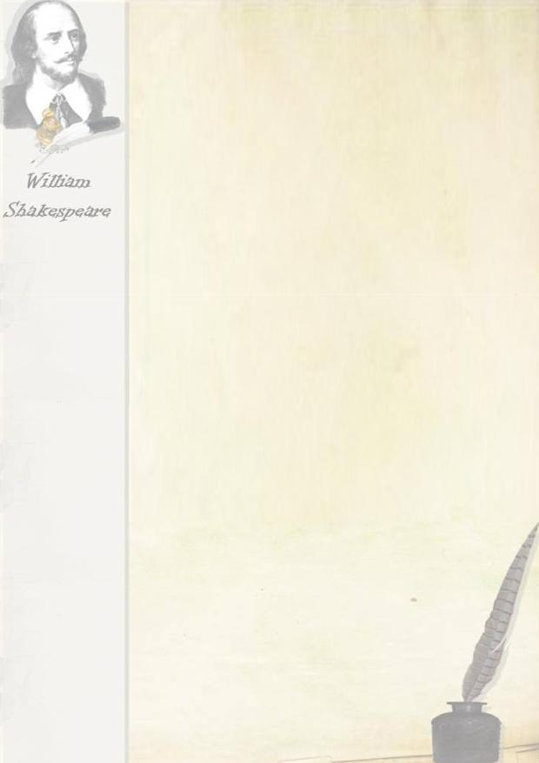
It was a difficult place at that time. The pupils had to be at school at six in the morning in the warm seasons and an hour later in winter. School days were long, and only during the holidays William could have a rest He went to the woods and to the river Avon,

But the best thing of all in Will's life were groups of actors who visited Stratford from time to time. He watched them and knew that he wanted to be an actor

William could read and translate Latin books. He was fond of English folk songs and ballads.

Task 2

Presentation slide Choose the right answer:

1. What is William Shakespeare?

- An English writer

- An American writer

- A famous painter

- The world's greatest writer 2.When was he born?

- April 23, 1560

- April 27, 1564

- April 23, 1564

- August 23, 1564

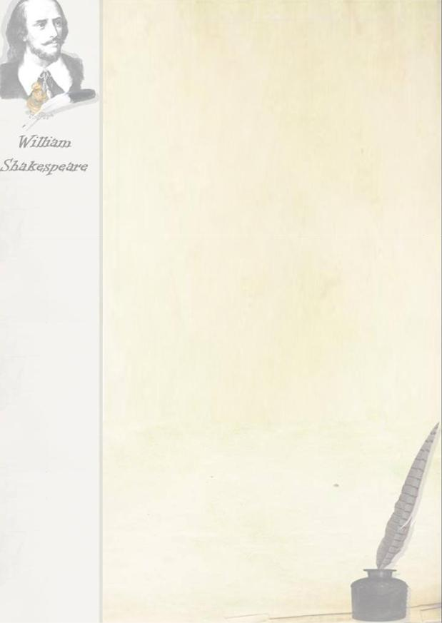
3.Where was he born?

- In Stratford-on-Avon

- In the village of Avon

- In Atford-on-Stravon

- In the town of Thames 4.Where did William study?

- a university

- At the Grammar School

- At a school for poor children 5.Where did he like to go? a)To the theatre

b)To the wood and to the river Avon c)To the meadows

d)To the field

6.What was he fond of at school? a)English pop songs

b)English fairy tales

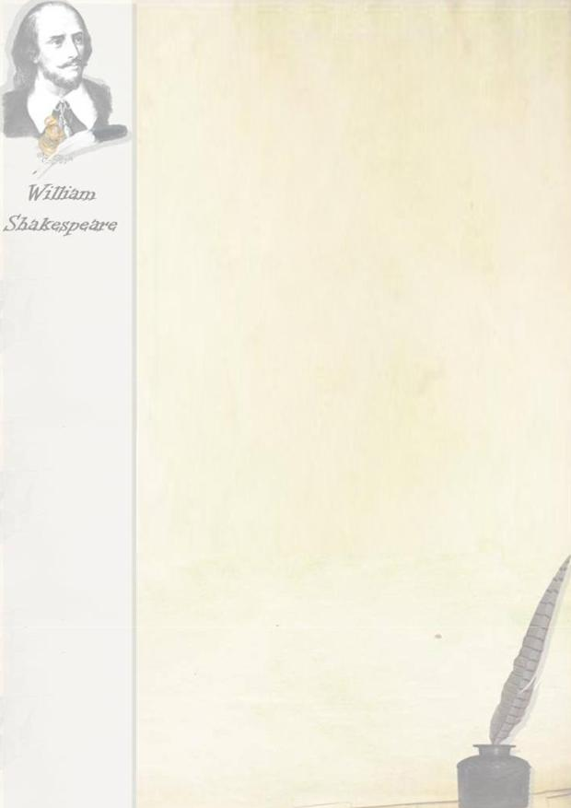
c)English folk songs and ballads

d) American ballads

C. Shakespeare's First Work

Some time later William's father became poor and William had to go to London and begin to work. There is a story that Shakespeare's first work in London was holding rich men's horses at the theatre door. But nobody can say whether this story is true.

Later Shakespeare became an actor and a member of one of the big acting companies. Soon he began to write plays for this company and in a few years became a well-known author

Presentation slide Task 3

Continue the following:

- Some time later William's father became ... .

- William had to go to London and begin to

- Thf first work was . .

- Later Shakespeare became ... .

- He began to write ... for this company

  - The Globe Theatre

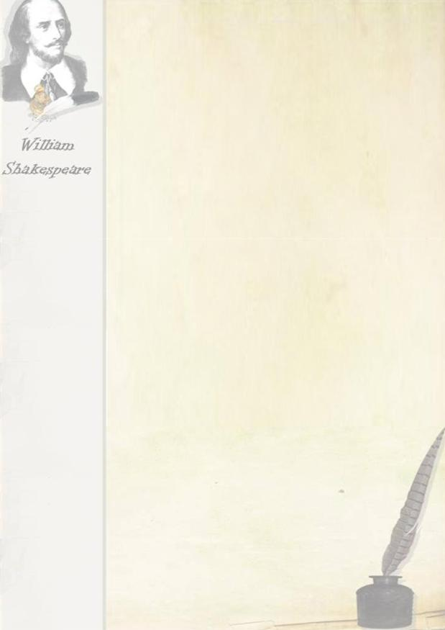
I am sure it will be of some interest for you to know what the theatre in the days of Shakespeare looked like. It did not look like our modern theatres.

It was a high round building without any roof except over the stage. In winter, the theatres were closed. As there was no artificial light in those days, the place took place in daytime, between one and three o'clock in the afternoon. A flag was put up above the building to show to everybody that a play was going on at the theatre.

Then there was no scenery and the public was informed where the action was taking place by a paper put up in such a way that the people could easily read it. There it was written: Field, Sea cost, Forest. Sometimes the actors told the public where they were

In those day women were not allowed to work in theatres. All the roles of girls and women were acted by boys. A boy first played the role of women and when he grew up he started acting men's parts at the same theatre.

The actors were often partners in the theatre business Shakespeare was one of the partners in the theatre where he acted and for which he wrote his dramas. It was the famous Globe.

Presentation slide .Task 4

Say if the following statements correspond to the text.

- Woman were always allowed to act on the stage.

- The theatres were open in winter in the days of Shakespeare.

- The actors were played without any scenery.

4.The plays were acted in the evening in those days.

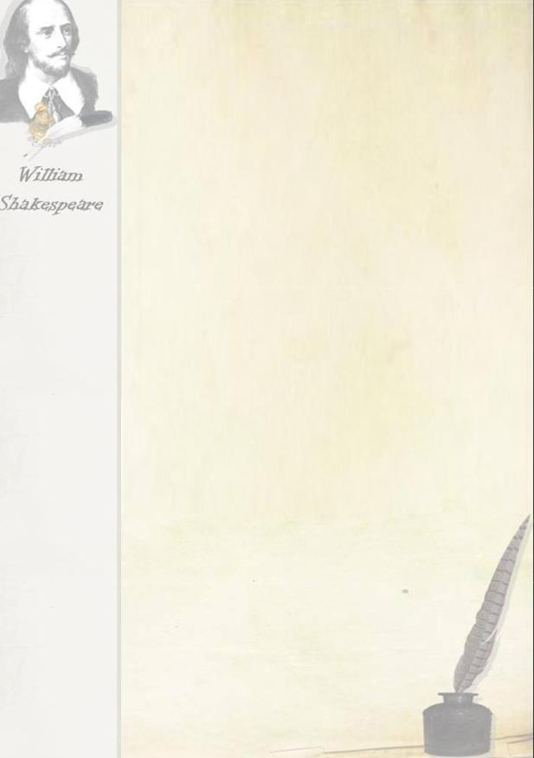
5.There was no artificial light in those days.

E. The Age of Shakespeare

Every Englishman knows more or less the works of his country's greatest poet, Words and phrases from Shakespeare's writing have become part of English language and are used by all.

Shakespeare made fuller use of the English language than any other writer did. There is no better way for a foreigner or an Englishman to understand the richness of the English language than by studying how Shakespeare used it.

The last half of the 16th century and the beginning of the 17th century are called the age of Shakespeare.

W. Shakespeare knew the stage and that helped him to write the most wonderful plays ever written. Shakespeare wrote 37 plays. Among them are tragedies such as Hamlet, King Lear, Othello, Macbeth, comedies such as All's Well That Ends Well, The Twelfth Night, Much Ado about Nothing, historical dramas such as Henry IV, Richard III. By that time, England had to become a powerful state, but there was not much change for the better in the life of the English people and the power of money grew stronger. Shakespeare saw these contrasts and showed them in his works. He showed the differences between the life of rich and poor people He watched the new life and he showed how differently people understood it. Life itself was shown in his plays.

Task 5

Presentation slide. Answer the questions.

- Who was William Shakespeare?

- How many plays did he write?

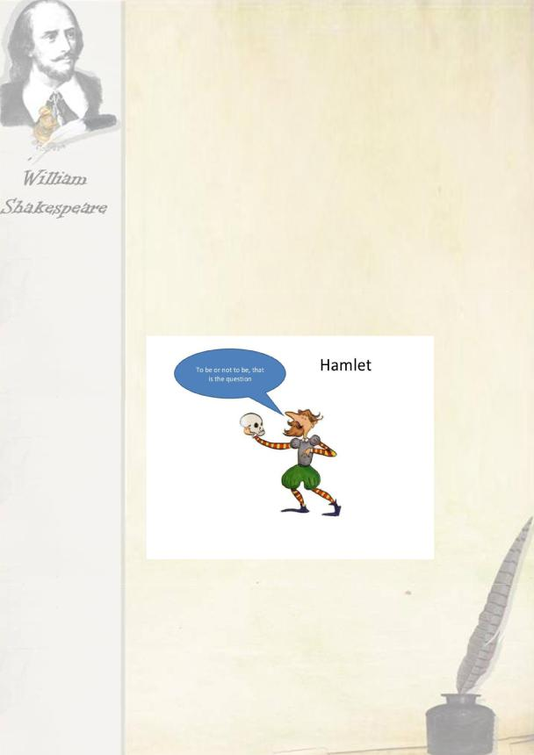
- Did William Shakespeare write comedies?

- What plays by Shakespeare do you know?

- What does Shakespeare show in his work? 6.What helped him to write such wonderful plays?

Watching this video scene from the movie.

Playing Hamlet`s Monologue by a pupil

A contest for boy “Who will be the best orator?” Say Hamlet’s words: “To be or not to be, that is the good question” like a small baby, a beautiful woman, a strict teacher, a good mom, the police, a naughty girl, a strict sports referee, a fairy, the seller from MacDonald’s.
Watching this video scene from the movie.

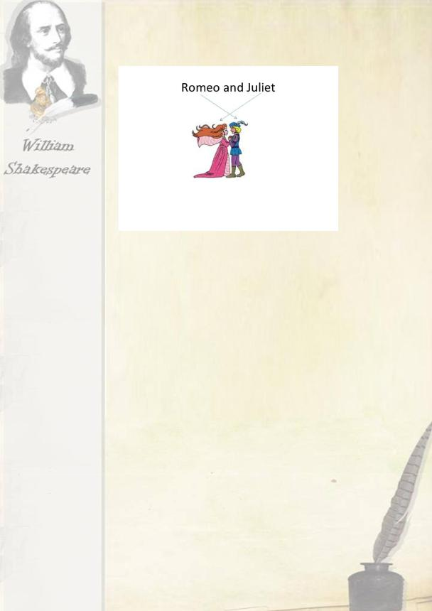

Playing scene .(dialogue Romeo and Juliet)

SMART BOARD. Pair work

Read the compliments on the slide and decide which are friendly (F), which are romantic (R) and which are cheesy (C). Circle the letter you think describes each compliment best and then compare your answers with your partner.

- You’re the most attractive person I’ve ever met. F R C

- You look nice today. F R C

- Flowers are jealous of your beauty. F R C

- You’re my favourite cook. F R C

- You cook very well. F R C

- I would walk a thousand miles for one of your meals. F R C

Ask students to pay each other a compliment and then return the compliment.

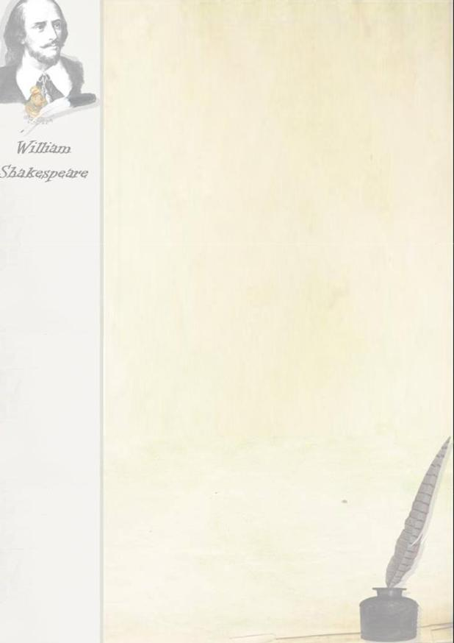

SMART BOARD. Grammar activity. The Globe

I. Fill in the gaps using the correct forms of the verbs in the box.

to invest, to pull down, to store, to enjoy, to rebuild, to sit, to disapprove, to save, to turn out, to base on

- The local people _ of the construction because they were afraid of the disturbances that might be caused by the theatre.

- The Burbage brothers___ the theatre piece by piece and had every timber taken across the Thames to the south side of the river.

- Many people were invited _______ in the theatre.

- The ideas about the interior________ the interior of the Swan theatre.

- Londoners of every sort__________ going to the theatre.

- The wealthy_________ in galleries.

- Here costumes and props ________.

- But the King's men decided________ the theatre on the old foundations.

Keys: 1. disapproved, 2. pulled down, 3. to invest, 4. were based on, 5. enjoyed, 6. sat, 7. were stored, 8. to rebuild.

SMART BOARD . Find the names of these Shakespeare's theatre plays.

SMART BOARD. Do the Crossword.

l.What is William Shakespeare's father's name? (John)

- Continue the sentence William studied at a Grammar School because his father wanted to give his son a good… (Education)

- What was the name of the theatre, founded by Shakespeare? (The Globe)

- The month in-which Shakespeare was born and died. (April)

- Is Shakespeare's play "King Lear" a comedy or a tragedy? (A tragedy)

6.A name of the young Prince of Denmark who de¬cided to be or not to be (Hamlet)

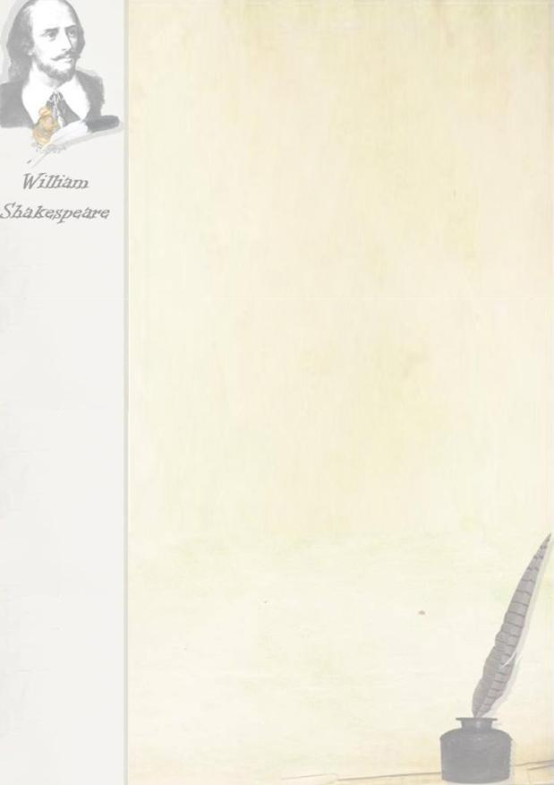
The Key Word -"Juliet”.

III. SUMMING UP

1.ACTIVITY “OPEN MICROPHONE”

Do you agree that Shakespeare's plays and son¬nets are just as relevant today as they were in the sixteenth century?

Опорні слова

- I think... (Я считаю ...)

- I am sure that ... (Я убежден в том, что,)

- As for me ... (Hа мой взгляд (по моему мнению) ...)

- I consider ... (Я считаю ...)

2.ACTIVITY "INTERVIEW"

T: Would you like to make a journey through time and to meet one of the greatest dramatists of Renaissance William Shakespeare? (Yes!) So! Get ready! Now you are journalists of the local newspaper "My School" (music of "Minuet" is played). Close your eyes and use your imagination. You are in a time machine that carries you back into the 16th century. Now you are going to visit a beautiful castle and be present at a grand ball. Ladies and gentlemen are dancing the Minuet. You can hear the sounds of hapricorde. Now open your eyes.

(Students can see a teacher, disguised as William Shakespeare. She's just put on the beret with a feather and a long black cloak.)

T: So, you are in the 16th century now. Here's William Shakespeare himself. You can make a great interview. Be sure that it will be a real sensation.

(Students ask all kinds of questions to the playwright.)

- Home Work : Design a webquest about the texts and authors that inspired Shakespeare.

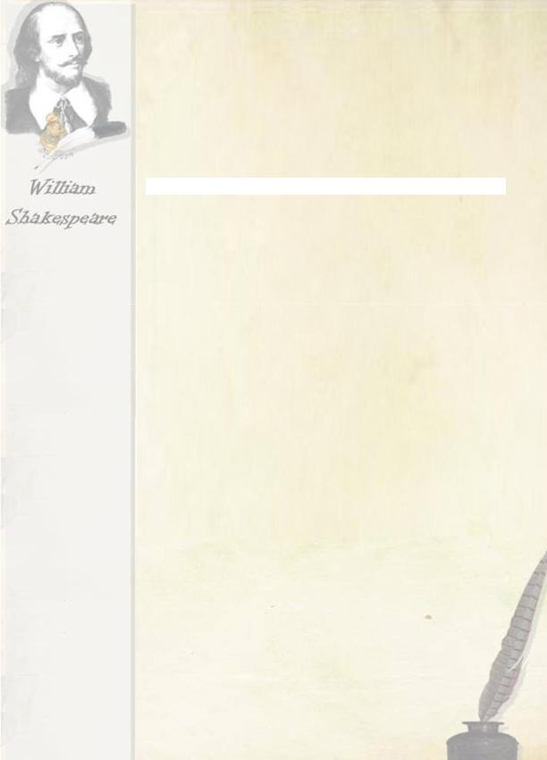
Used books:

  - Civil Z. T. "From Shakespeare to Shaw"; English writers of the XVI-XX centuries. Moscow, Education, 1992

  - Smirnov, A. A. "Shakespeare." Leningrad, Art, 1963

  - Anikst, A. A. "Shakespeare's Tragedy "Hamlet". Moscow, Education, 1986

    - Shakespeare W. "hamlet"; the English translation by M. Lozinsky. Moscow, Children's literature, 1982

- Internet resources:

- http://www.bardweb.net/

- http://www.shakespeare-online.com/biography/

- http://www.bioRraphy.com/people/william-shakespeare-9480323

- http://www.william-shakespeare.info/wiHiam-shakespeare-biography-marriaRe-wife-anne-hathaway.htm

- http://www.americanshakespearecenter.com/

- http://shahttp://www. globetheatrelive.com/kespeare. about. com/od/shakespeareslife/a/Anne-Hatha way-

- Shakespeares-Wife.htm

- http://globetheater.com/

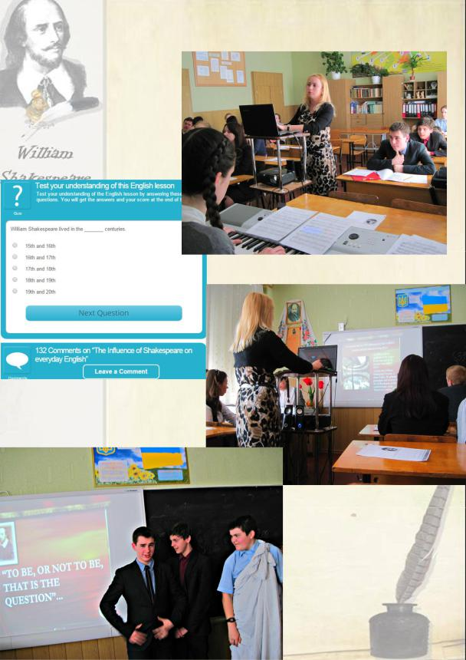
Photo report

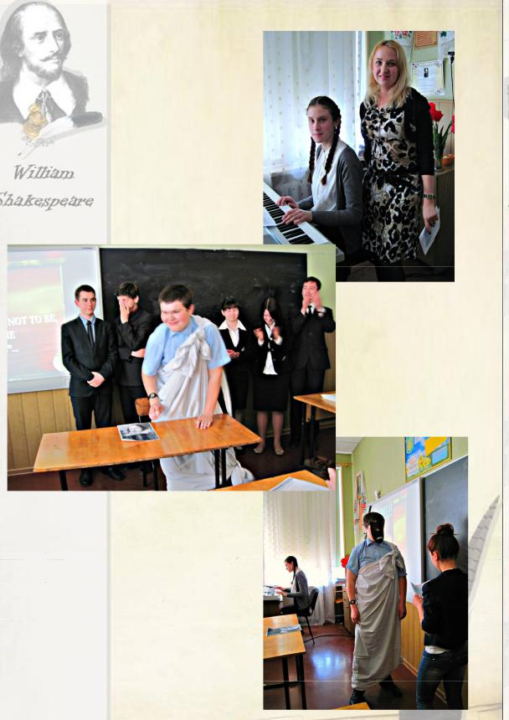
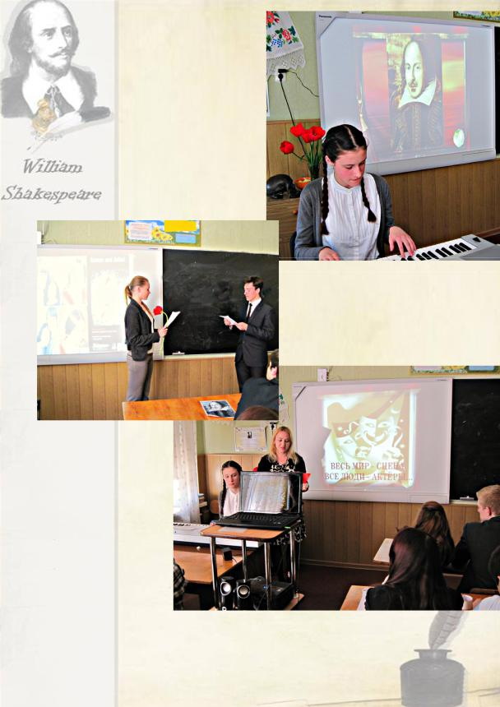

We had a great time!

