Міністерство освіти і науки України
Загальноосвітня школа І-ІІ ступенів с. Заруддя

План-конспект
позакласного заходу англійською
мовою в 1 класі
“Свято Букварика”
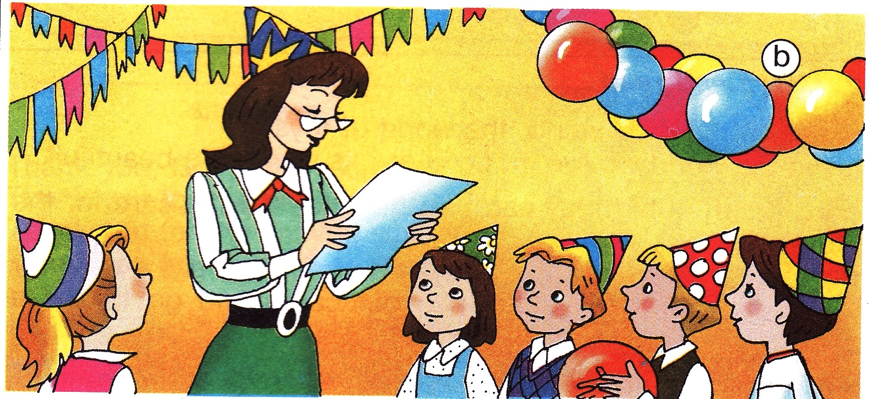

Підготувала вчитель англійської мови
ЗОШ І-ІІ ступенів с.Заруддя
Беш О.В.

Мета: Повторити вивчений лексичний і граматичний матеріал, англійський алфавіт. Вправляти учнів у застосуванні вивченого матеріалу через участь у іграх і інсценізаціях. Розвивати творчі здібності, увагу, уяву, учнів. Вправляти учнів в усному мовленні, читанні, письмі. Виховувати любов і зацікавленість до вивчення англійської мови.
Обладнання: телевізор, комп’ютер, аудіо запис та відеозапис пісень “Supersongs” (Oxford University Press), картки із завданнями, алфавіт, ілюстративний матеріал, декорації залу.
Тип заходу: урок-подорож з елементами гри.

1). Greetings.
Good morning, Dear ladies and gentleman.We are glad to see you today . Welcome to our ABC-party. We invite you to travel with us to our ABC-land. - Today we have a very adventuries trip to an ABC- land.Well, let`s begin our English party.
A song Hello
Hello, hello, hello!
Hello, friends, hello!
Hello- hi! Hello- hi!
Hooray, hello, hi!
Hooray, hello, hi!
2)Today we shall make an interesting and funny travelling from A to Z. Do you want to start?Dear children, your task is to take seats in our bus with your tickets. But your tickets will be our letters. Then you will recite the poems about the English letters. We shall begin with the first letter of the English alphabet. It`s the Letter A.
ABC –poems
Letter A
Apples here, apples there,
Apples, apples everywhere!
Letter B
Bounce! Bounce! It is my ball!
It doesn`t want to stop at all.
Letter C
I`m the cat. My name is Hat.
I`m not fat. I like to chat!
Letter D
I`m the dog. My name is Jack.
My coat is white. My nose is black.
Letter E
Little yellow bee, bee, bee!
How many flowers can you see?
Letter F
One, two, three, and four, and five!
I have got a fish alive!
Letter G
I`m a girl. I`ve got a doll.
Her name is Mary. We like to play.
Letter H
Little mouse, little mouse!
Where is your house?
I`m a poor mouse, I have no house.
Letter I
Spring is coming. Warm and nice.
Ice is melting. Poor ice!
Letter J
Merry Jimmy Jinn
is jumping in his jeans.
Letter K
The king is strong. The king is brave.
What is his name? He is Nick Grey.
Letter L
Who lives in Africa?
He, she or me?
One lion, two lions, three...
Letter M
Little mice, little mice!
Would you like a piece of ice?
We would like a piece of cheese. Yes, please!
Letter N
How much is one plus one?
Two big nuts for little son.
Letter O
“Tick-Tock! Tick-Tock!
Play and walk,” says the clock.
Letter P
I`v got a pet. My pet is a pig.
His name is Pick. He is not big.
Letter Q
Mary the Queen can dance and sing.
Letter R
One, two, three! One, two, three!
Nice red roses you can see!
Letter S
Mary! Come and see!
A big snake is in the tree!
Letter T
When tigers walk
They like to talk.
Letter U
Hurry, hurry Cinderella!
Quickly bring my blue umbrella!
Letter V
Can you dance? Can you sing?
I can play the violin.
Letter W
Hey, Letter W!
I like the words with you!
Whу, what, who,
Window, wall, two,
Swim, white, owl,
Down, town... Wow!
Letter X
I see two funny foxes
With two small boxes.
Letter Y
Fly! Fly! In the sky!
My nice and funny kite!
Letter Z
We go, we go, we go to the zoo!
We can see a tiger and a zebra, too.
3)And now we are at the first bus stop- at the zoo station. Your next task is to salve the riddle.
1) It can run and jump. It’s not big. It’s black, white or grey. It lives in the house. It says meaw, meaw (Cat)
2) It’s big. It can run. It lives in the zoo. It has got a long nose. (Elefant)
3) It’ s red or maybe orange. It’s not big. It can run. It can jump.It lives in the forest. It’s very sly. (Fox)
4) A lots of spots. A long, long neck
A funny scarf. It’s a (Giraffe)
5)A green and long with many teeth
Beautiful smile. It’s (Crocodile)
4) Sing a song “At the soo”
I can see a fox in the zoo.
I can see a rhino, it is blue.
I can see a monkey in the tree
I can see a black and yellow bee
A tiger, big lion, a small kangaroo
We can see them all in the zoo

5)And many animals are hidden. Try to find them.
Circle ,please
Jhefjfgih3jcatjklerj
Lfremndogkikpo
Mkpo3frognklllw
Vdnlvnlkpigyeu
Nknjkerelefants

6)Our next task is to visit a toy house
Sing a song
Toys for me, toys for you
Toys for everyone
A pink ballerina
A blue toy soldier
We are all having fun

Toys for me, toys for you
Toys for everyone
A brown teddy-bear
A yellow doll
We are all having fun

7) The children recite the poems about their favourite toys
This is my cat,
She looks for a rat,
Her name is Pete,
She likes to eat.

This is a dog,
He growls at a frog.
His name is Mark,
He likes to bark.

This is a pig,
She likes to dig,
Her name is Pat,
She is very fat.

This is a snake,
It lives by a lake,
It is on a log,
And look at a frog.

This is a fox,
She looks at a box,
She makes a plan
To catch a hen.

This is a monkey,
He is on a donkey,
His name is Pride,
He likes to ride.

This is a bear,
He sits on a chair,
His name is Toney,
He looks for honey.

My doll is very nice and big,
And everything it has:
Two big blue eyes, the curly wig,
The white and blue silk dress.

I like my teddy-bear,
The best of my friends,
I walk everywhere
And hold him in my hands.

It is blue, and green, and red,
It bounces higher, that my head,
It does not want to stop at all
What is it? It is my ball.

8) …Clap your hands…
9)Now we are repeating the colours.
Our next bus station is rainbow.
Now we are listening to a song and push the keys.

10) Now we are singing the song.
Red and yellow and pink and green
Purple and orange and blue
I can sing a rainbow
sing a rainbow
sing a rainbow too…
11)And now we must help the bees to gather the honey.
12) Now we are at the last bus station. This is the ABC palace. But it is closed. We should go upstairs with this clever man, OK!
13)The first stair is Missing letters.
I show you the word and you say me, what letter is missed.

14)And now we are going upstairs. The next stair is read the sentence. Dear, children, you must guess and read the sentence ( My cat is red).
15) Our next task is a scramble.
P N E- pen;
C T A-cat;
O D G –dog;
P G I-pig;
F O R G –frog.

16)And then our next stair is ABC song. Can you sing the ABC song.
Our last task is hidden by letter Z . We have already found the key from ABC land.
Our ABC party is over and we say Goodbye.

A song Goodbye.

Goodbye, Goodbye, Goodbye.
Goodbye, friends, Goodbye
Goodbye –bye!
Goodbye –bye!
Goodbye, Goodbye, Goodbye.
Goodbye, Goodbye, Goodbye.

