РОЗРОБКА ПОЗАКЛАСНОГО ЗАХОДУ З АНГЛІЙСЬКОЇ МОВИ
“DOES THE BIBLE HAVE A VALUE IN OUR TIME ?”
МЕТА: Розвинути любов до читання. Ознайомити учнів з однією з найпоширеніших у світі книг, привернути увагу до культурного, виховного, мовного аспекту висловів з Біблії, ознайомити з найбільш уживаними в англійській мові фразеологізмами біблійного походження, які допоможуть розуміти ці вислови і читати тексти в оригіналі; продемонструвати зразки майстерно сформованих думок із Біблії, привернути увагу до різноманіття мовних виразів і пробудити бажання досконалого їх вивчення; через «крилаті вислови» біблійного походження сприяти кращому знайомству з літературними скарбами англійської мови. Надати оцінку висловлюванням відомих людей стосовно даної теми.
Обладнання: Висловлювання відомих людей у формі плакатів:
“The Bible is worth all other books which have ever been printed.”
Patrick Henry
«There is no other book so various as the Bible, nor one so full of concentrated wisdom. Whether it be of law, business, morals etc…he who seeks for guidance…may look inside its covers and find illumination….»
Herbert Hoover
Тестові завдання, фото.
ХІД ЗАХОДУ
Teacher: Many ancient writings have been lost, destroyed, or just forgotten, but despite vicious attacks, the Bible has always survived. Some people have fought, at the risk of their life, to make it available to the masses.
Why should the Bible be worthy of our attention? The Bible has great cultural value. The Bible has influenced painting, music, literature and has led to many distinguished achievements. The Bible, written in the finest language and with clear logic, is an excellent aid in gaining wisdom and good sense. Herbert Hoover stated: “There is no other book so various as the Bible, nor one so full of concentrated wisdom. Whether it be of law, business, morals etc…he who seeks for guidance…may look inside its covers and find illumination.”
“Does the Bible have a value in our time ?»
Why do we have to read?
We interviewed youths from 11-th form to find out what they had to say
about the challenges and the benefits of reading. The following is what they said.
Teacher : Why do you find reading such a challenge?
“I seldom seem to be able to find time for it.” (Sasha)
“Reading is hard work. I think I am a little lazy.” (Yelena)
“I hate being forced to read about boring subjects.” (Christina)
“If a book is thin, I might feel like reading it. But if it is thick, it intimidates me.” (Yegor)
“I am easily distracted by other things. I can't concentrate.“ (Sveta)
Teacher : Make connektions!
Connect what you read with what you already know about yourself and
your surroundings. Ask yourself the following questions:
- Text-to-Text
Do the situations or problems described resemble those depicted in other books, magazines, or stories I have read? Do the characters share similar traits with other people I have learned about?
- Text-to-Self
How does this information relate to my circumstances, my culture, my dilemmas? Can I use the material to help me deal with problems or to make my life better?
- Text-to-Surroundings
What does this material teach me about nature, the environment, different cultures, or problems in society?
Teacher: Clearly, reading can be challenging. But is it worth
the effort? How have you benefited from reading?
“Reading has expanded my knowledge, and that has
made me more confident when I talk to people.” (Masha)
“Reading relaxes me and takes my mind off my troubles.” (Alisa)
“Reading takes me to places I would otherwise never be able to visit. “ (Diana)
“Reading helps me investigate things for myself, instead of having to rely on what others tell me.” (Artur)
Teacher: What has helped you to enjoy reading?
“From the time I was very young, my parents have encouraged me to read aloud.” (Tanya)
“My parents encouraged me to use my imagination while reading, to visualize the action. “ (Denis)
“By the time I was four, my parents had provided me a desk and a shelf with all the books they had set aside for me since I was born.” (Anna)
Teacher : Why do you think it is important to read the Bible? Is that difficult for you? If so, why?
“The Bible is such a big book! I think I wouldn't be able to finish it in my whole life!” (Anna)
“Some parts of the Bible are heavy going and not very entertaining.” (Oleg)
“I find it difficult to read the Bible regularly because my schedule is so disorganized.” (Elsa)
“It is challenging for me because chores and schoolwork take up so much of my time.” (Viktor)
“Bible reading is hard for me because I can't seem to cut down on the time I spend on my hobbies.” (Vlktoriya)
“People believe many things about the Bible that are not true. It's much better if you can check these things out for yourself.“ (Masha)
”The Bible requires a lot of thought. ” ( Nata )
Teacher: The Bible has influenced our thoughts. We understand that many expressions we use like “am I my brother’s keeper?” and “an eye for an eye ” come from the Bible. The correct and appropriate use of Bible expressions adds to the language unique originality, special expressiveness, accuracy, vividness. What are some other expressions common to our day that have their origin in the Bible?
a book with seven seals
a Solomonic ruling
the salt of the earth
An eye for eye, tooth for a tooth
Man does not live by bread alone
Task 1 Translate these expressions into Ukrainian
a double-edged sword («двосічний меч», ситуація з доброю і поганою стороною);
a thorn in the flesh (“бельмо в оці”; постійна досада, загроза );
a voice crying in the wilderness («голос волаючого у пустелі», застерігати непереконливо, марно попереджати);
a wolf in sheep's clothing («вовк в овечій шкірі», злий чоловік);
as with Sodom and Gomorrah («Содом і Гоморра», повний гріхів, аморальний );
Casting pearls before swine (« метати бісер перед свинями», даремно щось говорити перед людьми, які в цьому нічого не розуміють);
groping in the dark («блукати в темряві», не знаходити рішення);
heap coals of fire on somebody's head («присоромити кого-небудь»; «відплатити добром за зло»);
how to speak with the tongues of angels («говорити ангельським голосом»; пробувати переконати);
make someone a scapegoat («зробити кого-небудь козлом відпущення», звинуватити кого-небудь без уповноваження);
Man proposes and God disposes («Чоловік пропонує, а Бог розташовує»; чоловік думає про багато речей і робить плани але Бог вирішує, не дивлячись на все планування; невпевнене майбутнє) ;
old wine in new bottles («старе вино в новому міхурі»; той же вміст в новій формі, обман);
serve two masters («служити двом панам»; два нелегкі завдання / роботу робити одночасно);
shake the dust from (або off) one's feet («отрясти прах від ніг своїх»; залишити позаду заздрість, стару ненависть);
someone see the light («побачити світло», хто-небудь раптово починає розуміти, має ідею,знаходить рішення);
Swords into plowshares («Мечі в лемешах», перейти до мирної праці);
the A and (the) O («початок і кінець», «все існуюче»);
the land flowing with milk and honey («країна з молочними річками»; країна. де можна добре жити);
the massacre (або slaughter) of the innocents ( «биття немовлят»);
the prodigal son («блудний син»);
the Promised Land («земля обітована», земля, яка обіцяє хороше життя);
throw the first stone («першим засудити кого-небудь»);
to bear one's cross («нести свій хрест»);
to wash one's hands of somebody (something) (умити руки, зняти з себе відповідальність за кого-небудь (що-небудь);
to worship the golden calf («поклонятися золотому тельцеві»; поклонятися чому-небудь матеріальному; бути жадібним до грошей)
Task 2 What mean these expressions?
a promised land (a land of promise, a land that promises a good life; country to live a desirable life )
a preacher in the desert can be (no attention given; in vain effort; someone who is ignored )
a Solomonic ruling (a wise / surprisingly simple / fair trial, a judge's decision to live smart )
a thorn in the flesh (be a constant threat / warning / challenge and be a constant nuisance, someone who is a nuisance; watching someone suffer continuously )
a wolf in sheep's (an evil man who presents himself as innocent and harmless, something that is stronger / more powerful than it first appears )
dance around the golden calf (worship something material, are greedy for money, view wealth as the only purpose in life )
Task 3 Complete these proverbs
Everything good comes from ….(above )
Man does not live by….( bread alone )
Man proposes and God ….(disposes)
The last shirt has no …(pockets)
One should not praise the day before …(the evening )
Task 4 Complete these sentences
1.“Mayor Heinz Jansen struck ………………….and declared both teams to be winners of the Meppen school run”.
2.“Maurizio Kagel will continue to stay in the modern music industry despite his 60 years as the 'enfant terrible'. And that's probably a good thing, because that way he remains ……………of the avant-garde in the music industry “.
3.“The friendly Dr. Lester and his nice old friends turned out to be absolutely ruthless and murderous, as ravening as …………..”.
4.“Now I've failed twice already” – “Do not worry, according to the saying, ‘………………………………..’”.
5”…………………..is not a solution”
6.No one can …………….without irreconcilable conflict of interest.
7..“Even in casual conversation on a park bench, he is always a perfect gentleman ………., friendly cautious and always trying to be discreet”.
8.“The police in their investigations are still ……….completely”.
9.“Internet governance: a new regulatory approach or ……………?”
10.“Is Australia really …………..?”;
____________________________________________________________
Solomonic ruling
the thorn in the flesh
wolf in sheep's clothing
all good things come in threes
An eye for eye, tooth for a tooth
serve two masters
from head to toe
groping in the dark
old wine in new bottles
a promised land
Task 5 How would you answer?
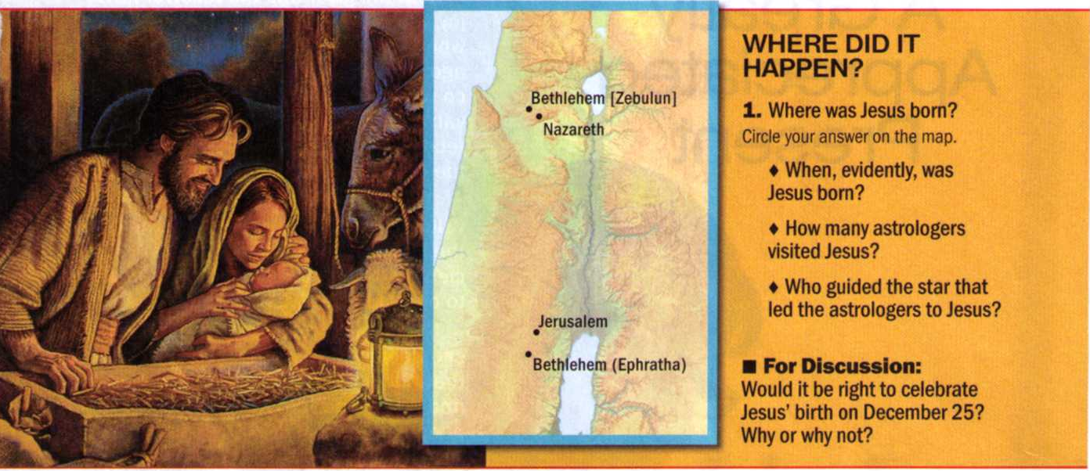

Task 6
CROSSWORD PUZZLE
Clues Across
1. Vessels of this type were used for trade in the days of King Solomon [3 words] (1 Kings 10:22)
7. What the apostle Paul said that he had run to the finish when near the end of his life (2 Timothy 4:7)
9. A grandson of Levi and uncle of Moses and Aaron (Numbers 3:19)
10. Pharaoh had one in which he saw seven fat cows eaten up by seven thin cows (Genesis 41:17-20)
11. Timothy's mother, from whom he received an excellent spiritual education (2 Timothy 1:5)
12. After Absalom was killed by Joab, Absalom's body was pitched into one (2 Samuel 18:17)
17. The “wages” it pays is death (Romans 6:23)
18. The word Jesus used to describe the effort of a camel's passing through the eye of a needle as compared with a rich man's getting into the Kingdom of God
(Matthew 19:24)
19. In regard to Jesus, it was on this subject that Felix listened to Paul (Acts 24:24)
20. It was said that Jacob's eyes had become dull because of this (Genesis 48:10)
21. Reaches a specified situation [2 words] (Proverbs 14:13)
26. According to Revelation 19:15, Jesus does this in the symbolic winepress of God's anger
27. The two tablets upon which God wrote the Law were made of this material (Exodus 31:18)
28. The term of honor and dignity called out before the chariot of Joseph after Pharaoh made him second in the kingdom (Genesis 41:43)
29. Forefather of a family of Solomon's servants (Ezra 2:55)
30. Paul recommended that Christian women display this by the way they adorned themselves [3 words] (1 Timothy 2:9)
Clues Down
1. Two were needed to support each of the tabernacle's panel frames [2 words] (Exodus 26:19)
2. Paul sent greetings to this Christian woman who lived in Rome and had “performed many labors in the Lord” (Romans 16:12)
3. Areas in which grain was separated from its stalk and chaff [two words] (Joel 2:24)
4. The concubine by whom Nahor fathered four sons (Genesis 22:24)
5. He suffocated Ben-hadad of Syria and began to rule in his place (2 Kings 8:13-15)
6. Figuratively speaking, it is said that Jehovah can measure "the waters" within this [4 words] (Isaiah 40:12)
8. Location of Adam and Eve's garden home (Genesis 2:15)
13. The prophet whose words stimulated Asa to eliminate “disgusting things” from his domain (2 Chronicles 15:8)
14. The jackals'home (Jeremiah 9:11)
15. Utilized (Leviticus 7:24)
16. The apparent site of a great cistern where Saul inquired as to the whereabouts of David and Samuel (1 Samuel 19:22)
22. Second son of Jacob, whose violence was disapproved by his father (Genesis 49:5-7)
23. Name given to one of the four rivers branching out from the river that issued out of Eden (Genesis 2:11)
24. If a Christian takes a false one, those with spiritual qualifications should try to readjust him in a spirit of mildness (Galatians 6:1)
25. Head of the fourth of the 24 priestly divisions selected by lot
during David's reign (1 Chronicles 24:8)

Crossword Solutions
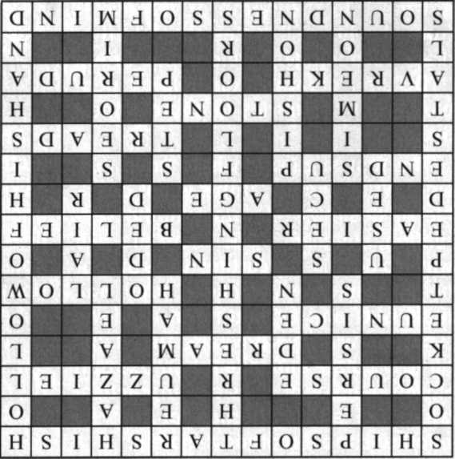

Заключний етап .Підсумки.

