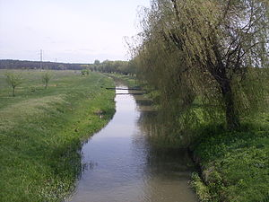

**Урок у 5 класі «Моє село»**

Полюхович Людмила Миколаївна, вчитель англійської мови Золотоношківської ЗОШ І-ІІІ ступенів Драбівського району Черкаської області

**Тема:** Моє село (Золотоношка, Черкаської області)

**Мета:** розвивати навички аудіювання, діалогічного, монологічного, спонтанного мовлення; створити на уроці комунікативну ситуацію з реального життя з метою заохочення учнів до висловлення своїх думок, вираження почуттів, використання життєвого досвіду.

Сприяти розвиткові мовної здогадки, логічного та творчого мислення учнів.

Стимулювати інтерес учнів до вивчення предмета за допомогою цікавих форм роботи та додаткового обладнання.

Виховувати любов до свого села, до людей праці.

**Обладнання:** підручник, роздатковий матеріал, аудіозапис, комп’ютер, мультимедійна дошка.

**Тип уроку:** засвоєння нових знань.

**Форма роботи:** парна, групова, колективна, рольова гра.

Хід уроку

**І. Підготовка до сприйняття іншомовного мовлення**

**1. Привітання**

T. Good morning, children! I’m glad to see you.

What a fine morning!

The day is sunny and bright.

My dear children, and I right?

Ps. Yes, you are right.

T. How are you?

Ps. Fine, thank you.

T. Do you like English lesson?

Ps. Yes, we do.

**2.Повідомлення теми та мети уроку**

Today we’ll do many interesting things. We shall speak about…

Loot at this train. Solve the puzzle and you’ll understand everything. it is written on the blackboard as a code. Each number refers to the number of the letter in the alphabet. These pictures may also help you. They are connected with our today’s topic. Who will be first?

14 1 20 9 22 5 22 9 12 12 1 7 5

Children, the subject of our today’s lesson is “Our village”. Today you will take part in the presentation of your village, ask questions and answer them; recite poems, listen, play a role play about the advantages of the life in a village.

**3.Уведення в іншомовну атмосферу.**

**1. Мовленнєва розминка.**

* How are you, my dear children?
* Are you angry? (No, we are not)
* Are you sad? (No, we are not)
* You are merry! (Yes, we are)
* You are clever! (Yes, we are)
* You are very, very kind! (Yes, we are).

**II. Основна частинауроку**

1. **Метод «Мікрофон». Учень у ролі репортера бере інтерв’ю.**

* Is your village big or small?
* What is there in your village?
* Do you live in the center of the village?
* What street do you live in?
* Are the houses in your street modern?
* Is your school far from your house or near it?
* Is your street beautiful?
* Is there a river in your village?
* Do you like your village?

1. **Мовленнєва розминка**

T. Some people think that the place where they were born is the best on the Earth.

Others move to other cities or countries and live there. Do you know any English proverbs about it?

P1. There is no place like home.

P2. Home, sweet home.

P3. East or West home is best.

P4. I strongly disagree. The best place for me is my granny’s place. I feel quiet. She allows me to do every think I want.

P5. I disagree. My cousin and his family moved to Canada. They are very happy there. Their home is far from away now!

1. **Активізація лексики. Скласти речення.**

A house, a garden, fields, geese, goats, chikens, cats, dogs, fruits, a river, a cow, a sheep, a pig, a hen, a cock, a farmer.

**3. Пісня**.

T. There is a song about domestic animals that live on a farm. Do you know this song? Song “Old Mac Donald”

T. Where does a caw live? (On the farm)

**4. Аудіювання. Учні слухають розповідь про село Золотоношка**

*Zolotonoshka known since the 17th century. Scientific evidence of the origin of the village there. There are several legends about the village:  
  The first shows the connection name of the town called River. It is said that in ancient times the river was navigable. Once it was moving caravel loaded with gold, jewels, fur. And it so happened that one of the ships sank. Since then, and began to call Zolotonoshka river. Later on its banks was the first settlement of the same name;  
    second legend says that the first house was on the left bank of the river, about 1611-1612 years. Picturesque nature, soils contributed resettlement on the river poor Cossacks, including the Cossack named gold;  
    third legend tells that carried a tribute by land, as they said "wore gold" at the venue on the Left Bank of Ukraine - Zolotonosha. The expression "to wear gold," and gave the name to the settlement.*

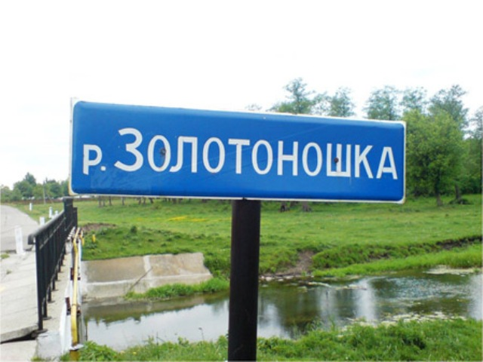

Перевірка розуміння тексту. Групова робота: з поміж запропонованої кількості малюнків вибрати ті, що відповідають тексту. Відтворити зміст тексту за малюнками (один представник від групи). Розмістити малюнки в такому порядку, в якому вони чули в тексті.

**5. Фізкультхвилинка. Аудіювання пісні про дотримання правил дорожнього руху**.

Look out! Look out!

When you cross the street,

Use your eyes, use your ears

Then you use your feet.

1. **Рольова гра про переваги сільського життя.**

And now let’s play the role-play about the advantages of the life in a village. Imagine you are a sociologist. You ask people about the advantages of the life of the village. You stop people in the street to ask them a few questions.

1. In a village there are not many buses, trolley-buses or trams. There is no metro here. There are not many big streetsand bridges in it. But there is not much noise here either.
2. In the evening you can see how the sun goes to sleep. In a village you can hear how birds sing. They sing their beautiful songs for everybody.
3. In a village many people know each other and in towns they run and run and don’t look at each other.
4. In a village children always say “Good afternoon!” to old people and other grows-ups. Even if they don’t know them they greet them. It is a tradition.
5. In a village when people are working in the field or kitchen-garden and other people are passing by they say to the workers, “Let go help you!”. It is a tradition too.
6. In towns only dogs and cats live in flats. But in villages there are many domestic animals and birds: cows, horses, goats, sheep, rabbits, hens, ducks, turkeys and geese. We have dogs and cats too, but they don’t live in the houses. Usually they live in the yard.

**6. Перевірка домашнього завдання. Конкурс гідів про Золотоношку. Перша група розповідає «Село моєї мрії». Друга – «Зелене село». Третя – «Загадкове село». (Презентації учнів) (додаток, СД-диск)**

**7. Проектна робота. Індивідуальний творчий проект «My Street”. Назаздалегідь підготовлених макетах учні за допомогою комплектів малюнків відтворюють, що вони бачать на своїй вулиці.**

**8. Представлення проектів.**

**ІІІ. Заключна частина уроку.**

1. Домашнє завдання.

Перша група- намалювати малюнок свого села, повторити слова.

Друга – скласти речення про своє село з опорою на таблицю. (картки)

Третя – написати листа другові про своє рідне село.

1. Підведення підсумків уроку.

Чи сподобався вам урок? Що цікавого ви дізналися? Що найбільше вам сподобалося?

* I was on excursion.
* Where did you been?
* I was in Zolotonoshka?
* What did you see there?
* I saw … I like the excursion very much.
* What will you retell your parents about the excursion? (Учні говорять, що їм найбільше сподобалось).
* Oh, it was very interesting there. I liked … best of all.
* Our tour has finished, I hope you have enjoyed this tour about Zolotonoshka.
* What places can you name?
* Do you know any English proverbs?

ДОДАТОК

East or West – home is best! It’s time to talk about the best village –**Zolotonoshka**. I live in Zolotonoshka. My village stands on the Zolotonoshka river. It is about years old. It is big and beautiful village. There was a cattle-farm,a pig-farm, a chicken-farm and a big garden in my village. There were many fruit-trees in the garden.

In the centre of the village you can see an old club, an old school, a hospital and many new nice shops. The houses in the village are not high, but they are very nice. Near the houses you can see many trees and flowers. There is a river in our village too.

My name is Taras. I live with my family in Shevchenko street. My street is not long. There are many green trees and flowers in our street. You can see many big houses and a new shop in our street. In my street are many men, women and children. I like it very much. My school is not far from my house.

* 1. **The house I live in.**

My house is on a quiet street. It is large and comfortable. It has got two floors. On the ground floor there is a beautiful living-room, a dining room, a modern kitchen and a bathroom. In the living room there is much furniture. There is a cupboard, a bookcase and a piano against the wall. There is a sofa and two armchairs in front of the fireplace. There is a TV in the corner of the room. Upstairs there are five big bedrooms and a small bathroom.

My bedroom is great. I’ve got a bed and a brown carpet on the floor. I’ve also got a small desk, two chairs and an old wardrobe next to the window. The curtain on the window areyello and they make the room bright and nice. There is a mirror and two lovely pictures on the wall.

* 1. **Green village (зелене село)**

Welcome you in Green village. Our village is very big. It is clean and beautiful. The ecological situation is good because there are any plants and factories. It is a village of green trees, gardens and many different flowers.

There is a Centre Park where we can see a rose garden. Beautiful park will make our village nice. Village visitors could spend time in the park.

A nice new club stands in the centre of the village. All people can listen to musik and see concerts of famous singers.

There is a new school.

There is a modern Fashion House. There are a lot of clothes, dresses, coats from Paris. You are welcome to the fashion show. We can meet famous models. They are very nice.

We like our village. We shall wait for you in it.

1. **Село моєї мрії**

We live in a big village and do not have a cinema in Zolotonoshka. We usually go to big cities to see shows.

I’d like to say that it will be great to have a cinema and a museum there.

Our village will be a big shopping center. There will be a big department store.

As for me, people should wear beautiful clothes. The shops will sell clothes, shoes, hats and other things. I like to go shopping.

To my mind, beautiful shop windows will make the streets of our village more beautiful. We think the most important place in any village or town is a plant where people will work. That’s why our village will have a plant.

I hope the people will be rich and happy because they will have work, money, place to live and many interesting places to go to in their village