Бінарний урок
“Music. Styles of music.”
Мета:
1. Навчальна: активізувати лексику з теми «Музика», формувати лексичні навички говоріння, удосконалювати техніку пошукового читання.
2. Розвиваюча: розвивати мовну інтуїцію, мовну реакцію, сприяти розвитку самостійного мислення, розвивати комунікативні навички
3. Виховна: виховувати зацікавленість у розширенні своїх знань, виховувати культуру спілкування, заохочувати до вивчення нового.
Тип уроку: бінарний урок
Обладнання: підручник, картинки, картки, фото музикантів.
Технічні засоби: магнітофон.
Хід уроку:
- Підготовка до сприймання іншомовного мовлення.
Greeting and aim.
Good afternoon. I am glad to see you. Let’s start our lesson. Today we’ll revise everything we have learnt about music, styles of music, practice our listening, reading, speaking. So our today’s topic is “Music. Styles of music.”

Warming up.
Answer the questions:
Who likes music?
What is your favourite group?
Who is your favourite singer?
Now I and Olia have a surprise for you. Olia wants to sing a song ”Yesterday”
Do you like her singing?
Do you know the style of song?
What is your impression?( brilliant, exciting, fantastic…)
What kind of music do you know?( classical, rock, jazz, rap…)
II.Основна частина уроку.
Oral Practice

All of you will be given a card. Read about the definitions of different styles of music. We’ll read one by one.
blues | choir music that has religious background
reggae | played with the help of electric instruments and steady rhythm
jazz | music played by military bands
country | music from the West Indians, with a strong regular beat. It develops in Jamaica, especially 1960s, and its best –known singer was Bob Marley
rock’n’roll | composed many years ago and sung by people or choirs [ kwaie]
folk | a musical style where the singer speaks or shouts the words
rap | a style of music that was popular especially in the 1950s but is still played now. It has a strong, loud beat and is usually played on electrical instruments. The best –known singer Elvis Prestley
heavy metal | A style based on blues and rhythm and blues, but with the electric instruments amplified so they are very loud.
classical | music that is popular and originated from the southern and western United States. It has
martial | a slow, sad style, originally from the southern states of the USA
rock | both music and dance from Latin America, especially Argentina
British Beat | The Beatles in the 1960s mixed rhythm and blues, rock and roll, and soul music. The new style was “beat” music. Groups used drums, bass and two guitars with vocal lead and harmony.

Now our teacher of music will play different styles of music and your task is to guess what style of music it is.
T. Are you ready for another task?
2. The next task is to complete the sentences with the words from the box.( work in pairs)
Pop music reggae classical music folk music jazz saxophone
Keyboard drums country music punk music guitar
- ________ is often played by a big orchestra in a concert hall.
- ________ is often played by young people with the guitars in a group.
- _________ is usually played by young people with brightly coloured hair.
- _________ comes originally from black American musicians.
- _________ usually offers simple tunes which are popular for a short time.
- ________ comes from a specific region and is usually popular for a long time.
- ________ has a strong regular rhythm. It’s originally from Jamaica.
- ________ is popular for dancing in discos.
- ________ is often played freely, not following written music.
- ________ is usually played the guitar , banjo and violin.
- The _____ is a string instruments while the _____ belongs to wind instruments and the _______ to percussion instruments.
- The piano and organ are ______ instruments.
Keys: 1. classical music; 2,5,8 pop music; 3. punk music;
4. jazz; 6. folk music; 7,9 reggae; 10. country music; 11. guitar, saxophone, drums;
12. keyboard.
3.Look at the pictures and say what styles of music do the musicians play?
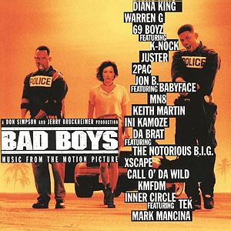  1. The Bad Bad Boys |   5. Sam and the Band | a) pop music  b) jazz
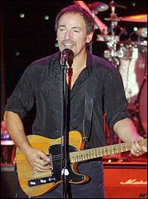  2. Jimmy Wild | 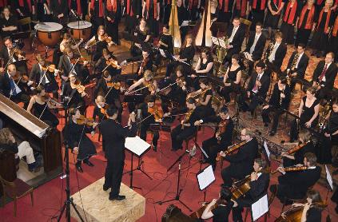  6.The Vienna Orchestra | c) Punk music  d) classical music
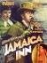  3. Jamaica Inn | 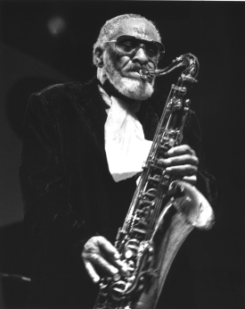  7. Ronnie Sonnie | e) rock music  f) reggae
  4. Las Palomas | 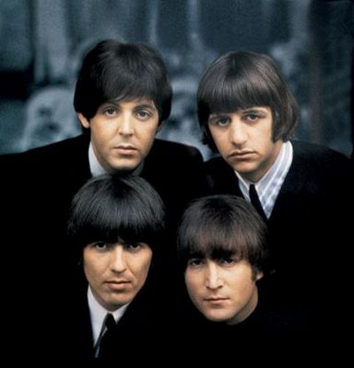  8. The Beatles | g) folk music  h) British Beat
Example:
Picture 1 is associated with the punk music.
Keys: 1c, 2e, 3f, 4g, 5a, 6d, 7b, 8 h.
- Do you know such style of music as gospel?
4. Reading. Read the text and answer the questions.
Gospel is good news in bad times. It evolves out of the Black church experience. The Gospel Sound evokes a call and response from its listeners and sends a message of hope, joy, suffering, and pain. This music has a long history and a struggle with being accepted by different cultures or ethnic groups. Some people use this as a comforter for difficult situations, some use it to praise God and others use to understand religion. Gospel music was nicknamed Negro spirituals, Work songs and Folk songs. It got the name from back in Slavery times, when the slaves sang these songs while working in the field and at praise services (church or bush meetings/camp meetings). Gospel music has a very interesting history, had a difficult struggle to be accepted by different cultures and ethnic groups, and now gospel music is more popular than ever and finally being accepted by more people today.
What is gospel?
How do people use this music?
How did gospel get the name?
Where can you hear it?
- Now listen to the gospel music. Do you like it? What is your impression?

- What is your favourite style of music?
- I like classical music. I can play the piano and I enjoy playing. The classical music makes me feel better. I dislike heavy metal. It’s really loud.
(висловлювання кількох учнів).
5. Music Questionnaire” Are you a lover of music?”
Many people like music but «lovers of music» love it and try to fill every minute of their life with music. As a rule they don't have much free time so they are very categorical in their choice of favourite music. A real «lover of music» chooses the best. And what about you? Do you belong to the category t «Music lovers»?
T. Answer the following questions and score:
1 point if you answered positively to the questions 2, 3, 6, 7, 8(b), 9, 11, 12;
1 point if you answered negatively to the questions 1, 4, 5, 10;
2 points if you answered positively to the question 8(d);
3 points if you said «Yes» to the question 8(c).
Then read the interpretation of you score and find out what your real attitude to music is.
- Do you think that interest in jazz will soon pass?
- Can you name 5 kinds of string instruments?
- Can you tell the sound of French horn from other instruments in the orchestra?
- Do you feel a fresh surge of energy when you listen to «hard» or «metal» rock?
- Can you fall asleep to music?
- Do you think a musical comedy is an old-fashioned genre of music?
- Does classical music help you to forget about your problems?
- Which of the following singers do you prefer to listen to when you are relaxing: a) Michael Jackson? b) Valeriy Leontyev?
c) Tina Turner? d) Elvis Presley?
9. Do you like to listen to folk songs?
- Your favourite song is being played at a party. Will you dance to it?
- Have you ever heard about a concert for a grandpiano and a tuba?
- Can you recognize a melody you liked from the first six notes if you hear it for the second time?
Score interpretation:
More than 8 points - you are a true «lover of music». Music can help you in your most difficult life situations and share your joys and sorrows. Music is necessary for you, it helps you to work and relax, to think and to create. You can't imagine your life without music and you think you know much about it. It is really so and we are happy for you.
4-8 points - You only like music which is pleasant to your ear. You listen to serious music only when you are in a corresponding mood. You are not a true «lover of music». You are more interested in the singer than in the music of a song.
Less than 4 - What you like is the music which is called «music for your feet». Well, anyway we hope that music helps you to relax and or have some exercise.

- Заключна частина уроку.
Summarizing.
Did you like the lessons?
Was there anything new for you?
Homework.
Your homework is to answer the question “ What kind of music do you like?”

